What is a Perceptron? Perceptron Vs Neuron | Perceptron Geometric Intuition
Desmos.com

The perceptron is a fundamental concept in the world of machine learning and forms the building block for more complex neural networks. If you’re venturing into supervised learning, understanding the perceptron is crucial.
What is a Perceptron?
A perceptron is a type of artificial neuron used in supervised learning. It is a mathematical model that mimics the way a biological neuron works. Essentially, it’s a function that takes input features, multiplies them by corresponding weights, adds a bias, and passes the result through an activation function to produce an output.
To make predictions with a perceptron, you first need to train it on labeled data. During training, the perceptron learns by adjusting its weights and bias values based on the errors it makes. Once trained, it can make predictions on new, unseen data, where important features are given higher weights.
A single perceptron can only solve linearly separable problems. However, when multiple perceptrons are combined, they form a neural network capable of tackling more complex tasks.
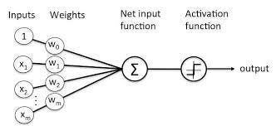

Effectively, this model takes in some input, processes it, and generates an output. This is similar to what happens in a biological neuron:
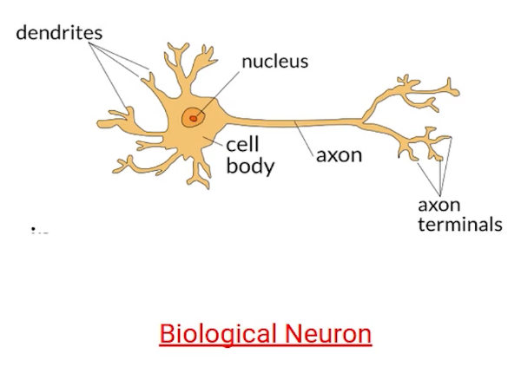

It takes the input to the dendrite, processes the provided information, and generates the output. You can see the similarity right? Thus the model that we’re talking about can also be called a Neuron.

This model of computation was intentionally called neuron, because it tried to mimic how the core building block of the brain worked. Just like brain neurons receive electrical signals, McCulloch and Pitts’ neuron received inputs and, if these signals were strong enough, passed them on to other neurons.
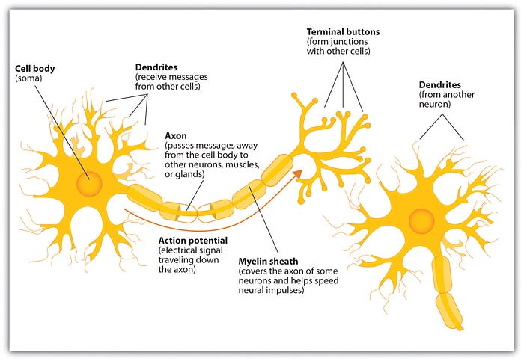
The first application of the neuron replicated a logic gate, where you have one or two binary inputs, and a boolean function that only gets activated given the right inputs and weights.
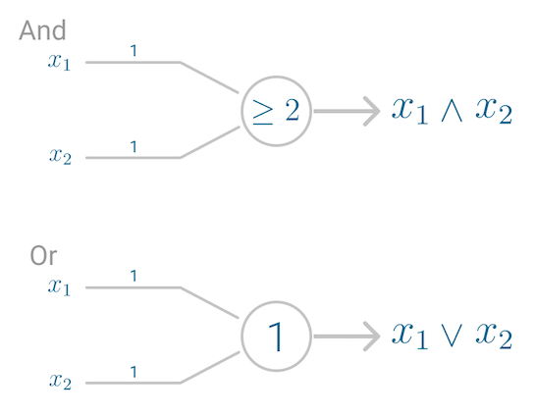
However, this model had a problem. It couldn’t learn like the brain. The only way to get the desired output was if the weights, working as catalyst in the model, were set beforehand.
The nervous system is a net of neurons, each having a soma and an axon […] At any instant a neuron has some threshold, which excitation must exceed to initiate an impulse[3].
It was only a decade later that Frank Rosenblatt extended this model, and created an algorithm that could learn the weights in order to generate an output.

A perceptron is the earliest form of a neural network unit, introduced by Frank Rosenblatt in 1958. It is a binary classifier that makes predictions based on a linear combination of input features. The perceptron algorithm was one of the first algorithms used to implement a simple neural network.
Perceptrons are supervised learning algorithms and is a type of an ANN
Components of a Perceptron:
- Inputs: The perceptron takes several inputs (x1,x2,…,xn)
- Weights: Each input is associated with a weight (w1,w2,…,wn).
- Bias: A bias term (b) is added to shift the decision boundary.
- Activation Function: The perceptron uses a step function (a simple thresholding function) to determine whether the weighted sum of inputs plus the bias is above or below a certain threshold.
- The mathematical representation is:
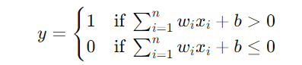
- Binary Output: The output of a perceptron is binary (1 or 0), making it suitable for linearly separable classification problems.
Limitations of Perceptron:
- Linear separability: The perceptron can only solve problems that are linearly separable (i.e., it can only classify data that can be separated by a straight line or hyperplane). It cannot solve more complex problems like XOR.
- Single-layer model: The original perceptron is a single-layer model and does not have hidden layers, limiting its expressiveness.
Press enter or click to view image in full size
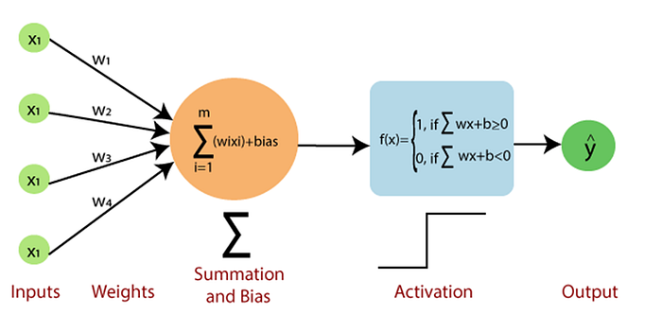

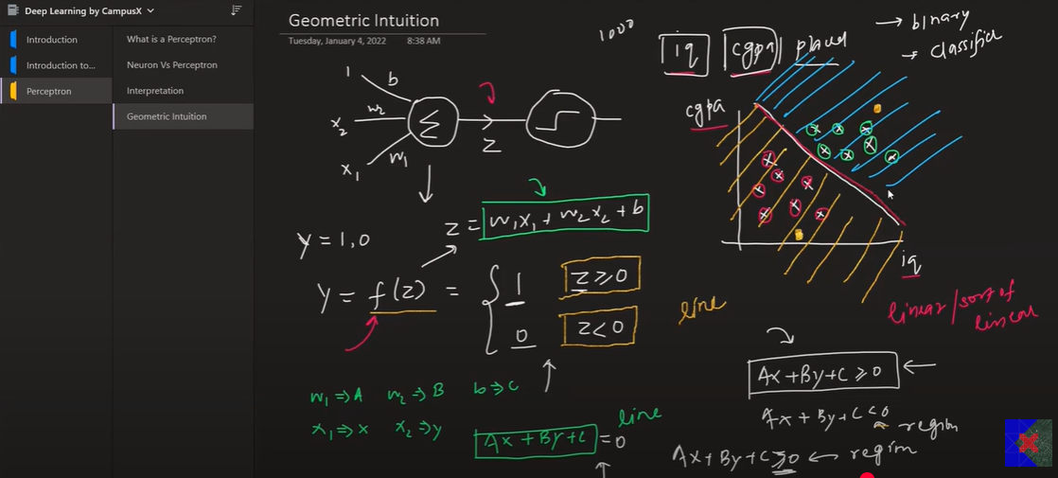

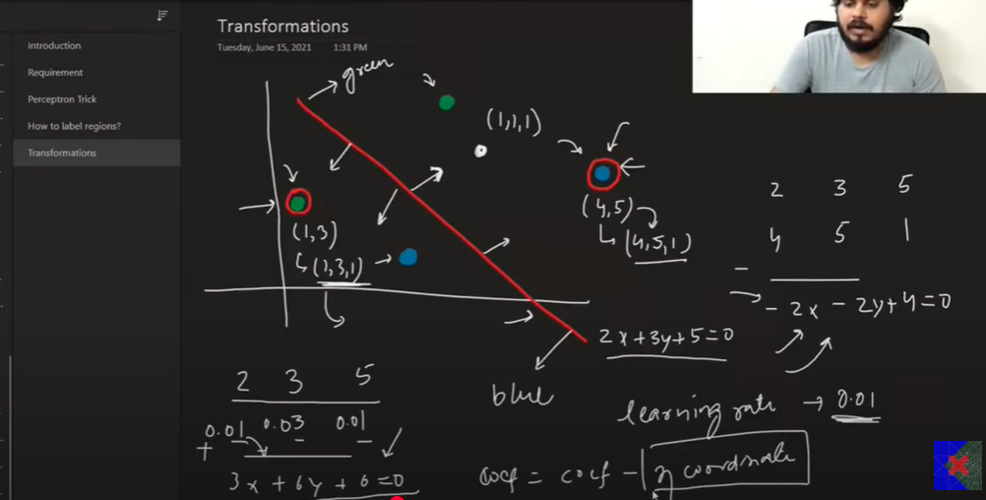

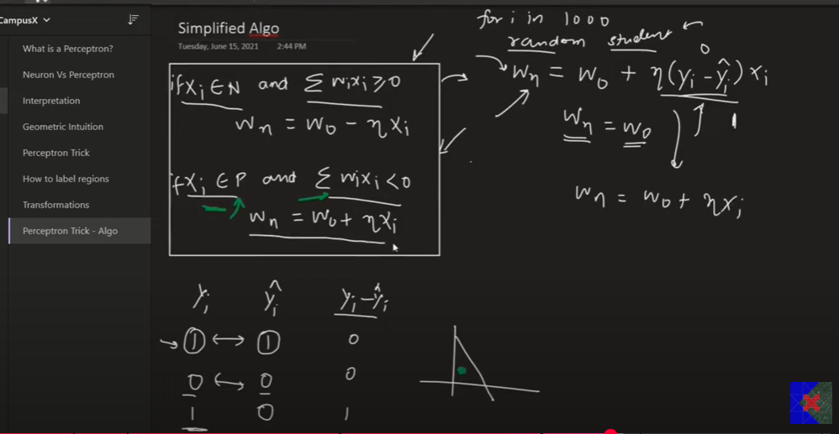

Desmos.com - this below same concept are followed in perceptron for classification problems
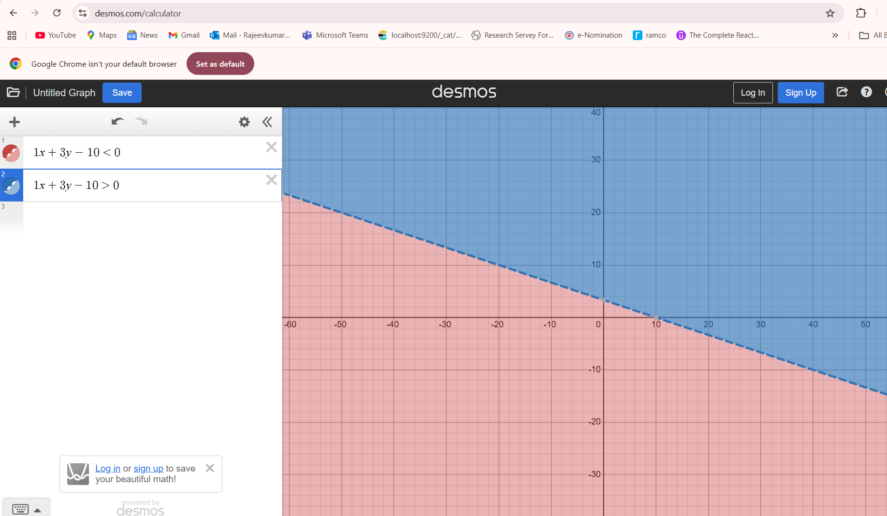

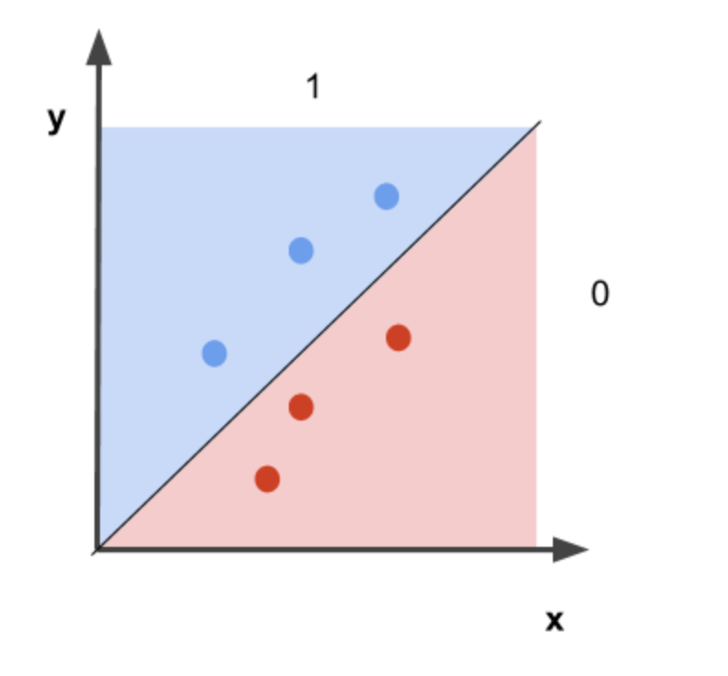

2. Neuron: A Generalized Unit in Neural Networks
A neuron, or artificial neuron, is a more generalized version of the perceptron and is the building block of modern deep learning architectures. Neurons in deep learning are part of multi-layer neural networks, which can have multiple hidden layers.
Key Differences and Features of a Neuron:
- Activation Function: Unlike the perceptron, which uses a simple step function for activation, neurons in modern neural networks can use a variety of activation functions, such as:
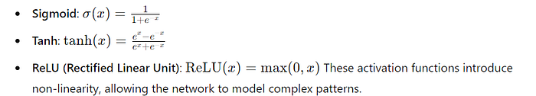
- Multi-layer Networks: Neurons are part of more sophisticated architectures called multi-layer perceptrons (MLPs) or deep neural networks, where neurons are organized into layers (input layer, hidden layers, and output layer). Each layer performs computations, and the output of one layer is fed as input to the next.
- Continuous Output: Neurons can output continuous values, unlike the binary output of a perceptron. This makes them more versatile for tasks like regression, multi-class classification, and complex feature extraction.
- Learning through Backpropagation: Neurons in deep learning models are trained using backpropagation and gradient descent, which adjusts the weights based on the error between the predicted and actual outputs. The perceptron uses a simpler update rule that works only for linearly separable problems.

The Limitations of Perceptron: Why it Struggles with XOR
Despite their historical importance as the building blocks of neural networks, perceptrons have several significant limitations that have led to the development of more advanced neural network models.
1. Inability to Solve Non-Linearly Separable Problems
One of the most fundamental limitations of perceptrons is their inability to solve problems that are not linearly separable. A perceptron can only draw a straight line (or hyperplane in higher dimensions) to separate two classes. If the data points from different classes cannot be separated by a straight line, the perceptron fails to classify them correctly.
Example: The XOR problem, where the output is `1` only when exactly one of the inputs is `1`, is a classic case that a perceptron cannot solve because it can’t separate the classes with a straight line. In contrast, the AND and OR problems are linear and can be handled by a perceptron. Let’s explore this in detail to understand why.
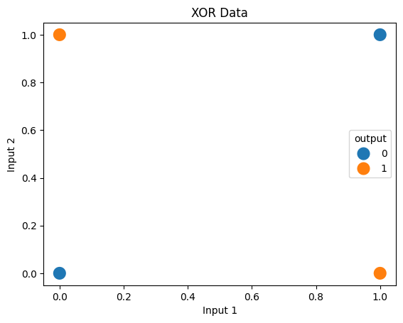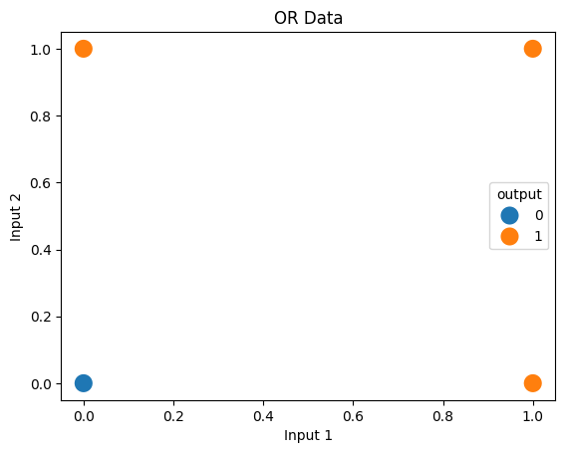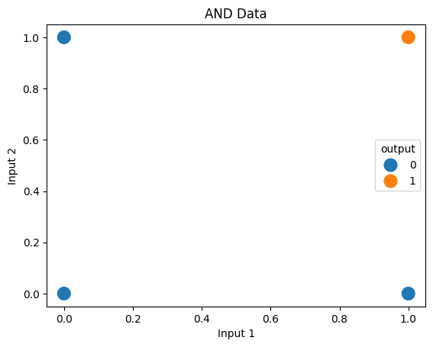
The XOR, OR, and AND data plots represent different logic gates with unique output conditions. The XOR gate outputs 1 when exactly one of the inputs is 1, resulting in a distinctive pattern in the plot. The OR gate outputs 1 if at least one input is 1, which is reflected in the pattern where any input combination with a 1 leads to a 1 output. The AND gate outputs 1 only when both inputs are 1, showing a pattern where only one specific input combination results in a 1 output.
The above graphs show the distribution of AND, OR, and XOR gates. Now we will look at whether the perception can classify all these gates properly or not.
Perceptron Performance on the AND and OR Gates
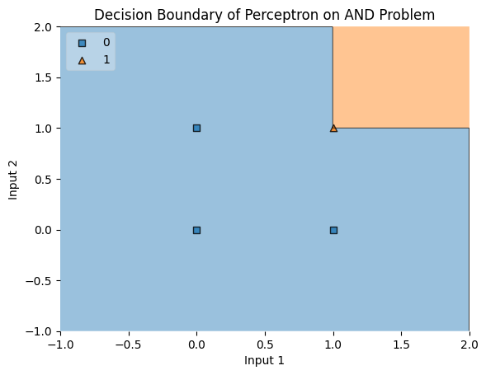
Decision Boundary of Perceptron for the AND gate
This graph shows the decision boundary created by a Perceptron model when trained on the AND logic gate problem. The boundary effectively separates the output classes, with the orange region representing the area where the model predicts 1 (when both inputs are 1), and the blue region where it predicts 0 (for all other input combinations). This demonstrates that the Perceptron successfully handles the linearly separable AND problem.
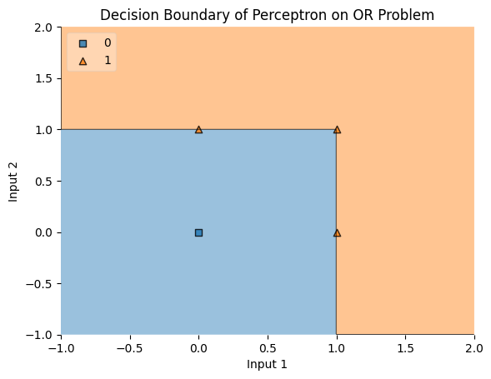
Decision Boundary of Perceptron for the OR gate
This graph shows the decision boundary created by a Perceptron model when trained on the OR logic gate problem. The boundary effectively separates the output classes, with the orange region representing the area where the model predicts 1 (when either or both inputs are 1), and the blue region where it predicts 0 (when both inputs are 0). This illustrates the Perceptron's ability to solve the linearly separable OR problem.
The XOR Problem: A Challenge for Perceptrons
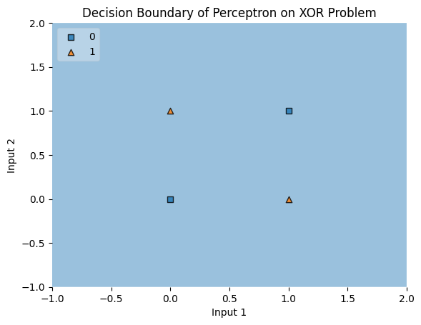
Decision Boundary of Perceptron for the XOR gate
This graph shows the decision boundary created by a Perceptron model when trained on the XOR logic gate problem. The model fails to find a correct boundary, as shown by the single blue region covering all the input space. This illustrates the Perceptron’s inability to solve the XOR problem, where the classes are not linearly separable.
2. Limited Representation Power
Perceptrons can only solve problems where the classes can be separated by a straight line. They are like simple tools that can only handle problems with a clear-cut separation. If a problem needs a more complex boundary, like a curve, a perceptron won’t work well.
3. Single-Layer Structure
A perceptron has just one layer of neurons. Because of this, it can’t learn or recognize complex patterns in the data. Without extra layers, it can’t understand more detailed or abstract features, which are needed for tougher problems.
4. Sensitivity to Input Data
Perceptrons are very picky about the data they get. The data needs to be well-prepared and easy to separate with a line. If the data is messy, noisy, or not well-prepared, the perceptron won’t work well and might even fail to learn.
5. No Capability for Multi-Class Classification
A regular perceptron can only decide between two classes, like 0 or 1. To handle more than two classes, additional methods are needed, but they are not as good or efficient as more advanced models that can naturally handle many classes.
6. Convergence Issues
Perceptrons learn by adjusting their weights based on mistakes. However, this only works if the data can be easily separated by a line. If it can’t, the perceptron will keep adjusting endlessly without finding the right answer.
7. No Capacity for Memory or Time-Sequencing
Perceptrons can’t remember past inputs or deal with data that changes over time. This makes them unsuitable for tasks that require understanding sequences or context, like predicting stock prices or recognizing speech, where memory is important.
8. Inefficient Training for Large Datasets
Training a perceptron can be slow and inefficient, especially with large datasets. The training involves adjusting weights for each input, and it might take a long time to get it right, especially if the learning rate isn’t set properly.
9. No Probabilistic Interpretation
Perceptrons only give a hard decision (0 or 1) and don’t provide a confidence level or probability. This is a problem in situations where knowing how certain the prediction is can be crucial, like in medical decisions or financial forecasts.
Conclusion
Perceptrons were important in the early days of neural networks, but they have clear limitations. They can’t solve complex problems, are sensitive to input data, and can only handle simple, linear tasks. Their single-layer structure and lack of memory make them unsuitable for more advanced tasks, and they struggle with multi-class problems and large datasets. Although newer models have taken their place, understanding perceptrons helps us appreciate the progress in AI and the need for more advanced models.

A perceptron consists of four parts: input values, weights and a bias, a weighted sum, and activation function.
Assume we have a single neuron and three inputs x1, x2, x3 multiplied by the weights w1, w2, w3 respectively as shown below,
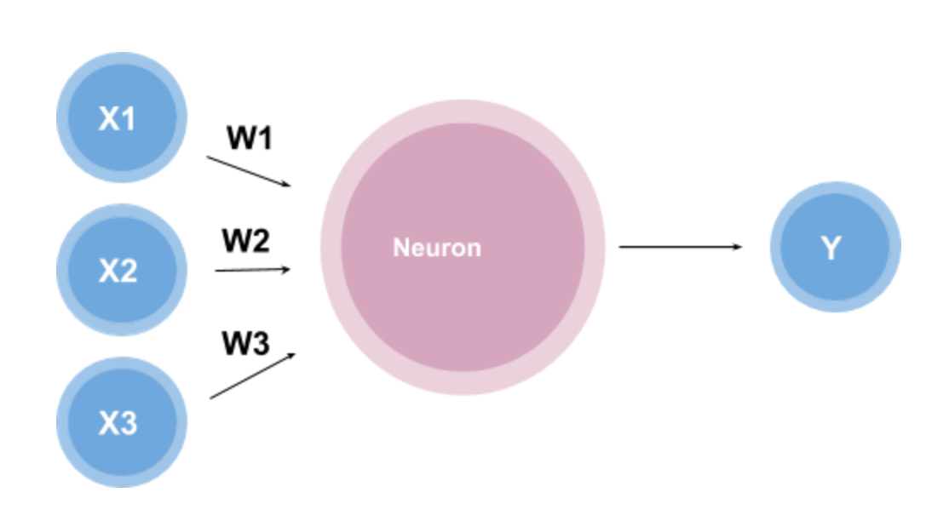
The idea is simple, given the numerical value of the inputs and the weights, there is a function, inside the neuron, that will produce an output. The question now is, what is this function?
One function may look like
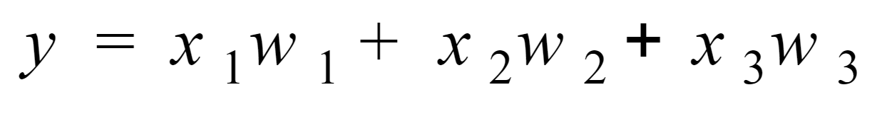
This function is called the weighted sum because it is the sum of the weights and inputs. This looks like a good function, but what if we wanted the outputs to fall into a certain range say 0 to 1.
We can do this by using something known as an activation function. An activation function is a function that converts the input given (the input, in this case, would be the weighted sum) into a certain output based on a set of rules.
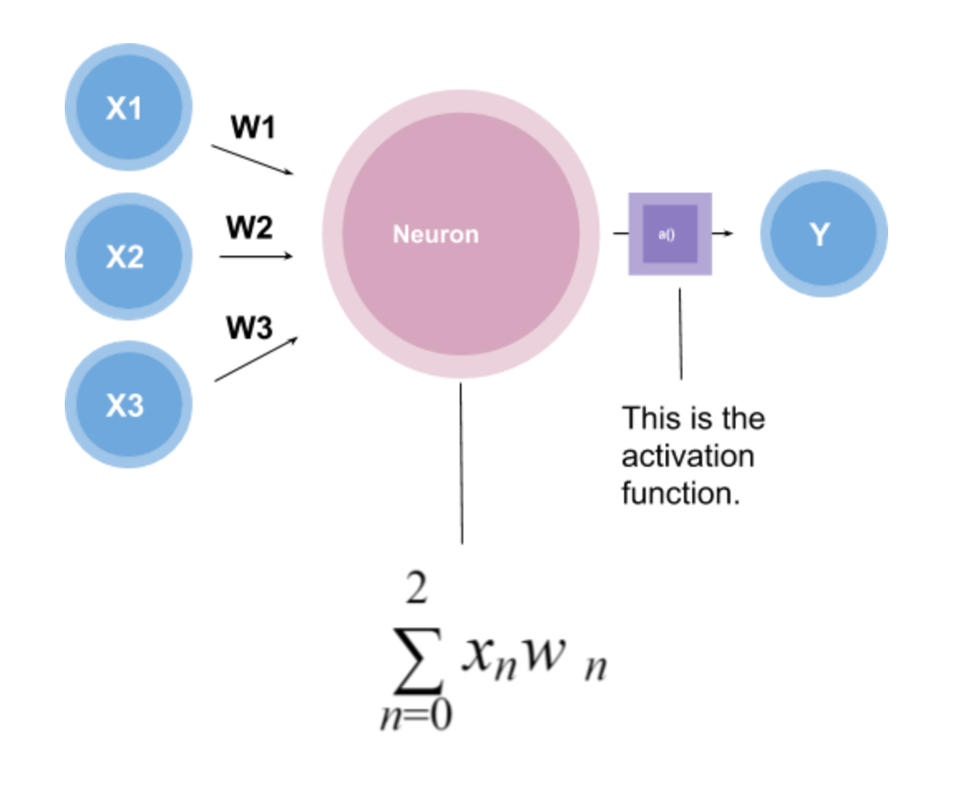
There are different kinds of **** activation functions that exist, for example:
- Hyperbolic Tangent: used to output a number from -1 to 1.
- Logistic Function: used to output a number from 0 to 1.
etc.
Note: Activation functions also allow for non-linear classification. If you are interested in knowing more about activation functions I recommend checking out [this](https://towardsdatascience.com/activation-functions-neural-networks-1cbd9f8d91d6) or check out this.
Since the range we are looking for is between 0 and 1, we will be using a Logistic Function to achieve this.
Logistic Functions
Logistical functions have the formula,
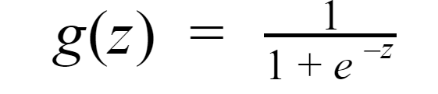
Where the graph looks like,
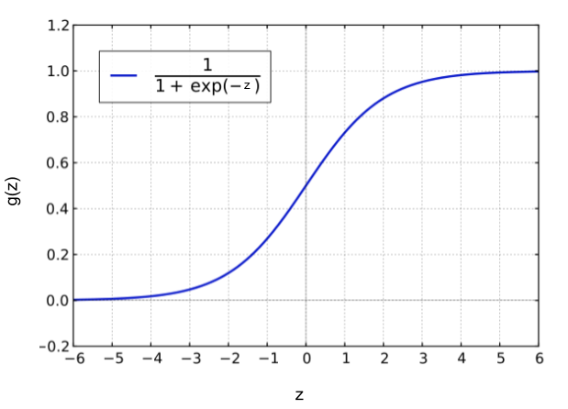

Notice that g(z) lies between the points 0 and 1 and that this graph is not linear. This will allow us to output numbers that are between 0 and 1 which is exactly what we need to build our perceptron.
Now we have almost everything we need to make our perceptron. The last thing we are missing is the bias. The bias is a threshold the perceptron must reach before the output is produced. So the final neuron equation looks like:
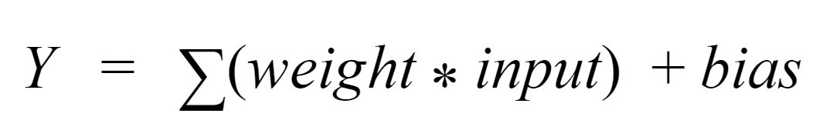Image by Author
Represented visually we see (where typically the bias is represented near the inputs),
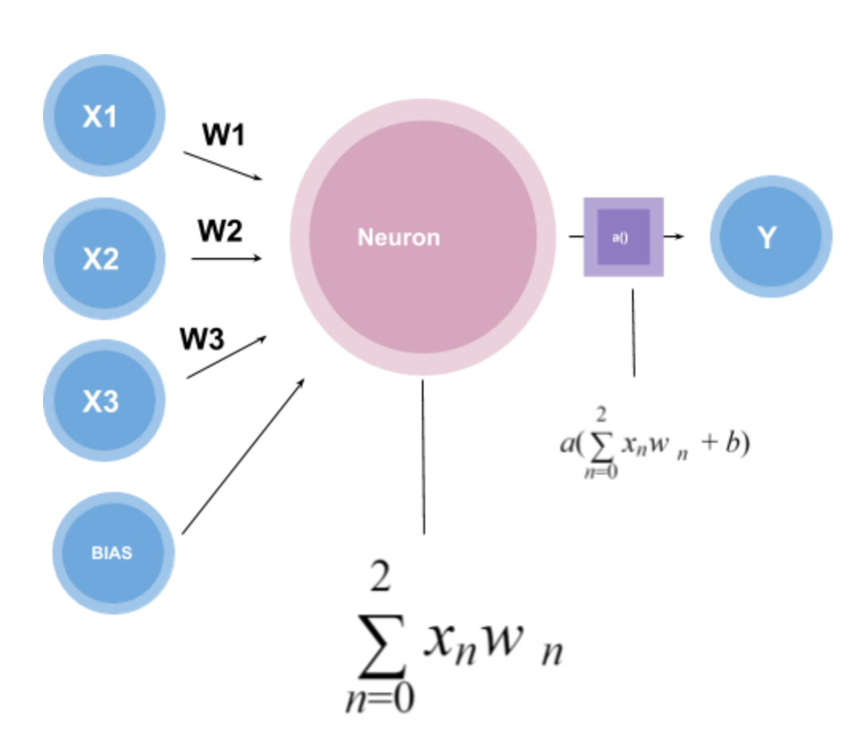Image by Author
Notice that the activation function takes in the weighted sum plus the bias as inputs to create a single output. Using the Logistical Function this output will be between 0 and 1.
Why are perceptron’s used?
Perceptrons are the building blocks of neural networks. It is typically used for supervised learning of binary classifiers. This is best explained through an example. Let’s take a simple perceptron. In this perceptron we have an input x and y, which is multiplied with the weights wx and wy respectively, it also contains a bias.
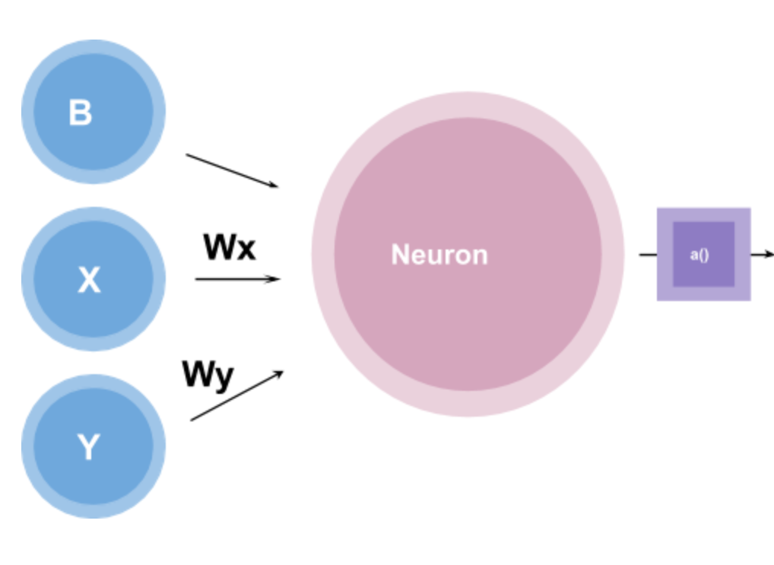Image by Author
Let’s also create a graph with two different categories of data represented with red and blue dots.
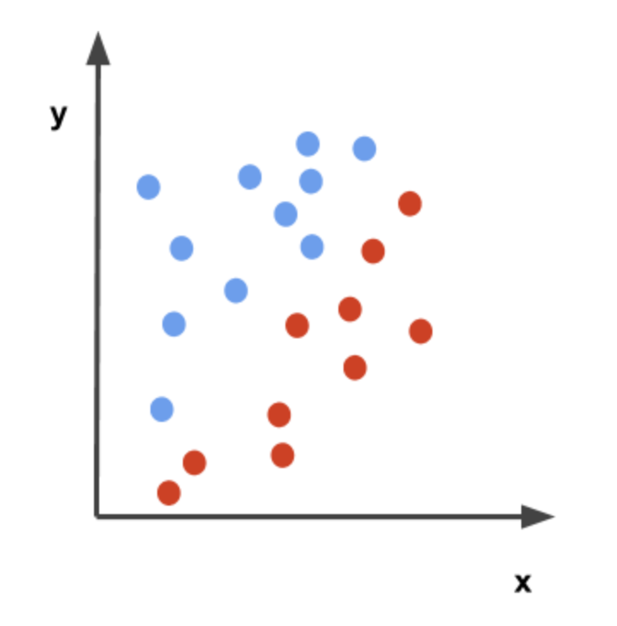Image by Author
Notice that the x-axis is labeled after the input x and the y-axis is labeled after the input y.
Suppose our goal was to separates this data so that there is a distinction between the blue dots and the red dots. How can we use the perceptron to do this?
A perceptron can create a decision boundary for a binary classification, where a decision boundary is regions of space on a graph that separates different data points.
Let’s play with the function to better understand this. We can say,
wx = -0.5
wy = 0.5
and b = 0
Then the function for the perceptron will look like,
0.5x + 0.5y = 0
and the graph will look like,
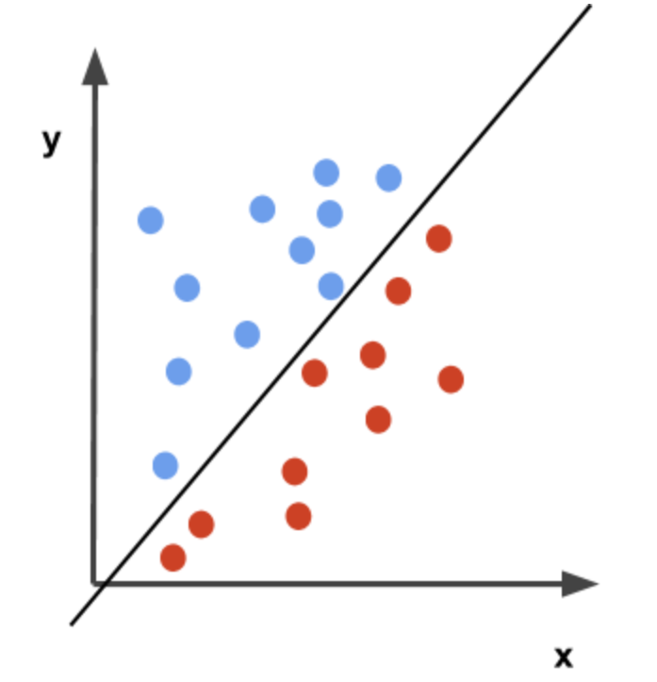Image by Author
Let’s suppose that the activation function, in this case, is a simple step function that outputs either 0 or 1. The perceptron function will then label the blue dots as 1 and the red dots as 0. In other words,
if 0.5x + 0.5y => 0, then 1
if 0.5x + 0.5y < 0, then 0.
Therefore, the function 0.5x + 0.5y = 0 creates a decision boundary that separates the red and blue points.

Overall, we see that a perceptron can do basic classification using a decision boundary.
_Note: In this example, the weights and biases were randomly chosen to classify the points, but what if we did not know what weights would create a good separation for the data. Is there a way that the perceptron could classify the points on its own (assuming the function is linear)? The answer is yes! There is a method called the ‘perceptron trick’, I will let you look into this one on your own :)._

https://ninamaamary.medium.com/the-intuition-behind-perceptrons-a58a03b1b874

Geometric Intuition
The perceptron is a binary classifier, meaning it can classify input data into one of two classes. Geometrically, in a 2D space, a perceptron creates a straight line (or decision boundary) that divides the plane into two regions, each corresponding to one of the classes.
When the number of input features increases, the perceptron no longer forms a simple line but rather a plane in higher dimensions. As the dimensionality grows, the perceptron introduces a hyperplane to separate the data into two regions.
However, it’s important to note that the perceptron excels at linear problems but fails when dealing with non-linear data. For instance, data arranged in a circular or cylindrical pattern cannot be correctly classified by a perceptron’s straight-line decision boundary.
Why Perceptrons Struggle with Non-Linear Data
The limitation of the perceptron becomes apparent when dealing with non-linear data. For example, consider data points arranged in concentric circles. No straight line, no matter how it’s positioned, can separate these points into two classes. This is where more advanced models, like multi-layer neural networks, come into play, capable of handling non-linear boundaries.
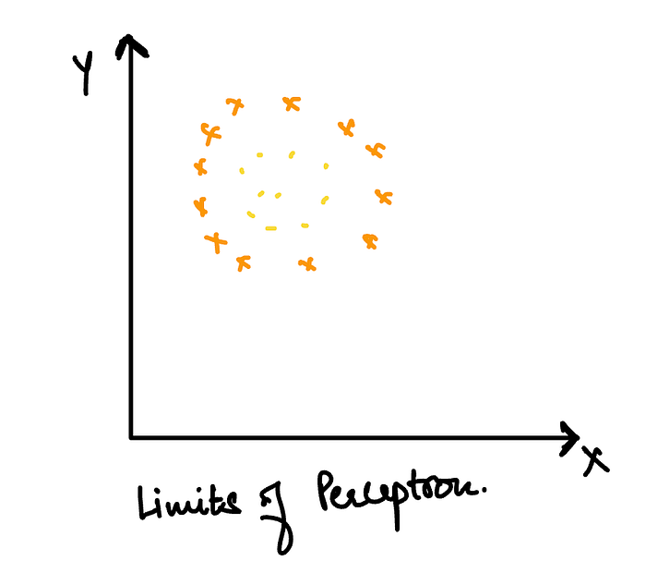
The Perceptron Trick: Training a Perceptron
Training a perceptron involves finding the optimal weights and bias that minimize the error on the training data. This process can be understood as moving a decision boundary in the feature space until it correctly classifies the training examples.
In the case of a 2D perceptron, the decision boundary can be expressed as a line:
Ax+By+C=0
The goal is to find the coefficients A and B that best separate the data. Training starts with a random decision boundary, and the algorithm iteratively adjusts the coefficients by comparing the predicted output with the actual data points. This adjustment continues until the boundary correctly classifies all points or until a specified number of iterations (epochs) is reached.
Moving the Line — Transformations:
- A → Adjusts the line’s slope about the x-axis.
- B → Adjusts the line’s slope about the y-axis.
- C → Moves the line parallel to its original position.
To visualize how these transformations work, you can use tools like https://www.desmos.com/ to see how adjusting these coefficients shifts the decision boundary in real-time.
Perceptron Trick Explained:
Imagine you’re teaching a computer program to distinguish between two categories, say cats and dogs in pictures. Initially, the program makes random guesses, which are often incorrect. The Perceptron Trick is a method that helps the program learn from its mistakes and improve its predictions.
Here’s how it works:
- The program makes a prediction.
- If the prediction is correct, nothing changes.
- If the prediction is wrong, the program adjusts its weights slightly in the direction that would correct the error.
- This process repeats for many examples, and over time, the program’s predictions improve.
So, the Perceptron Trick is a way for the computer to learn and get better at classifying things, much like how we learn from our mistakes.
Main Algorithm:
import numpy as np
def perceptron_training(X, y, learning_rate=0.01, epochs=100):
# Initialize weights and bias
W = np.zeros(X.shape[1]) # Assuming X is a NumPy array
b = 0
for epoch in range(epochs):
no_errors = True
for i in range(len(X)):
# Calculate weighted sum
weighted_sum = np.dot(W, X[i]) + b
# Predict class label (Step function)
y_pred = 1 if weighted_sum > 0 else 0
# Compute the error
error = y[i] - y_pred
# Update weights and bias if misclassified
if error != 0:
W += learning_rate * error * X[i]
b += learning_rate * error
no_errors = False
# Stop early if no misclassification in the entire epoch
if no_errors:
break
return W, b
During training:
- If a point belonging to the negative class is predicted as positive, the weights are adjusted to move the decision boundary upwards.
- If a point belonging to the positive class is misclassified as negative, the weights are adjusted to move the boundary downwards.
Instead of testing two conditions for updating the weights, a simplified rule is often used:
Perceptron Weight Update Rule
For misclassified points:
False Negative (Actual = 1, Predicted = 0)
- The model underestimates the class label.
- To correct this, we increase the weights by adding a small portion of the input value (scaled by the learning rate).
- Update Rule:
- New weight = Old weight + (Learning rate × Input value)
False Positive (Actual = 0, Predicted = 1)
- The model overestimates the class label.
- To fix this, we decrease the weights by subtracting a small portion of the input value.
- Update Rule:
- New weight = Old weight − (Learning rate × Input value)
This process repeats across multiple training cycles (epochs) until the model classifies all training points correctly or reaches a stopping condition.

The Perceptron algorithm is one of the foundational building blocks of machine learning, particularly within the domain of artificial neural networks. Despite its simplicity, it plays a crucial role in understanding more complex algorithms and models. Developed in the late 1950s by Frank Rosenblatt, the Perceptron is a type of linear classifier that is used for binary classification tasks. Its significance lies not only in its historical value but also in its ongoing relevance in the fields of machine learning and artificial intelligence.
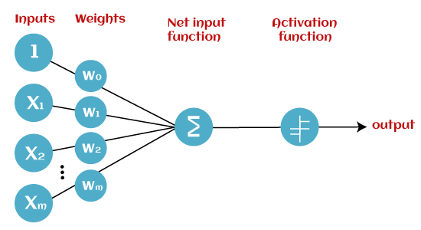
What is Perceptron?
Perceptron is the mathematical model mainly used as binary classifier in supervised learning. This is the simplest model. It is the single layer neural network.
The Perceptron is an algorithm that learns a linear decision boundary to separate data into two distinct classes. It operates on the principle of supervised learning, where the model is trained on a labeled dataset, and the goal is to classify new, unseen data points correctly.
Press enter or click to view image in full size
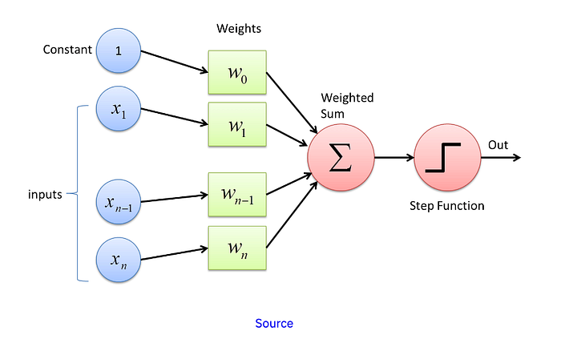

Here x1, x2,….xn are features . w1, w2….wn are weights. w0 is bias term. The sigma gives us the weighted sum z = w0x0 + w1x1 + w2x2 ……+ wnxn. The activation function is used to transform z in given range. The activation function can be anything. It can be a step function that gives output as -1 or 1. It can be sigmoid function that gives probability of each class or mean squared error. Note that as it is a binary classifier the output will always equal to either 0 or 1 or -1 or 1. The output depends on the activation function we are using.
Example -: We have dataset of 1000 students-:
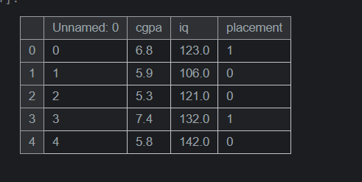
We can drop Unnamed :0 as it is of no use. Here iq = x1, cgpa = x2. So our perceptron will be -:
Press enter or click to view image in full size
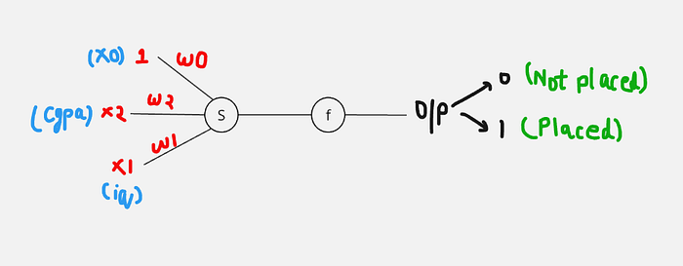
Activation function :- { z>=0 => O/p = 1 ; z<0 => O/p = 0}
Weights tells the strength of connections or tells the importance of each factor.
Geometric Intuition of Perceptron
The perceptron classifies the data by creating a decision boundary. If the data is 2D the decision boundary is a line ,if the data is 3D then the decision boundary is plane and for >=4D data the decision boundary is hyperplane. The perceptron works very well with linearly seperable data but it fails to classify non linear data. Here you can see how perceptron will classify the data of thousand students -:
Press enter or click to view image in full size
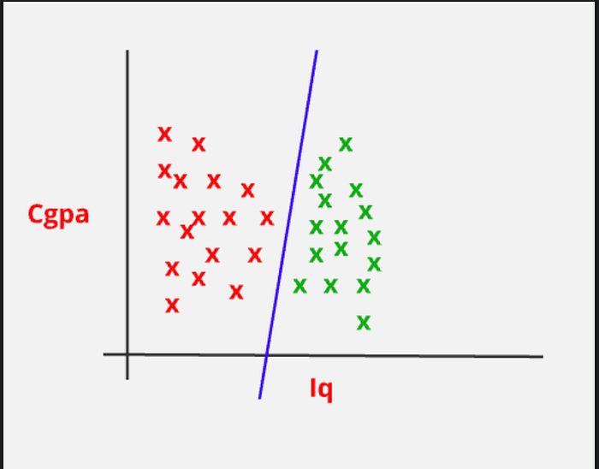
So here you can see that the line seperates the data points. The data points to the left of line or we can say that in the negative region of line are the students who are not placed and the data points to the right of line or we can say that in the positive region are the students who are placed. You can see that how beautifully the perceptron has classified the data because the data was linear. But if the data was non linear the perceptron would have failed.
Now we know that the general equation of line is -: Ax + By + C = 0
And any point say (x1,y1) is in the positive region if Ax1 + By1 + C > 0
And any point say (x1,y1) is in the negative region if Ax1 + By1 + C < 0
And any point say (x1,y1) is on the line if Ax1 + By1 + C = 0
You can check this terminology on a tool called Desmos -: https://www.desmos.com/
Single layer perceptrons are only capable of learning linear seperable patterns. When we combine these perceptrons to generate output and to train on data it is called Multi Layer Perceptron.
Working of Perceptron Algorithm
To know the working of Perceptron algorithm it is very important to know about the equation of line (what each term specifies).
Equation of line => Ax + By + C = 0
- A, B → determine the orientation or slope of the line.
- C → determine the position of line relative to origin. And you know that here we have weights w1 and w2 as A and B and w0 as bias C. So now you know that what weight and bias do in the equation.
The task of Perceptron algorithm is to classify data in a much better way this means it should create a decision boundary that classifies data very well.
Whenever a data point is misclassified we have to make changes in our decision boundary so that it gets correctly classified. These changes are the transformations that are performed on our Decision boundary. In case of line we perform Linear Transformations.
Suppose we have a data point say (x0,y0) and line Ax + By + C = 0. Now this point can either be on left or right side of the line or it can be on the line. Now the point is classified by line and it lies on left side but in reality it was supposed to be on right side, we have to move the line to correctly classify the given data point. In order to move the line we have to make changes in A, B and C (because they are parameters that controls the orientation of line). The changes that are to be made totally depends on the position of point let’s say d.
So d = Ax0 + By0 + C. The transformations are -:
- A’ = A +/- (lr)x0
- B’ = B +/- (lr)y0
- C’ = C +/- (lr)
A’, B’ and C’ are the new values of A, B and C. lr is Learning rate, it controls magnitude of adjustment. We will make small changes here as large changes will result in errors. By changing A, B and C we are altering the value of d so that the data point gets correctly classified. The choice of +/- depends on the value of d.
So the new equation of line is => A’x + B’y + C = 0.
Now you are wondering that this is the equation in case of 2D but what if we get the nD data. No worries same logic follows in nD data the difference is only the parameters are increased. We can represent matrices in the form of matrix as matrix allows us to encapsulate all transformation rules in a single structure. That is why we use matrix in our algorithms.
X’ = AX {matrix multiplication}, here X’ is transformed vector, A is transformation matrix and X is original vector.
Now here we have found a way to get appropriate decision boundary. But there can be other case. Let’s see -:
Press enter or click to view image in full size
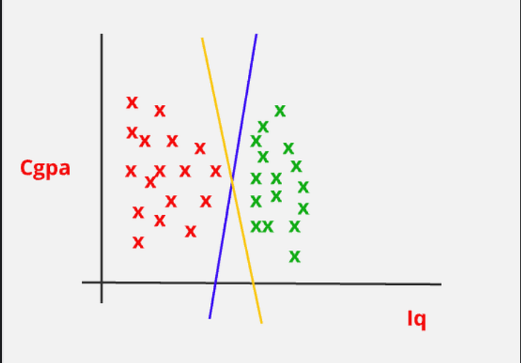
Here both the lines are classifying data appropriately but still we can’t distinguish between two lines (which one is better). Sometimes we can get blue line as decision boundary and sometimes we can get yellow line and this will affect accuracy of our model. Also we cannot quantify result. Let’s see how we solve this problem.
To solve problem Perceptron uses a Hinge Loss function, which is particulary suited for binary classification. The loss function helps to quantify how well the perceptron is performing and guides the weight update process.
Why do we use Hinge Loss?
We use Hinge Loss because it measure the distance of data points from the decision boundary. This helps approximate the possibility of incorrect predictions and evaluate the model’s performance. Basically it gives the optimal distance between data points and decision boundary.
We can write z = wx + b as -:
y_hat = sign(w.x + b) where y_hat belongs to {1, -1}
L(w,b ; xi,yi) = max(0, -yi(w(xi) + b)) , this is Hinge Loss.
- If yi(w(xi) + b) is positive, it means the data point is either on the wrong side of the margin or within the margin. In this case, the loss is positive and depends on how far the data point is from the decision boundary.
- If yi(w(xi) + b) is zero or negative, it means the data point is correctly classified and outside or on the margin. In this case, the loss is zero, indicating no penalty.
Press enter or click to view image in full size
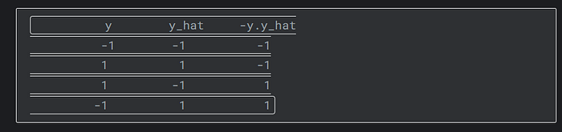
So our loss function will be -:
L = argmin[1/n (summation{i=1 to n} max(0, -yi(w(xi) + b)))]
This means we have select the values of wi and b such that the loss function is minimized. We will use Gradient Descent for this. Gradient descent says that making small change to a variable till we reach minima. Basically taking small steps to reach minima.
We will find partial derivative of L with respect to wi and b. And we subtract these partial derivatives from their respective old values.
That is,
w'i = wi - lr (partial derivative of L wrt wi) , lr = learning rate
Note that we are getting two different values of L in different cases so we will get different partial derivative in each case.
(partial derivative of L wrt wi) = 0 , (-yi(w(xi) + b) <= 0)
(partial derivative of L wrt wi) = -yi(xi) , (-yi(w(xi) + b) > 0)
This implies,
w'i = wi + lr(yi(xi))
b' = b + lr(yi)
We will find the values of wi and b till convergence. And this is how Perceptron algorithm works.
Note that the output generated here is either -1 or 1 i.e. discreet output that is why we have used Hinge loss function. If the output is probabilistic we could have used different activation function such as sigmoid function or softmax function. We can also use Mean squared error as our loss function and linear activation function and the output generated will be continuous.
Implementation of Perceptron Algorithm (Scratch)
from sklearn.datasets import make_classification
import numpy as np
X,y=make_classification(n_samples=100,n_features=2,n_informative=1,
n_redundant=0,n_classes=2,n_clusters_per_class=1,
random_state=41,hypercube=False,class_sep=15)
print(X)
print(y)
# check whether data is linearly seperable
from matplotlib import pyplot as plt
plt.scatter(X[:,0],X[:,1],c=y,cmap='winter')
Here we have created a classification dataset X with two categories and output array y . Then using scatterplot we have checked linearity of dataset.
class Perceptron:
def __init__(self, learning_rate=0.01, n_iter=1000):
self.learning_rate=learning_rate
self.n_iter = n_iter
self.weights=None
self.bias=1
def fit(self,X,y):
#Train the perceptron using the input data X and labels y.
#Parameters:
#X (numpy array): The feature matrix (shape: [n_samples, n_features])
#y (numpy array): The labels (shape: [n_samples])
# number of datapoints and features
m,n=X.shape
#initializing weights by 0
self.weights=np.ones(n)
#initializing bias by 0
self.bias=1
#training
for epoch in range(self.n_iter):
loss=0
for i,xi in enumerate(X):
# xi is ith data point
# z=wi.xi+b
z=np.dot(xi,self.weights)+self.bias
loss=max(0,(-1)*y[i]*z)
#Update
if(loss>0):
self.weights=self.weights+self.learning_rate*(y[i]*xi)
self.bias=self.bias+self.learning_rate*(y[i])
return self.weights,self.bias
def predict(self,X):
z=np.dot(X,self.weights)+self.bias
return np.sign(z)
We have created a class Perceptron which holds the scratch implementation of Perceptron algorithm. In this class we have defined a constructor in which values to the learning rate, weights, bias and epochs is assigned. We will basically do 1000 iterations on the dataset to optimally fit the algorithm i.e. find the optimal values of weights and bias for minimum loss function. Then we have fit method that takes the dataset and output and applies perceptron algorithm on the dataset. We have initialized the weights array as 1 and bias as 1. You can assign 0 too. Then we are iterating the dataset for n_iterations times. And each time we have calculated the loss function for data point. Note that we have used Hinge Loss here, you can also use Log Loss or Mean Squared Error as per your activation function. I have used step function as my activation function here that is why I have used Hinge Loss. I have checked the loss and accordingly updated weights and bias . Now training is completed it’s time to predict output for test data. For this I have defined a predict() function that takes dataset as input and predict output using equation -: z=np.dot(X,self.weights)+self.bias
perceptron = Perceptron(learning_rate=0.1)
weights,bias=perceptron.fit(X, y)
predictions = perceptron.predict(X)
print("Predictions:", predictions)
Here comes our predictions. Let’s plot the decision boundary here. As our data is 2D so our decision boundary will be line.
# Calculating slope m=-(A/B)
m=-(weights[0]/weights[1])
# Calculating intercept c=-(C/B)
c=-(bias/weights[1])
print(m)
print(c)
#generating 100 points
xi=np.linspace(-3,3,100)
#line
yi=m*xi+c
# plotting decision boundary
plt.plot(xi,yi,color='red',linewidth=3)
plt.scatter(X[:,0],X[:,1],c=y,cmap='winter',s=50)
plt.ylim(-3,2)
Press enter or click to view image in full size
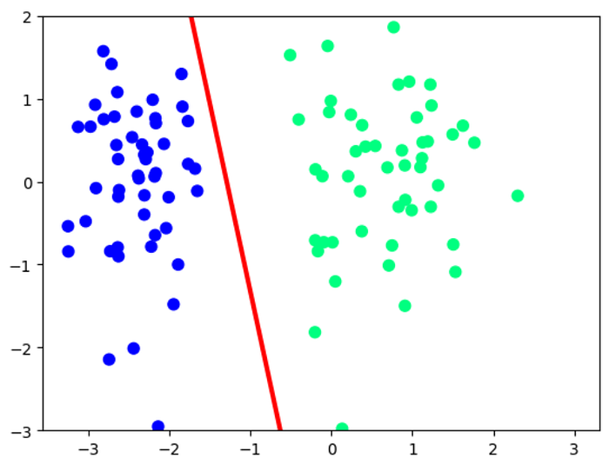
This is our decision boundary. We have generated equation of line y=mx+c . We have calculated slope and intercept using weights and bias.
Implementation of Perceptron Algorithm (Using library)
import pandas as pd
df=pd.read_csv('/kaggle/input/college-placement/placement-dataset.csv')
df.head()
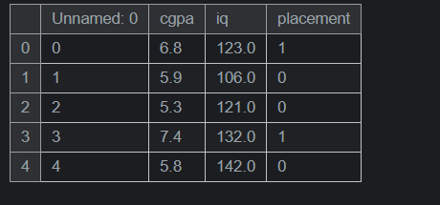
df.drop(['Unnamed: 0'],axis=1,inplace=True)
# spiltting input and output columns
X_=df.iloc[:,0:2]
y_=df.iloc[:,2:]
#checking linearity
plt.scatter(X_['cgpa'],X_['iq'],c=y_['placement'],cmap='winter',s=50)
#applying perceptron algorithm
from sklearn.linear_model import Perceptron
p=Perceptron()
p.fit(X_,y_)
In sklearn we have a Perceptron class which is used to implement Perceptron algorithm.
from mlxtend.plotting import plot_decision_regions
plot_decision_regions(X_.values,y_['placement'].values,clf=p,legend=2)
At last we have plotted Decision Boundary.
Applications of the Perceptron
Although the Perceptron algorithm is primarily of historical interest, it still has practical applications, particularly in situations where the data is linearly separable. Some of the areas where the Perceptron is used include:
- Binary Classification: The Perceptron can be used to classify data into two categories, such as spam vs. not spam, or positive vs. negative sentiment.
- Feature Selection: By analyzing the weights learned by the Perceptron, one can gain insights into the importance of different features in the classification task.
- Building Blocks for Neural Networks: The Perceptron forms the basis of more complex models like Multi-Layer Perceptrons (MLPs), which are used in deep learning.

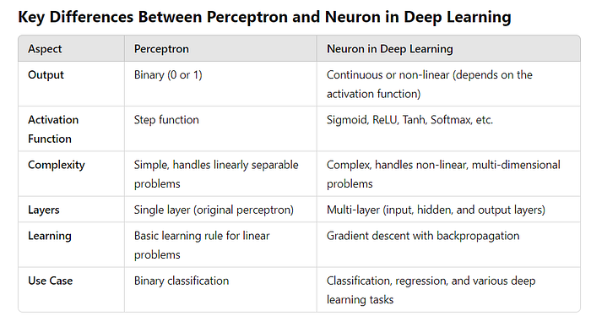
Difference between SLP and MLP
Press enter or click to view image in full size
