Back propagation

Backpropagation
Backpropagation is a training algorithm used for training feedforward neural networks. It plays an important part in improving the predictions made by neural networks. This is because backpropagation is able to improve the output of the neural network iteratively.
In a feedforward neural network, the input moves forward from the input layer to the output layer. Backpropagation helps improve the neural network’s output. It does this by propagating the error backward from the output layer to the input layer.
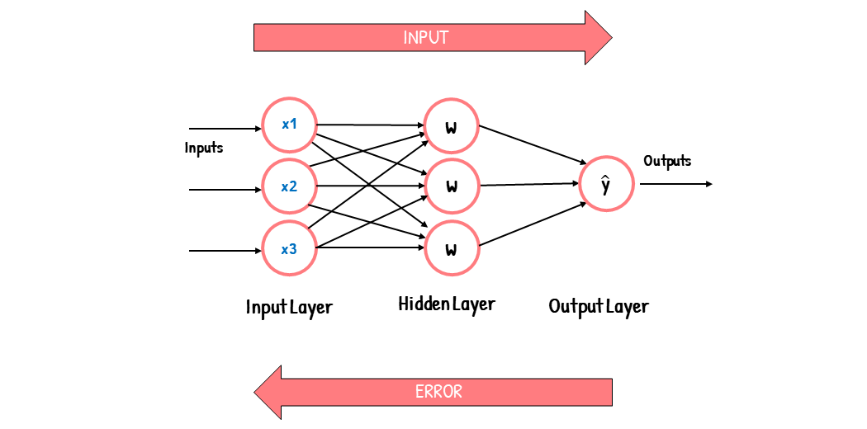
How Does Backpropagation Work?
To understand how backpropagation works, let’s first understand how a feedforward network works.
Feed Forward Networks
A feedforward network consists of an input layer, one or more hidden layers, and an output layer. The input layer receives the input into the neural network, and each input has a weight attached to it.
The weights associated with each input are numerical values. These weights are an indicator of the importance of the input in predicting the final output. For example, an input associated with a large weight will have a greater influence on the output than an input associated with a small weight.
When a neural network is first trained, it is first fed with input. Since the neural network isn’t trained yet, we don’t know which weights to use for each input. And so, each input is randomly assigned a weight. Since the weights are randomly assigned, the neural network will likely make the wrong predictions. It will give out the incorrect output.
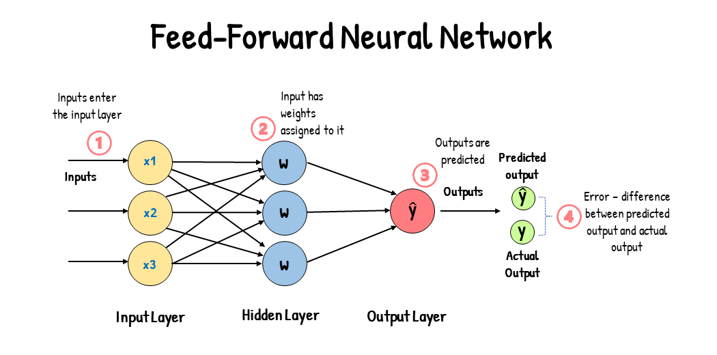
When the neural network gives out the incorrect output, this leads to an output error. This error is the difference between the actual and predicted outputs. A cost function measures this error.
The cost function (J) indicates how accurately the model performs. It tells us how far-off our predicted output values are from our actual values. It is also known as the error. Because the cost function quantifies the error, we aim to minimize the cost function.
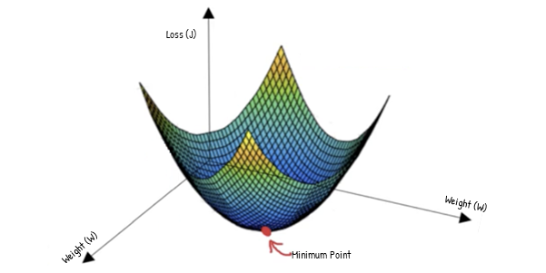
What we want is to reduce the output error. Since the weights affect the error, we will need to readjust the weights. We have to adjust the weights such that we have a combination of weights that minimizes the cost function.
This is where Backpropagation comes in…
Backpropagation allows us to readjust our weights to reduce output error. The error is propagated backward during backpropagation from the output to the input layer. This error is then used to calculate the gradient of the cost function with respect to each weight.
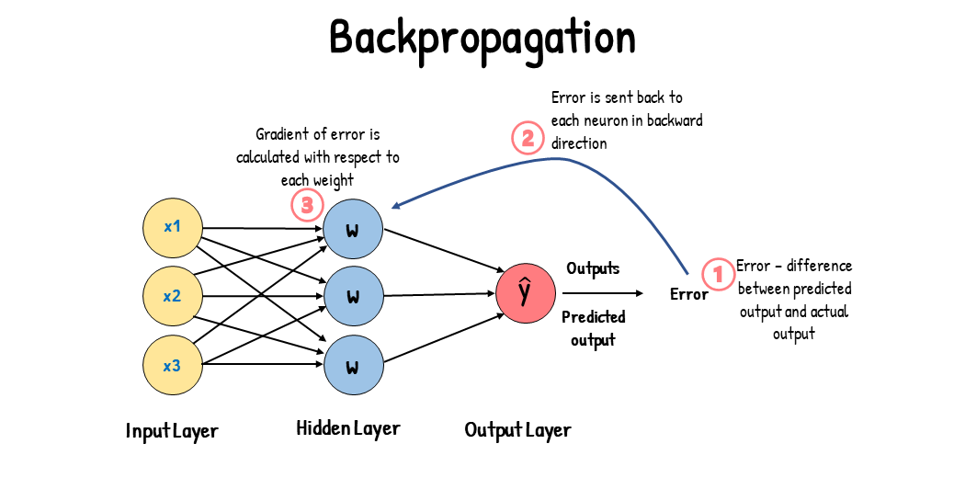
Essentially, backpropagation aims to calculate the negative gradient of the cost function. This negative gradient is what helps in adjusting of the weights. It gives us an idea of how we need to change the weights so that we can reduce the cost function.
Backpropagation uses the chain rule to calculate the gradient of the cost function. The chain rule involves taking the derivative. This involves calculating the partial derivative of each parameter. These derivatives are calculated by differentiating one weight and treating the other(s) as a constant. As a result of doing this, we will have a gradient.
Since we have calculated the gradients, we will be able to adjust the weights.
Gradient Descent
The weights are adjusted using a process called gradient descent.
Gradient descent is an optimization algorithm that is used to find the weights that minimize the cost function. Minimizing the cost function means getting to the minimum point of the cost function. So, gradient descent aims to find a weight corresponding to the cost function’s minimum point.
To find this weight, we must navigate down the cost function until we find its minimum point.
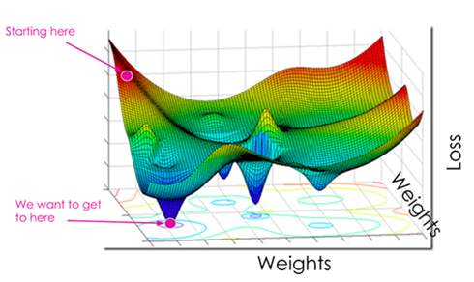
Source – Medium
But first, to navigate the cost function, we need two things: the direction in which to navigate and the size of the steps for navigating.
The Direction
The direction for navigating the cost function is found using the gradient.
The Gradient
To know in which direction to navigate, gradient descent uses backpropagation. More specifically, it uses the gradients calculated through backpropagation. These gradients are used for determining the direction to navigate to find the minimum point. Specifically, we aim to find the negative gradient. This is because a negative gradient indicates a decreasing slope. A decreasing slope means that moving downward will lead us to the minimum point. For example:
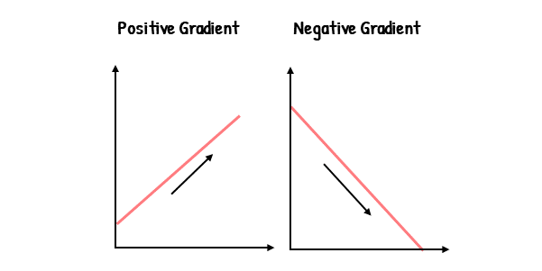
The Step Size
The step size for navigating the cost function is determined using the learning rate.
Learning Rate
The learning rate is a tuning parameter that determines the step size at each iteration of gradient descent. It determines the speed at which we move down the slope.
The step size plays an important part in ensuring a balance between optimization time and accuracy. The step size is measured by a parameter alpha (α). A small α means a small step size, and a large α means a large step size. If the step sizes are too large, we could miss the minimum point completely. This can yield inaccurate results. If the step size is too small, the optimization process could take too much time. This will lead to a waste of computational power.
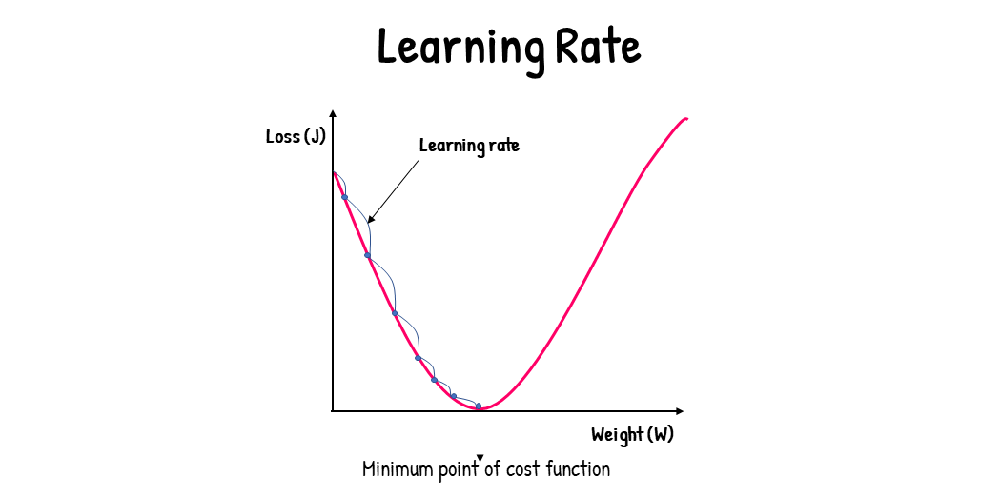
The step size is evaluated and updated according to the behavior of the cost function. The higher the gradient of the cost function, the steeper the slope and the faster a model can learn (high learning rate). A high learning rate results in a higher step value, and a lower learning rate results in a lower step value. If the gradient of the cost function is zero, the model stops learning.
Descending the Cost Function
Navigating the cost function consists of adjusting the weights. The weights are adjusted using the following formula:
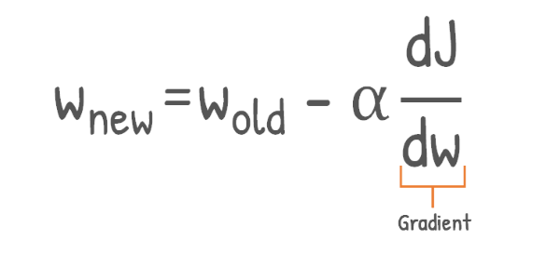
This is the formula for gradient descent. As we can see, to obtain the new weight, we use the gradient, the learning rate, and an initial weight.
Adjusting the weights consists of multiple iterations. We take a new step down for each iteration and calculate a new weight. Using the initial weight and the gradient and learning rate, we can determine the subsequent weights.
Let’s consider a graphical example of this:
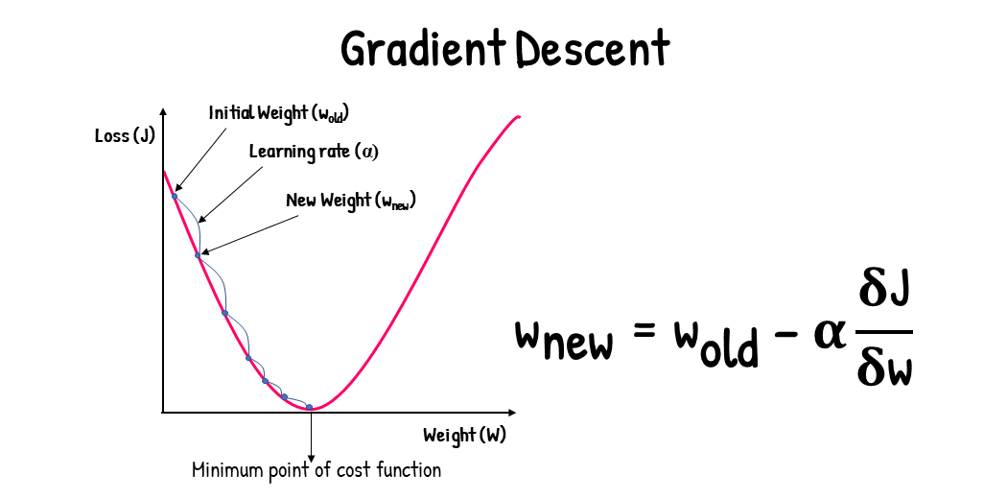
From the graph of the cost function, we can see that:
- To start descending the cost function, we first initialize a random weight.
- Then, we take a step down and obtain a new weight using the gradient and learning rate. With the gradient, we can know which direction to navigate. We can know the step size for navigating the cost function using the learning rate.
- We are then able to obtain a new weight using the gradient descent formula.
- We repeat this process until we reach the minimum point of the cost function.
- Once we’ve reached the minimum point, we find the weights that correspond to the minimum of the cost function.
Backpropagation vs. Gradient Descent
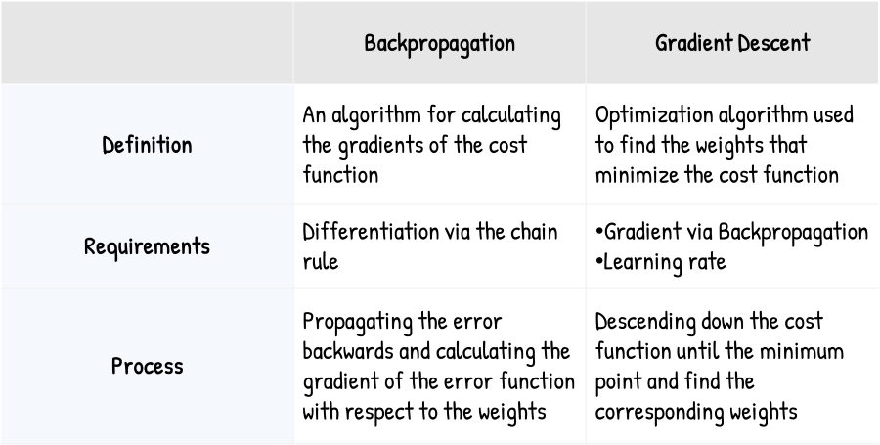
Summarizing Gradient Descent
Gradient descent is an optimization algorithm used to find the weights corresponding to the cost function. It needs to descend the cost function until its minimum point to find these weights. It needs the gradient and the learning rate to descend the cost function. The gradient helps find the direction for reaching the minimum point of the cost function. The learning rate helps determine the speed at which to reach the minimum point. Upon reaching the minimum point, gradient descent finds weights corresponding to the minimum point.
Summarizing Backpropagation
Backpropagation is the algorithm of calculating the gradients of the cost function with respect to the weights. Backpropagation is used to improve the output of neural networks. It does this by propagating the error in a backward direction and calculating the gradient of the cost function for each weight. These gradients are used in the process of gradient descent.

Other Article

Have you ever wondered how neural networks learn?
Have you ever wondered how your smartphone recognizes your face or how virtual assistants understand your voice?
The secret lies in a powerful algorithm called backpropagation.
Imagine trying to teach a child to ride a bike without giving them any feedback. It would be frustrating and time-consuming. This is exactly what happens to a neural network without backpropagation — learning becomes inefficient and impractical.
This article delves into backpropagation, explaining how it revolutionized machine learning by enabling efficient training of deep neural networks.
By the end of this article, you will understand how backpropagation works, why it’s crucial, and how it powers advancements in AI technologies like image recognition and natural language processing.
Understanding Backpropagation
What is Backpropagation?
Backpropagation is a supervised learning algorithm used for training artificial neural networks.
It computes the gradient of the loss function with respect to each weight by the chain rule.
This process allows the network to update its weights and biases, minimizing the error in predictions.
Without backpropagation, training deep neural networks would be inefficient and impractical.
The Importance of Backpropagation
Backpropagation revolutionized the field of machine learning by enabling the training of deep neural networks.
Before its introduction, training multi-layered networks was extremely challenging due to the vanishing gradient problem.
By efficiently calculating gradients, backpropagation allows for the effective training of complex models.
This capability has led to breakthroughs in image recognition, natural language processing, and many other AI applications.
The Mechanics of Backpropagation
The Forward Pass
In the forward pass, the neural network processes the input data to generate predictions.
Each layer of the network applies a set of weights and an activation function to the input from the previous layer.
The output of the final layer is the network’s prediction.
x (input) -> [Layer 1] -> [Layer 2] -> ... -> [Layer n] -> ŷ (output)
The Loss Function
The loss function measures the difference between the predicted output and the actual target.
Common loss functions include mean squared error for regression tasks and cross-entropy loss for classification tasks.
The goal of training is to minimize this loss function, thereby improving the accuracy of the network’s predictions.
L(ŷ, y) = measure of difference between prediction ŷ and true value y
Now that we have a way to quantify error, how do we use this information to improve our network?
Enter backpropagation to the game.
Backpropagation: The Learning Engine
Backpropagation is all about efficiently computing how each parameter in the network contributes to the overall error.
It does this by cleverly applying the chain rule of calculus, propagating the error gradient backwards through the network.
Chain Rule
The chain rule is a fundamental concept in calculus that is crucial for backpropagation.
It allows the computation of the derivative of a composite function by breaking it down into simpler parts.
In the context of neural networks, the chain rule helps in computing the gradient of the loss function with respect to each weight.
∂L/∂θ = (∂L/∂ŷ) * (∂ŷ/∂z) * (∂z/∂θ)
Where:
- L is the loss
- ŷ is the network output
- z is the input to the activation function
- θ is any weight or bias in the network
The Backward Pass: Propagating Gradients
The backward pass is where the magic happens.
We start at the output layer and work our way backwards, computing gradients for each parameter along the way.
- Compute the gradient of the loss with respect to the output: ∂L/∂ŷ 2- For each layer, from output to input
- Compute the gradient of the layer output with respect to its input: ∂z/∂x
- Compute the gradient of the layer output with respect to its weights and biases: ∂z/∂w, ∂z/∂b
- Propagate the gradient to the previous layer: ∂L/∂x = (∂L/∂z) * (∂z/∂x)
Gradient Descent: Optimizing the Network
Once we have our gradients, we use them to update the network’s parameters.
This is typically done using an optimization algorithm like gradient descent.
θ_new = θ_old - η * ∂L/∂θ
Where η (eta) is the learning rate, controlling how big of a step we take in the direction of the negative gradient.
By repeating this process many times over large datasets, the network gradually improves its performance, learning to make increasingly accurate predictions.
Computational Efficiency
Backpropagation’s elegance lies in its efficiency.
It allows us to compute gradients for networks with millions or even billions of parameters in a computationally feasible way.
This scalability is what enables the training of deep neural networks, unlocking their impressive capabilities in areas like computer vision, natural language processing, and reinforcement learning.
Vanishing and Exploding Gradients: Challenges in Deep Networks
As powerful as backpropagation is, it’s not without its challenges.
In very deep networks, gradients can sometimes become vanishingly small (vanishing gradient problem) or explosively large (exploding gradient problem) as they’re propagated backwards.
This can make training deep networks difficult or unstable.
Techniques like careful weight initialization, normalized activation functions (e.g., ReLU), and architectural innovations like skip connections (as in ResNets) help mitigate these issues.
These advancements have enabled the training of ever-deeper networks, pushing the boundaries of what’s possible in AI.
Implementing Backpropagation: A Practical Example
To truly understand backpropagation, let’s walk through a simple implementation.
We’ll create a basic neural network with one hidden layer and train it to approximate a simple function.
Press enter or click to view image in full size
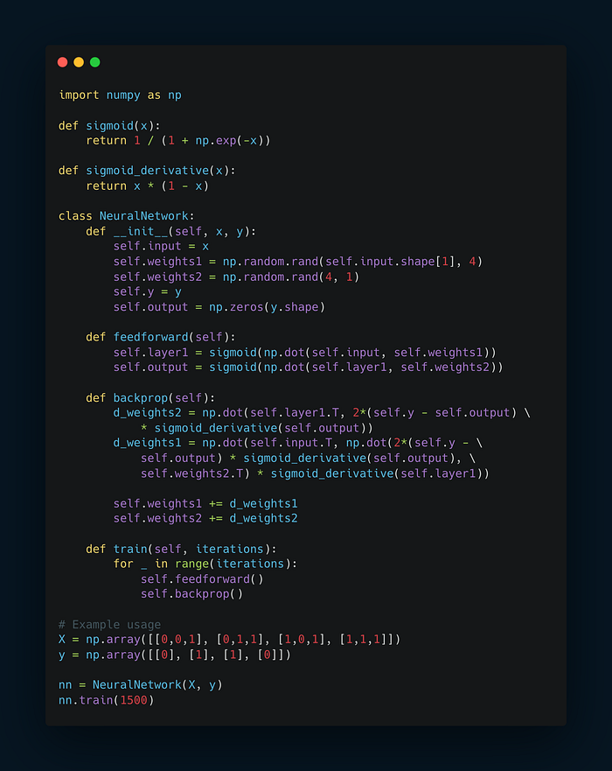
Beyond Basic Backpropagation: Advanced Techniques
As neural networks have evolved, so too have the techniques for training them.
While standard backpropagation remains the core algorithm, several advanced methods have been developed to enhance its effectiveness and efficiency.
Stochastic Gradient Descent (SGD) and Mini-batch Training
Instead of computing gradients over the entire dataset (which can be computationally expensive), SGD computes gradients on small subsets (mini-batches) of the data.
This approach introduces some noise into the optimization process, which can actually help the network escape local minima and potentially find better solutions.
Momentum and Adaptive Learning Rates
Techniques like momentum and adaptive learning rate algorithms (e.g., Adam, RMSprop) help accelerate training and navigate the loss landscape more effectively.
These methods adjust the learning rate dynamically based on the recent history of gradients, allowing for faster convergence and better handling of different scales of gradients across parameters.
Batch Normalization
Batch normalization normalizes the inputs to each layer, which can dramatically speed up training and allow for higher learning rates.
It helps mitigate the internal covariate shift problem, where the distribution of each layer’s inputs changes during training, making it harder for subsequent layers to adapt.
Regularization Techniques
Methods like L1/L2 regularization and dropout help prevent overfitting by adding constraints to the network’s parameters or randomly deactivating neurons during training.

