Setup and basic details roadmap

Here are some of the most well-known frameworks for Generative AI (GenAI), grouped by their main ecosystem and usage:

1. Python-based Deep Learning Frameworks
These are the core engines behind most GenAI applications.
- TensorFlow (by Google)
  - Widely used for training and deploying large-scale AI models, including text, image, and speech generation.
  - Has Keras as a high-level API for ease of use.
- PyTorch (by Meta)
  - Favored for research and rapid prototyping of GenAI models.
  - Hugely popular in the open-source community and supports libraries like Hugging Face Transformers.

2. Specialized GenAI Model Frameworks
Frameworks built specifically for Large Language Models (LLMs), diffusion models, and multimodal AI:
- Hugging Face Transformers
  - Pretrained models for text, vision, audio, and multimodal AI.
  - Includes LLaMA, GPT, BLOOM, Falcon, and Stable Diffusion models.
- LangChain
  - Designed for building LLM-powered applications with context management, chaining prompts, and connecting to tools/APIs.
- LlamaIndex (formerly GPT Index)
  - Helps connect LLMs with private or custom data sources.
- Diffusers (by Hugging Face)
  - For image/video generation using diffusion models like Stable Diffusion.

3. Enterprise & Production-Oriented GenAI Frameworks
These help scale GenAI into real applications:
- OpenAI API
  - Provides access to GPT models (text), DALL·E (image), Whisper (audio).
- Cohere AI
  - NLP models optimized for retrieval-augmented generation (RAG).
- Anthropic Claude API
  - Focus on safe and explainable conversational AI.
- Amazon Bedrock
  - Fully managed service for running foundation models from multiple providers.

4. Vector Database & RAG Tooling
For Retrieval-Augmented Generation pipelines:
- Pinecone, Weaviate, Milvus – for storing & searching embeddings.
- Chroma – open-source vector DB often used with LangChain.

5. Other Notable Frameworks
- Fast.ai – high-level wrapper on PyTorch for quick experimentation.
- DeepSpeed (by Microsoft) – for efficient large model training.
- vLLM – optimized inference engine for LLMs.

If you want, I can prepare a visual diagram mapping these frameworks into Training, Fine-tuning, Inference, and Application-layer categories so it’s easy to remember. That way you’ll see where each GenAI framework fits in the lifecycle.

Starting roadmap for LangChain.

1. What LangChain Is
LangChain is a framework for building applications using large language models (LLMs).
It helps with:
- Prompt engineering (managing and chaining prompts)
- Connecting to external data (databases, APIs, documents)
- Retrieval-Augmented Generation (RAG)
- Managing conversational memory
Think of it as a toolkit for going from "I have an LLM" → "I have a working AI app."

2. Prerequisites
Before starting, you should have:
- Python basics (functions, imports, pip)
- Some knowledge of OpenAI API or another LLM provider (Hugging Face, Cohere, Anthropic)
- Installed Python 3.9+

3. Installation
pip install langchain
pip install langchain-openai
pip install openai # if using OpenAI models
pip install chromadb # for local vector store

4. Your First LangChain App
Example: A simple Q&A bot using OpenAI + LangChain
from langchain_openai import OpenAI
from langchain.prompts import PromptTemplate
from langchain.chains import LLMChain

# Create LLM
llm = OpenAI(temperature=0.7)

# Create a prompt template
template = "You are a helpful assistant. Answer the following question:\n{question}"
prompt = PromptTemplate(input_variables=["question"], template=template)

# Create chain
chain = LLMChain(llm=llm, prompt=prompt)

# Run the chain
response = chain.run("What is the capital of France?")
print(response)
✅ Output: Paris

5. Core Concepts in LangChain
- LLM → The AI model (OpenAI GPT, Hugging Face, etc.)
- Prompt Templates → Reusable prompt structures
- Chains → Connect multiple steps (e.g., query DB → summarize → answer)
- Agents → LLMs that decide which tool to use next (like calling APIs)
- Memory → Stores chat history
- Vector Stores → Store & search embeddings for RAG

6. Next Step – Adding RAG
You can make your LLM answer from your own data instead of the public internet:
- Convert your documents into embeddings
- Store in a vector DB (e.g., Chroma, Pinecone)
- Use LangChain’s RetrievalQA to fetch relevant info before answering
Example:
from langchain.document_loaders import TextLoader
from langchain.vectorstores import Chroma
from langchain.embeddings.openai import OpenAIEmbeddings
from langchain.chains import RetrievalQA

# Load docs
loader = TextLoader("my_data.txt")
docs = loader.load()

# Create embeddings and vector store
embeddings = OpenAIEmbeddings()
db = Chroma.from_documents(docs, embeddings)

# Create retrieval chain
retriever = db.as_retriever()
qa = RetrievalQA.from_chain_type(llm=llm, retriever=retriever)

print(qa.run("What does my document say about sales in 2023?"))

7. Learning Resources
- 📚 LangChain Docs - https://python.langchain.com/docs/introduction/
- 🎥 YouTube Tutorials (search: "LangChain RAG tutorial") - https://www.youtube.com/playlist?list=PLKnIA16_RmvaTbihpo4MtzVm4XOQa0ER0
- https://www.youtube.com/watch?v=X0btK9X0Xnk
- https://www.youtube.com/watch?v=J5_-l7WIO_w
- 🛠 Playground: LangChain Hub - https://smith.langchain.com/

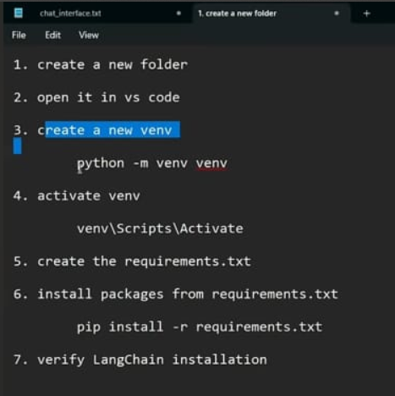

pip install -r requirements.txt -> where requirements.txt given below
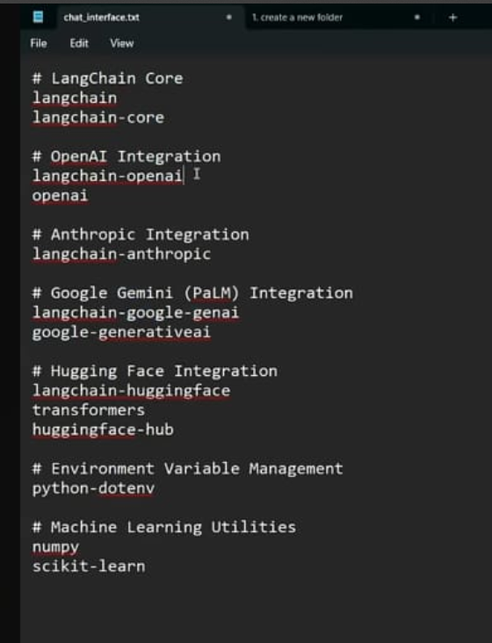

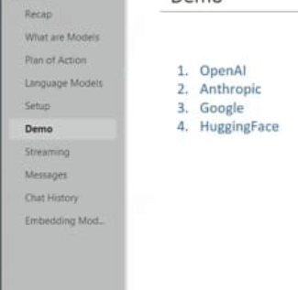

ModuleNotFoundError: Module langchain_community.document_loaders not found. Please install langchain-community to access this module. You can install it using `pip install -U langchain-community`

After completing RAG (text to text model ) we can go with below

Roadmap for Creative AI (2025 edition)
Step 1. Foundation in Diffusion Models
- Learn how diffusion models work (denoising process, latent diffusion).
- Framework:
  - 🤗 Hugging Face Diffusers → 🔥 most widely used open-source toolkit for:
    - Text → Image (Stable Diffusion, SDXL)
    - Image → Image (img2img, inpainting, outpainting)
    - Text → Video (with AnimateDiff, Zeroscope, Stable Video Diffusion)
  - Other libs: ComfyUI (no-code workflow for artists).
👉 Why: Diffusers give you hands-on with pipelines for image/video/audio generation.

Step 2. HD Image Generation
- Frameworks:
  - Stable Diffusion XL (SDXL) (high-quality, photorealistic images).
  - ControlNet → add control over pose, edges, depth maps.
- Learn:
  - Text prompts, prompt engineering.
  - Fine-tuning with LoRA for company-specific styles.
- Example use: Marketing banners, product design mockups.

Step 3. Text → Video & Image → Video
- Frameworks:
  - Hugging Face Diffusers + Stable Video Diffusion (SVD).
  - Pika Labs, RunwayML, Kaiber (popular SaaS, but can be inspiration).
- Learn to:
  - Convert single image → motion (AnimateDiff).
  - Multi-frame consistency → story clips.
- Example use: Promo ads, explainer videos, cinematic reels.

Step 4. Teaching Audio / Dubbing
- Speech synthesis & dubbing frameworks:
  - Coqui TTS (open-source, multi-speaker cloning).
  - OpenAI TTS (new GPT models for ultra-realistic voices).
  - XTTS (cross-lingual text-to-speech).
- Learn:
  - Voice cloning from samples.
  - Lip-sync for videos (Wav2Lip, SadTalker).
- Example use: Educational dubbing in different languages.

Step 5. Image Editing & Enhancement
- Tasks: inpainting (fill missing parts), super-resolution (HD upscale).
- Frameworks:
  - StableSR (super-resolution for SD).
  - Real-ESRGAN (upscale images to 4K).
  - PhotoMaker (face swap, identity preservation).
- Example: e-commerce images, movie posters.

Step 6. Advanced Video Generation
- Text → Video Research models (2024-25):
  - OpenAI Sora (🔥 upcoming game-changer, text → full video).
  - ModelScope T2V (open-source, Chinese researchers).
  - Gen-2 (Runway) → story-level video generation.
- Example use: Storytelling, short films, marketing reels.

Step 7. Integration & Deployment
- UI frameworks:
  - Streamlit → easy demo apps.
  - Gradio → great for model playgrounds.
- Deployment:
  - Hugging Face Spaces (free hosting).
  - Docker + Cloud (AWS, GCP, Azure).
  - GPU required (NVIDIA A100 / RTX 4090 recommended).

✅ Suggested Learning Order
- Diffusers basics → Text2Image, Image2Image.
- Add ControlNet + LoRA for style control.
- Move to Video → AnimateDiff, Stable Video Diffusion.
- Explore Audio dubbing (Coqui TTS, OpenAI TTS).
- Work on HD enhancement (Real-ESRGAN).
- Build UI app → Streamlit/Gradio chatbot + creative studio.

📌 Example Real-World Applications
- E-commerce → Auto-generate product images, 360° videos.
- Education → Auto-dub teaching videos into local languages.
- Marketing → Generate ad videos & posters from brand guidelines.
- Film/Animation → Storyboarding from text + script → video pipeline.

👉 My advice:
If your main goal is HD image/video/story generation → start with Hugging Face Diffusers. It’s the TensorFlow of creative AI — everything else plugs into it.
Would you like me to pick one use-case (say education dubbing or e-commerce ads) and build a step-by-step Streamlit production app with Diffusers + TTS + Video so you can see it all working together?

