Text Splitters in lang chain

https://chunkviz.up.railway.app/ I splitting demos

What is Text Splitting?
Text splitting is the process of breaking a long document into smaller, easier-to-handle parts. Instead of giving the entire document to an AI system all at once — which might be too much to process — text splitting helps divide the content into chunks of a manageable size.
These chunks are usually based on sentences, paragraphs, or character limits and sometimes include some overlap so the system doesn’t lose the meaning that flows from one part to the next.
Press enter or click to view image in full size
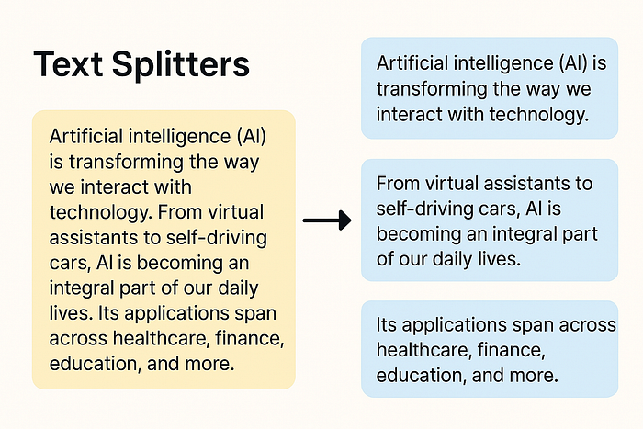
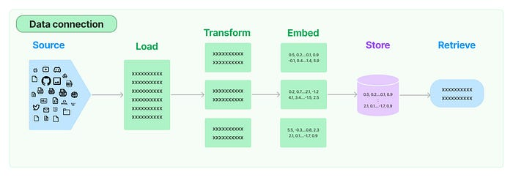

Need of Splitting Text
- LLMs have a limited number of input tokens. Feeding an entire long document may exceed this limit.
- RAG systems rely on vector similarity search to retrieve relevant text chunks from a document database. Without splitting, the entire document is embedded as one large chunk, which reduces retrieval accuracy.
- Chunking also affects the embedding quality. Smaller chunks reduce semantic noise and improve the embedding quality.
Now that we understand the need for text splitting, let us explore the different ways we can split the data.

Welcome to Part 10 of the LangChain series! So far, we’ve explored various foundational components — from Models and Prompts to Document Loaders. In this blog, we’ll take a deep dive into a critical yet often overlooked piece of the puzzle — Text Splitters.
Press enter or click to view image in full size
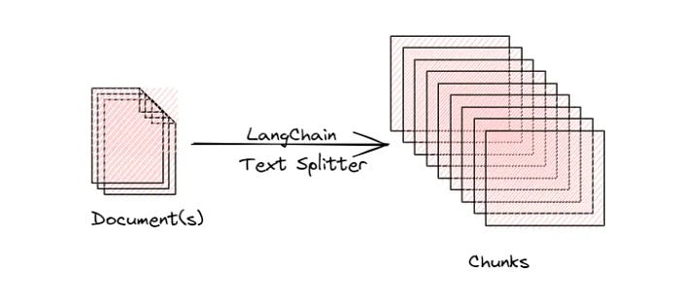
🔍 Why Do We Need Text Splitters?
When working with long documents, feeding the entire content to an LLM isn’t feasible due to context length limitations. Text splitters help by dividing large text data into smaller, manageable chunks.
But splitting isn’t just about dividing blindly. It’s about preserving context while minimizing loss of meaning — which is essential in applications like RAG (Retrieval-Augmented Generation).
✨ Advantages of Using Text Splitters
Overcoming model limitations: Many embedding models and language models have maximum input size constraints. Splitting allows us to process documents that would otherwise exceed these limits.
Downstream tasks: Text Splitting improves nearly every LLM-powered task:
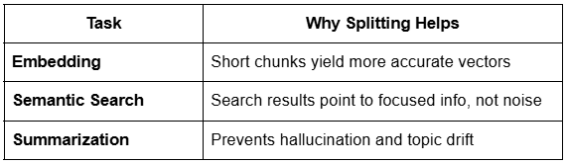
Optimizing computational resources: Working with smaller chunks of text can be more memory-efficient and allow for better parallelization of processing tasks.
📚 Types of Text Splitters in LangChain
LangChain provides various strategies for splitting documents into chunks, depending on the use case and content structure. Below are the main types of text splitters:

Length-Based Splitters:
Splits text into fixed-size chunks based on the number of characters or tokens, regardless of sentence or semantic boundaries.
Example:
Split a 1200-character document into chunks of 400 characters each.
from langchain.text_splitter import CharacterTextSplitter
splitter = CharacterTextSplitter(chunk_size=400, chunk_overlap=50)
chunks = splitter.split_text(document_text)
🧠 Understanding chunk_overlap:
chunk_overlap defines how much of the previous chunk is included in the next one.
- ✅ Ideal chunk overlap for RAG: 10–20% of chunk size
- 🔻 Too low overlap: May lose context across chunks
- 🔺 Too high overlap: Preserves context but increases the number of chunks → higher computation and latency
Advantages:
✅ Simple and fast to implement
✅ Works well for uniform, unstructured text
✅ Efficient with large datasets
Disadvantages:
❌ May break sentences in the middle
❌ Can lead to loss of semantic meaning
❌ Not ideal for content with rich structure

In LangChain we have different TextSplitter classes to split the text. Firstly, install the required package using the command: pip install langchain_text_splitter . For the examples below, we have used text data from a sample PDF. So we use a PyPDFLoader document loader to load the data. And then perform splitting.

Text Splitting based on Length
Here the splitting is done based on a predefined number of chunk_size . Below is an example.
from langchain_community.document_loaders import PyPDFLoader
from langchain_text_splitters import CharacterTextSplitter
loader = PyPDFLoader("AI_Introduction.pdf")
documents = loader.load()
text = documents[0].page_content
# print(len(text))
text_splitter = CharacterTextSplitter(
separator="\n",
chunk_size=100,
chunk_overlap=0
)
# chunks = text_splitter.split_documents(documents)
# print(type(chunks[0]))
chunks = text_splitter.split_text(text)
# print(len(chunks))
for chunk in chunks[22:]:
print(len(chunk))
print(chunk)
print()
We can directly split the Document objects using the method split_documents . Also, we can perform a split on text using the split_text method. Output is a list containing the resultant chunks.
Press enter or click to view image in full size
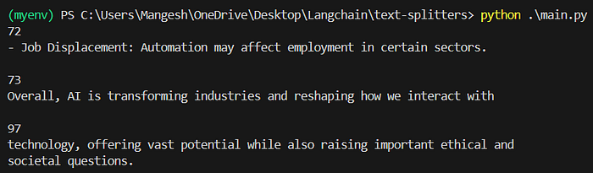
Output of Text Splitting based on Length
The chunk does not consist exactly of 100 characters because of what separator we have used. ext will be split only at new lines since we are using the new line (“\n”) as the separator. If any chunk has a size more than 100 but no new lines in it, it will be returned as such.
What is chunk_overlap ?
chunk_overlap is one of the properties of the TextSplitter class (see in the code example above) that specifies the number of characters that are repeated between consecutive chunks when splitting text.
This helps in preserving the semantic meaning between two adjacent chunks by not creating a strict partition between them. Let us code one example for this.
from langchain_community.document_loaders import PyPDFLoader
from langchain_text_splitters import CharacterTextSplitter
loader = PyPDFLoader("AI_Introduction.pdf")
documents = loader.load()
text = documents[0].page_content
text_splitter = CharacterTextSplitter(
separator="\n",
chunk_size=200,
chunk_overlap=20
)
chunks = text_splitter.split_text(text)
for chunk in chunks[1:5]:
print(len(chunk))
print(chunk)
print()
Press enter or click to view image in full size
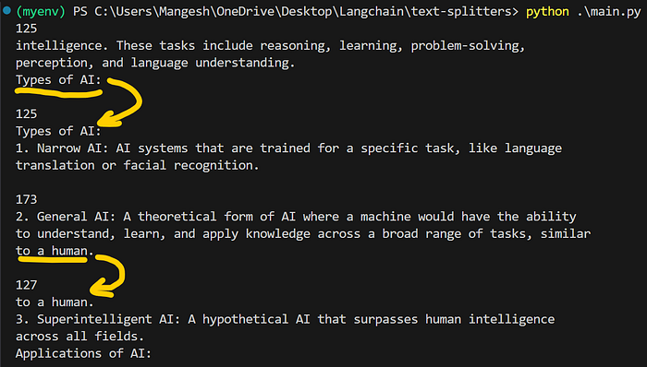
Output of chunk_overlap
Since we have set chunk_size=20 , 20 characters are shared between two consecutive chunks.

Text-Structure-Based Splitters:
These splitters leverage the natural structure of the text — such as newlines, paragraphs, or sentence breaks — to create semantically meaningful chunks.
This technique assumes that every text inherently follows a structure:
Text is inherently hierarchical:
📄 Document → 📝 Paragraphs → ✍️ Sentences → 🔤 Words
By following this structure, we can split documents in a way that preserves natural language flow and meaning.
Example:
Split text first by double newlines (paragraphs), then by single newlines (sentences).
from langchain.text_splitter import RecursiveCharacterTextSplitter
splitter = RecursiveCharacterTextSplitter(
chunk_size=500,
chunk_overlap=50,
separators=["\n\n", "\n", ".", " ", ""]
)
chunks = splitter.split_text(document_text)
Advantages:
✅ Maintains semantic coherence
✅ Reduces sentence-breaking issues
✅ More aligned with a human-readable format
Disadvantages:
❌ Performance depends on the presence of structured formatting (newlines, periods, etc.)
❌ Less control over exact chunk size compared to fixed-length methods

Text-structured based
This is the most widely used kind of text splitter, so we will focus more on understanding this. As a base, this uses the fact that text data is organised in some hierarchical structure. The hierarchy can be represented as:
- The highest level is Paragraphs.
- Next comes Sentences that make a paragraph.
- Words combine to phrase a sentence.
- Words are made up of Characters.
We use RecursiveCharacterTextSplitter class in LangChain to split text recursively into smaller units, while trying to keep each chunk size in the given limit.
How it works?
- Start from the highest level, e.g., paragraphs (separated by \n\n).
- If the paragraph is too long (exceeds the chunk_size), try to split it into sentences (e.g., using . or \n).
- If that’s still too large, go down to smaller units like words or characters.
- The splitting recurses downward until it produces chunks that are:
- Within the size limit (chunk_size)
- As semantically meaningful as possible.
Let us code it now!
from langchain_community.document_loaders import PyPDFLoader
from langchain_text_splitters import RecursiveCharacterTextSplitter
loader = PyPDFLoader("sample.pdf")
documents = loader.load()
text = documents[0].page_content
text_splitter = RecursiveCharacterTextSplitter(
separators=["\n\n", "\n", ".", " ", ""], # Paragraph → Line → Sentence → Word → Character
chunk_size=1000,
chunk_overlap=0
)
chunks = text_splitter.split_text(text)
for chunk in chunks:
print(chunk)
print()
This is an amazing tool to visualize the text splits for better understanding:

ChunkViz
Web site created using create-react-app
chunkviz.up.railway.app

Press enter or click to view image in full size
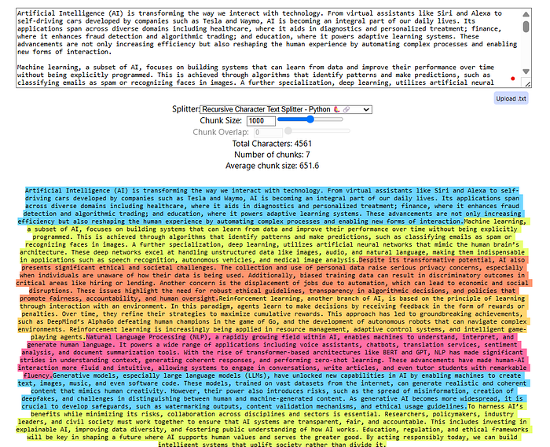
Output of RecursiveCharacterTextSplitter
In separators, we can define complex patterns to split text more efficiently. Play with the text split visualizer by experimenting with different parameter values of chunk_size , chunk_overlap , etc.

Document Structure-Based Splitters
These splitters are designed to handle documents that follow a non-standard structure, such as code files, markdown files, legal documents, etc., where traditional paragraph or sentence splitting doesn’t apply.
Use Case:
Whenever we want to split a text that is not regular prose (like English, Hindi, etc.), we use this splitter.
For example:
- Python code files
- Markdown documents
- HTML/XML files
- Log files
These formats often use symbols or syntactic patterns like ###, def, or - as logical breakpoints.
How It Works:
We still use the RecursiveCharacterTextSplitter, but the only difference is:
✅ We define custom separators based on the file structure.
For example, a markdown splitter may look like this:
from langchain.text_splitter import RecursiveCharacterTextSplitter,Language
text = """
# Project Name: Smart Student Tracker
A simple Python-based project to manage and track student data, including their grades, age, and academic status.
## Features
- Add new students with relevant info
- View student details
- Check if a student is passing
- Easily extendable class-based design
## 🛠 Tech Stack
- Python 3.10+
- No external dependencies
## Getting Started
1. Clone the repo
```bash
git clone https://github.com/your-username/student-tracker.git
"""
# Initialize the splitter
splitter = RecursiveCharacterTextSplitter.from_language(
language=Language.MARKDOWN,
chunk_size=200,
chunk_overlap=0,
)
# Perform the split
chunks = splitter.split_text(text)
These custom separators ensure that the split aligns with document-specific structure, not general language formatting.
Advantages:
✅ Tailored to specialized document formats (e.g., code, markdown)
✅ Preserves structural hierarchy when configured correctly
Disadvantages:
❌ Requires domain knowledge to define meaningful separators
❌ Might fail if the document uses inconsistent formatting

Semantic Meaning-Based Splitters
These splitters use sentence embeddings and cosine similarity to break text at meaningful semantic boundaries — ensuring that each chunk captures a cohesive idea.
🧠 How It Works Internally
- The input text is first split into sentences
- Each sentence is converted into an embedding vector
- Cosine similarity is calculated between each pair of neighboring sentence embeddings
- A standard deviation is computed from all the similarity scores
- Based on a threshold, the splitter identifies points where the similarity drops significantly
- The new chunk starts from the point where the similarity deviates from the standard deviation beyond the set limit
from langchain.text_splitter import SemanticChunker
from langchain.embeddings import HuggingFaceEmbeddings
embeddings = HuggingFaceEmbeddings(model_name="all-MiniLM-L6-v2")
splitter = SemanticChunker(embeddings, breakpoint_threshold_type="standard_deviation_z_score", breakpoint_threshold_amount=1.5)
chunks = splitter.split_text(long_text)
📏 Parameter: breakpoint_threshold_amount
This is the sensitivity setting that controls how aggressively the text is split:
breakpoint_threshold_amount = 1:
- High sensitivity:
- Even small drops in similarity → trigger a split
- 🔻 Result: More chunks, highly focused
breakpoint_threshold_amount = 3:
- Low sensitivity: High chance majority of sentences combine because we are giving much space from the standard deviation.
- More tolerance before splitting
- 🔺 Result: Fewer chunks, broader content span
The higher the threshold, the more sentences get grouped together.
from langchain.text_splitter import SemanticChunker
from langchain.embeddings import HuggingFaceEmbeddings
embeddings = HuggingFaceEmbeddings(model_name="all-MiniLM-L6-v2")
splitter = SemanticChunker(embeddings, breakpoint_threshold_type="standard_deviation_z_score", breakpoint_threshold_amount=1.5)
chunks = splitter.split_text(long_text)
Advantages:
✅ Semantically meaningful splits
✅ Ideal for Q&A, summarization, and semantic search
✅ Reduces context dilution and chunk overlap needs
Disadvantages:
❌ Requires embedding model (adds computational cost)
❌ Slower than structural/length-based methods
❌ Complex to tune threshold without experimentation

Some others splitters
Any NLP task involving a long document might need to be preprocessed or transformed to improve the accuracy or efficiency of the task at hand. Text Splitter comes in handy when it comes to breaking down huge documents into chunks that will enable analysis at a more granular level. LangChain provides the user with various options to transform the documents by chunking them into meaningful portions and then combining the smaller chunks into larger chunks of a particular size with overlap to retain the context. So the focus will be on how the text is split and how the chunk size is measured.
- Character Text Splitter: This is the simplest method of splitting the text by characters which is computationally cheap and doesn't require the use of any NLP libraries. Here the text split is done on characters and the chunk size is measured by the number of characters.
from langchain.text_splitter import CharacterTextSplitter
text_splitter = CharacterTextSplitter(
chunk_size=1000,
separator="\n\n",
chunk_overlap=100,
length_function=len,
is_separator_regex=False
)
texts = text_splitter.create_documents(texts)
The parameter chunk_overlap helps in retaining the semantic context between the chunks. The metadata can also be passed along with the documents.
2. NLTK Text Splitter: When we want to focus more on the nature of the context, we might end up using sentence chunking. The basic approach to sentence chunking is text.split(“.”). However, LangChain has a better approach that uses NLTK tokenizers to perform text splitting. Here the text split is done on NLTK tokens and the chunk size is measured by the number of characters.
from langchain.text_splitters import NLTKTextSplitter
text_splitter = NLTKTextSplitter(chunk_size=1000, chunk_overlap = 100)
texts = text_splitter.split_text(text)
3. Spacy Text Splitter: Another alternative to NLTK is the spaCy tokenizer which offers a more sophisticated sentence segmentation feature that separates the texts into chunks while preserving the context in a better way. Here the text split is done on spaCy tokens and the chunk size is measured by the number of characters.
from langchain.text_splitter import SpacyTextSplitter
text_splitter = SpaCyTextSplitter(chunk_size=1000, chunk_overlap = 100)
texts = text_splitter.split_text(text)
4. Recursive Character Text Splitter: This type of text splitter comes into the picture when the text exceeds the chunk length and there is no separator to chunk the text. This method uses a set of separators like [“\n\n”, “\n”, “ “, “”] and splits the text into smaller chunks in an iterative manner until the desired chunk is achieved. The resulting chunks will not be of the same size yet of similar sizes. Here the text split is done on the list of characters and the chunk size is measured by the number of characters.
from langchain.text_splitter import RecursiveCharacterTextSplitter
text_splitter = RecursiveCharacterTextSplitter(
separators=["\n\n", "\n", ' ', ''],
chunk_size = 1200,
chunk_overlap = 100,
length_function = len_fun,
is_separator_regex =False
)
chunk_list = text_splitter.create_documents(texts)
Note: The split first happens at “\n\n”, if the chunk size exceeds, it will move to the next separator, if it still exceeds, it will move to the next separator which is “ “ and so on.
5. Splitting on tokens: Handling token limits in language models is pivotal for seamless operations and optimal performance. It is a good practice to count the number of tokens after getting the chunks.
Tiktoken was created by OpenAI and is a fast BPE. It can be used to track the number of tokens used and better suits OpenAI models. Here the text split is done on the characters passed in and the chunk size is measured by the tiktoken tokenizer.
pip install tiktoken
from langchain.text_splitter import CharacterTextSplitter
text_splitter = CharacterTextSplitter.from_tiktoken_encoder(
separator="\n\n",
chunk_size=1200,
chunk_overlap=100,
is_separator_regex=False,
model_name='text-embedding-3-small',
encoding_name='text-embedding-3-small',
)
doc_list = text_splitter.create_documents([text])
doc_list
The model_name refers to the model used for calculating the tokens. The split text can also be converted to a list of documents.
from langchain.docstore.document import Document
doc_list = []
for line in line_list:
curr_doc = Document(page_content=line, metadata={"source": filepath})
doc_list.append(curr_doc)
doc_list
6. Sentence Transformers Token Text Splitter: This type is a specialized text splitter used with sentence transformer models.
from langchain.text_splitters import SentenceTransformersTokenTextSplitter
splitter = SentenceTransformersTokenTextSplitter(
tokens_per_chunk=64,
chunk_overlap=0,
model_name='intfloat/e5-base-v2')
text_token_count = splitter.split_text(text=text)
print(text_token_count)
7. Code Splitter: This type lets you split the code and it comes with multiple language options like Python, java, Latex, HTML, scala, c, and a lot more.
from langchain_text_splitters import Language, RecursiveCharacterTextSplitter
text_splitter = RecursiveCharacterTextSplitter.from_language(
language = Language.PYTHON,
chunk_size=50,
chunk_overlap =10
)
text_splitter.create_documents(texts = [python_code])
We can even find the type of separator used for the given language.
RecursiveCharacterTextSplitter.get_separators_for_language(Language.PYTHON)
And that’s not done there yet. Langchain has a lot of options to perform semantic chunking, token splitters for KoNLPY, Hugging Face, and more.
That’s all about text splitters. Experimenting with a range of chunk sizes will help in bringing a balance between preserving context and maintaining accuracy. Keep in mind that one solution will not work always, so get started with experimentation.
Now that we know how to chunk the text, let's see how we can embed the chunks in our next article. Thanks for reading.

Some other NLP Based Splitters

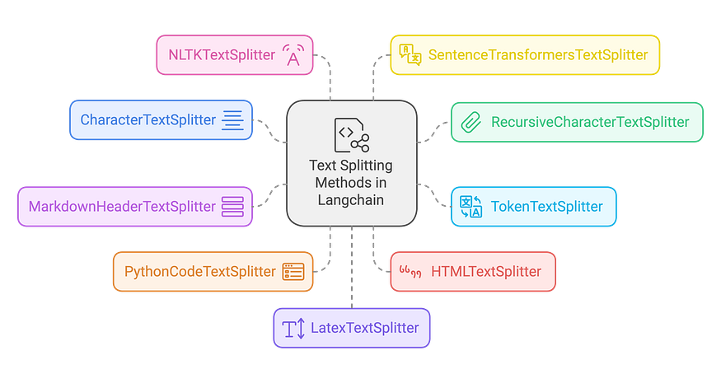
Introduction:
In the rapidly evolving world of Natural Language Processing (NLP), improving AI model outputs with relevant and concise information is key to enhancing user experiences. One such approach is Retrieval-Augmented Generation (RAG), where the preprocessing step of text splitting plays a pivotal role in achieving high accuracy. Text splitting divides large text into smaller, more manageable chunks, enabling AI systems to process and retrieve relevant content efficiently. Langchain provides an array of text splitting strategies, tailored for diverse document structures and NLP applications. In this article, we’ll discuss some essential text splitters in Langchain, highlight their specific use cases, and demonstrate their functionality with code samples.
1. Character-Driven Splitting: Simple Yet Effective
CharacterTextSplitter is one of Langchain’s simplest tools for dividing text into chunks based on a fixed character count. It is ideal for straightforward tasks where the document structure is uniform.
Best for:
- Homogeneous documents where each chunk is relatively equal in size.
- Simple scenarios where detailed control over chunking isn’t necessary.
from langchain.text_splitter import CharacterTextSplitter
text = "This is an example text that will be split into manageable chunks. Each chunk will have a maximum length defined."
splitter = CharacterTextSplitter(
separator=" ",
chunk_size=500, # 500 characters per chunk
chunk_overlap=100 # 100 characters overlap
)
chunks = splitter.split_text(text)
print(chunks)
Here, the splitter creates chunks of 1000 characters, ensuring a 200-character overlap, using double newlines as a separator to avoid splitting mid-paragraphs.
2. Flexibility in Chunking with Recursive Splitting
When more flexibility is required, RecursiveCharacterTextSplitter comes in handy. It allows splitting based on multiple separator patterns, progressively refining the chunking logic.
Best for:
- Handling documents with varied structures.
- Scenarios requiring optimal chunking based on specific delimiters.
from langchain.text_splitter import RecursiveCharacterTextSplitter
text = "This is a document with different types of delimiters. We will use recursive splitting to handle it."
splitter = RecursiveCharacterTextSplitter(
separators=["\n\n", "\n", " ", ""], # Multiple delimiters to ensure efficient chunking
chunk_size=400, # Chunk size adjusted for flexibility
chunk_overlap=50 # Overlap of 50 characters for maintaining context
)
chunks = splitter.split_text(text)
print(chunks)
This splitter works by first trying to split the text using double newlines, then falling back to single newlines, spaces, and finally individual characters if necessary.
3. Token-Based Chunking for Model-Sensitive Tasks
For language models that require processing based on token limits, TokenTextSplitter is the ideal solution. It ensures that the chunk sizes are optimized for models like GPT-3, which have token limits that can impact processing.
Best for:
- Ensuring chunks fit within token constraints for language models.
- Handling documents where token limits are crucial.
from langchain.text_splitter import TokenTextSplitter
text = "This document is being split based on token limits."
splitter = TokenTextSplitter(
encoding_name="cl100k_base",
chunk_size=80, # Split text into chunks of 80 tokens
chunk_overlap=20 # 20-token overlap for context
)
chunks = splitter.split_text(text)
print(chunks)
This splitter operates based on tokens rather than characters, crucial for high-performance models that require precise token management.
4. Splitting Based on Markdown Headers
MarkdownHeaderTextSplitter is perfect for splitting Markdown documents while maintaining their structural integrity. This method respects headers and organizes chunks based on the document hierarchy.
Best for:
- Markdown documentation.
- Projects where content must be divided based on sections, subsections, or headers.
from langchain.text_splitter import MarkdownHeaderTextSplitter
markdown_text = """
# Title
## Section 1
This is some content.
## Section 2
More content here.
"""
splitter = MarkdownHeaderTextSplitter(
headers_to_split_on=[("#", "Header 1"), ("##", "Header 2")]
)
chunks = splitter.split_text(markdown_text)
print(chunks)
This splitter uses the Markdown header hierarchy to create logically coherent text chunks, which is vital for maintaining a clean structure in large Markdown files.
5. Optimizing Code-Based Splitting
The PythonCodeTextSplitter is optimized for Python code documents, splitting text while respecting programming structures such as functions and classes. This method ensures the integrity of the code structure while facilitating easier analysis or documentation.
Best for:
- Python codebases.
- Preserving the structure of code while splitting for analysis or documentation.
from langchain.text_splitter import PythonCodeTextSplitter
python_code = """
def example_function():
print("This is an example.")
class ExampleClass:
def __init__(self):
self.val = 10
"""
splitter = PythonCodeTextSplitter(
chunk_size=100,
chunk_overlap=20
)
chunks = splitter.split_text(python_code)
print(chunks)
This approach ensures that code splits are done logically, respecting function or class boundaries for clearer, more structured output.
6. Web Content Parsing with HTMLTextSplitter
For web scraping or processing HTML content, HTMLTextSplitter is designed to handle the structure of HTML documents. It preserves the context of HTML tags, which is essential for proper content extraction or analysis.
Best for:
- HTML web pages.
- Projects where the HTML structure must be maintained for proper analysis.
from langchain.text_splitter import HTMLTextSplitter
html_text = """
<html>
<head><title>Example</title></head>
<body>
<h1>Main Title</h1>
<p>Paragraph 1</p>
</body>
</html>
"""
splitter = HTMLTextSplitter(
chunk_size=100,
chunk_overlap=20
)
chunks = splitter.split_text(html_text)
print(chunks)
This splitter works to preserve the integrity of HTML tags while breaking down content into manageable pieces.
7. Advanced Linguistic Splitting with NLTK
For those looking for text segmentation based on linguistic principles, NLTKTextSplitter utilizes the Natural Language Toolkit (NLTK) to split text based on sentence or paragraph boundaries.
Best for:
- Well-structured, linguistically rich text.
- Scenarios where sentence or paragraph integrity is important.
from langchain.text_splitter import NLTKTextSplitter
text = "This is a document. It contains multiple sentences. Each sentence is split separately."
splitter = NLTKTextSplitter(
chunk_size=150,
chunk_overlap=30
)
chunks = splitter.split_text(text)
print(chunks)
This method helps maintain linguistic structures, ensuring each chunk makes sense in the context of natural language.
8. Semantic Splitting with Sentence Embeddings
SentenceTransformersTextSplitter splits text based on sentence embeddings, ensuring that chunks retain semantic coherence, which is ideal for tasks requiring understanding of meaning across chunks.
Best for:
- Tasks requiring semantic chunking.
- Projects that depend on preserving context and meaning in each chunk.
from langchain.text_splitter import SentenceTransformersTextSplitter
text = "This is an example text. We aim to split it based on semantic meaning."
splitter = SentenceTransformersTextSplitter(
chunk_size=100,
chunk_overlap=20
)
chunks = splitter.split_text(text)
print(chunks)
This method guarantees that each chunk is semantically coherent, which is essential for higher-level NLP tasks.
9. LaTeX Document Processing
For academic or scientific documents written in LaTeX, LatexTextSplitter is designed to split text while respecting LaTeX-specific commands and environments.
Best for:
- LaTeX documents in academia or scientific research.
- Maintaining LaTeX formatting and structure in processing.
from langchain.text_splitter import LatexTextSplitter
latex_text = r"""
\documentclass{article}
\begin{document}
\section{Introduction}
This is an introduction section with some text.
\section{Methodology}
This section discusses the methods used for processing the data.
\section{Conclusion}
The conclusion summarizes the findings.
\end{document}
"""
splitter = LatexTextSplitter(
chunk_size=100, # Adjust chunk size as needed
chunk_overlap=20 # Adjust overlap for context retention
)
chunks = splitter.split_text(latex_text)
print(chunks)
This approach helps to split LaTeX files while keeping the formatting and structure intact for more accurate document processing.
Conclusion
Selecting the right text splitting method for your RAG pipeline is crucial for improving model performance and accuracy. Langchain offers several specialized splitters, each tailored to specific document types and use cases. Whether you’re working with plain text, code, Markdown, HTML, or LaTeX, Langchain provides flexible solutions that preserve the structure and meaning of your data.
By understanding the strengths and limitations of each text splitter, you can optimize your document processing and create more efficient RAG applications. Experiment with different techniques, tweak parameters to suit your project needs, and ensure that your AI-powered applications are as effective and precise as possible.

