Vector Store

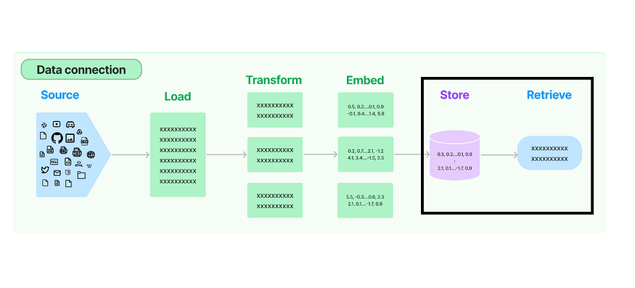
Welcome to the third article in this series of RAG where we explore the different components in the Retrieval process in RAG. So far we have looked into how to load unstructured data, transform it by means of text splitters and embed it using various text embedding models.
In this article, we will understand the functionalities of Vector Stores and Retrievers which are very important components in the Retrieval process.
So, what are Vector Stores?
Vector stores are essentially databases that are designed for a specific kind of data format — vector embeddings. They specialize in storing these embeddings very efficiently. Vector stores enable fast retrieval based on similarity searches.
Essentially the unstructured data is loaded, transformed and embedded into vectors and stored in a vector store. During query time, the unstructured query is embedded and the most similar embedding vectors with respect to the embedded query is retrieved. Vector stores takes care of storing the embedded data and performing vector search.
Press enter or click to view image in full size
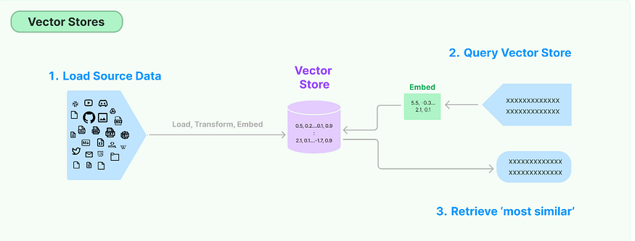
There are a lot of free, open-source vector stores namely, ChromaDB, FAISS, Qdrant, Lance, etc. Let’s look into the functionality of some of these.
Import all necessary dependencies.
Welcome to Part 11 of the LangChain series! After exploring Text Splitters in our previous post, we’re now ready to dive into one of the most essential components for Retrieval-Augmented Generation (RAG): Vector Stores.
Press enter or click to view image in full size
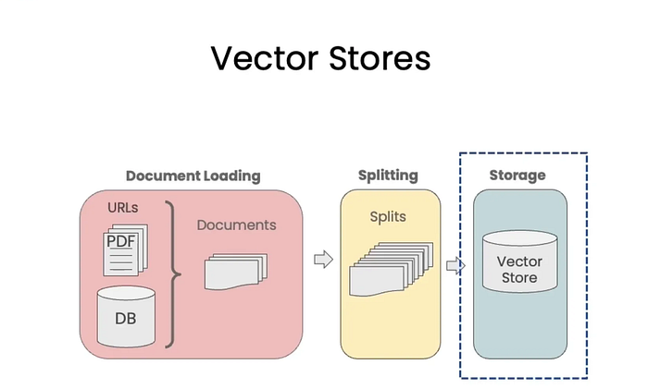
🎯 Why Do We Need Vector Stores?
Let’s say you’re building a movie recommender system.
You want to recommend movies not just by keyword matching on actors, genres, or titles, but based on the actual plot similarity.
To do this:
- You pass a movie plot (text) to a neural network (embedding model)
- It converts the text into a vector representation (aka embedding)
- You compute the cosine similarity between the vectors of different movies
- Movies with similar plots → higher similarity scores → better recommendations
This method powers semantic search, where meaning matters more than matching keywords.
🔧 Challenges in Building Vector-Based Systems
1. Generating Embeddings at Scale
You might have over 100,000 movies.
You need to generate embeddings for each, which requires computational resources and processing time.
2. Storing Embeddings Efficiently
These vectors cannot be stored in traditional databases like MySQL or Oracle because:
- They don’t support vector similarity search
- You can’t do cosine similarity calculations natively
3. Performing Fast Semantic Search
If you calculate similarity between a user query vector and every single vector, it’s inefficient.
We need a smarter way to search relevant vectors.
All above three problems solved by vector stores.
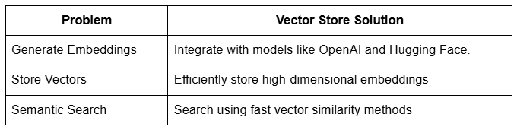
🧠 What are Vector Stores
A vector store is a system designed to store and retrieve data represented as numerical vectors.
🔑 Key Features
- Storage –
Ensures that vectors and their associated metadata are retained, whether in-memory for quick lookups or on-disk for durability and large-scale use.
- Similarity Search –
Helps retrieve the vectors most similar to a query vector.
- Indexing –
Provides a data structure or method that enables fast similarity searches on high-dimensional vectors (e.g., approximate nearest neighbor lookups)
- CRUD Operations — Manage the lifecycle of data:
- Adding new vectors
- Reading them
- Updating existing entries
- Removing outdated vectors
💡 Use-cases
- Semantic Search
- RAG (Retrieval-Augmented Generation)
- Recommender Systems
- Image / Multimedia Search
📊 Indexing: Speeding Up Search with Clustering
When storing millions of vectors, searching every one is slow.
To solve this, vector stores use indexing (often via clustering):
Example:
- You have 10 lakh (1 million) vectors
- You create 10 clusters, each with 1 lakh vectors
- Calculate the centroid (average vector) of each cluster
- When a query comes in:
- First compare with only 10 centroids
- Find the closest cluster (say cluster C3)
- Then search only within C3’s 1 lakh vectors
➡️ This reduces operations from 1 million → 100,010
➡️ Huge performance gain!
📊 Vector Store vs Vector Database
🧠 Vector Store
- Typically refers to a lightweight library or service that focuses on
storing vectors (embeddings) and performing similarity search.
- May not include traditional database features like transactions,
rich query languages, or role-based access control.
- Ideal for prototyping, smaller-scale applications.
- ✅ Example: FAISS — where you store vectors and can query them
by similarity, but you handle persistence and scaling separately.
🗃️ Vector Database
A vector database is a full-fledged database system designed to store and query vectors.
✅ Key Features:
- Distributed architecture for horizontal scaling
- Durability and persistence (replication, backup/restore)
- Metadata handling (schemas, filters)
- Potential for ACID or near-ACID guarantees
- Authentication/Authorization and more advanced security mechanisms
🔧 When to Use:
- Geared for production environments with large datasets and high scalability needs
🧪 Examples:
- Milvus
- Qdrant
- Weaviate
- Pinecone
A vector database is effectively a vector store with extra database features such as clustering, scaling, security, metadata filtering, and durability.
🧱 Vector Stores in LangChain
✅ Supported Stores:
LangChain integrates with multiple vector stores:
- FAISS
- Pinecone
- Chroma
- Qdrant
- Weaviate
Flexibility in scale, features, and deployment.
🧩 Common Interface:
LangChain offers a uniform API lets you swap out one backend (e.g. Chroma) for another (e.g. FAISS) with minimal code changes.
Metadata Handling:
Allows attaching metadata (like timestamps, authors, tags) to each document and enables filtered retrieval.
🟡 Chroma Vector Store
Chroma is a lightweight, open-source vector database ideal for local development or small to medium-scale production.
┌────────────┐
│ Tenant │
└─────┬──────┘
┌──────────────┴──────────────┐
┌───────▼───────┐ ┌────────▼───────┐
│ Database 1 │ │ Database 2 │
└──────┬────────┘ └───────┬────────┘
┌──────────┴──────────┐ ┌────────────┴────────────┐
│ Collection 1 │ │ Collection 2 │
│ Collection 2 │ │ Collection 3 │
└────────┬────────────┘ └────────────┬────────────┘
┌──────▼─────┐ ┌──────▼─────┐
│ Document │ │ Document │
│ Document │ │ Document │
└────────────┘ └────────────┘
🧠 Key:
- TenantThe user/workspace level
- DatabaseLogical grouping of vector data
- Collection Like tables in a DB, it contains related documents
- Document Individual vector entries (with embeddings + metadata)
- Each document contains:
- Embeddings
- Metadata
🌐 Chroma Highlights:
- Friendly for development
- Can act as both a vector store and a vector database
- Open-source and extensible
Code Example:
from langchain.vectorstores import Chroma
from langchain.schema import Document
from langchain_ollama import OllamaEmbeddings
# Create LangChain documents for IPL players
doc1 = Document(
page_content="Virat Kohli is one of the most successful and consistent batsmen in IPL history. Known for his aggressive batting style and fitness, he has led the Royal Challengers Bangalore in multiple seasons.",
metadata={"team": "Royal Challengers Bangalore"}
)
doc2 = Document(
page_content="Rohit Sharma is the most successful captain in IPL history, leading Mumbai Indians to five titles. He's known for his calm demeanor and ability to play big innings under pressure.",
metadata={"team": "Mumbai Indians"}
)
doc3 = Document(
page_content="MS Dhoni, famously known as Captain Cool, has led Chennai Super Kings to multiple IPL titles. His finishing skills, wicketkeeping, and leadership are legendary.",
metadata={"team": "Chennai Super Kings"}
)
doc4 = Document(
page_content="Jasprit Bumrah is considered one of the best fast bowlers in T20 cricket. Playing for Mumbai Indians, he is known for his yorkers and death-over expertise.",
metadata={"team": "Mumbai Indians"}
)
doc5 = Document(
page_content="Ravindra Jadeja is a dynamic all-rounder who contributes with both bat and ball. Representing Chennai Super Kings, his quick fielding and match-winning performances make him a key player.",
metadata={"team": "Chennai Super Kings"}
)
docs = [doc1, doc2, doc3, doc4, doc5]
embeddings = OllamaEmbeddings(
model="llama2",
)
vector_store = Chroma(
embedding_function=embeddings,
persist_directory='my_chroma_db',
collection_name='sample'
)
# add documents
vector_store.add_documents(docs)
# view documents
vector_store.get(include=['embeddings','documents', 'metadatas'])
# search documents
vector_store.similarity_search(
query='Who among these are a bowler?',
k=2
)
# search with similarity score
vector_store.similarity_search_with_score(
query='Who among these are a bowler?',
k=1
)
# meta-data filtering
vector_store.similarity_search_with_score(
query="",
filter={"team": "Chennai Super Kings"}
)
# update documents
updated_doc1 = Document(
page_content="Virat Kohli, the former captain of Royal Challengers Bangalore (RCB), is renowned for his aggressive leadership and consistent batting performances. He holds the record for the most runs in IPL history, including multiple centuries in a single season. Despite RCB not winning an IPL title under his captaincy, Kohli's passion and fitness set a benchmark for the league. His ability to chase targets and anchor innings has made him one of the most dependable players in T20 cricket.",
metadata={"team": "Royal Challengers Bangalore"}
)
vector_store.update_document(document_id='30c76702-79a0-4bd3-a09f-eb76b5dd38c2', document=updated_doc1)
# view documents
vector_store.get(include=['embeddings','documents', 'metadatas'])
# delete document
vector_store.delete(ids=['30c76702-79a0-4bd3-a09f-eb76b5dd38c2'])
# view documents
vector_store.get(include=['embeddings','documents', 'metadatas'])

from langchain_community.document_loaders import WikipediaLoader
from langchain.text_splitter import RecursiveCharacterTextSplitter
from langchain.embeddings import HuggingFaceBgeEmbeddings
Step 1: Document Loading- Let’s use WikipediaLoader as the Document Loader.
loader = WikipediaLoader(query = 'Elon Musk', load_max_docs=5)
documents = loader.load()
documents
Step 2: Text Splitting- We will use RecursiveCharacterTextSplitter as the text splitter.
text_splitter = RecursiveCharacterTextSplitter(chunk_size = 400, chunk_overlap = 100)
docs = text_splitter.split_documents(documents=documents)
print(docs)
Step 3: Embedding Function- For the embedding function, we will use HuggingFace BGE embedding model and let’s create a query.
model_name = "BAAI/bge-large-en-v1.5"
model_kwargs = {'device':'cpu'}
encode_kwargs = {'normalize_embeddings':True}
embedding_function = HuggingFaceBgeEmbeddings(
model_name = model_name,
model_kwargs = model_kwargs,
encode_kwargs = encode_kwargs
)
query = "Who is elon musk's father?"

FAISS
Let’s look into the functionalities of FAISS vector database, which makes use of the Facebook AI Similarity Search (FAISS) library.
pip install faiss-cpu
from langchain_community.vectorstores import FAISS
db = FAISS.from_documents(
docs,
embedding_function
)
Next, we can query the vector database. We can either do similarity search or similarity search with vector.
# Similarity search with query
matched_docs = db.similarity_search(query = query, k = 5)
matched_docs
# Similarity search with query vector
embedding_vector = embedding_function.embed_query(query)
matched_docs = db.similarity_search_by_vector(embedding_vector)
matched_docs
Since the embedding function is same for both, the result will be same.
Most of the times, we won’t necessarily use an in-memory database. Let’s create another open-source database.
ChromaDB
ChromaDB can be used as both an in-memory database and a backend with persistent storage options.
!pip install chromadb
from langchain.vectorstores import Chroma
db = Chroma.from_documents(docs, embedding_function, persist_directory="output/elon_muskdb")
# the persist_directory parameter saves the database in the specified path
Loading the database
loaded_db = Chroma(persist_directory = "output/elon_muskdb", embedding_function = embedding_function)
Similarly, here also we can do similarity search as well as similarity search with vector.
# Similarity search with query
matched_docs = loaded_db.similarity_search(query = query, k = 5)
matched_docs
# Similarity search with query vector
embedding_vector = embedding_function.embed_query(query)
matched_docs = loaded_db.similarity_search_by_vector(embedding_vector)
matched_docs

Background
As data volumes surge, engineers and technical professionals encounters the pressing challenge of efficiently managing vast quantities of unstructured data. With estimated data consumption doubling from 74 Zettabytes to 149 Zettabytes between 2021 and 2024, the demand for robust database solutions capable of processing, storing, and searching through diverse data types has never been more pressing.
Press enter or click to view image in full size
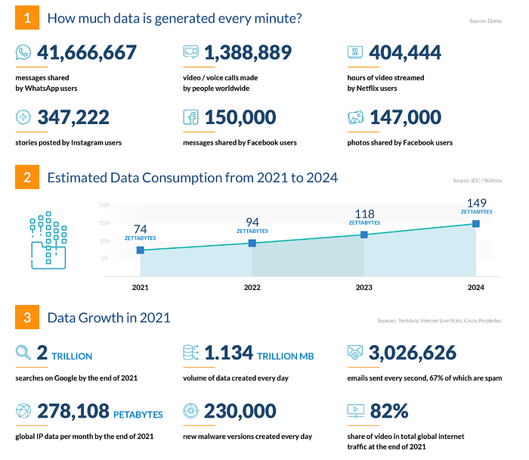
In the era of Generative AI and LLM models, the ability to effectively manage and harness vast amounts of high-dimensional data is paramount. Vector databases emerge as a cornerstone technology, offering a scalable and efficient solution for handling complex datasets and unlocking the full potential of AI-driven innovations.
Prerequisite
Let’s understand some nuances of Vector —
What is Vector & Embeddings?
Vector is the numerical representation of characteristics or features of mutidimensional objects. Whereas Embeddings is a technique of representing such high dimensional objects into numerical vectors. These embeddings captures the semantic similarity or relationeship between two different objects, which means similar object’s vector lie close to each other in vector space.
For our use case, we will be using text-embedding-ada-002, dimension 1536, and similarity metric as cosine. In a nutshell, the input text is converted into 1536 dimensions that represent various features and characteristics of the text. The cosine similarity metric measures the similarity between two text vectors in this high-dimensional space, providing a measure of how closely related they are in terms of their content and context.
Press enter or click to view image in full size
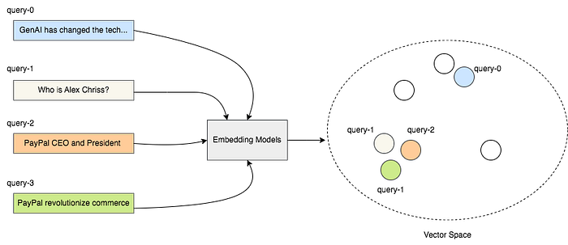
similar vectors lie nearby
What is a Vector Database?
It is a database that stores and manages unstructured data like text, audio, video, or image in high dimensional vectors to make it easy to find and retrieve similar objects at scale. there are various Vector DB like pinecone, Qdrant, Milvus etc. It has gained massive popularity due to the rise of LLM, as it provides high performance, scalability and data retrieval by finding similarities between them.
For our use case, we will explore Pinecone, which is a fully managed cloud-based vector database. It can handle large-scale ML applications with billions of data points with high throughput and low latency.
👨‍💻Setup Pinecone
- Go to https://app.pinecone.io/
- Create a new index say — “llm-service-embeddings”, and add dimension 1536 and metric as cosine as per your use case.
Press enter or click to view image in full size
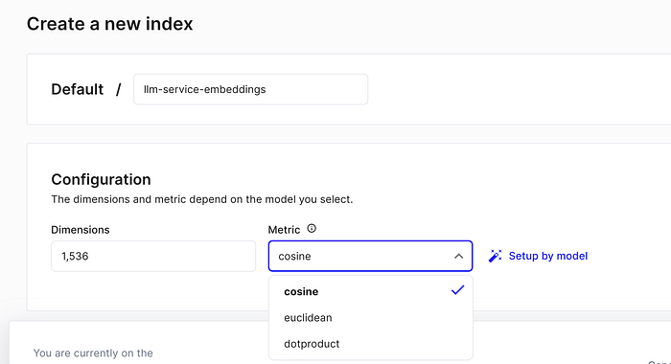
create index
3. Click on “Setup by model” to choose what embedding model you want to choose
Press enter or click to view image in full size
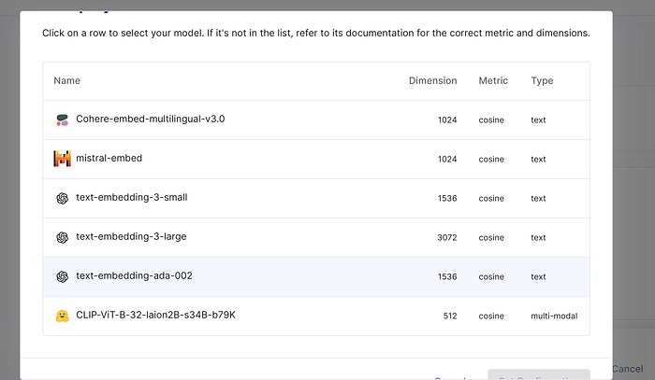
an embedding model
4. You are done!
👨‍💻Deep Dive — Let’s Code it
Let’s take a use case where we will provide some information about Alex Chriss as input and we are interested in knowing “who is Alex Chriss and what position he holds currently. provide me with a sentence summary.” We will divide this into two parts — Ingestion and Retrieval.
Ingestion
Press enter or click to view image in full size
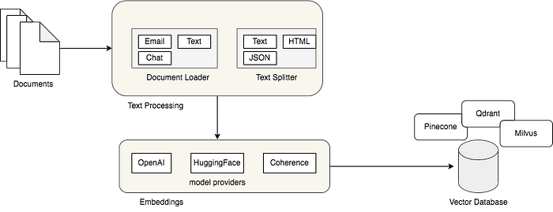
Ingestion
Ingestion consists of four main steps- Load, Split, Embed & Store.
Firstly, Suppose we have unstructured data in any format, it will be loaded using Document Loader provided by the framework LangChain — it has Python implementation for all types of document loader whether it is WhatsApp Chat Loader, PDF or GIT, etc. Refer- langchain-document-loader
Secondly, we split it into chunks of file — this is too make sure it doesn’t reach the max limit token. For our use case, we are taking chunk_size = 1000 token & chunk_overlap = 0. Refer- langchain-document-transformer
Note: Overlaps ensure that no information is missed at the boundaries of adjacent chunks, maintaining context integrity. It is essential to maintain stronger similarity between two chunks if exists, also doesn’t looses context.
Thridly, these chunks are converted into embeddings as explained above. there are different embedding providers. For our use case, we‘ll be using OpenAIEmbeddings. These embedding models convert chunks into numerical vectors. Alternative options for text embeddings may include models like Word2Vec, GloVe, or BERT, each offering distinct approaches and features for generating embeddings.
Fourthly, we require a database that can store, and manage embeddings.
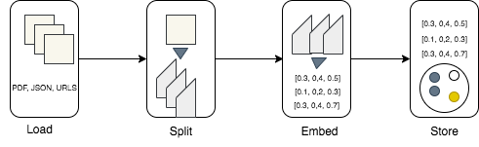
Ingestion
Code Snippet
Setting environment variables for the Pinecone API key and the index name. The vectors are ingested into Pinecone’s Vector Store, associating them with the specified index name.
if __name__ == "__main__":
os.environ['PINECONE_API_KEY'] = userdata.get('PINECONE_API_KEY')
os.environ['INDEX_NAME'] = userdata.get('INDEX_NAME')
loader = TextLoader("/content/llm_data/alex_chriss.txt")
document = loader.load()
print("Splitting::\n")
text_splitter = CharacterTextSplitter(chunk_size=1000, chunk_overlap=0)
texts = text_splitter.split_documents(document)
print(f"created {len(texts)} chunks")
embeddings = OpenAIEmbeddings(openai_api_key=userdata.get('OPENAI_API_KEY'))
print("Ingesting the document::\n")
PineconeVectorStore.from_documents(
texts, embeddings, index_name=os.environ["INDEX_NAME"]
)
print("finish")
Below is the vector represnetation of input data, in pinecone dashboard. It has 1536 dimensions that represents various features of a text.

1️) WHAT?
A vector store is a special type of database (or data structure) designed to store and efficiently retrieve vector embeddings — numerical representations of data (like text, images, or audio) in a high-dimensional space.
vector embeddings- When we use models like OpenAI’s text-embedding-ada-002, BERT, or CLIP, they convert input data (e.g., a sentence, paragraph, or image) into a long list of numbers.
2️) Why a vector store instead of a normal database?
We need a vector store even though we already have relational databases because the two serve very different purposes.
Think of it like the difference between a spreadsheet (relational DB) and a search engine’s index (vector DB) — both store information, but they’re optimized for different kinds of queries.
1️⃣ Purpose Difference
Press enter or click to view image in full size
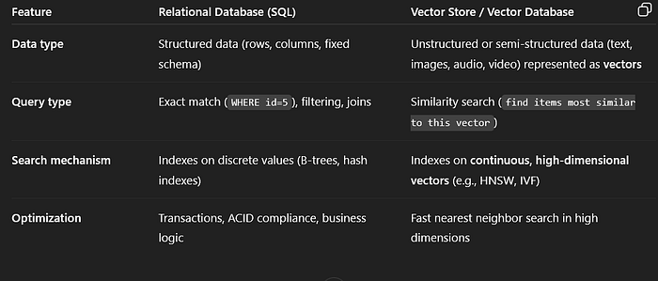
2️⃣ Why a Relational DB Alone Can’t Do It Well
Relational databases aren’t designed for semantic similarity.
Example:
If I ask in SQL:
SELECT * FROM products WHERE description = 'red running shoes';
It will only find exact matches of 'red running shoes'.
But in real-world AI tasks, we need:
“Find me items similar in meaning to ‘red running shoes’, even if the text says ‘maroon jogging sneakers’.”
To do this:
- Convert descriptions into embeddings (vectors) using models like OpenAI’s text-embedding-3-large.
- Store those vectors in a vector database.
- Perform Approximate Nearest Neighbor (ANN) search to find vectors that are close in meaning.
Relational DBs can technically store vectors as blobs or arrays, but:
- They have no specialized ANN indexes (search will be slow for millions of vectors).
- They’re not optimized for cosine similarity or Euclidean distance queries.
- Query complexity explodes in high dimensions (curse of dimensionality).
3️) What a vector store actually stores
A vector store usually stores:
- The vector embeddings themselves.
- The original data (text, metadata, file link).
- Indexes for fast similarity search.
4) What you can do with a vector store
- Semantic search → Search by meaning, not keywords.
- Context retrieval for RAG → Fetch the most relevant text chunks for an LLM prompt.
- Image similarity search → Find visually similar images.
- Recommendation systems → Suggest items close in vector space.
✅ In short:
A vector store is like a library where books are stored not by title or author, but by their meaning, so you can instantly find books that “feel” similar to the one you have in mind — and it works for text, images, and more.
5) Why Vector Stores Are Needed in RAG
In Retrieval-Augmented Generation (RAG):
- Embeddings of documents are stored in a vector database.
- At query time:
- User query is embedded into a vector.
- The vector DB finds top-k similar vectors.
3. Those matching documents are sent to the LLM for context-aware generation.
Without a vector store:
- Search would be slower (O(n) scanning through embeddings).
- Quality would drop because we can’t efficiently do semantic retrieval.
- RAG wouldn’t scale well to millions or billions of documents.
✅ In short:
- Relational DB = good for exact, structured queries.
- Vector DB = good for semantic, similarity queries in AI.
- In RAG, vector DB is essential for retrieving meaningfully related information quickly.
So, we solve few challenges by vector store- generate embedding vectors, need storage for storing them and intelligent semantic search(saving computation)
6) Examples of vector stores
- Local libraries: FAISS (Facebook AI Similarity Search), Annoy, ScaNN, Chroma
7) Key features of a vector stores
1. High-dimensional vector storage
- Can store large embeddings (often 100–2000+ dimensions).
- Handles data from models like BERT, CLIP, OpenAI embeddings, etc.
2. Similarity search
Finds closest vectors to a query vector using:
- Cosine similarity
- Euclidean distance
- Dot product
Enables semantic search instead of just keyword matching.
3. Specialized indexing
- Uses ANN (Approximate Nearest Neighbor) algorithms for speed.
Common methods:
- HNSW (Hierarchical Navigable Small World graphs)
- IVF (Inverted File Index)
- PQ (Product Quantization)
- These indexes allow millions of vectors to be searched in milliseconds.
4. Metadata storage & filtering (✅ Basic)
- Stores extra info (title, tags, author, date).
- Allows metadata-based filtering during search
(e.g., “find similar docs from 2023 in category ‘finance’”).
5. Scalability(⚠️ Limited / manual)
- Designed to store millions to billions of vectors.
- Often distributed and sharded (splitting a large dataset into smaller pieces (“shards”) and storing them across multiple machines or storage units, instead of keeping everything in one place) across multiple machines for huge datasets.
6. Multi-modal support
- Can store embeddings from text, images, audio, video — all in the same system.
7. Integration with ML pipelines
Works directly with:
- RAG (Retrieval-Augmented Generation)
- Recommendation engines
- Content-based filtering
- APIs for embedding insertion, update, and deletion.
8. Real-time updates(CRUD Operations) (if supported)
Many vector stores allow:
- Adding vectors on the fly.
- Updating embeddings if your model changes.
- Deleting outdated data.
9. Hybrid search (⚠️ Sometimes)
Some vector stores support hybrid queries:
- Combine keyword search (BM25, TF-IDF) with vector similarity.
- Useful for cases where meaning and exact terms both matter.
Vector store typically refers to a lightweight library or service that focuses on storing vectors, may not include many traditional database features like transcations, rich query languages or role based access control, ideal for prototyping, smaller scale applications. Example — FAISS where you store vectors and can query them by similarity but you handle persistence and scaling separately.
Vector Database:
To make more powerful applications Vector Database came into picture
A vector database is a specialized database system built for scalable storage, indexing, and searching of high-dimensional vectors.
It’s a type of database (like SQL or NoSQL), but optimized for:
- Similarity search (finding the “closest” vectors to a query vector)
- Hybrid search (combine semantic and keyword-based search)
- Massive scale (millions to billions of vectors)
- Real-time retrieval
Extra Features of Vector Databases
- Distributed storage
- Index optimization (HNSW, IVF, PQ, etc.)
- Integration with RAG pipelines
- API-based query execution
- User authentication
- Multi-tenancy
- Backup and recovery
- Scaling & replication
- Query language (like SQL-like or GraphQL-like)
- Metadata filtering at scale
Examples of Vector Databases:
- Pinecone (managed, cloud)
- Weaviate (open-source or cloud)
- Milvus (open-source, enterprise-scale)
- Qdrant (open-source, optimized for filters
- PostgreSQL with pgvector
COMPARISION:
Press enter or click to view image in full size
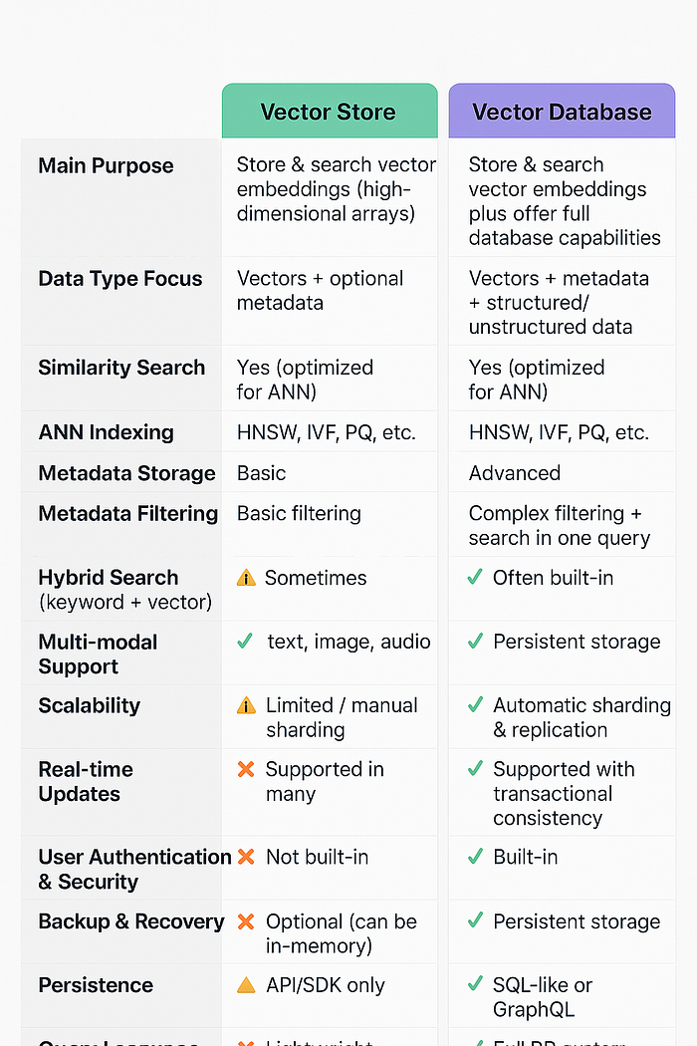
Press enter or click to view image in full size
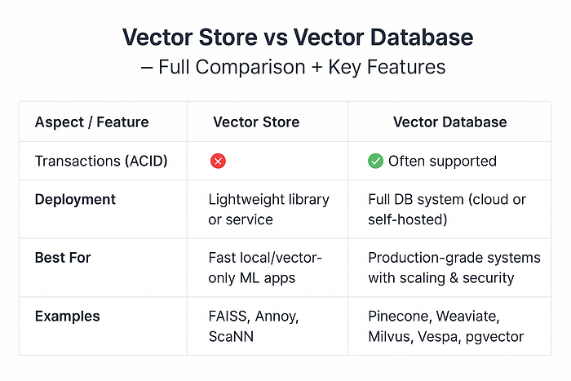
💡 How to think about it
- Vector Store → The engine for similarity search. Great for local or embedded ML apps.
- Vector Database → The production-ready system that includes a vector store inside but also handles scaling, security, and database features.
- Normal Database → Not built for semantic similarity search, but great for structured or document data.
- Vector Store = core engine for storing & searching vectors.
- Vector Database = vector store + database features for production use (security, scaling, backups, query language).
Why vector stores are still needed even if vector databases exist:
1️⃣ Vector stores are lightweight & faster to set up
- If you’re building a small or local ML project (like a semantic search prototype), you don’t need the heavy machinery of a full database.
- A vector store like FAISS can run in-process, without a server, user authentication, or complex config
Example:
- You have 500k embeddings in memory and want blazing-fast similarity search on your laptop → FAISS or Annoy is perfect.
2️⃣ No database overhead
- Vector databases have features like auth, sharding, replication, backup, which add complexity.
- If you only need vector search, a store is simpler, smaller, and often faster because there’s no extra layer.
3️⃣ Ideal for embedding inside apps
- You can integrate vector stores directly into Python scripts, mobile apps, or microservices without running a separate DB service.
- Example: A local chatbot app can use FAISS to store vectors entirely in memory — no internet, no DB server.
4️⃣ Cheaper for small datasets
- Many vector databases (Pinecone, Weaviate Cloud) charge based on storage and queries.
- A vector store running on your own machine or in memory has zero extra cost.
5️⃣ Great for experimentation
- When testing:
- You generate embeddings.
- Store them locally in FAISS.
- Run quick similarity searches.
- Once the logic is proven, you can migrate to a vector database for production.
6️⃣ Vector databases actually use vector stores inside
- Under the hood, vector databases are built on top of vector store engines like FAISS, HNSWlib, or Annoy.
The database wraps the store with:
- Query API
- Security
- Scaling logic
- Persistence layers
📌 Rule of Thumb
- Vector Store → Use it for local, small to medium, experimental, or embedded projects.
- Vector Database → Use it for large-scale, multi-user, distributed, production workloads.
The relationship
┌─────────────────────────────┐
│ Application Layer │
│ (LLM, Search, Recommendation)│
└───────────────┬───────────────┘
│ Query
▼
┌─────────────────────────────────┐
│ Vector Database │
│ (Full DB System for Vectors) │
│----------------------------------│
│ ✅ Authentication & Security │
│ ✅ Query Language (SQL/GraphQL) │
│ ✅ Sharding & Replication │
│ ✅ Metadata Filtering │
│ ✅ Backup & Recovery │
│ │
│ ┌───────────────────────────┐ │
│ │ Vector Store Engine │ │ ◄── This is the **core search engine**
│ │ (e.g., FAISS, HNSWlib) │ │ inside the database
│ │ ✅ ANN Indexing │ │
│ │ ✅ Similarity Search │ │
│ │ ✅ Vector Storage │ │
│ └───────────────────────────┘ │
└─────────────────────────────────┘
How to Remember the Difference
- Vector Store → Think “engine”: fast, focused on vector search, but minimal extra features.
- Vector Database → Think “engine + car”: has the same search engine inside but wrapped in a full-featured, production-ready system.
one-line memory trick 🧠✨
“A vector store is the brain; a vector database is the brain in a body with armor, muscles, and a passport.”
Why it works:
- Brain 🧠 = does the actual thinking/searching → that’s the vector store (stores vectors, finds nearest neighbors, indexes).
- Body with muscles 💪 = all the extra database infrastructure → scaling, replication, CRUD, metadata filtering at scale.
- Armor 🛡 = security, authentication, backups.
- Passport 📜 = lets it connect with the outside world → query languages, APIs, integrations.
*Chroma Vector Store:
Chroma is an open-source lightweight vector store that is especially friendly for local development and small to medium scale production needs.
🔹 What Chroma Does
- Stores embeddings (numeric vector representations of text, images, etc.).
- Searches by similarity using approximate nearest neighbor (ANN) algorithms.
- Keeps metadata so you can filter and query results contextually.
- Integrates directly with ML pipelines — especially in Python.
🔹 Where Chroma Fits
- Chroma is a vector store, not a full vector database.
- It gives you fast embedding storage & search
- It doesn’t have advanced database features like sharding, replication, transactions, or built-in authentication.
Perfect for:
- Local prototypes
- Edge/embedded AI
- RAG pipelines in Python notebooks
- Small to medium-scale apps
Features :
Open-source Free to use, self-host, and customize.
Embedded by default Runs locally in-process — no separate server required.
Persistent or in-memory storage Choose between temporary (RAM) or persistent disk storage.
Metadata filtering Search results can be filtered by tags, categories, or other metadata.
Simple Python API Store and query vectors with minimal code.
Multi-modal support Works with embeddings from text, images, audio, etc.
Integrations Works well with LangChain, LlamaIndex, and other LLM frameworks.
Self-hosting option Can run as a service for multi-user or distributed scenarios.
Chroma via LangChain (RAG-friendly)
pip install langchain langchain-community chromadb sentence-transformers
# chroma_langchain.py
from langchain_community.vectorstores import Chroma
from langchain_community.embeddings import HuggingFaceEmbeddings
from langchain.text_splitter import RecursiveCharacterTextSplitter
# 1) Your raw texts (can be from files, PDFs, etc.)
texts = [
("Chroma is an open-source embedding database.", {"source": "kb", "tag": "intro"}),
("Use Chroma with LangChain for retrieval-augmented generation.", {"source": "blog", "tag": "rag"}),
("You can filter queries using metadata fields.", {"source": "kb", "tag": "filter"})
]
# 2) (Optional) chunking
splitter = RecursiveCharacterTextSplitter(chunk_size=400, chunk_overlap=50)
docs = []
for t, meta in texts:
for chunk in splitter.split_text(t):
# LangChain expects Document objects with metadata
from langchain.docstore.document import Document
docs.append(Document(page_content=chunk, metadata=meta))
# 3) Embeddings (open-source)
emb = HuggingFaceEmbeddings(model_name="sentence-transformers/all-MiniLM-L6-v2")
# 4) Create persistent Chroma store
persist_dir = "./chroma_langchain"
vectordb = Chroma.from_documents(
documents=docs,
embedding=emb,
collection_name="my_docs",
persist_directory=persist_dir
)
vectordb.persist() # flush to disk
# 5) Simple similarity search
results = vectordb.similarity_search("How to do RAG with Chroma?", k=2)
for r in results:
print(r.page_content, r.metadata)
# 6) Metadata filtering
results = vectordb.similarity_search(
"Explain filtering",
k=2,
filter={"source": "kb"} # exact-match filter on metadata
)
for r in results:
print("FILTERED ->", r.page_content, r.metadata)
# 7) Retriever for LLM chains
retriever = vectordb.as_retriever(search_kwargs={"k": 3, "filter": {"tag": "rag"}})
context_docs = retriever.get_relevant_documents("How do I use Chroma for RAG?")
for d in context_docs:
print("CTX ->", d.page_content[:80], d.metadata)
* FAISS Vector Store:
- Full form: Facebook AI Similarity Search
- Purpose: FAISS is designed for fast nearest neighbor search in high-dimensional vector spaces.
- Use case: It’s mainly used to store embeddings (e.g., from NLP models, image feature extractors) and quickly retrieve the most similar items to a query vector.ChatGPT said:
- It’s designed for very fast similarity search in high-dimensional vector spaces — the kind you get from embeddings in NLP, computer vision, and other ML tasks.
💡 Simple analogy:
FAISS is like a Formula-1 race engine — insanely fast, but it’s just the engine. If you want a whole car (security, replication, query language), you need to build that around it or use a full vector database.
What FAISS Does
FAISS (Facebook AI Similarity Search) is a vector search library for:
- Storing large sets of dense vector embeddings (usually from text, images, or audio).
- Searching for the nearest vectors to a query vector — i.e., finding similar items.
- Doing it fast even with millions or billions of vectors.
Think of it as
“A highly optimized Google search — but instead of keywords, it searches by meaning, stored in high-dimensional numeric vectors.”
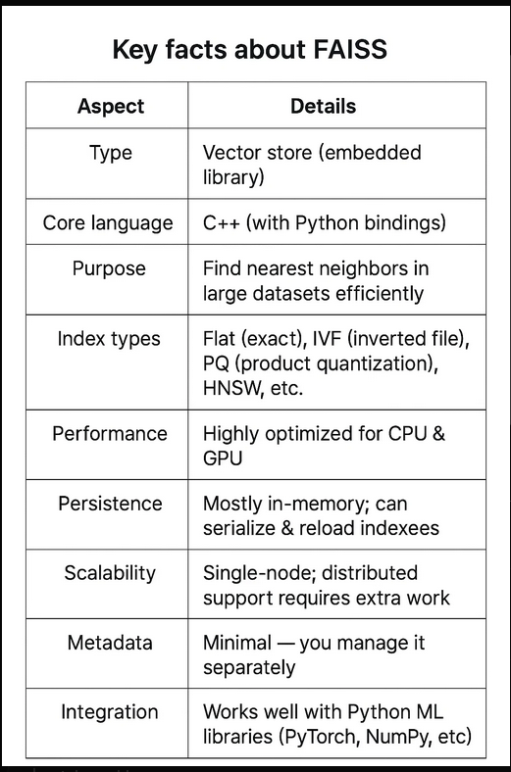
Perfect For
FAISS is perfect when:
- You have lots of vectors — 1 million to 1 billion — and need fast search.
- You want local / on-premise search (unlike cloud-only solutions like Pinecone).
- You care about speed — FAISS is written in C++ with Python bindings, uses GPU acceleration.
- You need flexibility — you choose your index type depending on:
- Accuracy vs. speed trade-off (exact search vs. approximate)
- Memory constraints (quantization, compression)
- You’re okay with managing your own storage — FAISS stores in files, not a hosted DB.
When FAISS Is Not the Best Choice
- If you want multi-user, always-on cloud API → better to use Pinecone, Weaviate, Vespa.
- If you need complex metadata filtering → FAISS can do some filtering but isn’t built as a rich query engine.
- If you don’t want to deal with index persistence manually.
FAISS is the engine for lightning-fast vector similarity search.
It’s perfect for high-performance, large-scale, local embedding search, often as the retrieval step in RAG pipelines or recommendation engines.
FAISS with LangChain
pip install langchain langchain-community sentence-transformers faiss-cpu
# faiss_langchain.py
# Install if needed:
# pip install langchain faiss-cpu openai
from langchain.vectorstores import FAISS
from langchain_openai import OpenAIEmbeddings
from langchain.schema import Document
# 1. Create some sample documents
docs = [
Document(page_content="FAISS is a library for efficient similarity search."),
Document(page_content="LangChain connects LLMs with external data."),
Document(page_content="Pinecone is a managed vector database service."),
]
# 2. Create embeddings
embeddings = OpenAIEmbeddings(model="text-embedding-ada-002")
# 3. Build FAISS vector store from documents
vectorstore = FAISS.from_documents(docs, embeddings)
# 4. Save to local folder
vectorstore.save_local("faiss_index")
# 5. Load the saved FAISS index
loaded_vectorstore = FAISS.load_local("faiss_index", embeddings, allow_dangerous_deserialization=True)
# 6. Perform similarity search
query = "What is FAISS?"
results = loaded_vectorstore.similarity_search(query, k=2)
# 7. Display results
for i, res in enumerate(results, 1):
print(f"{i}. {res.page_content}")
*Pinecone Vector Database:
Pinecone is a fully managed vector database service built specifically for semantic search, recommendation, and AI applications that work with vector embeddings.
Think of it as a cloud-based FAISS with database features — you get the performance of optimized ANN (Approximate Nearest Neighbor) search plus the database reliability, scaling, and operational tools.
Core Purpose
- Store high-dimensional vectors (e.g., embeddings from OpenAI, Hugging Face, CLIP, etc.)
- Perform fast similarity search at scale
- Handle billions of vectors without you worrying about sharding, replication, or maintenance
- Provide real-time updates (insert, update, delete vectors)
Architecture Overview
- Managed Service — You don’t run the database; Pinecone runs and scales it for you.
- Index Pods — Compute + memory units where your vectors are stored and searched.
- Namespaces — Logical partitions inside an index for grouping related data.
- Metadata Storage — Along with vectors, you can store JSON metadata for filtering.
- Automatic Sharding & Replication — Distributes data across pods automatically.
Press enter or click to view image in full size
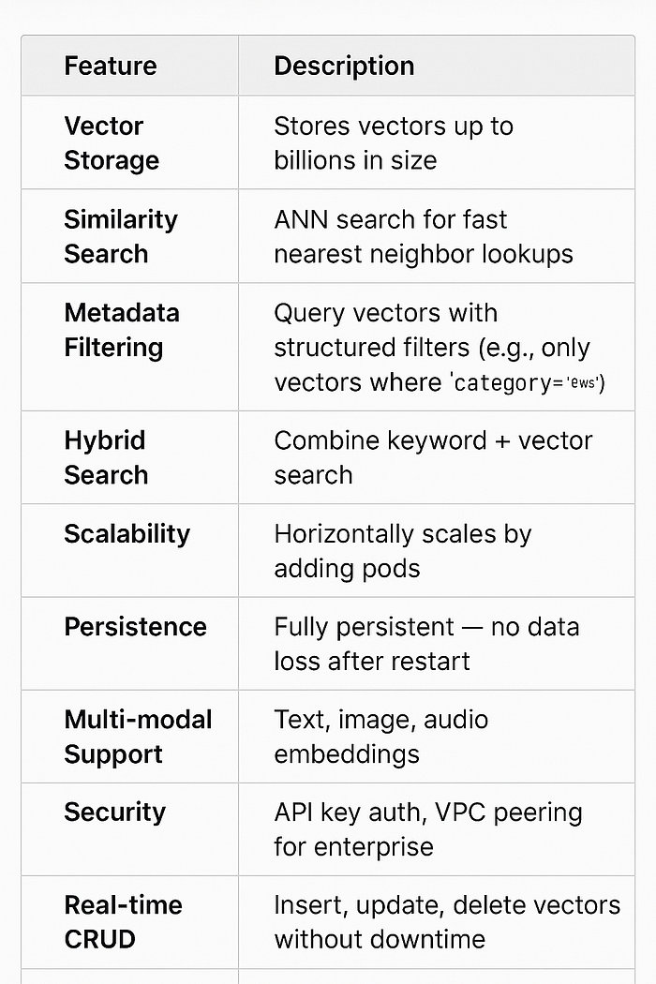
Ideal Use Cases
✅ Large-scale semantic search
✅ AI-powered recommendation engines
✅ RAG (Retrieval-Augmented Generation) pipelines for LLMs
✅ Multi-tenant SaaS apps needing secure, isolated vector storage
✅ Teams that don’t want to manage vector infra themselves
Limitations
⚠️ Cloud-only — you can’t run Pinecone locally
⚠️ Vendor lock-in — API-specific, not SQL-based
⚠️ Costs — can get expensive with billions of vectors
⚠️ Limited algorithm choice — you don’t choose IVF/HNSW; Pinecone manages that internally
Pinecone with LangChain (RAG-friendly)
pip install "pinecone>4" langchain langchain-community langchain-pinecone \
sentence-transformers
# pinecone_langchain.py
import os
from pinecone import Pinecone, ServerlessSpec
from langchain_pinecone import PineconeVectorStore
from langchain_community.embeddings import HuggingFaceEmbeddings
from langchain.schema import Document
# - - 0) Config - -
os.environ["PINECONE_API_KEY"] = "<YOUR_API_KEY>"
pc = Pinecone(api_key=os.environ["PINECONE_API_KEY"])
MODEL = "sentence-transformers/all-MiniLM-L6-v2" # 384-dim
DIM = 384
INDEX_NAME = "lc-mini"
# - - 1) Ensure index exists - -
if INDEX_NAME not in [idx.name for idx in pc.list_indexes()]:
pc.create_index(
name=INDEX_NAME,
dimension=DIM,
metric="cosine",
spec=ServerlessSpec(cloud="aws", region="us-east-1")
)
# - - 2) Embeddings - -
emb = HuggingFaceEmbeddings(model_name=MODEL)
# - - 3) Prepare documents - -
docs = [
Document(page_content="Pinecone is a managed vector DB.", metadata={"source": "kb", "cat": "intro"}),
Document(page_content="Use Pinecone for scalable RAG.", metadata={"source": "blog", "cat": "rag"}),
Document(page_content="You can filter by metadata.", metadata={"source": "kb", "cat": "filter"})
]
# - - 4) Create vector store handle (uses existing Pinecone index) - -
store = PineconeVectorStore(index_name=INDEX_NAME, embedding=emb)
# Upsert
store.add_documents(docs, ids=["d1", "d2", "d3"])
# - - 5) Similarity search - -
hits = store.similarity_search("How to use Pinecone in RAG?", k=2)
for h in hits:
print("HIT:", h.page_content, h.metadata)
# - - 6) Filtering - -
hits = store.similarity_search(
"Explain filtering",
k=3,
filter={"source": "kb"} # equality filter
)
for h in hits:
print("FILTERED:", h.page_content, h.metadata)
# - - 7) Retriever (for LLM chains) - -
retriever = store.as_retriever(search_kwargs={"k": 3, "filter": {"cat": "rag"}})
ctx = retriever.get_relevant_documents("Best way to scale RAG?")
for d in ctx:
print("CTX:", d.page_content[:70], d.metadata)
Quick Tips
- OpenAI embeddings? Swap in your embedding class (e.g., from langchain_openai import OpenAIEmbeddings) and set DIM=1536 (text-embedding-3-small) or 3072 (text-embedding-3-large).
- Namespaces help segment data per user/tenant (namespace="tenant_a").
- Hybrid search (BM25 + vectors) requires an external keyword engine; Pinecone is vector-first but plays nicely with reranking.
- Upserts are idempotent: sending the same id updates the vector/metadata.
Press enter or click to view image in full size
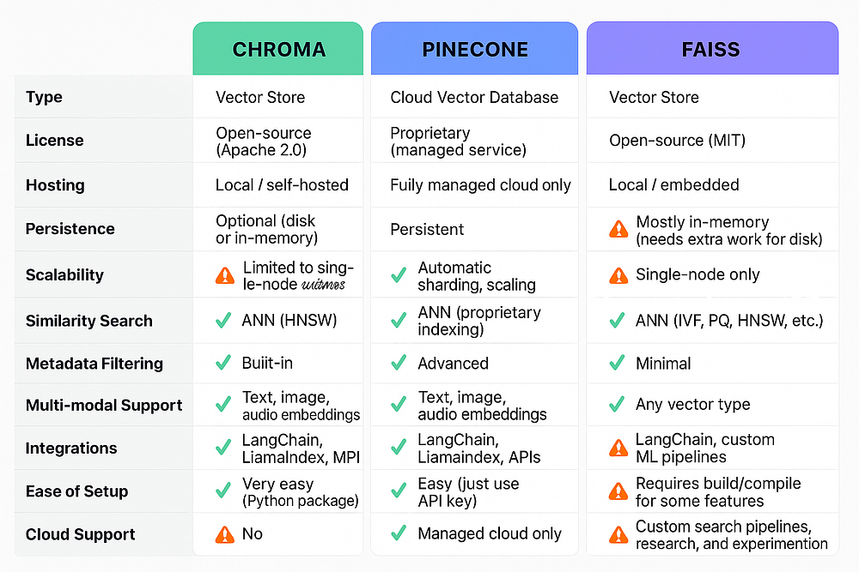
Press enter or click to view image in full size
