Gradient Boosting Classifier

Gradient Boosting Classification:
https://colab.research.google.com/drive/13p46IFhg3h6BIdjxUcfXPco13jIOCV6I?usp=sharing
https://colab.research.google.com/drive/15G44KBuSgHs7hdSIuhwh-LR7Qur4xRyD?usp=sharing
https://towardsdatascience.com/all-you-need-to-know-about-gradient-boosting-algorithm-part-2-classification-d3ed8f56541e/

https://www.digitalocean.com/community/tutorials/gradient-boosting-for-classification
https://datamapu.com/posts/classical_ml/gradient_boosting_regression/
https://www.analyticsvidhya.com/blog/2021/09/gradient-boosting-algorithm-a-complete-guide-for-beginners/
https://colab.research.google.com/drive/13p46IFhg3h6BIdjxUcfXPco13jIOCV6I?usp=sharing
https://colab.research.google.com/drive/15G44KBuSgHs7hdSIuhwh-LR7Qur4xRyD?usp=sharing

What is Gradient Boosting?
Let’s start by briefly reviewing ensemble learning. Like the name suggests, ensemble learning involves building a strong model by using a collection (or “ensemble”) of “weaker” models. Gradient boosting falls under the category of boosting methods, which iteratively learn from each of the weak learners to build a strong model. It can optimize:
- Regression
- Classification
- Ranking
Gradient Boosting has three main components:
- Loss Function - The role of the loss function is to estimate how good the model is at making predictions with the given data. This could vary depending on the problem at hand. For example, if we’re trying to predict the weight of a person depending on some input variables (a regression problem), then the loss function would be something that helps us find the difference between the predicted weights and the observed weights. On the other hand, if we’re trying to categorize whether a person will like a certain movie based on their personality, we’ll require a loss function that helps us understand how accurate our model is at classifying people who did or didn’t like certain movies.
- Weak Learner—A weak learner classifies our data but does so poorly, perhaps no better than random guessing. In other words, it has a high error rate. These are typically decision trees (also called decision stumps because they are less complicated than typical decision trees).
- Additive Model - This is the iterative and sequential approach of adding the trees (weak learners) one step at a time. After each iteration, we need to be closer to our final model. In other words, each iteration should reduce the value of our loss function.

A gradient-boosting classifier works when the target column is binary. You apply all the steps explained in the gradient-boosting regressor here, the only difference is changing the loss function. Earlier, we used Mean squared error when the target column was continuous, but we will use log-likelihood as our loss function this time.
Let’s see how this loss function works.
The loss function for the classification problem is given below:
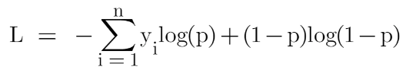

Our first step in the Gradient Boosting Algorithm in Machine Learning was to initialize the model with some constant value, there we used the average of the target column but here we’ll use log(odds) to get that constant value. The question arises: Why log(odds)?
When we differentiate this loss function, we will get a function of log(odds), and then we need to find a value of log(odds) for which the loss function is minimum.

Our first step in the Gradient Boosting Algorithm in Machine Learning was to initialize the model with some constant value, there we used the average of the target column but here we’ll use log(odds) to get that constant value. The question arises: Why log(odds)?
When we differentiate this loss function, we will get a function of log(odds), and then we need to find a value of log(odds) for which the loss function is minimum.

After finding the residuals, we can build a decision tree with all independent variables and target variables as “Residuals”.
When we have our first decision tree, we find the final output of the leaves because there might be a case where a leaf gets more than 1 residuals, so we need to calculate the final output value. The math behind this step is out of the scope of this article, so I will mention the direct formula to calculate the output of a leaf:
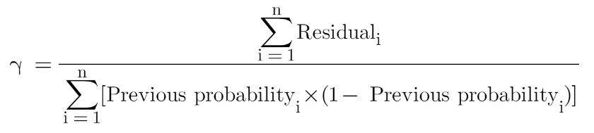

Finally, we are ready to get new predictions by adding our base model with the new tree we made on residuals.

Why Log(Odds) in Gradient Boosting Classification?
Gradient Boosting for binary classification is typically trained to minimize the log-loss, and under the hood it models the log-odds (also called logit) rather than probabilities directly.

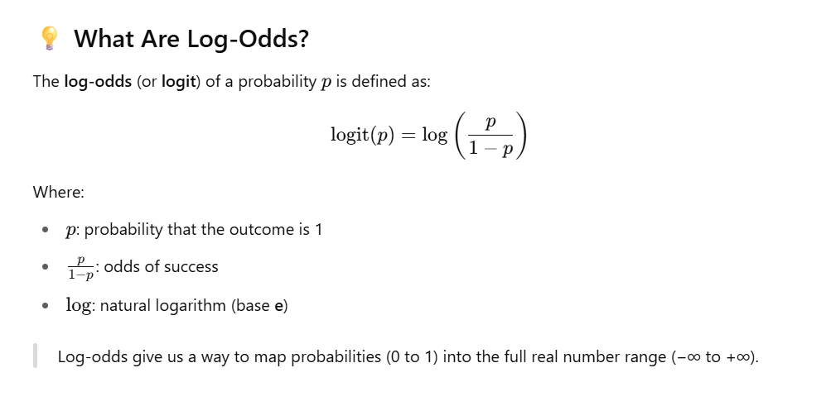
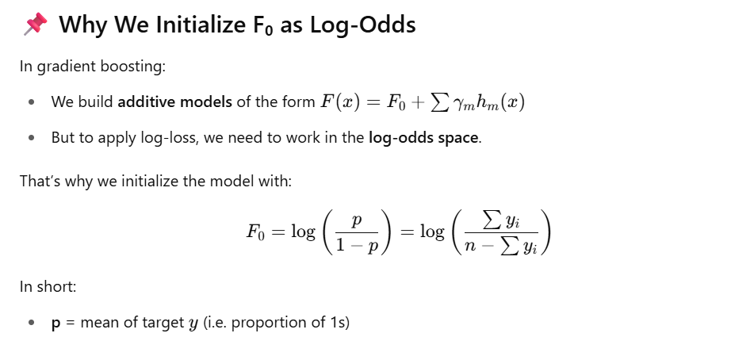

All steps from scratch:

Gradient Boosting for Binary Classification (with Log Loss)
Gradient Boosting builds an ensemble of decision trees, where each tree fits the residuals (gradients) of the previous model. In binary classification with log loss, this process is optimized using derivatives of the log-loss function.

🔹 1. Initial Prediction — Log-Odds
Formula
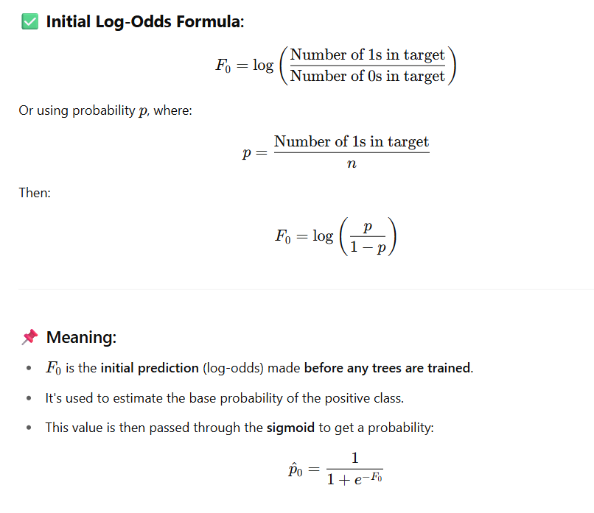
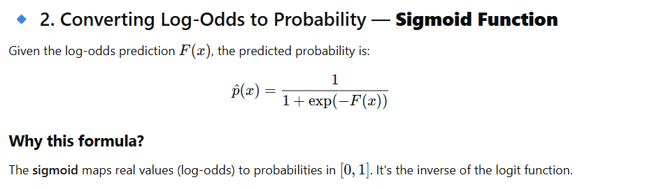

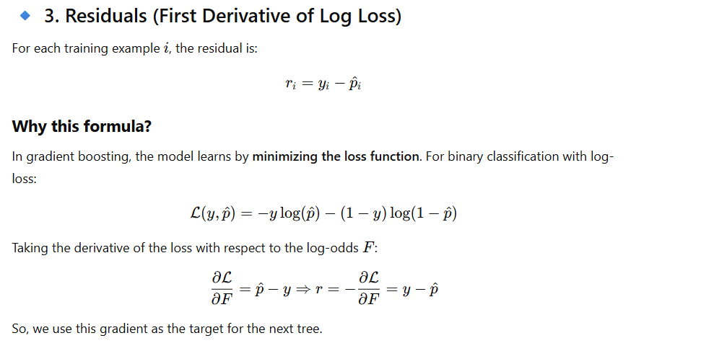
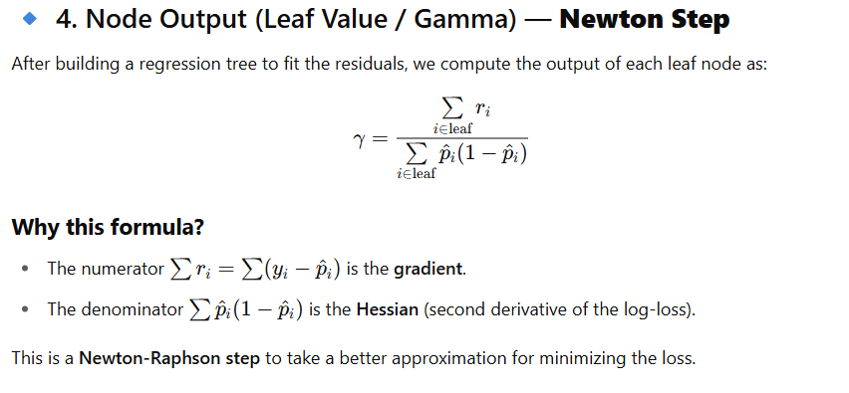
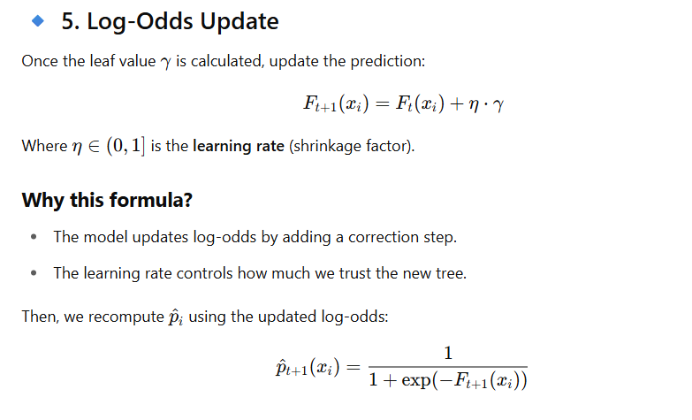
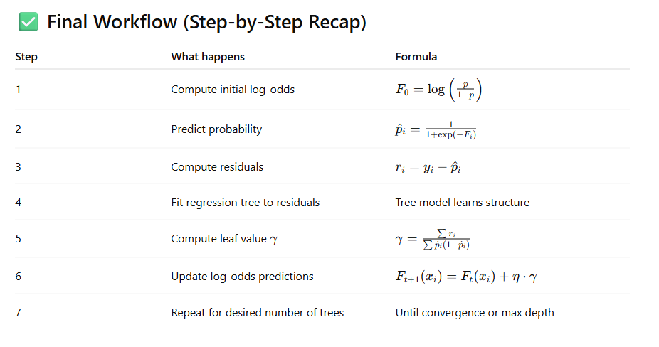

https://www.digitalocean.com/community/tutorials/gradient-boosting-for-classification

We will use log loss function in ‘Gradient boosting classification’ instead of MSE as used in ‘Gradient boosting regressor’ while algorithm will be same given below
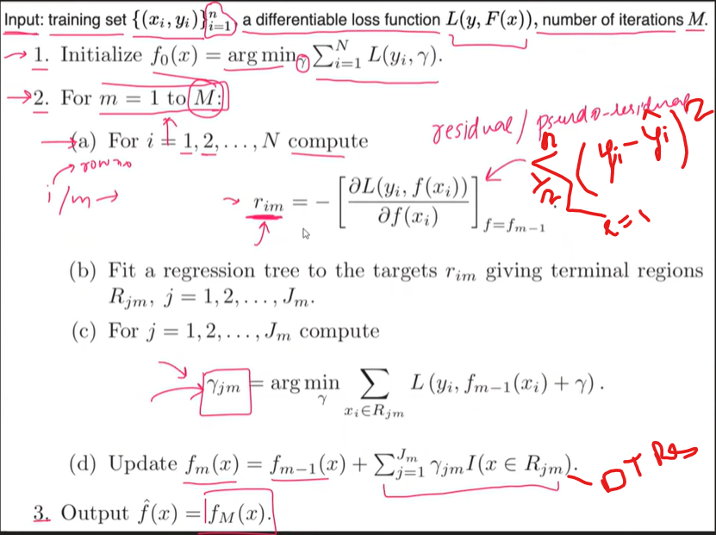

In regressor problem F0 simple model was calculated throw mean but here as target data will be as (1,0) so there so no meaning of calculating means instead we will calculate as below
F0 = log (odds) = log ((number of ones)/number of zeros)
As before residual r1 was calculated using (target y – F0) but as in classification y will be zero and ones while other size F0 is calculated on probability so we can’t do the same here
We will follow other formula as
R = ( 1/(1+pow(e,-log(odds) ) ) )

Gradient Boost has a range between 8 leaves to 32 leaves.
Because of the limit on leaves, one leaf can have multiple values. Predictions are in terms of log(odds), but these leave are derived from probability, which causes disparity. So, we can’t just add the single leaf we got earlier and this tree to get new predictions because they’re derived from different sources. We have to use some kind of transformation. The most common form of transformation used in Gradient Boost for Classification is :

The numerator in this equation is the sum of residuals in that particular leaf.
The denominator is sum of (previous prediction probability for each residual ) * (1 - same previous prediction probability).

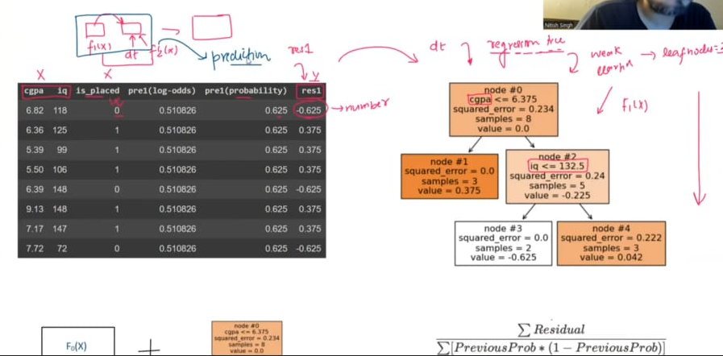

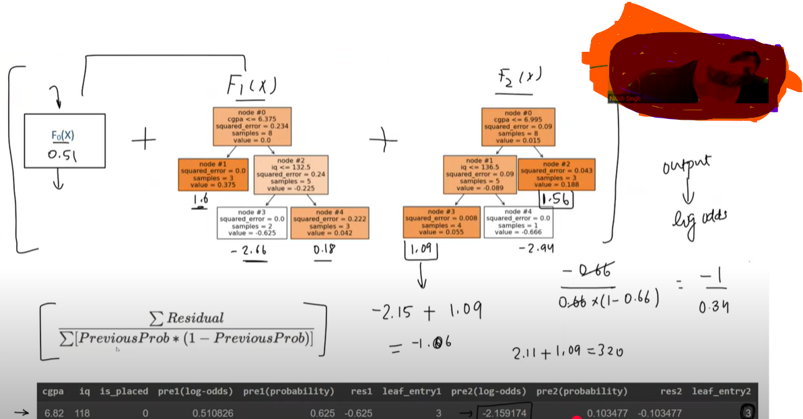

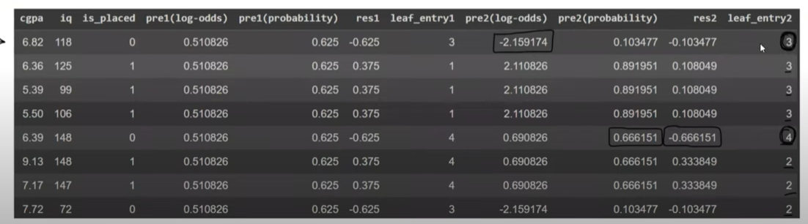

intuition behind Gradient Boosting for Classification, step-by-step with all formulas, and then walk through an example with realistic sample data and all outputs for a 3-tree binary classification model.

🎯 Goal
Train a binary classifier (e.g., predict if a house sells above 300K: Yes or No) using Gradient Boosting Classification, which works by:
- Minimizing log-loss,
- Fitting decision trees to pseudo-residuals (gradients of the loss),
- And updating the model in function space.

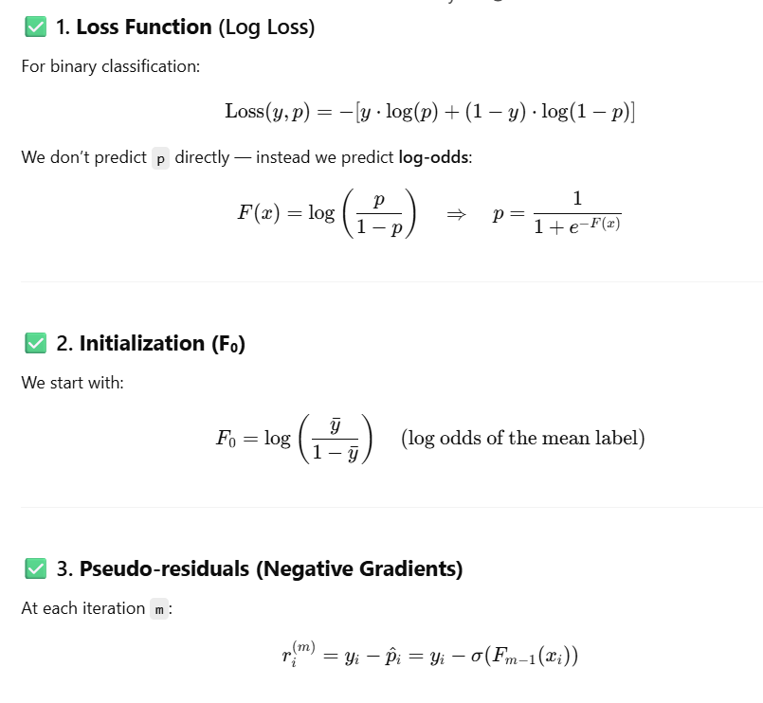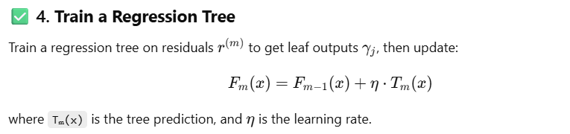

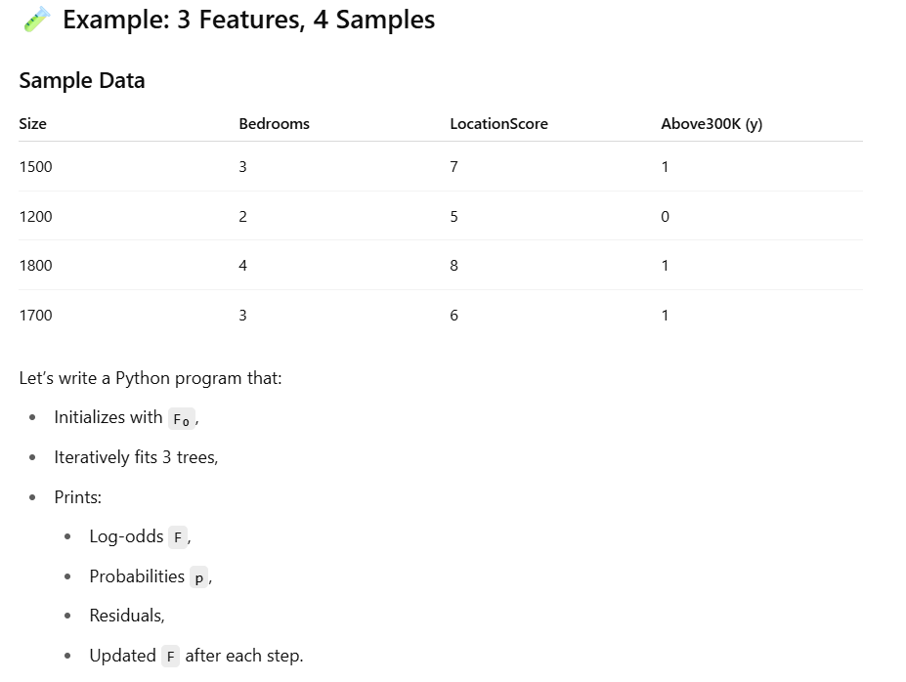
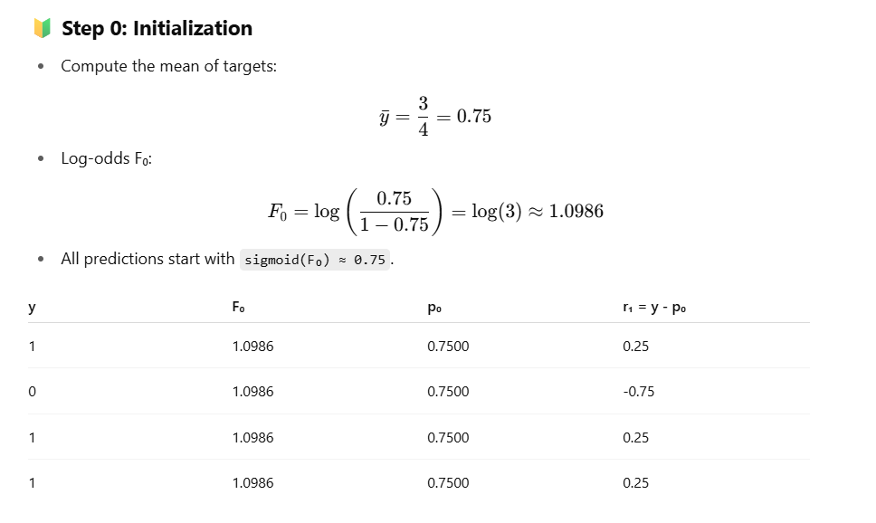
Here Po is calculated using sigmoid function as below

Sigmoid = 1/ (1+ e(-F(x)))

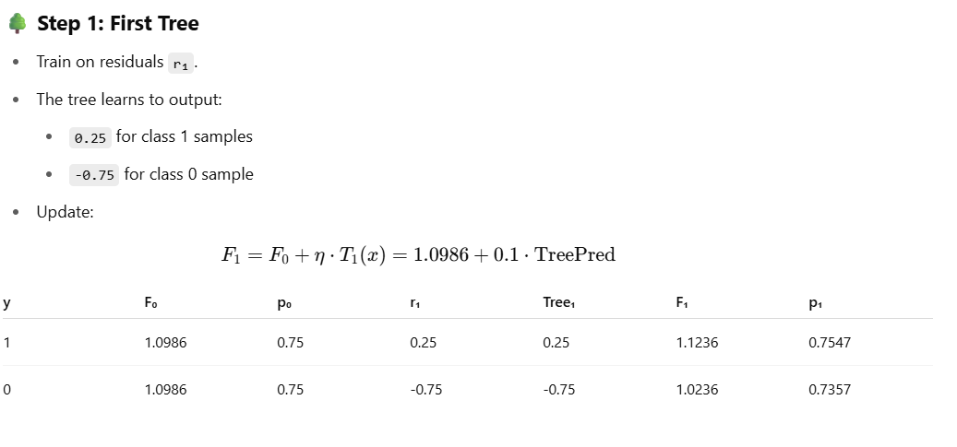
Here TreePred is the Prediction made by Tree 1 for input sample x as the node may have multiple row values in one due to tree height limit so it can’t nbe the same tree value as were in regression so need to be calculated using below formula-


This above is same as below mathematical formula
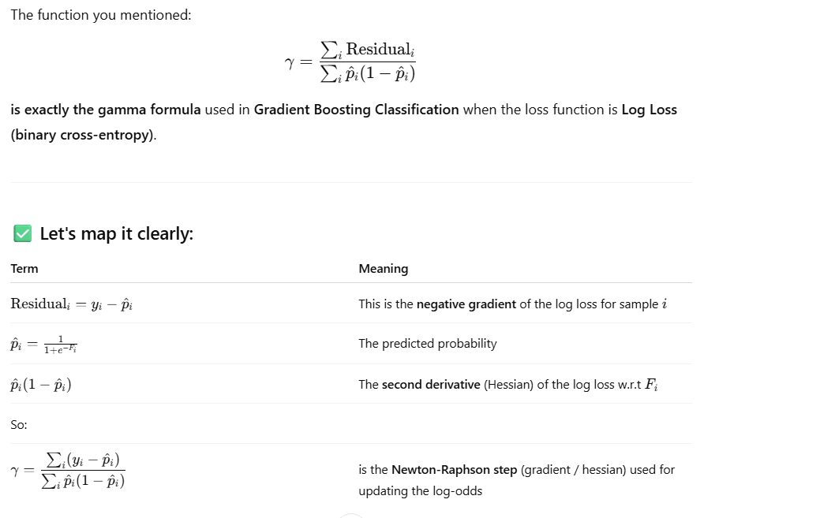

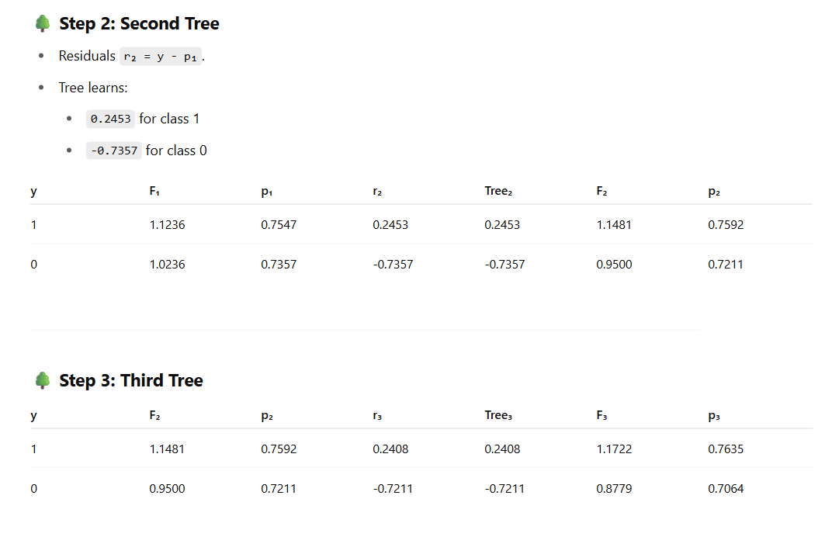
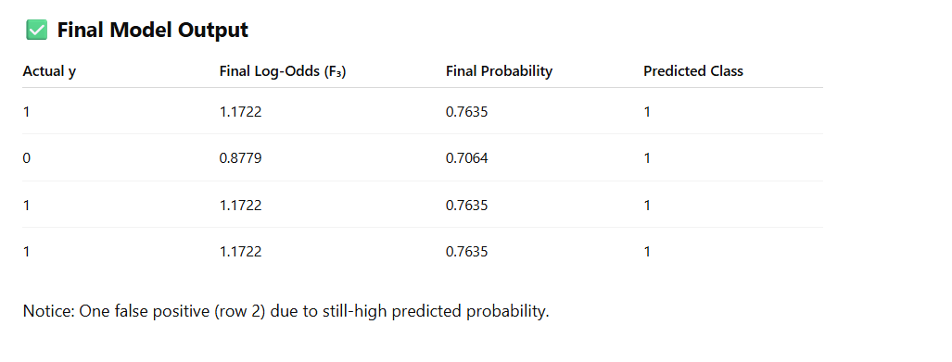

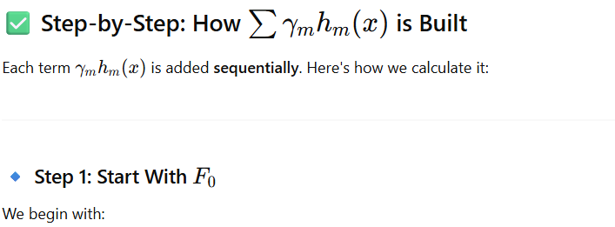

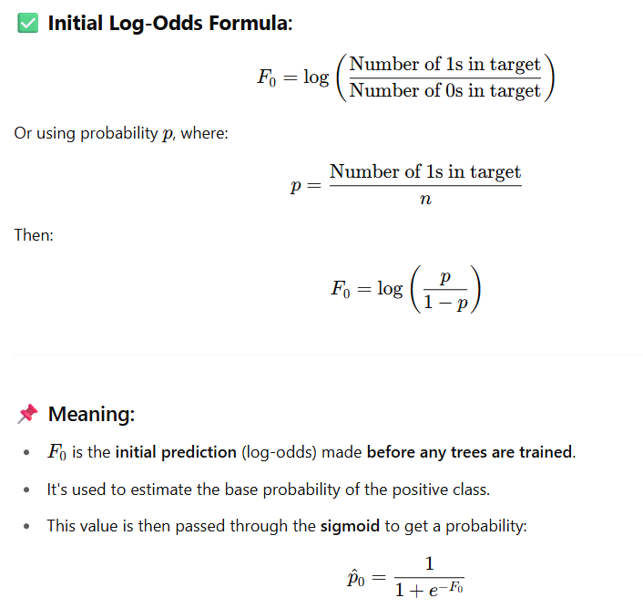

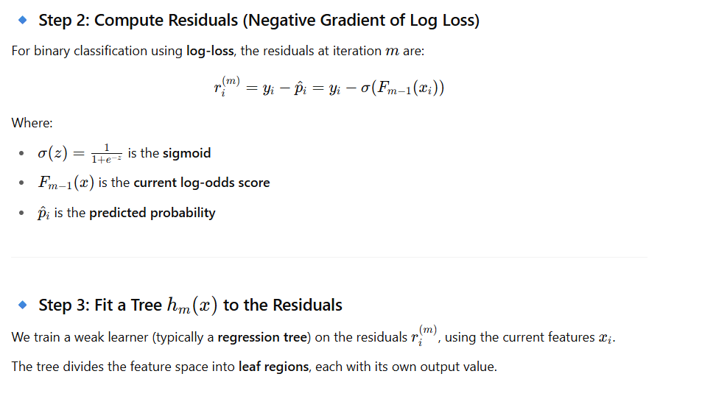

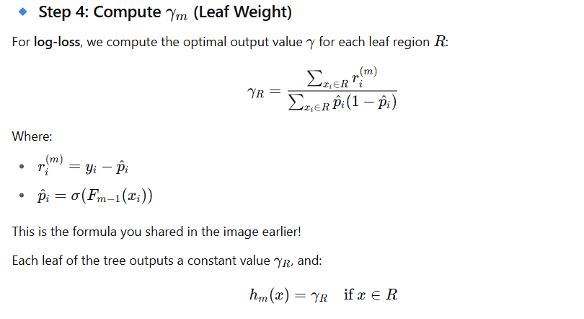
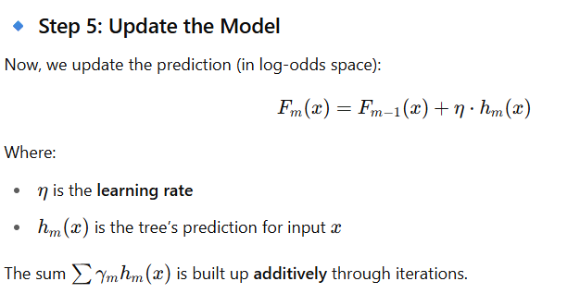

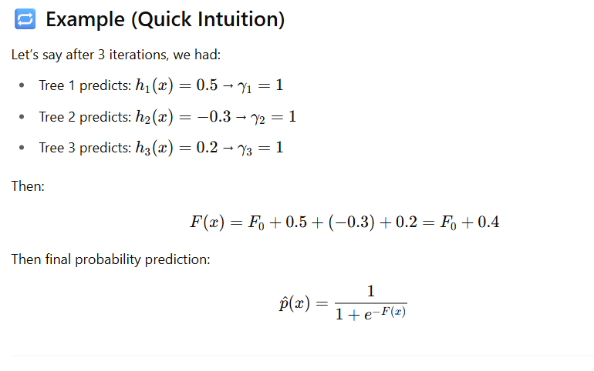
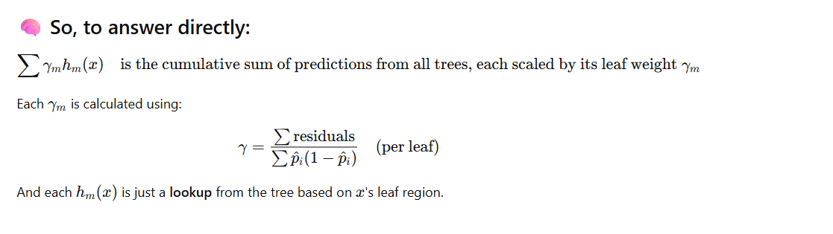

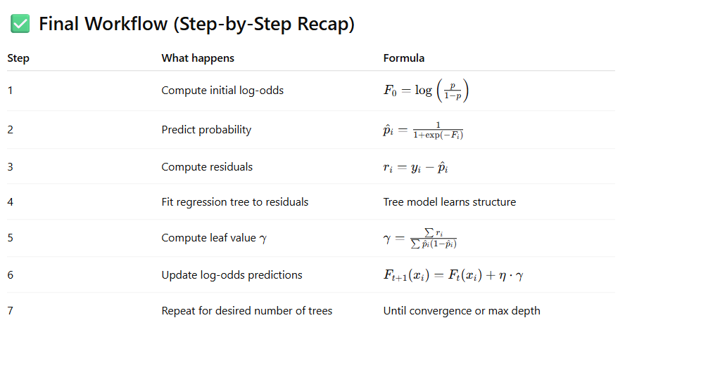

🔢 Dataset Used
plaintext
CopyEdit
Index | Feature1 | Feature2 | Feature3 | Feature4 | y
------------------------------------------------------
0 | 2.5 | 1.2 | 3.1 | 0.5 | 1
1 | 1.0 | 0.7 | 2.2 | 1.0 | 0
2 | 3.6 | 2.5 | 4.0 | 0.3 | 1
3 | 4.0 | 3.6 | 5.1 | 0.2 | 1
4 | 0.5 | 0.3 | 1.0 | 1.2 | 0

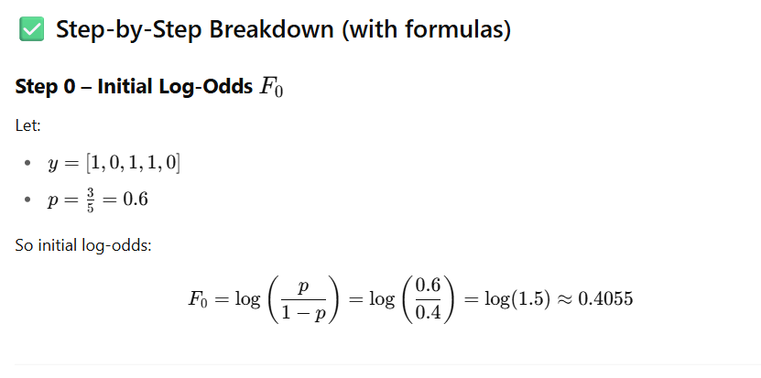

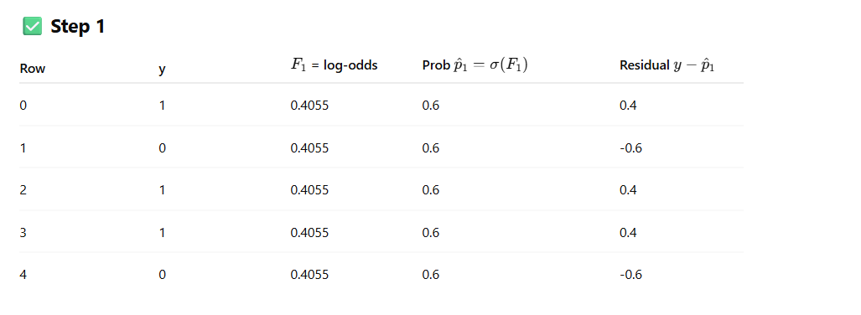
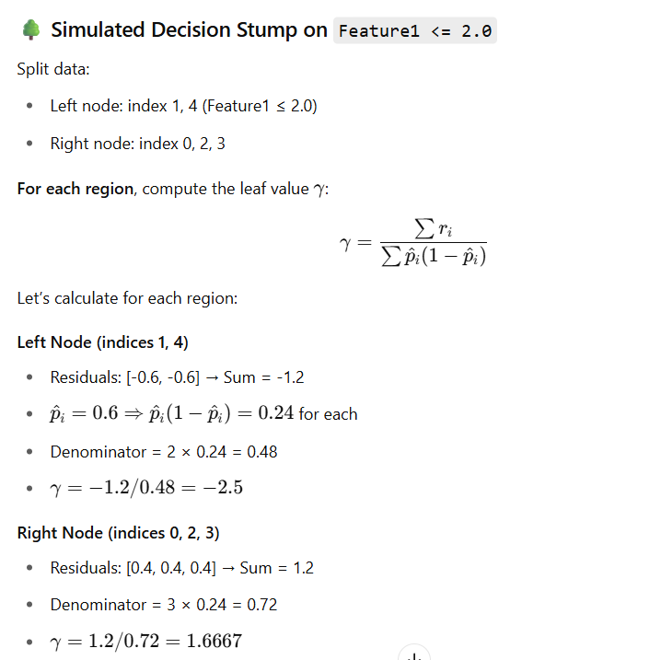
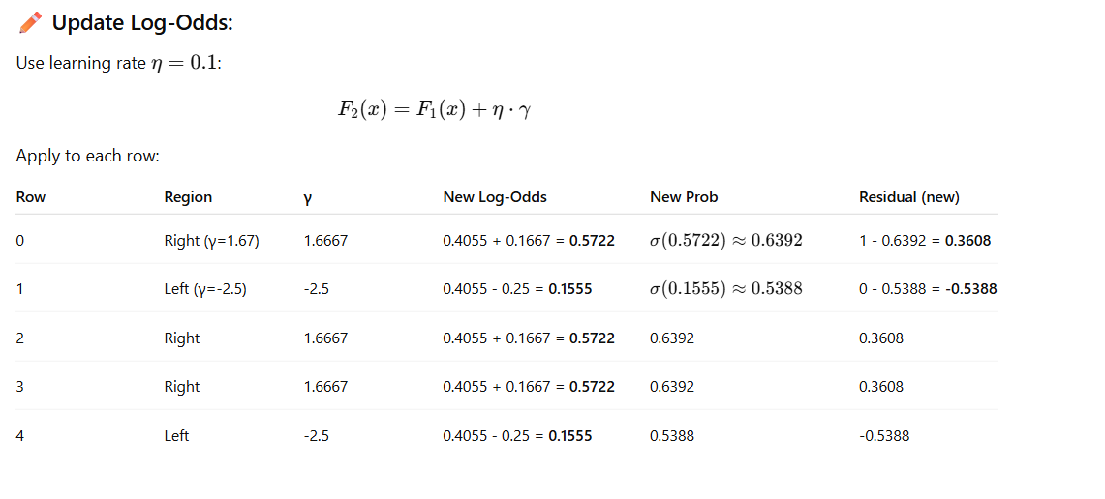
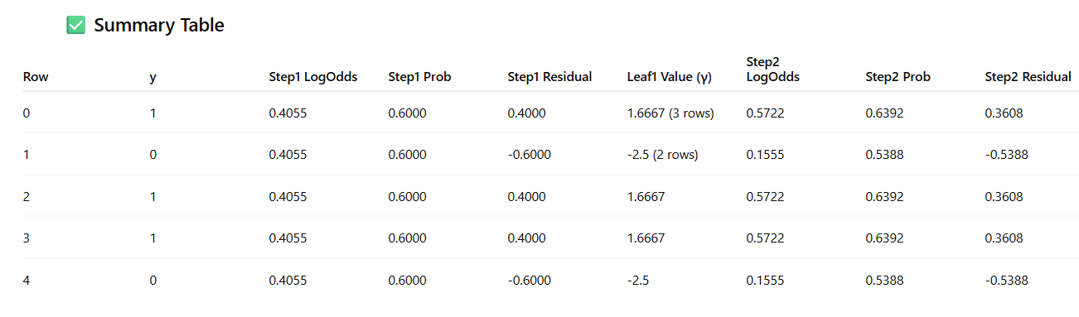

import numpy as np
import pandas as pd
from sklearn.tree import DecisionTreeRegressor

# Sample binary classification dataset
df = pd.DataFrame({
'Feature1': [2, 1, 3, 4, 2, 1],
'Feature2': [1, 2, 1, 3, 2, 1],
'Feature3': [0, 1, 0, 1, 0, 1],
'Target': [0, 1, 0, 1, 0, 1]
})

# Step 1: Initial log-odds F0
n_pos = df['Target'].sum()
n_neg = len(df) - n_pos
F0 = np.log(n_pos / n_neg) # initial log odds
df['F'] = F0 # initial log-odds prediction

# Learning rate
lr = 0.1

# Initialize tracking
all_rounds = []

# Step 2: Compute initial probabilities and residuals
df['P'] = 1 / (1 + np.exp(-df['F']))
df['Residual'] = df['Target'] - df['P']

# Perform 3 rounds of boosting
for round_num in range(1, 4):
# Step 3: Train weak learner on residuals
features = ['Feature1', 'Feature2', 'Feature3']
tree = DecisionTreeRegressor(max_depth=1)
tree.fit(df[features], df['Residual'])

# Step 4: Apply tree to assign leaf nodes
leaf_ids = tree.apply(df[features])
df[f'Leaf{round_num}'] = leaf_ids

# Step 5: Calculate gamma for each leaf
gammas = {}
for leaf in np.unique(leaf_ids):
indices = df[f'Leaf{round_num}'] == leaf
residuals = df.loc[indices, 'Residual']
probs = df.loc[indices, 'P']
numerator = residuals.sum()
denominator = (probs * (1 - probs)).sum()
gamma = numerator / denominator if denominator != 0 else 0
gammas[leaf] = gamma

# Step 6: Apply gamma and update predictions
df[f'Gamma{round_num}'] = df[f'Leaf{round_num}'].map(gammas)
df[f'F{round_num}'] = df['F'] + lr * df[f'Gamma{round_num}']
df['F'] = df[f'F{round_num}'] # update log-odds
df['P'] = 1 / (1 + np.exp(-df['F'])) # update probability
df['Residual'] = df['Target'] - df['P'] # update residuals

# Save results for this round
round_df = df[[
'Feature1', 'Feature2', 'Feature3', 'Target',
f'F{round_num}', 'P', 'Residual',
f'Leaf{round_num}', f'Gamma{round_num}'
]].copy().rename(columns={
f'F{round_num}': 'Log-Odds (F)',
'P': 'Probability (P)',
'Residual': 'Residual',
f'Leaf{round_num}': 'Leaf ID',
f'Gamma{round_num}': 'Leaf Output (γ)'
})
round_df.insert(0, 'Round', round_num)
all_rounds.append(round_df)

# Combine results
results_df = pd.concat(all_rounds, ignore_index=True)
results_df = results_df.round(4)
results_df.head(18) # Display full results for all rounds

1. What is Gradient Boosting?
Answer:
Gradient Boosting is an ensemble learning technique that builds models sequentially, where each new model tries to correct the errors made by the previous ones. It uses gradient descent to minimize a loss function by fitting new learners (typically decision trees) to the negative gradient of the loss.

2. How is Gradient Boosting different from AdaBoost?
Answer:
- Error handling:
  - AdaBoost reweights the training samples to focus on misclassified ones.
  - Gradient Boosting fits new learners to the residual errors (or negative gradients).
- Loss function:
  - AdaBoost uses an exponential loss.
  - Gradient Boosting allows any differentiable loss (e.g., MSE, log-loss, MAE).
- Optimization:
  - AdaBoost is a specific boosting method.
  - Gradient Boosting is a more general optimization framework.

3. How does Gradient Boosting work step-by-step?
Answer:
Let’s say we have N=1200 records and we’re doing regression.
- Initialize model with a constant value (e.g., mean for regression).
- Compute residuals: Find the difference between actual and predicted values.
- Fit a weak learner (e.g., decision tree) to the residuals.
- Make predictions from the weak learner.
- Update the model by adding the predictions from the weak learner multiplied by a learning rate.
- Repeat steps 2–5 for M iterations (trees) until stopping criteria is met.

4. What is the role of the learning rate in Gradient Boosting?
Answer:
The learning rate (shrinkage) controls how much each new tree contributes to the model.
- Low learning rate → Slower learning, requires more trees, usually improves generalization.
- High learning rate → Faster learning, risk of overfitting.

5. What are common loss functions used in Gradient Boosting?
Answer:
- Regression: Mean Squared Error (MSE), Mean Absolute Error (MAE), Huber loss.
- Classification: Log-loss (binary/multi-class), exponential loss.
- Ranking: Pairwise loss.

6. How is overfitting handled in Gradient Boosting?
Answer:
- Use early stopping.
- Lower the learning rate and increase the number of trees.
- Reduce max_depth of trees.
- Use subsample (row sampling) and colsample_bytree (feature sampling).

7. What is the difference between Gradient Boosting, XGBoost, LightGBM, and CatBoost?
Answer:
- Gradient Boosting: Base algorithm, sequential trees.
- XGBoost: Optimized, parallelized, regularized GBM.
- LightGBM: Histogram-based, faster on large datasets, supports leaf-wise growth.
- CatBoost: Special handling for categorical features, symmetric tree building.

8. What is subsampling in Gradient Boosting?
Answer:
Instead of using the full dataset to train each tree, a random subset of data is used.
- Helps prevent overfitting.
- Speeds up training.
- Introduces randomness (similar to bagging).

9. What is the bias-variance tradeoff in Gradient Boosting?
Answer:
- Adding more trees reduces bias but increases variance.
- Smaller learning rates reduce variance but may increase bias unless more trees are added.

10. How do you tune hyperparameters in Gradient Boosting?
Answer:
Key hyperparameters:
- n_estimators (number of trees)
- learning_rate (step size)
- max_depth (tree depth)
- min_samples_split, min_samples_leaf (minimum samples per split/leaf)
- subsample (row sampling)
- colsample_bytree (feature sampling)
Use GridSearchCV or RandomizedSearchCV with cross-validation.

11. Can Gradient Boosting handle missing values?
Answer:
Basic Gradient Boosting implementations can’t handle missing values directly, but libraries like XGBoost, LightGBM, and CatBoost have built-in handling.

12. What are the disadvantages of Gradient Boosting?
Answer:
- Computationally expensive (sequential learning).
- Sensitive to hyperparameters.
- Can overfit if not regularized.
- Slower than bagging methods like Random Forest for very large datasets.

13. When would you choose Gradient Boosting over Random Forest?
Answer:
- When model accuracy is more important than training speed.
- When you can tune hyperparameters carefully.
- When the problem benefits from minimizing a specific differentiable loss function.

