DBSCAN clustering

URL: https://www.analyticsvidhya.com/blog/2020/09/how-dbscan-clustering-works/
https://www.naftaliharris.com/blog/visualizing-dbscan-clustering/
https://colab.research.google.com/drive/1yZ0bg0cK6X84u6rawgRgoPzlgAmhVy2E?usp=sharing

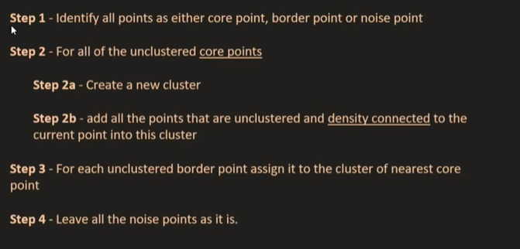

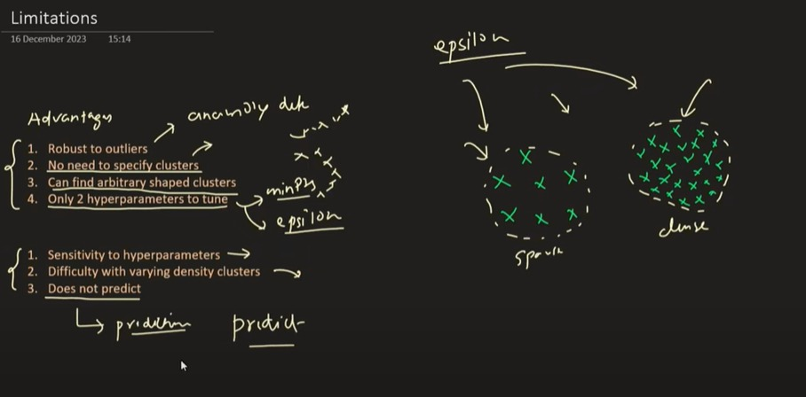

import numpy as np
import matplotlib.pyplot as plt
from collections import deque
from enum import Enum

# --------------------------
# ENUM for Point Type Labels
# --------------------------
class PointType(Enum):
UNVISITED = 0
CORE = 1
BORDER = 2
NOISE = 3

# --------------------------
# Generate Sample Data
# --------------------------
from sklearn.datasets import make_moons
X, _ = make_moons(n_samples=300, noise=0.05, random_state=42)

# --------------------------
# DBSCAN Hyperparameters
# --------------------------
eps = 0.2
min_pts = 5

# --------------------------
# Initialize data structures
# --------------------------
n_points = len(X)
point_types = [PointType.UNVISITED] * n_points # Track type of each point
cluster_labels = [-1] * n_points # Track cluster assignment
cluster_id = 0 # Start from cluster 0

# --------------------------
# Region query: find neighbors within eps
# --------------------------
def region_query(X, idx, eps):
neighbors = []
for i in range(len(X)):
if np.linalg.norm(X[idx] - X[i]) <= eps:
neighbors.append(i)
return neighbors

# --------------------------
# Expand cluster function
# --------------------------
def expand_cluster(X, idx, neighbors, cluster_id, eps, min_pts):
cluster_labels[idx] = cluster_id
point_types[idx] = PointType.CORE

queue = deque(neighbors)

while queue:
current_idx = queue.popleft()

if point_types[current_idx] == PointType.UNVISITED:
current_neighbors = region_query(X, current_idx, eps)

if len(current_neighbors) >= min_pts:
point_types[current_idx] = PointType.CORE
queue.extend(current_neighbors)
else:
point_types[current_idx] = PointType.BORDER

if cluster_labels[current_idx] == -1:
cluster_labels[current_idx] = cluster_id

# --------------------------
# DBSCAN Main Loop
# --------------------------
for i in range(n_points):
if point_types[i] != PointType.UNVISITED:
continue

neighbors = region_query(X, i, eps)

if len(neighbors) < min_pts:
point_types[i] = PointType.NOISE
else:
expand_cluster(X, i, neighbors, cluster_id, eps, min_pts)
cluster_id += 1

# --------------------------
# Visualization
# --------------------------
plt.figure(figsize=(10, 6))

# Define colors
colors = plt.cm.tab10(np.linspace(0, 1, cluster_id))

for i in range(n_points):
x, y = X[i]
label = cluster_labels[i]
ptype = point_types[i]

if ptype == PointType.NOISE:
plt.scatter(x, y, color='black', marker='x', label='Noise' if 'Noise' not in plt.gca().get_legend_handles_labels()[1] else "")
elif ptype == PointType.BORDER:
plt.scatter(x, y, color=colors[label], marker='s', label=f'Cluster {label} (Border)' if f'Cluster {label} (Border)' not in plt.gca().get_legend_handles_labels()[1] else "")
elif ptype == PointType.CORE:
plt.scatter(x, y, color=colors[label], marker='o', label=f'Cluster {label} (Core)' if f'Cluster {label} (Core)' not in plt.gca().get_legend_handles_labels()[1] else "")

plt.title("Manual DBSCAN with Core, Border, Noise Points")
plt.xlabel("X")
plt.ylabel("Y")
plt.legend()
plt.grid(True)
plt.show()

What is Epsilon (ε)?
Epsilon (ε) is a distance threshold that defines the neighborhood radius around a data point.
- It tells DBSCAN how close points need to be to each other to be considered part of the same cluster.
- In simpler terms: "How far should we look around a point to count how many neighbors it has?"

🔍 How Epsilon is Used in DBSCAN
DBSCAN uses ε in combination with min_samples (minimum number of points required to form a cluster):
Based on ε, DBSCAN classifies each point as:
Type | Condition
Core Point | Has at least min_samples points (including itself) within ε-radius.
Border Point | Has fewer than min_samples within ε, but is in the neighborhood of a core point.
Noise Point | Not a core point and not in the ε-neighborhood of any core point.

📈 Example
Assume:
- ε = 0.5
- min_samples = 4
For each point:
- Draw a circle of radius 0.5.
- Count how many points lie within that circle (including the point itself).
- If count ≥ 4 → core point.
- If not, but it lies within the circle of a core point → border point.
- Otherwise → noise (outlier).

✅ Choosing the Right Epsilon
Too small:
- Many points labeled as noise.
- May not find any meaningful clusters.
Too large:
- Different clusters may merge into one.
- Less accurate separation.
🔧 Tip:
Use a k-distance plot (plot distance to k-th nearest neighbor) to visually determine a good ε:
- The "elbow" in the graph suggests a suitable value for ε.

🧠 Summary
Parameter | Meaning | Role in DBSCAN
ε | Radius of neighborhood | Defines locality to find dense regions
Affects | Core point identification, cluster shape, sensitivity to noise

Would you like the code to generate a k-distance plot to help pick the right epsilon?
You said:
what is density based clustering, DBSCAN full form, min point inside circle,dencity hyperplane
ChatGPT said:
Let’s break down everything clearly:

📌 What is Density-Based Clustering?
Density-based clustering is a technique that groups data points based on regions of high density, separating them from regions of low density.
- Unlike K-Means (which assumes spherical clusters), density-based methods can find:
  - Arbitrary-shaped clusters (like spirals or curves)
  - Noise or outliers (points in low-density areas)

📘 What is the Full Form of DBSCAN?
DBSCAN = Density-Based Spatial Clustering of Applications with Noise
It's a popular density-based clustering algorithm that:
- Groups together points that are closely packed
- Marks points in low-density areas as noise

🔍 What is minPts in DBSCAN?
minPts (minimum points) is a hyperparameter that defines:
The minimum number of points (including the center point) that must lie within a point's ε-neighborhood (a circle of radius ε), for that point to be considered a core point.
- If a point has ≥ minPts in its ε-radius → it's a core point.
- If a point has < minPts, it may be:
  - A border point (near a core point)
  - Or noise (if not near any core)

📏 What is the Density Hyperplane?
While not an official DBSCAN term, "density hyperplane" typically refers to:
A boundary or decision surface that separates high-density regions (clusters) from low-density areas (noise/outliers) in high-dimensional space.
- In DBSCAN:
  - The algorithm does not explicitly construct a hyperplane, unlike SVM.
  - But you can think of ε as defining a "density boundary" for forming clusters.

🧠 Summary Table
Term | Explanation
DBSCAN | Density-Based Spatial Clustering of Applications with Noise
Density-based | Clusters formed based on areas with many nearby points
ε (epsilon) | Radius of neighborhood (how far to look around a point)
minPts | Minimum number of points required inside ε to form a dense region
Core Point | Point with ≥ minPts in its ε-neighborhood
Border Point | Has < minPts but lies near a core point
Noise Point | Lies in low-density region; not part of any cluster
Density Hyperplane | Conceptual surface dividing dense clusters and sparse regions (not explicitly used in DBSCAN)

Would you like to visualize DBSCAN with a real 2D example and animation?
You said:
what are core point, bordor, noise, Density connected points in DBSCAN
ChatGPT said:
Great! Let’s go deep into the core concepts of DBSCAN clustering. These definitions form the backbone of how DBSCAN identifies and groups clusters.

📘 Key Concepts in DBSCAN
1. Core Point
- A data point is a core point if:
  - At least minPts points (including itself) are within its ε (epsilon) neighborhood.
- This means the point lies in a dense region.
✅ Example: If ε = 0.5 and minPts = 4, and a point has 4 or more points within 0.5 radius, it's a core point.

2. Border Point
- A border point is:
  - Not a core point (i.e., fewer than minPts in its ε-neighborhood)
  - But it lies within the ε-neighborhood of a core point.
- It is close enough to be part of the cluster but not dense enough to be a core itself.

3. Noise (Outlier)
- A point is labeled noise (or outlier) if:
  - It is not a core point, and
  - It does not lie within the ε-neighborhood of any core point.
❌ These are isolated points in sparse regions.

4. Directly Density-Reachable
- A point p is directly density-reachable from point q if:
  - q is a core point, and
  - p lies within ε of q.
Only core points can have other points directly density-reachable from them.

5. Density-Reachable
- A point p is density-reachable from q if:
  - There exists a chain of points: q → p₁ → p₂ → … → p, such that each is directly density-reachable from the previous.
- The chain starts from a core point.
Note: This relationship is not symmetric.

6. Density-Connected
- Two points p and q are density-connected if:
  - There exists a point o such that both p and q are density-reachable from o.
- This relation is symmetric, unlike density-reachability.

✅ Summary Table
Term | Meaning
Core Point | ≥ minPts points within ε
Border Point | < minPts, but near a core point
Noise Point | Not a core or border point
Directly Density-Reachable | p is within ε of core q
Density-Reachable | Chain of directly density-reachable steps
Density-Connected | Two points share a common reachable core point

🔁 Example Diagram (textual):
less
CopyEdit
[Core]——[Core]——[Border]
|
[Noise] [Border]

Would you like a plotted visualization of these concepts with real 2D points to see them in action?
You said:
why we require DBSCAN while i already had k-Means, hyperparameters of DBSCAN, advantage and limitations in DBSCAN
ChatGPT said:
Great question! Let's clarify why DBSCAN is needed, its hyperparameters, and its advantages vs limitations — especially compared to K-Means.

🤔 Why Use DBSCAN When K-Means Exists?
Feature | K-Means | DBSCAN
Assumes cluster shape | Spherical (circular) | Arbitrary (any shape)
Requires cluster count (K) | Yes | ❌ No need
Handles noise/outliers | Poorly | ✅ Very well
Cluster density | Assumes similar size/density | Can handle varying densities
Sensitive to initial seed | ✅ Yes | ❌ No
Works with non-globular data | ❌ No | ✅ Yes
✅ Use DBSCAN When:
- You don’t know K ahead of time.
- You expect irregular or non-circular shapes.
- Your data has noise or outliers you want to detect.
- Clusters have different densities.

⚙️ Hyperparameters of DBSCAN
- eps (ε):
  - Maximum distance to consider neighbors.
  - Radius of the neighborhood around a point.
- min_samples:
  - Minimum number of points (including the point itself) required in ε-neighborhood to qualify as a core point.
- (Optional) metric:
  - Distance metric used (e.g., 'euclidean', 'manhattan', etc.)
python
CopyEdit
from sklearn.cluster import DBSCAN

model = DBSCAN(eps=0.5, min_samples=5, metric='euclidean')

✅ Advantages of DBSCAN
Advantage | Description
🚫 No need to specify K | Automatically detects number of clusters
🤖 Detects noise | Classifies low-density points as outliers
🔄 Arbitrary shapes | Finds clusters of non-spherical form
📉 Not sensitive to initialization | Unlike K-Means which depends on random centroids
🔍 Works well for spatial data | Ideal for GPS, image segmentation, etc.

❌ Limitations of DBSCAN
Limitation | Description
🔩 Sensitive to eps and min_samples | Small changes may affect results heavily
🧩 Fails with varying density | Cannot detect clusters with very different densities
🚀 Slow on high-dimensional data | Distance calculation is expensive in high dimensions
💥 Can't handle very large datasets easily | Less scalable than K-Means (no mini-batch version)
📊 Hard to tune | No clear rule for choosing best eps and min_samples (often needs a k-distance plot)

🔁 Summary
Point | K-Means | DBSCAN
Needs K? | ✅ Yes | ❌ No
Handles noise? | ❌ No | ✅ Yes
Works with arbitrary shapes? | ❌ No | ✅ Yes
Hyperparameters | n_clusters, init, max_iter, etc. | eps, min_samples, metric

Would you like a side-by-side plot showing how K-Means and DBSCAN behave differently on the same dataset?
2/2
You said:
uses of DBSCAN if we can't do predictions for new point, what is dendograph,outlier vs noise
ChatGPT said:
Great set of questions! Let’s address each one thoroughly and clearly.

🔍 1. Uses of DBSCAN if We Can’t Do Predictions on New Points?
You're right that DBSCAN is not inherently designed for prediction (classification) like K-Means or supervised learning algorithms.
However, DBSCAN is extremely useful for:
Use Case | Explanation
Exploratory Data Analysis (EDA) | Helps to discover hidden patterns and groupings in unlabelled data.
Outlier Detection | Classifies low-density points as noise, ideal for fraud detection, anomaly detection, etc.
Spatial Clustering | Works well for geospatial data, e.g., clustering regions based on GPS coordinates.
Preprocessing | Can be used to filter noise or group similar data before applying supervised learning.
Image Segmentation | Identifies dense pixel areas (useful in medical or satellite images).
🔁 For New Points?
- DBSCAN doesn’t learn a model → it doesn’t generalize like a classifier.
- For prediction:
  - Use HDBSCAN, which supports soft clustering and probabilistic assignment.
  - Or treat DBSCAN as preprocessing → cluster first, then train a classifier on labeled clusters

