MLP Memoization | Complete Deep Learning Playlist
Unraveling the Basic Mechanics of Deep Learning (MLP): A Journey with an Athlete Learning a Sport

Introduction
In the realm of artificial intelligence, the Multi-Layered Perceptron (MLP) has been a cornerstone of deep learning, enabling the mastery of complex tasks. Among its most crucial components are forward propagation and backward propagation. However, despite its effectiveness, the MLP encounters challenges such as vanishing and exploding gradients. In this blog, we will explore these concepts using an example of an athlete learning a sport, shedding light on how deep learning models mimic the human learning process.
1. The Multi-Layered Perceptron (MLP)
The Multi-Layered Perceptron is a fundamental type of artificial neural network (ANN). It consists of input, hidden, and output layers, and its primary goal is to learn patterns and representations from input data to produce accurate output predictions. Each layer contains nodes (neurons) connected to nodes in the adjacent layers through weighted connections.
Press enter or click to view image in full size
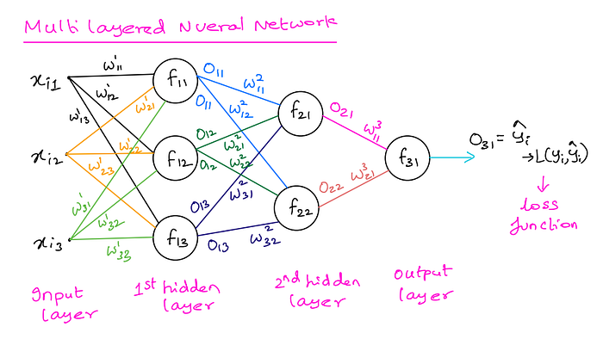
Press enter or click to view image in full size
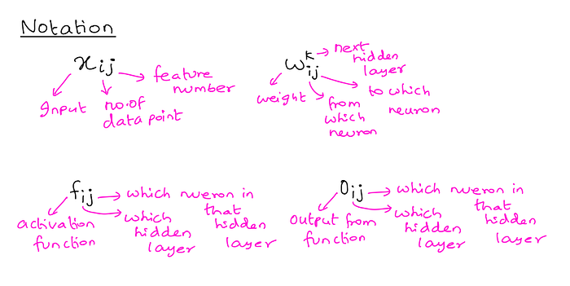
Press enter or click to view image in full size
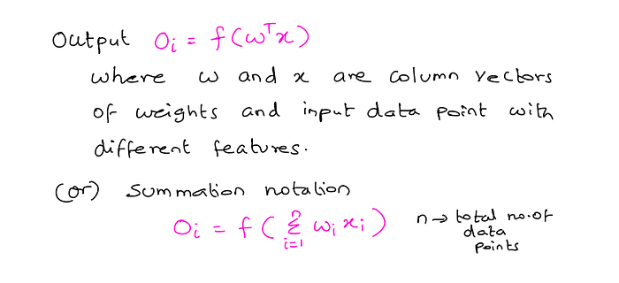
2. Forward Propagation
Forward propagation is the process of passing input data through the MLP to generate an output. It begins by feeding the input data into the input layer, which then calculates the weighted sum of the input data and passes it through an activation function. This process is repeated in each subsequent hidden layer until the final output layer produces the model’s prediction.
Imagine our athlete is learning to shoot a basketball. In this case, the input data could include the player’s stance, arm position, and the angle of the shot. Forward propagation will then compute these inputs to generate an output, which could be the predicted success of the shot.
Press enter or click to view image in full size
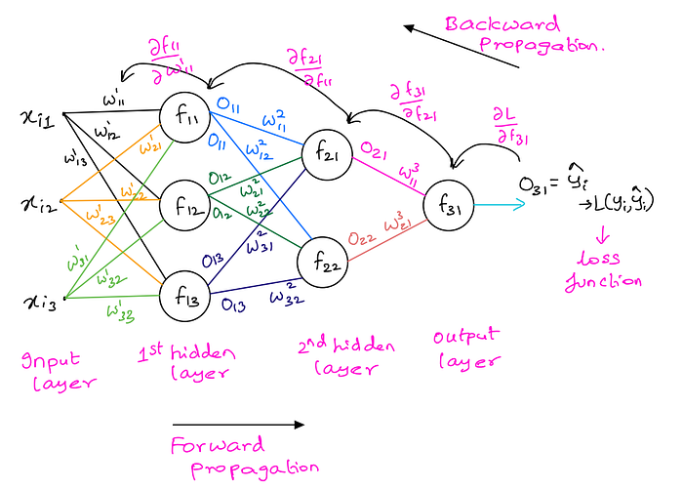
Press enter or click to view image in full size
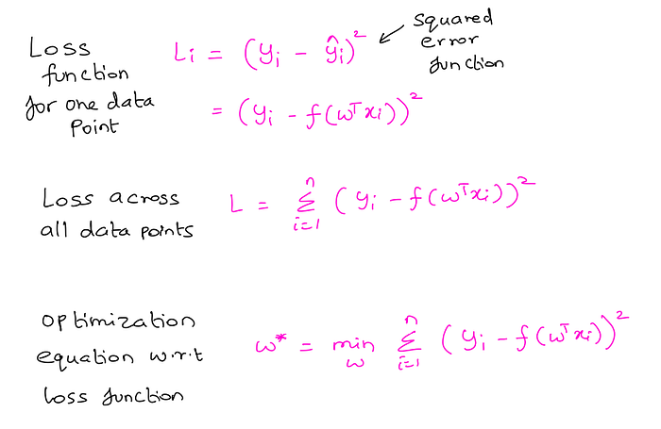
3. Backward Propagation (Backpropagation)
Backward propagation is the key to training the MLP. Once the forward propagation has produced an output, we compare it to the actual target value (e.g., whether the shot was successful or not). The objective is to minimize the difference between the predicted output and the true target.
Through the use of a loss function (e.g., Squared Error), the model calculates the error between the predicted output and the target value. Backpropagation then works by propagating this error backward through the network, adjusting the weights and biases of each neuron to minimize the error in subsequent iterations.
Our athlete receives feedback after each shot, indicating how far their shot was from the target. Backpropagation simulates this process, tweaking their stance, arm position, and angle of the shot to gradually improve their accuracy over time.
Basic steps to train MLP:
1) Initialize all the weights.
2) We do Forward Propagation with the weights and inputs and get the outputs and finally calculate the loss function w.r.t original and predicted output.
3) We do Backward Propagation by using Chain Rule and Memoization to get the Grad of loss function (Partial derivative).
4) Once we have the Grad we will use weight update rule to get updated weights.

5) Continue with steps 2 to 4 until the product of Learning rate and the Grad of loss is almost equal to zero, thereby the updated weight is almost equal to old weight. This is convergence and we can stop.
6) These weights are final and the training process is done. We can use the final model on unseen test data.
So in the sense the athlete would start throwing the ball in to the basket from any random place in the court. Depending on whether he makes the shot or misses the shot he will receive the feedback. Based on the feedback he would adjust his position, stance, arm position so on and keep making the shots until he find the ideal spot.
Issue with MLP during 1980’s and 1990’s: During this era they mainly used to use only two activation functions called Sigmoid function and Tanh function.
Press enter or click to view image in full size
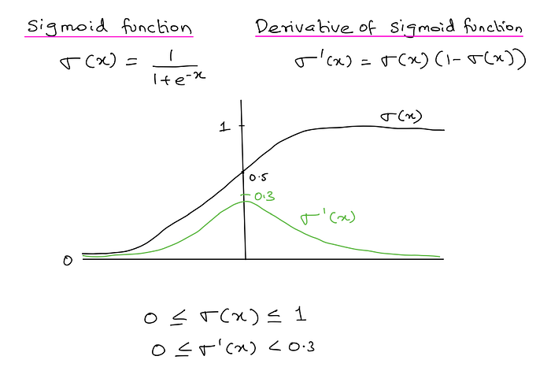
Press enter or click to view image in full size
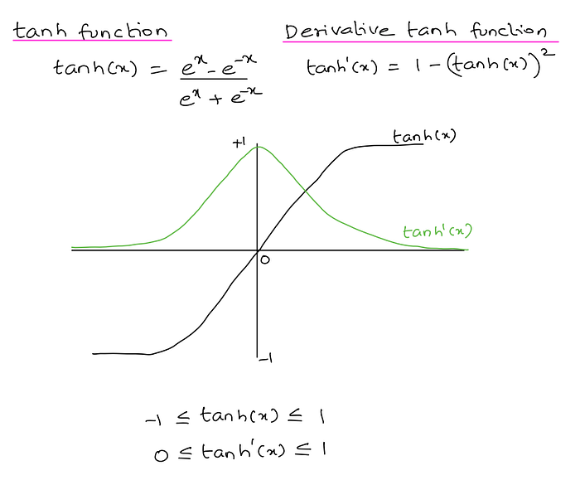
As seen above both these functions derivatives were less than 1. This posed some issues when more hidden layers were introduced in to the neural network. So deep neural networks had major issues like: Vanishing Gradient (high probability of occurring) and Exploding Gradient (less probability of occurring but still posed some concerns).
4. Vanishing Gradient
Vanishing gradient is a challenge encountered in deep neural networks, particularly during backpropagation. It occurs when the gradients of the loss function become extremely small as they are propagated backward through the network. Consequently, the weights of early layers are updated at an exceedingly slow pace, inhibiting learning.
Using our athlete analogy, vanishing gradient could manifest when the feedback provided to improve their shot is too subtle or vague. As a result, they struggle to make meaningful adjustments, and their shooting technique remains unchanged.
5. Exploding Gradient
Conversely, the exploding gradient is another issue faced in deep neural networks. During backpropagation, the gradients can become incredibly large, causing weight updates to be too substantial. This can lead to instability in the training process, as the model’s parameters oscillate wildly and fail to converge.
In our athlete example, the exploding gradient might translate to receiving highly exaggerated feedback after each shot. This makes it challenging for the athlete to make sense of the input and improve their performance consistently.
Conclusion
In summary, the Multi-Layered Perceptron, with its forward and backward propagation mechanisms, forms the backbone of modern deep learning. The example of an athlete learning a sport sheds light on how these concepts mimic the human learning process. However, vanishing and exploding gradients serve as reminders of the challenges encountered in deep learning, necessitating further research and optimization techniques to improve model training and performance.

Vanishing Gradient Problem in ANN | Exploding Gradient Problem | Code Example

All about Gradient Descent, Vanishing Gradient Descent and Exploding Gradient Descent



Abhishek Jain
Follow
3 min read
·
Feb 7, 2024
24

Is Gradient the Same as Slope?
Short Answer: Yes, but only in one dimension. In higher dimensions (like in deep learning), gradient is the generalized version of slope.
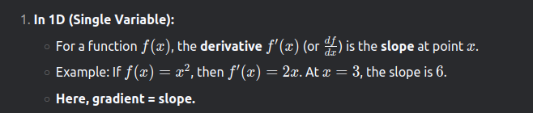
The goal of gradient descent is to update weights in such a way that the loss function returns a value as low as possible which signifies that our predictions are close to the actual values.
Gradient Descent is an optimizer.
Press enter or click to view image in full size
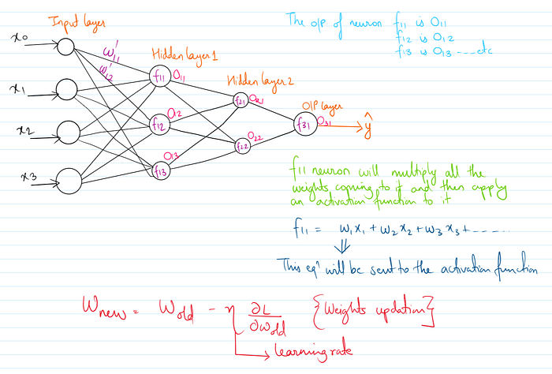
The reason why we are finding the derivative is because it will give us the direction as to where the global minima or the point of convergence is.
Vanishing gradient descent and exploding gradient descent happens because of updation of weights, or during backpropagation
Vanishing Gradient Descent
The vanishing gradient problem happens due to sigmoid activation function. To eradicate this problem, we can make use of ReLU activation function.
As the number of hidden layers in the neural network increases, the lesser the values of the weights gets affected. So, this is called vanishing gradient problem where the weights do not change by a significant amount due to the width of the neural network and the activation function being used.
A problem where the gradients (partial derivatives of the loss w.r.t. the weights) become extremely small (close to zero) as they are backpropagated through the network. This causes the early layers to learn very slowly or stop updating entirely.
As the sigmoid activation function value ranges from 0 to 1, its derivative forms a bell shaped graph ranging from 0 to 0.25. And as the width of the neural network increases the derivative term in the weight updation formula decreases which eventually results in the values of the new weight and the old weight to be similar.
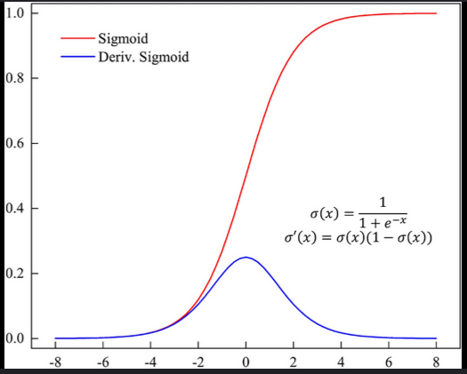
Press enter or click to view image in full size
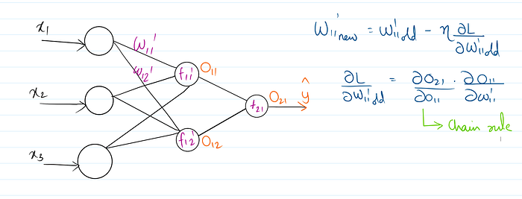
If the loss remains constant during training, it is more likely related to vanishing gradients than exploding gradients. Gradients become extremely small (≈0), so weights stop updating (or update negligibly). Since weights don’t change, the loss stalls at a fixed value.
In vanishing gradients, it is not mandatory that all weights in the model change at a very slow pace. Weights closer to the output layer may update significantly, while those near the input layer barely change.
Tips to get rid of vanishing gradient descent
- Proper weight initialization technique: These methods ensure that weights are initialized to values that prevent gradients from vanishing too quickly.
- Use of activation functions such as Leaky ReLU, ReLU etc. These activation functions provide non-saturating gradients for positive inputs, allowing gradients to flow more freely during backpropagation.
- Batch Normalization
- Dropouts of neurons/ Skip connections
Exploding Gradient Descent
- In some cases, particularly with deep neural networks or certain architectures, the gradients computed during backpropagation can become very large.
- This can happen when the network has a large number of layers, each with its own set of parameters, and when the activation functions or initialization schemes cause the gradients to amplify as they propagate backward through the layers.
- When the gradients become extremely large, the weight updates during optimization can also become excessively large. This can lead to the parameters diverging, causing the model to become unstable and fail to converge to a good solution.
A problem where the gradients grow exponentially large during backpropagation, causing weight updates to become unstable (overshooting optimal values)
Tips to get rid of exploding gradient descent
- Use of proper Learning rate
- Weight Regularization like L1 regularization and L2 regularization
- Gradient based optimization algorithms such as Adam, RMSProp, or AdaGrad, which adaptively adjust learning rates. These algorithms help prevent gradient explosions by dynamically scaling learning rates and ensuring stable updates during optimization.

Why Do the Gradients Even Vanish/Explode?
Certain activation functions, like the logistic function (sigmoid), have a huge difference between the variance of their inputs and the outputs. In simpler words, they shrink and transform a larger input space into a smaller output space between the range of [0,1].
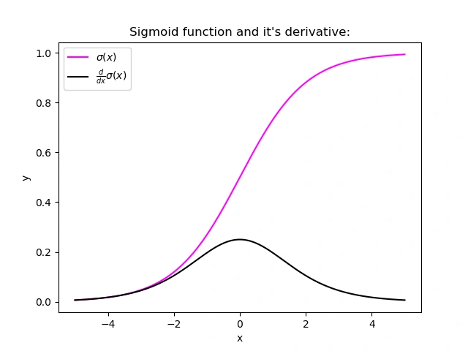
Image source: Google Images
Observing the above graph of the Sigmoid function, we can see that for larger inputs (negative or positive), it saturates at 0 or 1 with a derivative very close to zero. Thus, when the backpropagation algorithm chips in, it virtually has no gradients to propagate backwards in the network, and whatever little residual gradients exist keep on diluting as the algorithm progresses down through the top layers. So, this leaves nothing for the lower layers.
Similarly, suppose the initial weights assigned to the network generate some large loss in some cases. Now, the gradients can accumulate during an update and result in very large gradients, which eventually results in large updates to the network weights and leads to an unstable network. The parameters can sometimes become so large that they overflow, resulting in NaN values.
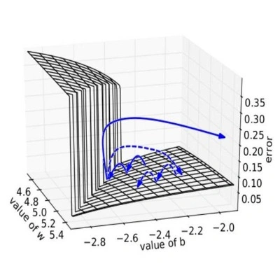
Image Source: Google Images
How to Know if Our Model is Suffering From the Exploding/Vanishing Gradient Problem?
Following are some signs that can indicate that our gradients are vanishing and exploding gradients :

Exploding | Vanishing
There is an exponential growth in the model parameters. | The parameters of the higher layers change significantly whereas the parameters of lower layers would not change much (or not at all).
The model weights may become NaN during training. | The model weights may become 0 during training.
The model experiences avalanche learning. | The model learns very slowly and perhaps the training stagnates at a very early stage just after a few iterations.
Certainly, neither do we want our signal to explode or saturate nor do we want it to die out. The signal needs to flow properly both in the forward direction when making predictions as well as in the backward direction while calculating gradients.
Solutions
Now that we understand the vanishing/exploding gradients problems, we can learn some techniques to fix them.
Proper Weight Initialization
In their paper, researchers Xavier Glorot, Antoine Bordes, and Yoshua Bengio proposed a way to alleviate this problem remarkably.
For the proper flow of the signal, the authors argue that:
- The variance of outputs of each layer should be equal to the variance of its inputs.
- The gradients should have equal variance before and after flowing through a layer in the reverse direction.
Although both conditions cannot hold for any layer in the network unless the number of inputs to the layer (fanin) equals the number of neurons in the layer (fanout), they proposed a well-proven compromise that works incredibly well in practice. They randomly initialize the connection weights for each layer in the network using the following equation, popularly known as Xavier initialization (after the author’s first name) or Glorot initialization (after his last name).
where fanavg = ( fanin + fanout ) / 2
- Normal distribution with mean 0 and variance σ² = 1/ fan_{avg}
- Or a uniform distribution between -r and +r , with r = sqrt( 3 / fan_{avg} )
Following are some more very popular weight initialization strategies for different activation functions, they only differ by the scale of variance and by the usage of either fan_{avg} or fan_{in}
for uniform distribution, calculate r as: r = sqrt( 3*σ² )
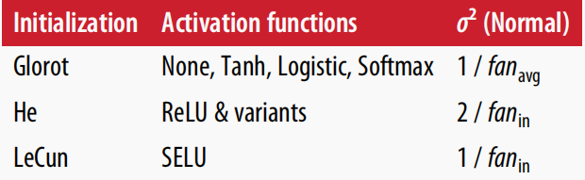Source : A book from Aurelien Geron
Using the above initialization strategies can significantly speed up the training and increase the odds of gradient descent converging at a lower generalization error.
Wait, but how do we put these strategies into code ??
Relax! We will not need to hardcode anything; Keras does it for us.
- Keras uses Xavier’s initialization strategy with uniform distribution.
- If we wish to use a strategy different from the default one, this can be done using the kernel_initializer parameter while creating the layer. For example :
keras.layer.Dense(25, activation = "relu", kernel_initializer="he_normal")
or
keras.layer.Dense(25, activation = "relu", kernel_initializer="he_uniform")
If we wish to use the initialization based on fan_{avg} rather than fan_{in} , we can use the VarianceScaling initializer like this :
he_avg_init = keras.initializers.VarianceScaling(scale=2., mode='fan_avg', distribution='uniform')
keras.layers.Dense(20, activation="sigmoid", kernel_initializer=he_avg_init)
Using Non-saturating Activation Functions
In an earlier section, while studying the nature of the sigmoid activation function, we observed that its saturating nature for larger inputs (negative or positive) was a major reason behind the vanishing and exploding gradients, thus making it non-recommendable to use in the hidden layers of the network.
So to tackle the issue regarding the saturation of activation functions like sigmoid and tanh, we must use some other non-saturating functions like ReLu and its alternatives.
ReLU ( Rectified Linear Unit )
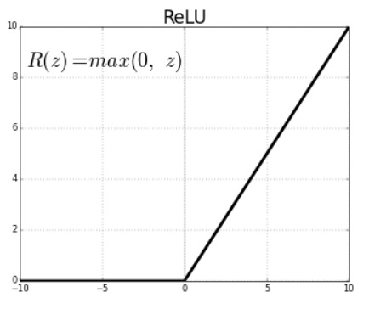
Relu(z) = max(0,z)
- Outputs 0 for any negative input.
- Range: [0, infinity]
Unfortunately, the ReLu function is also not a perfect pick for the intermediate network layers “in some cases”. It suffers from a problem known as dying ReLus wherein some neurons just die out, meaning they keep on throwing 0 as outputs with the advancement in training.
Read about the dying relus problem in detail here.
Some popular alternative functions of the ReLU that mitigate the problem of vanishing gradients when used as activation for the intermediate layers of the network are LReLU, PReLU, ELU, Sand ELU :
LReLU (Leaky ReLU)
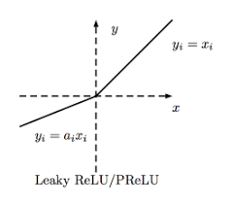
LeakyReLUα(z) = max(αz, z)
- The amount of “leak” is controlled by the hyperparameter α, it is the slope of the function for z < 0.
- The smaller slope for the leak ensures that the neurons powered by leaky Relu never die; although they might venture into a state of coma for a long training phase they always have a chance to eventually wake up.
- The model can also train α, learning its value during training. This variant, where α is considered a parameter rather than a hyperparameter, is called parametric leaky ReLU (PReLU).
ELU (Exponential Linear Unit)
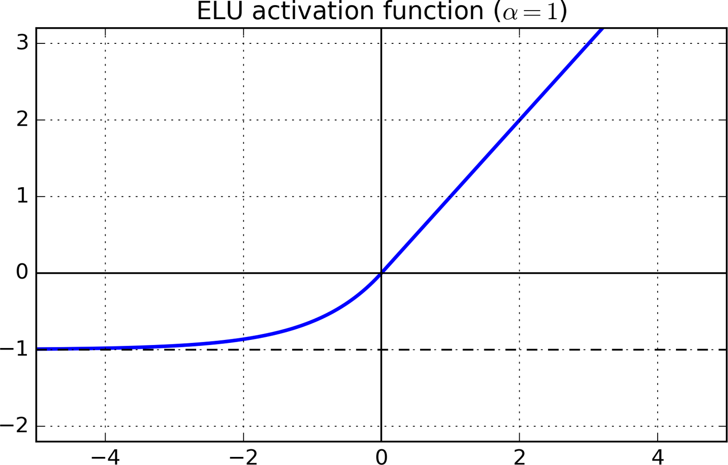Source: Google Images
For z < 0, it takes on negative values, which allow the unit to have an average output closer to 0 thus alleviating the vanishing gradient problem.
- For z < 0, the gradients are non-zero. This avoids the dead neurons problem.
- For α = 1, the function is smooth everywhere. This speeds up the gradient descent since it does not bounce right and left around z=0.
- A scaled version of this function ( SELU: Scaled ELU ) is often used in Deep Learning.
Batch Normalization
Using the initialization along with any variant of the ReLU activation function can significantly reduce the chances of vanishing/exploding problems at the beginning. However, it does not guarantee that the problem won’t reappear during training.
In 2015, Sergey Ioffe and Christian Szegedy proposed a paper in which they introduced batch normalization, a technique for addressing the problem of vanishing/exploding gradients.
The following key points explain the intuition behind BN and how it works:
- It consists of adding an operation in the model just before or after the activation function of each hidden layer.
- This operation simply zero-centres and normalizes each input, then scales and shifts the result using two new parameter vectors per layer: one for scaling, the other for shifting.
- In other words, the operation lets the model learn the optimal scale and mean of each layer’s input.
- The algorithm needs to estimate each input’s mean and standard deviation to zero-centre and normalise the inputs.
- It does so by evaluating the mean and standard deviation of the input over the current mini-batch (hence the name “Batch Normalization”).
model = keras.models.Sequential([keras.layers.Flatten(input_shape=[28, 28]),keras.layers.BatchNormalization(),keras.layers.Dense(300, activation="relu"),keras.layers.BatchNormalization(),keras.layers.Dense(100, activation="relu"),keras.layers.BatchNormalization(),keras.layers.Dense(10, activation="softmax")])
We just added batch normalization after each layer (dataset: FMNIST)model.summary()
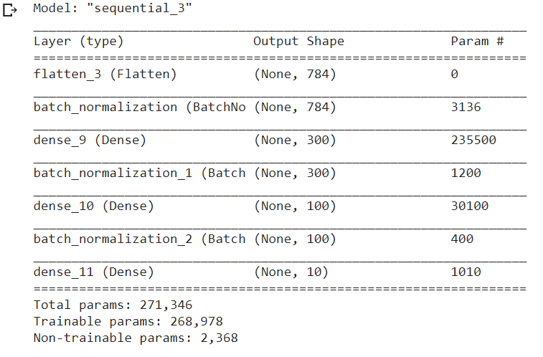
Gradient Clipping
Another popular technique to mitigate the exploding gradient problem is to clip the gradients during backpropagation so that they never exceed some threshold. This is called Gradient Clipping.
- This optimizer will clip every component of the gradient vector to a value between –1.0 and 1.0.
- This means we will clip all the partial derivatives of the loss for each trainable parameter between –1.0 and 1.0.
optimizer = keras.optimizers.SGD(clipvalue = 1.0)
- The threshold is a hyperparameter we can tune.
- The orientation of the gradient vector may change due to this: for example, let the original gradient vector be [0.9, 100.0], pointing mostly in the direction of the second axis. Once we clip it by some value, we get [0.9, 1.0], which now points somewhere around the diagonal between the two axes.
- We should clip by norm rather than by value to ensure that the orientation remains intact even after clipping.
optimizer = keras.optimizers.SGD(clipnorm = 1.0)
- If the threshold we pick is less than the ℓ2 norm, we will clip the whole gradient. For example, if clipnorm=1, we will clip the vector [0.9, 100.0] to [0.00899, 0.999995], thus preserving its orientation.

How to Improve the Performance of a Neural Network

https://www.analyticsvidhya.com/blog/2019/11/4-tricks-improve-deep-learning-model-performance/
1. Understanding Neural Networks: The Basics
Neural networks are inspired by the human brain and are made up of layers: input, hidden, and output. Each “neuron” processes parts of data, and through multiple layers, a neural network can solve complex problems.
Perceptrons and Multi-Layer Perceptrons
- Perceptron: A single layer neural network, best for simple binary classification.
- Multi-Layer Perceptron (MLP): A network with multiple layers (hidden layers), which helps capture intricate patterns in data.
2. Key Techniques to Improve Neural Network Performance
Boosting a neural network’s performance involves optimizing hyperparameters, handling overfitting, and improving training efficiency. Here are the essential techniques:
A. Hyperparameter Tuning
- Number of Layers and Neurons:
- Experiment with different hidden layers to find the optimal structure.
- Start with small numbers, like 1–3 hidden layers, each with 32–128 neurons. Too many neurons or layers can cause overfitting, while too few may underfit.
2. Learning Rate:
- The learning rate controls how much the model’s weights are adjusted with each training step.
- Example: A high learning rate may train quickly but miss optimal solutions, while a low rate may be slow but steady.
- Tip: Use a learning rate scheduler, which adjusts the rate over time to achieve balanced results.
B. Training Optimization Techniques
- Batch Size and Gradient Descent Variants:
- Training data is often processed in “batches.”
- Batch Gradient Descent processes the entire dataset at once — stable but slow.
- Stochastic Gradient Descent updates weights for each data point, making it faster but less stable.
- Mini-Batch Gradient Descent combines both, ideal for large datasets.
2. Optimizers:
- Optimizers like Adam or RMSProp automatically adjust the learning rate and other parameters to improve training.
- Example: Adam optimizes faster and is less sensitive to parameter settings than basic gradient descent.
C. Handling Overfitting and Underfitting
Overfitting occurs when a model learns the training data too well but fails on new data. Techniques to prevent overfitting include:
- Regularization:
- L1 and L2 regularization add constraints to model weights, limiting how much each weight can grow.
2. Dropouts:
- Dropout is a method that “drops” random neurons during training to prevent over-reliance on specific neurons, improving generalization.
3. Improving Training Stability
Deep learning models can face issues like vanishing and exploding gradients. Here are solutions:
- Activation Functions:
- Common choices include ReLU (Rectified Linear Unit), which improves gradient flow and reduces vanishing gradients compared to Sigmoid.
2. Batch Normalization:
- Batch normalization scales inputs for each layer, stabilizing training, especially in deep networks.
- Gradient Clipping:
- To handle exploding gradients, clip gradients at a maximum value, ensuring they don’t grow too large.
4. Practical Steps for Training Neural Networks
- Early Stopping:
- Stop training when the model’s performance on a validation set stops improving. This prevents overfitting and saves time.
- Using Transfer Learning:
- Use a pre-trained model on similar tasks to save time and improve accuracy.
- Example: Use a model trained on ImageNet for your own image classification tasks.
2. Experiment with Epochs:
- An epoch is one full pass of the dataset. Increase epochs gradually to avoid overfitting. Use early stopping if improvement stalls.
Conclusion: Your Neural Network Roadmap
By using these techniques, you’re set to maximize your neural network’s performance. Start simple, experiment, and refine your models over time. With every iteration, you’ll better understand which methods work best for your specific tasks. Dive into deep learning and watch your neural network skills grow!

Early Stopping In Neural Networks | End to End Deep Learning Course

Early stopping is a technique used while training neural networks to prevent the model from overfitting. Before understanding what actually early stopping is, you must know what is overfitting.
What is Overfitting?
Overfitting is a common problem in machine learning and deep learning where a model learns the training data too well. It happens when the model captures not only the underlying patterns in the data but also the noise or random fluctuations. As a result, the model performs exceptionally well on the training data but poorly on unseen data (test data or real-world data).
Causes of Overfitting:
- Complex Model: Using a model with too many parameters relative to the number of observations can lead to overfitting. The model might capture the noise in the training data, making it perform poorly on new data.
- Insufficient Training Data: If the dataset is too small, the model might not have enough examples to learn the underlying patterns effectively. It might end up learning the noise in the data.
- Lack of Regularization: Regularization techniques, such as L1 and L2 regularization, add a penalty to the loss function to prevent the model from fitting the training data too closely. Without these, the model might overfit.
There are few more causes that could lead to overfitting including data leakage and overly optimisic evaluation metrics.
Preventing the model from overfitting involves following techniques:
- Use More Data
- Regularization
- Dropout
- Early Stopping
- Data Augmentation
And there are still many other ways to prevent overfitting. But in this blog, I would specifically explain about ‘Early Stopping’.

Why Use Early Stopping?
- Avoid Overfitting: Early stopping prevents the model from memorizing the training data by halting the process before overfitting occurs.
- Save Resources: Stopping early reduces training time and computational costs, especially in large models.
- Improves Generalization: Models trained with early stopping tend to generalize better, performing well on unseen data.

What is Early Stopping?
Early stopping is a form of regularization used to prevent overfitting in machine learning and deep learning models. It involves stopping the training process before the model starts to overfit. The idea is to monitor the model’s performance on a validation set during the training process and stop training when the performance starts to degrade, which is an indication that the model is beginning to overfit the training data.
Press enter or click to view image in full size
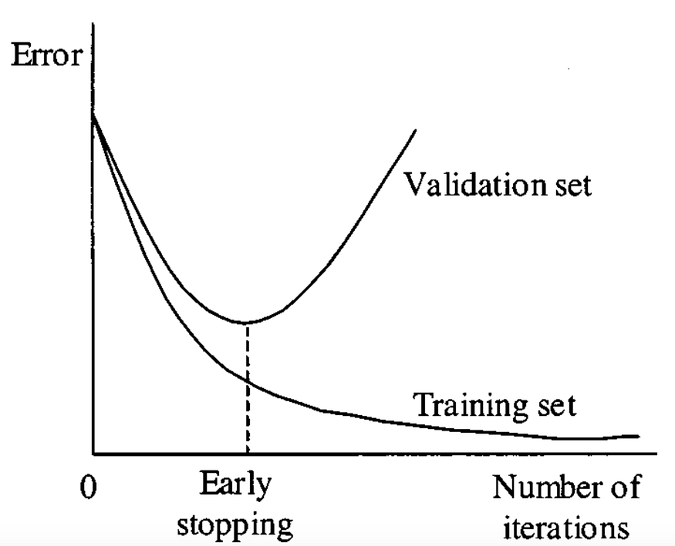
How Early Stopping Works
- Validation Set: During training, a portion of the training data is set aside as a validation set. This set is used to evaluate the model’s performance at each epoch (iteration over the entire dataset).
- Performance Monitoring: The model’s performance on the validation set is monitored at each epoch. Common metrics used for this purpose include accuracy, loss, or any other metric relevant to the problem at hand.
- Early Stopping Criterion: If the performance on the validation set starts to degrade (e.g., the loss increases or the accuracy decreases), it’s an indication that the model is beginning to overfit the training data. At this point, early stopping is triggered, and the training process is halted.
- Model Selection: Since the training is stopped before overfitting occurs, the model at the point of early stopping is typically the best model, as it has not yet learned the noise in the training data
How does early stopping works in the code
To be honest, this is all there is to early stopping. Before finishing this blog, I would like to show you, how to implement early stopping in PyTorch.
import torch
import torch.nn as nn
import torch.optim as optim
from torch.utils.data import DataLoader
from torchvision import datasets, transforms
# Define your model, loss function, and optimizer
model = ...
criterion = nn.CrossEntropyLoss()
optimizer = optim.SGD(model.parameters(), lr=0.01)
# Load your data
train_data = datasets.MNIST(...)
train_loader = DataLoader(train_data, batch_size=64, shuffle=True)
# Early stopping parameters
patience = 5 # Number of epochs to wait before stopping
min_delta = 0.01 # Minimum change in loss to qualify as an improvement
patience_counter = 0
best_loss = float('inf')
for epoch in range(100): # Maximum number of epochs
running_loss = 0.0
for inputs, labels in train_loader:
# training logic here
# Validation
val_loss = ... # Calculate validation loss
# Check for improvement
if val_loss < best_loss - min_delta:
best_loss = val_loss
patience_counter = 0
else:
patience_counter += 1
if patience_counter >= patience:
print(f"Early stopping at epoch {epoch}")
break
print(f"Best validation loss: {best_loss}")
In this example, we’re using a simple model and a placeholder for the validation loss calculation. You’ll need to replace this with your actual validation loss calculation. The key part is the early stopping logic, which checks if the validation loss has improved by at least min_delta from the best loss seen so far. If not, it increments paitence_counter. If patience_counter reaches the patience value, training is stopped.

Example 2.
Implementing Early Stopping: A Simple Example
Let’s walk through an example of implementing early stopping with a neural network that classifies points in a 2D space (e.g., using circles and shapes as data points).
- Create a Neural Network: Suppose our network has a single hidden layer with 256 neurons.
- Train the Network: We’ll train the network on our data for 3,500 epochs.
- Apply Early Stopping: Monitor the validation loss after each epoch. If the validation loss stops decreasing for a specified number of epochs (patience parameter), we stop training.
Here’s a Python code snippet that demonstrates this:
from tensorflow.keras.models import Sequential
from tensorflow.keras.layers import Dense
from tensorflow.keras.callbacks import EarlyStopping
# Create a simple model
model = Sequential()
model.add(Dense(256, activation='relu', input_shape=(2,)))
model.add(Dense(1, activation='sigmoid'))# Compile the model
model.compile(optimizer='adam', loss='binary_crossentropy', metrics=['accuracy'])# Early stopping callback
early_stopping = EarlyStopping(monitor='val_loss', patience=10, restore_best_weights=True)# Train the model with early stopping
history = model.fit(X_train, y_train, epochs=3500, validation_data=(X_val, y_val), callbacks=[early_stopping])
Explanation of the Code:
- We use EarlyStopping from Keras, specifying monitor='val_loss' to track the validation loss.
- The patience parameter indicates the number of epochs to wait for an improvement. If validation loss doesn’t decrease within this patience period, training stops.
- restore_best_weights=True reverts the model to its state with the lowest validation loss.
How Early Stopping Works in Practice
Let’s imagine we set the patience to 10 epochs. During training, the validation loss keeps decreasing, but after epoch 2500, it stabilizes and eventually starts to increase. Since the model doesn’t improve for 10 consecutive epochs, early stopping stops the training process. This prevents the model from overfitting and saves us time.
Example Results:
Imagine we have a dataset with 500 points. Without early stopping, we train for 3,500 epochs, but our model overfits. With early stopping, the model stops training after 2,500 epochs, maintaining a balance between training accuracy and generalization on new data.
Conclusion
Early stopping is an essential technique for building neural networks that generalize well without wasting resources. By halting training at the right time, you can create models that are both effective and efficient. When working with deep learning, remember to set up early stopping in your models, especially if you’re dealing with a limited dataset or are training for a high number of epochs.

# %%
import tensorflow as tf
import numpy as np
import pandas as pd
from pylab import rcParams
import matplotlib.pyplot as plt
import warnings
from mlxtend.plotting import plot_decision_regions
from matplotlib.colors import ListedColormap
from tensorflow.keras.models import Sequential
from tensorflow.keras.layers import Dropout
from tensorflow.keras.layers import Dense
from tensorflow.keras.callbacks import EarlyStopping
from sklearn.model_selection import train_test_split
from sklearn.datasets import make_circles
import seaborn as sns

# %%
X, y = make_circles(n_samples=100, noise=0.1, random_state=1)

# %%
sns.scatterplot(X[:,0],X[:,1],hue=y)

# %%
X_train, X_test, y_train, y_test = train_test_split(X, y, test_size=0.20, random_state=2)

# %%
model = Sequential()

model.add(Dense(256, input_dim=2, activation='relu'))
model.add(Dense(1, activation='sigmoid'))

# %%
model.compile(loss='binary_crossentropy', optimizer='adam', metrics=['accuracy'])

# %%
history = model.fit(X_train, y_train, validation_data=(X_test, y_test), epochs=3500, verbose=0)

# %%
plt.plot(history.history['loss'], label='train')
plt.plot(history.history['val_loss'], label='test')
plt.legend()
plt.show()

# %%
plot_decision_regions(X_test, y_test.ravel(), clf = model, legend=2)
plt.show()

# %% [markdown]
# # Early Stopping

# %%
model = Sequential()

model.add(Dense(256, input_dim=2, activation='relu'))
model.add(Dense(1, activation='sigmoid'))

# %%
model.compile(loss='binary_crossentropy', optimizer='adam', metrics=['accuracy'])

# %%
callback = EarlyStopping(
monitor="val_loss",
min_delta=0.00001,
patience=20,
verbose=1,
mode="auto",
baseline=None,
restore_best_weights=False
)

# %%
history = model.fit(X_train, y_train, validation_data=(X_test, y_test), epochs=3500, callbacks=callback)

# %%
plt.plot(history.history['loss'], label='train')
plt.plot(history.history['val_loss'], label='test')
plt.legend()
plt.show()

# %%
plot_decision_regions(X_test, y_test.ravel(), clf = model, legend=2)
plt.show()

# %%

Data Scaling in Neural Network | Feature Scaling in ANN | End to End Deep Learning Course

What is Feature Scaling?
Feature scaling is a preprocessing technique that transforms feature values to a similar scale, ensuring all features contribute equally to the model. It’s essential for datasets with features of varying ranges, units, or magnitudes. Common techniques include standardization, normalization, and min-max scaling. This process improves model performance, convergence, and prevents bias from features with larger values.
https://towardsdatascience.com/all-about-feature-scaling-bcc0ad75cb35/
https://www.analyticsvidhya.com/blog/2020/04/feature-scaling-machine-learning-normalization-standardization/
Analysis:
Machine learning is like making a mixed fruit juice. If we want to get the best-mixed juice, we need to mix all fruit not by their size but based on their right proportion. We just need to remember apple and strawberry are not the same unless we make them similar in some context to compare their attribute. Similarly, in many machine learning algorithms, to bring all features in the same standing, we need to do scaling so that one significant number doesn’t impact the model just because of their large magnitude.
Feature scaling in machine learning is one of the most critical steps during the pre-processing of data before creating a machine learning model. Scaling can make a difference between a weak machine learning model and a better one.
The most common techniques of feature scaling are Normalization and Standardization.
Normalization is used when we want to bound our values between two numbers, typically, between [0,1] or [-1,1]. While Standardization transforms the data to have zero mean and a variance of 1, they make our data unitless. Refer to the below diagram, which shows how data looks after scaling in the X-Y plane.

Why do we need scaling?
Machine learning algorithm just sees number – if there is a vast difference in the range say few ranging in thousands and few ranging in the tens, and it makes the underlying assumption that higher ranging numbers have superiority of some sort. So these more significant number starts playing a more decisive role while training the model.
The machine learning algorithm works on numbers and does not know what that number represents. A weight of 10 grams and a price of 10 dollars represents completely two different things – which is a no brainer for humans, but for a model as a feature, it treats both as same.
Suppose we have two features of weight and price, as in the below table. The "Weight" cannot have a meaningful comparison with the "Price." So the assumption algorithm makes that since "Weight" > "Price," thus "Weight," is more important than "Price."
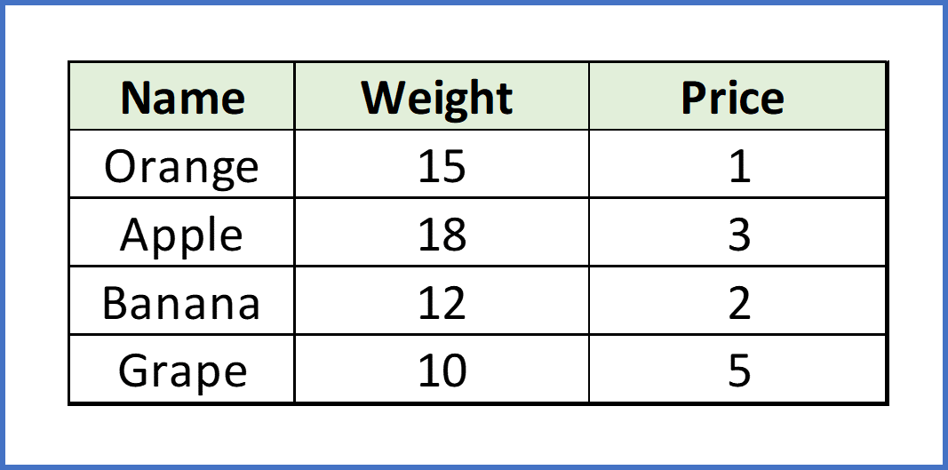

So these more significant number starts playing a more decisive role while training the model. Thus feature scaling is needed to bring every feature in the same footing without any upfront importance. Interestingly, if we convert the weight to "Kg," then "Price" becomes dominant.
Another reason why feature scaling is applied is that few algorithms like Neural network gradient descent converge much faster with feature scaling than without it.
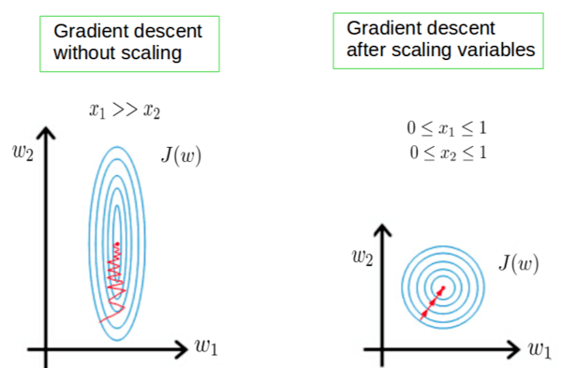Photo Credit
One more reason is saturation, like in the case of sigmoid activation in Neural Network, scaling would help not to saturate too fast.

When to do scaling?
Feature scaling is essential for machine learning algorithms that calculate distances between data. If not scale, the feature with a higher value range starts dominating when calculating distances, as explained intuitively in the "why?" section.
The ML algorithm is sensitive to the "relative scales of features," which usually happens when it uses the numeric values of the features rather than say their rank.
In many algorithms, when we desire faster convergence, scaling is a MUST like in Neural Network.
Since the range of values of raw data varies widely, in some machine learning algorithms, objective functions do not work correctly without normalization. For example, the majority of classifiers calculate the distance between two points by the distance. If one of the features has a broad range of values, the distance governs this particular feature. Therefore, the range of all features should be normalized so that each feature contributes approximately proportionately to the final distance.
Even when the conditions, as mentioned above, are not satisfied, you may still need to rescale your features if the ML algorithm expects some scale or a saturation phenomenon can happen. Again, a neural network with saturating activation functions (e.g., sigmoid) is a good example.
Rule of thumb we may follow here is an algorithm that computes distance or assumes normality, scales your features.
Some examples of algorithms where feature scaling matters are:
- K-nearest neighbors (KNN) with a Euclidean distance measure is sensitive to magnitudes and hence should be scaled for all features to weigh in equally.
- K-Means uses the Euclidean distance measure here feature scaling matters.
- Scaling is critical while performing Principal Component Analysis(PCA). PCA tries to get the features with maximum variance, and the variance is high for high magnitude features and skews the PCA towards high magnitude features.
- We can speed up gradient descent by scaling because θ descends quickly on small ranges and slowly on large ranges, and oscillates inefficiently down to the optimum when the variables are very uneven.
Algorithms that do not require normalization/scaling are the ones that rely on rules. They would not be affected by any monotonic transformations of the variables. Scaling is a monotonic transformation. Examples of algorithms in this category are all the tree-based algorithms – CART, Random Forests, Gradient Boosted Decision Trees. These algorithms utilize rules (series of inequalities) and do not require normalization.
Algorithms like Linear Discriminant Analysis(LDA), Naive Bayes is by design equipped to handle this and give weights to the features accordingly. Performing features scaling in these algorithms may not have much effect.
Few key points to note :
- Mean centering does not affect the covariance matrix
- Scaling of variables does affect the covariance matrix
- Standardizing affects the covariance

Data Scaling
Data scaling is a critical step in preparing data for machine learning and AI. Its purpose is to normalize and standardize the data to a consistent level. This ensures that no particular feature dominates the data and causes biased predictions. In addition, data scaling improves the performance of optimization algorithms used to train deep neural networks. Normalization and standardization are two commonly used data scaling methods in AI and machine learning.
Press enter or click to view image in full size
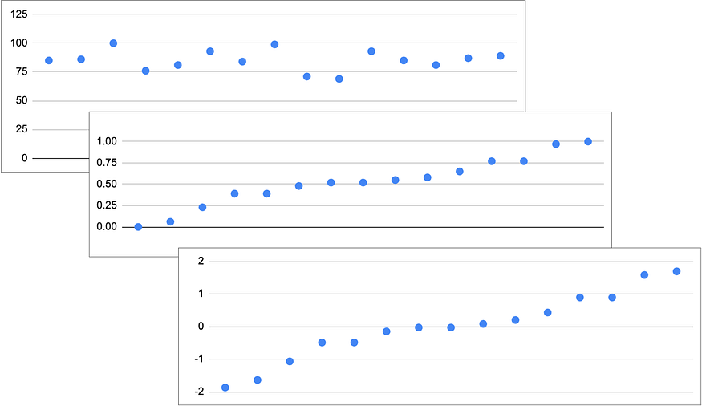
Figure 1: Comparison of Original, Normalized, and Standardized Data
Normalization, also called min-max scaling, changes the values of features to occupy a range of [0, 1] or [-1, 1], reducing the influence of unusual values on the model. In contrast, standardization modifies the data to have a mean of zero and a standard deviation of one, making it conform to a standard normal distribution. We will examine when each method is best and how it affects AI model performance, giving you a useful guide for applying them to data preparation.
Let’s say we need to convert the following data, which is a list of test scores for a group of students, into its normalized and standardized form
Student scores:
85, 86, 100, 76, 81, 93, 84, 99, 71, 69, 93, 85, 81, 87, 89
Below is the formula for calculating the standard form:
Press enter or click to view image in full size
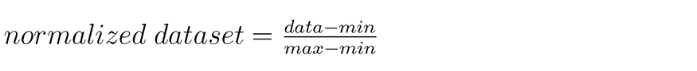
In the above equation, the symbol ‘data’ represents each data element in the data set, min is the minimum value and max is the maximum value of the data set. From the above data set, we can obtain the min and max values as shown below:
min = 69
max = 100
Using these values for min, max, and data, we can calculate the normalized data set, rounded to 2 decimal places, as follows
normalized dataset:
0.52, 0.55, 1.00, 0.23, 0.39, 0.77, 0.48, 0.97, 0.06, 0.00, 0.77, 0.52, 0.39, 0.58, 0.65
Next, let’s convert the data set to the standardized data set format. Below is the formula:
Press enter or click to view image in full size
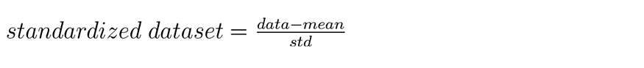
In the above equation, the symbol ‘data’ represents each data element in the data set, min is the minimum value and max is the maximum value of the data set. From the above data set, we can obtain the min and max values as shown below:
min = 69
max = 100
Using these values for min, max, and data, we can calculate the normalized data set, rounded to 2 decimal places, as follows
normalized dataset:
0.52, 0.55, 1.00, 0.23, 0.39, 0.77, 0.48, 0.97, 0.06, 0.00, 0.77, 0.52, 0.39, 0.58, 0.65
Next, let’s convert the data set to the standardized data set format. Below is the formula:
Press enter or click to view image in full size

In the equation above, the symbol “data” represents each data item in the data set, “mean” is the mean, and “std” is the standard deviation of the data set. Below are the formulas for calculating the mean and standard deviation:
Press enter or click to view image in full size
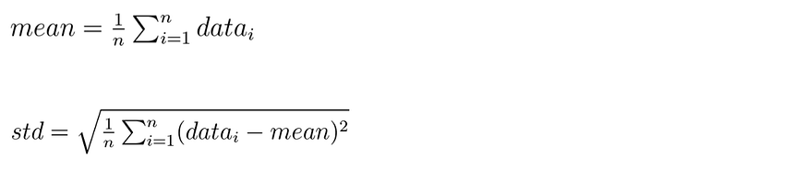
Using the data set above and applying these formulas, we calculate the mean and standard deviation (std) as shown below:
mean = 85.27
std = 8.70
By substituting these mean and std values into the Standardized Data Set formula, we get the converted data set below.
standardized dataset:
-0.03,0.08,1.69,-1.07,-0.49,0.89,-0.15,1.58,-1.64,-1.87,0.89,-0.03,-0.49,0.20,0.43
Summary
Data scaling is an essential preprocessing step in machine learning and AI, aimed at normalizing and standardizing data to ensure consistent feature influence and unbiased predictions. Normalization, or min-max scaling, adjusts feature values to a range of [0, 1] or [-1, 1], reducing the impact of outliers, while standardization modifies the data to have a mean of zero and a standard deviation of one, aligning it with a standard normal distribution. By enhancing the performance of optimization algorithms used in training neural networks, data scaling is crucial for improving model accuracy. The document illustrates these concepts through practical examples of converting student test scores into normalized and standardized formats, providing a clear guide for applying these techniques in data preparation.

# %%
import numpy as np
import pandas as pd

# %%
df = pd.read_csv('/content/Social_Network_Ads.csv')

# %%
df = df.iloc[:,2:]
df.head()

# %%
import seaborn as sns

# %%
sns.scatterplot(df.iloc[:,0],df.iloc[:,1])

# %%
X = df.iloc[:,0:2]
y = df.iloc[:,-1]

# %%
from sklearn.model_selection import train_test_split
X_train,X_test,y_train,y_test = train_test_split(X,y,test_size=0.2,random_state=2)

# %%
import tensorflow as tf
from tensorflow import keras
from keras import Sequential
from keras.layers import Dense

# %%
model = Sequential()

model.add(Dense(128,activation='relu',input_dim=2))
model.add(Dense(1,activation='sigmoid'))

# %%
model.summary()

# %%
model.compile(optimizer='adam',loss='binary_crossentropy',metrics=['accuracy'])

# %%
history = model.fit(X_train,y_train,validation_data=(X_test,y_test),epochs=100)

# %%
import matplotlib.pyplot as plt
plt.plot(history.history['val_accuracy'])

# %%
# Applying scaling

# %%
from sklearn.preprocessing import StandardScaler
scaler = StandardScaler()

X_train_scaled = scaler.fit_transform(X_train)
X_test_scaled = scaler.transform(X_test)

# %%
X_train_scaled

# %%
sns.scatterplot(X_train_scaled[:,0],X_train_scaled[:,1])

# %%
model = Sequential()

model.add(Dense(128,activation='relu',input_dim=2))
model.add(Dense(1,activation='sigmoid'))

model.compile(optimizer='adam',loss='binary_crossentropy',metrics=['accuracy'])

history = model.fit(X_train_scaled,y_train,validation_data=(X_test_scaled,y_test),epochs=100)

# %%
import matplotlib.pyplot as plt
plt.plot(history.history['val_accuracy'])

# %%
===========
Dropout Layer in Deep Learning | Dropouts in ANN | End to End Deep Learning

What is Dropout?
Dropout is a technique that randomly disables (or “drops”) a fraction of neurons during each training iteration. This prevents the network from becoming too dependent on certain nodes and encourages it to learn more generalized features, which helps it perform better on new data.
To better understand, let’s compare a neural network using dropout to a group study session where different students (neurons) are randomly asked to leave the room during each session. The remaining students must still work together to solve problems, which strengthens each person’s understanding of the material.
How Does Dropout Work?
- During Training: At each training iteration, dropout randomly disables a fraction (e.g., 50%) of neurons in the network. This effectively creates a new, smaller neural network with fewer neurons for that iteration. As a result, the model learns to work without depending on any one specific neuron, which reduces overfitting.
- During Testing: During testing or inference (when the model is predicting on new data), all neurons are active. However, the weights of the neurons are scaled down by the dropout rate to account for the different training structure. This scaling is typically by a factor of (1 — dropout rate) to ensure the same output range as during training.
For example, if you set a dropout rate of 0.5, during training, half of the neurons are disabled in each iteration. In testing, all neurons are active, but each neuron’s output is multiplied by 0.5 to balance the network’s response.
Example
Let’s look at a simple neural network with three layers: an input layer, a hidden layer with four neurons, and an output layer. Suppose we set the dropout rate at 0.5.
- Epoch 1: Two neurons in the hidden layer are randomly disabled.
- Epoch 2: A different set of neurons might be disabled, such as one neuron in the input layer and one in the hidden layer.
- Epoch 3: Again, a different configuration of active neurons is used.
Each epoch has a unique configuration of active and inactive neurons, which means the network is training in a slightly different way each time. Over multiple epochs, this randomness leads to a robust model that doesn’t rely on any single neuron.
Why Dropout Works
By randomly disabling neurons, dropout effectively trains multiple “subnetworks” within the main network, which makes the overall model more adaptable and prevents it from memorizing specific data points (overfitting). This technique has shown to improve model accuracy by up to 2%, especially on complex datasets.
Comparing Dropout to Random Forests
In Random Forests, multiple decision trees are trained on different subsets of data. The final output is the majority vote or average of these trees. Dropout works similarly by creating different “subnetworks” and averaging their learned features, leading to a well-rounded model that performs better on new data.
Practical Tips for Using Dropout
- Choosing Dropout Rate: Common dropout rates range from 0.2 to 0.5. A higher dropout rate may be beneficial in very complex networks with many layers, while a lower rate is better for simpler models.
- Using Dropout with Other Regularization: Dropout is often combined with other regularization methods like L2 regularization to further improve performance.
- Early Stopping: Track model performance during training to determine when it starts to overfit. Early stopping allows you to halt training at the optimal point, preventing unnecessary overfitting.
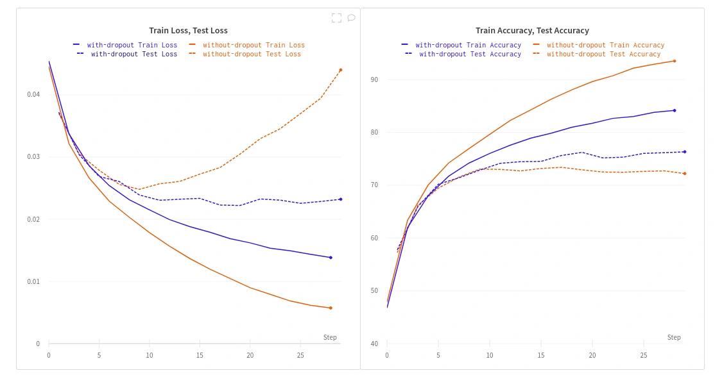

Classification Code - https://colab.research.google.com/dri... Regression Code - https://drive.google.com/file/d/1p9I7...
# %%
import numpy as np
import matplotlib.pyplot as plt

# %%
X = np.array([[-1.58986e-01, 4.23977e-01],

# %%
y = np.array([1., 1., 1., 1., 1., 1., 1., 1., 1., 1., 1., 1., 1., 1., 1., 1., 1.,

# %%
import matplotlib.pyplot as plt
plt.scatter(X[:,0], X[:,1], c=y)
plt.show()

# %%
from tensorflow.keras.models import Sequential
from tensorflow.keras.layers import Dense
from tensorflow.keras.layers import Dropout
from tensorflow.keras.optimizers import Adam

# %%
model = Sequential()

model.add(Dense(128, input_dim=2, activation="relu"))
model.add(Dense(128, activation="relu"))
model.add(Dense(1, activation="sigmoid"))

adam = Adam(learning_rate=0.01)
model.compile(loss='binary_crossentropy', optimizer=adam, metrics=['accuracy'])

history = model.fit(X, y, epochs=500, validation_split = 0.2,verbose=1)

# %%
from mlxtend.plotting import plot_decision_regions

# %%
plot_decision_regions(X, y.astype('int'), clf=model, legend=2)
plt.xlim(-0.7,0.5)
plt.ylim(-0.8,0.8)
plt.show()

# %%
plt.plot(history.history['loss'])
plt.plot(history.history['val_loss'])

# %%
plt.plot(history.history['accuracy'])
plt.plot(history.history['val_accuracy'])

# %%
model = Sequential()

model.add(Dense(128, input_dim=2, activation="relu"))
model.add(Dropout(0.5))
model.add(Dense(128, activation="relu"))
model.add(Dropout(0.5))
model.add(Dense(1, activation="sigmoid"))

adam = Adam(learning_rate=0.01)
model.compile(loss='binary_crossentropy', optimizer=adam, metrics=['accuracy'])

history = model.fit(X, y, epochs=500, validation_split = 0.2,verbose=1)

# %%
plot_decision_regions(X, y.astype('int'), clf=model, legend=2)
plt.xlim(-0.7,0.5)
plt.ylim(-0.8,0.8)
plt.title('p = 0.5')
plt.show()

# %%
plt.plot(history.history['loss'])
plt.plot(history.history['val_loss'])

# %%
plt.plot(history.history['accuracy'])
plt.plot(history.history['val_accuracy'])

# %%
Regularization in Deep Learning | L2 Regularization in ANN | L1 Regularization | Weight Decay in ANN
https://www.analyticsvidhya.com/blog/2018/04/fundamentals-deep-learning-regularization-techniques/

Weight decay, also known as L2 regularization, is a fundamental technique used in deep learning to improve model performance. It acts as a regularizer that penalizes large weights in the network, leading to several benefits:
1. Reduces Overfitting:
Large weights can lead to the model memorizing the training data and failing to generalize to unseen examples. Weight decay penalizes large weights, encouraging the model to learn smaller weights that capture the underlying patterns in the data rather than memorizing specific details. This leads to better generalization performance on unseen data.
2. Improves Model Stability:
Large weights can make the training process unstable and sensitive to noise in the data. Weight decay helps to stabilize the training process by preventing the weights from becoming too large. This makes the model less prone to overfitting and improves its overall robustness.
3. Promotes Feature Sharing:
Weight decay encourages the model to learn weights that are similar across different neurons. This promotes feature sharing, where a single feature is used by multiple neurons in the network. This can lead to a more efficient model with fewer parameters.
4. Improves Generalization in Overparameterized Models:
In modern deep learning, models often have many more parameters than the amount of data they are trained on. This phenomenon is known as overparameterization. Weight decay helps to control the complexity of overparameterized models and improves their generalization performance.
How it Works:
Weight decay adds a penalty term to the loss function that is proportional to the sum of the squared weights in the model. This penalty term encourages the model to learn smaller weights during training.
The weight decay penalty is typically implemented in one of two ways:
- L2 regularization: This directly adds a term to the loss function that is proportional to the sum of the squared weights.
- Weight decay in the optimizer: This modifies the update rule of the optimizer to include a decay factor that reduces the weights at each update step.
Choosing the Right Weight Decay:
The optimal value of the weight decay parameter depends on various factors such as the size and complexity of the model, the amount of training data, and the learning rate. It is important to find the right balance between preventing overfitting and optimizing model performance. Techniques like grid search, hyperparameter optimization, and cross-validation can be used to find the best value for weight decay.
Alternatives to Weight Decay:
While weight decay is a popular and effective regularization technique, other methods can be used to achieve similar results:
- L1 regularization: This penalizes the sum of the absolute values of the weights, encouraging sparsity in the model.
- Dropout: This randomly sets some neurons to zero during training, preventing them from co-adapting and promoting feature independence.
- Early stopping: This stops training once the validation loss starts to increase, preventing overfitting.
Conclusion:
Weight decay is a powerful and widely used technique in deep learning that can significantly improve model performance by preventing overfitting, promoting feature sharing, and improving model stability. Understanding how it works and how to choose the right value for the weight decay parameter is crucial for building robust and generalizable deep learning models.

What is Weight Decay?
Weight decay is a regularization technique used to prevent models from overfitting. It works by adding a penalty term to the loss function, discouraging the model from assigning large values to its weights.
In simple terms, weight decay tells the model:
“Hey, don’t get too confident. Keep your weights small unless absolutely necessary.”
The Formula Behind Weight Decay
During training, models usually try to minimize a loss function, like cross-entropy. Weight decay modifies this loss function like this:
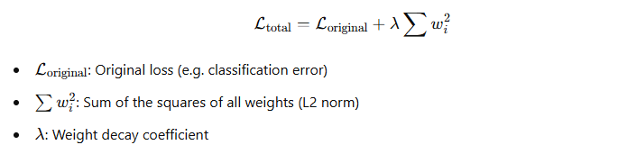
The second term is the regularization part. It penalizes large weights, forcing the model to keep them smaller.
Why Use Weight Decay in LLMs?
Large Language Models are highly expressive, often with billions of parameters. Without regularization, they can memorize training data instead of learning general patterns , a problem called overfitting.
Weight decay acts as a constraint, promoting simpler and more generalizable models.
How Does It Affect Model Performance?
Let’s break it down:
- Increasing weight decay → stronger penalty → smaller weights
- Decreasing weight decay → weaker penalty → larger weights
Now here’s the trick:
- Too little weight decay = overfitting
- Too much weight decay = underfitting
So, it’s a balancing act!
A Closer Look: How Weights Shrink Mathematically
Imagine this: you’re using a simple optimizer like SGD. The update rule with weight decay looks like this:
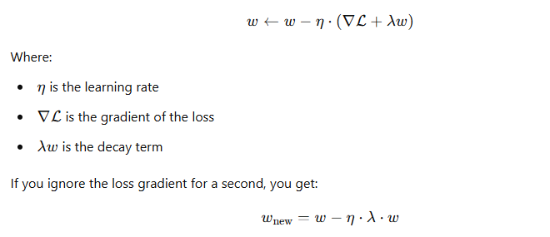
Which means:
- Every weight update shrinks the weight a bit, pulling it toward zero
- The higher the λ, the stronger this pull
Numerical Example
Let’s say our original weights are:
[5.4, -2.1, 3.7]
Now, we apply one update step with different weight decay values:
Press enter or click to view image in full size
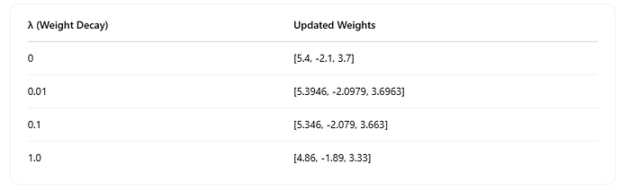
You can see: the bigger the λ, the smaller the weights after the update.
Shrinking Weights Over Time
To make this visual, we created an animation showing how weights change over multiple training steps with weight decay applied. Here’s what happens with λ = 0.0, 0.01, 0.1, 1.0:
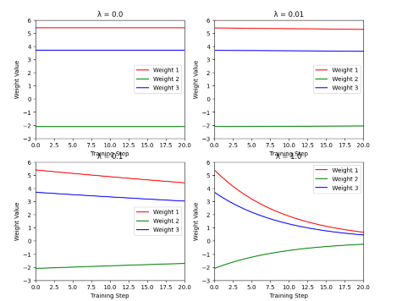
In the animation, you can see the weights steadily pulled toward zero over 20 steps , a direct result of the decay term in action.
Want to try different λ values? λ = 0 results in flat lines (no change), while λ = 1.0 shows rapid decay to near-zero weights.
Caution: More Isn’t Always Better
Weight decay is powerful, but using too much can cripple your model:
- Very high λ: Weights become too small to learn anything meaningful → underfitting
- Very low λ: Weights grow unchecked → overfitting
In practice:
- LLMs use decays in the range of 0.01 to 0.1
- You’ll often tune it as a hyperparameter
Summary
- Weight decay is a regularization tool that penalizes large weights.
- It adds a shrinkage force during training updates.
- Higher decay = more shrinkage = simpler models.
- Too much decay = underfitting, too little = overfitting.
- It’s crucial in training stable and generalizable LLMs.
Final Thoughts
Weight decay might seem like a tiny detail, but it has a huge impact on model behavior — especially in complex neural networks like LLMs. Think of it as a gentle nudge that keeps your model humble and generalizable.

L1 Parameter Regularization:
L1 regularization is a method of doing regularization. It tends to be more specific than gradient descent, but it is still a gradient descent optimization problem.
Formula and high level meaning over here:
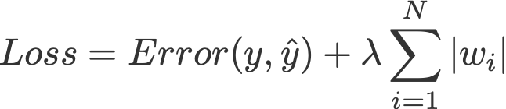
Formula for L1 regularization terms
Lasso Regression (Least Absolute Shrinkage and Selection Operator) adds “Absolute value of magnitude” of coefficient, as penalty term to the loss function.
Lasso shrinks the less important feature’s coefficient to zero; thus, removing some feature altogether. So, this works well for feature selection in case we have a huge number of features.
The L1 regularizer basically looks for the parameter vectors that minimize the norm of the parameter vector (the length of the vector). This is essentially the problem of how to optimize the parameters of a single neuron, a single layer neural network in general, and a single layer feed-forward neural network in particular.

A good way of conceptualizing about it is that it is a method of maximizing the area of the parameter hyperspace that the true parameter vector is within. To do this, it finds the “sharpest” edge, one that is as close to the parameter vector as possible. Key points that should be noted for L1 regularization:
- L1 regularization is that it is easy to implement and can be trained as a one-shot thing, meaning that once it is trained you are done with it and can just use the parameter vector and weights.
- L1 regularization is robust in dealing with outliers. It creates sparsity in the solution (most of the coefficients of the solution are zero), which means the less important features or noise terms will be zero. It makes L1 regularization robust to outliers.
To understand the above mentioned point, let us go through the following example and try to understand what it means when an algorithm is said to be sensitive to outliers
- For instance we are trying to classify images of various birds of different species and have a neural network with a few hundred parameters.
- We find a sample of birds of one species, which we have no reason to believe are of any different species from all the others.
- We add this image to the training set and try to train the neural network. This is like throwing an outlier into the mix of all the others. By looking at the edge of the hyperspace where the hyperplane is closest to, we pick up on this outlier, but by the time we’ve got to the hyperplane it’s quite far from the plane and is hence an outlier.
- The solution in such cases is to perform iterative dropout. L1 regularization is a one-shot solution, but in the end we are going to have to make some kind of hard decision on where to cut off the edges of the hyperspace.
- Iterative dropout is a method of deciding exactly where to cut off. It is a little more expensive in terms of training time, but in the end it might give us an easier decision about how far the hyperspace edges are.
Along with shrinking coefficients, the lasso performs feature selection, as well. (Remember the ‘selection‘ in the lasso full-form?) Because some of the coefficients become exactly zero, which is equivalent to the particular feature being excluded from the model.

L2 Parameter Regularization:
The Regression model that uses L2 regularization is called Ridge Regression.
Press enter or click to view image in full size
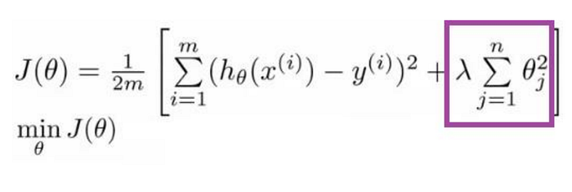
Formula for Ridge Regression
Regularization adds the penalty as model complexity increases. The regularization parameter (lambda) penalizes all the parameters except intercept so that the model generalizes the data and won’t overfit. Ridge regression adds “squared magnitude of the coefficient” as penalty term to the loss function. Here the box part in the above image represents the L2 regularization element/term.
Press enter or click to view image in full size
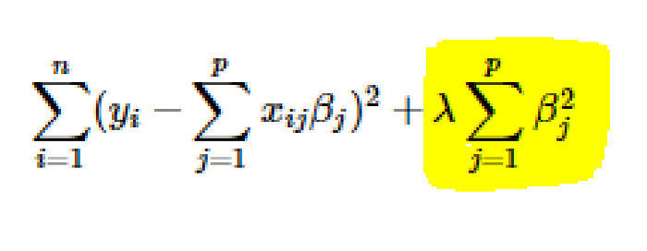
Lambda is a hyperparameter.
If lambda is zero, then it is equivalent to OLS.
Ordinary Least Square or OLS, is a stats model which also helps us in identifying more significant features that can have a heavy influence on the output.
But if lambda is very large, then it will add too much weight, and it will lead to under-fitting. Important points to be considered about L2 can be listed below:
- Ridge regularization forces the weights to be small but does not make them zero and does not give the sparse solution.
- Ridge is not robust to outliers as square terms blow up the error differences of the outliers, and the regularization term tries to fix it by penalizing the weights.
- Ridge regression performs better when all the input features influence the output, and all with weights are of roughly equal size.
- L2 regularization can learn complex data patterns
Differences, Usage and Importance:
It is important to understand the demarcation between both these methods. In comparison to L2 regularization, L1 regularization results in a solution that is more sparse.
Sparsity in this context refers to the fact that some parameters have an optimal value of zero. The sparsity of L1 regularization is a qualitatively different behavior than arises with L2 regularization
The sparsity feature used in L1 regularization has been used extensively as a feature selection mechanism in machine learning. Feature selection is a mechanism which inherently simplifies a machine learning problem by efficiently choosing which subset of the available features should be used of the model.
Lasso integrates an L1 penalty with a linear model and a least-squares cost function. The L1 penalty causes a subset of the weights to becomes zero, which is safe to suggest that the corresponding features associated with the respective weights, may easily be discarded.
Regularization as Bayesian inference?
Many regularization techniques can be interpreted as MAP Bayesian inferences.
- L2 in particular is almost equivalent to MAP Bayesian inference with a Gaussian prior on the weights.
- In L1 regularization, the penalty term used to penalize the cost function can be compared to the log-prior term that is maximized by MAP Bayesian inference when the prior is an isotropic Laplace Distribution over the real number dataset

# -*- coding: utf-8 -*-
"""regularization.ipynb

Automatically generated by Colab.

Original file is located at
https://colab.research.google.com/drive/1PObj5KrXLDDmHjoJ1x0bVmxAFbif5s7q
"""

import numpy as np
import matplotlib.pyplot as plt
from sklearn.datasets import make_moons
import seaborn as sns
from mlxtend.plotting import plot_decision_regions

import tensorflow
from tensorflow.keras.models import Sequential
from tensorflow.keras.layers import Dense
from tensorflow.keras.layers import Dropout
from tensorflow.keras.optimizers import Adam

X, y = make_moons(100, noise=0.25,random_state=2)

import matplotlib.pyplot as plt
plt.scatter(X[:,0], X[:,1], c=y)
plt.show()

model1 = Sequential()

model1.add(Dense(128,input_dim=2, activation="relu"))
model1.add(Dense(128, activation="relu"))
model1.add(Dense(1,activation='sigmoid'))

model1.summary()

adam = Adam(learning_rate=0.01)
model1.compile(loss='binary_crossentropy', optimizer=adam, metrics=['accuracy'])

history1 = model1.fit(X, y, epochs=2000, validation_split = 0.2,verbose=0)

plot_decision_regions(X, y.astype('int'), clf=model1, legend=2)
plt.xlim(-2,3)
plt.ylim(-1.5,2)
plt.show()

plt.plot(history1.history['loss'])
plt.plot(history1.history['val_loss'])

model2 = Sequential()

model2.add(Dense(128,input_dim=2, activation="relu",kernel_regularizer=tensorflow.keras.regularizers.l1(0.001)))
model2.add(Dense(128, activation="relu",kernel_regularizer=tensorflow.keras.regularizers.l1(0.001)))
model2.add(Dense(1,activation='sigmoid'))

model2.summary()

adam = Adam(learning_rate=0.01)
model2.compile(loss='binary_crossentropy', optimizer=adam, metrics=['accuracy'])

history2 = model2.fit(X, y, epochs=2000, validation_split = 0.2,verbose=0)

plot_decision_regions(X, y.astype('int'), clf=model2, legend=2)
plt.xlim(-2,3)
plt.ylim(-1.5,2)
plt.show()

plt.plot(history2.history['loss'])
plt.plot(history2.history['val_loss'])

model1_weight_layer1 = model1.get_weights()[0].reshape(256)
model2_weight_layer1 = model2.get_weights()[0].reshape(256)

sns.boxplot(model1_weight_layer1)

sns.boxplot(model2_weight_layer1)

model1_weight_layer1.min()

model2_weight_layer1.min()

sns.distplot(model1_weight_layer1)
sns.distplot(model2_weight_layer1)

model1.get_weights()[0].reshape(256)

Activation Functions in Deep Learning | Sigmoid, Tanh and Relu Activation Function
Relu Variants Explained | Leaky Relu | Parametric Relu | Elu | Selu | Activation Functions Part 2
Weight Initialization Techniques | What not to do? | Deep Learning
# -*- coding: utf-8 -*-
"""zero-initialization-relu.ipynb

Automatically generated by Colab.

Original file is located at
https://colab.research.google.com/drive/1bsVRmTjYjiQUFee3REHCYeY3vv5r7nfH
"""

import numpy as np
import pandas as pd
import matplotlib.pyplot as plt

df = pd.read_csv('/content/ushape.csv')

df.head()

plt.scatter(df['X'],df['Y'],c=df['class'])

X = df.iloc[:,0:2].values
y = df.iloc[:,-1].values

import tensorflow
from tensorflow import keras
from keras import Sequential
from keras.layers import Dense

model = Sequential()

model.add(Dense(2,activation='sigmoid',input_dim=2))
model.add(Dense(1,activation='sigmoid'))

model.summary()

# Set parameters to 0
model.get_weights()

initial_weights = model.get_weights()

initial_weights[0] = np.ones(model.get_weights()[0].shape)*0.5
initial_weights[1] = np.ones(model.get_weights()[1].shape)*0.5
initial_weights[2] = np.ones(model.get_weights()[2].shape)*0.5
initial_weights[3] = np.ones(model.get_weights()[3].shape)*0.5

model.set_weights(initial_weights)

model.get_weights()

model.compile(loss='binary_crossentropy',optimizer='adam',metrics=['accuracy'])

history = model.fit(X,y,epochs=100,validation_split=0.2)

model.get_weights()

from mlxtend.plotting import plot_decision_regions
plot_decision_regions(X,y.astype('int'), clf=model, legend=2)

# -*- coding: utf-8 -*-
"""zero-initialization-sigmoid.ipynb

Automatically generated by Colab.

Original file is located at
https://colab.research.google.com/drive/1M4q5yRA0iQXh9h8Y3J7zFGIQzO_Pv9n0
"""

import numpy as np
import pandas as pd
import matplotlib.pyplot as plt

df = pd.read_csv('/content/ushape.csv')

df.head()

plt.scatter(df['X'],df['Y'],c=df['class'])

X = df.iloc[:,0:2].values
y = df.iloc[:,-1].values

import tensorflow
from tensorflow import keras
from keras import Sequential
from keras.layers import Dense

model = Sequential()

model.add(Dense(10,activation='sigmoid',input_dim=2))
model.add(Dense(1,activation='sigmoid'))

model.summary()

# Set parameters to 0
model.get_weights()

initial_weights = model.get_weights()

initial_weights[0] = np.zeros(model.get_weights()[0].shape)
initial_weights[1] = np.zeros(model.get_weights()[1].shape)
initial_weights[2] = np.zeros(model.get_weights()[2].shape)
initial_weights[3] = np.zeros(model.get_weights()[3].shape)

model.set_weights(initial_weights)

model.get_weights()

model.compile(loss='binary_crossentropy',optimizer='adam',metrics=['accuracy'])

history = model.fit(X,y,epochs=100,validation_split=0.2)

model.get_weights()

from mlxtend.plotting import plot_decision_regions
plot_decision_regions(X,y.astype('int'), clf=model, legend=2)

Xavier/Glorat And He Weight Initialization in Deep Learning

Understanding Glorot and He Initialization: A Guide for Students

When training deep neural networks, the initialization of the weights can significantly affect how well and how quickly the model learns. Two widely used initialization techniques are Glorot (or Xavier) Initialization and He Initialization. These methods are designed to address the vanishing and exploding gradients problems, ensuring that the signal flows properly through the network both during forward propagation and backpropagation. Let’s break down these concepts in a way that’s easy to understand.
The Need for Proper Initialization
In a neural network, the signal needs to flow correctly in two directions:
- Forward Direction: When making predictions, the input data is passed through the network to generate an output.
- Reverse Direction: During backpropagation, the error gradient is propagated back through the network to update the weights.
For the network to learn effectively, we want the signal to neither die out nor explode. This means maintaining a consistent variance of the outputs and gradients through each layer.
Glorot (Xavier) Initialization
The Principle
Glorot and Bengio proposed that for the signal to flow properly, the variance of the outputs of each layer should be equal to the variance of its inputs. Additionally, the gradients should maintain equal variance before and after flowing through a layer during backpropagation. This helps prevent the gradients from vanishing or exploding.
The Implementation
To achieve this, they introduced the Glorot Initialization, which sets the weights of each layer according to the following formulas:
Normal Distribution:
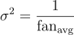
where
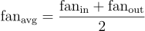
Uniform Distribution:
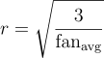
In these formulas, fan<sub>in</sub> is the number of input neurons, and fan<sub>out</sub> is the number of output neurons for a given layer.
Practical Example
In Keras, you can use Glorot Initialization as follows:
# Example of He initialization in TensorFlow
initializer = tf.keras.initializers.HeNormal()
layer = tf.keras.layers.Dense(units=128, activation='relu', kernel_initializer=initializer)
He Initialization
The Principle
He Initialization is particularly well-suited for networks using ReLU (Rectified Linear Unit) activation functions. ReLU tends to zero out negative inputs, which can lead to a loss of variance in the network. To address this, He Initialization sets the variance of the weights to be twice as large as Glorot Initialization.
The Implementation
He Initialization sets the weights using the following formulas:
Normal Distribution:
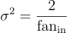
Uniform Distribution:
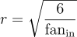
Practical Example
In Keras, you can implement He Initialization like this:
# Example of He initialization in TensorFlow
initializer = tf.keras.initializers.HeNormal()
layer = tf.keras.layers.Dense(units=128, activation='relu', kernel_initializer=initializer)
Why These Initializations Work
Variance Balance
Both Glorot and He Initializations aim to balance the variance of the outputs and gradients across layers. This balance helps maintain a stable flow of gradients during backpropagation, preventing them from vanishing or exploding. By setting the weights based on the number of input and output neurons, these methods ensure that the network learns effectively from the data.
Other Initialization Techniques
LeCun Initialization
LeCun Initialization is designed for networks using the SELU (Scaled Exponential Linear Unit) activation function. It sets the variance as:
Normal Distribution:
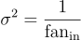
LeCun Initialization works best with SELU because it maintains self-normalizing properties within the network.
Practical Tips for Using Initializations
- Default in Keras: By default, Keras uses Glorot Initialization with a uniform distribution. This is suitable for many activation functions, including tanh, sigmoid, and softmax.
- Changing Initialization: You can specify different initializations when creating a layer in Keras by setting the kernel_initializer parameter.
# Using He initialization with a uniform distribution based on fan_avg
he_avg_init = tf.keras.initializers.VarianceScaling(scale=2., mode='fan_avg', distribution='uniform')
layer = tf.keras.layers.Dense(10, activation='sigmoid', kernel_initializer=he_avg_init)
Conclusion
Proper weight initialization is a crucial step in training deep neural networks effectively. Glorot and He Initializations have been proven to work well in practice by maintaining the variance of activations and gradients across layers. By using these techniques, you can ensure that your neural network trains efficiently and achieves better performance.
Understanding and applying these initialization methods will give you a solid foundation for building robust neural networks. Happy learning!

The Need for Proper Initialization
In a neural network, the signal needs to flow correctly in two directions:
- Forward Direction: When making predictions, the input data is passed through the network to generate an output.
- Reverse Direction: During backpropagation, the error gradient is propagated back through the network to update the weights.
For the network to learn effectively, we want the signal to neither die out nor explode. This means maintaining a consistent variance of the outputs and gradients through each layer.
Glorot (Xavier) Initialization
The Principle
Glorot and Bengio proposed that for the signal to flow properly, the variance of the outputs of each layer should be equal to the variance of its inputs. Additionally, the gradients should maintain equal variance before and after flowing through a layer during backpropagation. This helps prevent the gradients from vanishing or exploding.
The Implementation
To achieve this, they introduced the Glorot Initialization, which sets the weights of each layer according to the following formulas:
Normal Distribution:

where

Uniform Distribution:

In these formulas, fan<sub>in</sub> is the number of input neurons, and fan<sub>out</sub> is the number of output neurons for a given layer.
Practical Example
In Keras, you can use Glorot Initialization as follows:
# Example of He initialization in TensorFlow
initializer = tf.keras.initializers.HeNormal()
layer = tf.keras.layers.Dense(units=128, activation='relu', kernel_initializer=initializer)
He Initialization
The Principle
He Initialization is particularly well-suited for networks using ReLU (Rectified Linear Unit) activation functions. ReLU tends to zero out negative inputs, which can lead to a loss of variance in the network. To address this, He Initialization sets the variance of the weights to be twice as large as Glorot Initialization.
The Implementation
He Initialization sets the weights using the following formulas:
Normal Distribution:

Uniform Distribution:

Practical Example
In Keras, you can implement He Initialization like this:
# Example of He initialization in TensorFlow
initializer = tf.keras.initializers.HeNormal()
layer = tf.keras.layers.Dense(units=128, activation='relu', kernel_initializer=initializer)
Why These Initializations Work
Variance Balance
Both Glorot and He Initializations aim to balance the variance of the outputs and gradients across layers. This balance helps maintain a stable flow of gradients during backpropagation, preventing them from vanishing or exploding. By setting the weights based on the number of input and output neurons, these methods ensure that the network learns effectively from the data.
Other Initialization Techniques
LeCun Initialization
LeCun Initialization is designed for networks using the SELU (Scaled Exponential Linear Unit) activation function. It sets the variance as:
Normal Distribution:

LeCun Initialization works best with SELU because it maintains self-normalizing properties within the network.
Practical Tips for Using Initializations
- Default in Keras: By default, Keras uses Glorot Initialization with a uniform distribution. This is suitable for many activation functions, including tanh, sigmoid, and softmax.
- Changing Initialization: You can specify different initializations when creating a layer in Keras by setting the kernel_initializer parameter.
# Using He initialization with a uniform distribution based on fan_avg
he_avg_init = tf.keras.initializers.VarianceScaling(scale=2., mode='fan_avg', distribution='uniform')
layer = tf.keras.layers.Dense(10, activation='sigmoid', kernel_initializer=he_avg_init)
Conclusion
Proper weight initialization is a crucial step in training deep neural networks effectively. Glorot and He Initializations have been proven to work well in practice by maintaining the variance of activations and gradients across layers. By using these techniques, you can ensure that your neural network trains efficiently and achieves better performance.

# -*- coding: utf-8 -*-
"""Untitled26.ipynb

Automatically generated by Colab.

Original file is located at
https://colab.research.google.com/drive/1Z3pWYFWgUKP7htokOj201APi574a3-vY
"""

import numpy as np
import pandas as pd
import matplotlib.pyplot as plt

df = pd.read_csv('/content/ushape.csv')

df.head()

plt.scatter(df['X'],df['Y'],c=df['class'])

X = df.iloc[:,0:2].values
y = df.iloc[:,-1].values

import tensorflow
from tensorflow import keras
from keras import Sequential
from keras.layers import Dense

model = Sequential()

model.add(Dense(10,activation='relu',input_dim=2,kernel_initializer='he_normal'))
model.add(Dense(10,activation='relu',kernel_initializer='he_normal'))
model.add(Dense(10,activation='relu',kernel_initializer='he_normal'))
model.add(Dense(10,activation='relu',kernel_initializer='he_normal'))
model.add(Dense(1,activation='sigmoid'))

model.summary()

model.get_weights()

initial_weights = model.get_weights()

initial_weights[0] = np.random.randn(2,10)*np.sqrt(1/2)
initial_weights[1] = np.zeros(model.get_weights()[1].shape)
initial_weights[2] = np.random.randn(10,10)*np.sqrt(1/10)
initial_weights[3] = np.zeros(model.get_weights()[3].shape)
initial_weights[4] = np.random.randn(10,10)*np.sqrt(1/10)
initial_weights[5] = np.zeros(model.get_weights()[5].shape)
initial_weights[6] = np.random.randn(10,10)*np.sqrt(1/10)
initial_weights[7] = np.zeros(model.get_weights()[7].shape)
initial_weights[8] = np.random.randn(10,1)*np.sqrt(1/10)
initial_weights[9] = np.zeros(model.get_weights()[9].shape)

model.set_weights(initial_weights)

model.get_weights()

model.compile(loss='binary_crossentropy',optimizer='adam',metrics=['accuracy'])

history = model.fit(X,y,epochs=100,validation_split=0.2)

model.get_weights()

from mlxtend.plotting import plot_decision_regions
plot_decision_regions(X,y.astype('int'), clf=model, legend=2)

(np.random.randn(10,10)*0.01).min()

(np.random.randn(10,10)*0.01).max()

Batch Normalization in Deep Learning | Batch Learning in Keras

What is Batch Normalization?
Batch normalization is a technique in deep learning that normalizes the output of each layer in a neural network. It was introduced by Sergey Ioffe and Christian Szegedy in 2015, with the goal of making the training process faster and more stable.
Simple Definition:
Batch normalization is an algorithmic method that helps improve the speed and stability of training deep neural networks. It does this by normalizing the inputs of each layer to have a mean of zero and a standard deviation of one.
Let’s break down the benefits of this technique.
Why Do We Use Batch Normalization?
- Faster Training: Normalizing inputs helps in quicker convergence (reaching the optimal solution faster).
- Stable Training: It prevents extreme changes in activations between layers, reducing the chances of getting stuck or diverging during training.
- Improves Learning Rates: Batch normalization allows us to use higher learning rates without risking unstable training.
- Reduces Overfitting: It introduces a slight regularization effect, which can help prevent the model from memorizing data (overfitting).
Example: Training Without Batch Normalization
Imagine training a neural network to predict student performance based on input features like CGPA and IQ. If these features are on different scales (CGPA between 0–10, IQ between 90–130), it can cause the network to train slower and sometimes lead to suboptimal results.
This is where batch normalization comes in!
How Does Batch Normalization Work?
Step 1: Normalization
During training, the inputs of each layer are normalized by subtracting the mean and dividing by the standard deviation of the current batch. This brings the values closer to a mean of 0 and a standard deviation of 1.
Formula for normalization:
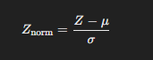
where:
- Z is the activation output from a neuron,
- μ is the mean of the batch,
- σ is the standard deviation of the batch.
Step 2: Scaling and Shifting
After normalization, the model learns parameters called gamma (γ) and beta (β) that help scale and shift the normalized data. This enables the network to learn different distributions.
Final transformation:
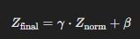
Example:
Consider a neural network layer with activations of four neurons. Each activation is normalized within the batch to a mean of 0 and standard deviation of 1. Then, using learned gamma and beta values, the activations are adjusted to help the network learn more effectively.
Internal Covariate Shift
When training neural networks, layer activations can shift due to changes in network parameters. This shift, called internal covariate shift, can make training unstable and slow. Batch normalization helps counter this by keeping layer outputs in a stable range, allowing for smoother training.
Batch Normalization During Testing
During testing, we don’t have batches like in training. Instead, we use an exponentially weighted moving average of the means and variances calculated during training to ensure consistent scaling.
Advantages of Batch Normalization
1. Stabilized Training
Batch normalization reduces the likelihood of gradient explosion or vanishing, making it easier to train deep networks.
2. Faster Training with Higher Learning Rates
With normalized inputs, we can safely increase the learning rate, which reduces training time.
3. Acts as a Regularizer
Batch normalization introduces a slight randomness to each layer’s activations, which can prevent overfitting.
4. Less Sensitivity to Weight Initialization
With normalized inputs, the initial weights of neurons have less impact on training, making it easier to tune neural networks.
Batch Normalization Example Code in Python (Using Keras)
Here’s a simple example of how you can add batch normalization to a neural network using Python and Keras:
import tensorflow as tf
from tensorflow.keras.models import Sequential
from tensorflow.keras.layers import Dense, BatchNormalization
# Create a simple model with batch normalization
model = Sequential([
Dense(64, input_shape=(20,), activation='relu'),
BatchNormalization(),
Dense(32, activation='relu'),
BatchNormalization(),
Dense(1, activation='sigmoid')
])# Compile the model
model.compile(optimizer='adam', loss='binary_crossentropy', metrics=['accuracy'])# Summary of the model
model.summary()
Summary
Batch normalization is a powerful technique in deep learning, especially for training deep neural networks. By normalizing activations in each batch, it stabilizes and accelerates training, improves performance, and helps prevent overfitting. For anyone looking to improve their neural network’s training stability and speed, batch normalization is an essential tool.
Key Takeaways:
- Normalizes activations: Maintains a mean of 0 and standard deviation of 1 in each batch.
- Improves learning rates: Enables using higher learning rates.
- Acts as a regularizer: Reduces overfitting without the need for dropout.
- Stable and fast training: Reduces internal covariate shift, making training faster and more stable.
What is Batch Normalization?
Before entering into Batch normalization, let’s understand the term “Normalization”.
Normalization is a data pre-processing tool that brings numerical data to a common scale without distorting its shape.
Generally, when we input the data to a machine learning algorithm or deep learning algorithm, we tend to change the values to a balanced scale. We normalize partly to ensure that our model can generalize appropriately.
Now, back to batch normalization is a process that makes neural networks faster and more stable by adding extra layers to a deep neural network. The new layer performs the standardizing and normalizing operations on the input of a layer coming from a previous layer.
But what is the reason behind the term “Batch” in batch normalization? A typical neural network is trained using a collected input data set called batch. Similarly, the normalizing process takes place in batches, not as a single input.
Let’s understand this through an example. We have a deep neural network, as shown in the following image.
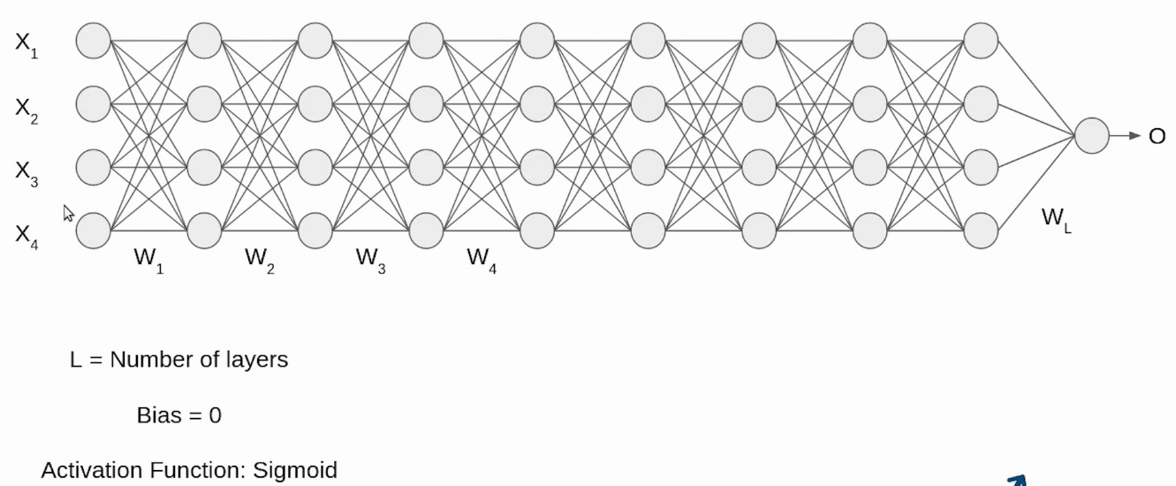
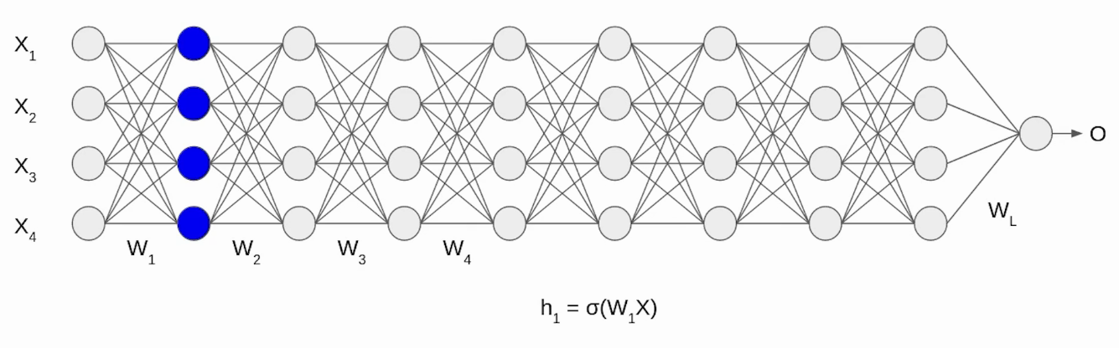
Initially, our inputs X1, X2, X3, and X4 are normalized as they come from the pre-processing stage. When the input passes through the first layer, it transforms as a sigmoid function applied over the dot product of input X and the weight matrix W. Similarly, this transformation will take place for the second layer and continue until the last layer L, as shown in the following image.
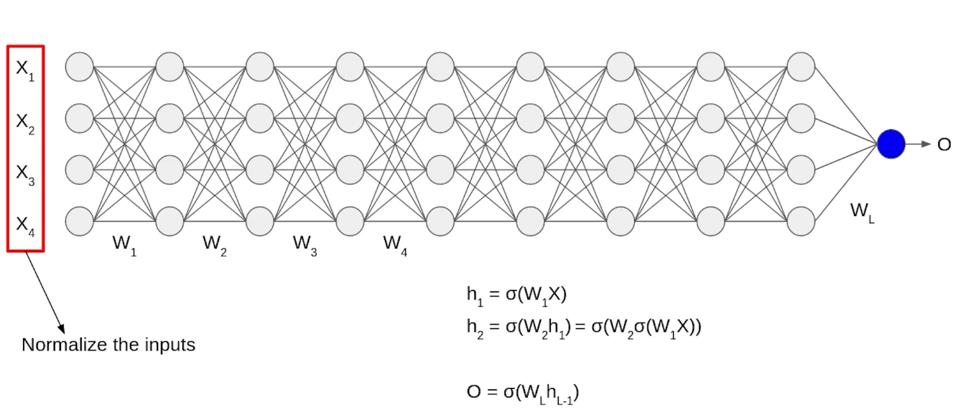
Although our input X was normalized with time, the output will no longer be on the same scale. As the data pass through multiple layers of the neural network and L activation functions are applied, it leads to an internal co-variate shift in the data.
How does Batch Normalization work?
Since we now have a clear idea of why we need Batch Normalization in CNN, let’s understand how it works. It is a two-step process. First, the input is normalized, and later, rescaling and offsetting are performed.
Normalization of the Input
Normalization is the process of transforming the data to have a mean zero and standard deviation one. In this step we have our batch input from layer h, first, we need to calculate the mean of this hidden activation.
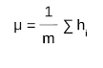
Here, m is the number of neurons at layer h.
Once we have achieved our goal, the next step is to calculate the standard deviation of the hidden activations.
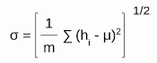
Further, as we have the mean and the standard deviation ready. We will normalize the hidden activations using these values. For this, we will subtract the mean from each input and divide the whole value with the sum of standard deviation and the smoothing term (ε).
The smoothing term(ε) assures numerical stability within the operation by stopping a division by a zero value.
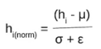
Rescaling of Offsetting
In the final operation, the input is re-scaled and offset. Here, two components of the BN algorithm come into the picture: γ(gamma) and β (beta). These parameters are used for re-scaling (γ) and shifting(β) of the vector containing values from the previous operations.
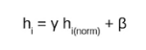
These two are learnable parameters. During the training, the neural network ensures the optimal values of γ and β are used. This will enable the accurate normalization of each batch.
Batch Normalization Techniques
Batch normalization is a deep learning technique that helps our models learn and adapt quickly. It’s like a teacher who helps students by breaking down complex topics into simpler parts.
Why do we need it?
Imagine you’re trying to hit a moving target with a dart. It would be much harder than hitting a stationary one, right? Similarly, in deep learning, our target keeps changing during training due to the continuous updates in weights and biases. This is known as the “internal covariate shift”. Batch normalization helps us stabilize this moving target, making our task easier.
How does it work?
Batch normalization works by normalizing the output of a previous activation layer by subtracting the batch mean and dividing by the batch standard deviation. However, these normalized values may not follow the original distribution. To tackle this, batch normalization introduces two learnable parameters, gamma and beta, which can shift and scale the normalized values.
Benefits of Batch Normalization
- Speeds up learning: Reducing internal covariate shift helps the model train faster.
- Regularizes the model: It adds a little noise to your model, and in some cases, you might not even need to use dropout or other regularization techniques.
- Allows higher learning rates: Gradient descent usually requires small learning rates for the network to converge. Batch normalization helps us use much larger learning rates, speeding up the training process.
Advantages of Batch Normalization
Now, let’s look into the advantages the BN process offers.
Speed Up the Training
By Normalizing the hidden layer activation, the Batch Normalization in CNN speeds up the training process.
Handles internal covariate shift
It solves the problem of internal covariate shift. Through this, we ensure that the input for every layer is distributed around the same mean and standard deviation. If you are unaware of what is an internal covariate shift, look at the following example.
Internal covariate shift
Suppose we train an image classification model that classifies images into Dog or Not Dog. Let’s say we have images of white dogs only. These images will also have a certain distribution. Using these images will update the model’s parameters.
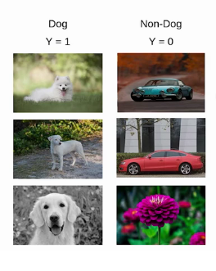
Later, if we get a new set of images consisting of non-white dogs, these new images will have a slightly different distribution from the previous images. Now, the model will change its parameters according to these new images. Hence, the distribution of the hidden activation will also change. This change in hidden activation is known as an internal covariate shift.
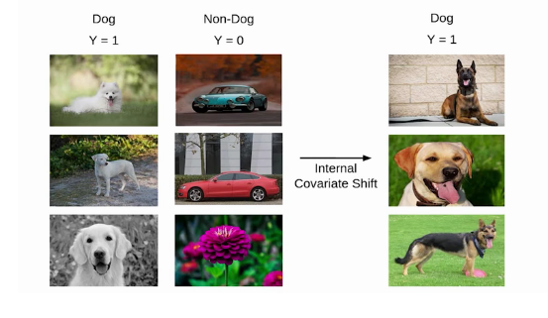
However, according to a study by MIT researchers, batch normalization does not solve the problem of internal covariate shift.
In this research, they trained three models
Model-1: standard VGG network without batch normalization.
Model-2: Standard VGG network with batch normalization.
Model-3: Standard VGG with batch normalization and random noise.

# -*- coding: utf-8 -*-
"""batch-norm-example.ipynb

Automatically generated by Colab.

Original file is located at
https://colab.research.google.com/drive/1473vOd0lCPbRW-co_Rm-_TBXgeajkJZ_
"""

import numpy as np
import pandas as pd
import matplotlib.pyplot as plt

df = pd.read_csv('/content/concertriccir2.csv')

df.head()

plt.scatter(df['X'],df['Y'],c=df['class'])

X = df.iloc[:,0:2].values
y = df.iloc[:,-1].values

import tensorflow
from tensorflow import keras
from keras import Sequential
from keras.layers import Dense
from tensorflow.keras.layers import BatchNormalization

model = Sequential()

model.add(Dense(2,activation='relu',input_dim=2))
model.add(Dense(2,activation='relu'))
model.add(Dense(1,activation='sigmoid'))

model.summary()

model.compile(loss='binary_crossentropy',optimizer='adam',metrics=['accuracy'])

history1 = model.fit(X,y,epochs=200,validation_split=0.2)

model = Sequential()

model.add(Dense(3,activation='relu',input_dim=2))
model.add(BatchNormalization())
model.add(Dense(2,activation='relu'))
model.add(BatchNormalization())
model.add(Dense(1,activation='sigmoid'))

model.summary()

model.compile(loss='binary_crossentropy',optimizer='adam',metrics=['accuracy'])

history2 = model.fit(X,y,epochs=200,validation_split=0.2)

plt.plot(history1.history['val_accuracy'],color='black')
plt.plot(history2.history['val_accuracy'],color='green')

=====

Optimizers in Deep Learning | Part 1 | Complete Deep Learning Course
Adam Optimizer Explained in Detail with Animations | Optimizers in Deep Learning Part 5

What is Optimizer?
In deep learning, an optimizer is a crucial element that fine-tunes a neural network’s parameters during training. Its primary role is to minimize the model’s error or loss function, enhancing performance. Various optimization algorithms, known as optimizers, employ distinct strategies to converge towards optimal parameter values for improved predictions efficiently.
What are Optimizers in Deep Learning?
In deep learning, optimizers are crucial as algorithms that dynamically fine-tune a model’s parameters throughout the training process, aiming to minimize a predefined loss function. These specialized algorithms facilitate the learning process of neural networks by iteratively refining the weights and biases based on the feedback received from the data. Well-known optimizers in deep learning encompass Stochastic Gradient Descent (SGD), Adam, and RMSprop, each equipped with distinct update rules, learning rates, and momentum strategies, all geared towards the overarching goal of discovering and converging upon optimal model parameters, thereby enhancing overall performance.
Choosing the Right Optimizer
Optimizer algorithms are essential for enhancing the performance of deep learning models by improving accuracy and training speed. They adjust the neural network’s weights and learning rates during each training epoch to minimize the loss function. Given that deep learning models often have millions of parameters, selecting the right optimization algorithm is crucial for effective training. Therefore, a solid understanding of these algorithms is vital for data scientists venturing into the field. Check out how to Choose optimizer:
- Optimizers adjust weights and learning rates in machine learning models.
- The choice of optimizer depends on the specific application.
- Beginners may be tempted to try all optimizers to find the best one.
- Randomly selecting optimizers can waste time with large datasets.
- A single epoch can be time-consuming when working with hundreds of gigabytes of data.
- This guide covers various deep-learning optimizers, including Gradient Descent and others.
- Optimizers discussed include Stochastic Gradient Descent, Mini-Batch Gradient Descent, Adagrad, RMSProp, AdaDelta, and Adam.
- By the end of the article, readers will compare different optimizers and understand their procedures
Important Deep Learning Terms
Before proceeding, there are a few terms that you should be familiar with.
- Epoch – The number of times the algorithm runs on the whole training dataset.
- Sample – A single row of a dataset.
- Batch – It denotes the number of samples to be taken to for updating the model parameters.
- Learning rate – It is a parameter that provides the model a scale of how much model weights should be updated.
- Cost Function/Loss Function – A cost function is used to calculate the cost, which is the difference between the predicted value and the actual value.
- Weights/ Bias – The learnable parameters in a model that controls the signal between two neurons.

Gradient Descent in Neural Networks | Batch vs Stochastics vs Mini Batch Gradient Descent
Now let’s explore each optimizer.
Gradient Descent Deep Learning Optimizer
Gradient Descent can be considered the popular kid among the class of optimizers in deep learning. This optimization algorithm uses calculus to consistently modify the values and achieve the local minimum. Before moving ahead, you might question what a gradient is.
In simple terms, consider you are holding a ball resting at the top of a bowl. When you lose the ball, it goes along the steepest direction and eventually settles at the bottom of the bowl. A Gradient provides the ball in the steepest direction to reach the local minimum which is the bottom of the bowl.
The above equation means how the gradient is calculated. Here alpha is the step size that represents how far to move against each gradient with each iteration.
Gradient descent works as follows:
- Initialize Coefficients: Start with initial coefficients.
- Evaluate Cost: Calculate the cost associated with these coefficients.
- Search for Lower Cost: Look for a cost value lower than the current one.
- Update Coefficients: Move towards the lower cost by updating the coefficients’ values.
- Repeat Process: Continue this process iteratively.
- Reach Local Minimum: Stop when a local minimum is reached, where further cost reduction is not possible.
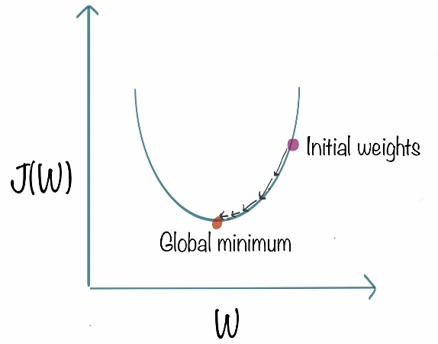
Gradient descent works best for most purposes. However, it has some downsides too. It is expensive to calculate the gradients if the size of the data is huge. Gradient descent works well for convex functions, but it doesn’t know how far to travel along the gradient for nonconvex functions.

Gradient Descent
Gradient descent is an optimization algorithm based on a convex function and tweaks its parameters iteratively to minimize a given function to its local minimum. Gradient Descent iteratively reduces a loss function by moving in the direction opposite to that of steepest ascent. It is dependent on the derivatives of the loss function for finding minima. uses the data of the entire training set to calculate the gradient of the cost function to the parameters which requires large amount of memory and slows down the process.
Press enter or click to view image in full size
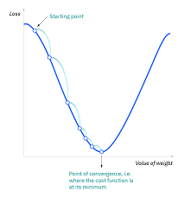
Gradient Descent
Press enter or click to view image in full size
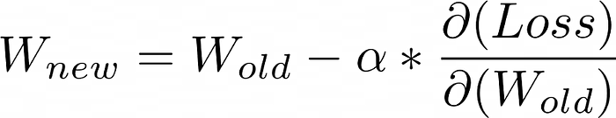
Advantages of Gradient Descent
- Easy to understand
- Easy to implement
Disadvantages of Gradient Descent
- Because this method calculates the gradient for the entire data set in one update, the calculation is very slow.
- It requires large memory and it is computationally expensive.

Learning Rate
How big/small the steps are gradient descent takes into the direction of the local minimum are determined by the learning rate, which figures out how fast or slow we will move towards the optimal weights.
Press enter or click to view image in full size
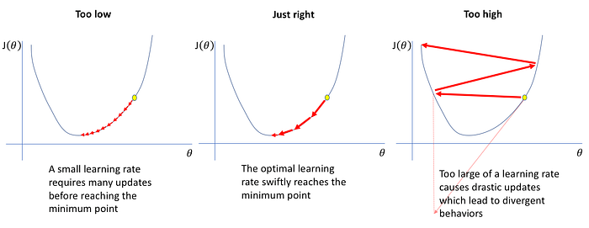

Stochastic Gradient Descent Deep Learning Optimizer
At the end of the previous section, you learned why there might be better options than using gradient descent on massive data. To tackle the challenges large datasets pose, we have stochastic gradient descent, a popular approach among optimizers in deep learning. The term stochastic denotes the element of randomness upon which the algorithm relies. In stochastic gradient descent, instead of processing the entire dataset during each iteration, we randomly select batches of data. This implies that only a few samples from the dataset are considered at a time, allowing for more efficient and computationally feasible optimization in deep learning models.
The procedure is first to select the initial parameters w and learning rate n. Then randomly shuffle the data at each iteration to reach an approximate minimum.
Since we are not using the whole dataset but the batches of it for each iteration, the path taken by the algorithm is full of noise as compared to the gradient descent algorithm. Thus, SGD uses a higher number of iterations to reach the local minima. Due to an increase in the number of iterations, the overall computation time increases. But even after increasing the number of iterations, the computation cost is still less than that of the gradient descent optimizer. So the conclusion is if the data is enormous and computational time is an essential factor, stochastic gradient descent should be preferred over batch gradient descent algorithm.
It is a variant of Gradient Descent. It update the model parameters one by one. If the model has 10K dataset SGD will update the model parameters 10k times.
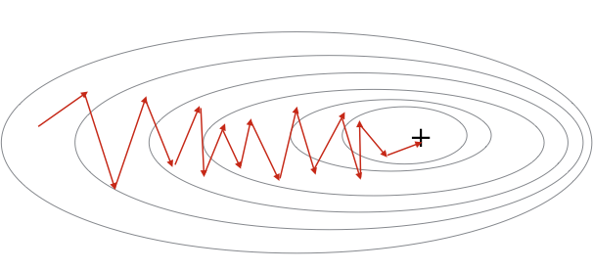
Stochastic Gradient Descent
Advantages of Stochastic Gradient Descent
- Frequent updates of model parameter
- Requires less Memory.
- Allows the use of large data sets as it has to update only one example at a time.
Disadvantages of Stochastic Gradient Descent
- The frequent can also result in noisy gradients which may cause the error to increase instead of decreasing it.
- High Variance.
- Frequent updates are computationally expensive.

SGD with Momentum Explained in Detail with Animations | Optimizers in Deep Learning Part 2
Stochastic Gradient Descent With Momentum Deep Learning Optimizer
As discussed in the earlier section, you have learned that stochastic gradient descent takes a much more noisy path than the gradient descent algorithm when addressing optimizers in deep learning. Due to this, it requires a more significant number of iterations to reach the optimal minimum, and hence, computation time is very slow. To overcome the problem, we use stochastic gradient descent with a momentum algorithm.
What the momentum does is helps in faster convergence of the loss function. Stochastic gradient descent oscillates between either direction of the gradient and updates the weights accordingly. However, adding a fraction of the previous update to the current update will make the process a bit faster. One thing that should be remembered while using this algorithm is that the learning rate should be decreased with a high momentum term.
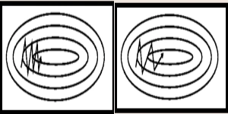
In the above image, the left part shows the convergence graph of the stochastic gradient descent algorithm. At the same time, the right side shows SGD with momentum. From the image, you can compare the path chosen by both algorithms and realize that using momentum helps reach convergence in less time. You might be thinking of using a large momentum and learning rate to make the process even faster. But remember that while increasing the momentum, the possibility of passing the optimal minimum also increases. This might result in poor accuracy and even more oscillations.

Checkout this article – Coding Neural Networks From Scratch in Python and R
Mini Batch Gradient Descent Deep Learning Optimizer
In this variant of gradient descent, instead of using all the training data, we only use a subset of the dataset to calculate the loss function. Since we use a batch of data instead of the whole dataset, we need fewer iterations. That is why the mini-batch gradient descent algorithm is faster than both stochastic gradient descent and batch gradient descent algorithms. This algorithm is more efficient and robust than the earlier variants of gradient descent. As the algorithm uses batching, you do not need to load all the training data into memory, which makes the process more efficient to implement. Moreover, the cost function in mini-batch gradient descent is noisier than the batch gradient descent algorithm but smoother than that of the stochastic gradient descent algorithm. Because of this, mini-batch gradient descent is ideal and provides a good balance between speed and accuracy.
Despite all that, the mini-batch gradient descent algorithm has some downsides too. It requires a hyperparameter called ‘mini-batch-size,’ which you must tune to achieve the required accuracy. A batch size of 32 is generally appropriate for almost every case. Also, in some cases, it results in poor final accuracy. Due to this, there needs a rise to look for other alternatives too.
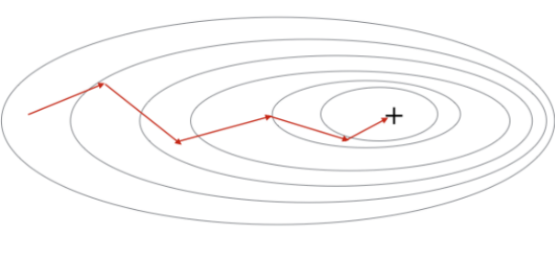
Mini Batch Gradient Descent
Advantages of Mini Batch Gradient Descent:
- It leads to more stable convergence.
- more efficient gradient calculations.
- Requires less amount of memory.
Disadvantages of Mini Batch Gradient Descent
- Mini-batch gradient descent does not guarantee good convergence,
- If the learning rate is too small, the convergence rate will be slow. If it is too large, the loss function will oscillate or even deviate at the minimum value.

AdaGrad Explained in Detail with Animations | Optimizers in Deep Learning Part 4
Adagrad (Adaptive Gradient Descent) Deep Learning Optimizer
The adaptive gradient descent algorithm is slightly different from other gradient descent algorithms. This is because it uses different learning rates for each iteration. The change in learning rate depends upon the difference in the parameters during training. The more the parameters get changed, the more minor the learning rate changes. This modification is highly beneficial because real-world datasets contain sparse as well as dense features. So it is unfair to have the same value of learning rate for all the features. The Adagrad algorithm uses the below formula to update the weights. Here the alpha(t) denotes the different learning rates at each iteration, n is a constant, and E is a small positive to avoid division by 0.
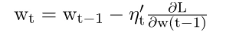
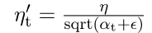
The benefit of using Adagrad is that it abolishes the need to modify the learning rate manually. It is more reliable than gradient descent algorithms and their variants, and it reaches convergence at a higher speed.
One downside of the AdaGrad optimizer is that it decreases the learning rate aggressively and monotonically. There might be a point when the learning rate becomes extremely small. This is because the squared gradients in the denominator keep accumulating, and thus the denominator part keeps on increasing. Small learning rates prevent the model from acquiring more knowledge, which compromises its accuracy.
RMSProp Explained in Detail with Animations | Optimizers in Deep Learning Part 5
RMS Prop (Root Mean Square) Deep Learning Optimizer
RMS prop is one of the popular optimizers among deep learning enthusiasts. This is maybe because it hasn’t been published but is still very well-known in the community. RMS prop is ideally an extension of the work RPPROP. It resolves the problem of varying gradients. The problem with the gradients is that some of them were small while others may be huge. So, defining a single learning rate might not be the best idea. RPPROP uses the gradient sign, adapting the step size individually for each weight. In this algorithm, the two gradients are first compared for signs. If they have the same sign, we’re going in the right direction, increasing the step size by a small fraction. If they have opposite signs, we must decrease the step size. Then we limit the step size and can now go for the weight update.
The problem with RPPROP is that it doesn’t work well with large datasets and when we want to perform mini-batch updates. So, achieving the robustness of RPPROP and the efficiency of mini-batches simultaneously was the main motivation behind the rise of RMS prop. RMS prop is an advancement in AdaGrad optimizer as it reduces the monotonically decreasing learning rate.
RMS Prop Formula
The algorithm mainly focuses on accelerating the optimization process by decreasing the number of function evaluations to reach the local minimum. The algorithm keeps the moving average of squared gradients for every weight and divides the gradient by the square root of the mean square.
where gamma is the forgetting factor. Weights are updated by the below formula
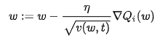
In simpler terms, if there exists a parameter due to which the cost function oscillates a lot, we want to penalize the update of this parameter. Suppose you built a model to classify a variety of fishes. The model relies on the factor ‘color’ mainly to differentiate between the fishes. Due to this, it makes a lot of errors. What RMS Prop does is, penalize the parameter ‘color’ so that it can rely on other features too. This prevents the algorithm from adapting too quickly to changes in the parameter ‘color’ compared to other parameters. This algorithm has several benefits as compared to earlier versions of gradient descent algorithms. The algorithm converges quickly and requires lesser tuning than gradient descent algorithms and their variants.
The problem with RMS Prop is that the learning rate has to be defined manually, and the suggested value doesn’t work for every application.

AdaDelta Deep Learning Optimizer
AdaDelta can be seen as a more robust version of the AdaGrad optimizer. It is based upon adaptive learning and is designed to deal with significant drawbacks of AdaGrad and RMS prop optimizer. The main problem with the above two optimizers is that the initial learning rate must be defined manually. One other problem is the decaying learning rate which becomes infinitesimally small at some point. Due to this, a certain number of iterations later, the model can no longer learn new knowledge.
To deal with these problems, AdaDelta uses two state variables to store the leaky average of the second moment gradient and a leaky average of the second moment of change of parameters in the model.
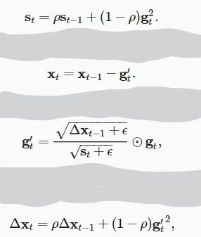
Here St and delta Xt denote the state variables, g’t denotes rescaled gradient, delta Xt-1 denotes squares rescaled gradients, and epsilon represents a small positive integer to handle division by 0.

Adam Optimizer in Deep Learning
Adam optimizer, short for Adaptive Moment Estimation optimizer, serves as an optimization algorithm commonly used in deep learning. It extends the stochastic gradient descent (SGD) algorithm and updates the weights of a neural network during training.
The name ‘Adam’ comes from ‘adaptive moment estimation,’ highlighting its ability to adaptively adjust the learning rate for each network weight individually. Unlike SGD, which maintains a single learning rate throughout training, Adam optimizer dynamically computes individual learning rates based on the past gradients and their second moments.
The creators of Adam optimizer incorporated the beneficial features of other optimization algorithms such as AdaGrad and RMSProp. Similar to RMSProp, Adam optimizer considers the second moment of the gradients, but unlike RMSProp, it calculates the uncentered variance of the gradients (without subtracting the mean).
By incorporating both the first moment (mean) and second moment (uncentered variance) of the gradients, Adam optimizer achieves an adaptive learning rate that can efficiently navigate the optimization landscape during training. This adaptivity helps in faster convergence and improved performance of the neural network.
In summary, Adam optimizer is an optimization algorithm that extends SGD by dynamically adjusting learning rates based on individual weights. It combines the features of AdaGrad and RMSProp to provide efficient and adaptive updates to the network weights during deep learning training.
Adam Optimizer Formula
The adam optimizer has several benefits, due to which it is used widely. It is adapted as a benchmark for deep learning papers and recommended as a default optimization algorithm. Moreover, the algorithm is straightforward to implement, has a faster running time, low memory requirements, and requires less tuning than any other optimization algorithm.
The above formula represents the working of adam optimizer. Here B1 and B2 represent the decay rate of the average of the gradients.
If the adam optimizer uses the good properties of all the algorithms and is the best available optimizer, then why shouldn’t you use Adam in every application? And what was the need to learn about other algorithms in depth? This is because even Adam has some downsides. It tends to focus on faster computation time, whereas algorithms like stochastic gradient descent focus on data points. That’s why algorithms like SGD generalize the data in a better manner at the cost of low computation speed. So, the optimization algorithms can be picked accordingly depending on the requirements and the type of data.

The above visualizations create a better picture in mind and help in comparing the results of various optimization algorithms.

Nesterov Accelerated Gradient (NAG) Explained in Detail | Animations | Optimizers in Deep Learning

Welcome to our next discussion in the deep learning series! In this article, we’ll cover an important optimization technique called Nesterov Accelerated Gradient (NAG), which is commonly used to enhance training speed and stability in neural networks. Building on our previous discussion of momentum-based optimization, this article will explore how NAG works, its advantages, and how to implement it in deep learning libraries like Keras.
What is an Optimizer?
An optimizer is an algorithm used in machine learning to adjust a model’s parameters, such as weights, in order to minimize the loss function and improve model accuracy. Optimization is crucial because it allows the model to learn and generalize better from data.
Common optimizers include gradient descent variants like:
- Batch Gradient Descent: Uses all data points to compute the gradient and update weights. This can be accurate but slow.
- Stochastic Gradient Descent (SGD): Updates weights based on each individual data point, making it faster but less stable.
- Mini-Batch Gradient Descent: Combines the best of both worlds by updating weights based on small, random batches of data points.
Why Use Momentum?
Traditional gradient descent methods can be slow, especially when optimizing complex neural networks. To speed things up, momentum is introduced to keep the model moving in the same direction as the previous steps, thereby helping it overcome areas of slow progress.
Momentum optimization works by adjusting the weights based on both the current gradient and a fraction of the past gradients. This helps prevent oscillations around the optimal value, allowing for smoother and faster convergence. However, even momentum has limitations, particularly when navigating complex error surfaces with multiple valleys and peaks.
Enter Nesterov Accelerated Gradient (NAG)
Nesterov Accelerated Gradient is a refined version of momentum-based optimization, designed to further smooth and speed up convergence. It does so by looking ahead at the future gradient and adjusting accordingly, which helps reduce overshooting and improves stability.
In simple terms, NAG calculates the gradient at a “look-ahead” position rather than the current position. This look-ahead step is what makes NAG more effective at navigating tricky error surfaces, especially in non-convex optimization problems.
How NAG Works: Breaking It Down
To understand NAG, let’s explore how it differs from simple momentum:
- Momentum Update: Traditional momentum calculates an update based on the current gradient and a weighted sum of past gradients, creating a “velocity” term that guides the update direction.
- NAG Update: Instead of calculating the gradient at the current point, NAG takes a look-ahead step using the momentum term. It then computes the gradient at this new look-ahead position and adjusts the update based on this gradient. This approach makes it easier to predict when the optimizer is likely to overshoot, allowing for more controlled updates.
Example:
Imagine rolling a ball down a hill. With simple momentum, you only know the direction you’re moving in and rely on past speed to guide you. But with NAG, it’s like you’re peeking a few steps ahead to see if you’re about to overshoot. This helps you adjust the speed to avoid missing the target.
Mathematical Formulation of NAG
Let’s break down the math behind NAG:
- Calculate the Look-Ahead Point: First, we determine where we’d be if we took a step forward with just the momentum.
where w is the weight, β is the momentum factor, and v(t−1)​ is the previous velocity term.
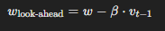
2. Calculate the Gradient at the Look-Ahead Point: We compute the gradient at this position:
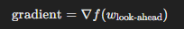
3. Update the Velocity Term: The velocity term is adjusted based on the look-ahead gradient:
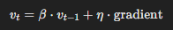
where η is the learning rate.
4. Update the Weights: Finally, the weights are updated based on the look-ahead velocity:
This adjustment helps NAG to better control the update, especially when the model is nearing an optimal point, reducing oscillations that could lead to overshooting.
Advantages of NAG
- Reduced Oscillations: By peeking ahead, NAG reduces oscillations around the minimum, which can be especially useful in error surfaces with multiple peaks and valleys.
- Faster Convergence: NAG often converges faster than simple momentum-based methods because it reduces unnecessary steps around the optimum.
Implementing NAG in Keras
Implementing NAG in Keras is straightforward. Keras provides a Stochastic Gradient Descent (SGD) optimizer that can be configured to use NAG by adjusting the parameters.
Here’s how to set it up:
- SGD without Momentum:
from tensorflow.keras.optimizers import SGD
optimizer = SGD(learning_rate=0.01, momentum=0.0, nesterov=False
- SGD with Momentum:
optimizer = SGD(learning_rate=0.01, momentum=0.9, nesterov=False)
- Nesterov Accelerated Gradient (NAG):
optimizer = SGD(learning_rate=0.01, momentum=0.9, nesterov=True)
Simply set nesterov=True to activate NAG, and you’re all set.

Hands-on Optimizers
We have learned enough theory, and now we need to do some practical analysis. It’s time to try what we have learned and compare the results by choosing different optimizers on a simple neural network. As we are talking about keeping things simple, what’s better than the MNIST dataset? We will train a simple model using some basic layers, keeping the batch size and epochs the same but with different optimizers. For the sake of fairness, we will use the default values with each optimizer.
The steps for building the network are given below:
Import Necessary Libraries
import keras
from keras.datasets import mnist
from keras.models import Sequential
from keras.layers import Dense, Dropout, Flatten
from keras.layers import Conv2D, MaxPooling2D
from keras import backend as K
(x_train, y_train), (x_test, y_test) = mnist.load_data()
print(x_train.shape, y_train.shape)
Load the Dataset
x_train= x_train.reshape(x_train.shape[0],28,28,1)
x_test= x_test.reshape(x_test.shape[0],28,28,1)
input_shape=(28,28,1)
y_train=keras.utils.to_categorical(y_train)#,num_classes=)
y_test=keras.utils.to_categorical(y_test)#, num_classes)
x_train= x_train.astype('float32')
x_test= x_test.astype('float32')
x_train /= 255
x_test /=255
Build the Model
batch_size=64

num_classes=10

epochs=10

def build_model(optimizer):

model=Sequential()

model.add(Conv2D(32,kernel_size=(3,3),activation='relu',input_shape=input_shape))

model.add(MaxPooling2D(pool_size=(2,2)))

model.add(Dropout(0.25))

model.add(Flatten())

model.add(Dense(256, activation='relu'))

model.add(Dropout(0.5))

model.add(Dense(num_classes, activation='softmax'))

model.compile(loss=keras.losses.categorical_crossentropy, optimizer= optimizer, metrics=['accuracy'])

return model
Train the Model
optimizers = ['Adadelta', 'Adagrad', 'Adam', 'RMSprop', 'SGD']

for i in optimizers:

model = build_model(i)

hist=model.fit(x_train, y_train, batch_size=batch_size, epochs=epochs, verbose=1, validation_data=(x_test,y_test))
We have run our model with a batch size of 64 for 10 epochs. After trying the different optimizers, the results we get are pretty interesting. Before analyzing the results, what do you think will be the best optimizer for this dataset?
Table Analysis
Optimizer | Epoch 1  Val accuracy | Val loss | Epoch 5  Val accuracy | Val loss | Epoch 10  Val accuracy | Val loss | Total Time
Adadelta | .4612 | 2.2474 | .7776 | 1.6943 | .8375 | 0.9026 | 8:02 min
Adagrad | .8411 | .7804 | .9133 | .3194 | .9286 | 0.2519 | 7:33 min
Adam | .9772 | .0701 | .9884 | .0344 | .9908 | .0297 | 7:20 min
RMSprop | .9783 | .0712 | .9846 | .0484 | .9857 | .0501 | 10:01 min
SGD with momentum | .9168 | .2929 | .9585 | .1421 | .9697 | .1008 | 7:04 min
SGD | .9124 | .3157 | .9569 | 1451 | .9693 | .1040 | 6:42 min
The above table shows the validation accuracy and loss at different epochs. It also contains the total time that the model took to run on 10 epochs for each optimizer. From the above table, we can make the following analysis.
- The adam optimizer shows the best accuracy in a satisfactory amount of time.
- RMSprop shows similar accuracy to that of Adam but with a comparatively much larger computation time.
- Surprisingly, the SGD algorithm took the least time to train and produced good results as well. But to reach the accuracy of the Adam optimizer, SGD will require more iterations, and hence the computation time will increase.
- SGD with momentum shows similar accuracy to SGD with unexpectedly larger computation time. This means the value of momentum taken needs to be optimized.
- Adadelta shows poor results both with accuracy and computation time.
You can analyze the accuracy of each optimizer with each epoch from the below graph.
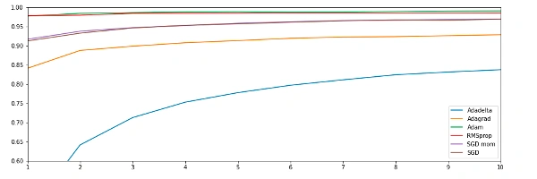
We’ve now reached the end of this comprehensive guide. To refresh your memory, we will go through a summary of every optimization algorithm that we have covered in this guide. To refresh your memory, we will go through a summary of every optimization algorithm that we have covered in this guide.
Conclusion
SGD is a very basic algorithm and is hardly used in applications now due to its slow computation speed. One more problem with that algorithm is the constant learning rate for every epoch. Moreover, it is not able to handle saddle points very well. Adagrad works better than stochastic gradient descent generally due to frequent updates in the learning rate. It is best when used for dealing with sparse data. RMSProp shows results similar to the gradient descent algorithm with momentum; it just differs in how the algorithm calculates the gradients.
Lastly comes the Adam optimizer that inherits the good features of RMSProp and other algorithms. The results of the Adam optimizer are generally better than every other optimization algorithm, have faster computation time, and require fewer parameters for tuning. Adam serves as the recommended default optimizer for most applications due to its effectiveness and versatility. Choosing the Adam optimizer for your application might give you the best probability of getting the best results.
But by the end, we learned that even Adam optimizer has some downsides. Also, there are cases when algorithms like SGD might be beneficial and perform better than Adam optimizer. So, it is of utmost importance to know your requirements and the type of data you are dealing with to choose the best optimization algorithm and achieve outstanding results.

Exponentially Weighted Moving Average or Exponential Weighted Average | Deep Learning
What is EWMA?
The Exponential Weighted Moving Average (EWMA) is a statistical technique used to find trends in time-series data. Unlike a simple moving average, which treats all data points equally, EWMA gives more weight to recent observations. This helps capture more current trends, making it useful in various fields, including finance, stock prediction, and especially in deep learning optimizers like Adam.
Why Use EWMA?
EWMA is highly effective because:
- Smoothing: It helps smooth out data to show trends more clearly.
- Responsiveness: It is more responsive to recent data, making it adaptive to sudden changes.
- Reducing Noise: EWMA reduces random fluctuations, focusing on significant patterns.
How Does EWMA Work?
To calculate EWMA, we assign a decay rate or smoothing factor (usually denoted by α), a value between 0 and 1. The smoothing factor controls how much weight is given to recent values versus past values.
The formula for EWMA at any time ttt is:
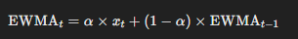
- x(t)​ is the current data point.
- α is the smoothing factor..
- EWMA(t−1)​ is the previous EWMA value.
The higher the value of α, the more weight given to recent data. For example, if α = 0.8, 80% of the EWMA is based on the latest data point, making the EWMA highly responsive to new information.

The Exponentially Weighted Moving Average (EWMA) is commonly used as a smoothing technique in time series. However, due to several computational advantages (fast, low-memory cost), the EWMA is behind the scenes of many optimization algorithms in deep learning, including Gradient Descent with Momentum, RMSprop, Adam, etc.
In order to compute the EWMA, you must define one parameter β. This parameter decides how important the current observation is in the calculation of the EWMA.
Press enter or click to view image in full size
Lets make an example based on the temperatures of Paris, France, in 2019 ([1]).
Press enter or click to view image in full size
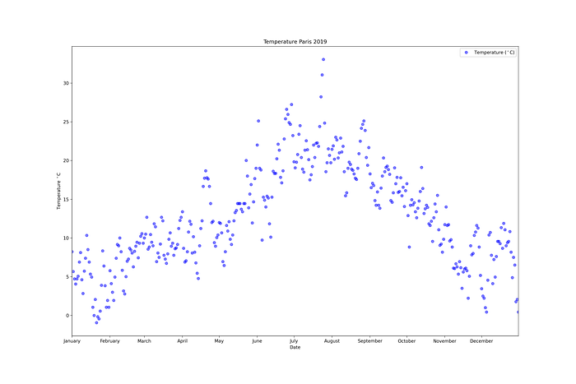
Define:
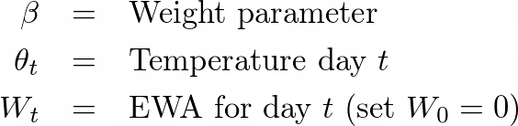
For this example, suppose that β = 0.9, so the EWA aims to combine the temperature of the current day with the previous temperatures.
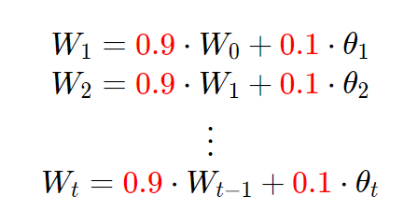
In general to compute the EWA for a given weight parameter β we use
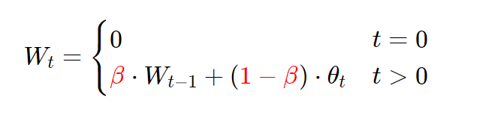
If we plot this in red, we can see that what we get is a moving average of the daily temperature, it’s like a smooth, less noisy curve.
Press enter or click to view image in full size
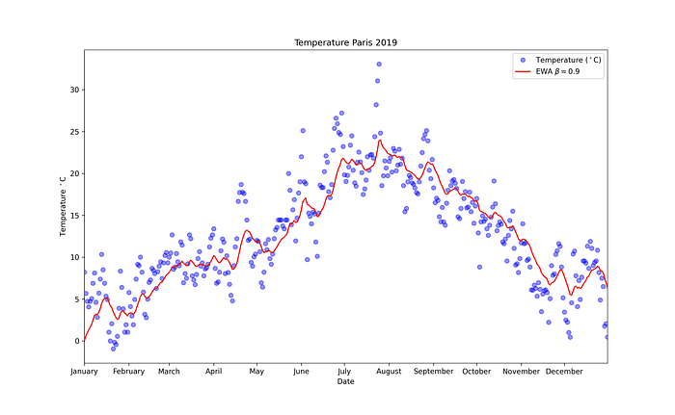
Lets explain a bit more the general equation:
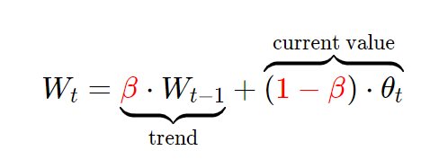
We can see that the value of β determines how important the previous value is (the trend), and (1-β) how important the current value is.
Take a value of β = 0.98 and plot it in green, notice that the curve is smoother because the trend now is more important (and the current temperature value is less important), so it will adapt more slowly when the temperature changes.
Press enter or click to view image in full size
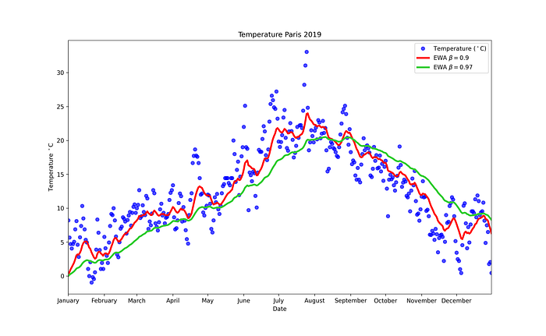
Lets try the other extreme and set β = 0.5, this way the graph you get is noisier, because it is more susceptible to the current temperature (and this includes outliers).
But it adapts more quickly to changes in temperature.
Press enter or click to view image in full size
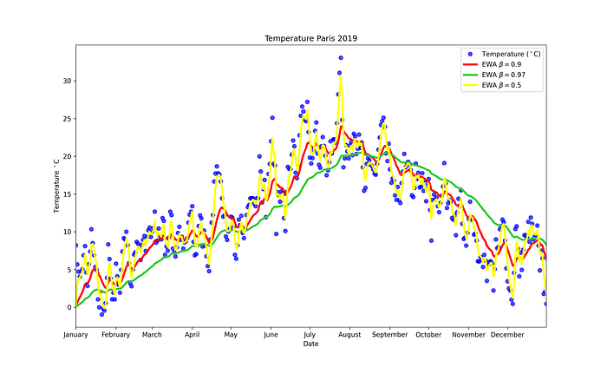
If you want to understand the meaning of the parameter β, you can think of the value
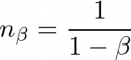
as the numbers of observations used to adapt your EWA.
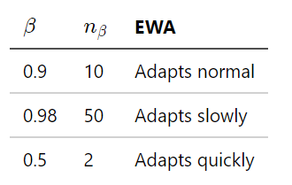
In order to go a little bit deeper into the intuitions of what this algorithm actually does.
Lets expand the 3rd term (W₃) using the main equation:
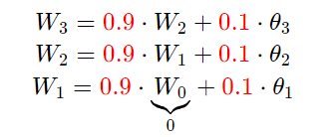
Plugin W₁ in W₂ and then in W₃:
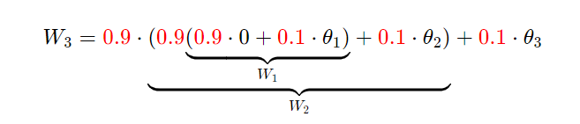
Simplifying
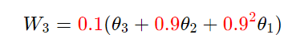
Here it is quite clear what the roll of β = 0.9 parameter is in EWA, we can see older observations are given lower weights. The weights fall exponentially as the data point gets older hence the name exponentially weighted.
In general, we have:
Press enter or click to view image in full size
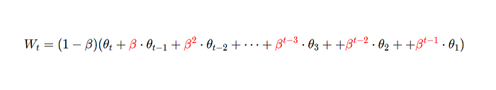
or the closed formula:
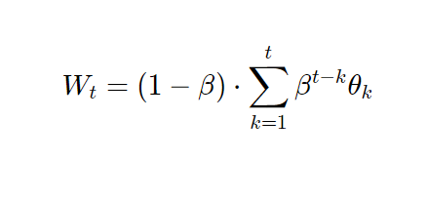
If you are a visual learner, this is another approach:
Rewrite Wₜ using the dot product (*):
Press enter or click to view image in full size
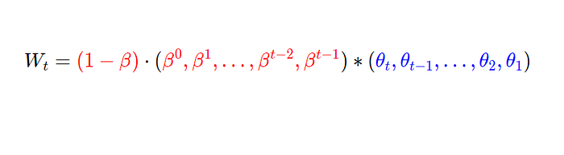
And then think Wₜ as the product of the following two plots:
- Exponential Weights
- Temperature
In this plot we see how the weights decay when t increase:
Press enter or click to view image in full size
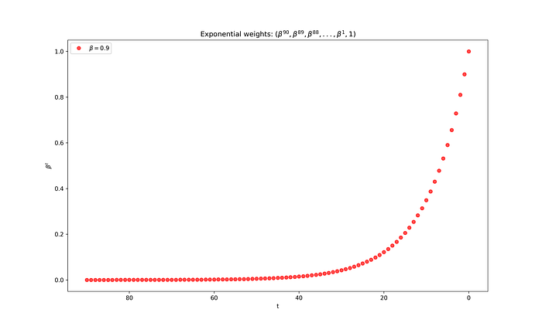
Then plot the temperature
Press enter or click to view image in full size
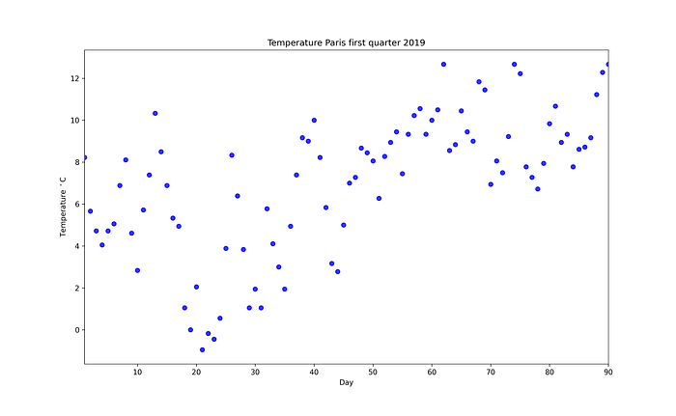
Now in order to get Wₜ, just multiply each point (weights and temperature) and add them up, doing this for each t we obtain the magenta curve.
Press enter or click to view image in full size
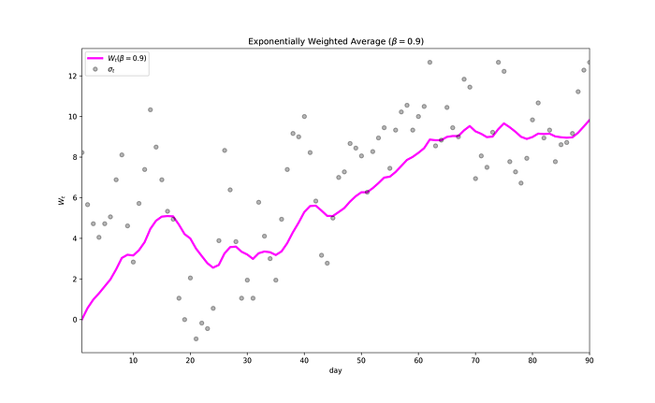
References:

Keras Tuner | Hyperparameter Tuning a Neural Network
Mastering Hyperparameter Tuning for Neural Networks with Keras Tuner

Introduction
In neural networks we have lots of hyperparameters, it is very hard to tune the hyperparameter manually. So, we have Keras Tuner which makes it very simple to tune our hyperparameters of neural networks. It is just like that Grid Search or Randomized Search that you have seen in machine learning.
In this article, you will learn about How to tune your hyperparameters of a neural network using Keras Tuner, we will start with a very simple neural network and then we will do hyperparameter tuning and compare the results. You will learn about everything you need to know about Keras Tuner.

But What are hyperparameters?
Developing deep learning models is an iterative process, You start with an initial architecture then reconfigure until you get a model that can be trained efficiently in terms of time and compute resources.
These settings that you adjust are called hyperparameters, you get the idea, you write code and see the performance, and again you to the same process until you have good performance.
So, there is a way where you can adjust the setting of your neural networks which is called hyperparameters and the process of finding a good set of hyperparameters is called hyperparameter tuning.
Hyperparameter tuning is a very important part of the building, if not done, then it might cause major problems in your model like taking lots of time, useless parameters, and a lot more.
Hyperparameters are usually two types:-
- Model-based hyperparameters:- These types of hyperparameters include, number of hidden layers, neurons, etc.
- Algorithms based:- These types influence the speed as well as efficiencies, like learning rate in Gradient Descent, etc.
The number of hyperparameters can increase dramatically for more complex models, and tuning them manually can be quite challenging.
The benefit of the Keras tuner is that it will help in doing one of the most challenging tasks, i.e. hyperparameter tuning very easily in just some lines of code.

Keras Tuner
Keras tuner is a library for tuning the hyperparameters of a neural network that helps you to pick optimal hyperparameters in your neural network implement in Tensorflow.
For installation of Keras tuner, you have to just run the below command,
pip install keras-tuner
But wait!, Why do we need Keras tuner?
So, the answer is hyperparameters plays an important role in developing a good model, it can make large differences, it will help you to prevent overfitting, it will help you in having good bias and variance trade-off, and a lot more.

Tuning our hyperparameter using Keras Tuner
First, we will develop a baseline model, and then we will use Keras tuner for developing our model. I will be using Tensorflow for implementation.
Step:- 1 ( Download and Prepare the dataset )
from tensorflow import keras # importing keras
(x_train, y_train), (x_test, y_test) = keras.datasets.mnist.load_data() # loading the data using keras datasets api
x_train = x_train.astype('float32') / 255.0 # normalize the training images
x_test = x_test.astype('float32') / 255.0 # normalize the testing images
Step:- 2 ( Developing the baseline model )
Now, we will build our baseline neural network using the mnist dataset that will help in recognizing the digits, so let’s build a deep neural network.
model1 = keras.Sequential()
model1.add(keras.layers.Flatten(input_shape=(28, 28))) # flattening 28 x 28
model1.add(keras.layers.Dense(units=512, activation='relu', name='dense_1')) # you have 512 neurons with relu activation
model1.add(keras.layers.Dropout(0.2)) # we added a dropout layer with the rate of 0.2
model1.add(keras.layers.Dense(10, activation='softmax')) # output layer, where we have total 10 classes
Step:- 3 ( Compiling and Training the model )
Now, we have built our baseline model, now it’s time to compile our model and train the model, we will use Adam optimizer with a learning rate of 0.0, for training we will run our model for 10 epochs, with the validation split of 0.2.
model1.compile(optimizer=keras.optimizers.Adam(learning_rate=0.001),
loss=keras.losses.SparseCategoricalCrossentropy(),
metrics=['accuracy'])
model1.fit(x_train, y_train, epochs=10, validation_split=0.2)
Step:- 4 ( Evaluating our model )
So, now we have trained, now we will evaluate our model on the test set, to see the model performance.
model1_eval = model.evaluate(img_test, label_test, return_dict=True)
Tuning your model using Keras Tuner
Step:- 1 (Importing the libraries)
import tensorflow as tf
import kerastuner as kt
Step:- 2 (Building the model using Keras Tuner)
Now, you will set up a Hyper Model (The model you set up for hypertuning is called a hypermodel), we will define your hypermodel using the model builder function, which you can see in the function below returns the compiled model with tuned hyperparameters.
In the below classification model, we will fine-tune the model hyperparameters which are several neurons as well as the learning rate of the Adam optimizer.
def model_builder(hp):
'''
Args:
hp - Keras tuner object
'''
# Initialize the Sequential API and start stacking the layers
model = keras.Sequential()
model.add(keras.layers.Flatten(input_shape=(28, 28)))
# Tune the number of units in the first Dense layer
# Choose an optimal value between 32-512
hp_units = hp.Int('units', min_value=32, max_value=512, step=32)
model.add(keras.layers.Dense(units=hp_units, activation='relu', name='dense_1'))
# Add next layers
model.add(keras.layers.Dropout(0.2))
model.add(keras.layers.Dense(10, activation='softmax'))
# Tune the learning rate for the optimizer
# Choose an optimal value from 0.01, 0.001, or 0.0001
hp_learning_rate = hp.Choice('learning_rate', values=[1e-2, 1e-3, 1e-4])
model.compile(optimizer=keras.optimizers.Adam(learning_rate=hp_learning_rate),
loss=keras.losses.SparseCategoricalCrossentropy(),
metrics=['accuracy'])
return model
In the above code, here are some notes:-
- Int() method to define the search space for the Dense units. This allows you to set a minimum and maximum value and the step size when incrementing between these values.
- Choice() method for the learning rate. This allows you to define discrete values to include in the search space when hypertuning.
Step:-3) Instantiating the tuner and tuning the hyperparameters
You will HyperBand Tuner, It is an algorithm developed for hyperparameter optimization. It uses adaptive resource allocation and early-stopping to quickly converge on a high-performing model. You can read more about this intuition here.
But the basic algorithm is below in the picture, if you are not able to understand, kindly ignore it and move forward. It’s a large topic that requires another blog.
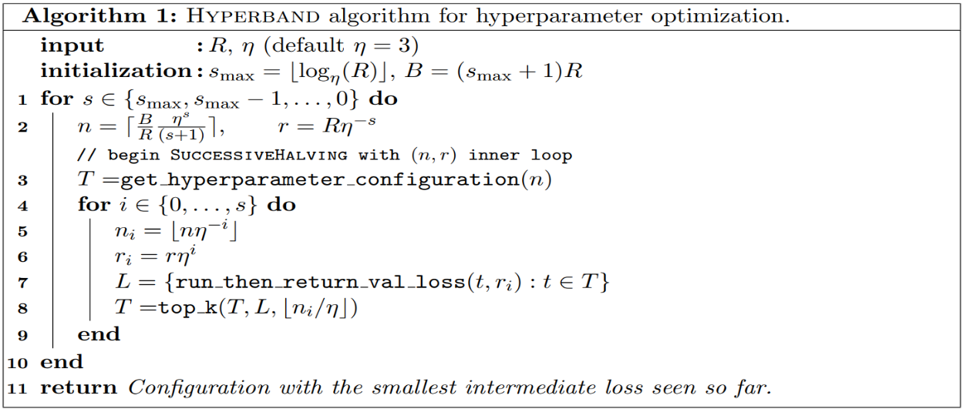
Hyperband determines the number of models to train in a bracket by computing 1 + log_factor(max_epochs) and rounding it up to the nearest integer.
# Instantiate the tuner
tuner = kt.Hyperband(model_builder, # the hypermodel
objective='val_accuracy', # objective to optimize
max_epochs=10,
factor=3, # factor which you have seen above
directory='dir', # directory to save logs
project_name='khyperband')
# hypertuning settings
tuner.search_space_summary()
Output:-

# Search space summary
# Default search space size: 2
# units (Int)
# {'default': None, 'conditions': [], 'min_value': 32, 'max_value': 512, 'step': 32, 'sampling': None}
# learning_rate (Choice)
# {'default': 0.01, 'conditions': [], 'values': [0.01, 0.001, 0.0001], 'ordered': True}
Step:- 4 ( Searching the best hyperparameter )
stop_early = tf.keras.callbacks.EarlyStopping(monitor='val_loss', patience=5)
# Perform hypertuning
tuner.search(x_train, y_train, epochs=10, validation_split=0.2, callbacks=[stop_early])
best_hp=tuner.get_best_hyperparameters()[0]
Step:- 5 ( Rebuilding and Training the Model with optimal hyperparameters )
# Build the model with the optimal hyperparameters
h_model = tuner.hypermodel.build(best_hps)
h_model.summary()
h_model.fit(x_train, x_test, epochs=10, validation_split=0.2)
Now, you can evaluate this model,
h_eval_dict = h_model.evaluate(img_test, label_test, return_dict=True)
Comparison of with and Without Hyperparameter Tuning
Baseline Model Performance:-
BASELINE MODEL:
number of units in 1st Dense layer: 512
learning rate for the optimizer: 0.0010000000474974513
loss: 0.08013473451137543
accuracy: 0.9794999957084656
HYPERTUNED MODEL:
number of units in 1st Dense layer: 224
learning rate for the optimizer: 0.0010000000474974513
loss: 0.07163219898939133
accuracy: 0.979200005531311
- If you have seen the timing of training of your baseline model that is more than this hyperparameter tuned model because it has lesser neurons, so it is faster.
- The Hyperparameter model is more robust, you can see the loss of your baseline model and see the loss of the hyper tuned model, so we can say that is a more robust model.

