Graph Types and Applications
A graph G = (V, E) consists of a set of vertices V = { V1, V2, . . . } and set of edges E = { E1, E2, . . . }. The set of unordered pairs of distinct vertices whose elements are called edges of graph G such that each edge is identified with an unordered pair (Vi, Vj) of vertices.
The vertices (Vi, Vj) are said to be adjacent if there is an edge Ek which is associated to Vi and Vj. In such a case Vi and Vj are called end points and the edge Ek is said to be connect/joint of Vi and Vj.
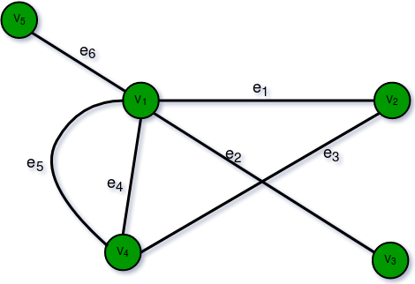
Types of Graph:
- Finite Graphs: A graph is said to be finite if it has finite number of vertices and finite number of edges.
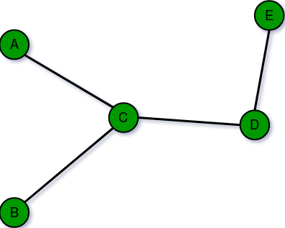
- Infinite Graph: A graph is said to be infinite if it has infinite number of vertices as well as infinite number of edges.
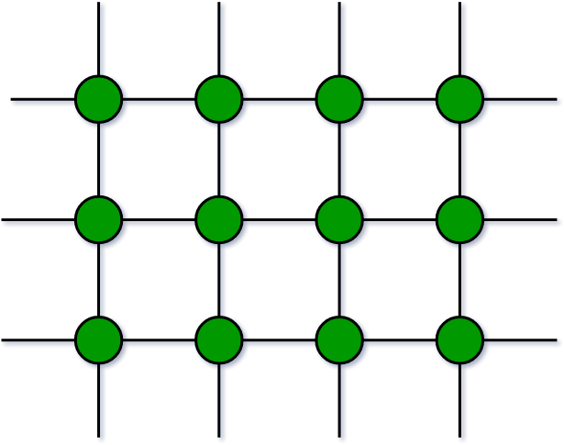
- Trivial Graph: A graph is said to be trivial if a finite graph contains only one vertex and no edge.
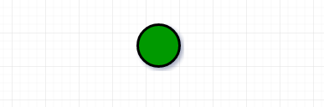
- Simple Graph: A simple graph is a graph which does not contains more than one edge between the pair of vertices. A simple railway tracks connecting different cities is an example of simple graph.
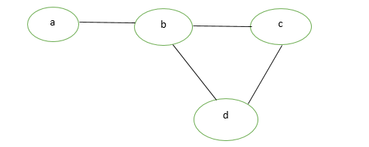
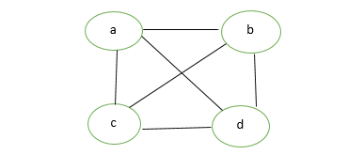
- Multi Graph: Any graph which contain some parallel edges but doesn’t contain any self-loop is called multi graph. For example A Road Map.

  - Parallel Edges: If two vertices are connected with more than one edge than such edges are called parallel edges that is many roots but one destination.
  - Loop: An edge of a graph which join a vertex to itself is called loop or a self-loop.
- Null Graph: A graph of order n and size zero that is a graph which contain n number of vertices but do not contain any edge.
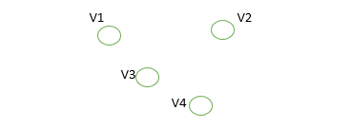
- Complete Graph: A simple graph with n vertices is called a complete graph if the degree of each vertex is n-1, that is, one vertex is attach with n-1 edges. A complete graph is also called Full Graph.
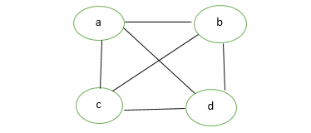
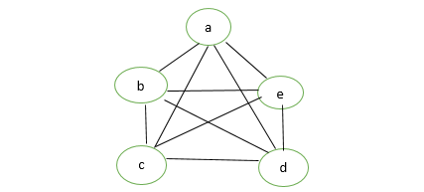
- Pseudo Graph: A graph G with a self loop and some multiple edges is called pseudo graph.
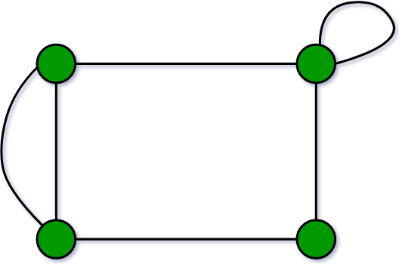
- Regular Graph: A simple graph is said to be regular if all vertices of a graph G are of equal degree. All complete graphs are regular but vice versa is not possible.
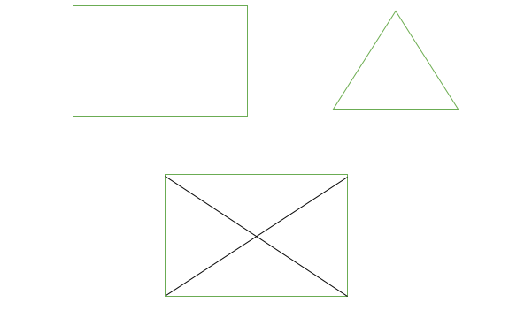
- Bipartite Graph: A graph G = (V, E) is said to be bipartite graph if its vertex set V(G) can be partitioned into two non-empty disjoint subsets. V1(G) and V2(G) in such a way that each edge e of E(G) has its one end in V1(G) and other end in V2(G).
The partition V1 U V2 = V is called Bipartite of G.
Here in the figure:
V1(G)={V5, V4, V3}
V2(G)={V1, V2}
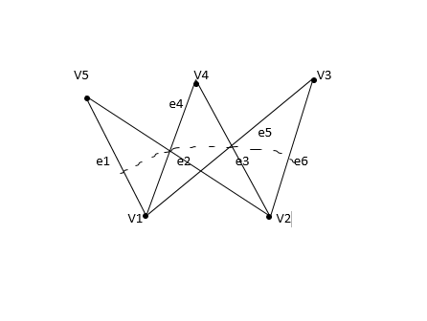
- Labelled Graph: If the vertices and edges of a graph are labelled with name, data or weight then it is called labelled graph. It is also called Weighted Graph.
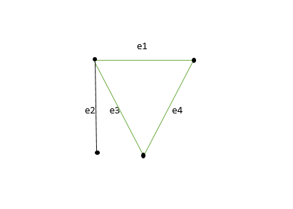
- Digraph Graph: A graph G = (V, E) with a mapping f such that every edge maps onto some ordered pair of vertices (Vi, Vj) is called Digraph. It is also called Directed Graph. Ordered pair (Vi, Vj) means an edge between Vi and Vj with an arrow directed from Vi to Vj.
Here in the figure:
e1 = (V1, V2)
e2 = (V2, V3)
e4 = (V2, V4)
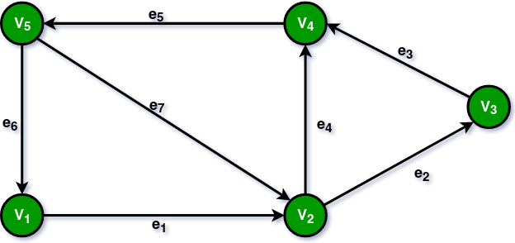
- Subgraph: A graph G = (V1, E1) is called subgraph of a graph G(V, E) if V1(G) is a subset of V(G) and E1(G) is a subset of E(G) such that each edge of G1 has same end vertices as in G.
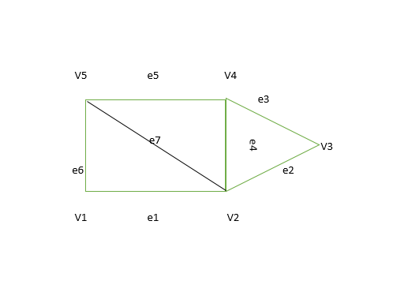
Types of Subgraph:
  - Vertex disjoint subgraph: Any two graph G1 = (V1, E1) and G2 = (V2, E2) are said to be vertex disjoint of a graph G = (V, E) if V1(G1) intersection V2(G2) = null. In figure there is no common vertex between G1 and G2.
  - Edge disjoint subgraph: A subgraph is said to be edge disjoint if E1(G1) intersection E2(G2) = null. In figure there is no common edge between G1 and G2.
Note: Edge disjoint subgraph may have vertices in common but vertex disjoint graph cannot have common edge, so vertex disjoint subgraph will always be an edge disjoint subgraph.
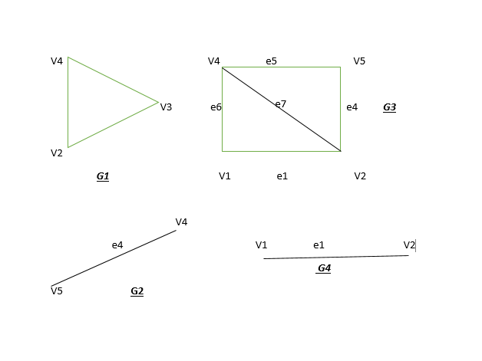
- Connected or Disconnected Graph: A graph G is said to be connected if for any pair of vertices (Vi, Vj) of a graph G are reachable from one another. Or a graph is said to be connected if there exist atleast one path between each and every pair of vertices in graph G, otherwise it is disconnected. A null graph with n vertices is disconnected graph consisting of n components. Each component consist of one vertex and no edge.
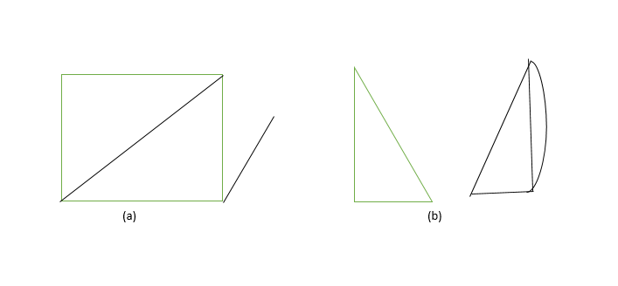
- Cyclic Graph: A graph G consisting of n vertices and n> = 3 that is V1, V2, V3- – – – – – – – Vn and edges (V1, V2), (V2, V3), (V3, V4)- – – – – – – – — -(Vn, V1) are called cyclic graph.
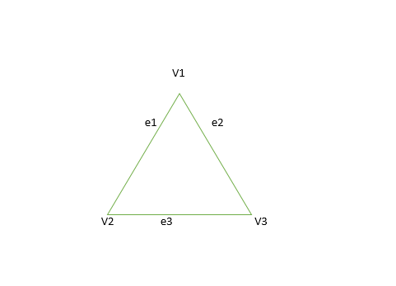
Application of Graphs:
    - Computer Science: In computer science, graph is used to represent networks of communication, data organization, computational devices etc.
    - Physics and Chemistry: Graph theory is also used to study molecules in chemistry and physics.
    - Social Science: Graph theory is also widely used in sociology.
    - Mathematics: In this, graphs are useful in geometry and certain parts of topology such as knot theory.
    - Biology: Graph theory is useful in biology and conservation efforts.

Tree Terminology
A tree is a hierarchical data structure defined as a collection of nodes. Nodes represent value and nodes are connected by edges. A tree has the following properties:
- The tree has one node called root. The tree originates from this, and hence it does not have any parent.
- Each node has one parent only but can have multiple children.
- Each node is connected to its children via edge.
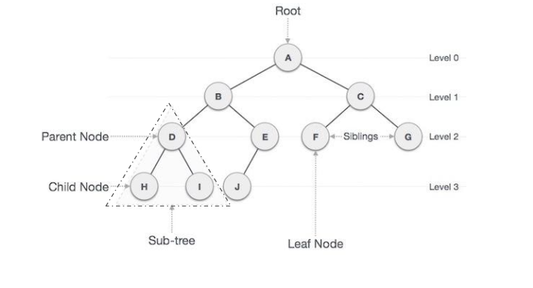
Terminology | Description | Example From Diagram
Root | Root is a special node in a tree. The entire tree originates from it. It does not have a parent. | Node A
Parent Node | Parent node is an immediate predecessor of a node. | B is parent of D & E
Child Node | All immediate successors of a node are its children. | D & E are children of B
Leaf | Node which does not have any child is called as leaf | H, I, J, F and G are leaf nodes
Edge | Edge is a connection between one node to another. It is a line between two nodes or a node and a leaf. | Line between A & B is edge
Siblings | Nodes with the same parent are called Siblings. | D & E are siblings
Path / Traversing | Path is a number of successive edges from source node to destination node. | A – B – E – J is path from node A to E
Height of Node | Height of a node represents the number of edges on the longest path between that node and a leaf. | A, B, C, D & E can have height. Height of A is no. of edges between A and H, as that is the longest path, which is 3. Height of C is 1
Levels of node | Level of a node represents the generation of a node. If the root node is at level 0, then its next child node is at level 1, its grandchild is at level 2, and so on | Level of H, I & J is 3. Level of D, E, F & G is 2
Degree of Node | Degree of a node represents the number of children of a node. | Degree of D is 2 and of E is 1
Sub tree | Descendants of a node represent subtree. | Nodes D, H, I represent one subtree.

Types of Trees in Data Structure
Below are the types of trees in a data structure:

1. General Tree
If no constraint is placed on the tree’s hierarchy, a tree is called a general tree. Every node may have infinite numbers of children in General Tree. The tree is the super-set of all other trees.

2. Binary Tree
The binary tree is the kind of tree in which most two children can be found for each parent. The kids are known as the left kid and right kid. This is more popular than most other trees. When certain constraints and characteristics are applied in a Binary tree, a number of others such as AVL tree, BST (Binary Search Tree), RBT tree, etc. are also used. When we move forward, we will explain all these styles in detail.
Full Binary Tree A Binary Tree is a full binary tree if every node has 0 or 2 children. The following are the examples of a full binary tree. We can also say a full binary tree is a binary tree in which all nodes except leaf nodes have two children.
18
/ \
15 30
/ \ / \
40 50 100 40

18
/ \
15 20
/ \
40 50
/ \
30 50

18
/ \
40 30
/ \
100 40
Complete Binary Tree: A Binary Tree is a Complete Binary Tree if all the levels are completely filled except possibly the last level and the last level has all keys as left as possible
The following are examples of Complete Binary Trees

18
/ \
15 30
/ \ / \
40 50 100 40

18
/ \
15 30
/ \ / \
40 50 100 40
/ \ /
8 7 9
Practical example of Complete Binary Tree is Binary Heap.
Perfect Binary Tree A Binary tree is a Perfect Binary Tree in which all the internal nodes have two children and all leaf nodes are at the same level.
The following are the examples of Perfect Binary Trees.
18
/ \
15 30
/ \ / \
40 50 100 40

18
/ \
15 30
In a Perfect Binary Tree, the number of leaf nodes is the number of internal nodes plus 1
L = I + 1 Where L = Number of leaf nodes, I = Number of internal nodes.
A Perfect Binary Tree of height h (where the height of the binary tree is the longest path from the root node to any leaf node in the tree, height of root node is 1) has 2^{h} – 1 node.
An example of a Perfect binary tree is ancestors in the family. Keep a person at root, parents as children, parents of parents as their children.
Balanced Binary Tree
A binary tree is balanced if the height of the tree is O(Log n) where n is the number of nodes. For Example, the AVL tree maintains O(Log n) height by making sure that the difference between the heights of the left and right subtrees is at most 1. Red-Black trees maintain O(Log n) height by making sure that the number of Black nodes on every root to leaf paths is the same and there are no adjacent red nodes. Balanced Binary Search trees are performance-wise good as they provide O(log n) time for search, insert and delete.
A degenerate (or pathological) tree A Tree where every internal node has one child. Such trees are performance-wise same as linked list.
10
/
20
\
30
\
40

3. Binary Search Tree
Binary Search Tree is a node-based binary tree data structure which has the following properties:
- The left subtree of a node contains only nodes with keys lesser than the node’s key.
- The right subtree of a node contains only nodes with keys greater than the node’s key.
- The left and right subtree each must also be a binary search tree.

4. AVL Tree
AVL tree is a binary search tree self-balancing. On behalf of the inventors Adelson-Velshi and Landis, the name AVL is given. This was the first tree that balanced dynamically. A balancing factor is allocated for each node in the AVL tree, based on whether the tree is balanced or not. The height of the node kids is at most 1. AVL vine. In the AVL tree, the correct balance factor is 1, 0 and -1. If the tree has a new node, it will be rotated to ensure that it is balanced. It will then be rotated. Common operations such as viewing, insertion, and removal take O(log n) time in the AVL tree. It is mostly applied when working with Lookups operations.
AVL tree is a self-balancing Binary Search Tree (BST) where the difference between heights of left and right subtrees cannot be more than one for all nodes
https://www.geeksforgeeks.org/avl-tree-set-1-insertion/

5. Red-Black Tree
A red-black tree is a kind of self-balancing binary search tree where each node has an extra bit, and that bit is often interpreted as the colour (red or black). These colours are used to ensure that the tree remains balanced during insertions and deletions. Although the balance of the tree is not perfect, it is good enough to reduce the searching time and maintain it around O(log n) time, where n is the total number of elements in the tree. This tree was invented in 1972 by Rudolf Bayer.
It must be noted that as each node requires only 1 bit of space to store the colour information, these types of trees show identical memory footprint to the classic (uncoloured) binary search tree.

Rules That Every Red-Black Tree Follows:
- Every node has a colour either red or black.
- The root of the tree is always black.
- There are no two adjacent red nodes (A red node cannot have a red parent or red child).
- Every path from a node (including root) to any of its descendants NULL nodes has the same number of black nodes.

Why Red-Black Trees?
Most of the BST operations (e.g., search, max, min, insert, delete.. etc) take O(h) time where h is the height of the BST. The cost of these operations may become O(n) for a skewed Binary tree. If we make sure that the height of the tree remains O(log n) after every insertion and deletion, then we can guarantee an upper bound of O(log n) for all these operations. The height of a Red-Black tree is always O(log n) where n is the number of nodes in the tree.
Sr. No. | Algorithm | Time Complexity
1. | Search | O(log n)
2. | Insert | O(log n)
3. | Delete | O(log n)

6. N-ary Tree
The maximum number of children in this type of tree with a node is N. A binary tree is a two-year tree, as at most 2 children in every binary tree node. A complete N-ary tree is a tree where kids of a node either are 0 or N.

Advantages of Tree
Now we will understand the Advantages of Tree:
- The tree reflects the data structural connections.
- The tree is used for hierarchy.
- It offers an efficient search and insertion procedure.
- The trees are flexible. This allows subtrees to be relocated with minimal effort.

Heap Data Structure
A Heap is a special Tree-based data structure in which the tree is a complete binary tree. Generally, Heaps can be of two types:
- Max-Heap: In a Max-Heap the key present at the root node must be greatest among the keys present at all of it’s children. The same property must be recursively true for all sub-trees in that Binary Tree.
- Min-Heap: In a Min-Heap the key present at the root node must be minimum among the keys present at all of it’s children. The same property must be recursively true for all sub-trees in that Binary Tree.
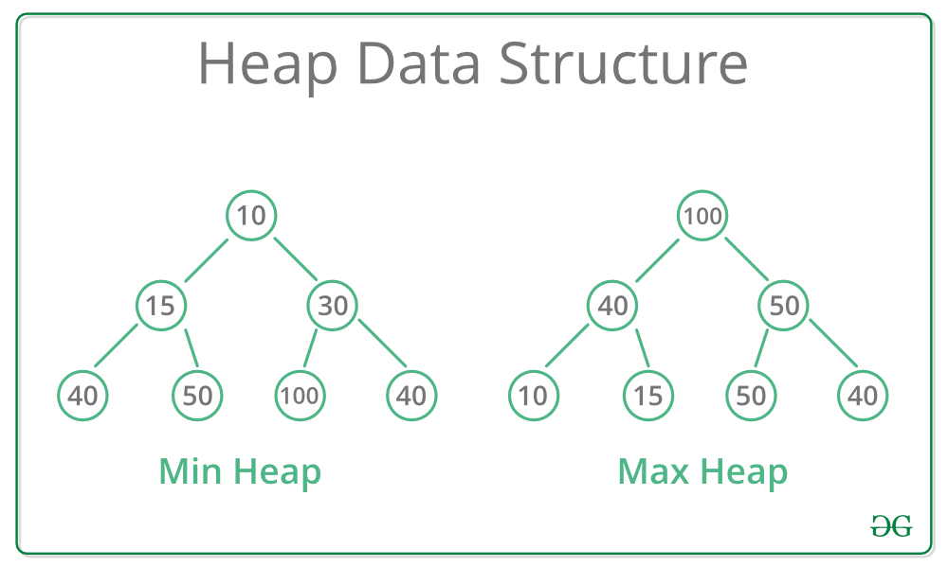
Consider the following algorithm for building a Heap of an input array A.
BUILD-HEAP(A)
heapsize := size(A);
for i := floor(heapsize/2) downto 1
do HEAPIFY(A, i);
end for
END
A quick look over the above algorithm suggests that the running time is {o( log (n) )}, since each call to Heapify costs {o(log(n) )} and Build-Heap makes {o(n)} such calls.
This upper bound, though correct, is not asymptotically tight.
We can derive a tighter bound by observing that the running time of Heapify depends on the height of the tree ‘h’ (which is equal to lg(n), where n is number of nodes) and the heights of most sub-trees are small.
The height ’h’ increases as we move upwards along the tree. Line-3 of Build-Heap runs a loop from the index of the last internal node (heapsize/2) with height=1, to the index of root(1) with height = log(n). Hence, Heapify takes different time for each node, which is { o(h) }.
For finding the Time Complexity of building a heap, we must know the number of nodes having height h.
For this we use the fact that, A heap of size n has at most { n/ 2^(h+1) } nodes with height h.

