Spring Cloud Session 3 Inter Microservice Communication Synchronous
In this tutorial we are going to see how microservices communicate with each other. -There are two types of communication between microservice one is synchronous, and the other is asynchronous.
- In synchronous communication calling microservice waits till the called microservice responds.
- In asynchronous communication calling microservice will not wait till the called microservice responds.
- In this session we focus on Synchronous communication.
- There are two ways a microservice can communicate with other microservices
  - Direct: Microservice A speaks with Microservice B Directly
  - Via Gateway: Instead of taking directly, Microservice A speaks with Microservice B via gateway
- This tutorial covers both the scenarios
- We will be developing report api which gives employee name,salary by communicating with employee-api,payroll-api microservices.
- For the purpose of this tutorial we developed two microservices
  - report-api-direct which calls employee-api,payroll-api directly
  - report-api-via-gateway calls employee-api,payroll-api via gateway
- Note: In real world we favour to call microservices via a gateway even for inter communication. So I recommend using the microservice report-api-via-gateway
Overview
- Run registry service on 8761.
- Run employee-api service on dynamic port. Where it takes employee id and returns employee name.
- Run payroll-api service on dynamic port. Where it takes employee id and returns employee salary.
- Run report-api-direct service on dynamic port. Where it takes employee id and returns employee name and salary by directly communicating with employee-api and payroll-api.
- Run report-api-via-gateway service on dynamic port. Where it takes employee id and returns employee name and salary by directly communicating with employee-api and payroll-api indirectly via gateway.
- Run Gateway service on 8080 and reverse proxy requests to all the services (employee-api,payroll-api,report-api-direct,report-api-via-gateway)
- All the microservices (employee-api,payroll-api,report-api-direct,report-api-via-gateway,gateway) when they startup they register their service endpoint (rest api url) with registry
- Gateway Spring Cloud load balancer (Client side load balancing) component in Spring Cloud Gateway acts as reverse proxy. It reads a registry for microservice endpoints and configures routes.
Important Notes
- Netflix Eureka Server plays a role of Registry. Registry is a spring boot application with Eureka Server as dependency.
- Netflix Eureka Client is present in all the micro services (employee-api,payroll-api,report-api-direct,report-api-via-gateway,gateway) and they discover Eureka server and register their availability with server.
- Generally Netflix Ribbon Component is used as Client Side load balancer, but it is deprecated project. We will be using Spring Cloud Load balaner in gateway

Source Code
git clone https://github.com/balajich/spring-cloud-session-3-inter-microservice-communication-sync.git

Video
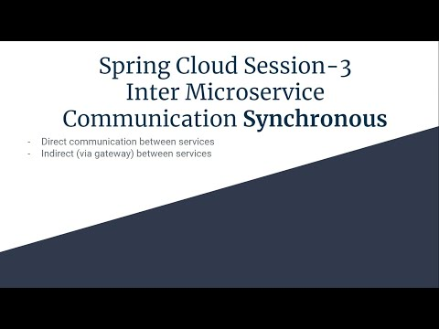
- https://youtu.be/MqD0vLwFDaQ

Architecture Direct Communication between microservices
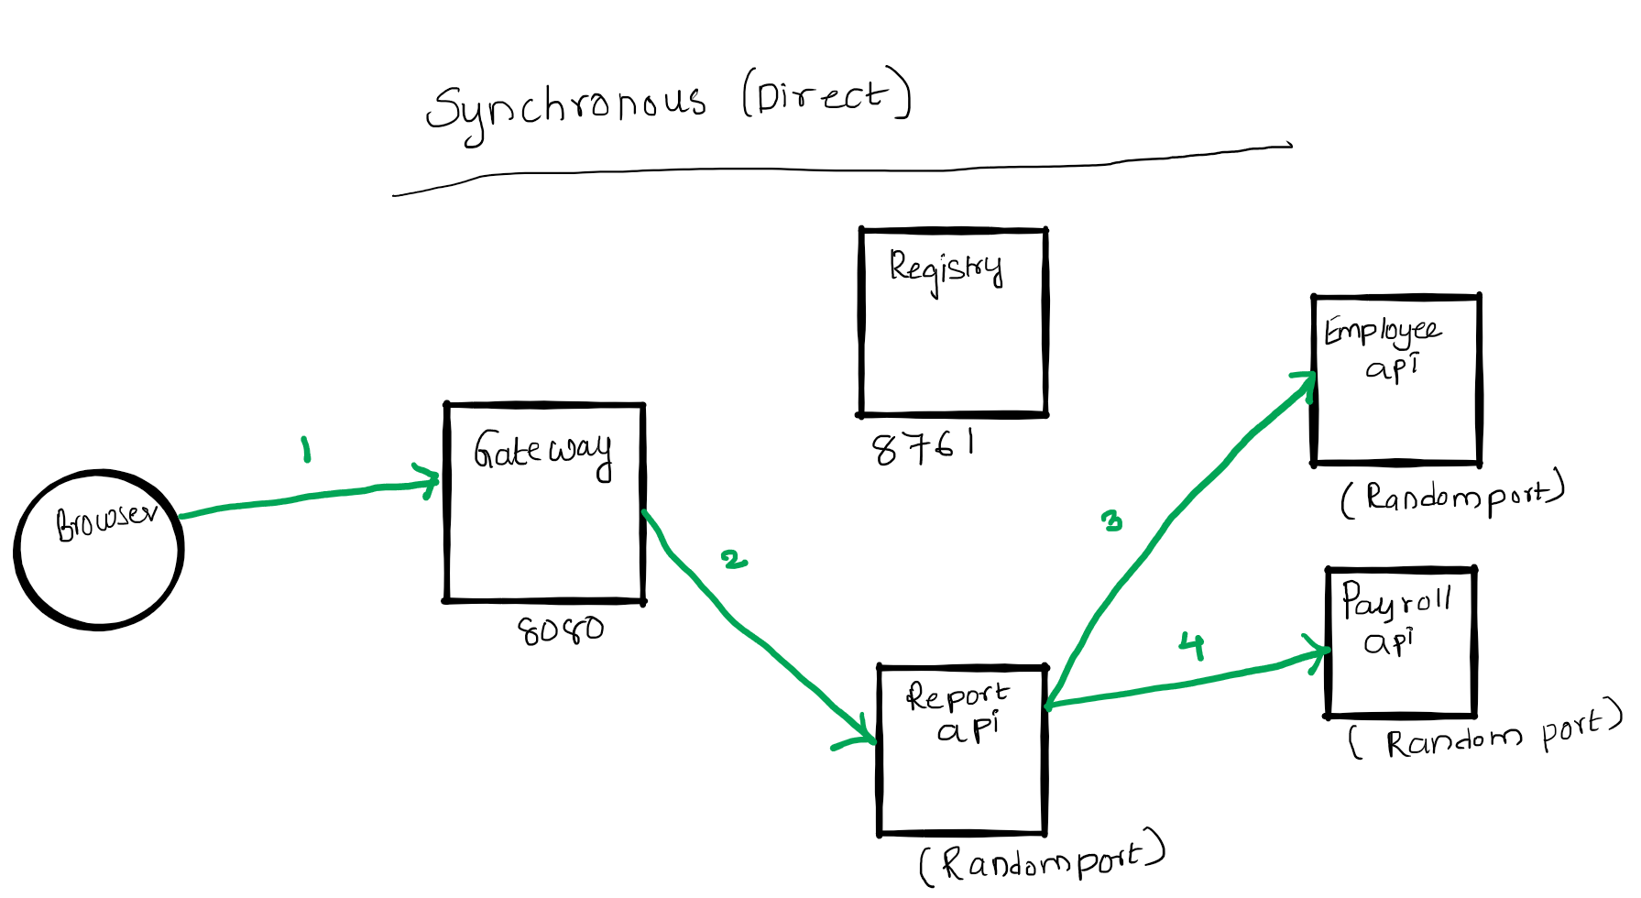

Architecture via Gateway Communication between microservices
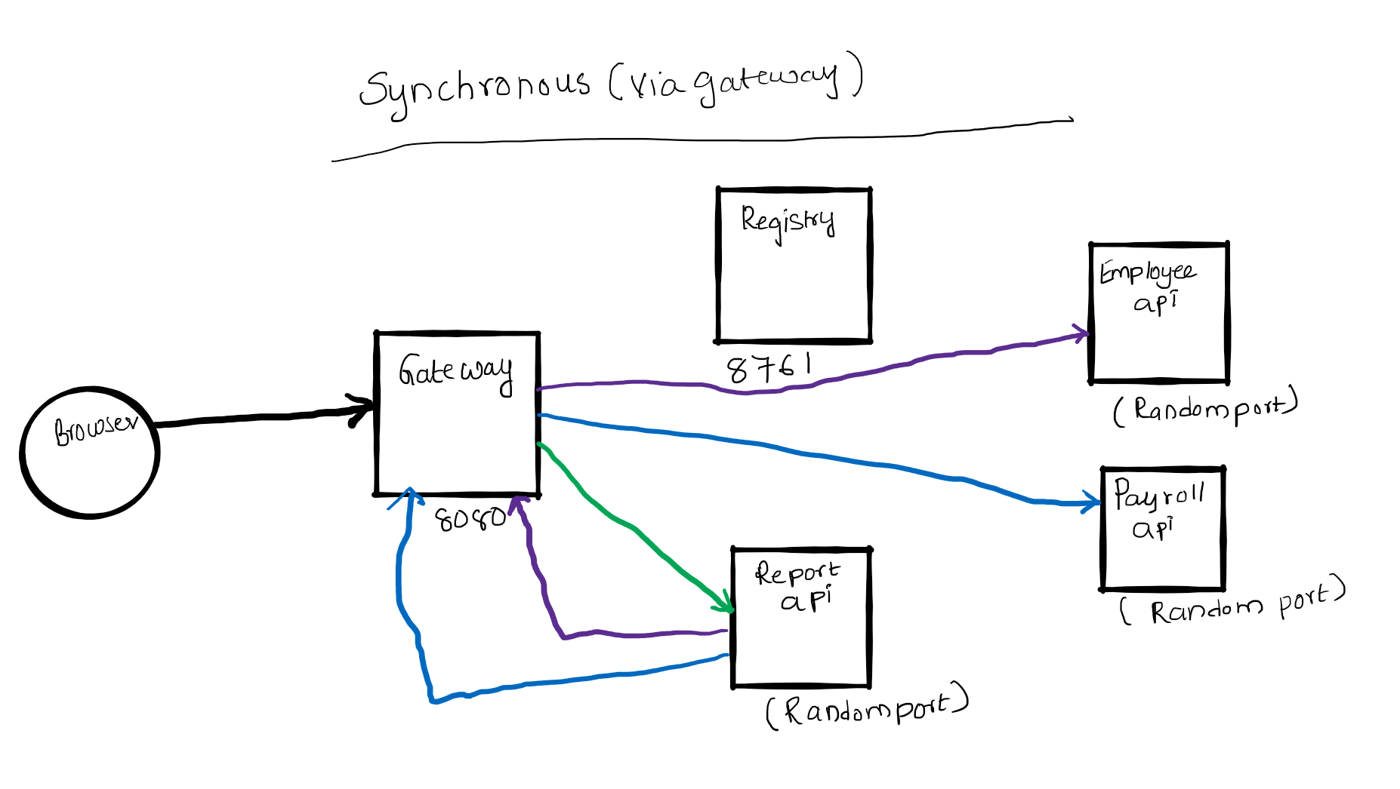

Prerequisite
- JDK 1.8 or above
- Apache Maven 3.6.3 or above

Clean and Build
- Java
  - cd spring-cloud-session-3-inter-microservice-communication-sync
  - mvn clean install

Running components
- Registry: java -jar .\registry\target\registry-0.0.1-SNAPSHOT.jar
- Employee API: java -jar .\employee-api\target\employee-api-0.0.1-SNAPSHOT.jar
- Payroll API: java -jar .\payroll-api\target\payroll-api-0.0.1-SNAPSHOT.jar
- Report API Direct: java -jar .\report-api-direct\target\report-api-direct-0.0.1-SNAPSHOT.jar
- Report API via gateway: java -jar .\report-api-via-gateway\target\report-api-via-gateway-0.0.1-SNAPSHOT.jar
- Gateway: java -jar .\gateway\target\gateway-0.0.1-SNAPSHOT.jar

Using curl to test environment
Note I am running CURL on windows, if you have any issue. Please use postman client, its collection is available at spring-cloud-session-3-inter-microservice-communication-sync.postman_collection.json
- Get employee report using report api ( direct): curl -s -L http://localhost:8080/report-api-direct/100
- Get employee report using report-api-via-gateway: curl -s -L http://localhost:8080/report-api-via-gateway/100
Note: In real world we favour to call microservices via a gateway even for inter communication. So I recommend using the microservice report-api-via-gateway

Code
In this section will focus only on report-api and how communicates employee-api,payroll-api.
ReportController in app report-api-direct. RestTemplate calls eureka ribbon client which fetches "employee-api,payroll-api" information from registry and calls the microservices directly. The @LoadBalanced annotation makes ribbon client to round-robbin requests if there are multiple instances of them.
@Autowired
RestTemplate restTemplate;

@RequestMapping(value = "/report-api-direct/{employeeId}", method = RequestMethod.GET)
public Employee getEmployeeDetails(@PathVariable int employeeId) {
logger.info(String.format("Getting Complete Details of Employee with id %s", employeeId));
//Get employee name from employee-api
Employee responseEmployeeNameDetails = restTemplate.getForEntity("http://employee-api/employee/" + employeeId, Employee.class).getBody();
//Get employee salary from payroll-api
Employee responseEmployeePayDetails = restTemplate.getForEntity("http://payroll-api/payroll/" + employeeId, Employee.class).getBody();
return new Employee(responseEmployeeNameDetails.getId(), responseEmployeeNameDetails.getName(), responseEmployeePayDetails.getSalary());
}

@Bean
@LoadBalanced
public RestTemplate restTemplate() {
return new RestTemplate();
}
ReportController in app report-api-via-gateway. RestTemplate calls eureka ribbon client which fetches "gateway" information from registry and calls the employee,payroll api via gateway. The @LoadBalanced annotation makes ribbon client to round-robbin requests if there are multiple instances of them.
@Autowired
RestTemplate restTemplate;

@RequestMapping(value = "/report-api-via-gateway/{employeeId}", method = RequestMethod.GET)
public Employee getEmployeeDetails(@PathVariable int employeeId) {
logger.info(String.format("Getting Complete Details of Employee with id %s", employeeId));
//Get employee name from employee-api via gateway
Employee responseEmployeeNameDetails = restTemplate.getForEntity("http://gateway/employee/" + employeeId, Employee.class).getBody();
//Get employee salary from payroll-api via gateway
Employee responseEmployeePayDetails = restTemplate.getForEntity("http://gateway/payroll/" + employeeId, Employee.class).getBody();
return new Employee(responseEmployeeNameDetails.getId(), responseEmployeeNameDetails.getName(), responseEmployeePayDetails.getSalary());
}

@Bean
@LoadBalanced
public RestTemplate restTemplate() {
return new RestTemplate();
}
Gateway
cloud:
loadbalancer:
ribbon:
enabled: false
gateway:
routes:
- id: employee-api
uri: lb://EMPLOYEE-API
predicates:
- Path=/employee/**
- id: payroll-api
uri: lb://PAYROLL-API
predicates:
- Path=/payroll/**
- id: report-api-direct
uri: lb://REPORT-API-DIRECT
predicates:
- Path=/report-api-direct/**
- id: report-api-via-gateway
uri: lb://REPORT-API-VIA-GATEWAY
predicates:
- Path=/report-api-via-gateway/**

Next Steps
- Inter microservice communication in asynchronous fashion

References
- Spring Microservices in Action by John Carnell
- Hands-On Microservices with Spring Boot and Spring Cloud: Build and deploy Java microservices using Spring Cloud, Istio, and Kubernetes -Magnus Larsson

Next Tutorial
https://github.com/balajich/spring-cloud-session-4-inter-microservice-communication-async

