Spring Cloud Session 5 Microservices Documentation
In this tutorial we are going to learn how do we document REST API microservices using OpenAPI/Swagger.
- Swagger is one of the mostly used standard while documenting REST API services.
- We will use SpringFox to produce Swagger/OpenAPI documentation.
Overview
- We will be using SpringFox to document employee-api , payroll-api
- API documentation will be viewed via gateway.
- Access Swagger UI of employee-api and make few rest calls.
- Import OpenAPI definition to postman to generate client code.
Important Notes
- Please refer my previous sessions to understand how these microservices work. In this session we will focus on documenting API and accessing API documentation.
- Using SpringFox we can have API code and documentation present in same source files, This makes api documentation doesn't go out of sync with code.
- In 2015, SmartBear Software donated the Swagger specification to the Linux Foundation under the OpenAPI Initiative and created the OpenAPI Specification. To create the API documentation, we will use SpringFox.
- We will not be focusing on in depth SpringFox annotations our goal is to quickly enable documentation for RESTAPI.

Source Code
git clone https://github.com/balajich/spring-cloud-session-5-microservices-documentation.git

Video
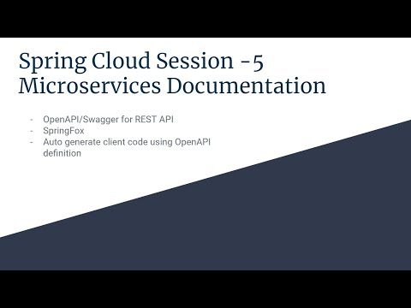
- https://youtu.be/RjPAX3pkBq4

Architecture
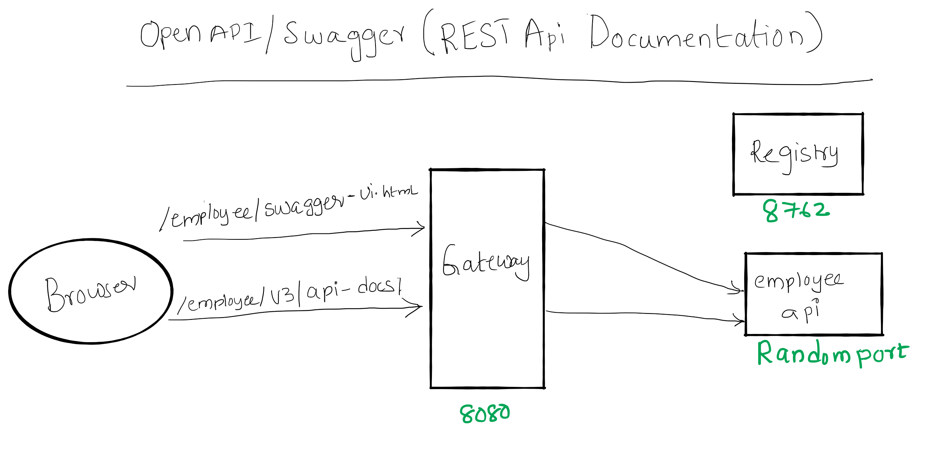

Prerequisite
- JDK 1.8 or above
- Apache Maven 3.6.3 or above

Clean and Build
- Java
  - cd spring-cloud-session-5-microservices-documentation
  - mvn clean install

Running components
- Registry: java -jar .\registry\target\registry-0.0.1-SNAPSHOT.jar
- Employee API: java -jar .\employee-api\target\employee-api-0.0.1-SNAPSHOT.jar
- Payroll API: java -jar .\payroll-api\target\payroll-api-0.0.1-SNAPSHOT.jar
- Gateway: java -jar .\gateway\target\gateway-0.0.1-SNAPSHOT.jar

Accessing Swagger UI of employee and payroll api
- OpenAPI definition of employee api curl -s -L http://localhost:8080/employee/v3/api-docs/
- Swagger UI of employee api via gateway: http://localhost:8080/employee/swagger-ui.html
- OpenAPI descriptions of payroll api curl -s -L http://localhost:8080/payroll/v3/api-docs/
- Swagger UI of payroll api via gateway: http://localhost:8080/payroll/swagger-ui.html
- You can use postman collection Spring Cloud Session 5 Microservices Documentation.postman_collection.json

Code
In employee-api pom.xml add dependency springdoc-openapi-ui.
<dependency>
<groupId>org.springdoc</groupId>
<artifactId>springdoc-openapi-ui</artifactId>
<version>1.2.32</version>
</dependency>
Set swagger-ui and api-docs paths to be accessible on employee context, So that they can be accessed from gateway easily. application.yml
springdoc:
swagger-ui:
path: /employee/swagger-ui.html
api-docs:
path: /employee/v3/api-docs/
Note: I didn't customize the documentation generated by SpringFox, if need please use appropriate annotations.

Next Steps
- How deploy microservices using docker

References
- Hands-On Microservices with Spring Boot and Spring Cloud: Build and deploy Java microservices using Spring Cloud, Istio, and Kubernetes -Magnus Larsson
- Spring Microservices in Action by John Carnell

Next Tutorial
- https://github.com/balajich/spring-cloud-session-6-microservices-deployment-docker

