Spring Cloud Session-4 Inter Microservice Communication ASynchronous using Kafka
In this tutorial we are going to learn how microservices communicate with each other in asynchronous fashion. In asynchronous communication calling microservice will not wait till the called microservice responds. This pattern can be achieved with message bus infrastructures like Kafka.Here we use Spring Cloud Stream framework to communicate with message bus.
Overview
- When report-api microservice receives a request to get employee details it is going to fetch details and write results to message bus.
- Mail microservice listens on the bus for employee details and when those details are available on bus. It is going to read send SMS and email.
- report-api play a role of Producer
- mail-client microservice plays a role of Consumer
- Kafka play a role of mediator or message bus
Flow
- Run Kafka server, it binds to port 9092 and admin ui application (Control Center web interface) to port 9021.
- Run registry service on 8761.
- Run employee-api service on dynamic port. Where it takes employee id and returns employee name.
- Run payroll-api service on dynamic port. Where it takes employee id and returns employee salary.
- Run report-api service on dynamic port. Where it takes employee id and returns employee name and salary by directly communicating with employee-api and payroll-api. It also publishes employee details to message bus
- Run mail-client service (it is not a rest api, it a java process and doesn't bind to any port). Where it subscribes to message bus for employee details message and sends mail,sms.
- Run Gateway service on 8080 and reverse proxy requests to all the services (employee-api,payroll-api,report-api)
- All the microservices (employee-api,payroll-api,report-api,gateway) when they startup they register their service endpoint (rest api url) with registry
- Gateway Spring Cloud load balancer (Client side load balancing) component in Spring Cloud Gateway acts as reverse proxy. It reads a registry for microservice endpoints and configures routes.
Important Notes
- Netflix Eureka Server plays a role of Registry. Registry is a spring boot application with Eureka Server as dependency.
- Netflix Eureka Client is present in all the micro services (employee-api,payroll-api,report-api,gateway) and they discover Eureka server and register their availability with server.
- Generally Netflix Ribbon Component is used as Client Side load balancer, but it is deprecated project. We will be using Spring Cloud Load balaner in gateway

Source Code
git clone https://github.com/balajich/spring-cloud-session-4-inter-microservice-communication-async-kafka.git

Video
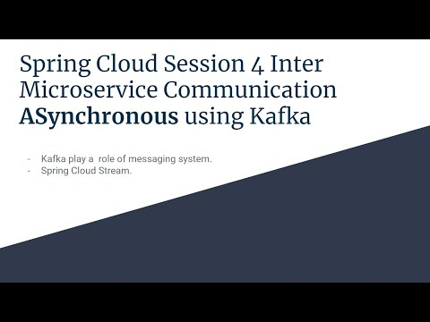
- https://youtu.be/sP2WcMutbn0

Architecture
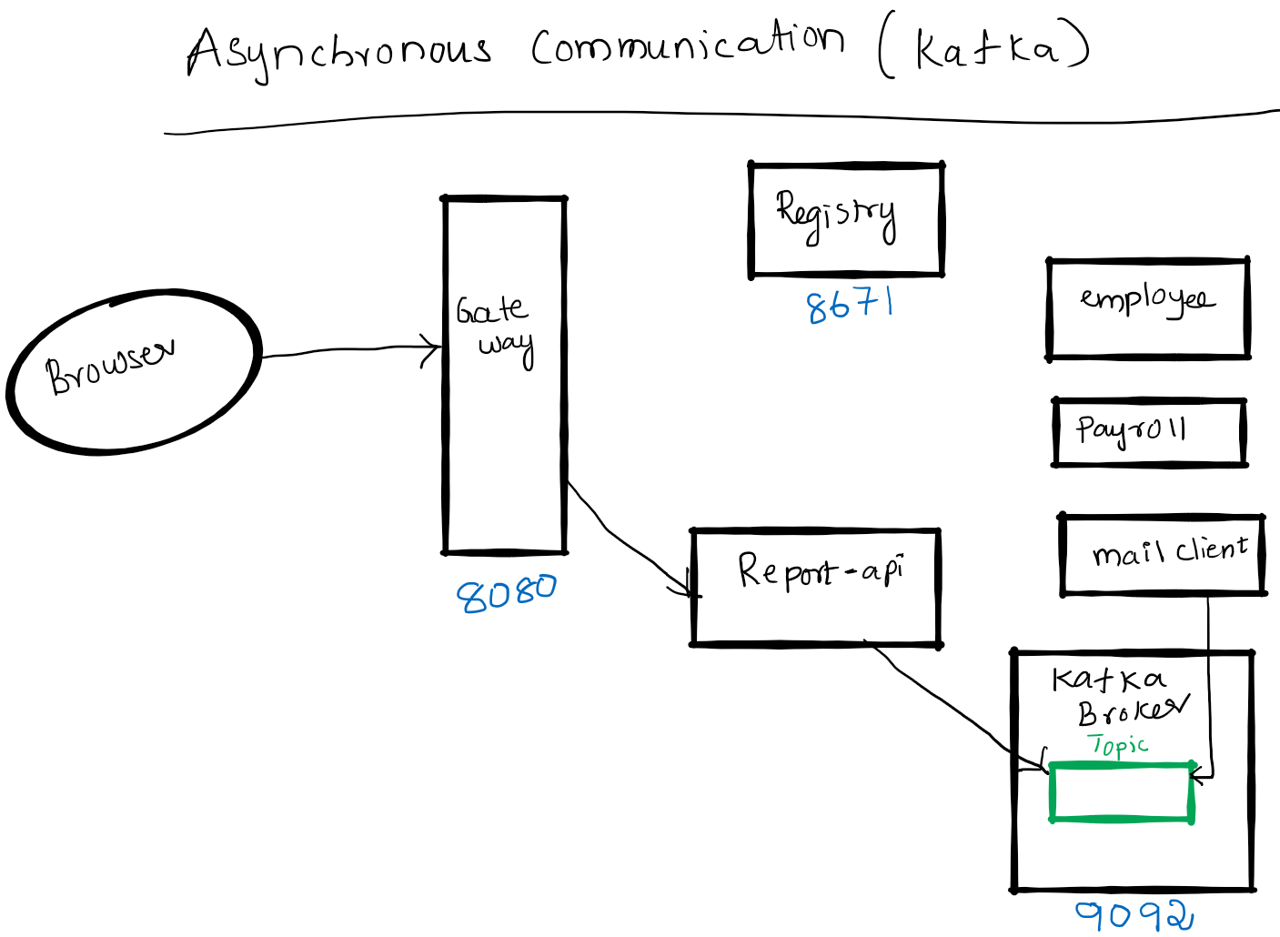

Kafka Terminology
- Producer, publisher A Producer is the application that is sending the messages Kafka server.
- Consumer A Consumer is the application that receives the messages from the Kafka server.
- Message- A message is a simple array of bytes.
- Kafka Broker - Broker is a Kafka server.
- Topic - Producer sends message to topic and consumer reads message from topic. Note: We are not covering concepts like Partitions,Offsets,Consumer Groups ..etc. Please check my kafka tutorial blog.

Spring Cloud Stream Concepts
Spring cloud stream abstracts underneath communication with Messagebus. This helps to foucs on business logic instead of nettigritty of message bus. We can easily switch from Kafka to Kafka etc without code changes.
- Bindings — a collection of interfaces that identify the input and output channels.
- Channel — represents the communication pipe between messaging-middleware and the application.
- StreamListeners- Listens to messages on Input channel and serializes them to java objects.

Prerequisite
- JDK 1.8 or above
- Apache Maven 3.6.3 or above
- Vagrant, Virtualbox (To run Kafka Server)

Start Kafka Server and Build Microservices
We will be running Kafka server inside a docker container. I am running docker container on CentOS7 virtual machine. I will be using vagrant to stop or start a virtual machine.
- Kafka Server
  - cd spring-cloud-session-4-inter-microservice-communication-async-kafka
  - Bring virtual machine up vagrant up
  - ssh to virtual machine vagrant ssh
  - Switch to root user sudo su -
  - Change folder where docker-compose files is available cd /vagrant
  - Start Kafka Server using docker-compose docker-compose up -d
- Java
  - mvn clean install

Kafka Server Admin UI (Control Center web interface)
- http://localhost:9021/clusters
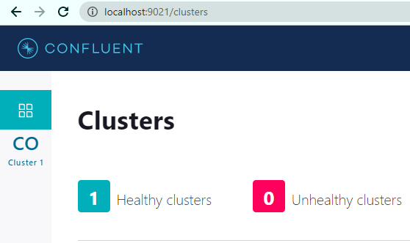

Running components
- Registry: java -jar .\registry\target\registry-0.0.1-SNAPSHOT.jar
- Employee API: java -jar .\employee-api\target\employee-api-0.0.1-SNAPSHOT.jar
- Payroll API: java -jar .\payroll-api\target\payroll-api-0.0.1-SNAPSHOT.jar
- Report API: java -jar .\report-api\target\report-api-0.0.1-SNAPSHOT.jar
- Mail Client App: java -jar .\mail-client\target\mail-client-0.0.1-SNAPSHOT.jar
- Gateway: java -jar .\gateway\target\gateway-0.0.1-SNAPSHOT.jar

Using curl to test environment
Note I am running CURL on windows, if you have any issue. Please use postman client, its collection is available at spring-cloud-session-3-inter-microservice-communication-sync.postman_collection.json
- Access Kafka UI: http://localhost:9021/clusters
- Get employee report using report api ( direct): curl -s -L http://localhost:8080/report-api/100

Code
In this section will focus only on report-api code which publishes employee details to queue queue.email
ReportController in app report-api. @SendTo(Processor.OUTPUT) makes the function to invoke Kafka and writes details to topic queue.email.
@SendTo(Processor.OUTPUT)
public Employee getEmployeeDetails(@PathVariable int employeeId) {

Employee finalEmployee = new Employee(responseEmployeeNameDetails.getId(), responseEmployeeNameDetails.getName(), responseEmployeePayDetails.getSalary());
// Send to message bus
processor.output().send(MessageBuilder.withPayload(finalEmployee).build());

}
application.yml in report-api.
cloud:
stream:
bindings:
output:
destination: queue.email
kafka:
binder:
brokers: 127.0.0.1
defaultBrokerPort: 9092
mail-client code that reads messages from queue. @StreamListener(Processor.INPUT) reads data from queue email.queue
@SpringBootApplication
@EnableBinding(Processor.class)
public class MailClientApplication {

public static void main(String[] args) {
SpringApplication.run(MailClientApplication.class, args);
}

@StreamListener(Processor.INPUT)
public void receivedEmail(Employee employee) {
System.out.println("Received employee details: " + employee);
System.out.println("Sending email and sms: "+employee.getName());
}

}
application.yml of mail-client
spring:
application:
name: email-api
cloud:
stream:
bindings:
input:
destination: queue.email
group: emailconsumers
kafka:
binder:
brokers: 127.0.0.1
defaultBrokerPort: 9092

References
- https://www.baeldung.com/spring-cloud-stream
- Spring Microservices in Action by John Carnell
- Hands-On Microservices with Spring Boot and Spring Cloud: Build and deploy Java microservices using Spring Cloud, Istio, and Kubernetes -Magnus Larsson
- https://medium.com/@ruwansriw/apache-kafka-terminology-f0b5350c26e4

FAQ
- https://github.com/balajich/Spring-Cloud-Sessions-Microservices-FAQ/blob/master/README.md

Next Tutorial
Document microservices using OpenAPI/Swagger
- https://github.com/balajich/spring-cloud-session-5-microservices-documentation

