**Semantic vs Vector search**

**Understanding Semantic Search**

Semantic search is all about context and meaning. It employs a blend of natural language processing (NLP) techniques and understanding (NLU) to interpret the nuances, synonyms, and relationships inherent in language. The aim is to deliver search results that are not just textually similar but are meaningfully relevant to the user's search intent, even if the exact words used in the query aren't present in the content.

Thanks to the semantic understanding embedded in the vectors, a search for "climate change effects" could return relevant documents that discuss "global warming impacts," even if the search doesn't use that exact phrase.

Beyond this, semantic search can leverage rich representations of data, such as those found in **knowledge graphs**, to uncover deeper connections and insights. Knowledge graphs organize information into entities and their relationships, making it possible to query complex relationships or generate recommendations based on contextual understanding. For example, they can help in discovering how climate change impacts interact with economic factors.

Moreover, semantic search often benefits from **inference engines**, which are used to derive logical conclusions from the available data. These engines, powered by advanced algorithms, enable systems to answer complex queries and make predictions based on a combination of explicit facts and inferred relationships. For instance, an inference engine could connect topics like "rising sea levels" and "coastal property insurance" to infer potential risks or financial implications, even if these links are not explicitly stated in the data.

By extending its capabilities with such technologies, semantic search becomes an even more powerful tool, not only for retrieving meaningfully relevant results but also for supporting complex decision-making processes in fields like scientific research, healthcare, and enterprise knowledge management.

Check out this article for more details on [semantic search](https://www.timescale.com/learn/understanding-semantic-search?__hstc=231067136.aaa28e5c697edfcccb5e1d3d0cf37958.1755084214417.1755084214417.1755084214417.1&__hssc=231067136.1.1755084214417&__hsfp=3344225942).

**The Role of Vector Search**

How do we translate this nuanced understanding into something computers can work with? That's where vector search comes in. Vector search transforms words, sentences, or entire documents into vectors—think of them as points in a multidimensional space. These vectors are not just random points; they're calculated so that similar meanings are positioned closer together. For instance, vectors for "trucks" and "cars" would be near each other.

Some of the foundational approaches to creating these embeddings include models like [**Word2Vec**](https://en.wikipedia.org/wiki/Word2vec), which maps words into vectors based on their contextual relationships, allowing computers to process their meanings more effectively. More recently, advanced embeddings such as [**OpenAI token embeddings**](https://platform.openai.com/docs/guides/embeddings) have further expanded these capabilities, providing richer, context-aware representations for tasks like semantic search, recommendation systems, and more.

When you search, the model converts your query into a vector and then looks for other vectors (documents, web pages, etc.) close by in this multidimensional space. The closer they are, the more relevant they're deemed to be. By leveraging these embedding techniques, vector search enables a deep understanding of user queries and content, supporting powerful applications in semantic search, personalization, and intelligent retrieval.

**Learn more about**[**vector search**](https://www.timescale.com/learn/understanding-vector-search?__hstc=231067136.aaa28e5c697edfcccb5e1d3d0cf37958.1755084214417.1755084214417.1755084214417.1&__hssc=231067136.1.1755084214417&__hsfp=3344225942)**.**

Leveraging Vector Search for Semantic Understanding

So, how does vector search turn into semantic search? It's all about leveraging those [embeddings](https://www.timescale.com/blog/a-beginners-guide-to-vector-embeddings/?__hstc=231067136.aaa28e5c697edfcccb5e1d3d0cf37958.1755084214417.1755084214417.1755084214417.1&__hssc=231067136.1.1755084214417&__hsfp=3344225942) to capture the essence of your query's intent. By analyzing the positions and distances of vectors, we can infer semantic relationships, such as synonyms, related concepts, or even nuanced thematic links between seemingly unrelated terms.

To leverage vector search for semantic search, systems typically follow a multi-step process:

1. **Embedding generation for the content**: the content to be searched is transformed into vectors using embedding models.
2. **Storing the content and embeddings in a vector database**: both the content and its embedding are stored in a vector database that then allows performant search on the embeddings.
3. **Embedding generation for the query**: the query is transformed into a vector using the same embedding model we used for the content.
4. **Retrieving relevant data from the vector database**: The database is then asked to return all items whose embeddings are closest to the queries’ embedding. For this task, the vector database will use a distance function between vectors, such as cosine or Euclidean distance.

[Learn how to refine your vector search queries with time filters in pgvector—with a single SQL query.](https://www.timescale.com/blog/refining-vector-search-queries-with-time-filters-in-pgvector-a-tutorial/?__hstc=231067136.aaa28e5c697edfcccb5e1d3d0cf37958.1755084214417.1755084214417.1755084214417.1&__hssc=231067136.1.1755084214417&__hsfp=3344225942)

**Boost Your Vector Search**

**Semantic search** is a powerful concept that enables much more helpful computer systems. Instead of users having to figure out the exact keyword to search for, the system returns relevant content for a much broader range of queries. **Vector search**, with its ability to process and understand the geometry of meanings, provides the foundation to develop an advanced semantic search system. This synergy not only enhances the accuracy of search results but also makes digital interactions more intuitive and human-like.

Understanding these concepts is crucial, especially for those venturing into AI and data science. If you’re building AI applications, check out [**Timescale's open-source PostgreSQL stack for AI applications**](https://www.timescale.com/ai?__hstc=231067136.aaa28e5c697edfcccb5e1d3d0cf37958.1755084214417.1755084214417.1755084214417.1&__hssc=231067136.1.1755084214417&__hsfp=3344225942). It includes pgvector along with two open-source extensions developed by the Timescale team: [pgai](https://github.com/timescale/pgai/) and [pgvectorscale](https://github.com/timescale/pgvectorscale).

While **pgai** makes it easier for developers to build search and retrieval-augmented generation (RAG) applications by bringing more AI workflows into PostgreSQL, **pgvectorscale** enables developers to build more scalable AI applications with [higher-performance embedding search and cost-efficient storage](https://www.timescale.com/blog/pgvector-vs-pinecone/?__hstc=231067136.aaa28e5c697edfcccb5e1d3d0cf37958.1755084214417.1755084214417.1755084214417.1&__hssc=231067136.1.1755084214417&__hsfp=3344225942).

Both extensions are available for you to install in the [pgai](https://github.com/timescale/pgai/) and [pgvectorscale](https://github.com/timescale/pgvectorscale) GitHub repositories (GitHub stars are much appreciated!). For a seamless developer experience with greater time series and analytics capabilities, try [Timescale Cloud](https://console.cloud.timescale.com/signup?__hstc=231067136.aaa28e5c697edfcccb5e1d3d0cf37958.1755084214417.1755084214417.1755084214417.1&__hssc=231067136.1.1755084214417&__hsfp=3344225942), which provides ready access to pgvector, pgvectorscale, and pgai, plus a fully managed PostgreSQL cloud database experience.

Inthe era of data explosion and advanced AI technologies, the way we search for and retrieve information has evolved dramatically. Two key players in this evolution are semantic search and vector search. While often mentioned in the same breath, these technologies have distinct characteristics and applications. This article aims to provide a comprehensive, in-depth look at semantic search and vector search, exploring their similarities, differences, and real-world applications.

*Before we begin, I’d like to mention my book “*[*Build AI Applications with FastAPI*](https://unfoldai.com/book-build-ai-applications-with-fastapi/)*”. It covers FastAPI fundamentals, advanced topics like asynchronous processing, and AI integration. The book guides you through building LLM Hub, a real-world AI application using Ollama. It includes practical examples of authentication, deployment, and optimization techniques. Whether you’re a beginner or experienced developer, it’s a valuable resource for creating AI-powered web applications. Now, let’s dive into the difference and the common between Semantic and Vector search!*

**Understanding the basics**

Before diving into the intricacies of semantic and vector search, let’s establish a foundational understanding of these concepts.

**What is semantic search?**

Semantic search is an advanced information retrieval method that focuses on understanding the intent and contextual meaning of a search query, rather than just matching keywords. It employs natural language processing (NLP) and machine learning techniques to interpret the nuances, synonyms, and relationships inherent in language.

Check [**this article**](https://unfoldai.com/what-is-semantic-search/) if you are interested to learn more.

**What is vector search?**

Vector search, on the other hand, is a technique that transforms words, sentences, or entire documents into vectors — numerical representations in a multidimensional space. These vectors capture the essence of the content, allowing for similarity comparisons based on their positions in this vector space.

**The technology behind semantic search**

Semantic search leverages several advanced technologies to understand and process natural language:

1. **Natural Language Processing (NLP):** NLP techniques help in parsing and understanding the structure and meaning of text.
2. **Machine Learning (ML):** ML algorithms learn from vast amounts of data to improve their understanding of language and context over time.
3. **Knowledge graphs:** These represent relationships between concepts, entities, and data points, allowing for more contextual understanding.
4. **Inference engines:** These systems use logical rules to derive new information from existing knowledge.

**How semantic search works**

1. **Query analysis:** The search engine interprets the user’s query, considering context, intent, and potential ambiguities.
2. **Concept extraction:** Key concepts and entities are identified from the query.
3. **Knowledge graph consultation:** The system consults its knowledge graph to understand relationships between concepts.
4. **Context-aware matching:** Instead of exact keyword matching, the system looks for content that matches the query’s intent and context.
5. **Result ranking:** Results are ranked based on relevance to the query’s semantic meaning.

**More about vector search**

Vector search is at the heart of many modern search systems, including those that power semantic search. Let’s explore its inner workings:

**Vector embeddings**

At the core of vector search are vector embeddings. These are numerical representations of words, phrases, or documents in a high-dimensional space. For example, a simple vector might look like this:

word_vector = [0.2, -0.5, 0.8, 0.1, ...]

In practice, these vectors can have hundreds or thousands of dimensions.

**Creating vector embeddings**

Vector embeddings are typically created using machine learning models trained on large corpora of text. Popular models include:

* [**Word2Vec**](https://www.tensorflow.org/text/tutorials/word2vec)
* [**GloVe**](https://nlp.stanford.edu/projects/glove/)
* [**BERT**](https://arxiv.org/abs/1810.04805)
* [**GPT**](https://paperswithcode.com/paper/improving-language-understanding-by)

These models learn to represent words or pieces of text in a way that captures semantic relationships. For instance, in a well-trained model, the vectors for “king” and “queen” might be close to each other, reflecting their semantic similarity.

**For example:**

Press enter or click to view image in full size

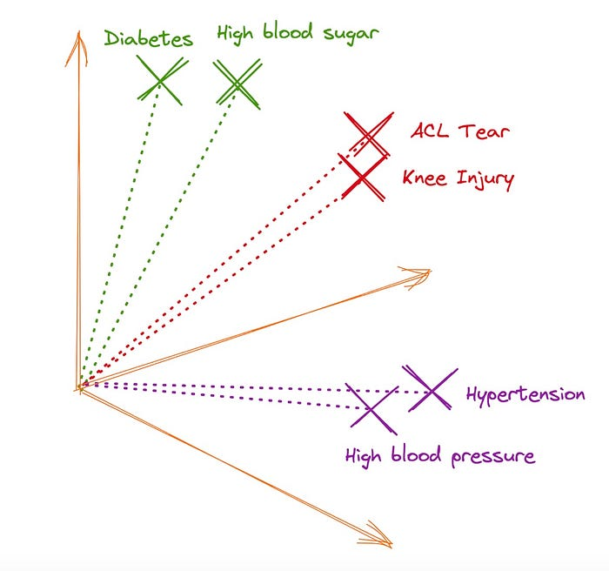

Similar objects are close to each other in the vector space

**Similarity measures**

Once we have vector representations, we need ways to measure how similar they are. Common similarity measures include:

**1. Cosine similarity:**Measures the cosine of the angle between two vectors.

* **Formula:**



**2. Euclidean distance:** Measures the straight-line distance between two points in space.

* **Formula**:



**3. Dot product:** A simple multiplication of corresponding elements.

* **Formula**:



**Vector search process**

1. **Indexing**: Documents or items are converted into vector embeddings and stored in a database.
2. **Query vectorization**: The search query is converted into a vector using the same embedding model.
3. **Similarity calculation:** The system calculates the similarity between the query vector and all (or a subset of) document vectors.
4. **Ranking:** Results are ranked based on their similarity scores.

Press enter or click to view image in full size

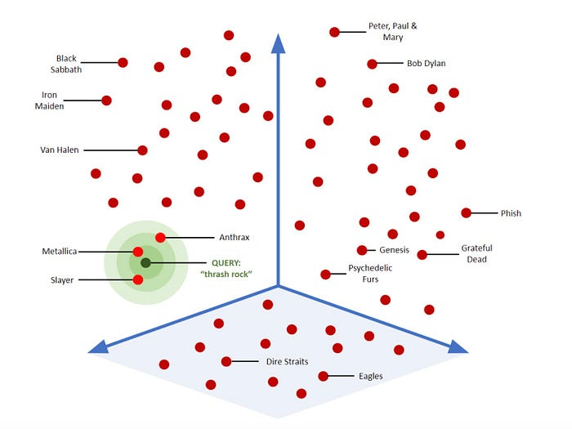

Process of vector search

**Semantic search vs Vector search: Key differences**

While semantic search and vector search are related and often used together, they have some key differences:

**Approach to understanding:**

* Semantic search: Focuses on understanding the meaning and intent behind queries and content.
* Vector search: Relies on mathematical representations and similarity calculations.

**Contextual understanding:**

* Semantic search: Can handle complex queries and understand context beyond individual words.
* Vector search: Primarily relies on learned representations, which may or may not capture all contextual nuances.

**Knowledge representation:**

* Semantic search: Often uses knowledge graphs and ontologies to represent relationships.
* Vector search: Represents knowledge as points in a high-dimensional space.

**Query processing:**

* Semantic search: May involve complex NLP pipelines to understand query intent.
* Vector search: Typically involves converting the query to a vector and performing similarity calculations.

**Scalability**:

* Semantic search: Can be computationally intensive, especially with large knowledge graphs.
* Vector search: Often more scalable, with efficient indexing techniques for large datasets.

**Optimization techniques in vector search**

As datasets grow larger, efficient search becomes crucial. Several optimization techniques have been developed for vector search:

**1. Approximate Nearest Neighbor (ANN) search**

ANN algorithms trade off some accuracy for significant speed improvements. Popular ANN algorithms include:

* [**Locality-Sensitive Hashing (LSH)**](https://en.wikipedia.org/wiki/Locality-sensitive_hashing)
* [**Hierarchical Navigable Small World graphs (HNSW)**](https://en.wikipedia.org/wiki/Hierarchical_navigable_small_world)
* [**Product Quantization (PQ)**](https://towardsdatascience.com/similarity-search-product-quantization-b2a1a6397701)

**2. Indexing strategies**

Various indexing strategies help in organizing and quickly retrieving vectors:

* [**Inverted File Index (IVF)**](https://docs.oracle.com/en/database/oracle/oracle-database/23/vecse/understand-inverted-file-flat-vector-indexes.html)
* Flat Index (for small datasets)
* Hybrid approaches combining multiple techniques

**3. Dimensionality reduction**

Techniques like Principal Component Analysis (PCA) can reduce the dimensionality of vectors while preserving most of the important information, leading to faster searches.

**Real-world applications**

Both semantic and vector search have found numerous applications across industries:

**E-commerce:**

* Semantic search: Understanding product queries beyond exact matches.
* Vector search: Finding visually similar products.

**Content recommendation:**

* Semantic search: Understanding user preferences and content themes.
* Vector search: Quickly finding similar articles or videos.

**Healthcare**:

* Semantic search: Interpreting complex medical queries.
* Vector search: Finding similar patient cases or research papers.

**Legal research:**

* Semantic search: Understanding the intent behind legal queries.
* Vector search: Finding relevant case law and precedents.

**Customer support:**

* Semantic search: Interpreting customer inquiries.
* Vector search: Quickly retrieving relevant support documentation.

**Implementing semantic and vector Search**

For developers looking to implement these technologies, several tools and platforms are available:

**Semantic search tools:**

* Apache Lucene/Solr
* Elasticsearch (with semantic search capabilities)
* Google’s Natural Language API

**Vector Search Databases:**

* Milvus (Open Source)
* Pinecone
* Weaviate
* Faiss (Facebook AI Similarity Search)

**Embedding Models:**

* OpenAI’s GPT models
* Google’s BERT
* FastText

**Code example: Basic vector search implementation**

Here’s a simple Python example using numpy to perform vector search:

import numpy as np  
  
# Create some example document vectors  
documents = np.array([  
 [0.5, 0.2, 0.1], # Document 1  
 [0.1, 0.8, 0.3], # Document 2  
 [0.3, 0.4, 0.7] # Document 3  
])  
  
# Create a query vector  
query = np.array([0.4, 0.3, 0.2])  
  
# Calculate cosine similarity  
def cosine_similarity(a, b):  
 return np.dot(a, b) / (np.linalg.norm(a) * np.linalg.norm(b))  
  
# Calculate similarities  
similarities = [cosine_similarity(query, doc) for doc in documents]  
  
# Find the most similar document  
most_similar = np.argmax(similarities)  
  
print(f"Most similar document: {most_similar}")  
print(f"Similarity scores: {similarities}")

This example demonstrates the basic principle of vector search using cosine similarity. In practice, you’d use more sophisticated libraries and larger datasets.

**Future trends and challenges**

As these technologies continue to evolve, several trends and challenges are emerging:

1. **Integration of semantic and vector approaches:** Many systems are now combining semantic understanding with vector search for more accurate results.
2. **Multimodal search:** Incorporating text, images, and even audio in search systems. (check out my [**semantic search engine Similarix**](https://similarix.com/))
3. **Privacy concerns:** As search becomes more personalized, addressing privacy issues becomes crucial.
4. **Scalability:** Handling ever-increasing amounts of data while maintaining search speed and accuracy.
5. **Explainability:** Making search results more interpretable, especially in critical applications like healthcare or finance.
6. **Continuous learning:** Developing systems that can adapt and improve their understanding over time.

**Conclusion**

Semantic search and vector search represent significant advancements in information retrieval technology. While they approach the problem from different angles — semantic search focusing on meaning and context, and vector search on mathematical representations — they often work in tandem to provide powerful, accurate search capabilities.