

|  |
| --- |
| Software Testing  Fall 2019 |
|  |
| November 14  Submitted By:  Rajeev Pankaj Shukla (MT2018091) Ravindra Singh Pawar (MT2018093) |



Contents

Problem Statement 6

Control Flow Graph 6

Edge Coverage 6

Prime Path Coverage 6

Testing the Application 7

Control Flow Graph 7

Edge Coverage and Prime Path Coverage 13

Combination Feature Testing 13

Factorial Feature Testing 16

Area Unit Converter Feature Testing 18

Length Unit Converter Testing 21

Temperature Unit Converter Testing 24

Weight Unit Converter Testing 26

Contribution of Members 29

About the Application

The application features unit converter with factorial and combinations as additional features.

The unit converter comes up with conversion in four categories - weight, area, length and temperature. Each of these categories in included with subcategories given as follows:

1. Weight: milligram, centigram, gram, kilogram, decigram, ton, pound, ounce.
2. Area: sq. Millimeter, sq. Centimeter, sq. Meter, sq. Meter, sq. Kilometer, sq. Acre, sq. Hectare.
3. Length: nanometer, millimeter, centimeter, meter, kilometer, inch, foot, yard, mile.
4. Temperature: Celsius, kelvin, Fahrenheit.

The factorial features calculation of factorial with a given numeric value. The interface is provided with inbuilt digit buttons to enter numeric value.

The combination features calculation of mathematical value of C(n, r) after entering numeric value of n and r.

Git Repository: <https://github.com/RajeevPankajShukla/SoftwareTesting.git>

Features:

* Easy to use and light weight application.
* Beautiful, simple and stylish design.
* Backspace button to delete the last digit to correct a simple mistake.

Screenshots of our application are added on next page.

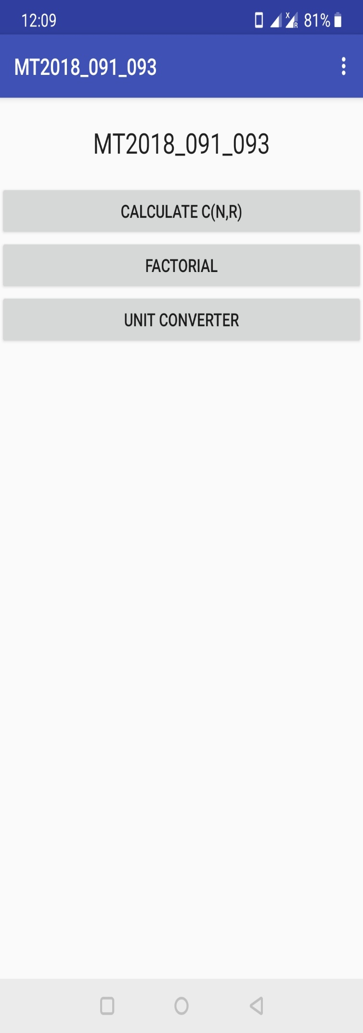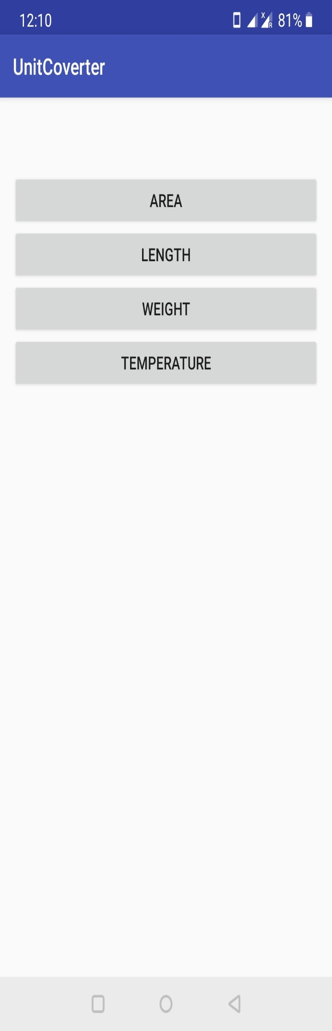

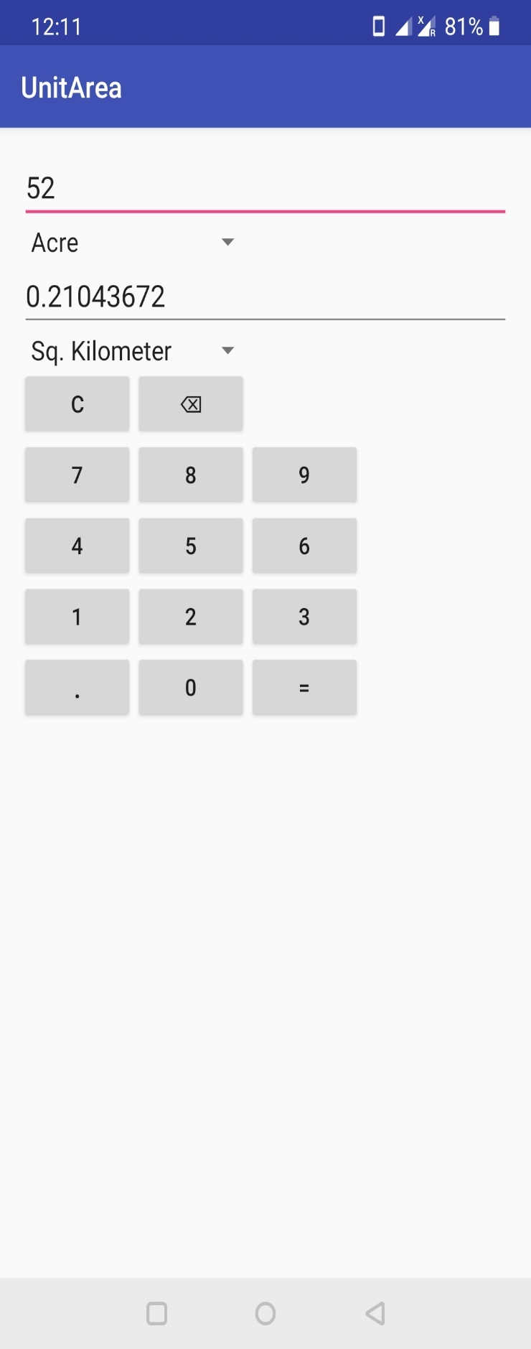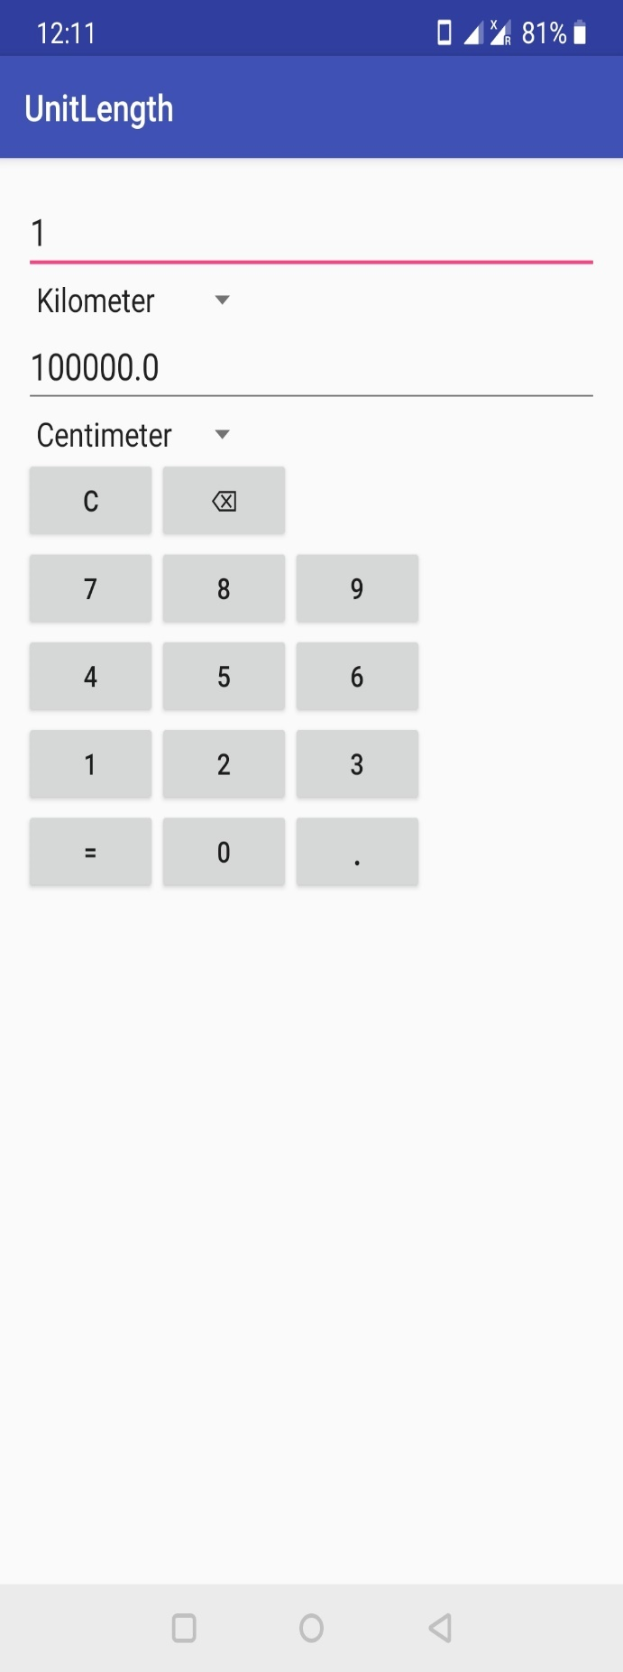

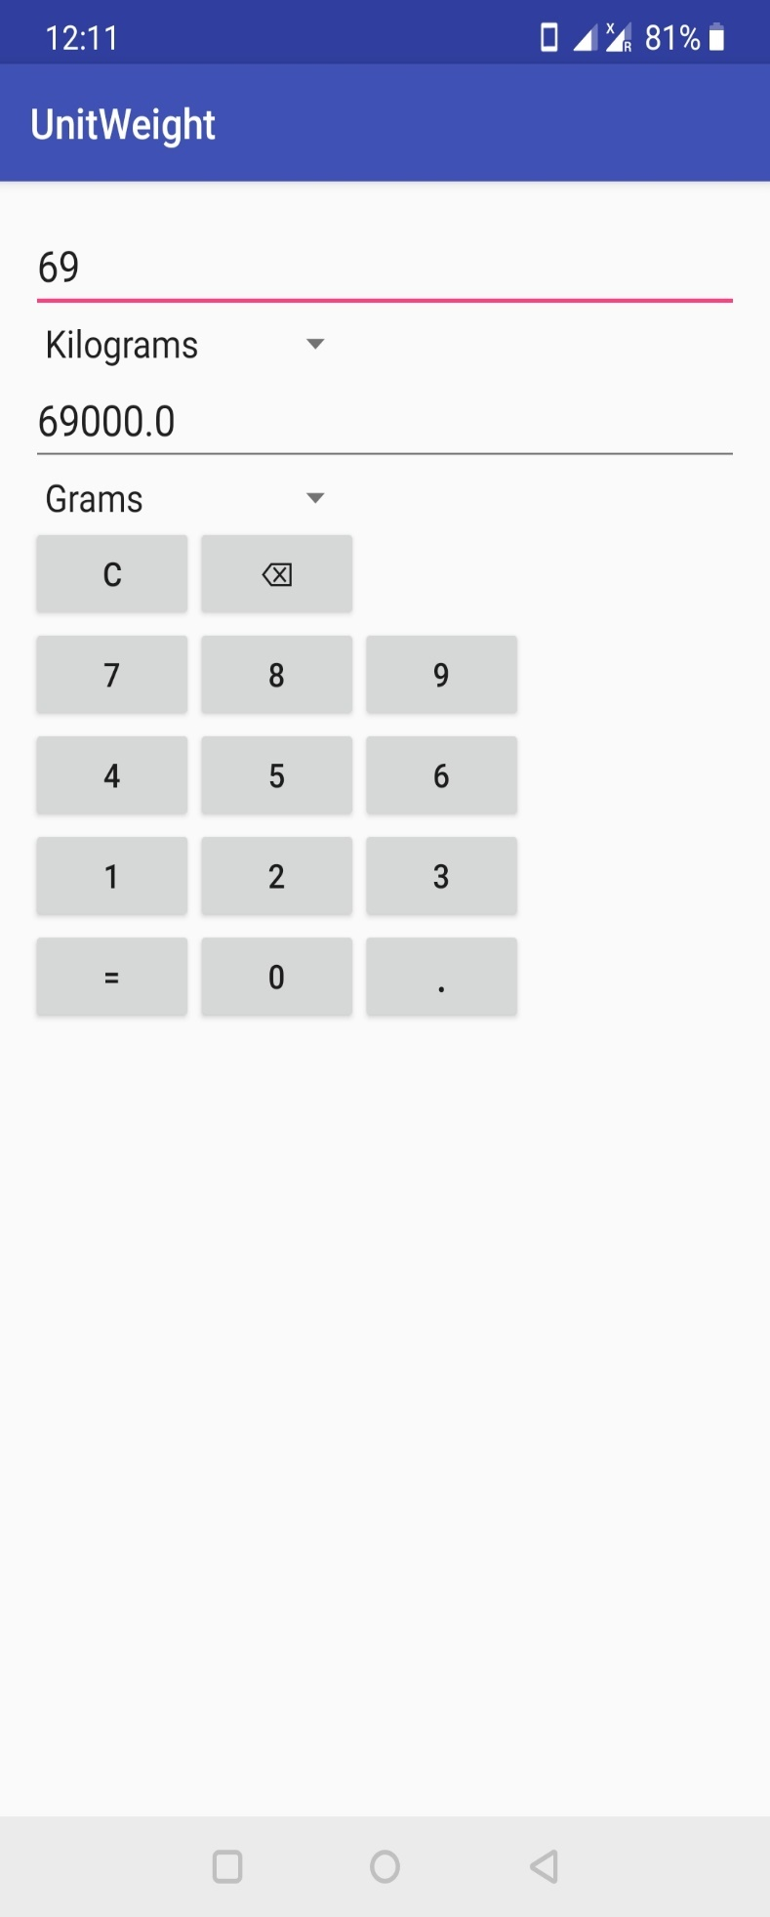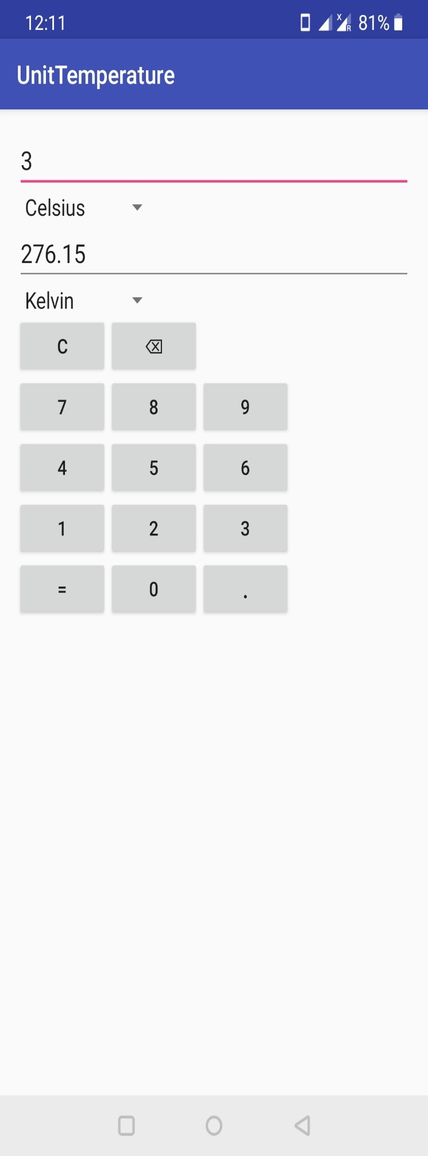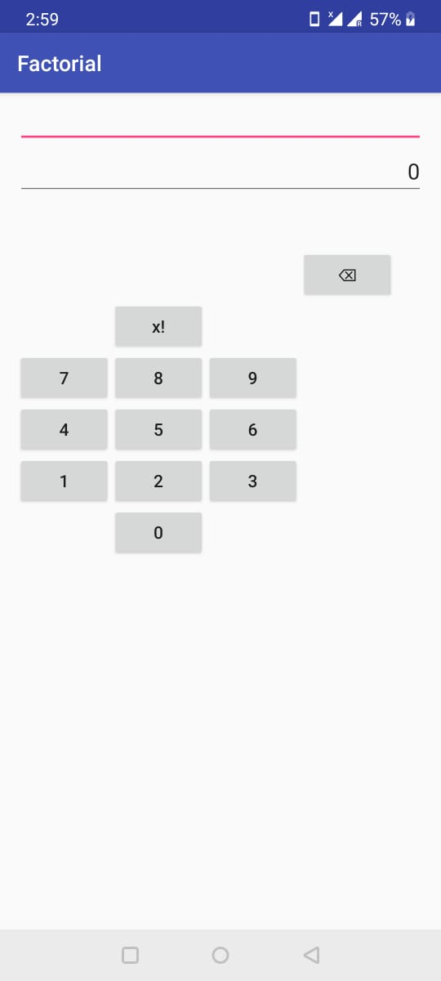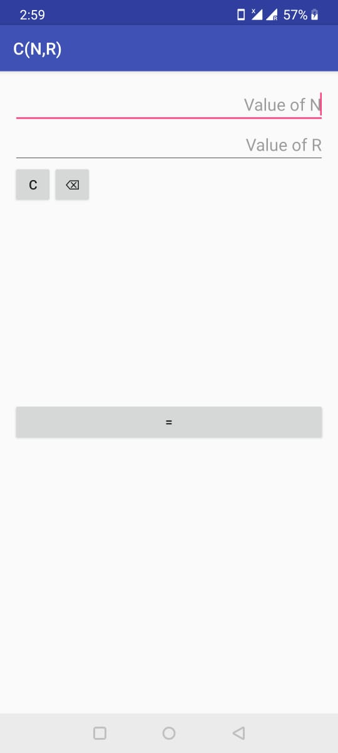

# Problem Statement

To design test cases for Edge Coverage and for Prime Paths Coverage represented by using Control Flow Graph (CFG).

# Control Flow Graph

A Control Flow Graph (CFG) is the graphical representation of control flow or computation during the execution of programs or applications. Control flow graphs are mostly used in static analysis as well as compiler applications, as they can accurately represent the flow inside of a program unit.

Elements of control flow graph:

1. Nodes: Statements or sequences of statements (basic blocks).
2. Edges: Transfers of control.

Basic Block: A sequence of statements such that if the ﬁrst statement is executed, all statements will be (no branches).

# Edge Coverage

Test requirement TR, contains each reachable path of length up to 1, inclusive, in graph G. By path of length it means that it allows edge coverage for graphs with one node and no edges.

# Prime Path Coverage

A prime path is a simple path that does not appear as a proper sub-path of any other simple path. The test requirement TR, contains each prime path in graph G.

# Testing the Application

## Control Flow Graph

Tools Used: Understand scitools (<https://scitools.com/>)   
 Control flow graphs of functions under testing are added below.

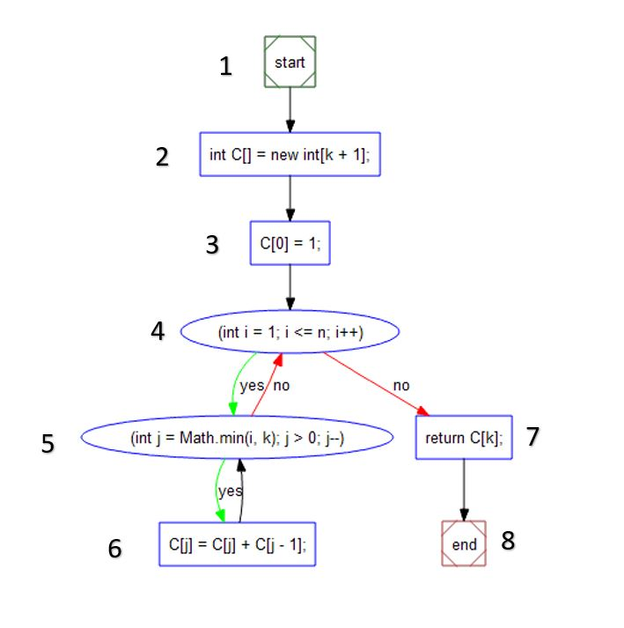

Figure 1: Combination(n,r) CFG

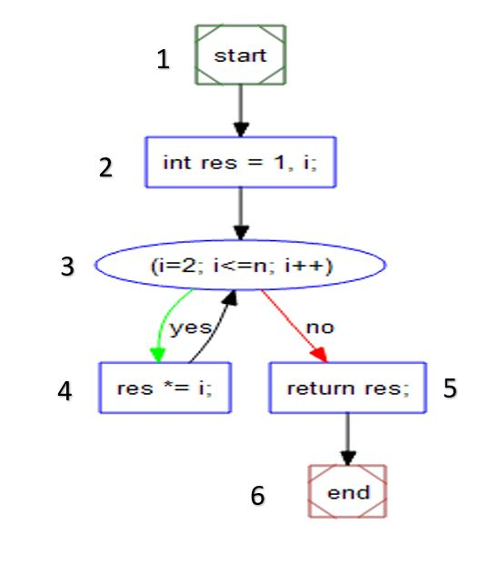

Figure 2: Factorial CFG

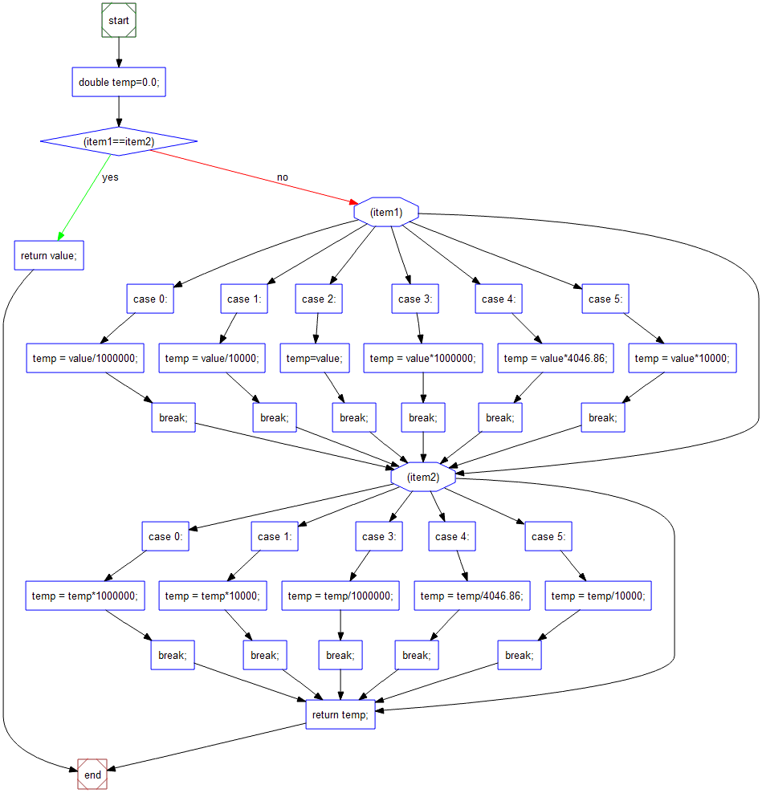

Figure 3: Area Conversion CFG

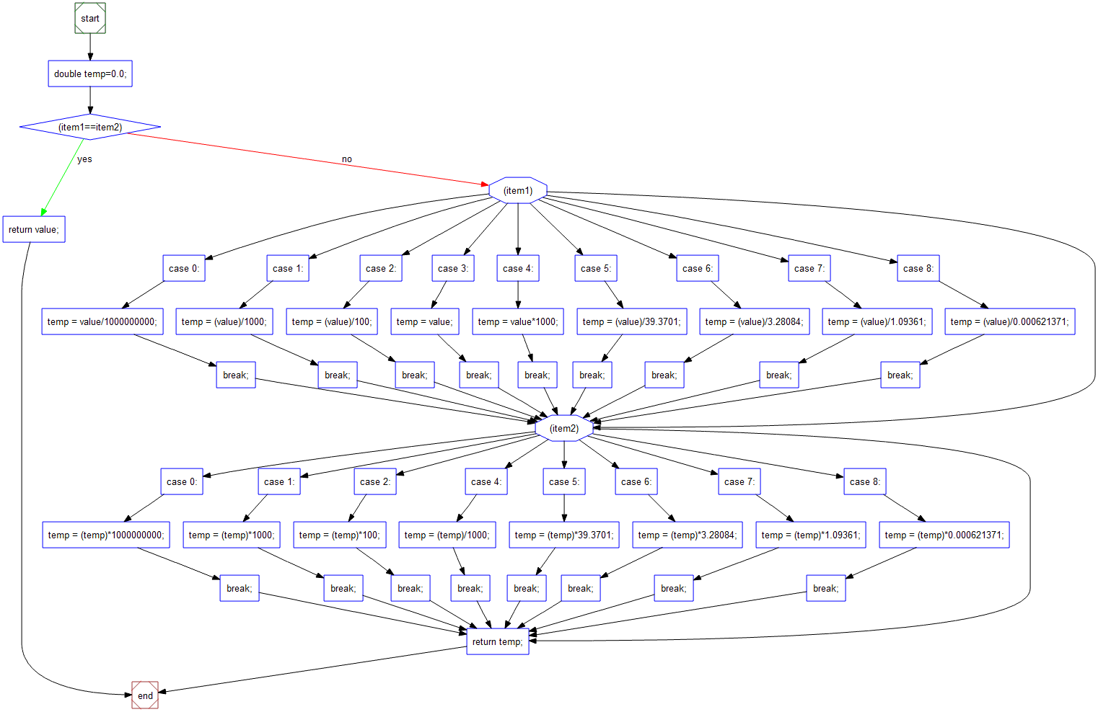

Figure 4: Length Conversion CFG

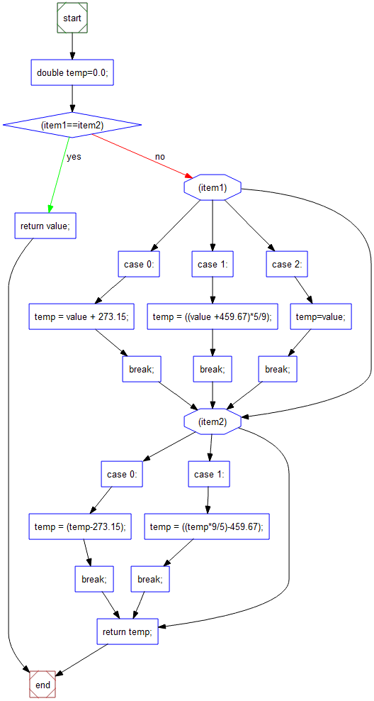

Figure 5: Temperature Conversion CFG

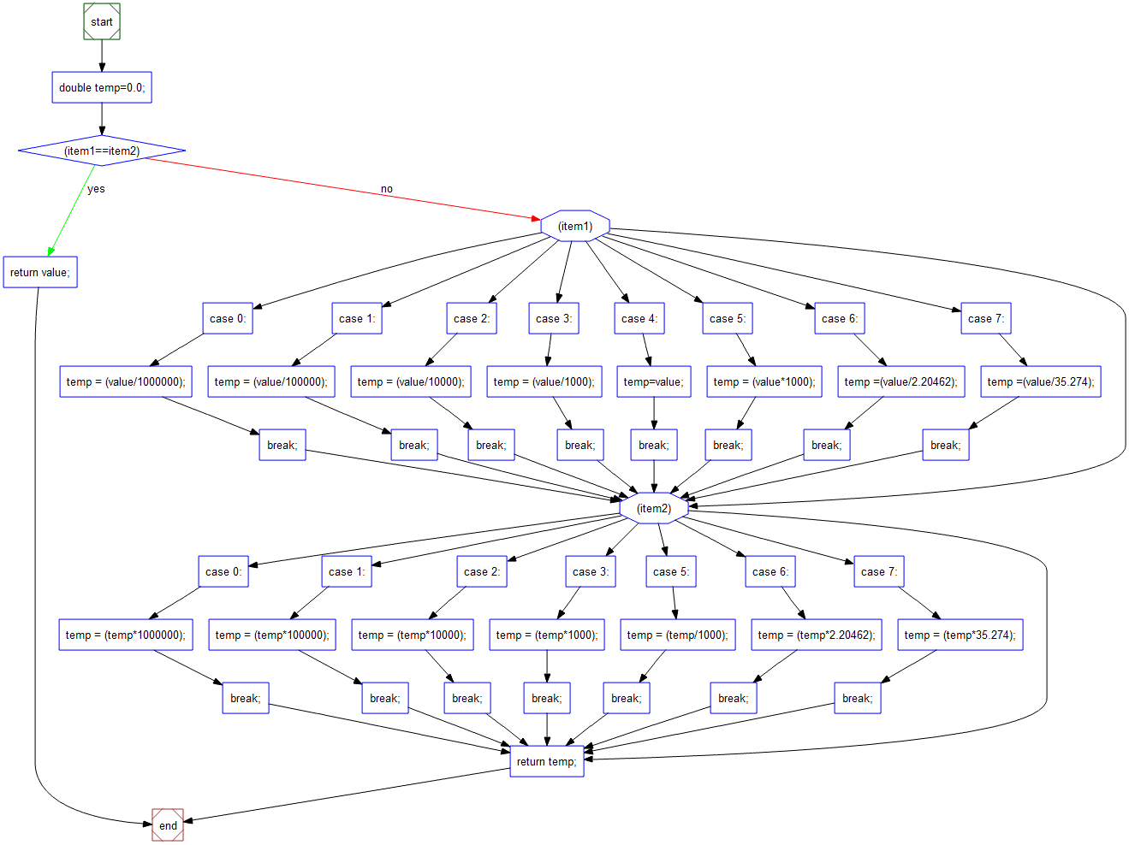

Figure 6: Weight Conversion CFG

## Edge Coverage and Prime Path Coverage

Tools Used:

Android Studio (<https://developer.android.com/studio>),

JUnit5 (<https://junit.org/junit5/>),

George Masen University Tool (<https://cs.gmu.edu:8443/offutt/coverage/GraphCoverage>)

### Combination Feature Testing

Test Requirement for Edge Coverage

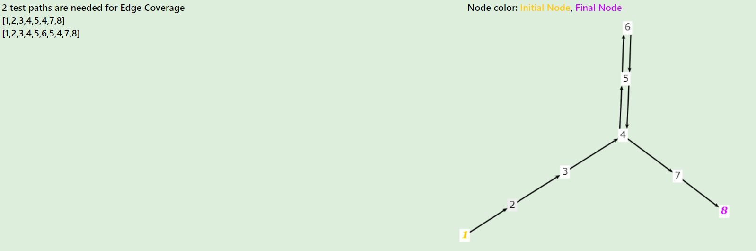

Test Requirement for Prime Path Coverage

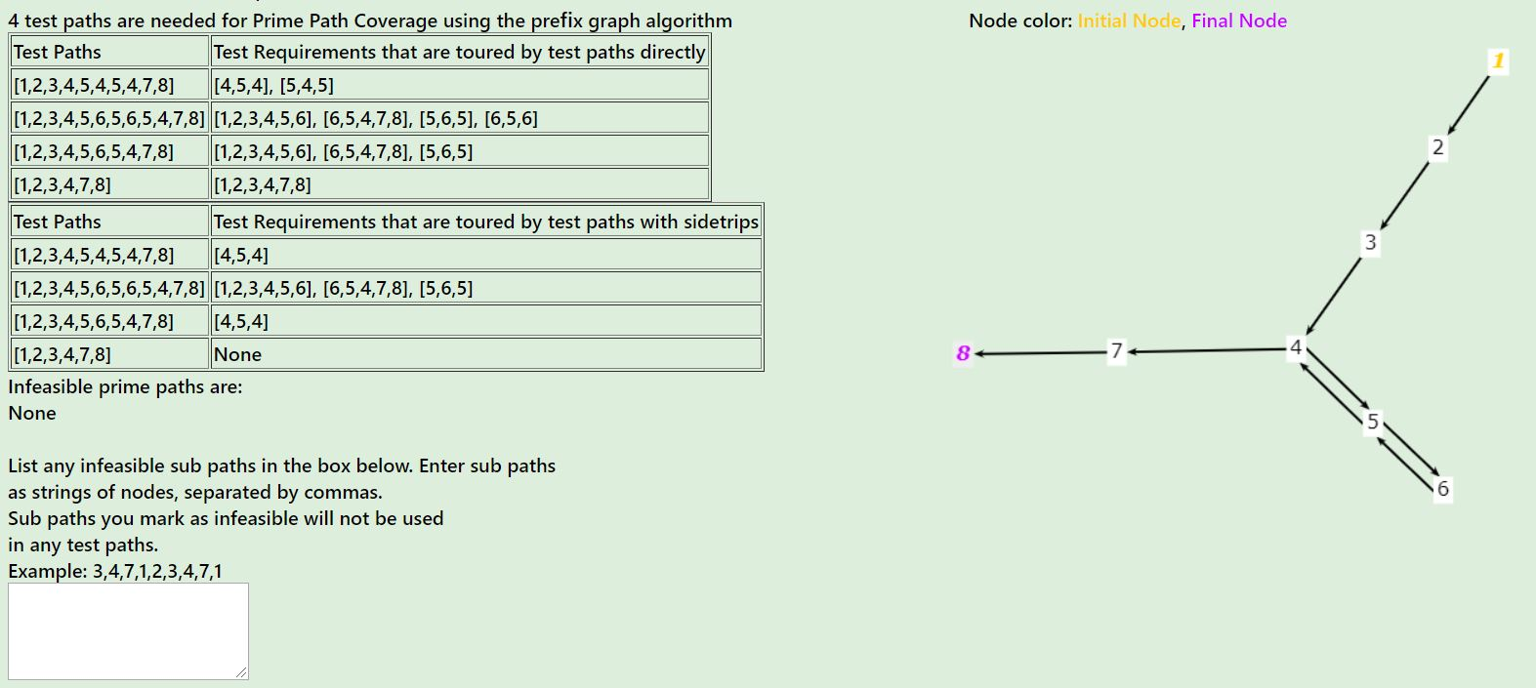

Test Cases

|  |  |  |  |  |  |
| --- | --- | --- | --- | --- | --- |
| S.no | N | K | Expected Output | Actual Output | Status |
| 1 | 5 | 2 | 10 | 10 | Pass |
| 2 | 10 | 2 | 45 | 45 | Pass |
| 3 | 15 | 4 | 1365 | 1365 | Pass |
| 4 | 20 | 10 | 184756 | 184756 | Pass |
| 5 | 5 | 1 | 10 | 5 | Fail (Negative Test Case) |

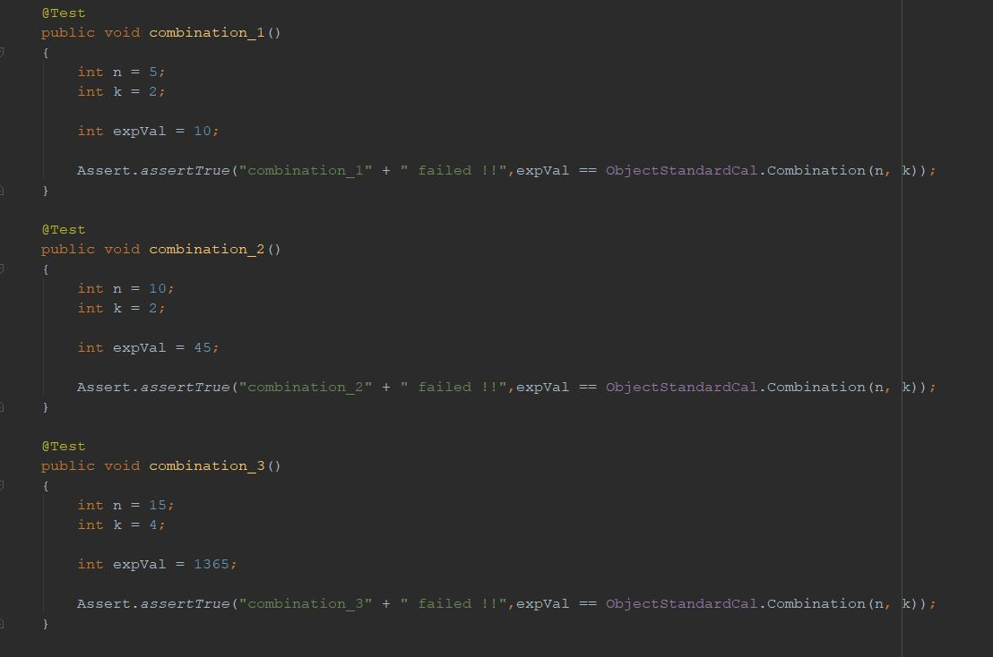

Code Coverage

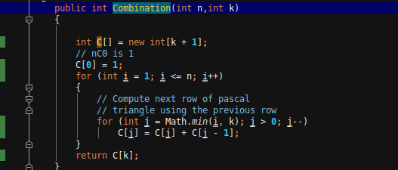

### Factorial Feature Testing

Test Requirement for Edge Coverage

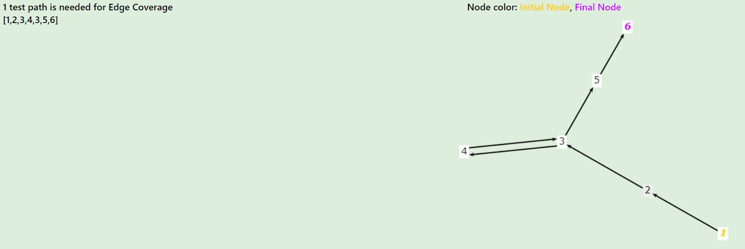

Test Requirement for Prime Path Coverage

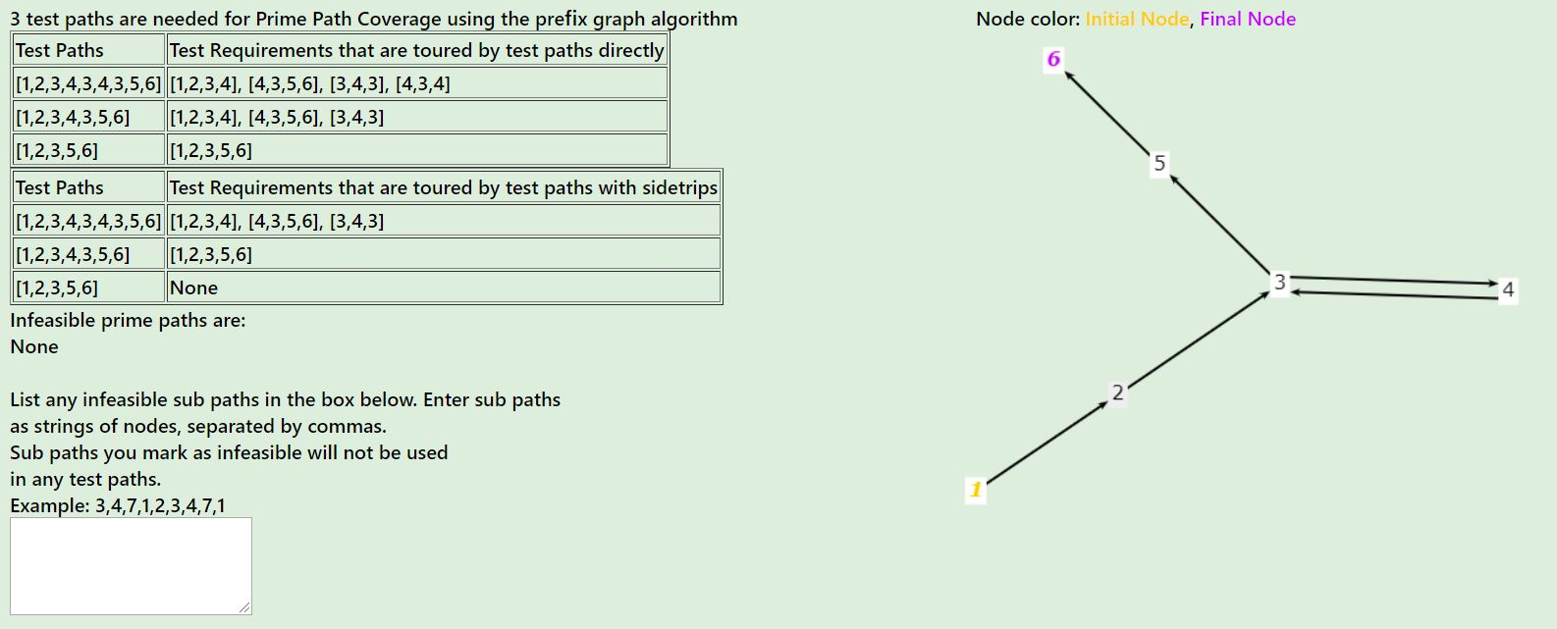

Test Cases

|  |  |  |  |  |
| --- | --- | --- | --- | --- |
| S.no | N | Expected Output | Actual Output | Status |
| 1 | 5 | 120 | 120 | Pass |
| 2 | 4 | 24 | 24 | Pass |
| 3 | 6 | 720 | 720 | Pass |
| 4 | 3 | 6 | 6 | Pass |
| 5 | 5 | 120 | 20 | Fail |

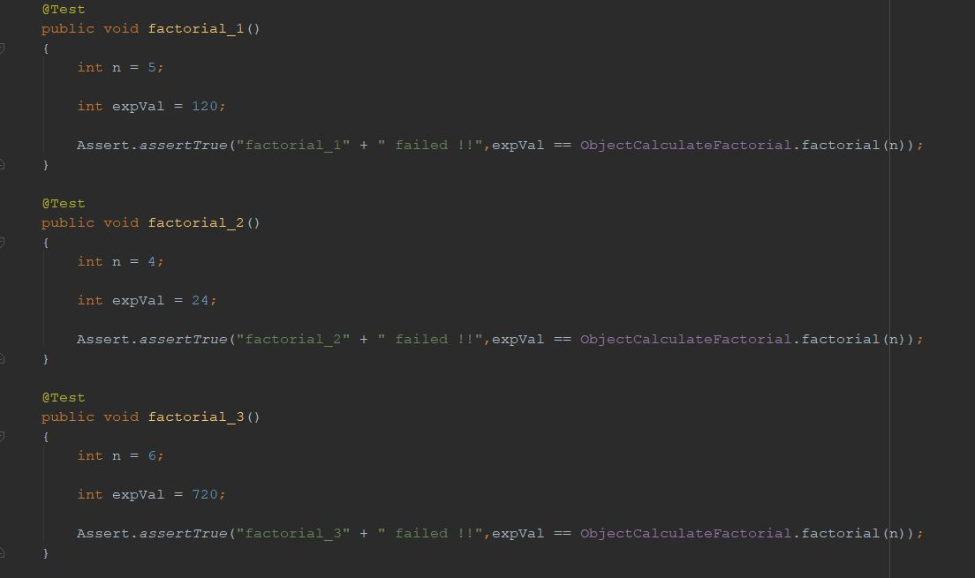

Code Coverage

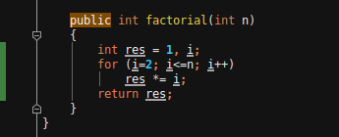

### Area Unit Converter Feature Testing

Test Cases

|  |  |  |  |  |  |  |
| --- | --- | --- | --- | --- | --- | --- |
| S.no | Choice1 | Choice2 | Value | Expected Output | Actual Output | Status |
| 1 | 2 | 2 | 20 | 20 | 20 | Pass |
| 2 | 0 | 2 | 2000000 | 2 | 2 | Pass |
| 3 | 1 | 2 | 20000 | 2 | 2 | Pass |
| 4 | 3 | 2 | 2 | 2000000 | 2000000 | Pass |
| 5 | 4 | 2 | 1 | 4046.86 | 4046.86 | Pass |
| 6 | 5 | 2 | 1 | 10000 | 10000 | Pass |
| 7 | 2 | 0 | 2 | 2000000 | 2000000 | Pass |
| 8 | 2 | 1 | 2 | 20000 | 20000 | Pass |
| 9 | 2 | 3 | 2000000 | 2 | 2 | Pass |
| 10 | 2 | 4 | 4046.86 | 1 | 1 | Pass |
| 11 | 2 | 5 | 20 | 20 | .0002 | Fail (Negative Test case) |

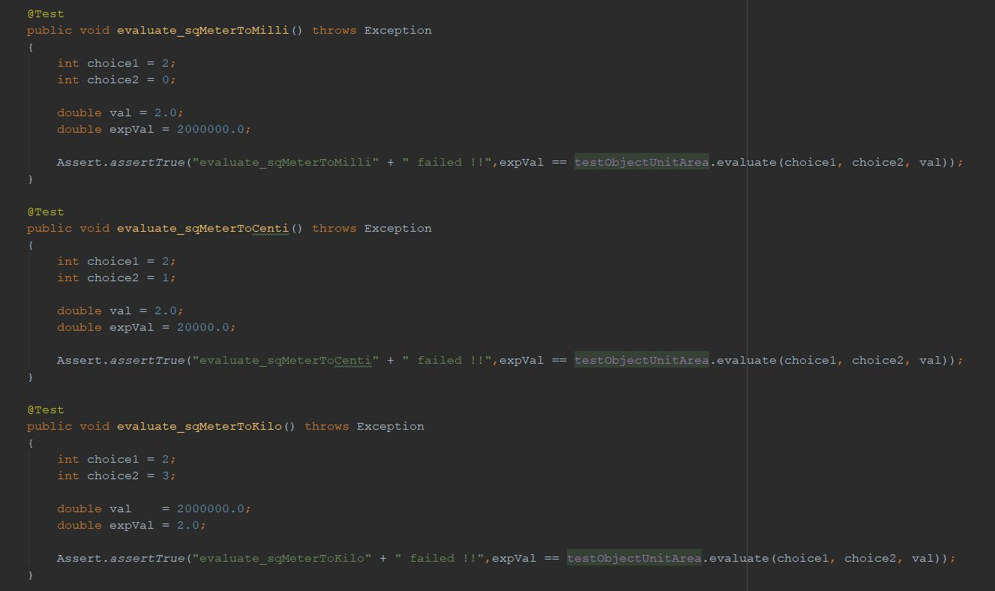

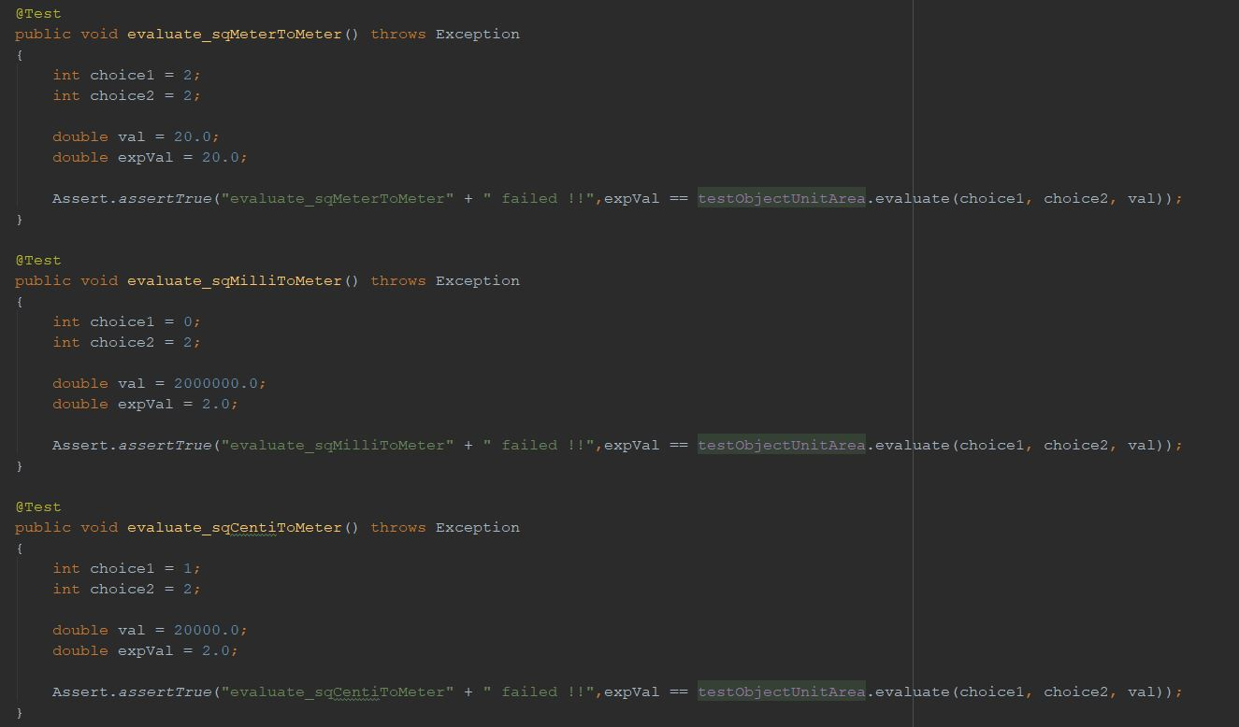

Code Coverage

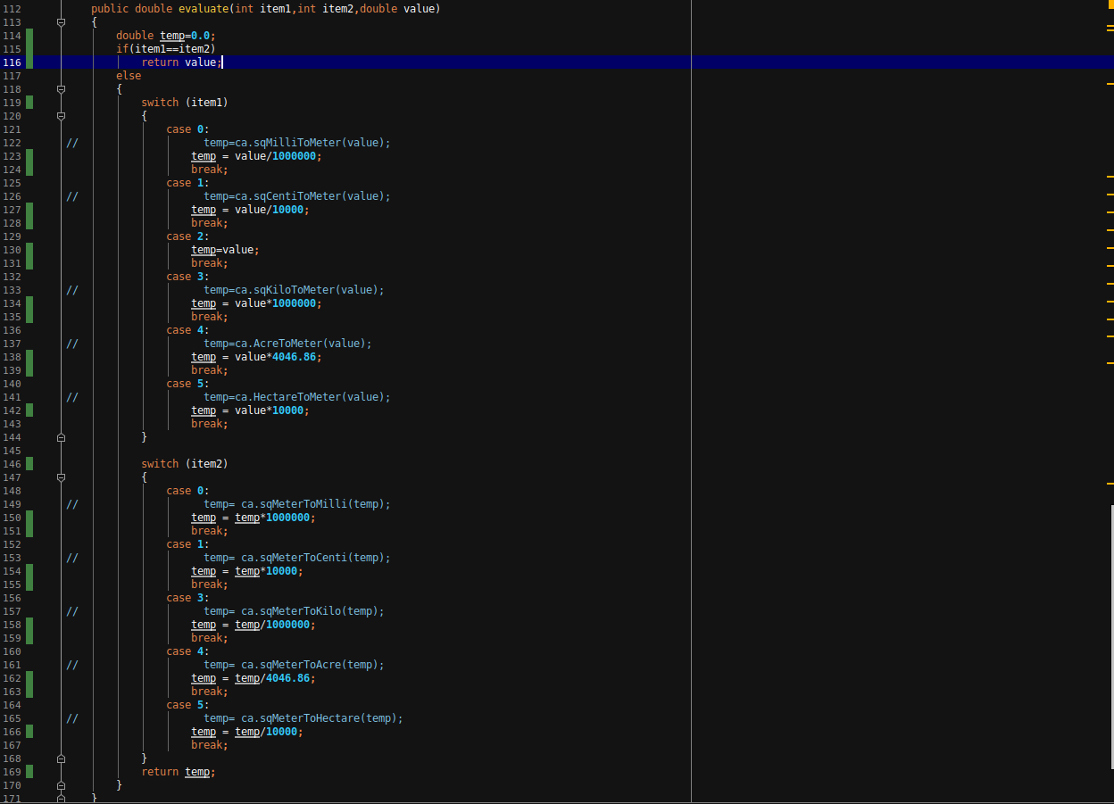

### Length Unit Converter Testing

Test Cases

|  |  |  |  |  |  |  |
| --- | --- | --- | --- | --- | --- | --- |
| S.no | Choice1 | Choice2 | Value | Expected Output | Actual Output | Status |
| 1 | 5 | 5 | 20 | 20 | 20 | Pass |
| 2 | 0 | 3 | 2 | 2E-9 | 2E-9 | Pass |
| 3 | 1 | 3 | 2 | .002 | .002 | Pass |
| 4 | 2 | 3 | 2 | .02 | .002 | Pass |
| 5 | 3 | 3 | 2 | 2 | 2 | Pass |
| 6 | 4 | 3 | 2 | 2000 | 2000 | Pass |
| 7 | 5 | 3 | 2 | 78.7402 | .0508 | Fail (Negative TestCase) |
| 8 | 6 | 3 | 2 | 6.56168 | 0.6096 | Fail (Negative TestCase) |
| 9 | 7 | 3 | 2 | 1.8287988 | 1.82 | Fail (Negative TestCase) |
| 10 | 8 | 3 | 2 | 3281.68895 | 3218.69 | Fail (Negative TestCase) |
| 11 | 3 | 0 | 2 | 2E+9 | 2E+9 | Pass |
| 12 | 3 | 1 | 2 | 2E+6 | 2E+3 | Fail (Negative TestCase) |
| 13 | 3 | 2 | 2 | 200 | 200 | Pass |
| 14 | 3 | 4 | 2 | 2E-3 | 2E-3 | Pass |
| 15 | 3 | 5 | 2 | 78.7402 | 78.7402 | Pass |
| 16 | 3 | 6 | 2 | 6.56168 | 6.56168 | Pass |
| 17 | 3 | 7 | 2 | 2.18722 | 2.18722 | Pass |
| 18 | 3 | 8 | 2 | 1242742E-6 | 1242742E-6 | Pass |

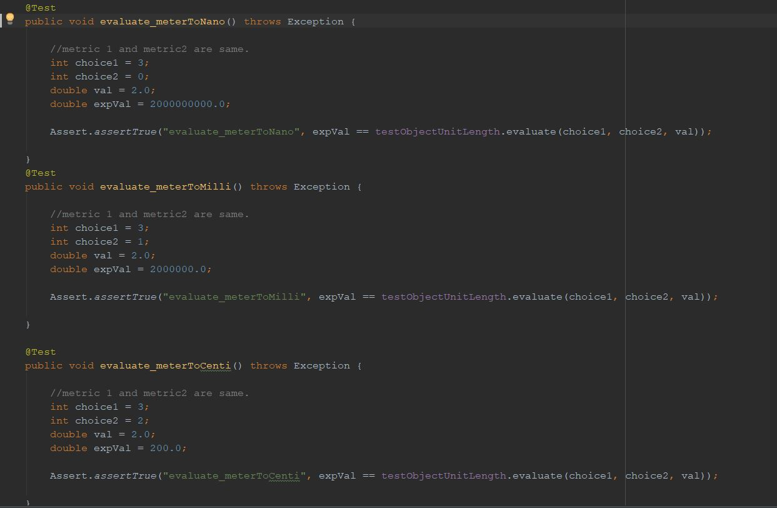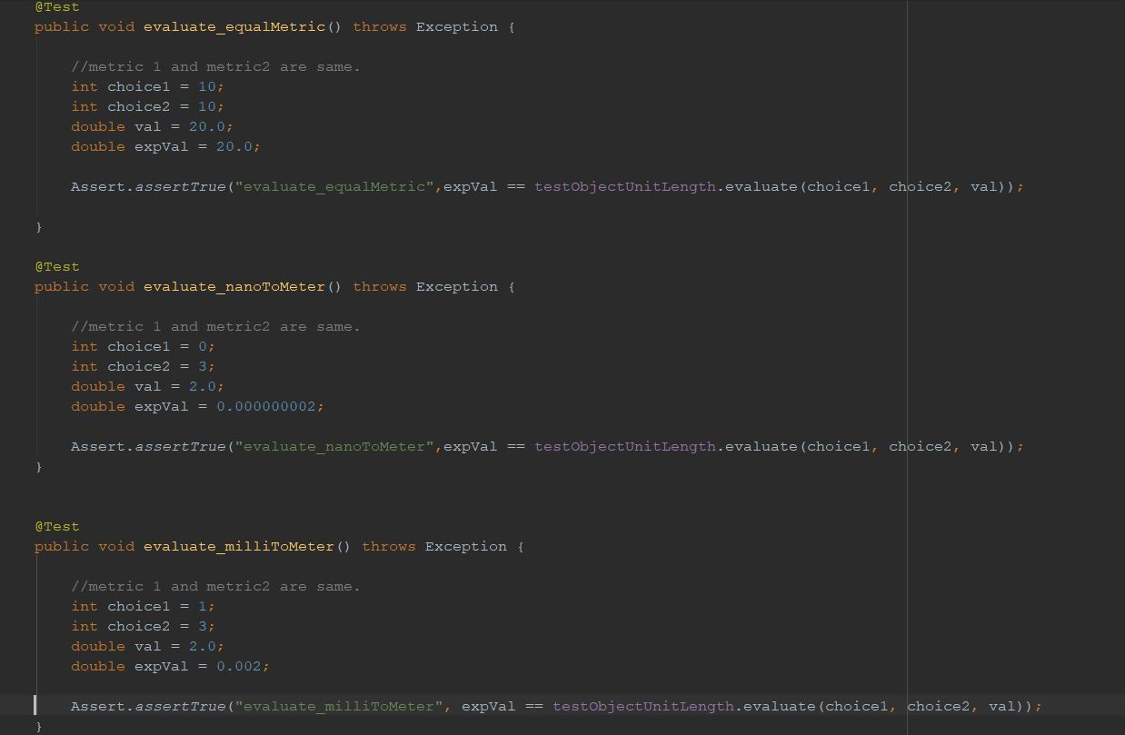

Code Coverage

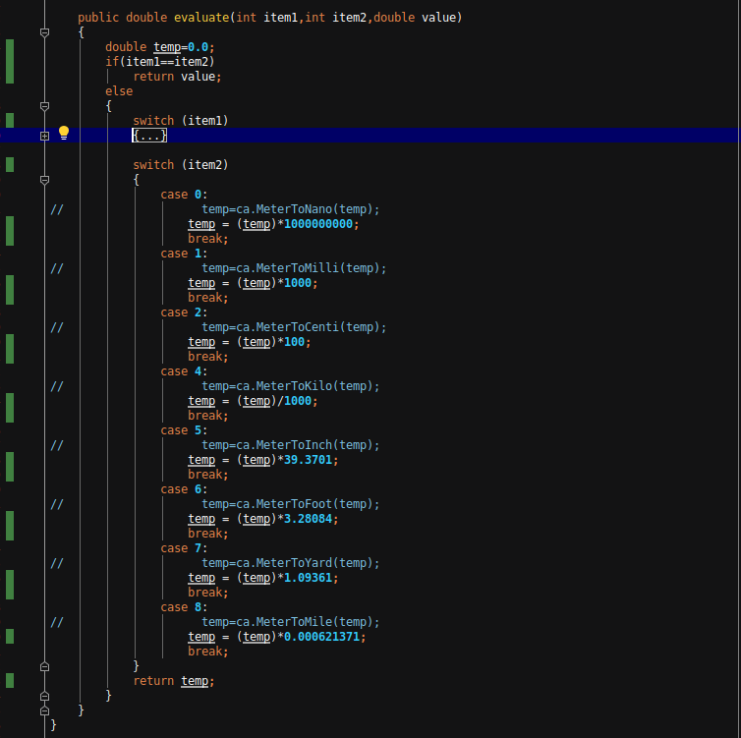

### Temperature Unit Converter Testing

Test Cases

|  |  |  |  |  |  |  |
| --- | --- | --- | --- | --- | --- | --- |
| S.no | Choice1 | Choice2 | Value | Expected Output | Actual Output | Status |
| 1 | 2 | 2 | 20 | 20 | 20 | Pass |
| 2 | 0 | 2 | 1 | 274.15 | 274.15 | Pass |
| 3 | 1 | 2 | 20 | 20 | 266.483 | Fail (Negative Test Case) |
| 4 | 2 | 0 | 274.15 | 1 | 1 | Pass |
| 5 | 2 | 1 | 20 | 20 | -423.67 | Fail (Negative Test Case) |

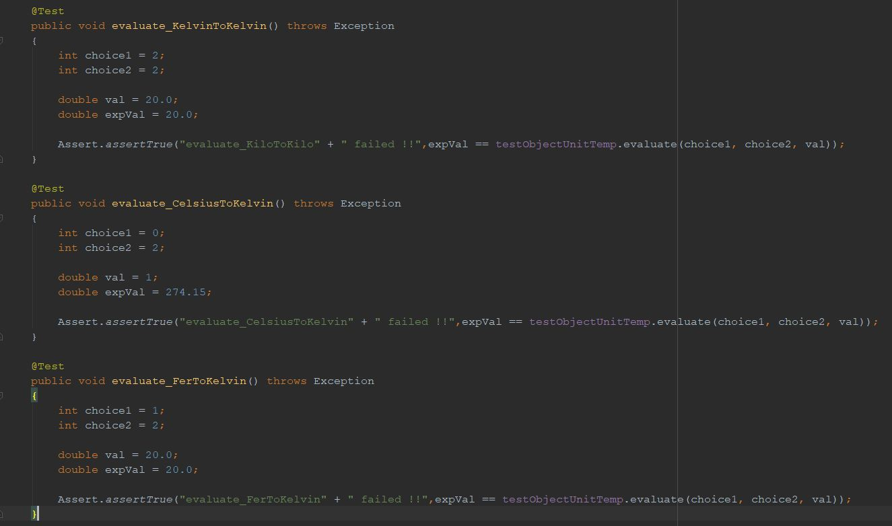

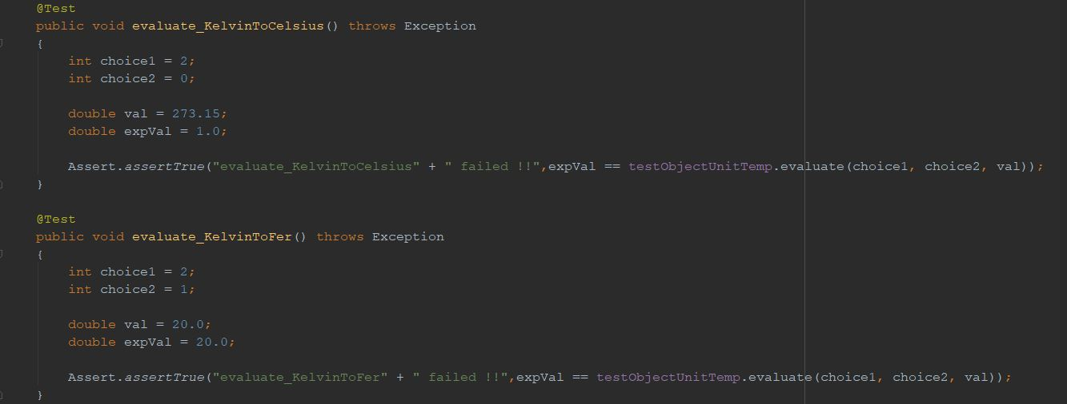

Code Coverage

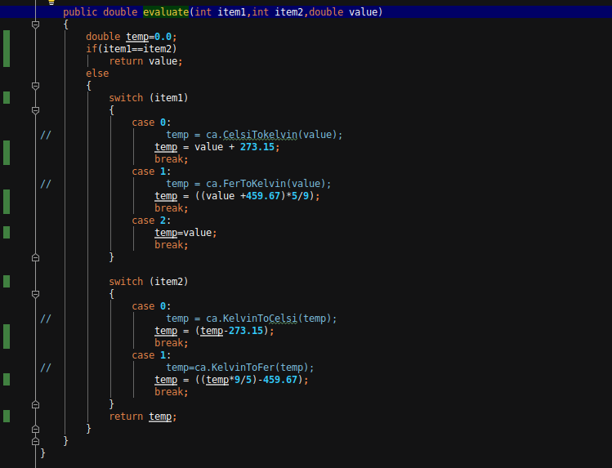

### Weight Unit Converter Testing

Test Cases

|  |  |  |  |  |  |  |
| --- | --- | --- | --- | --- | --- | --- |
| S.no | Choice1 | Choice2 | Value | Expected Output | Actual Output | Status |
| 1 | 4 | 4 | 20 | 20 | 20 | Pass |
| 2 | 0 | 4 | 2000000 | 2 | 2 | Pass |
| 3 | 1 | 4 | 200000 | 2 | 2 | Pass |
| 4 | 2 | 4 | 20000 | 2 | 2 | Pass |
| 5 | 3 | 4 | 200 | 2 | .2 | Fail (Negative TestCase) |
| 6 | 5 | 4 | 2 | 2000 | 2000 | Pass |
| 7 | 6 | 4 | 2.20462 | 1 | 1 | Pass |
| 8 | 7 | 4 | 70 | 1 | 1.98447 | Fail (Negative TestCase) |
| 9 | 4 | 0 | 5 | 5000000 | 5000000 | Pass |
| 10 | 4 | 1 | 5 | 500000 | 500000 | Pass |
| 11 | 4 | 2 | 5 | 50000 | 50000 | Pass |
| 12 | 4 | 3 | 5 | 5000 | 5000 | Pass |
| 13 | 4 | 5 | 5 | 5000 | 5000 | Pass |
| 14 | 4 | 6 | 1 | 2.20462 | 2.20462 | Pass |
| 15 | 4 | 7 | 1 | 35.274 | 35.274 | Pass |

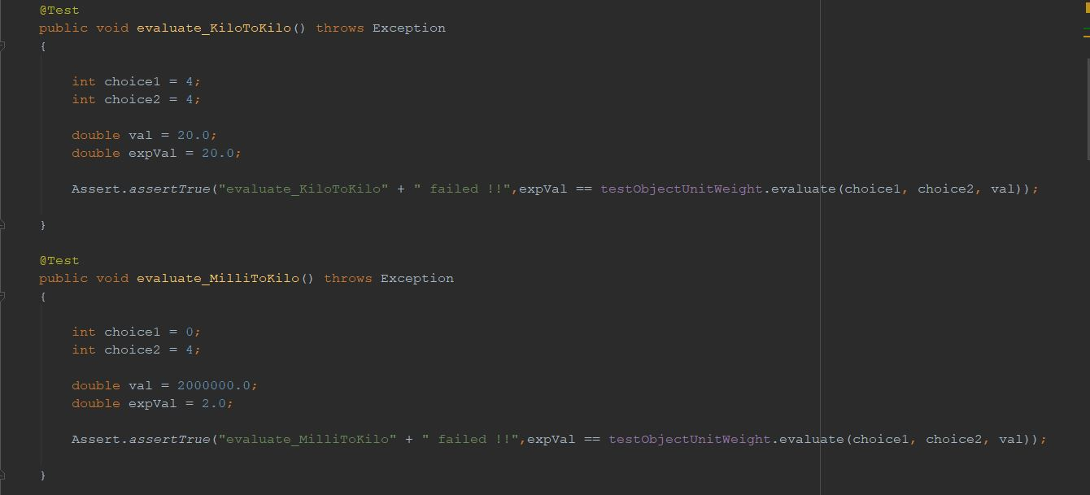

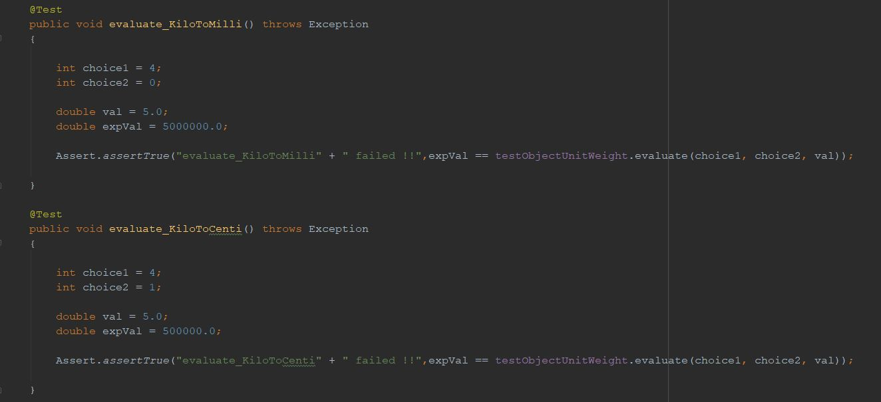

Test Coverage

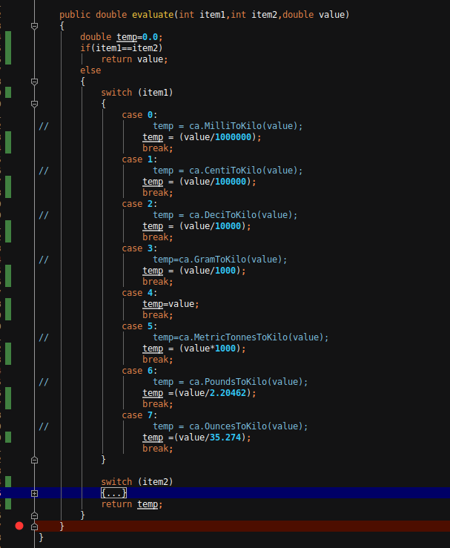

# Contribution of Members

Rajeev Pankaj Shukla (MT2018091) – Application development and Testing for Combination view, Unit Weight Converter view and Unit Area Converter View and Integration.

Ravindra Singh Pawar (MT2018093) - Application development and Testing for Factorial view, Unit Length Converter view and Unit Temperature Converter View and Integration.