Insert Your Title Here∗

Insert Subtitle Here

Smit Sheth  
 Computer Science  
 NYU Tandon School of Engineering  
 City State Country  
 shs572@nyu.edu

Akshat Khare  
 Computer Science  
 NYU Tandon School of Engineering  
 City State Country  
 [email@email.com](mailto:email@email.com)

Rajeev Reddy  
 Computer Science  
 NYU Tandon School of Engineering  
 City State Country  
 email@email.com

ABSTRACT

Our project aims to analyse the NYC 311 complaints for each of the five boroughs that form New York City. Based on the results of our analysis, we intend to further explore these trends and discover the reasons behind the increase or decrease in the number of the complaint types.

INTRODUCTION

For accuracy check of the structured paper, user can run the option **Manuscript Validation**. It informs the user of the wrong or missing values in the paper. The user must correct the paper as per validation messages and rerun **Manuscript Validation**.



PART 3

For this part of the project we did analysis on the NYC 311 complaints dataset for the year 2018. The dataset contains all the service request reported through the 311. The dataset is organized into 41 columns much of which was not used for analysis with over 2.6 million records.

We analyzed the number of reported service requests with respect to Boroughs that form New York City. To do so, we extracted

eight columns of our interest from the main data set: ‘Created Date’, ‘Closed Date’, ‘Agency’, ‘Complaint Type’, ‘Descriptor’, ‘Incident Zip’, ‘City’, ‘Borough’.

We began our analysis with a set of specific questions we formed from exploring and thinking about the dataset, owing to which we had extracted the above-mentioned columns from the

main data set.

1. What are the 3 most frequent 311 complaints types for

each borough.

1. Monthly analysis of complains to see if there are months were the complaints increases/ decreased.
2. Does more rental houses in neighborhood influence

specific type of complaint.

1. Does more number of complaints in each borough mean more time to process the requests.

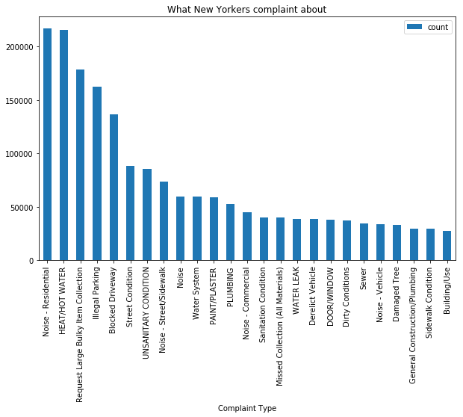

**Figure 1**: Figure shows complaint distribution for New York city

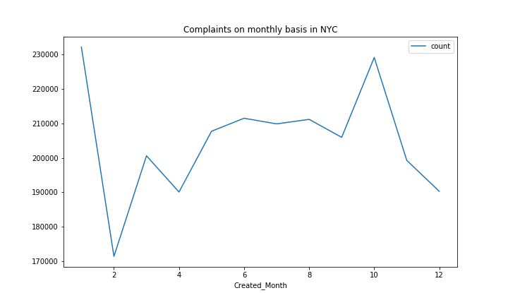

**Figure 1**: Figure shows monthly complaint distribution in New York city

The decline in complaints volume during the month of December can be related to the vacation period as more people are out of the city to celebrate Christmas and New Year’s Eve and also there are holidays at work as well as schools.

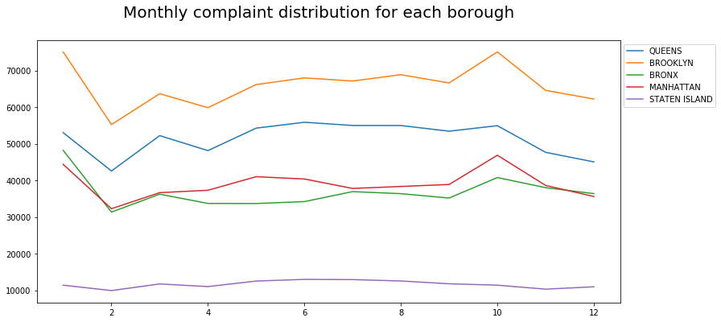**Figure 1**: Figure shows monthly complaint distribution across each borough

The visualizations by borough reveal that the complaint types in New York are uneven across the boroughs. They do seem to vary by the roughly according to the population. Brooklyn is the most populated borough and has the highest number of complaints followed by Queens. Staten Island is much less populated and has the lowest complaints as well.

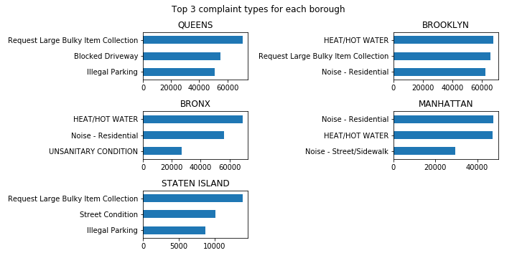

Figure 1: Figure shows the top 3 most frequent complaint types in each borough

One interesting point seen from the above chart is though it appears that Brooklyn saw the most Heat/ Hot water complaints, Bronx (1.4M) with its population at 1.2M less than Brooklyn (2.6M), sees nearly 1000 more complaints of this type. This leads us to consider whether the living conditions in Bronx are much more difficult especially during the winter season.

Before we looked at the data, we had predicted that there would be spike in the complaints during the winters- because heat/hot water complains would drastically increase during winters than in summers. The resulting graphs support our hypothesis.

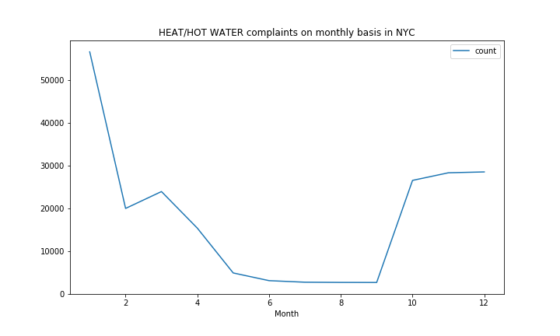

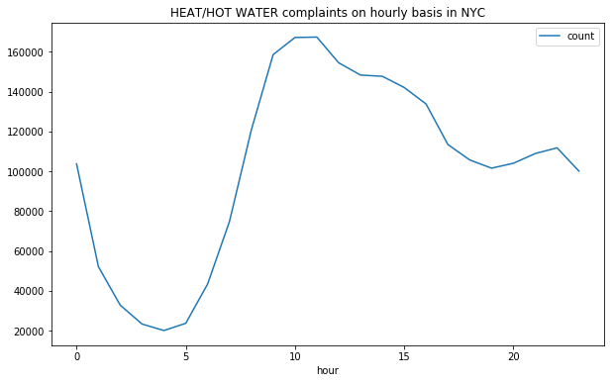

After visualizing the distribution of complaints related to heat/hot water which is the single most-frequent housing complaint in **most of the** borough**s**, we decided to drill down further to find out why the borough Staten Island did not have heat/hot water as one of its most frequent complaints throughout the year. For this we explored the Housing NYC buildings by Units dataset which gives us the information about the construction projects and the type of houses it has.

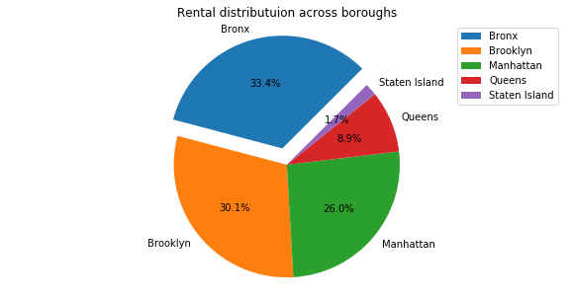

**Figure 1**: Figure shows rental units distribution

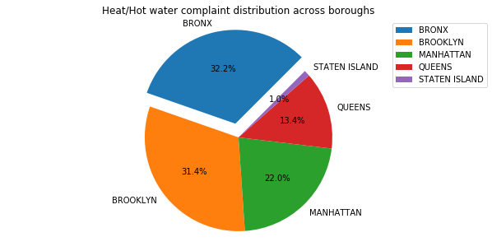

**Figure 1**: Figure shows heat/hot water complaint distribution

As seen from the above diagram, Staten Island only accounts for 1% of the city-wide complaints. The reason is that there aren’t many rental houses available in Staten Island and most Islanders own their house and hence they are not going to complain about heat or water issues instead they’ll fix them themselves. Whereas in Brooklyn, Bronx and Manhattan there are many people staying on rent and hence complain lots of heat and water issues as they are the basic needs. The resulting visualizations support our hypothesis that more the rental houses the more the number of heat/water complaints.

|  |  |  |
| --- | --- | --- |
| Borough | Rental Units | Total Units |
| Bronx | 37212 | 42666 |
| Brooklyn | 33505 | 53831 |
| Manhattan | 28932 | 53341 |
| Queens | 9898 | 15641 |
| Staten Island | 1936 | 2756 |

**Figure 1**: Figure shows the breakdown of number of units constructed from 2014 to 2018

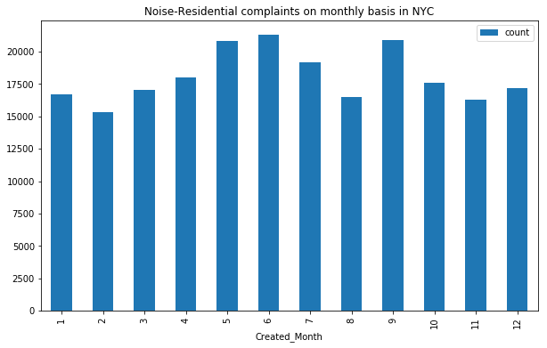

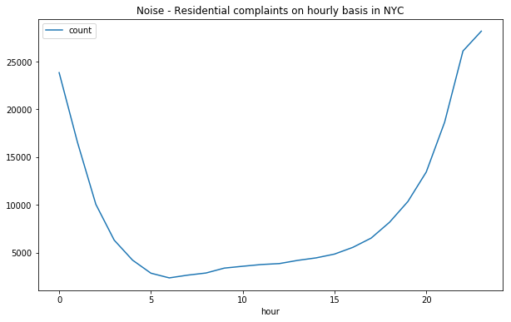

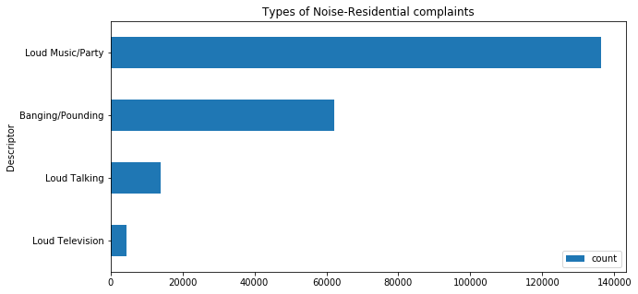

Noise – Residential (which is the complaint about other residential units) is the second most complaint in New York city which makes sense in such a crowded and densely populated city. It hits the highest peak of submission during the 11th hour in the night. The majority of the calls tend to be placed during 10 pm - 1 am. Complaints usually start to ramp up starting at 4pm when usually start returning to their home from their work/school.

Overall Loud Music/Partying had the highest volume of calls across almost all zip codes all boroughs with Brooklyn, Bronx and Manhattan having the most, which is not surprising given the large numbers of younger residents in those neighborhoods.

Loud noise complaints starts to peak from the month of May- September when it becomes warmer, schools are out, and there are more activities to do outside. June has the highest volume of calls.

1.1 Heading Level 2

In the below paragraph, it is explained how alt-txt value is placed in **MS Word 2010**. To add alternative text to a picture in Word 2010, follow these steps:

1. In a Word 2010 document, insert a picture.
2. Right click on the inserted picture and select the **Format Picture** option.
3. Select the **Alt Txt** option from the left-side panel options.
4. In the "Title:" and "Description:" text boxes, type the text you want to represent the picture, and then click "Close".

Below are steps to place alt-txt value in **MS Word 2013/2016**. To add alternative text to a picture in Word 2013/2016, follow these steps:

1. In a Word 2013/2016 document, insert a picture.
2. Right click on the inserted picture and select the **Format Picture** option.
3. In the settings at the right side of the window, click on the "Layout & Properties" icon (3rd option).
4. Expand **Alt Txt** option.
5. In the "Title:" and "Description:" text boxes, type the text you want to represent the picture, and then click "Close".

*1.1.1 Heading Level 3.* Insert paragraph text here. Insert paragraph text here. Insert paragraph text here. Insert paragraph text here. Insert paragraph text here. Insert paragraph text here. Insert paragraph text here. Insert paragraph text here. Insert paragraph text here. Insert paragraph text here. Insert paragraph text here.

*1.1.1.1 Heading Level 4.*Insert paragraph text here. Insert paragraph text here. Insert paragraph text here. Insert paragraph text here. Insert paragraph text here. Insert paragraph text here. Insert paragraph text here. Insert paragraph text here. Insert paragraph text here. Insert paragraph text here. Insert paragraph text here.

ACKNOWLEDGMENTS

Insert paragraph text here. Insert paragraph text here. Insert paragraph text here. Insert paragraph text here. Insert paragraph text here. Insert paragraph text here. Insert paragraph text here. Insert paragraph text here. Insert paragraph text here. Insert paragraph text here. Insert paragraph text here.

REFERENCES

[1] Patricia S. Abril and Robert Plant, 2007. The patent holder's dilemma: Buy, sell, or troll? *Commun. ACM* 50, 1 (Jan, 2007), 36-44. DOI: <https://doi.org/>10.1145/1188913.1188915.

[2] Sten Andler. 1979. Predicate path expressions. In *Proceedings of the 6th. ACM SIGACT-SIGPLAN Symposium on Principles of Programming Languages (POPL '79)*. ACM Press, New York, NY, 226-236. DOI:https://doi.org/10.1145/567752.567774

[3] Ian Editor (Ed.). 2007. *The title of book one* (1st. ed.). The name of the series one, Vol. 9. University of Chicago Press, Chicago. DOI:https://doi.org/10.1007/3-540-09237-4.

[4] David Kosiur. 2001. *Understanding Policy-Based Networking* (2nd. ed.). Wiley, New York, NY..

Conference Name:ACM Woodstock conference

Conference Short Name:WOODSTOCK’18

Conference Location:El Paso, Texas USA

ISBN:978-1-4503-0000-0/18/06

Year:2018

Date:June

Copyright Year:2018

Copyright Statement:rightsretained

DOI:10.1145/1234567890

RRH: F. Surname et al.

Price:$15.00