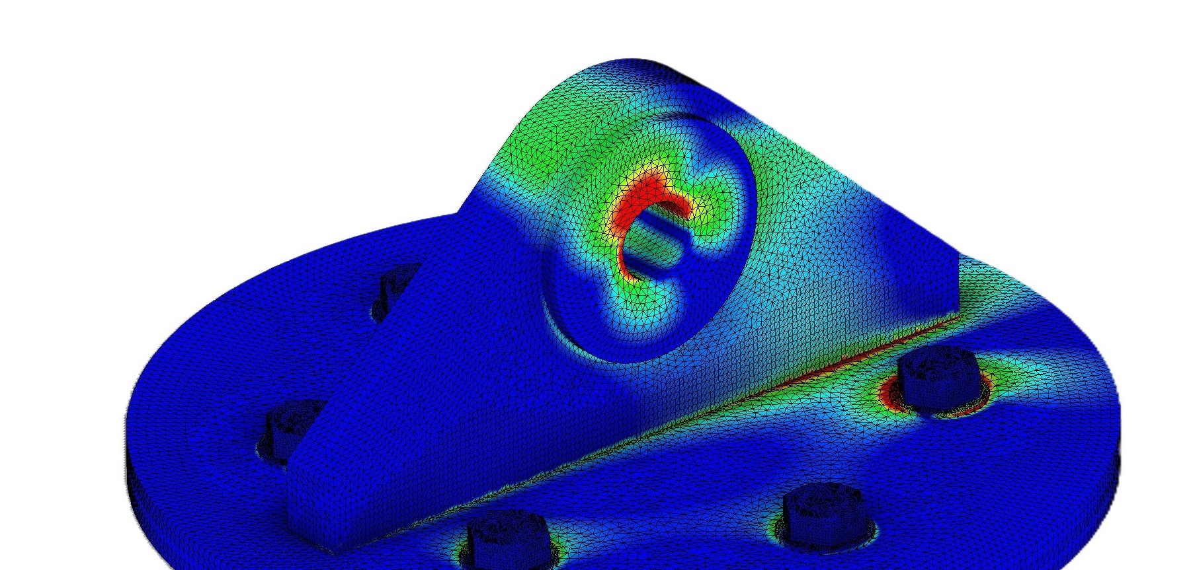

Padeye calculator is a tool used used in engineering and construction to determine the required dimensions and specifications for padeyes, which are integral for lifting and rigging systems.

Ook padeye calculator

Calculator help us to design a pad-eye to be used for lifting or lashing during transport. calculator considers a number of factors, to make sure the padeye can safely support the intended load without failing, including the weight of the load, the angle of lift, the material and thickness of the structure, and safety considerations.

It can be used for the design of a standard pad-eye with

1. No brackets

2. Single cheek plate on either side

It makes the following checks

1. Geometry check: Main plate radius, Shackle clearances

2. Stress Check for Pin Hole (Tensile, Bearing, Shear, Hertz stress)

3. Stress check for Base Plate (Tensile, Bending, Shear, Von Mises and Combined)

4. Stress Check for Base Weld (Tensile, Bending, Shear, Total Stress)

5. Shear Stress Check for Cheek Plate Weld

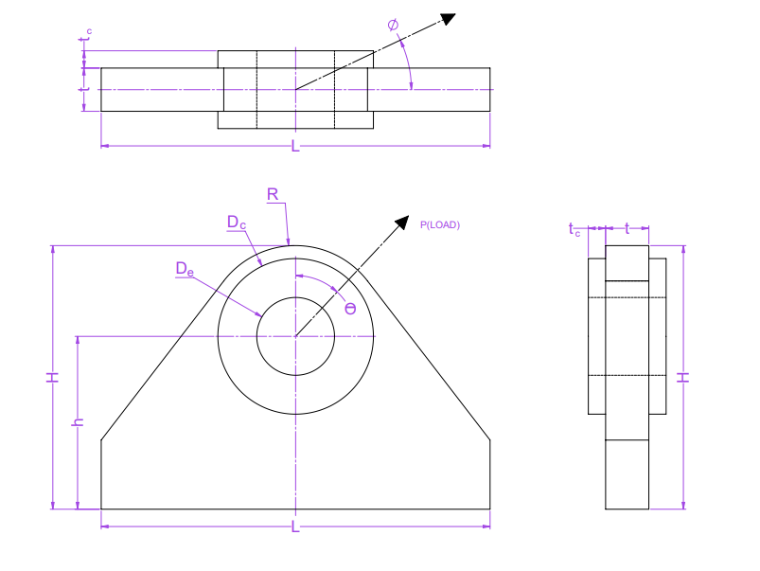

Padeye

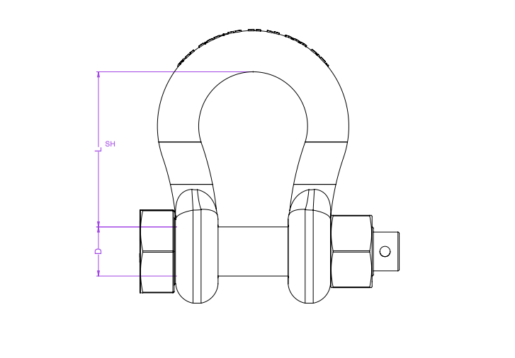

shackle

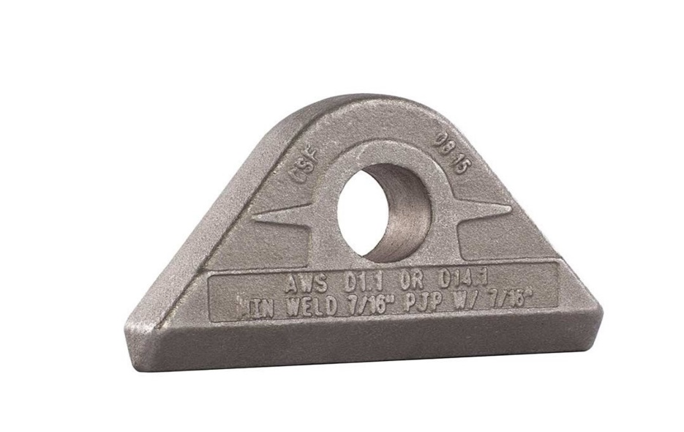Padeye: Lifting

Consist of main plate having hole and with or without occasional ring stiffeners (cheek plate)

welded to the main plate.

Drop down

Factors affecting padeye selection are:

* Load Capacity: For single point lift padeye load capacity should be exceed than the total weight of the load. For multi-point load capacity of total padeye exeed than the total weight of load.
* Material Selection: padeye material must be crossive resistant, ductile, and have good strength and durability.
* Shackle Compatibility: SWL of the shackle should equal or exceed the SWL of the padeye.

Padeye hole diameter must match the shackle pin diameter, with a clearance not exceeding 6% of the pin diameter.

* Weld Type and Size: The type and size of welds must be suitable to handle the load and material. Welds must be designed to distribute stress evenly and avoid creating weak points.
* Lift Configuration: Type of lift, such as straight lifting or multi-point lifts, will affect the padeye design. Such as vertical padeyes are used for straight lifts, while angular designs may be needed for multi-point lifts to prevent lateral bending moments.

Applications of padeye

* Lifting and rigging operation: Padeyes are used for lifting heavier or complex loads. Designed to withstand the forces associated during lifting.
* Towing & mooring: Padeye is used for towing vessel or securing them at docks.
* Securing cargo: Padeyes on decks serve as attachment points for cargo, preventing movement during transportation and ensuring goods are transported safely.

Input parameters

Drop down

1. PADEYE MATERIAL PARAMETER

* Yield strength: stress at which material start deform plastically (permanent changes in shape even after the load is removed).
* Tensile strength: maximum amount of tensile stress that a material can sustain before failure.
* Modulus of elasticity: Material property which indicates how much a material will deform when subjected to load. Materials having high elastic modulus can resist deformation more effectively, while with a low elastic modulus are more flexible and deform more easily under the same load.

2.WELDING PARAMETERS

Weld leg size(twc): length of each side of the triangular cross-section of a fillet weld, measured from the root of the weld (where the two pieces of metal meet) to the toe (the outermost point of the weld) on each side.

3. padeye load parameters

* Angle of load with vertical(θ): angle of sling with respect to padeye in a plane parallel to the padeye.
* Out of plane angle(Φ): angle of sling with respect to padeye in a plane perpendicular to the padeye.
* Dynamic load factor(DLF): used to account for the dynamic forces that can be experienced by a padeye due to sudden accelerations, decelerations, and other dynamic forces that can significantly increase the stresses on the padeye beyond the static load during a lifting operation.

Output parameters:

Drop down

* Bearing stress (σB) is the stress induced between the surface of the pin and the inner surface of the hole due to point contact.

Allowable values for bearing stresses are:

Allowable bearing stress: σbe(allow) = 0.9 x σy (Mpa)

* Tensile stress (σt): When load is lifting with the help of padeye. padeye experiences a tensile force due to the load of the component and the sling connected to padeye. This tensile force creates stress within the material of the padeye. The cheek plates are not included in this stress calculation

Allowable values for tensile stresses are:

Allowable tensile stress: σt(allow) = 0.6 x σy (Mpa)

Allowable tensile stress at pin hole: σtp(allow) = 0.45 x σy (Mpa)

* Shear stress (τ) when the load is lifted due to lateral forces or shifting can cause the padeye to experience shear forces. These shear forces act parallel to the surface of the padeye and can result in shear stress within the material of the lug.

Allowable tensile stress: σs(allow) = 0.4 x σy (Mpa)

when the load is not perfectly aligned with the axis of the padeye, it can induce bending moments. These bending moments can also lead to shear stress in the padeye, especially at points where the padeye is attached to the lifting apparatus.

* Bending stress: Developed at the padeye base due to lateral loads.

Types of bending stress

1. In plane bending stress(σBd)allow: Produce when the load is applied parallel to the plane of the material.
2. Out of plane bending stress(σBdo)allow: Produce when the load is applied perpendicular to the plane of the material.

* Allowable bending stress (in plane): σbd(allow) = 0.6 x σy (Mpa)
* Allowable bending stress (out of plane): σbo(allow) = 0.75 x σy (Mpa)
* Hertz stress: used to calculate the amount of stress produced when two curved surfaces (such as a pin and a padeye hole) come into contact and deform slightly

under the loads involved.

Allowable weld stress: σw(allow) = 0.25 x σu (Mpa)

* Weld stress(σw): Both shear and tensile/compressive stresses developed at the welded connections of a padeye, depending on the type of joint and loading conditions.

Allowable weld stress: σw(allow) = 0.3 x σu (Mpa)

* Throat Thickness(σwtc): Shortest distance from the root of the fillet weld to the face of the weld.

It is the critical dimension that determines the cross-sectional area of the weld that resists shear and tensile forces.

* Weld length(Lwc): Total length of the joint weld the joint.
* Welded area(Awc): Cross-sectional area of the weld that is effective in resisting applied loads.
* Design load(Pd): maximum amount of load that a structure is designed to handle.
* Section modulus of weld(Z): Measure of the distribution of the cross-sectional area of a structure relative to a given axis and is used to calculate the bending strength.In padeye it is used to determine the strength and stability of welded joints.
* Design moment(Md): maximum moment that a structural element, such as a beam, column, or welded joint, can safely withstand without failure.

Lugs: Lugs are typically used for lifting small loads. Designed to withstand the forces associated during lifting. Contain single plate having hole welded to the surface of the load.

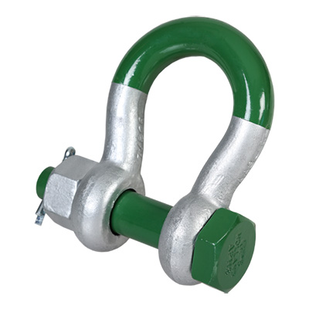Shackle: u-shaped, load-bearing connecting device designed to be strong, durdable, and capable of withstanding high stress and loads. Shackles are typically made of metal, and they come in a variety of shapes and sizes.

Drop down

Input parameters

Drop down

Shackle Safe Working Load (Swl): Maximum load that shackle can handle safely.

Shackle pin diameter: shackle pin diameter must match the Padeye hole diameter, with a clearance not exceeding 6% of the pin diameter.

Shackles are used in a wide variety of applications, including:

* Lifting and rigging: Shackles are used to lift and move heavy objects. They are typically used with other lifting equipment, such as cranes and hoists.
* Towing: Shackles are used to tow vehicles and other objects. They are typically used in conjunction with chains or tow straps.
* Securing: Shackles are used to secure objects in place. They are typically used to secure cargo, equipment, and livestock.

Choosing the Right Shackle

When choosing a shackle, it is essential to consider the following factors:

* Load capacity: The shackle swl should be higher than the weight of the load.
* Type of load: The shackle must be compatible with the type of load. For example, a chain shackle should not be used to tow a vehicle.
* Environment: The shackle must withstand the environment in which it will be used. For example, a shackle used in a marine environment must be made of stainless steel.
* Price: Shackles can range from a few dollars to hundreds of dollars. It is vital to choose a shackle that fits your budget.

Slings: Essential component designed to move large and heavy loads that would be extremely difficult or impossible to move manually.

Drop down

Input

Sling parameter

* Sling diameter(Dsling): Sling diameter directly influences the strength and its load-bearing capacity

Factor affecting sling seletion:

* Weight of the Load: Sling has a specific load carrying capacity. Always ensure the selected sling’s capacity exceeds the load weight.
* Sling angle: As the angle decreases form, the tension on sling increases, which could potentially exceed the sling's rated capacity and cause a failure.

Sling angle should not be less than 60deg.

* Type of Lift: Nature of the lift, such as vertical, choker, or basket lift, also affects sling selection. Each type has different load capacities and application methods suited to specific lifting scenarios.
* Environmental Conditions: Environmental factors, such as temperature, chemicals, and moisture, can impact the material properties of the sling.
* Sling Material

1. Wire Rope Slings: Suitable for heavy-duty applications, high strength, and resistance to abrasion and heat.
2. Chain Slings: Durable, adjustable, ideal for high-temperature environments and rugged conditions.
3. Synthetic Slings (Nylon and Polyester): Lightweight, flexible, and non-conductive. Nylon slings absorb shock loads but are susceptible to chemical damage. Polyester slings are resistant to most chemicals and UV light.
4. Metal Mesh Slings: High temperature and abrasion resistance, good for handling abrasive materials.