DDL commands: Commands which alters the schema of the database are called as data definition language.
1. create: create command is used create database or table
2. drop: drop command is used to drop database or table.
3. alter: alter command is used to add or drop attributes of existing tables, it can also be used to change data type of an attribute of existing table.

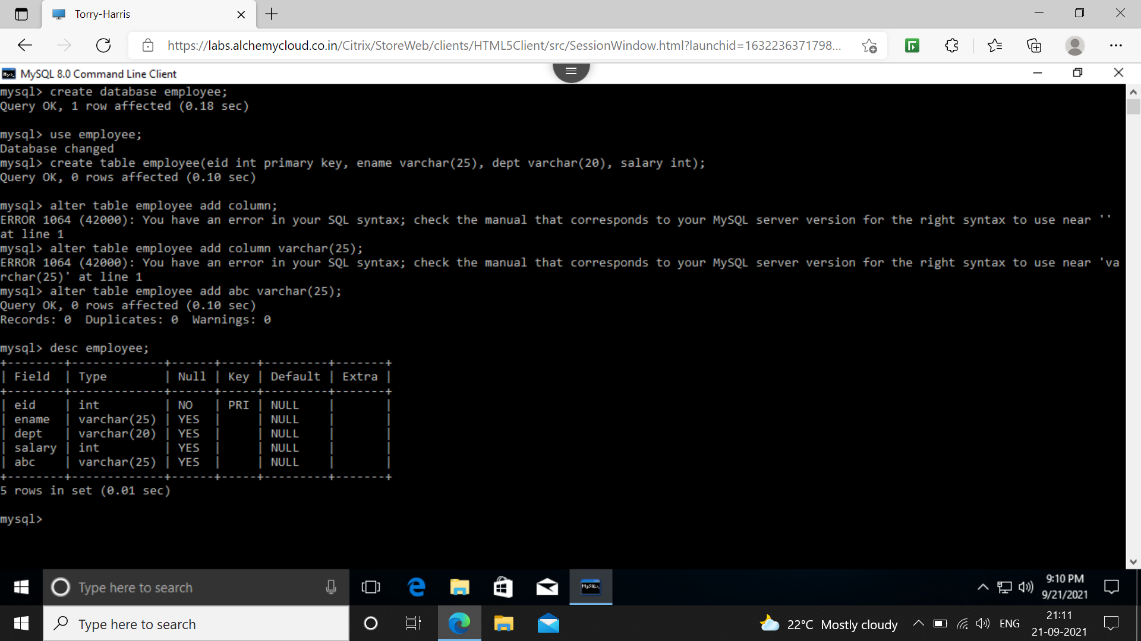
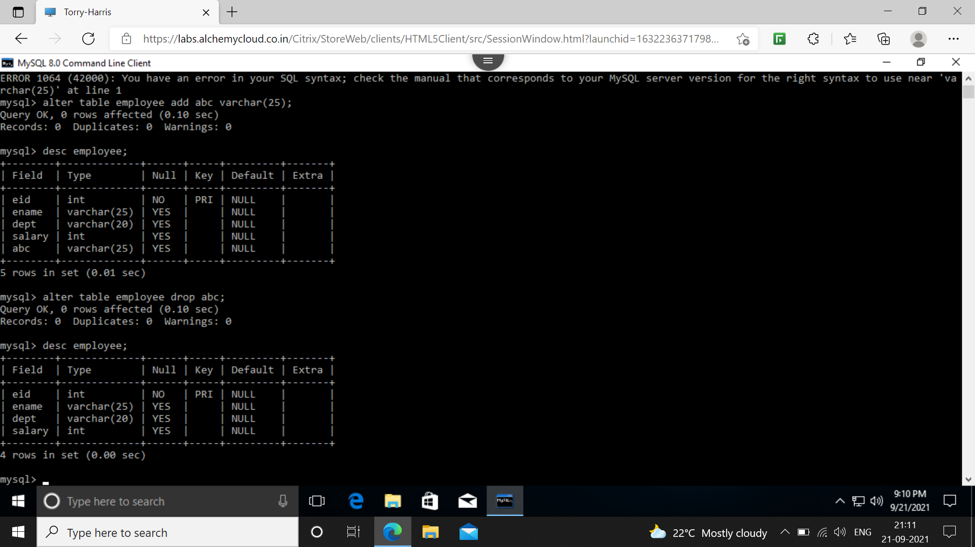

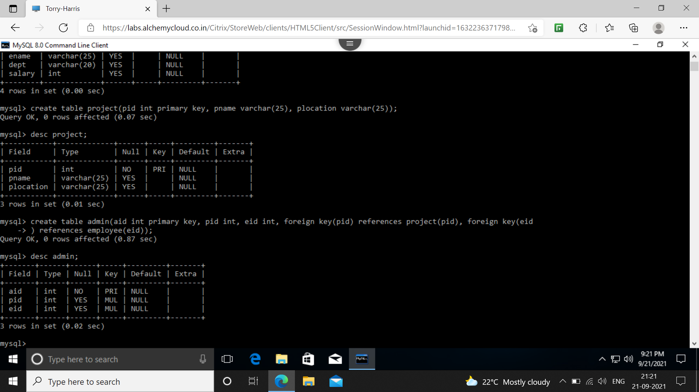

DML commands: commands which works on data of a database rather than its schema are called as data manipulation language.
1. insert: This command is use to insert values to tables.
2. delete: This command is use to delete any particular row of a table.
3. update: is use to change the value of the already existing tuple.
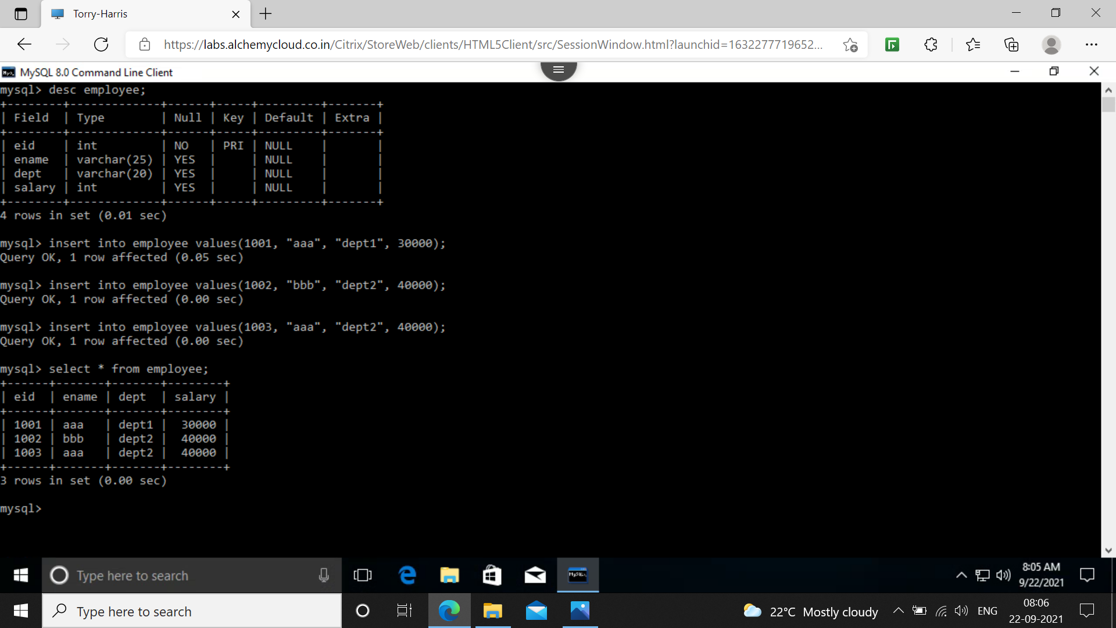

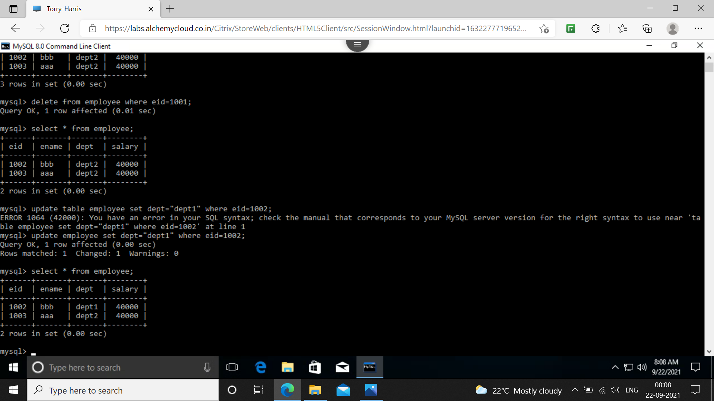

DQL: Data query language command is use to read from a table.
1. select: this command is use to read from table.

Constraints: constraints are added to attributes to avoid any kind of problem that can arise in the future.
1. Not null: this constraint when applied won’t let user to fill null value for the specified attribute.
2. unique: This constraint when applied on an attribute, it won’t let user to enter duplicate values to the attribute.
3. primary key: This key is applied when attribute value cannot be null and should be unique.
4. foreign key: This key might be primary key of another table or unique key of another table.
5. default: This constraint applies with a value, which is going to be replaced with default keyword.
6. check: This constraint is use to check for a particular condition before inserting any value to the table and lasts forever with the table.

