Q1:

WebForm1.aspx

<%@ Page Language="C#" AutoEventWireup="true" CodeBehind="WebForm1.aspx.cs" Inherits="Q1.WebForm1" %>

<!DOCTYPE html>

<html xmlns="http://www.w3.org/1999/xhtml">

<head runat="server">

<title></title>

</head>

<body>

<form id="form1" runat="server">

<div>

<div style="font-weight: 700">

<strong>Choose a Fruit:</strong><asp:CheckBoxList ID="CheckBoxList1" runat="server" style="margin-top: 0px" >

</asp:CheckBoxList>

<br />

Choose an Ice-Cream:<asp:RadioButtonList ID="RadioButtonList1" runat="server">

</asp:RadioButtonList>

<br />

<asp:Button ID="Button1" runat="server" OnClick="Button1_Click" Text="Make Milkshake" />

<br />

<br />

<asp:Label ID="Label1" runat="server"></asp:Label>

</div>

</form>

</body>

</html>

WebForm1.aspx.cs

using System;

using System.Collections.Generic;

using System.Linq;

using System.Web;

using System.Web.UI;

using System.Web.UI.WebControls;

namespace Q1

{

public partial class WebForm1 : System.Web.UI.Page

{

protected void Page_Load(object sender, EventArgs e)

{

if (!IsPostBack)

{

List<string> Fruit = new List<string>();

Fruit.Add("Mango");

Fruit.Add("Orange");

CheckBoxList1.DataSource = Fruit;

List<string> IceCream = new List<string>();

IceCream.Add("Black Current");

IceCream.Add("Chocolate");

IceCream.Add("Vanilla");

RadioButtonList1.DataSource = IceCream;

this.DataBind();

}

}

protected void Button1_Click(object sender, EventArgs e)

{

int[] arr = { 10, 20, 30 };

Random r = new Random();

int num = r.Next(0, 3);

Label1.Text = "The Milkshake you picked has <br/>Fruit: " + CheckBoxList1.SelectedItem.Text + "<br/>Ice-Cream: " + RadioButtonList1.SelectedItem.Text + "<br/><br/>The price of your milkshake is : Rs." + arr[num].ToString();

}

}

}

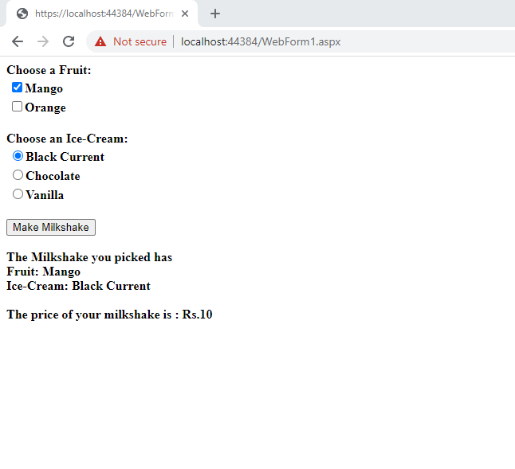

Q2: