|  |  |
| --- | --- |
| Activity | Data Type |
| Number of beatings from Wife | Discrete |
| Results of rolling a dice | Discrete |
| Weight of a person | Continuous |
| Weight of Gold | Continuous |
| Distance between two places | Continuous |
| Length of a leaf | Continuous |
| Dog's weight | Continuous |
| Blue Color | Discrete |
| Number of kids | Discrete |
| Number of tickets in Indian railways | Discrete |
| Number of times married | Discrete |
| Gender (Male or Female) | Discrete |

Q1) Identify the Data type for the Following:

Q2) Identify the Data types, which were among the following

Nominal, Ordinal, Interval, Ratio.

|  |  |
| --- | --- |
| Data | Data Type |
| Gender | Nominal |
| High School Class Ranking | Ordinal |
| Celsius Temperature | Interval |
| Weight | Ratio |
| Hair Color | Ratio |
| Socioeconomic Status | Interval |
| Fahrenheit Temperature | Interval |
| Height | Ratio |
| Type of living accommodation | Ordinal |
| Level of Agreement | Interval |
| IQ(Intelligence Scale) | Interval |
| Sales Figures | Interval |
| Blood Group | Nominal |
| Time Of Day | Ordinal |
| Time on a Clock with Hands | Interval |
| Number of Children | Interval |
| Religious Preference | Nominal |
| Barometer Pressure | Ratio |
| SAT Scores | Interval |
| Years of Education | Ordinal |

Q3) Three Coins are tossed, find the probability that two heads and one tail are obtained?

***HHH, HHT, HTH, HTT, THH, THT, TTH, TTT***

***P (E)= 3/8***

Q4) Two Dice are rolled, find the probability that sum is

1. Equal to 1

***Ans, 0***

1. Less than or equal to 4

***Ans. 2,3,4***

***2= 1,1***

***3=2,1&1,2***

***4=2,2&3,1***

***P(E) = 5/36***

1. Sum is divisible by 2 and 3

***Ans. Divisible by 6= (1,5),(2,4),(3,3),(4,2),(5,1),(6,6)***

***P(E) = 6/36***

Q5) A bag contains 2 red, 3 green and 2 blue balls. Two balls are drawn at random. What is the probability that none of the balls drawn is blue?

***P(E) = 7C2***

***N(E) = 5C2***

***Probability of the ball not being blue = N(E)/P(E)***

***= 10/21***

Q6) Calculate the Expected number of candies for a randomly selected child

Below are the probabilities of count of candies for children (ignoring the nature of the child-Generalized view)

|  |  |  |
| --- | --- | --- |
| CHILD | Candies count | Probability |
| A | 1 | 0.015 |
| B | 4 | 0.20 |
| C | 3 | 0.65 |
| D | 5 | 0.005 |
| E | 6 | 0.01 |
| F | 2 | 0.120 |

Child A – probability of having 1 candy = 0.015.

Child B – probability of having 4 candies = 0.20

***Expected number of candies for a randomly selected child***

***= 1 * (0.015) + 4*(0.20) + 3 *(0.65) + 5*(0.005) + 6* (0.01) + 2 *(0.12)***

***= 0.015 + 0.8 + 1.95 + 0.025 + 0.06 + 0.24***

***= 3.090***

Q7) Calculate Mean, Median, Mode, Variance, Standard Deviation, Range & comment about the values / draw inferences, for the given dataset

* For Points,Score,Weigh>

Find Mean, Median, Mode, Variance, Standard Deviation, and Range and also Comment about the values/ Draw some inferences.

**Use Q7.csv file**

Q8) Calculate Expected Value for the problem below

1. The weights (X) of patients at a clinic (in pounds), are

108, 110, 123, 134, 135, 145, 167, 187, 199

Assume one of the patients is chosen at random. What is the Expected Value of the Weight of that patient?

***Mean= 145.3***

**Q9) Calculate Skewness, Kurtosis & draw inferences on the following data**

**Cars speed and distance**

**Use Q9_a.csv**

**SP and Weight(WT)**

**Use Q9_b.csv**

**Q10) Draw inferences about the following boxplot & histogram**



***Histogram:- Chick weight data is right skewed or positively skewed.***

***- More than 50% Chick Weight is between 50 to 150.***

***- Most of the chick weight is between 50 to 100.***



***- The data is right skewed.***

***- There are outliers at upper side***

**Q11)** Suppose we want to estimate the average weight of an adult male in Mexico. We draw a random sample of 2,000 men from a population of 3,000,000 men and weigh them. We find that the average person in our sample weighs 200 pounds, and the standard deviation of the sample is 30 pounds. Calculate 94%,98%,96% confidence interval?

***CI for 94% = 201.26***

***CI for 98% = 201.56***

***CI for 96% = 201.17***

**Q12)** Below are the scores obtained by a student in tests

**34,36,36,38,38,39,39,40,40,41,41,41,41,42,42,45,49,56**

1. Find mean, median, variance, standard deviation.

***Mean = 41***

***Median = n/2***

***18/2 = 9***

***Median =40***

***Variance = 24.1***

***Standard Deviation = 4.91***

1. What can we say about the student marks?

***The students marks data is normally distributed data***

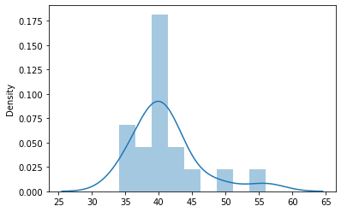

Q13) What is the nature of skewness when mean, median of data are equal?

Ans. ***Skewness = 0***

Q14) What is the nature of skewness when mean > median?

Ans. ***Positively Skewed data***

Q15) What is the nature of skewness when median > mean?

Ans. ***Negatively Skewed data***

Q16) What does positive kurtosis value indicates for a data ?

Ans.  ***It indicates that the distribution of data is peaked and has thick tails***

Q17) What does negative kurtosis value indicates for a data?

Ans. ***Distribution is much flatter and has lighter tails***

Q18) Answer the below questions using the below boxplot visualization.



What can we say about the distribution of the data?

***The data is right skewed and most of the data is between 14 to 16.***

What is nature of skewness of the data?

***Data is Right Skewed.***

What will be the IQR of the data (approximately)?   
  
***IQR = Q3-Q1  
IQR = 18 - 10  
IQR = 8***

Q19) Comment on the below Boxplot visualizations?



* ***Box plots 1 and 2 have the same median***
* ***In box plot 1 most of the data lies between 250 to 280***
* ***In box plot 2 most of the data lies between 225 to 312***
* ***The data is follows normal distribution in both the box plots***

Draw an Inference from the distribution of data for Boxplot 1 with respect Boxplot 2.

***Box plot 2 lies in the interquartile range of boxplot 1***

Q 20) Calculate probability from the given dataset for the below cases

Data _set: Cars.csv

Calculate the probability of MPG of Cars for the below cases.

MPG <- Cars$MPG

* 1. P(MPG>38)

0.34759392515827137

* 1. P(MPG<40)

0.7293498762151609

c. P (20<MPG<50)

0.8988689169682047

Q 21) Check whether the data follows normal distribution

1. Check whether the MPG of Cars follows Normal Distribution

Dataset: Cars.csv

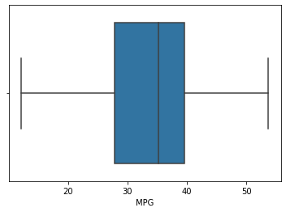

***Yes the data is normally distributed and has a negative skew***

1. Check Whether the Adipose Tissue (AT) and Waist Circumference(Waist) from wc-at data set follows Normal Distribution

Dataset: wc-at.csv

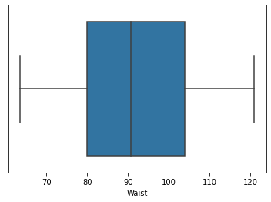

***The data of Waist follows normal distribution***

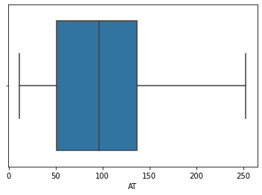

***The AT data is left skewed.***

Q 22) Calculate the Z scores of 90% confidence interval,94% confidence interval, 60% confidence interval

***Ans. For 90% Z = 1.645***

***For 94% Z = 1.555***

***For 60% Z = 0.253***

Q 23) Calculate the t scores of 95% confidence interval, 96% confidence interval, 99% confidence interval for sample size of 25

***T value for 95% = 2.06389***

***T value for 96% = 2.17154***

***T value for 99% = 2.96939***

Q 24**)** A Government company claims that an average light bulb lasts 270 days. A researcher randomly selects 18 bulbs for testing. The sampled bulbs last an average of 260 days, with a standard deviation of 90 days. If the CEO's claim were true, what is the probability that 18 randomly selected bulbs would have an average life of no more than 260 days

Hint:

rcode 🡪 pt(tscore,df)

df 🡪 degrees of freedom

***Ans. 0.32167***