Question One

1. Print a webpage with your name 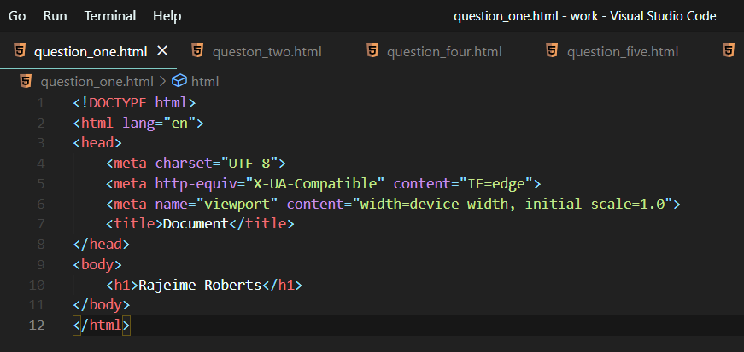
2. Print a webpage with the number from one 1 – 10

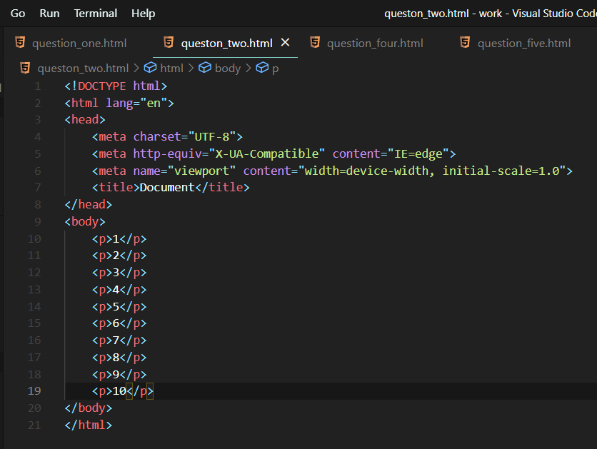

1. Print a webpage with the title “This is a webpage”

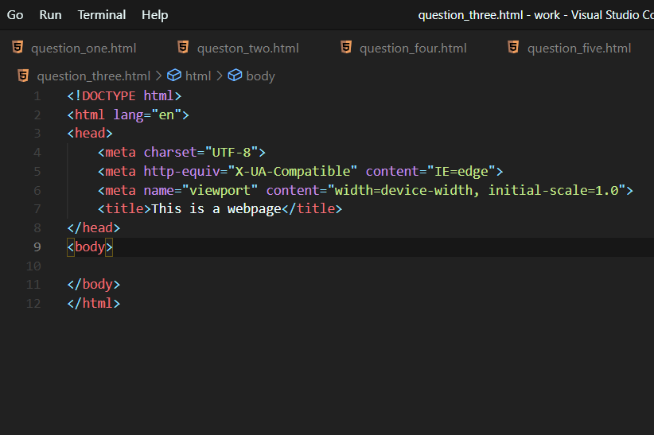

1. Print a webpage wit the question “when was this web page created”, look for answer in the title

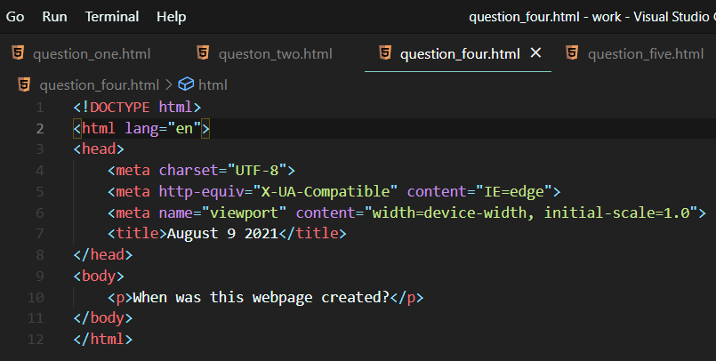

1. Print a webpage counting from 1-10, each number having a different color

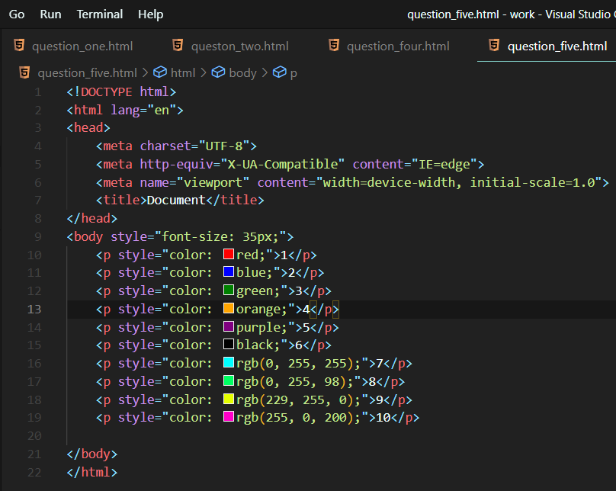

1. Create a paragraph with 4-5 sentences, each sentence having a different color and font.

