**Submitted by Rajendra Kulkarni , TY CSE**

**C++ Assessment**

Add LambdaTest branding to Chromium browser for MacOS

1. Checkout source code of chromium from https://www.chromium.org/developers/how-tos/get-

the-code

2. Make changes in the code for adding LambdaTest branding to Chromium (Replace Chromium by

LT Browser)

a. Replace all URLs listed under chrome://chrome-urls/ with LT Browser. eg. (Replace

chrome://version with lt-browser://version)

b. Replace application name from Chromium to LT Browser.

c. Replace chrome logo with LT Browser logo. If you don't have LT Browser logo you can use

any other of your choice.

d. Change default color scheme of browser

3. Create a new build for MacOS and Windows and send it to us as attachment.

Brownie points

- Replace content of chrome://newtab page with lambdatest.com. i.e. if we enter lt-

browser://newtab it should render contents of lambdatest.com (optional)

**Steps :**

1. Followed all the step as per instructions given on <https://chromium.googlesource.com/chromium/src/+/refs/heads/main/docs/windows_build_instructions.md>
2. The download size was around 17.6 GB.
3. Downloaded the LambdaTest logo from google Images.
4. Created multiple images from the same with different resolutions.
5. Renamed all the images in it with reference to the images in src of chromium.
6. Replaced all the original chromium images with LT logos into following locations :

**src/chrome/app/theme/chromium/product_logo_22_mono.png src/chrome/app/theme/chromium/product_logo_24.png src/chrome/app/theme/chromium/product_logo_48.png src/chrome/app/theme/chromium/product_logo_64.png src/chrome/app/theme/chromium/product_logo_128.png src/chrome/app/theme/chromium/product_logo_256.png src/chrome/app/theme/default_100_percent/chromium/product_logo_16.png src/chrome/app/theme/default_100_percent/chromium/product_logo_32.png src/chrome/app/theme/default_100_percent/chromium/product_logo_name_22.png src/chrome/app/theme/default_200_percent/chromium/product_logo_16.png src/chrome/app/theme/default_200_percent/chromium/product_logo_32.png src/chrome/app/theme/default_200_percent/chromium/product_logo_name_22.png src/chrome/app/theme/default_200_percent/chromium/product_logo_name_48.png src/chrome/app/theme/chromium/win/tiles/Logo.png src/chrome/app/theme/chromium/win/tiles/SmallLogo.png**

1. Also replaced the main icon file from following position with LT icon file

**src/chrome/app/theme/chromium/win/chromium.ico**

1. Now to replace the brand name with LT Browser , I edited the following files and replaced the occurrences of “ Chromium ” and “ Chrome ” with “LT Browser” and “lt-browser” into the following locations.

**src/chrome/app/theme/chromium/BRANDING**

**src/chrome/app/generated_resources.grd**

**src/chrome/app/chromium_strings.grd**

1. I accomplished the above steps as per reference from <https://stackoverflow.com/questions/64166411/how-to-change-chromium-browser-logo-and-name>

And at the time of gn build, It started throwing errors and after hundreds of troubleshooting attempts my PC froze and I had to delete that working folder.

Hence I failed in generating a custom build.

1. **Then I got an idea to modify the assets of chrome browser**

So I edited the resource files and image files packed into .pak format by first extracting the .pak file with the tool chrome-pak-customizer by myfreeer <https://github.com/myfreeer/chrome-pak-customizer>

1. Then I edited those files and could achieve only the following things as per the screen shots.

The Chrome Icon changed at the taskbar.

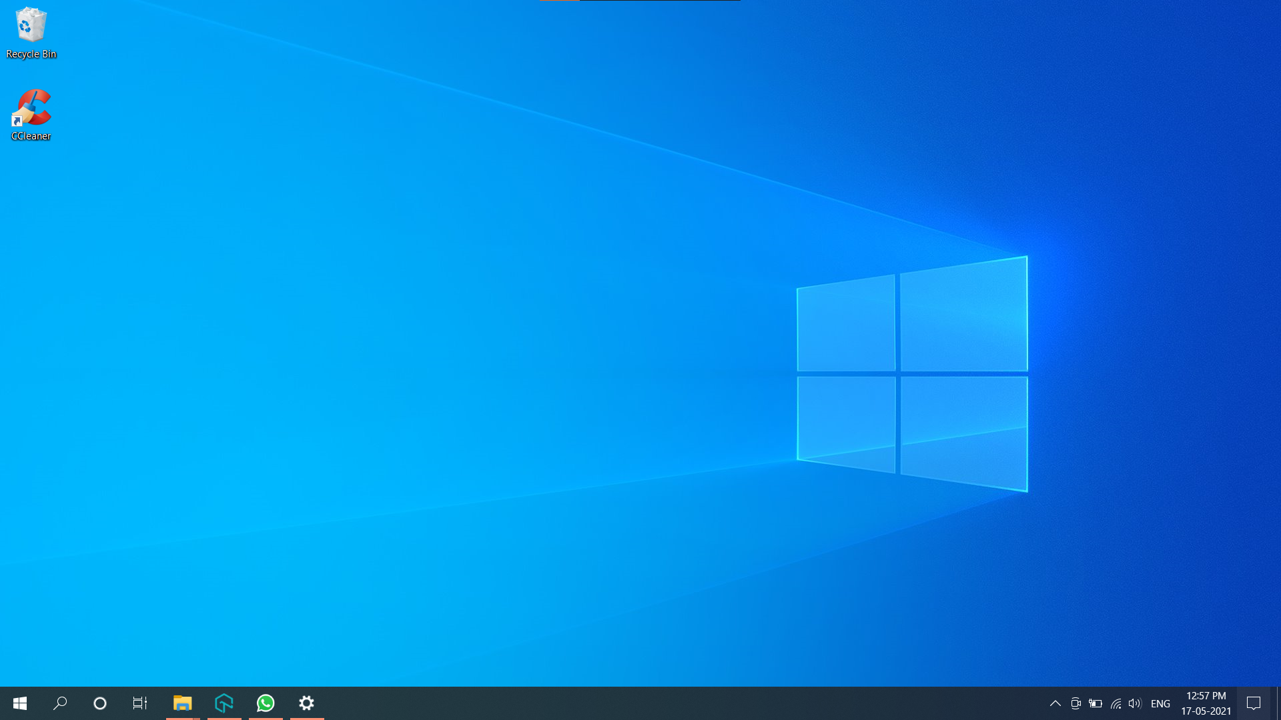

The Chrome Icon changed at the tile

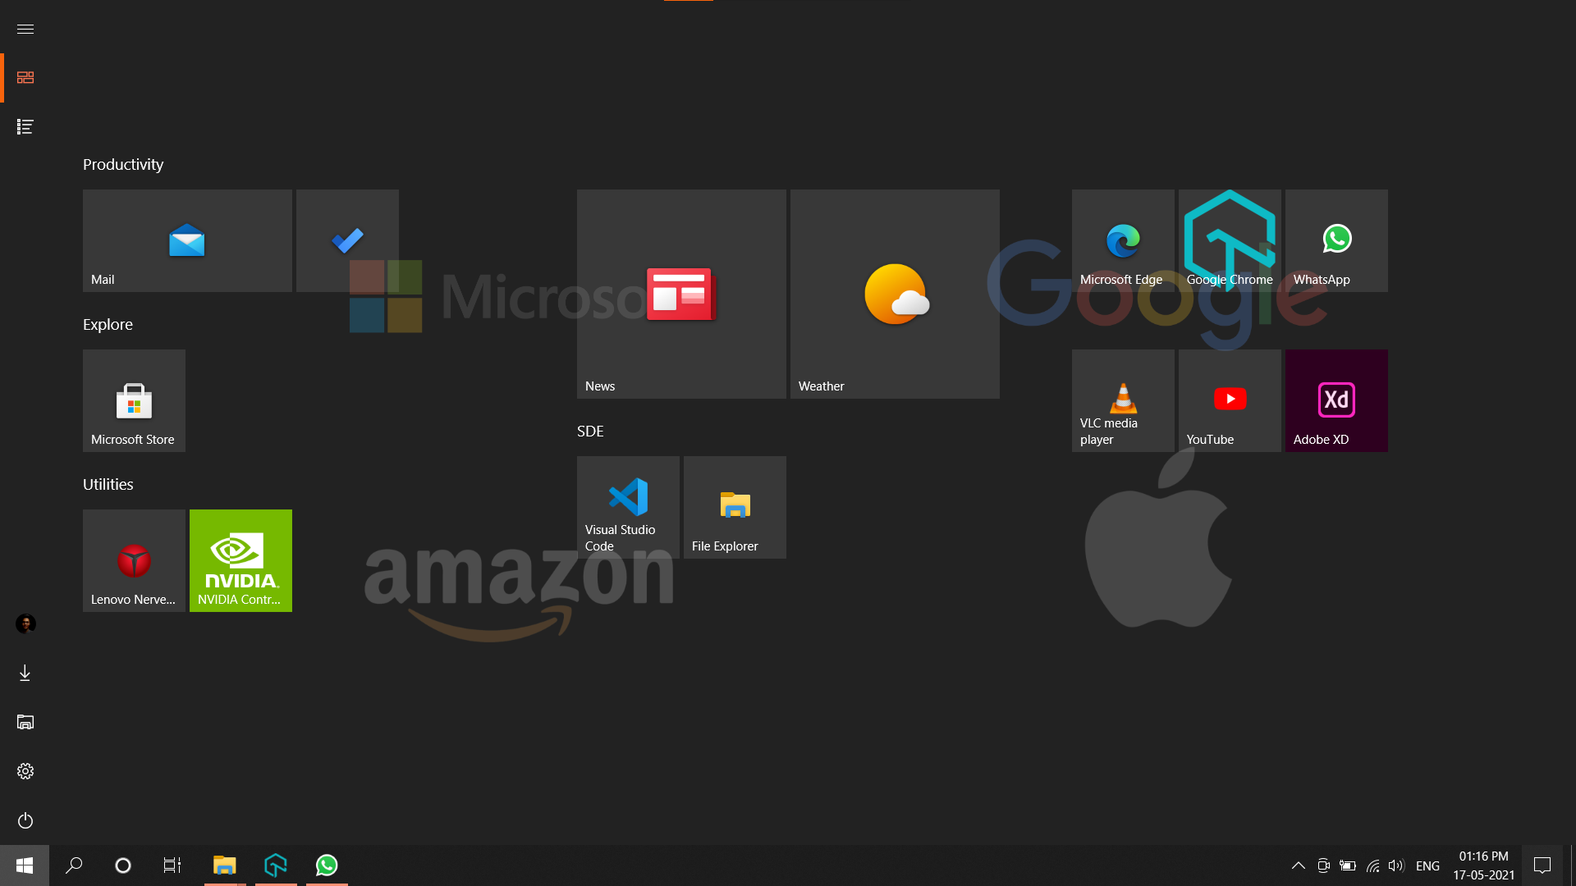

About chrome icon

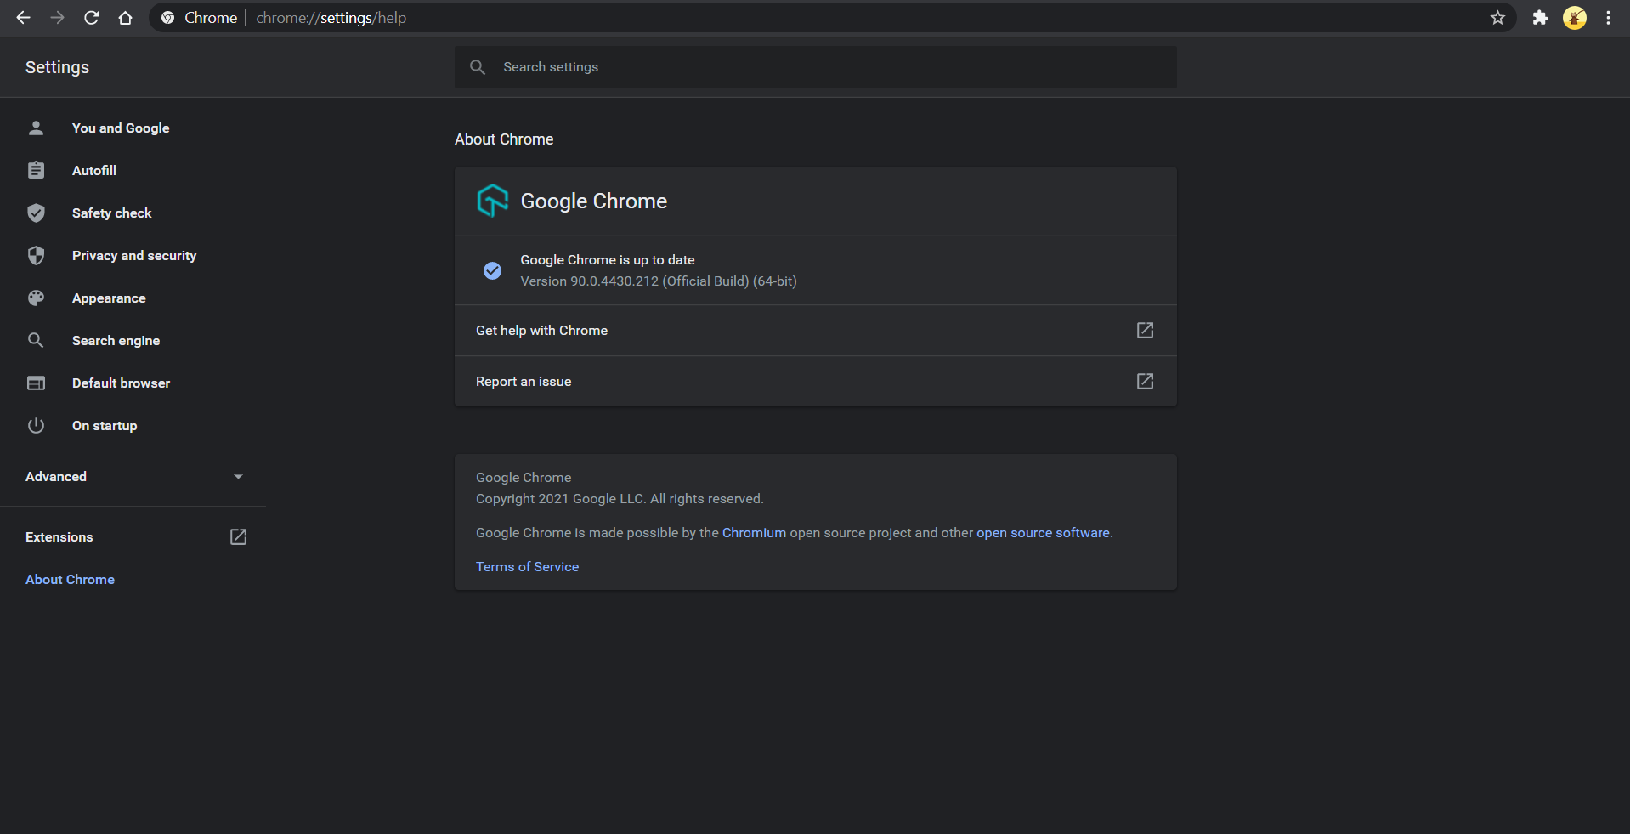

Chrome apps page ( at bottom )

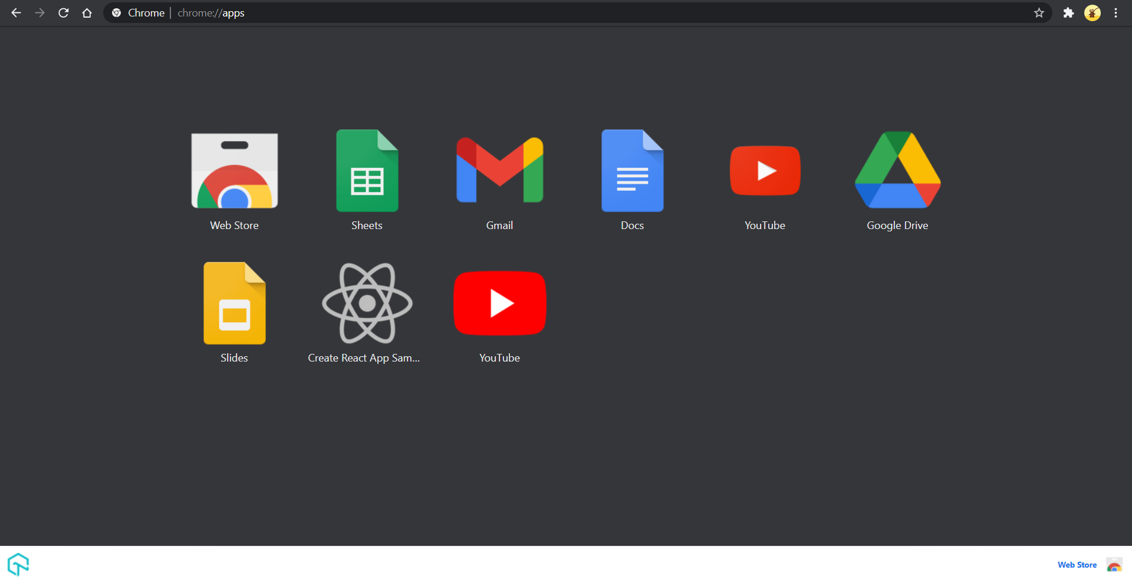

In Profile section

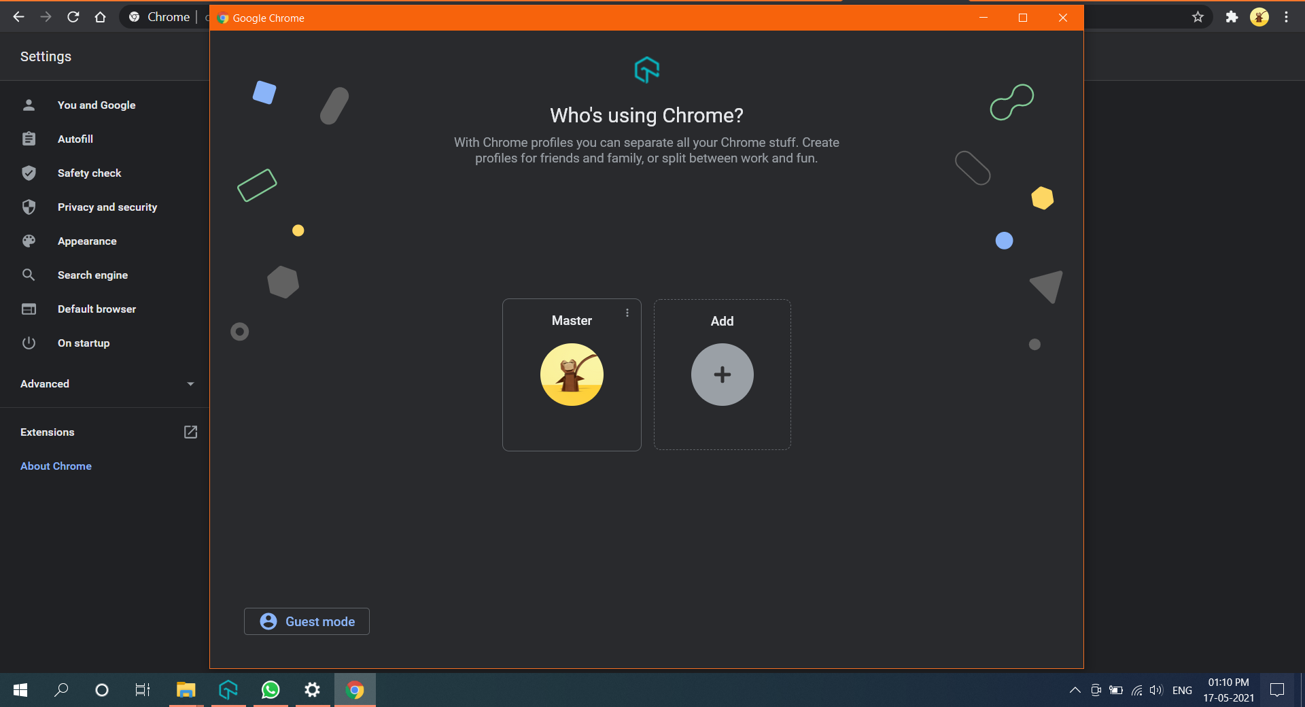

But I could not change the strings.

Thank you for reading this document.