**High Level System Design**

**Overview**

This document explain the basic approach to design SafeCab. SafeCab can be disgined with microservices to scale require component independantly.

**Customer Registration Service**

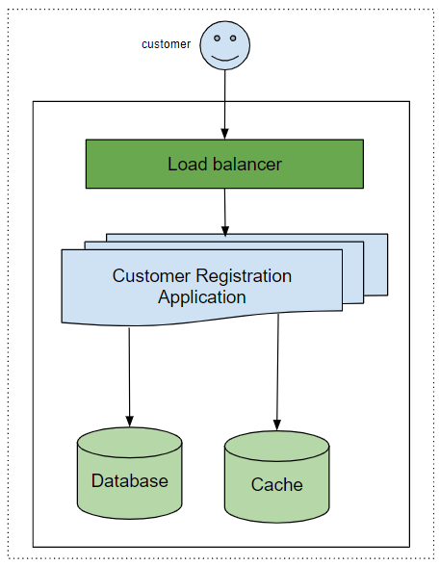

**Components**

1. Load Balancer: All the request will be coming through load balance to the application and application be scaled-in and out on the basic of load.
2. Customer Registration Service contains the registration logic for the application.
3. Database: DB is used to store the customer information
4. Cache: To serve the GET end point we are using cache to reduce the latency

**Cab Registration Service**

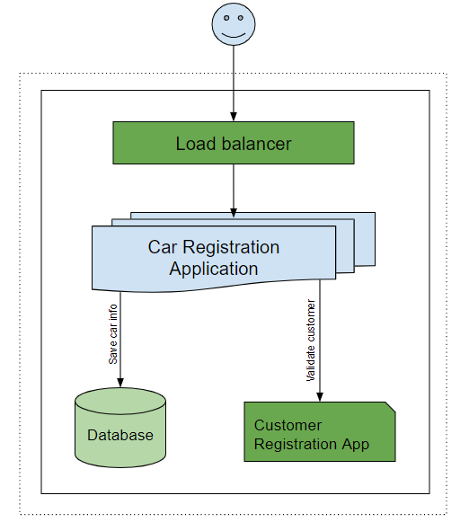

**Components**

1. Load Balancer: All the request will be coming through load balance to the application and application be scaled-in and out on the basic of load.
2. Car Registration Application: Service contains the registration logic for the application.
3. Database: DB is used to store the customer information
4. Customer Registration App: Service is used to validate the car owner information

**Booking Service**

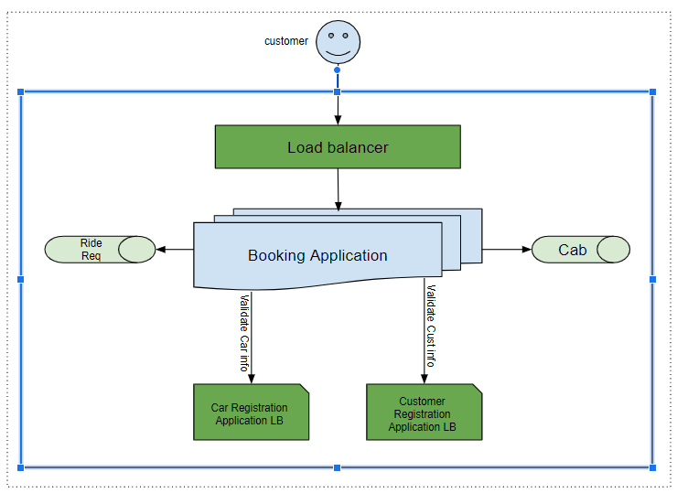

**Components**

1. Load Balancer: All the request will be coming through load balance to the application and application be scaled-in and out on the basic of load.
2. Booking App: Booking application contains the logic to interact with different components of the application
3. Ride Req : Customer will request to book the car and after necessary validation request will be stored in queue
4. Cab : Car owner will be offering ride and after necessary validation request will be stored in queue
5. Customer Registration Application LB : Application will be used to validate the customer information
6. Car Registration Application LB : Application will be used to validate the car information

**Booking Process Service**

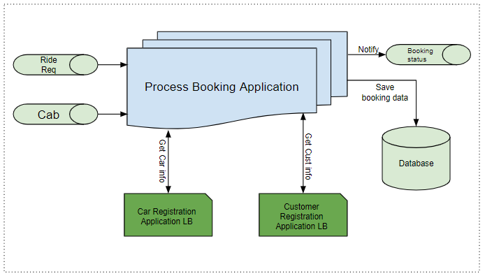

**Components**

1. Process Booking Application: Booking application contains the logic to interact with different components of the application and process the booking
2. Ride Req : Customer request available in the queue and same info is used to book the cab
3. Cab : Cab request available in the queue and same info is used to book the cab
4. Booking status : This queue will be used to send the notification to end user
5. Customer Registration Application LB : Application will be used to GET and validate the customer information
6. Car Registration Application LB : Application will be used to GET and validate the car information
7. Database: DB will be used to store the booking information.

**Notification Service**

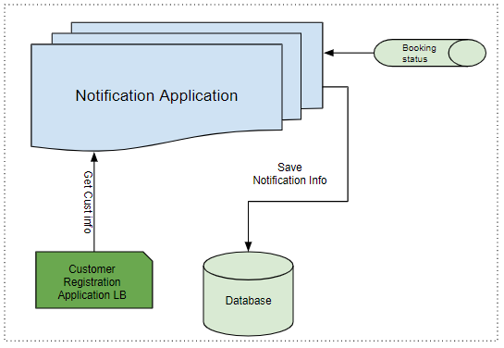

**Components**

1. Notification Application: This application contains the logic to send the booking status to customer
2. Booking status : This queue contains the notification details and same is used to send the notification
3. Customer Registration Application LB : Application will be used to GET and validate the customer information
4. Database: DB will be used to store the notification information.