**MADAN BHANDARI MEMORIAL COLLEGE**

**Department of Computer Science and Information Technology**



**Lab-Report for partial fulfilment of**

**Web Technology**

**PRACTICAL EXAM-2078**

**Submitted by:**

Jeevan Shrestha (T.U. Roll No.21049)

**Madan Bhandari Memorial College**

Department of Computer Science and Technology

Binayaknagar, New Baneshwor, Kathmandu

**Submitted to:**

Mr.Shivraj Panday

**Madan Bhandari Memorial College**

Department of Computer Science and Technology

Binayaknagar, New Baneshwor, Kathmandu

**Madan Bhandari Memorial College**

**Department of Computer Science (BSc. CSIT)**

Binayaknagar, New Baneshwor, Kathmandu

**Practical Sheet**

|  |  |  |  |
| --- | --- | --- | --- |
| **Roll No:**  **Submitted by:**  **Submitted to:** | 21049  Jeevan shrestha  Shivraj Panday | **Program No.:**  **Lab Date:**  **Submission Date:** | 01  12/12/2078  13/12/2078 |

**Title: Create a HTML form containing username, password, email, radio button, check box, text area, submit button and show use of action attribute.**

**<!-- index.html -->**

<html>

<head>

<title>Form</title>

</head>

<body>

<!-- Action attribute of form tag. The action attribute specifies where to send the form-data when a form is submitted.-->

<form action="Message_on_submit.html">

<fieldset>

<legend>Data Form</legend>

User Name:<br>

<input type="text" placeholder="please enter your name" autofocus><br><br>

Password:<br>

<input type="password" placeholder="enter your password"><br><br>

Email:<br>

<input type="email" placeholder="enter your email"><br><br>

Gender:<br>

<input type="radio" name="Gender" checked>Male

<input type="radio" name="Gender">Female

<input type="radio" name="Gender">Other<br><br>

Hobbies:<br>

<input type="checkbox">Dancing

<input type="checkbox">Singing<br>

<input type="checkbox">Traveling

<input type="checkbox">Rafting<br>

<input type="checkbox">Playing Football

<input type="checkbox">Watching Movies

<br><br>

Comment:<br>

<textarea row="20" cols="30"></textarea><br><br>

<input type="submit" value="Submit">

<input type="reset" value="Reset">

</fieldset>

</form>

</body>

</html>

**<!-- Message_on_submit.html -->**

<html>

<head>

<title>Action attribute of form tag</title>

</head>

<body>

<h1>Thanks for submitting..</h1>

</body>

</html>

* **Output in web browser:**

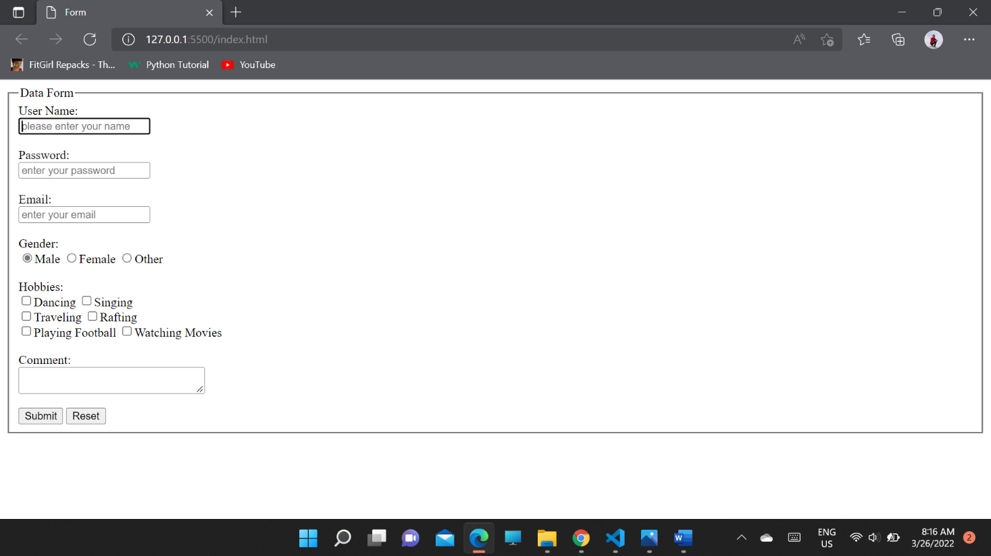

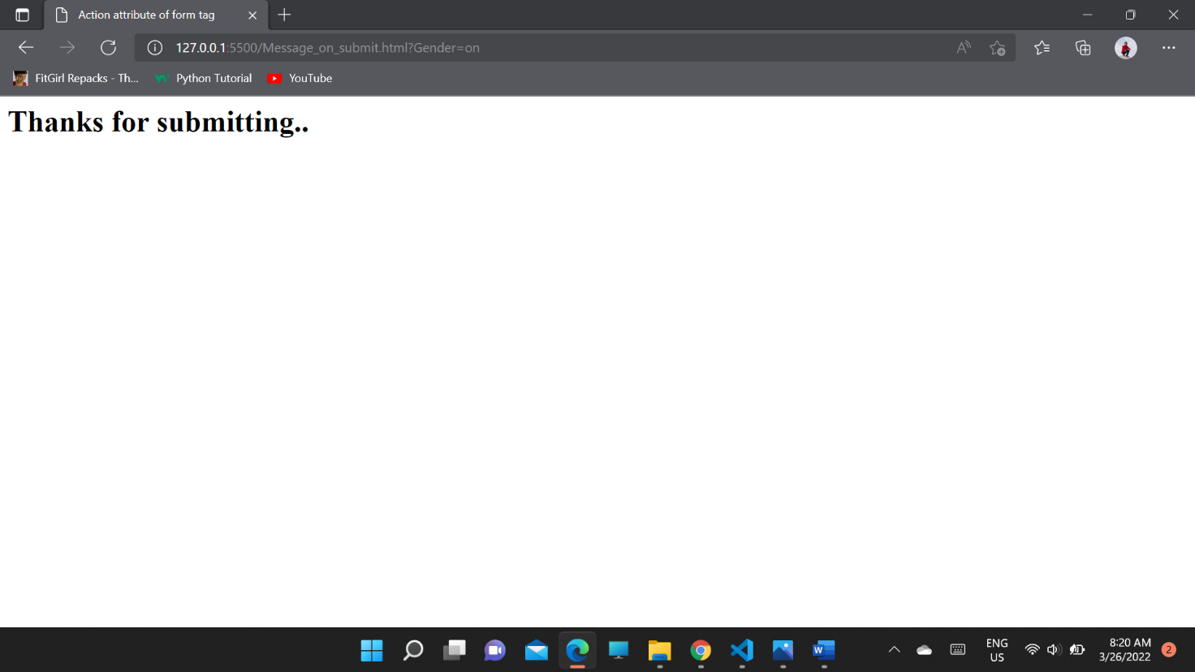

**Madan Bhandari Memorial College**

**Department of Computer Science (BSc. CSIT)**

Binayaknagar, New Baneshwor, Kathmandu

**Practical Sheet**

|  |  |  |  |
| --- | --- | --- | --- |
| **Roll No:**  **Submitted by:**  **Submitted to:** | 21049  Rajendra Thapa  Shivraj Pandey | **Program No.:**  **Lab Date:**  **Submission Date:** | 04  12/12/2078  13/12/2078 |

**Title: Through server side scripting connect to the database and create a database and table.**

**<!-- Creating Database -->**

**<!--create_Database-->**

<?php

$servername = "localhost";

$username = "username";

$password = "";

// Create connection

$con = mysqli_connect($servername, $username, $password);

// Check connection

if (!$con) {

die("Connection failed: " . mysqli_connect_error());

}

// Create database

$sql = "CREATE DATABASE Website";

if (mysqli_query($con, $sql)) {

echo "Database created successfully";

} else {

echo "Error creating database: " . mysqli_error($con);

}

mysqli_close($con);

?>

**Output in web browser:**

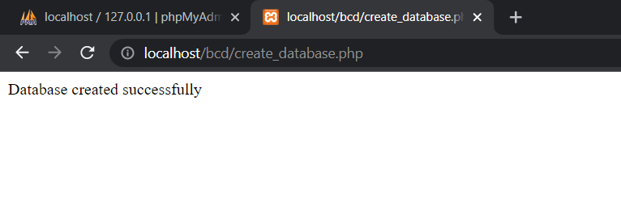

**<!-- Creating table -->**

**<!--Createtable.php-->**

<?php

$con=mysqli_connect("localhost","root","","website");

if($con)

echo"connection was successfull!";

else{

echo "connection was not successfull!";

}

// sql to create table

$sql = "CREATE TABLE webT (

id INT(6) UNSIGNED AUTO_INCREMENT PRIMARY KEY,

firstname VARCHAR(30) NOT NULL,

lastname VARCHAR(30) NOT NULL,

email VARCHAR(50),

phone INT(10)

)";

if ($con->query($sql) === TRUE) {

echo "Table Myweb created successfully";

} else {

echo "Error creating table: " . $con->error;

}

$sql="INSERT INTO webT(id,firstname,lastname,email,phone)

VALUES('1','Jeevan','Shrestha','abc@gmail.com','76643847');";

if(mysqli_query($con,$sql)){

echo"ok";

}

else{

echo"error";

}

mysqli_close($con);

?>

**Output:**

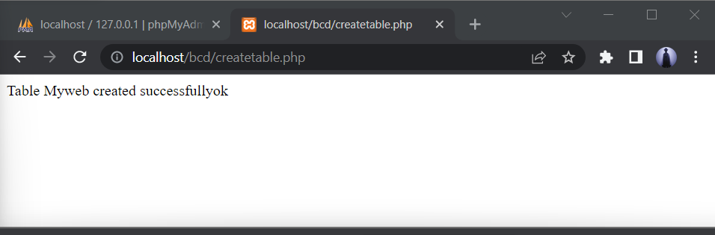

**<!-- Insert data into the database table using php scripting -->**

**<!--Inserting First data-->**

**<!--inserttable-->**

<?php

$con=mysqli_connect("localhost","root","","website");

if($con)

echo"connection was successfull!<br>";

else{

echo "connection was not successfull!";

}

$sql="INSERT INTO webT(id,firstname,lastname,email,phone)

VALUES('2','Bijay','Shrestha','abc@gmail.com','76643847');";

if(mysqli_query($con,$sql)){

echo"Insert Successfully.";

}

else{

echo"error";

}

mysqli_close($con);

?>

**Output:**

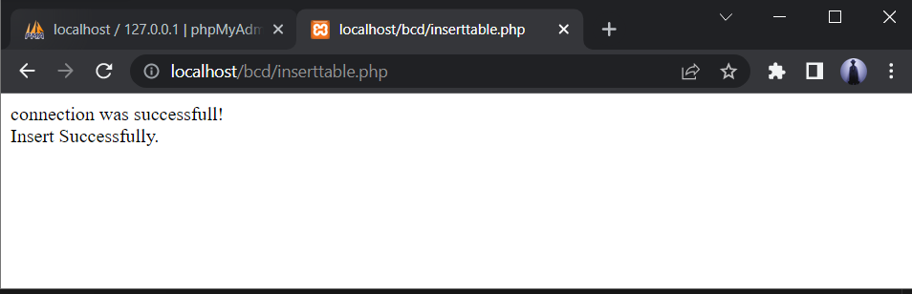

**<!-- Inserting next data -->**

**<!--insertcol.php-->**

<?php

$con=mysqli_connect("localhost","root","","website");

$sql="INSERT INTO webT(id,firstname,lastname,email,phone)

VALUES('3','Hari','Shrestha','asdbc@gmail.com','766433847');";

if(mysqli_query($con,$sql)){

echo"Inserted.";

}

else{

echo"error";

}

?>

**Output:**

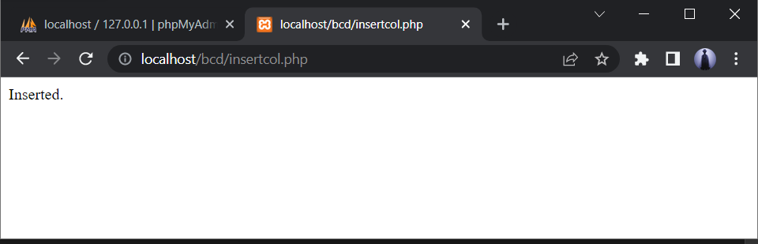

**<!-- Display the inserted data -->**

**<!--display.php-->**

<table border="1px" align="center" style="border-collapse: collapse; border-color: red; margin: 10px; padding:10px; background-color:beige">

<tr>

<th>id</th>

<th>Firstname</th>

<th>Lastname</th>

<th>Email</th>

<th>Phone</th>

<th>Edit</th>

<th>Delete</th>

</tr><br>

<?php

$con=mysqli_connect('localhost','root','','website');

$query="select * from webt order by id desc";

$res=mysqli_query($con,$query);

//for checking data is inserted or not

// if($res){

// echo "data is collected";

// }

// else

// echo "data is not collected";

while($row=mysqli_fetch_assoc($res)){

?>

<tr>

<td><?php echo $row['id']; ?></td>

<td><?php echo $row['firstname']; ?></td>

<td><?php echo $row['lastname']; ?></td>

<td><?php echo $row['email']; ?></td>

<td><?php echo $row['phone']; ?></td>

<td><a href="insertrow.php?id=<?php echo $row['id'];?>">edit</a></td>

<td><a href="deleterow.php?id=<?php echo $row['id'];?>">delete</a></td>

</tr>

<?php

}

?>

<button style="background-color: aqua;"><a href="insertrow.php" style=" color: black;">Insert Data</a></button>

<button style="background-color: aqua;"><a href="deleterow.php" style=" color: black;">Delete Data</a></button>

</table>

**Output:**

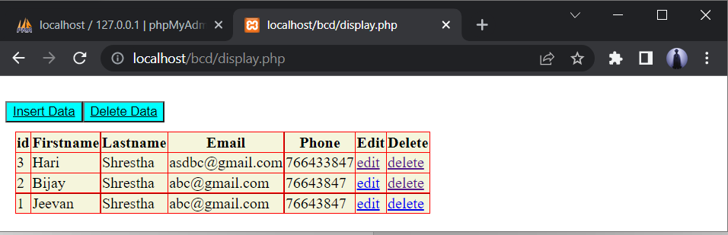

**<!-- Deleting a specific row data after clicking delete button -->**

**<!--deleterow.php-->**

<?php

$con=mysqli_connect("localhost","root","","website");

$id = (int)$_GET['id'];

$sql="DELETE FROM webT WHERE id='$id'";

if(mysqli_query($con,$sql)){

echo " Data with Id ".$id." deleted.<br>";

echo"Updated Table:";

include("insert.php");

}

else{

echo"error";

}

?>

**Output after deleting:**

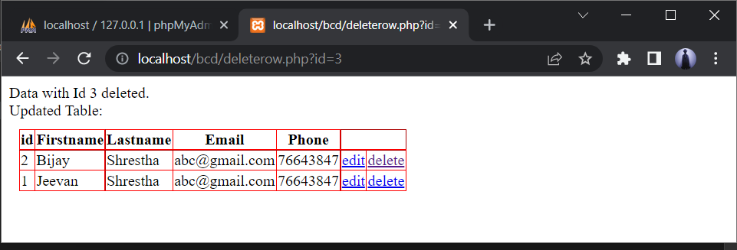

**Displaying the data:**

**<!-- Display.php -->**

<table border="1px" align="center" style="border-collapse: collapse; border-color: red; margin: 10px; padding:10px; background-color:beige">

<tr>

<th>id</th>

<th>Firstname</th>

<th>Lastname</th>

<th>Email</th>

<th>Phone</th>

<th>Edit</th>

<th>Delete</th>

</tr><br>

<?php

$con=mysqli_connect('localhost','root','','webtechnology');

$query="select * from webt order by id desc";

$res=mysqli_query($con,$query);

//for checking data is inserted or not

// if($res){

// echo "data is collected";

// }

// else

// echo "data is not collected";

while($row=mysqli_fetch_assoc($res)){

?>

<tr>

<td><?php echo $row['id']; ?></td>

<td><?php echo $row['firstname']; ?></td>

<td><?php echo $row['lastname']; ?></td>

<td><?php echo $row['email']; ?></td>

<td><?php echo $row['phone']; ?></td>

<td><a href="insertrow.php?id=<?php echo $row['id'];?>">edit</a></td>

<td><a href="deleterow.php?id=<?php echo $row['id'];?>">delete</a></td>

</tr>

<?php

}

?>

<button style="background-color: aqua;"><a href="insertrow.php" style=" color: black;">Insert Data</a></button>

<button style="background-color: aqua;"><a href="delete.php" style=" color: black;">Delete Data</a></button>

</table>

**Output:**

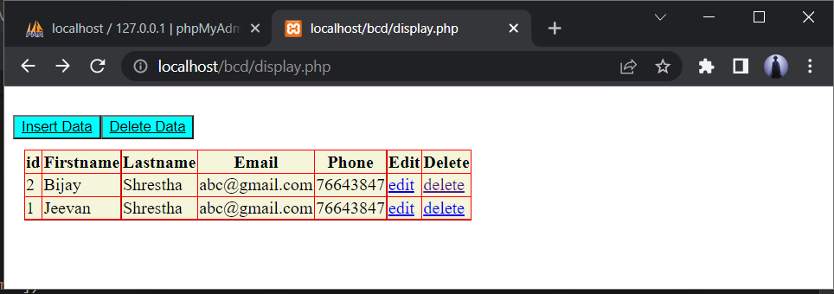

**After clicking the Insert Data button insertrow.php file is executed:**

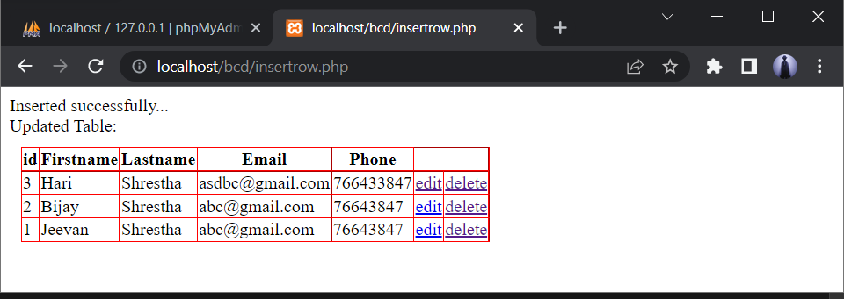

**Madan Bhandari Memorial College**

**Department of Computer Science (BSc. CSIT)**

Binayaknagar, New Baneshwor, Kathmandu

**Practical Sheet**

|  |  |  |  |
| --- | --- | --- | --- |
| **Roll No:**  **Submitted by:**  **Submitted to:** | 21049  Rajendra Thapa  Shivraj Pandey | **Program No.:**  **Lab Date:**  **Submission Date:** | 04  12/12/2078  13/12/2078 |

**Title: Simple login system through session variable.**

**Creating SESSION variable:**

<?php

// Start the session and get the data

session_start();

session_unset();

session_destroy();

echo "<br> You have been logged out";

?>

**Login page using SESSION variable:**

**<!-- login.php -->**

<?php

ob_start();

session_start();

?>

<html lang="en">

<head>

<title>Session login page</title>

<style>

.con{

width: fit-content;

background-color:palegoldenrod;

}

.btn{

color: greenyellow;

background-color: wheat;

}

</style>

</head>

<body>

<h3>Login Page</h3>

<div class="container form-signin">

<?php

$msg = '';

if (

isset($_POST['login']) && !empty($_POST['username'])

&& !empty($_POST['password'])

) {

if (

$_POST['username'] == 'Web' &&

$_POST['password'] == '1234'

) {

$_SESSION['valid'] = true;

$_SESSION['timeout'] = time();

$_SESSION['username'] = 'Web';

echo 'You have entered valid use name and password';

} else {

$msg = 'Wrong username or password';

}

}

?>

</div> <!-- /container -->

<div class="container">

<form class="form-signin" role="form" action="<?php echo htmlspecialchars($_SERVER['PHP_SELF']);

?>" method="post">

<fieldset class="con">

<h4 class="form-signin-heading"><?php echo $msg; ?></h4>

Username:

<input type="text" class="form-control" name="username" placeholder="username" required autofocus></br>

Password:

<input type="password" class="form-control" name="password" placeholder="password" required><br>

<button type="submit" name="login">Login</button>

</fieldset>

</form>

Click here to clean <a href="logout.php" tite="Logout">Session.

</div>

</body

</html>

**Output:**

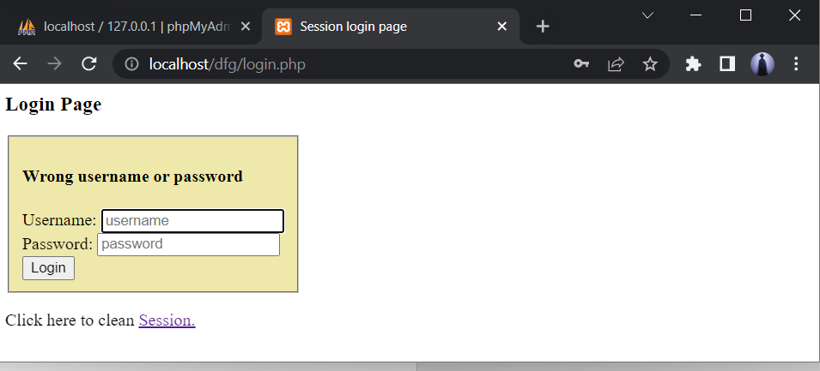

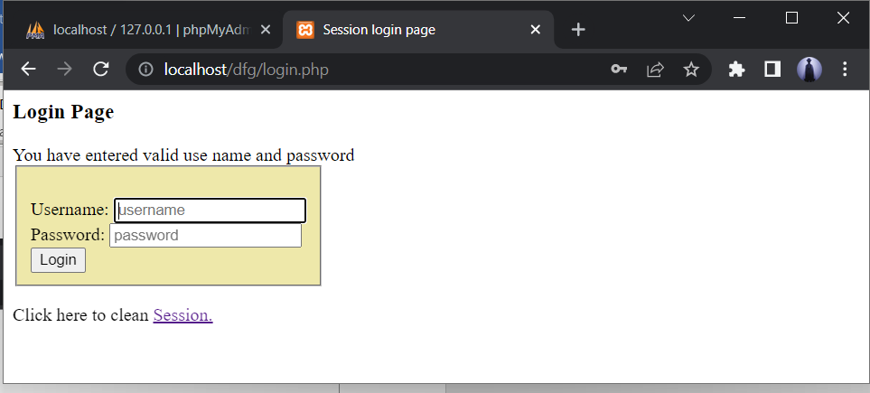

**Logout.php**

**After clicking on Session button, session variable are unset.**

<?php

   session_start();

   unset($_SESSION["username"]);

   unset($_SESSION["password"]);

   echo 'You have cleaned session';

   header('Refresh: 2; URL = login.php');

?>

**Output:**

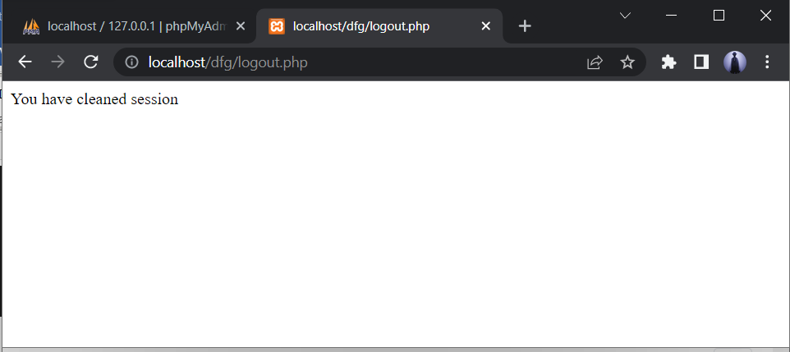

Hence, the session variables are cleared successfully.