**MADAN BHANDARI MEMORIAL COLLEGE**

**Department of Computer Science and Information Technology**



**Lab-Report for partial fulfilment of**

**Web Technology**

**PRACTICAL EXAM-2078**

**Submitted by:**

Rajendra Thapa (T.U. Roll No.21060)

**Madan Bhandari Memorial College**

Department of Computer Science and Technology

Binayaknagar, New Baneshwor, Kathmandu

**Submitted to:**

Mr. Shivraj Pandey

**Madan Bhandari Memorial College**

Department of Computer Science and Technology

Binayaknagar, New Baneshwor, Kathmandu

**Madan Bhandari Memorial College**

**Department of Computer Science (BSc. CSIT)**

Binayaknagar, New Baneshwor, Kathmandu

**Practical Sheet**

|  |  |  |  |
| --- | --- | --- | --- |
| **Roll No:**  **Submitted by:**  **Submitted to:** | 21060  Rajendra Thapa  Shivraj Pandey | **Program No.:**  **Lab Date:**  **Submission Date:** | 01  12/12/2078  13/12/2078 |

**Title: Create a HTML form containing username, password, email, radio button, check box, text area, submit button and show use of action attribute.**

**<!-- index.html -->**

<html>

<head>

<title>Form</title>

</head>

<body>

<!-- Action attribute of form tag. The action attribute specifies where to send the form-data when a form is submitted.-->

<form action="Message_on_submit.html">

<fieldset>

<legend>Data Form</legend>

User Name:<br>

<input type="text" placeholder="please enter your name" autofocus><br><br>

Password:<br>

<input type="password" placeholder="enter your password"><br><br>

Email:<br>

<input type="email" placeholder="enter your email"><br><br>

Gender:<br>

<input type="radio" name="Gender" checked>Male

<input type="radio" name="Gender">Female

<input type="radio" name="Gender">Other<br><br>

Hobbies:<br>

<input type="checkbox">Dancing

<input type="checkbox">Singing<br>

<input type="checkbox">Traveling

<input type="checkbox">Rafting<br>

<input type="checkbox">Playing Football

<input type="checkbox">Watching Movies

<br><br>

Comment:<br>

<textarea row="20" cols="30"></textarea><br><br>

<input type="submit" value="Submit">

<input type="reset" value="Reset">

</fieldset>

</form>

</body>

</html>

**<!-- Message_on_submit.html -->**

<html>

<head>

<title>Action attribute of form tag</title>

</head>

<body>

<h1>Thanks for submitting..</h1>

</body>

</html>

* **Output in web browser:**

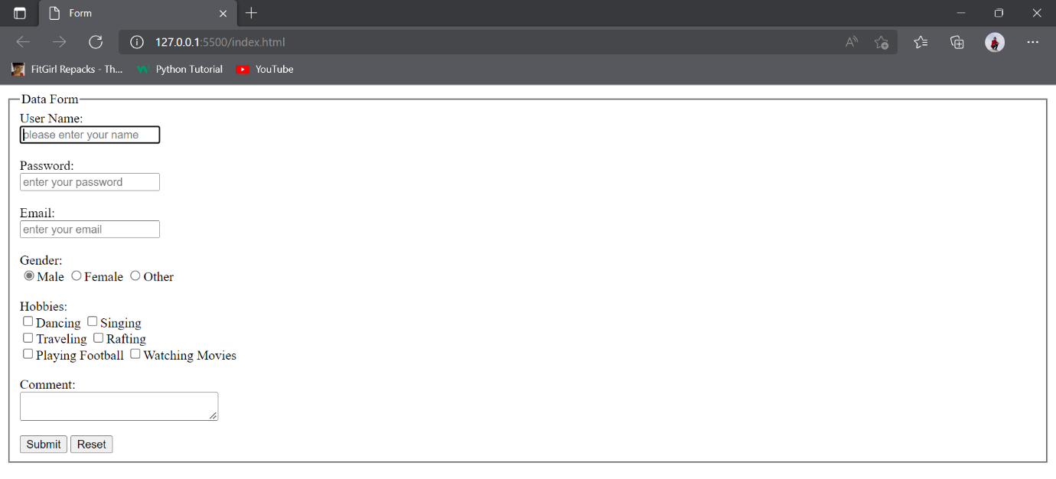

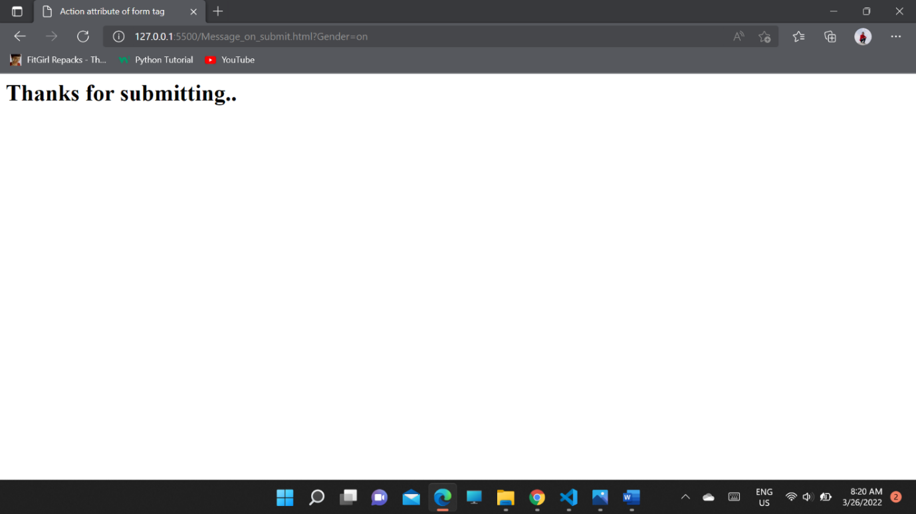

**Madan Bhandari Memorial College**

**Department of Computer Science (BSc. CSIT)**

Binayaknagar, New Baneshwor, Kathmandu

**Practical Sheet**

|  |  |  |  |
| --- | --- | --- | --- |
| **Roll No:**  **Submitted by:**  **Submitted to:** | 21060  Rajendra Thapa  Shivraj Pandey | **Program No.:**  **Lab Date:**  **Submission Date:** | 02  12/12/2078  13/12/2078 |

**Title: Using JavaScript show the event handling.**

**<!-- eventhandling.html -->**

<html>

<head>

<title>switch button for bulb</title>

<script>

function off()

{

image.src="off.gif";

}

function on()

{

image.src="on.gif";

}

</script>

</head>

<body>

<div class="main" align="center">

<img id="image" src="off.gif" height="400px"><br><br>

<button onclick="off()">Off</button><br><br>

<button onclick="on()">On</button>

</div>

</body>

</html>

* **Output in web browser:**

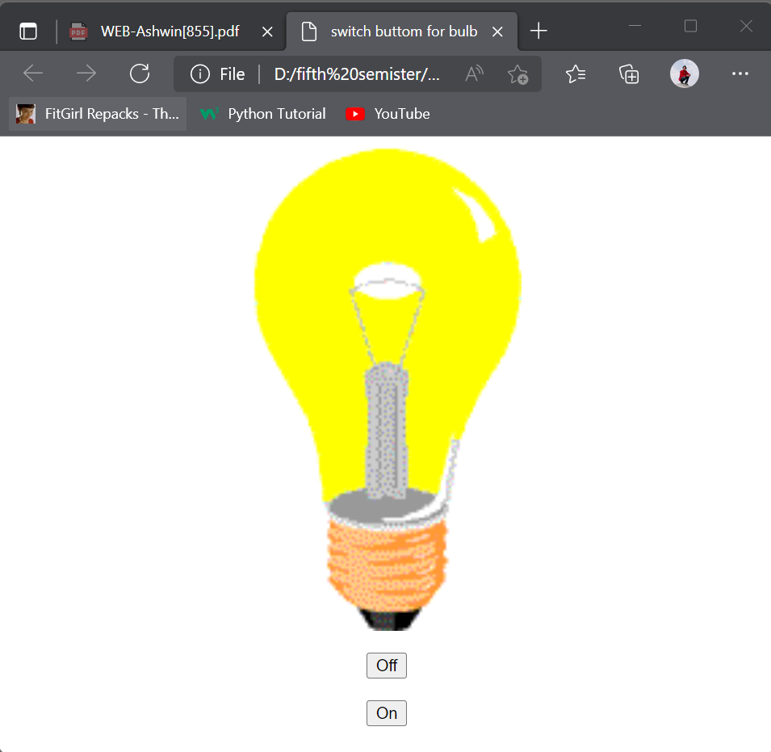

* **Conclusion:** When we click the on button on function will be called that means it will tigger the on event and when we click the off button off function will be called that means it will tigger the off event. By this we handle the event using javascript.

**Madan Bhandari Memorial College**

**Department of Computer Science (BSc. CSIT)**

Binayaknagar, New Baneshwor, Kathmandu

**Practical Sheet**

|  |  |  |  |
| --- | --- | --- | --- |
| **Roll No:**  **Submitted by:**  **Submitted to:** | 21060  Rajendra Thapa  Shivraj Pandey | **Program No.:**  **Lab Date:**  **Submission Date:** | 03  12/12/2078  13/12/2078 |

**Title: Show the form validation for user name, phone number, text area etc.**

**<!-- form validation -->**

<html>

<head>

<title>form validation</title>

<script src="validation.js" type="text/javascript" ></script>

</head>

<body>

<form>

Username:

<input type="text" id="uname" placeholder="enter name" autofocus onkeyup="validname()">

<span id="errname"></span>

<br><br>

Phone number:

<input type="text" id="upnum" placeholder="enter phone number" onkeyup="validphone()">

<span id="errphone"></span>

<br><br>

Email:

<input type="email" placeholder="e.g. abc123@gmail.com" id="uemail" onkeyup="validemail()">

<span id="erroremail"></span><br><br>

Comment:<br>

<textarea id="ucomnt"placeholder="give some comment" onkeyup="validcomment()"></textarea>

<span id="errcomment"></span>

</form>

</body>

</html>

// validation.js

function validname(){

var uname=document.getElementById("uname").value;

if(uname.length==0)

showMessage("name field can't be empty","errname","red");

else if(uname.length<5)

showMessage("not enough characters","errname","red");

else if(!uname.match(/^[a-zA-Z]{5,30}\s{1}[a-zA-Z]{3,30}$/))

showMessage("enter first name and last name with space","errname","red");

else

showMessage("valid name","errname","green");

}

function validphone(){

var uphoneno=document.getElementById("upnum").value;

if(uphoneno.length==0)

showMessage("phone field cannot be empty","errphone","red");

else if(!uphoneno.match(/^[0-9]*$/))

showMessage("enter number only","errphone","red");

else if(uphoneno.substr(0,2)!="98")

showMessage("must star with 98","errphone","blue");

else if(uphoneno.length!=10)

showMessage("enter exactly 10 digits","errphone","red");

else

showMessage("valid phone number","errphone","green");

}

function validemail(){

var umail=document.getElementById('uemail').value;

if(umail.length==0)

showMessage("please enter email","erroremail","red");

else

showMessage("valid email","erroremail","green");

}

function validcomment(){

var ucomment=document.getElementById("ucomnt").value;

if(ucomment.length<10)

showMessage("not enough comment","errcomment","red");

else

showMessage("valid comment","errcomment","green");

}

function showMessage(message,location,color){

document.getElementById(location).innerHTML=message;

document.getElementById(location).style.color=color;

}

* **Output in web browser:**

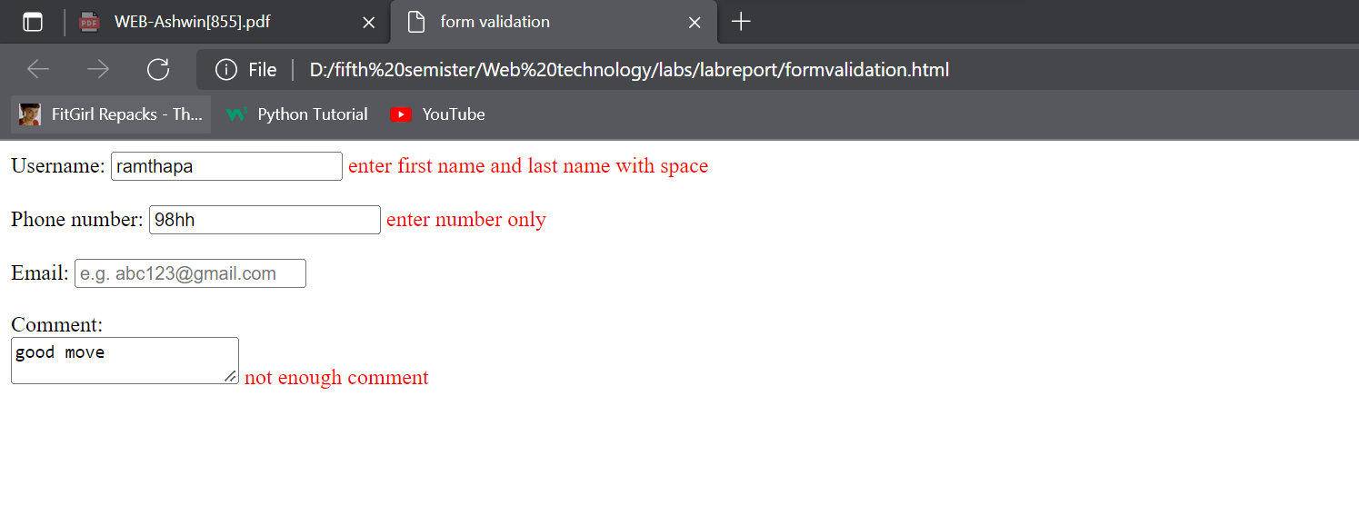

**Program no:4**

**Title: Through Server-side scripting connect to the database and create database and table.**

**//Create connection**

<?php

$con=mysqli_connect("localhost","root","","db_connection");

if($con)

echo "connection was successfull!";

else

echo "connection was not successfull!";

echo"<br>";

?>

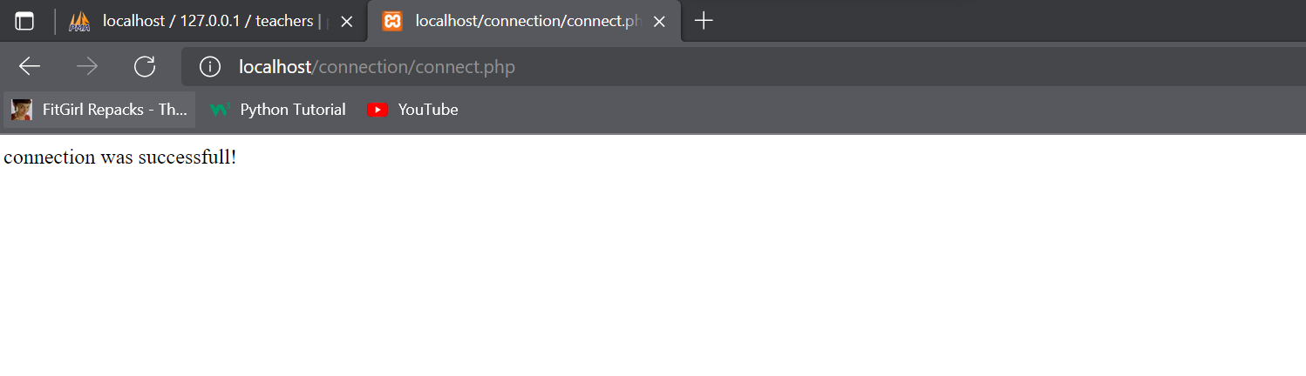

<?php

**//create db_connection for creating teachers database**

$con=mysqli_connect("localhost","root","","db_connection");

if($con)

echo "connection was successfull!";

else

echo "connection was not successfull!";

echo("<br>");

**//create Teacher database**

$sql = "CREATE DATABASE Teachers";

if (mysqli_query($con, $sql)) {

echo "Database created successfully";

} else {

echo "Error creating database: ";

}

?>

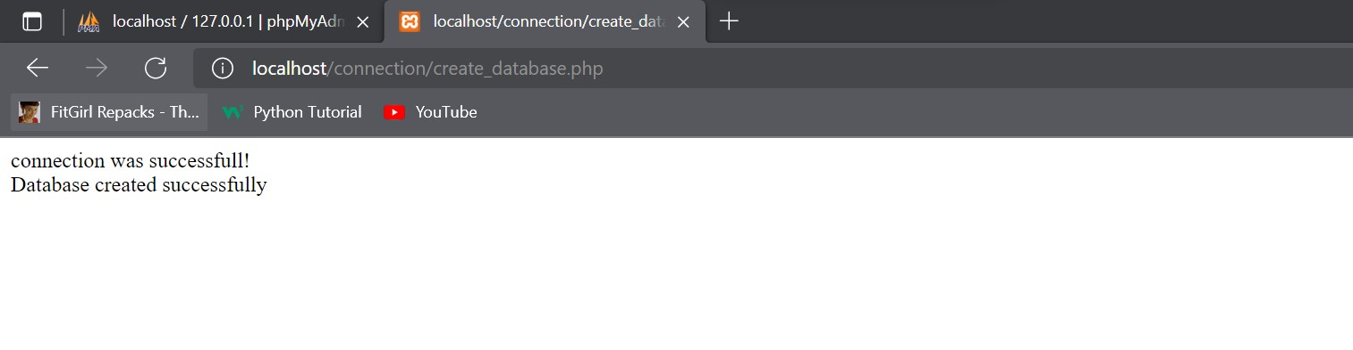

**<!-- to create teachers database connection for creating teacher table-->**

<?php

$con=mysqli_connect("localhost","root","","Teachers");

if($con)

echo "connection was successfull!";

else

echo "connection was not successfull!";

echo("<br>");

$sql = "CREATE TABLE Teacher (

id INT(6) UNSIGNED AUTO_INCREMENT PRIMARY KEY,

firstname VARCHAR(30) NOT NULL,

lastname VARCHAR(30) NOT NULL,

email VARCHAR(50),

phone INT(10)

)";

if ($con->query($sql) === TRUE) {

echo "Table Teacher created successfully";

} else {

echo "Error creating table: " . $con->error;

}

?>

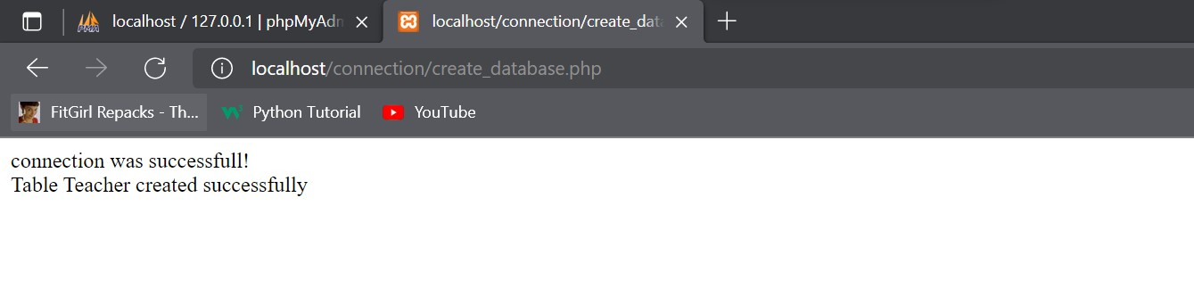

**Program-5**

**<!-- to create teachers database connection for inserting data in the database table using php**

**-->**

<?php

$con=mysqli_connect("localhost","root","","Teachers");

if($con)

echo "connection was successfull!";

else

echo "connection was not successfull!";

echo("<br>");

**//to insert row in the teacher table**

$sql="INSERT INTO Teacher(id,firstname,lastname,email,phone)

VALUES('3',Hikmat ',Baral ','eabcde@gmail.com',' 600135841');";

if(mysqli_query($con,$sql)){

echo"ok";

}

else{

echo"error";

}

mysqli_close($con);

?>

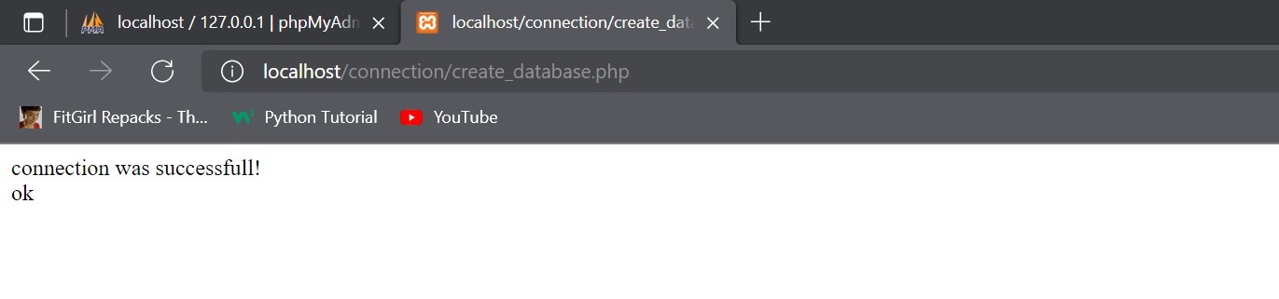

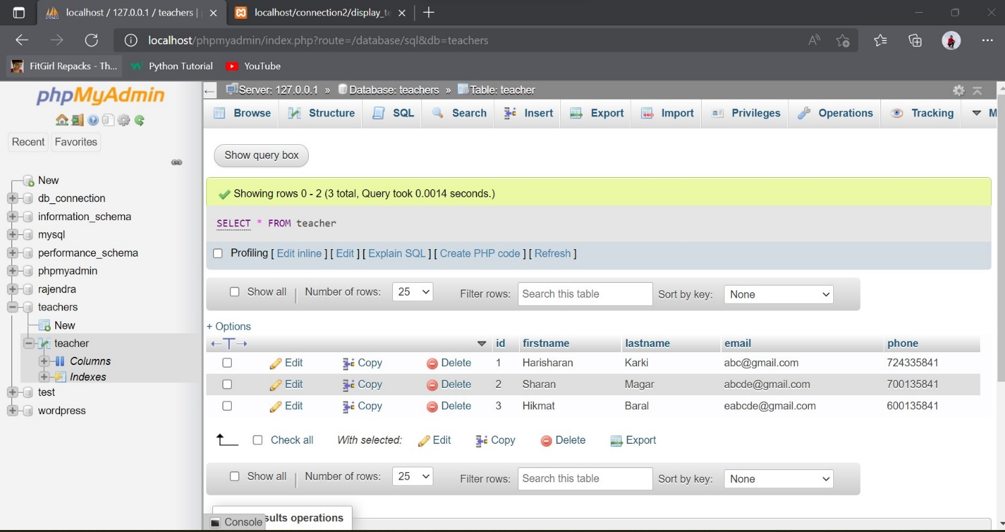

**Program-6**

**<!--display_teachers_database.php this file show the inserted data during creating database with its table-->**

<table border="1px" align="center" style="border-collapse: collapse; border-color: red; margin: 10px; padding:10px; background-color:beige">

<tr>

<th>id</th>

<th>Firstname</th>

<th>Lastname</th>

<th>Email</th>

<th>Phone</th>

<th>Edit</th>

<th>Delete</th>

</tr><br>

<?php

$con=mysqli_connect('localhost','root','','teachers');

$query="select * from teacher order by id desc";

$res=mysqli_query($con,$query);

//for checking data is inserted or not

// if($res){

// echo "data is collected";

// }

// else

// echo "data is not collected";

while($row=mysqli_fetch_assoc($res)){

?>

<tr>

<td><?php echo $row['id']; ?></td>

<td><?php echo $row['firstname']; ?></td>

<td><?php echo $row['lastname']; ?></td>

<td><?php echo $row['email']; ?></td>

<td><?php echo $row['phone']; ?></td>

<td><a href="insertrow.php?id=<?php echo $row['id'];?>">edit</a></td>

<td><a href="deleterow.php?id=<?php echo $row['id'];?>">delete</a></td>

</tr>

<?php

}

?>

<button style="background-color: aqua;"><a href="insertrow.php" style=" color: black;">Insert Data</a></button>

<button style="background-color: aqua;"><a href="deleterow.php" style=" color: black;">Delete Data</a></button>

</table>

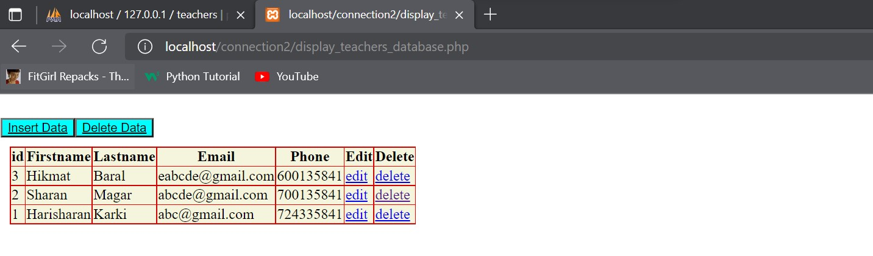

**Program-7**

**<!-- deleterow.php Deleting a specific row data after clicking delete button -->**

<?php

$con=mysqli_connect("localhost","root","","teachers");

$id = (int)$_GET['id'];

$sql="DELETE FROM teacher WHERE id='$id'";

if(mysqli_query($con,$sql)){

echo " Data with Id ".$id." deleted.<br>";

echo"Updated Table:";

include("insert.php");

}

else{

echo"error";

}

?>

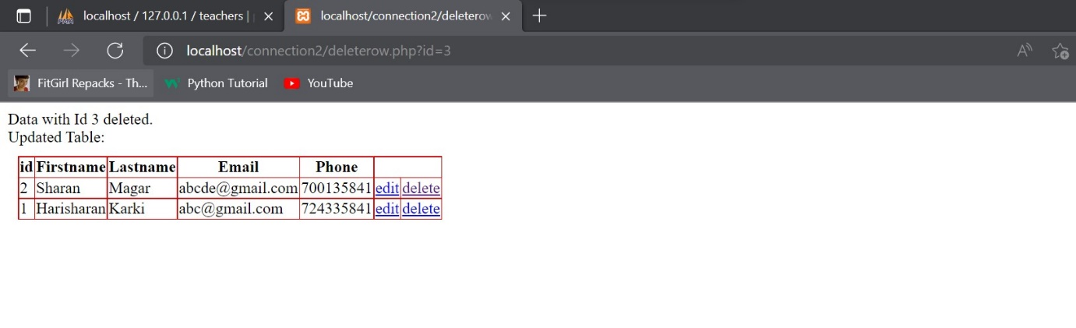

**Program-8**

**<!-- after clicking the insert data butoon insertrow.php file is executed. -->**

<?php

$con=mysqli_connect("localhost","root","","teachers");

$sql="INSERT INTO teacher(id,firstname,lastname,email,phone)

VALUES('3','Hari','Shrestha','asdbc@gmail.com','766433847');";

if(mysqli_query($con,$sql)){

echo"Inserted successfully...<br>";

echo "\n";

echo"Updated Table:\n";

include("insert.php");

}

else{

echo"Error";

}

mysqli_close($con);

?>

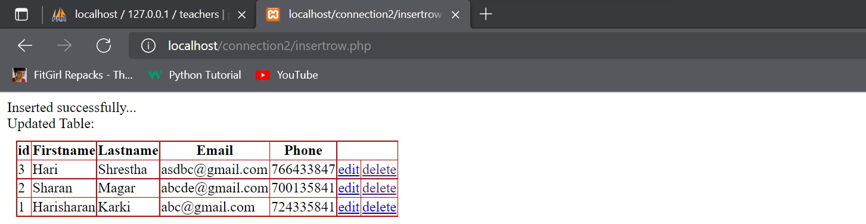

**Program-9**

**Title: Creating Session Variables.**

<?php

// Start the session and get the data

session_start();

session_unset();

session_destroy();

echo "<br> You have been logged out";

?>

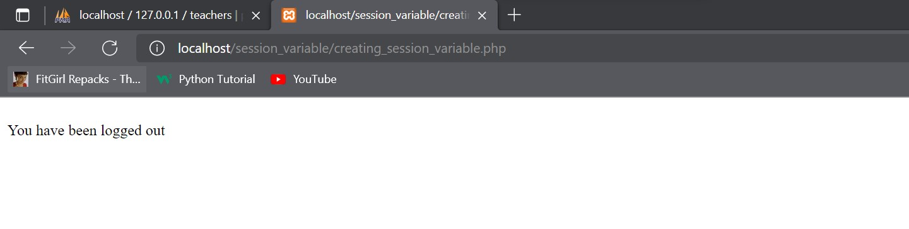

**Program-10**

**Login page using SESSION variable:**

**<!-- login.php -->**

<?php

ob_start();

session_start();

?>

<html lang="en">

<head>

<title>Session login page</title>

<style>

.con{

width: fit-content;

background-color:palegoldenrod;

}

.btn{

color: greenyellow;

background-color: wheat;

}

</style>

</head>

<body>

<h3>Login Page</h3>

<div class="container form-signin">

<?php

$msg = '';

if (

isset($_POST['login']) && !empty($_POST['username'])

&& !empty($_POST['password'])

) {

if (

$_POST['username'] == 'Web' &&

$_POST['password'] == '1234'

) {

$_SESSION['valid'] = true;

$_SESSION['timeout'] = time();

$_SESSION['username'] = 'Web';

echo 'You have entered valid use name and password';

} else {

$msg = 'Wrong username or password';

}

}

?>

</div> <!-- /container -->

<div class="container">

<form class="form-signin" role="form" action="<?php echo htmlspecialchars($_SERVER['PHP_SELF']);

?>" method="post">

<fieldset class="con">

<h4 class="form-signin-heading"><?php echo $msg; ?></h4>

Username:

<input type="text" class="form-control" name="username" placeholder="username" required autofocus></br>

Password:

<input type="password" class="form-control" name="password" placeholder="password" required><br>

<button type="submit" name="login">Login</button>

</fieldset>

</form>

Click here to clean <a href="logout.php" tite="Logout">Session.

</div>

</body

</html>

**Output:**

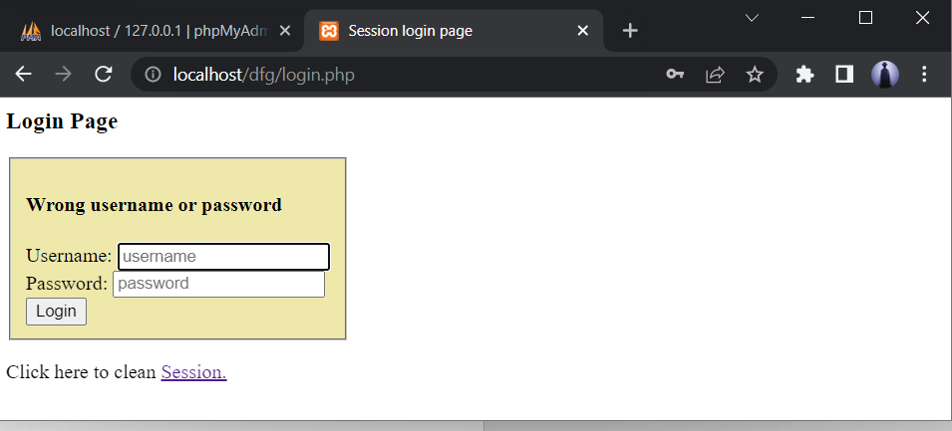

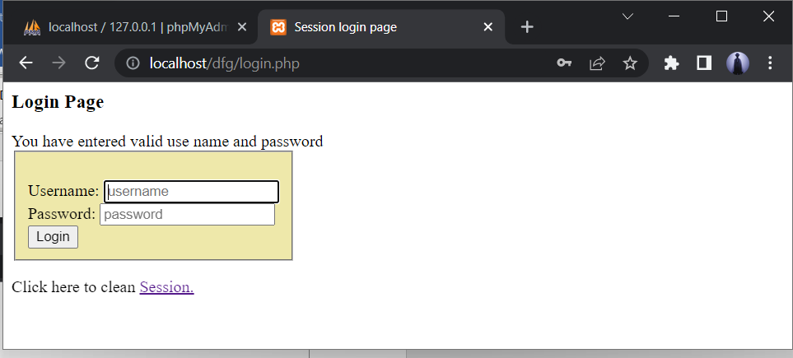

**Logout.php**

**After clicking on Session button, session variable are unset.**

<?php

   session_start();

   unset($_SESSION["username"]);

   unset($_SESSION["password"]);

   echo 'You have cleaned session';

   header('Refresh: 2; URL = login.php');

?>

**Output:**

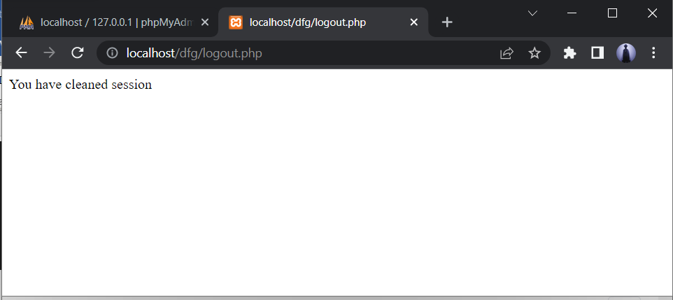

Hence, the session variables are cleared successfully.