**MADAN BHANDARI MEMORIAL COLLEGE**

**Department of Computer Science and Information Technology**



**Lab-Report for partial fulfilment of**

**Web Technology**

**PRACTICAL EXAM-2078**

**Submitted by:**

Jeevan Shrestha (T.U. Roll No.21049)

**Madan Bhandari Memorial College**

Department of Computer Science and Technology

Binayaknagar, New Baneshwor, Kathmandu

**Submitted to:**

Mr.Shivraj Panday

**Madan Bhandari Memorial College**

Department of Computer Science and Technology

Binayaknagar, New Baneshwor, Kathmandu

**Madan Bhandari Memorial College**

**Department of Computer Science (BSc. CSIT)**

Binayaknagar, New Baneshwor, Kathmandu

**Practical Sheet**

|  |  |  |  |
| --- | --- | --- | --- |
| **Roll No:**  **Submitted by:**  **Submitted to:** | 21049  Jeevan shrestha  Shivraj Panday | **Program No.:**  **Lab Date:**  **Submission Date:** | 01  12/12/2078  13/12/2078 |

**Title: Create a HTML form containing username, password, email, radio button, check box, text area, submit button and show use of action attribute.**

**<!-- index.html -->**

<html>

<head>

<title>Form</title>

</head>

<body>

<!-- Action attribute of form tag. The action attribute specifies where to send the form-data when a form is submitted.-->

<form action=" submit.html">

<fieldset>

<legend>Data Form</legend>

User Name:<br>

<input type="text" placeholder="please enter your name" autofocus><br><br>

Password:<br>

<input type="password" placeholder="enter your password"><br><br>

Email:<br>

<input type="email" placeholder="enter your email"><br><br>

Gender:<br>

<input type="radio" name="Gender" checked>Male

<input type="radio" name="Gender">Female

<input type="radio" name="Gender">Other<br><br>

Hobbies:<br>

<input type="checkbox">Dancing

<input type="checkbox">Singing<br>

<input type="checkbox">Traveling

<input type="checkbox">Rafting<br>

<input type="checkbox">Playing Football

<input type="checkbox">Watching Movies

<br><br>

Comment:<br>

<textarea row="20" cols="30"></textarea><br><br>

<input type="submit" value="Submit">

<input type="reset" value="Reset">

</fieldset>

</form>

</body>

</html>

**<!-- submit.html -->**

<html>

<head>

<title>Action attribute of form tag</title>

</head>

<body>

<h1>Thanks for submitting..</h1>

</body>

</html>

**Output in web browser:**

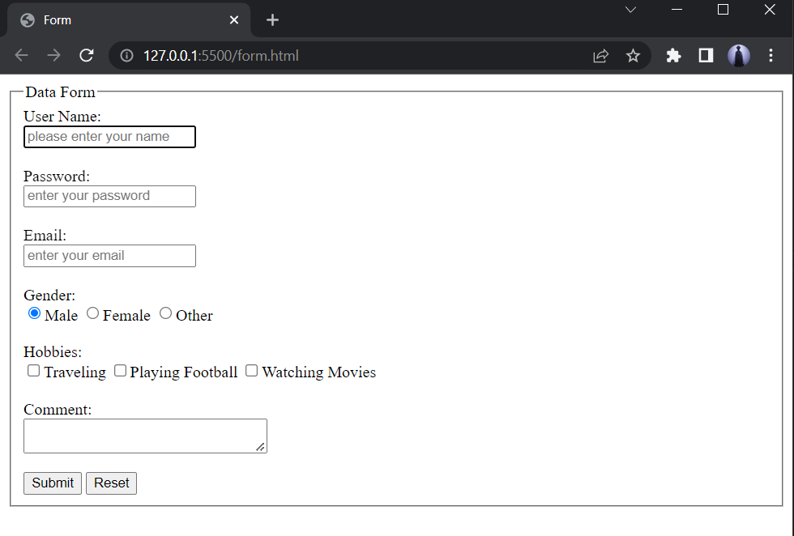

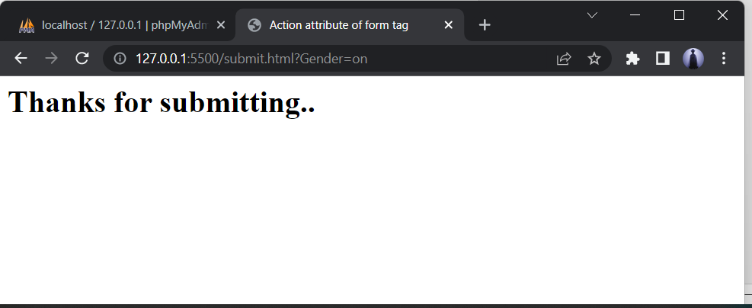

**1.2)Form Validation:**

**<!--form.html-->**

<!-- index.html -->

<!DOCTYPE html>

<html

<head

<meta charset="UTF-8">

<meta name="viewport" content="width=device-width, initial-scale=1.0">

<title>Form Registration</title>

<script src="validation.js"></script>

</head>

<body>

<h2>Client Side Form Validation</h2>

<body>

<form >

<div>

<label> Username: </label>

<input type="text" name="username" id="username" required>

</div><br>

<div>

<label> Password: </label>

<input type="password" name="password" id="password" required>

</div><br>

<div>

<label> Phone: </label>

<input type="number" name="phone" id="phone">

</div><br>

<div>

<label> Gender: </label>

<label><input type="radio" value="m" name="gender" checked> Male </label>

<label><input type="radio" value="f" name="gender"> Female </label>

<label><input type="radio" value="0" name="gender"> Others </label>

</div><br>

<div>

<label> Hobbies: </label>

<label><input type="checkbox" name="hobbies"> Reading </label>

<label><input type="checkbox" name="hobbies"> Writing </label>

<label><input type="checkbox" name="hobbies"> Playing </label>

<label><input type="checkbox" name="hobbies"> Music </label>

</div><br>

<div>

<label> Comments:</label>

<textarea id="comment" cols="30" rows="10"></textarea><br><br>

</div>

<button onclick="validate()">Submit</button>

</form>

</body>

</html>

**Validation.js**

function validate() {

var username = document.getElementById("username").value;

var password = document.getElementById("password").value;

var phone = document.getElementById("phone");

var comment= document.getElementById("comment");

if (username == null || username == "") {

alert("Please enter the username.");

return false;

}

if (password == null || password == "") {

alert("Please enter the password.");

return false;

}

var phoneno = /^\(?([0-9]{3})\)?[-. ]?([0-9]{3})[-. ]?([0-9]{4})$/;

if(phone.value.match(phoneno)){

alert("Enter valid password.");

}

if(comment.value==null){

alert("Enter comment.")

}

alert('Login successful');

}

* **Output with empty Name:**

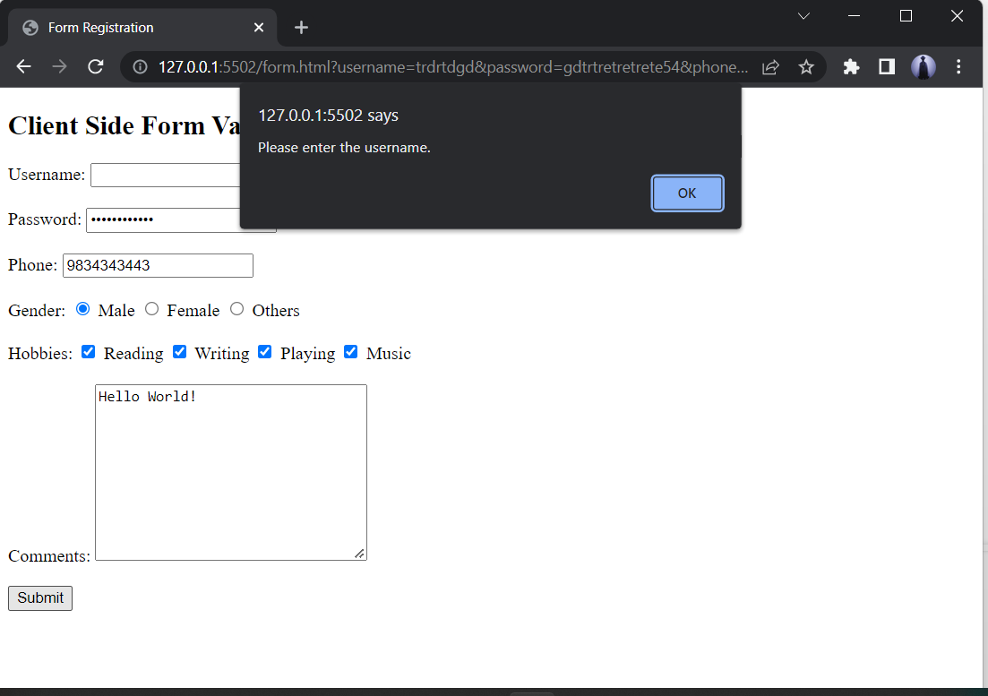

**Output with Username:**

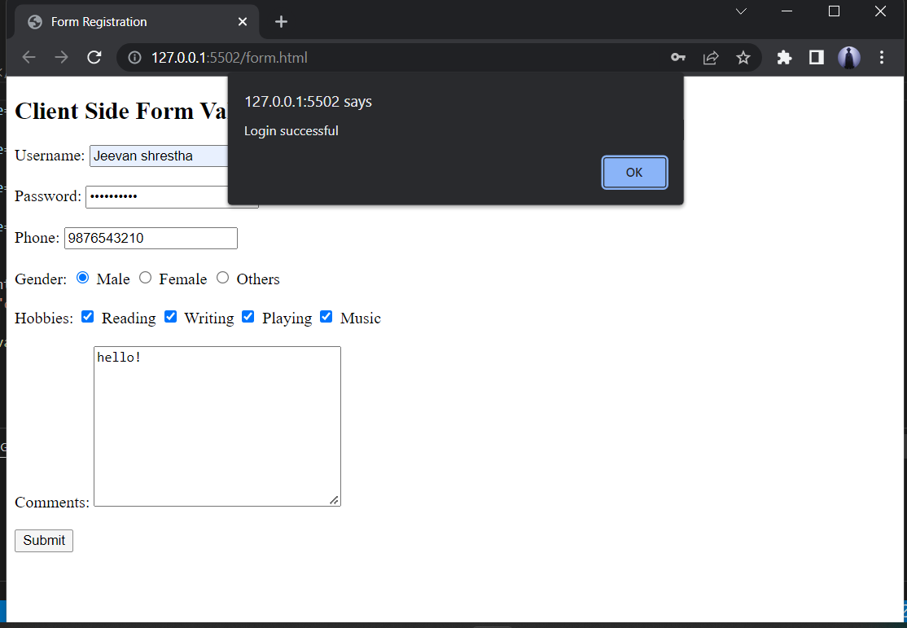

**1.3)Password Validation:**

**<!--Form.html-->**

<!DOCTYPE html>

<html>

<head>

<meta name="viewport" content="width=device-width, initial-scale=1">

<style>

/* Style all input fields */

input {

width: 100%;

padding: 12px;

border: 1px solid #ccc;

border-radius: 4px;

box-sizing: border-box;

margin-top: 6px;

margin-bottom: 16px;

}

/* Style the submit button */

input[type=submit] {

background-color: #04AA6D;

color: white;

}

/* Style the container for inputs */

.container {

background-color: #f1f1f1;

padding: 20px;

}

/* The message box is shown when the user clicks on the password field */

#message {

display:none;

background: #f1f1f1;

color: #000;

position: relative;

padding: 20px;

margin-top: 10px;

}

#message p {

padding: 10px 35px;

font-size: 18px;

}

/* Add a green text color and a checkmark when the requirements are right */

.valid {

color: green;

}

.valid:before {

position: relative;

left: -35px;

content: "✔";

}

/* Add a red text color and an "x" when the requirements are wrong */

.invalid {

color: red;

}

.invalid:before {

position: relative;

left: -35px;

content: "✖";

}

</style>

</head>

<body>

<h3>Password Validation</h3>

<p>Try to submit the form.</p>

<div class="container">

<form action="/action_page.php">

<label for="usrname">Username</label>

<input type="text" id="usrname" name="usrname" required>

<label for="psw">Password</label>

<input type="password" id="psw" name="psw" pattern="(?=.*\d)(?=.*[a-z])(?=.*[A-Z]).{8,}" title="Must contain at least one number and one uppercase and lowercase letter, and at least 8 or more characters" required>

<input type="submit" value="Submit">

</form>

</div>

<div id="message">

<h3>Password must contain the following:</h3>

<p id="letter" class="invalid">A <b>lowercase</b> letter</p>

<p id="capital" class="invalid">A <b>capital (uppercase)</b> letter</p>

<p id="number" class="invalid">A <b>number</b></p>

<p id="length" class="invalid">Minimum <b>8 characters</b></p>

</div>

<script>

var myInput = document.getElementById("psw");

var letter = document.getElementById("letter");

var capital = document.getElementById("capital");

var number = document.getElementById("number");

var length = document.getElementById("length");

// When the user clicks on the password field, show the message box

myInput.onfocus = function() {

document.getElementById("message").style.display = "block";

}

// When the user clicks outside of the password field, hide the message box

myInput.onblur = function() {

document.getElementById("message").style.display = "none";

}

// When the user starts to type something inside the password field

myInput.onkeyup = function() {

// Validate lowercase letters

var lowerCaseLetters = /[a-z]/g;

if(myInput.value.match(lowerCaseLetters)) {

letter.classList.remove("invalid");

letter.classList.add("valid");

} else {

letter.classList.remove("valid");

letter.classList.add("invalid");

}

// Validate capital letters

var upperCaseLetters = /[A-Z]/g;

if(myInput.value.match(upperCaseLetters)) {

capital.classList.remove("invalid");

capital.classList.add("valid");

} else {

capital.classList.remove("valid");

capital.classList.add("invalid");

}

// Validate numbers

var numbers = /[0-9]/g;

if(myInput.value.match(numbers)) {

number.classList.remove("invalid");

number.classList.add("valid");

} else {

number.classList.remove("valid");

number.classList.add("invalid");

}

// Validate length

if(myInput.value.length >= 8) {

length.classList.remove("invalid");

length.classList.add("valid");

} else {

length.classList.remove("valid");

length.classList.add("invalid");

}

}

</script>

</body>

</html>

* **Output:**

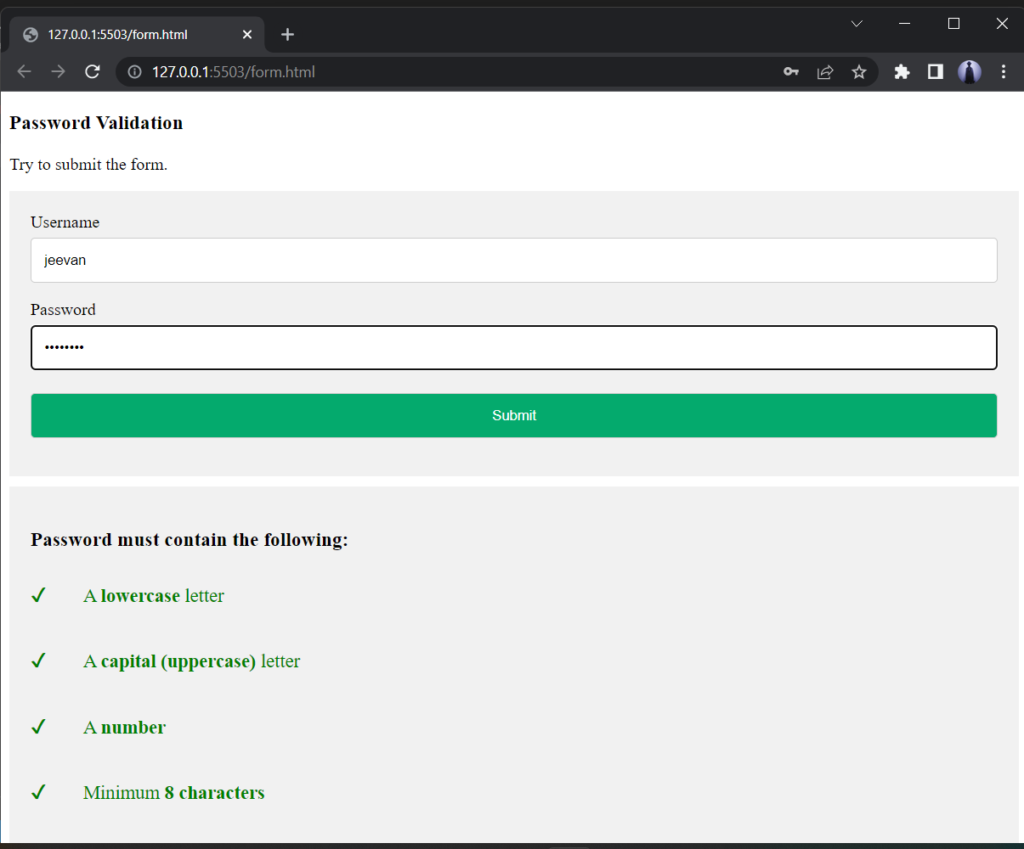

**1.4) JQuery:JQuery basic effects:**

<html>

<head>

<title>jquery basic effects</title>

<script type="text/javascript" src="jquery-3.6.0.min.js"></script>

<script type="text/javascript">

$(document).ready(function(){

$('#hide').click(function(){

$('.main').hide(30,function(){

// alert("This is hide effect")

});

});

$('#show').click(function(){

$('.main').show(30);

});

$('#toggle').click(function(){

$('.main').toggle(30);

});

$('#fadeout').click(function(){

$('.main').fadeOut(300);

});

$('#fadein').click(function(){

$('.main').fadeIn(300);

});

$('#fadetoggle').click(function(){

$('.main').fadeToggle(3000);

});

$('#slidetoggle').click(function(){

$('.main').slideToggle(2000);

});

$('#append').click(function(){

$('ol').append('<li> mango</li>');

});

$('#prepend').click(function(){

$('ol').prepend('<li> cat</li>');

});

});

</script>

</head>

<body>

<center>

<button id="hide">hide</button>

<button id="show">show</button>

<button id="toggle">toogle</button>

<button id="fadeout">fadeout</button>

<button id="fadein">fadein</button>

<button id="fadetoggle">fadetoggle</button>

<button id="slidetoggle">slidetoggle</button>

<div class="main" style="background-color: rgb(75, 15, 15); height: 300px; width: 500px;"></div>

<ol>

<li>apple</li>

</ol>

<button id="append">append</button>

<button id="prepend">prepend</button>

</center>

</body>

</html>

**Output:**

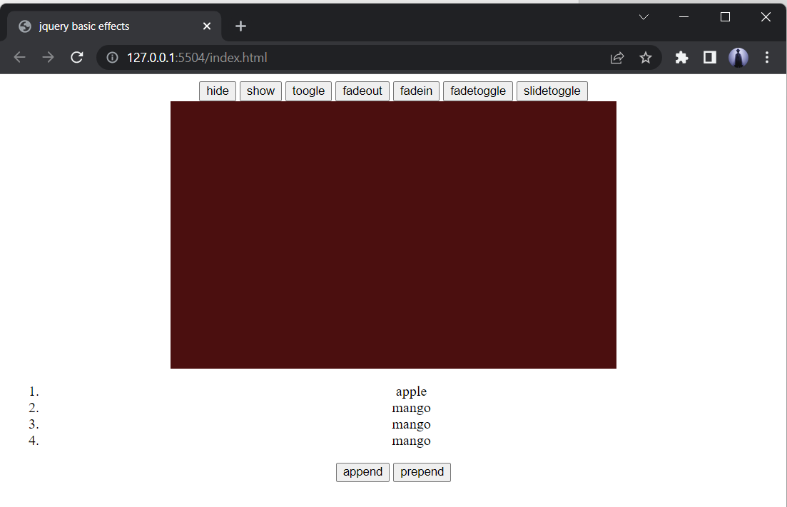

**Madan Bhandari Memorial College**

**Department of Computer Science (BSc. CSIT)**

Binayaknagar, New Baneshwor, Kathmandu

**Practical Sheet**

|  |  |  |  |
| --- | --- | --- | --- |
| **Roll No:**  **Submitted by:**  **Submitted to:** | 21049  Rajendra Thapa  Shivraj Pandey | **Program No.:**  **Lab Date:**  **Submission Date:** | 04  12/12/2078  13/12/2078 |

**Title: Through server side scripting connect to the database and create a database and table.**

**<!-- Creating Database -->**

**<!--create_Database-->**

<?php

$servername = "localhost";

$username = "username";

$password = "";

// Create connection

$con = mysqli_connect($servername, $username, $password);

// Check connection

if (!$con) {

die("Connection failed: " . mysqli_connect_error());

}

// Create database

$sql = "CREATE DATABASE Website";

if (mysqli_query($con, $sql)) {

echo "Database created successfully";

} else {

echo "Error creating database: " . mysqli_error($con);

}

mysqli_close($con);

?>

**Output in web browser:**

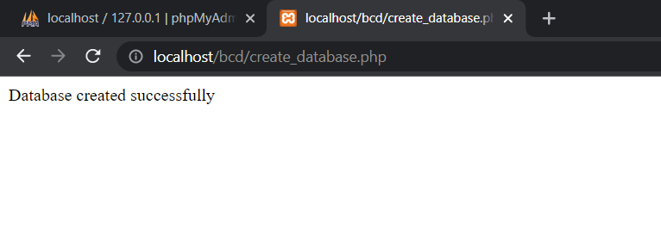

**<!-- Creating table -->**

**<!--Createtable.php-->**

<?php

$con=mysqli_connect("localhost","root","","website");

if($con)

echo"connection was successfull!";

else{

echo "connection was not successfull!";

}

// sql to create table

$sql = "CREATE TABLE webT (

id INT(6) UNSIGNED AUTO_INCREMENT PRIMARY KEY,

firstname VARCHAR(30) NOT NULL,

lastname VARCHAR(30) NOT NULL,

email VARCHAR(50),

phone INT(10)

)";

if ($con->query($sql) === TRUE) {

echo "Table Myweb created successfully";

} else {

echo "Error creating table: " . $con->error;

}

$sql="INSERT INTO webT(id,firstname,lastname,email,phone)

VALUES('1','Jeevan','Shrestha','abc@gmail.com','76643847');";

if(mysqli_query($con,$sql)){

echo"ok";

}

else{

echo"error";

}

mysqli_close($con);

?>

**Output:**

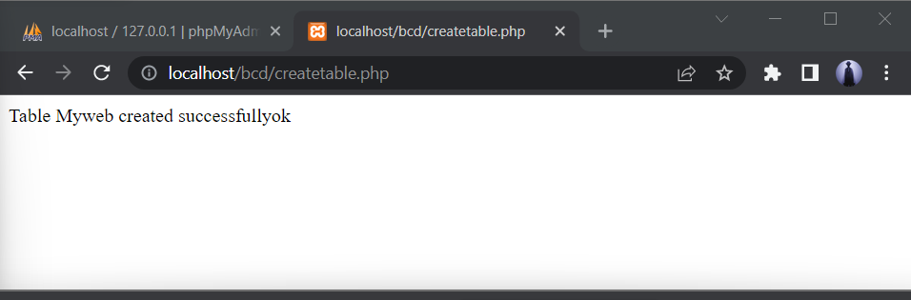

**<!-- Insert data into the database table using php scripting -->**

**<!--Inserting First data-->**

**<!--inserttable-->**

<?php

$con=mysqli_connect("localhost","root","","website");

if($con)

echo"connection was successfull!<br>";

else{

echo "connection was not successfull!";

}

$sql="INSERT INTO webT(id,firstname,lastname,email,phone)

VALUES('2','Bijay','Shrestha','abc@gmail.com','76643847');";

if(mysqli_query($con,$sql)){

echo"Insert Successfully.";

}

else{

echo"error";

}

mysqli_close($con);

?>

**Output:**

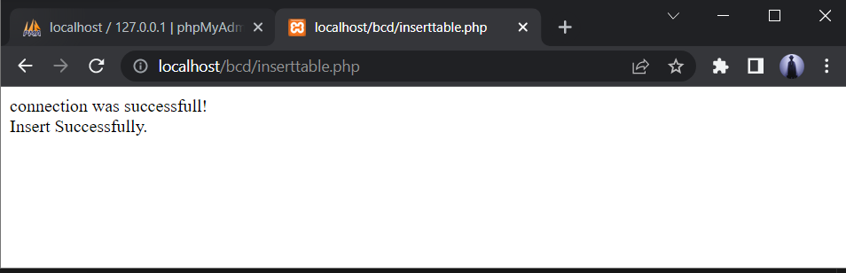

**Inserting next data**

**<!--insertcol.php-->**

<?php

$con=mysqli_connect("localhost","root","","website");

$sql="INSERT INTO webT(id,firstname,lastname,email,phone)

VALUES('3','Hari','Shrestha','asdbc@gmail.com','766433847');";

if(mysqli_query($con,$sql)){

echo"Inserted.";

}

else{

echo"error";

}

?>

**Output:**

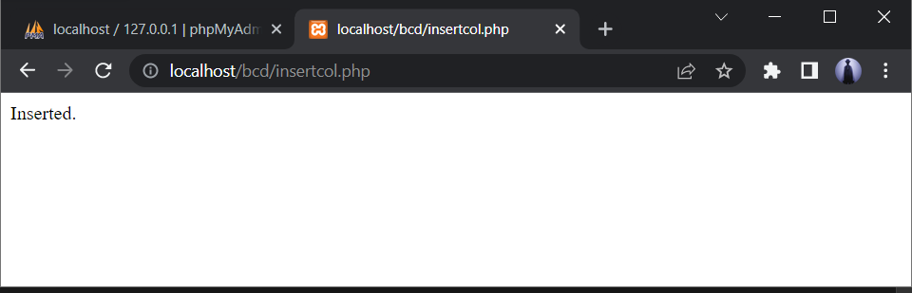

**<!-- Display the inserted data -->**

**<!--display.php-->**

<table border="1px" align="center" style="border-collapse: collapse; border-color: red; margin: 10px; padding:10px; background-color:beige">

<tr>

<th>id</th>

<th>Firstname</th>

<th>Lastname</th>

<th>Email</th>

<th>Phone</th>

<th>Edit</th>

<th>Delete</th>

</tr><br>

<?php

$con=mysqli_connect('localhost','root','','website');

$query="select * from webt order by id desc";

$res=mysqli_query($con,$query);

//for checking data is inserted or not

// if($res){

// echo "data is collected";

// }

// else

// echo "data is not collected";

while($row=mysqli_fetch_assoc($res)){

?>

<tr>

<td><?php echo $row['id']; ?></td>

<td><?php echo $row['firstname']; ?></td>

<td><?php echo $row['lastname']; ?></td>

<td><?php echo $row['email']; ?></td>

<td><?php echo $row['phone']; ?></td>

<td><a href="insertrow.php?id=<?php echo $row['id'];?>">edit</a></td>

<td><a href="deleterow.php?id=<?php echo $row['id'];?>">delete</a></td>

</tr>

<?php

}

?>

<button style="background-color: aqua;"><a href="insertrow.php" style=" color: black;">Insert Data</a></button>

<button style="background-color: aqua;"><a href="deleterow.php" style=" color: black;">Delete Data</a></button>

</table>

**Output:**

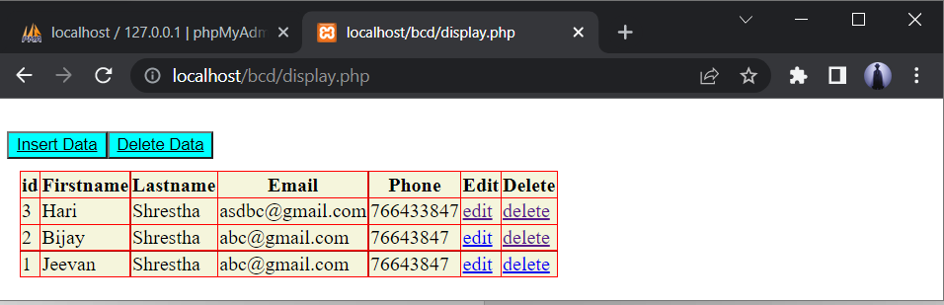

**<!-- Deleting a specific row data after clicking delete button -->**

**<!--deleterow.php-->**

<?php

$con=mysqli_connect("localhost","root","","website");

$id = (int)$_GET['id'];

$sql="DELETE FROM webT WHERE id='$id'";

if(mysqli_query($con,$sql)){

echo " Data with Id ".$id." deleted.<br>";

echo"Updated Table:";

include("insert.php");

}

else{

echo"error";

}

?>

**Output after deleting:**

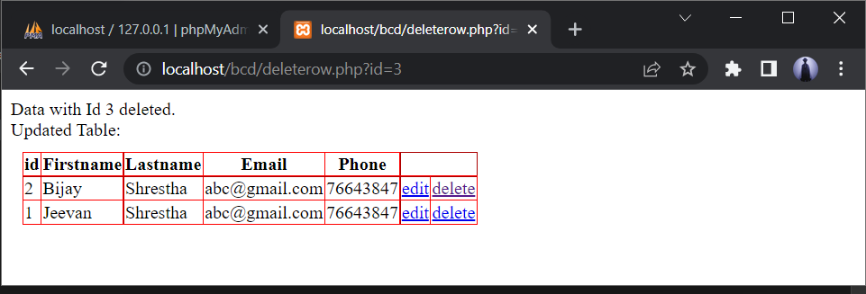

**Displaying the data:**

**<!-- Display.php -->**

<table border="1px" align="center" style="border-collapse: collapse; border-color: red; margin: 10px; padding:10px; background-color:beige">

<tr>

<th>id</th>

<th>Firstname</th>

<th>Lastname</th>

<th>Email</th>

<th>Phone</th>

<th>Edit</th>

<th>Delete</th>

</tr><br>

<?php

$con=mysqli_connect('localhost','root','','webtechnology');

$query="select * from webt order by id desc";

$res=mysqli_query($con,$query);

//for checking data is inserted or not

// if($res){

// echo "data is collected";

// }

// else

// echo "data is not collected";

while($row=mysqli_fetch_assoc($res)){

?>

<tr>

<td><?php echo $row['id']; ?></td>

<td><?php echo $row['firstname']; ?></td>

<td><?php echo $row['lastname']; ?></td>

<td><?php echo $row['email']; ?></td>

<td><?php echo $row['phone']; ?></td>

<td><a href="insertrow.php?id=<?php echo $row['id'];?>">edit</a></td>

<td><a href="deleterow.php?id=<?php echo $row['id'];?>">delete</a></td>

</tr>

<?php

}

?>

<button style="background-color: aqua;"><a href="insertrow.php" style=" color: black;">Insert Data</a></button>

<button style="background-color: aqua;"><a href="delete.php" style=" color: black;">Delete Data</a></button>

</table>

**Output:**

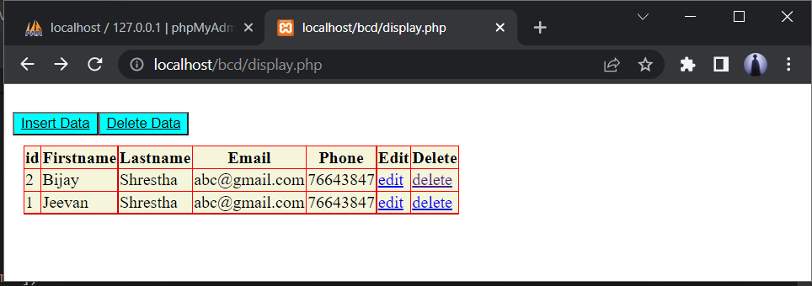

**After clicking the Insert Data button insertrow.php file is executed:**

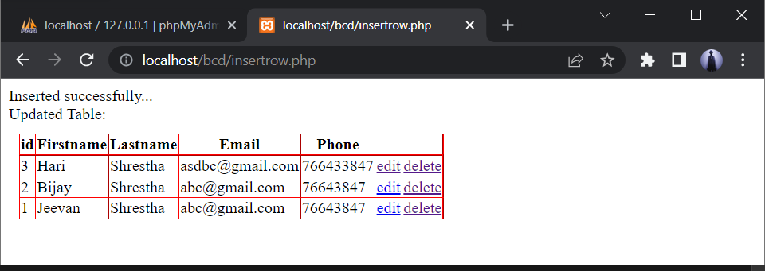

**Madan Bhandari Memorial College**

**Department of Computer Science (BSc. CSIT)**

Binayaknagar, New Baneshwor, Kathmandu

**Practical Sheet**

|  |  |  |  |
| --- | --- | --- | --- |
| **Roll No:**  **Submitted by:**  **Submitted to:** | 21049  Rajendra Thapa  Shivraj Pandey | **Program No.:**  **Lab Date:**  **Submission Date:** | 04  12/12/2078  13/12/2078 |

**Title: Simple login system through session variable.**

**Creating SESSION variable:**

<?php

// Start the session and get the data

session_start();

session_unset();

session_destroy();

echo "<br> You have been logged out";

?>

**Login page using SESSION variable:**

**<!-- login.php -->**

<?php

ob_start();

session_start();

?>

<html lang="en">

<head>

<title>Session login page</title>

<style>

.con{

width: fit-content;

background-color:palegoldenrod;

}

.btn{

color: greenyellow;

background-color: wheat;

}

</style>

</head>

<body>

<h3>Login Page</h3>

<div class="container form-signin">

<?php

$msg = '';

if (

isset($_POST['login']) && !empty($_POST['username'])

&& !empty($_POST['password'])

) {

if (

$_POST['username'] == 'Web' &&

$_POST['password'] == '1234'

) {

$_SESSION['valid'] = true;

$_SESSION['timeout'] = time();

$_SESSION['username'] = 'Web';

echo 'You have entered valid use name and password';

} else {

$msg = 'Wrong username or password';

}

}

?>

</div> <!-- /container -->

<div class="container">

<form class="form-signin" role="form" action="<?php echo htmlspecialchars($_SERVER['PHP_SELF']);

?>" method="post">

<fieldset class="con">

<h4 class="form-signin-heading"><?php echo $msg; ?></h4>

Username:

<input type="text" class="form-control" name="username" placeholder="username" required autofocus></br>

Password:

<input type="password" class="form-control" name="password" placeholder="password" required><br>

<button type="submit" name="login">Login</button>

</fieldset>

</form>

Click here to clean <a href="logout.php" tite="Logout">Session.

</div>

</body

</html>

**Output:**

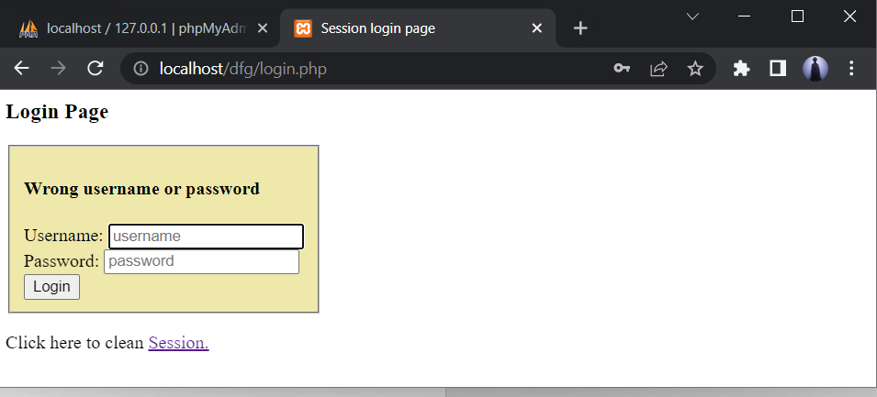

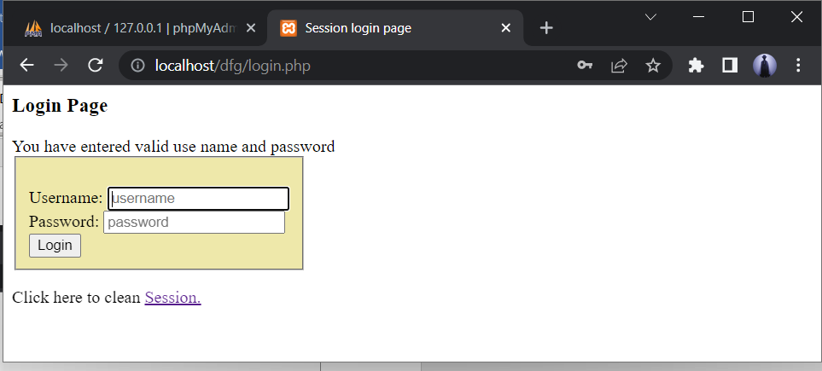

**Logout.php**

**After clicking on Session button, session variable are unset.**

<?php

   session_start();

   unset($_SESSION["username"]);

   unset($_SESSION["password"]);

   echo 'You have cleaned session';

   header('Refresh: 2; URL = login.php');

?>

**Output:**

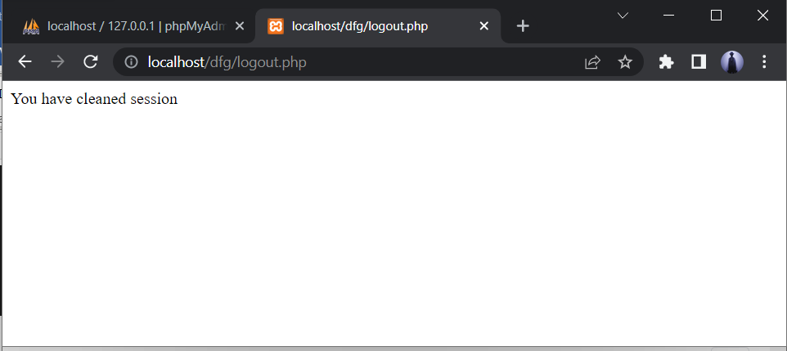

Hence, the session variables are cleared successfully.