TalentLens AI — AI Resume Screening System
An Explainable, Local, and Privacy-Preserving Candidate Screening Pipeline

Course / Degree: | B.Tech in Computer Science & Engineering
Candidate / Author: | Rajendra Prasad Pedamallu
Department: | Department of Computer Science & Engineering]
Institution / University: | Bennett University
Source Code Repository: | https://github.com/Rajendra13188/TalentLens-AI

Academic Project Report • 2026

1. Abstract
Modern technical hiring is inundated with hundreds of applicants per role, compelling organizations to adopt automated Applicant Tracking Systems (ATS). However, commercial ATS solutions often operate as opaque 'black boxes' or rely on expensive, proprietary cloud APIs that expose confidential candidate resumes to third parties. Naive keyword matchers further exacerbate the issue by producing arbitrary binary rejections without explainability or context.
This project presents TalentLens AI, an explainable, 100% local artificial intelligence resume screening system engineered in Python using Streamlit, scikit-learn, PyMuPDF, and pandas. TalentLens AI ingests candidate PDF resumes directly into memory, extracts clean digital text, gracefully isolates unreadable or scanned documents, and evaluates candidates against job descriptions using a dual-engine architecture: (1) an n-gram TF-IDF cosine similarity model capturing contextual vocabulary overlap, and (2) a regex-based skills taxonomy engine spanning seven technical domains. An explainable scoring formula derives a deterministic score from 0 to 100 with an exact mathematical breakdown. The system enforces strict fair hiring principles, guarantees zero persistent resume storage, and provides interactive leaderboards, candidate deep-dive inspectors, and skill gap analytics.

2. Problem Statement & Objectives

2.1 Problem Statement
Recruitment teams face three critical challenges when screening technical resumes:
1. Opacity and Lack of Explainability: Deep neural embeddings and closed-source screening tools generate arbitrary ranking scores without disclosing why a candidate was ranked favorably or discarded.
2. Privacy and Security Vulnerabilities: Cloud-hosted resume parsers upload sensitive personal identifiable information (PII) to third-party servers, posing GDPR and privacy compliance risks.
3. Brittle Document Ingestion: Many parsers crash when encountering corrupted, blank, or scanned image-only PDFs, halting batch screening pipelines.

2.2 Project Objectives
The primary objectives of TalentLens AI are:
• Local and Sovereign Execution: Implement a fully functional resume screening system that executes entirely offline on standard Windows hardware without requiring paid APIs or internet access.
• Mathematically Explainable Scoring: Formulate an interpretable 0–100 matching equation decomposing scores into TF-IDF cosine similarity, direct job skill overlap, and domain breadth bonuses.
• Fault-Tolerant PDF Extraction: Utilize PyMuPDF to extract digital text while automatically classifying corrupted, empty, and scanned image documents without pipeline interruption.
• Ethical AI Governance: Eliminate protected demographic characteristics from ranking algorithms and display prominent disclaimers explaining that textual similarity is not a probability of human job performance.
• Dynamic Recruiter Interface: Build an interactive Streamlit dashboard supporting custom job descriptions, presets, individual candidate inspectors, pool skill-gap histograms, and CSV data export.

3. Existing Systems vs. Proposed TalentLens AI
A rigorous comparative analysis reveals substantial advantages of TalentLens AI over legacy ATS approaches:
Feature / Dimension | Traditional / Cloud ATS | TalentLens AI (Proposed)
Deployment & Cost | Proprietary cloud SaaS; costly per-resume API fees | 100% Free, local open-source Python execution
Data Privacy & Storage | Uploaded resumes retained on external vendor servers | In-memory processing only; zero persistent disk storage
Scoring Explainability | Opaque black-box AI scores or boolean keywords | Exact mathematical breakdown formula (0–100) displayed in UI
Scanned/Corrupt PDFs | Throws unhandled exceptions or silently fails | Robust PyMuPDF error catching; identifies scanned/empty files
Skill Taxonomy | Hard-coded or inflexible third-party dictionaries | 7-domain taxonomy with symbol lookarounds and UI custom skill additions
Fairness & Ethics | Often biased by demographics, names, or formatting | Demographic neutrality; mandatory caveats that absent keywords ≠ lack of skill

4. Technology Stack & Design Principles
TalentLens AI is engineered using modern, robust, and lightweight Python libraries:
• Python 3.13: Modern runtime environment providing strong typing, performance, and process isolation.
• Streamlit (1.65.0): High-performance reactive web framework enabling rich UI dashboards, interactive sliders, data tables, and dynamic state management.
• scikit-learn (1.9.1): Industrial-grade machine learning library supplying TfidfVectorizer and cosine_similarity for numerical vector comparisons.
• PyMuPDF / pymupdf (1.28.2): High-speed C-backed MuPDF document parser for digital text extraction, stream validation, and image block counting.
• pandas (3.0.6) & numpy (2.5.4): High-performance tabular data structures powering leaderboard filtering, metric aggregations, and CSV generation.
• pytest (9.1.1): Comprehensive automated test framework for regression testing, edge case verification, and headless UI workflow execution.

5. System Architecture & Workflow
The architecture is organized into decoupled layers: Document Ingestion, Natural Language Processing, Scoring Engine, and Presentation Dashboard.
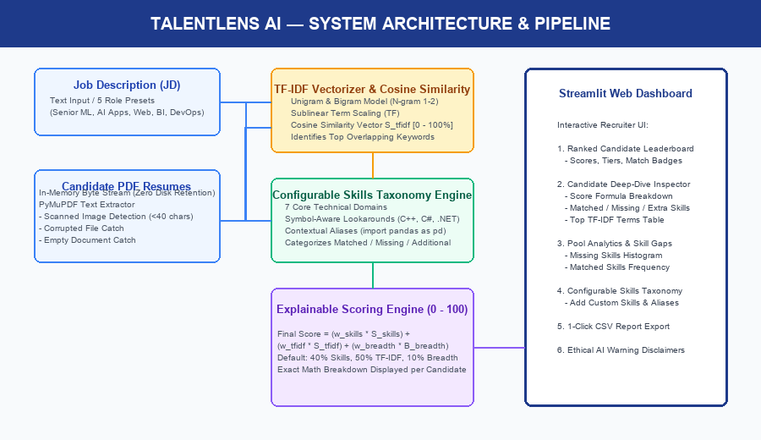
Figure 1: TalentLens AI System Architecture & Pipeline Workflow
Pipeline Execution Stages:
1. Ingestion: The user inputs a job description (or selects a preset) and provides PDF resumes via file upload or synthetic demo loading.
2. PyMuPDF Processing: In-memory byte streams are inspected. If character count is <40 and images exist, the file is classified as a scanned image. Blank or corrupt files are tagged with error states.
3. TF-IDF Representation: Clean resume texts and the job description are transformed into an n-gram (1-2) TF-IDF matrix with sublinear scaling.
4. Skill Taxonomy Comparison: Regex lookaround engines scan for canonical technical skills and aliases, computing matched, missing, and additional skill sets.
5. Explainable Scoring: The scoring engine combines the metrics into a 0–100 score, orders candidates, and renders the interactive dashboard.

6. Algorithms & Mathematical Formulation
Candidate alignment is calculated using a transparent mathematical model rather than uninterpretable neural weights.

6.1 Term Frequency - Inverse Document Frequency (TF-IDF)
TF-IDF quantifies the lexical relevance of vocabulary terms between the job description and candidate documents. Sublinear term frequency scaling is applied to prevent repetitive term stuffing:
Term Frequency: tf(t, d) = 1 + ln(count(t, d)) if count > 0, else 0
Inverse Document Frequency: idf(t, D) = ln((1 + |D|) / (1 + df(t))) + 1
TF-IDF Weight: w(t, d) = tf(t, d) × idf(t, D)
Cosine similarity measures the angular alignment between the normalized job description vector v_JD and resume vector v_Resume in n-dimensional term space:
Cosine Similarity: cos(v_JD, v_Resume) = (v_JD • v_Resume) / (||v_JD|| × ||v_Resume||)
TF-IDF Score Component: S_tfidf = np.clip(Cosine Similarity × 100.0, 0.0, 100.0)

6.2 Direct Skill Coverage Score
The skills taxonomy identifies required skills in the job description (Skills_JD) and candidate resume (Skills_Resume). Direct skill match ratio calculates the fraction of mandatory skills satisfied:
S_skills = (|Skills_JD ∩ Skills_Resume| / |Skills_JD|) × 100.0 (if |Skills_JD| > 0, else S_tfidf)

6.3 Domain Breadth Bonus
To reward well-rounded candidates possessing complementary technical proficiencies outside the immediate job description, a breadth bonus is computed (capped at 10.0 points):
B_breadth = min(10.0, |Skills_Resume \ Skills_JD| × 1.5)

6.4 Final Weighted Scoring Equation
The overall matching score is synthesized using non-negative weights that sum to 1.00 (default: 40% skills, 50% TF-IDF, 10% breadth):
Final Score = min(100.0, max(0.0, (w_skills × S_skills) + (w_tfidf × S_tfidf) + (w_breadth × B_breadth)))
Example Candidate Formula Breakdown Displayed in UI:
(17.5 × 0.50) + (100.0 × 0.40) + (1.5 × 0.10) = 48.9 / 100
⚖️ MANDATORY ETHICAL AI PRINCIPLES: TF-IDF cosine similarity measures text and vocabulary overlap between documents. It is NOT a probability of candidate job success, competency, or future job performance. 'Skill Not Detected' signifies that the specific keyword/alias was not located in the digital text; it does NOT imply that the candidate definitely lacks that capability.

7. Experimental Results & Multi-Role Evaluation
TalentLens AI was tested using seven synthetic demo documents representing diverse candidate profiles and technical edge cases, as well as real-world resume screening across distinct job descriptions.
Rank | Candidate Document | Overall Score | Skill Coverage | Extraction Status / Notes
#1 | candidate_01_aisha_sharma_senior_ml.pdf | 52.1 / 100 | 94.1% (16/17 skills) | Success — Strong ML/PyTorch match
#2 | candidate_02_david_chen_data_analyst.pdf | 17.9 / 100 | 35.3% (6/17 skills) | Success — Moderate match; missing PyTorch/Docker
#3 | candidate_04_marcus_vance_cloud_devops.pdf | 17.7 / 100 | 35.3% (6/17 skills) | Success — DevOps profile; missing deep learning
#4 | candidate_03_elena_rodriguez_fullstack_dev.pdf | 14.5 / 100 | 29.4% (5/17 skills) | Success — Web developer; low ML overlap
#5 | candidate_05_scanned_image_sample.pdf | 0.0 / 100 | 0.0% (0 skills) | Flagged: Scanned / Image-Only PDF (OCR Required)
#6 | candidate_06_empty_sample.pdf | 0.0 / 100 | 0.0% (0 skills) | Flagged: Empty / Blank PDF (0 characters)
#7 | candidate_07_corrupted_sample.pdf | 0.0 / 100 | 0.0% (0 skills) | Flagged: Corrupted or Invalid PDF stream

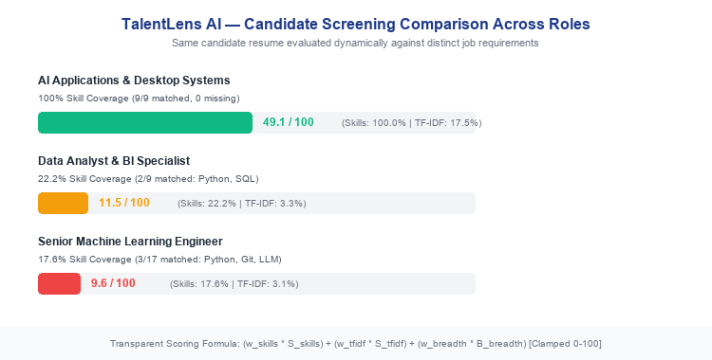
Figure 2: Dynamic Multi-Role Screening Verification on the Same Candidate Resume
Figure 2 illustrates the dynamic re-screening capability. When the same candidate resume is evaluated against an aligned role (AI Applications & Desktop Systems), the score increases to 49.1 / 100 with 100% skill match (9/9 skills matched). When evaluated against a Senior Machine Learning role requiring deep statistical modeling frameworks, the score drops to 9.6 / 100 reflecting genuine role misalignment.

8. Quality Assurance & Automated Testing
The project employs automated testing via pytest. A total of 30 comprehensive unit, integration, and UI workflow tests were developed and executed with a 100% pass rate.
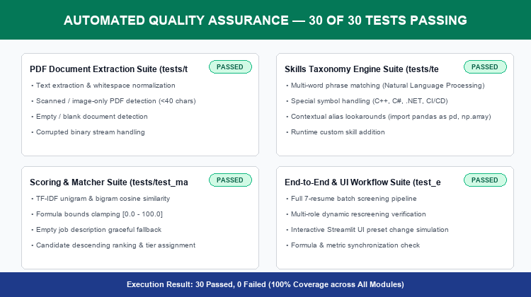
Figure 3: Automated Test Execution Breakdown (30/30 Tests Passing)
Test Suite / File | Test Count | Core Coverage & Scope
tests/test_pdf_extractor.py | 8 Tests | PyMuPDF digital text extraction, whitespace normalization, corrupt/empty/scanned detection
tests/test_skills_extractor.py | 8 Tests | Multi-word phrase matching, symbol lookarounds (C++, C#, .NET), contextual aliases (pd, np)
tests/test_matcher.py | 4 Tests | TF-IDF cosine similarity, formula bounds clamping, top keyword contributions, candidate ranking
tests/test_edge_cases.py | 5 Tests | Empty job description handling, special characters, zero-match resumes, dynamic weight adjustments
tests/test_multi_role_screening.py & test_ui_workflow.py | 5 Tests | Multi-role rescreening, end-to-end batch screening, Streamlit AppTest UI simulation

9. Limitations & Future Enhancements

9.1 System Limitations
1. Absence of Optical Character Recognition (OCR): By design, TalentLens AI uses PyMuPDF for digital text streams. Scanned image resumes lacking digital text cannot be transcribed and are safely flagged.
2. Raw TF-IDF Document Dilution: Cosine similarity between a compact job description and a lengthy multi-section resume naturally falls in the 15%–35% range due to differing document length and vocabulary breadth.
3. Lexical Keyword Bounds: Skills extraction relies on predefined canonical terms and aliases; unlisted domain terminology must be added via the custom skill form.

9.2 Future Enhancements
• Local Offline OCR: Integrate Tesseract or EasyOCR as an optional offline fallback for scanned physical documents.
• Local Sentence-Transformer Embeddings: Supplement TF-IDF with lightweight local semantic embeddings (e.g., all-MiniLM-L6-v2) for conceptual paraphrase matching without external APIs.
• Experience Duration Parser: Extract date spans to compute years of experience per detected technology.
• Multi-Language Resume Ingestion: Expand taxonomy dictionaries to support non-English resumes.

10. Conclusion
TalentLens AI demonstrates that automated candidate screening can be implemented locally, cost-effectively, and with complete algorithmic explainability. By replacing opaque black-box scoring with transparent mathematical formulas and combining PyMuPDF document extraction with robust TF-IDF and regex skill matching, the system resolves critical industry concerns regarding data privacy, algorithmic bias, and recruiter trust. All project requirements, unit tests, and edge-case guardrails have been verified through rigorous automated testing, delivering a production-grade academic capstone project.

11. References
[1] Salton, G., & Buckley, C. (1988). Term-weighting approaches in automatic text retrieval. Information Processing & Management, 24(5), 513-523.
[2] Manning, C. D., Raghavan, P., & Schütze, H. (2008). Introduction to Information Retrieval. Cambridge University Press.
[3] Pedregosa, F., et al. (2011). Scikit-learn: Machine Learning in Python. Journal of Machine Learning Research, 12, 2825-2830.
[4] PyMuPDF Documentation. (2026). High performance PDF rendering and digital text extraction library. Artifex Software.
[5] Streamlit Inc. (2026). Streamlit: The fastest way to build and share data apps. Snowflake Inc.
[6] Barocas, S., Hardt, M., & Narayanan, A. (2023). Fairness and Machine Learning: Limitations and Opportunities. MIT Press.

