UX DESIGN & END-TO-END FLOW BLUEPRINT
AI-Native Multi-Vertical CRM Platform | Construction • Clinical Research • Maritime Logistics
Version 1.0 | Design baseline | 31 October 2026
Purpose: one professionally illustrated, implementation-oriented reference for product owners, UX designers, frontend engineers, backend/AI teams, security reviewers and QA.

Document control
Item | Definition
Status | Proposed design; subject to stakeholder validation
Inputs | AI-Native CRM PRD v1.0 and Detailed Solution Architecture v1.0
Design scope | Information architecture, screen flows, user journeys, interaction rules, AI workflows, errors and acceptance
Not included | Final pixel-perfect Figma components, brand identity, signed-off regulatory validation
Principle | CRM-first; three independent vertical experiences on a shared multi-tenant platform

How to read the diagrams
Blue nodes = standard user/system steps; green nodes = AI/ML processing or approved actions; amber nodes = decisions/exceptions; violet nodes = security/data services. Arrows indicate sequence or information exchange; diagrams are logical, not network-topology guarantees.

1. Product design principles
- Suite-specific navigation and terminology, with shared CRM patterns and consistent interaction controls.
- Progressive disclosure: simple primary tasks, optional advanced detail and explainable AI suggestions.
- Human approval for clinical decisions, contractual commitments, billing, shipment changes and significant project actions.
- Tenant, suite, role and record permissions enforced by the backend; hiding a button is not authorization.
- Accessible responsive desktop-first design; keyboard navigation, screen-reader labels, readable status text and contrast.
- Every AI result displays provenance, uncertainty/limitations, timestamp, and an explicit review or correction path.

2. Global information architecture

Figure 01 — Platform navigation and suite boundaries
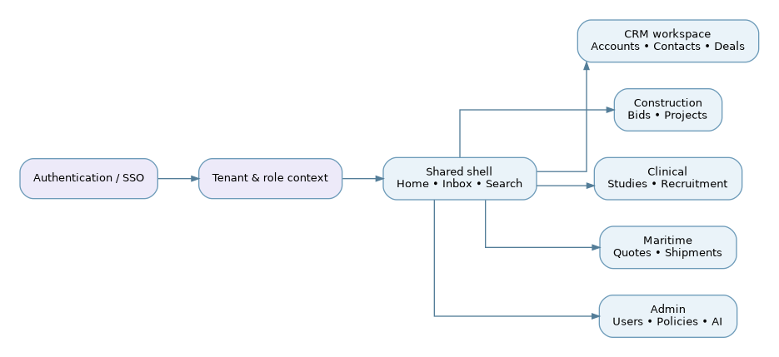
Design note | Tenant subscription and role permissions determine available suites; global search must apply tenant and record-level filters.

3. Shared application shell and layout

Figure 02 — Screen composition
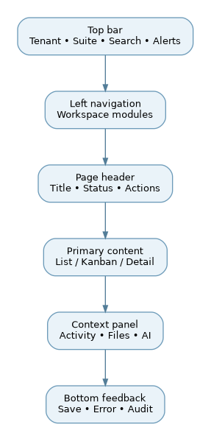
Design note | Wireframe-level composition; side panel is optional, collapsible and never required for critical task completion.

4. Roles, access and navigation
Role | Landing view | Typical allowed tasks | Guardrails
Tenant Admin | Tenant overview | Users, suite settings, policy, billing | Cannot bypass audit or clinical safeguards
Sales / Account Manager | Pipeline | Accounts, contacts, quotes, follow-ups | Cannot approve restricted operational steps
Construction Estimator / PM | Bid / project board | Estimate, bid, track change orders | Approval thresholds apply
Clinical Coordinator | Study / recruitment board | Screen, schedule, manage recruitment | Consent and PHI access restricted
Clinical Investigator | Study oversight | Review eligibility, clinical approvals | Clinical judgment remains human
Freight Operator | Shipment board | Booking, milestones, documents | Carrier/customs integration permissions
Finance / Approver | Approvals / finance | Review budgets, invoices, approvals | Segregation of duties
Viewer / Auditor | Read-only dashboard | Inspect permitted records and logs | No write, export may be restricted

Figure 03 — Sign-in, onboarding and suite activation
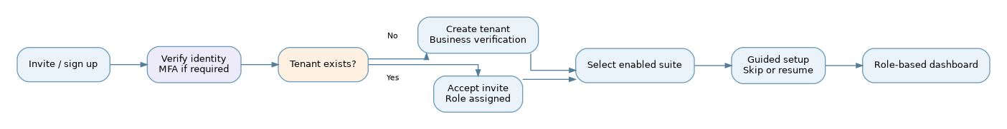
Design note | Self-service tenant creation is rate-limited, verified and abuse-monitored. Guided setup saves progress and remains resumable.

5. Shared CRM core flows

Figure 04 — Lead-to-opportunity-to-account lifecycle
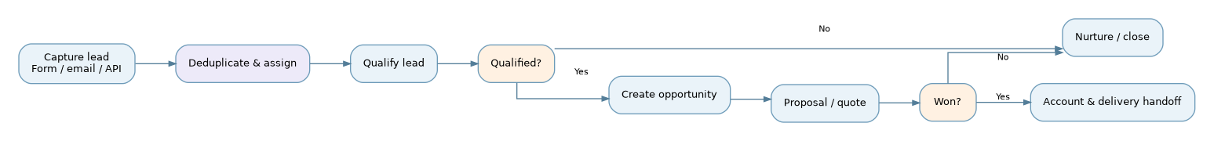
Design note | Lead stage changes are auditable; conversion preserves source, ownership, history, contacts and attachments.

Figure 05 — Universal list, detail, edit and approval interactions
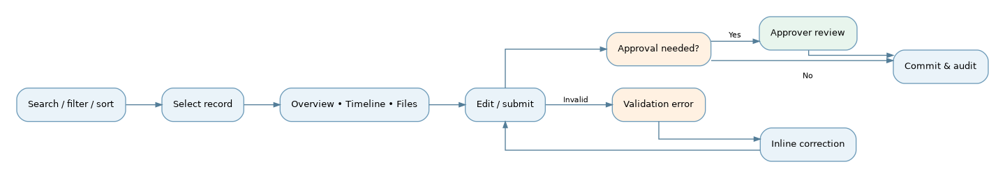
Design note | Draft autosave is distinct from final submit; approval actions display impact and require confirmation.

6. Construction suite — UX design
Primary navigation: Dashboard | Leads | Bid Board | RFQs | Estimates | Projects | Change Orders | Field Logs | Documents | Financials | Reports.

Figure 06 — Construction bid-to-project journey
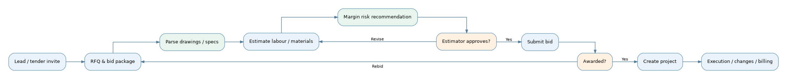
Design note | AI extraction must reference sheet/page and confidence; estimated prices never auto-submit. Award handoff retains approved scope and version.

Figure 07 — Construction change-order approval
Design note | No approved change order silently rewrites the original contract; retain versions, signature/evidence and effective dates.

7. Clinical suite — UX design
Primary navigation: Dashboard | Sponsors | Studies | Sites | Recruitment | Prescreening | Visits | Consent Records | Documents | Reports | Audit.

Figure 08 — Clinical recruitment-to-enrolment journey
Design note | AI never independently determines eligibility, obtains informed consent or gives clinical advice. Rejections and withdrawals follow configured retention policies.

Figure 09 — Clinical PHI-aware document question
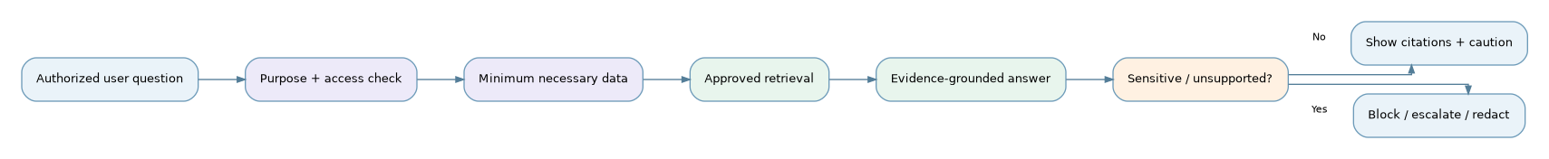
Design note | PHI access is logged and constrained by study/site, role and purpose. Do not expose clinical documents to unapproved external models.

8. Maritime suite — UX design
Primary navigation: Dashboard | Customers | Enquiries | Rate Cards | Quotations | Bookings | Shipments | Containers | Documents | Customs | Finance | Reports.

Figure 10 — Maritime enquiry-to-delivery journey
Design note | Show currency, rate validity, charge basis, Incoterms and quote version. ETA forecasts must distinguish carrier-reported from ML-predicted times.

Figure 11 — Shipment exception and escalation
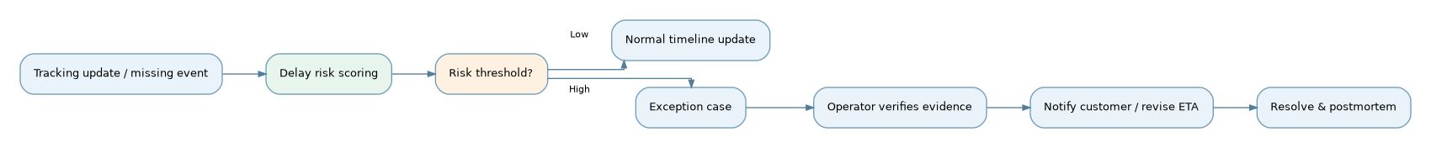
Design note | External tracking events are untrusted until normalized and deduplicated. Customer notifications require configured approval.

9. AI-powered user experience

Figure 12 — AI assistant interaction contract
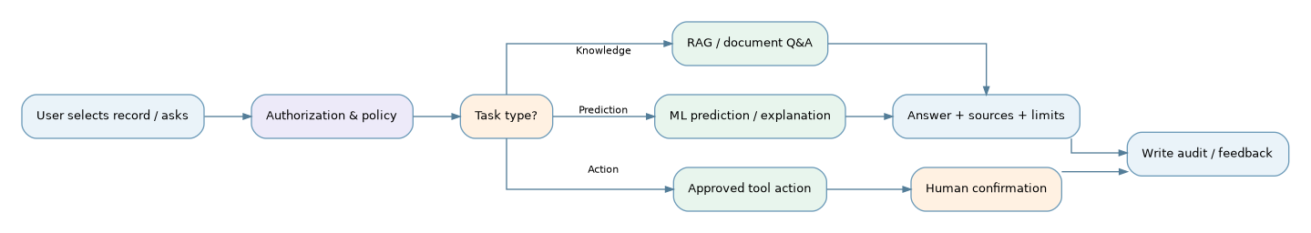
Design note | UI clearly separates extracted facts, generated summaries, predictive estimates and proposed actions. AI cannot execute irreversible actions without authorization.

Figure 13 — Document ingestion, RAG and grounded answer
Design note | Index ACLs at document and chunk level; enforce again at retrieval. No numeric guarantee of 100% precision or zero hallucination.

Figure 14 — NLP extraction and correction loop
Design note | Extracted data must display source page, bounding region when possible, field confidence and provenance.

Figure 15 — Predictive ML lifecycle and UI feedback
Design note | Display score semantics and confidence, not just a red badge. Clinical dropout predictions are decision support, not eligibility criteria.

Figure 16 — LLMOps routing, guardrails and cost control
Design note | Cache key includes tenant, user permission scope, source versions, model/prompt versions and sensitivity class; never cross-cache PHI.

10. System states, failures and safeguards

Figure 17 — Failure handling and recovery
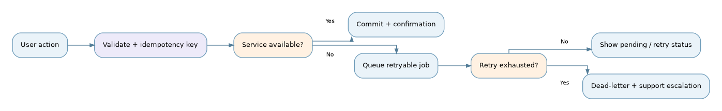
Design note | Never show a success toast before persistence or durable queue acknowledgement. Preserve drafts, retry safely and surface correlation IDs.

11. Screen inventory and screen-level contracts
Screen ID | Screen / layout | Primary user action | Critical data / validation
G-01 | Login / MFA | Authenticate | Session, lockout, MFA, device status
G-02 | Tenant setup wizard | Create workspace | Verified business email, suite, locale
G-03 | Home dashboard | Prioritize work | Role-scoped KPIs and alerts
G-04 | Universal search | Find records | ACL-aware results and facets
G-05 | CRM pipeline | Qualify / convert | Stage, owner, next step, source
G-06 | Account detail | Manage relationship | Contacts, opportunities, history
G-07 | Activity inbox | Act on tasks | Due dates, assignment, audit
G-08 | Documents workspace | Upload / compare / ask | Versions, source, permission, ingestion status
G-09 | AI assistant drawer | Ask / review / cite | Sources, confidence, feedback, token usage
G-10 | Approval center | Approve / reject | Threshold, rationale, immutable decision
C-01 | Construction bid board | Manage bids | Due date, estimate version, status
C-02 | Estimate builder | Price bid | Units, margin, labour, material
C-03 | Project detail | Track delivery | Scope, baseline, milestones, cost
C-04 | Change order detail | Submit change | Evidence, impact, approvals
C-05 | Field log | Record site events | Date, location, attachments
T-01 | Study workspace | Manage study | Protocol version, site, stage
T-02 | Recruitment funnel | Track candidates | Consent state, permitted identifiers
T-03 | Prescreen form | Record responses | Criteria version, review required
T-04 | Visit schedule | Schedule visits | Timezone, reminders, permissions
T-05 | Consent record | Track consent | Version, status, withdrawal, audit
M-01 | Freight quote builder | Prepare quote | Currency, charges, validity, Incoterms
M-02 | Shipment detail | Track shipment | Milestones, container IDs, ETA source
M-03 | Exception queue | Resolve delays | Severity, evidence, ownership
M-04 | Freight financials | Reconcile margin | Rates, cost, invoice, FX
A-01 | Tenant & suite settings | Configure access | Role matrix, limits, audit
A-02 | AI admin & evaluations | Manage model policy | Allowlist, prompt version, evaluations
A-03 | ML monitoring | Review models | Drift, cohort metrics, rollback

12. Reusable UI component and interaction rules
Component | Behavior | States / accessibility
Data table | Saved filters, pagination, bulk actions only if permitted | Loading, empty, error; keyboard row actions
Record detail | Header + tabs + timeline + contextual panel | Read-only, draft, edit, locked, archived
Stage board | Kanban with server-validated transitions | Drag alternative via accessible menu
Wizard / form | Step validation, progress, save/resume | Unsaved-change guard, inline errors
Document viewer | Version comparison, anchored citations | Unavailable preview fallback; accessible download
AI evidence card | Source, generated time, caveat, feedback | Unverified, verified, abstained, blocked
Risk indicator | Score, time horizon, top factors, threshold | Never rely on color alone
Approval panel | Impact diff, reason, approve/reject | Explicit confirmation, audit timestamp
Notification | In-app and optional email / SMS | User preferences, PHI-safe content
Audit timeline | Actor, action, before/after, correlation ID | Immutable backend source; permission-aware

13. Key design rules by domain
- Construction: estimates require units, currencies, taxes, scope versions and change-order traceability; AI suggestions cannot become commercial commitments automatically.
- Clinical: separate participant identity from study activity where feasible; explicit consent state and restricted PHI views; investigators control eligibility.
- Maritime: use standardized container identifiers, vessel/voyage references, location codes, event timezones and rate validity; distinguish predicted and observed milestones.
- Shared: users can export only authorized data; all record links must be protected server-side; no cross-tenant autocomplete or search leakage.

14. Acceptance criteria and test scenarios
ID | Scenario | Expected result
UX-01 | Role enters non-subscribed suite | No navigation or API access; appropriate explanation
UX-02 | User opens inaccessible record URL | Backend denies without exposing existence/details
UX-03 | User refreshes partially completed wizard | Draft resumes without duplicate tenant or records
UX-04 | Estimator corrects AI-extracted quantity | Provenance retained and approved value persists
UX-05 | Clinical AI asked to decide enrolment | Assistant abstains; routes to authorized clinician
UX-06 | Cross-tenant vector retrieval attempt | Zero unauthorized chunks returned; security event logged
UX-07 | Shipment event arrives twice | Idempotent processing; single visible milestone
UX-08 | LLM provider outage | Policy-approved fallback or graceful error; no silent data transfer
UX-09 | AI answer lacks supporting evidence | Clear abstention or unsupported-answer warning
UX-10 | Approval rejected | No protected record mutation; reason and audit visible
UX-11 | Keyboard-only workflow | Complete primary actions with visible focus and labels
UX-12 | Prediction model version changes | Record displays model/version and updated timestamp

15. Suggested delivery and UX validation sequence
Iteration | Deliverables | Exit gate
0 — Discovery | Persona interviews, terminology, data classification, domain review | Approved assumptions and risks
1 — Shared foundation | Navigation, design system, onboarding, CRM screens | Role and tenant flow walkthrough
2 — Construction | Bid, estimate, project and change-order prototypes | Estimator and PM task validation
3 — Maritime | Quote, shipment, exception prototypes | Freight operator scenario validation
4 — Clinical | Study, recruitment, prescreening and consent prototypes | Privacy, clinical and compliance review
5 — AI experience | Document viewer, assistant, evidence, ML risk cards | Grounding, human approval and safe-failure tests
6 — Handoff | Figma-ready inventory, API contracts, test cases | Signed-off screen specifications

16. Open decisions before high-fidelity UI
- Brand, product name, colors, typography and design-system ownership.
- Exact subscription packages, tenant signup requirements, identity providers and country rollout.
- Construction: estimating depth, accounting integration and mobile offline field operations.
- Clinical: countries, study types, data controller/processor roles, consent process and regulated-system validation scope.
- Maritime: transport modes, carrier APIs, customs geographies, billing/accounting depth and rate providers.
- AI: approved model providers per data class, PHI boundaries, retention policy, human-review thresholds and budget limits.
- ML: available labelled data, outcome definitions, fairness review, thresholds and target operating metrics.

Appendix A — Design-to-engineering handoff checklist
- Each screen has ID, persona, entry point, primary/secondary actions, empty/loading/error states and responsive behavior.
- Each transition maps to backend API, permission, validation, audit event and idempotency policy.
- Each AI surface maps to retrieval/model provenance, evaluation criteria, feedback path and fallback behavior.
- Each domain workflow has happy path, exception path, approval path and data-retention handling.
- Accessibility review covers keyboard, labels, focus, contrast, tables and status announcements.
- No UI prototype is treated as evidence of regulatory compliance without formal review and validation.

Appendix B — Diagram catalogue
Figures 01–17: navigation; layout; onboarding; CRM lifecycle; record approval; construction bid and change order; clinical recruitment and PHI query; maritime shipment and exception; AI assistant; RAG; NLP extraction; MLOps; LLMOps; recovery.

