Lab Sheet-05: Reinforcement Learning
MCA III Semester (Session 2026-2027)
COER University, Roorkee, Uttarakhand
Name: Rajendra Singh Bisht

1. Objective
- To understand the basic ideas of Reinforcement Learning (RL): agent, environment, state, action and reward.
- To implement Q-Learning on the FrozenLake environment and on a custom Grid World.
- To implement a Deep Q-Network (DQN) with PyTorch and train it on CartPole.
- To study the effect of hyperparameters, replay memory and the target network.
- To compare the performance of the algorithms.

2. Algorithm / Procedure

2.1 Q-Learning
1. Create the environment and a Q-table of zeros (one row per state, one column per action).
2. For each episode, reset the environment and choose actions with the epsilon-greedy policy (random action with probability epsilon, otherwise the best known action).
3. After each step, update: Q(s,a) = Q(s,a) + alpha * [ r + gamma * max Q(s',a') - Q(s,a) ].
4. Reduce epsilon slowly so the agent explores first and exploits later.
5. After training, test the greedy policy (epsilon = 0) and measure the success rate.

2.2 Deep Q-Network (DQN)
1. Build a neural network that takes the CartPole state (4 numbers) and gives a Q-value for each action.
2. Store every transition (state, action, reward, next state, done) in the replay memory.
3. At each step, sample a random mini-batch from the memory and compute the loss between the predicted Q-value and the target r + gamma * max Q_target(s', a').
4. Update the network with the Adam optimizer. Copy its weights to the target network every 250 steps.
5. Repeat for many episodes, then test the trained network, save it with torch.save and load it again.

2.3 Environments and libraries
Environment | Type | Used for
FrozenLake-v1 (4x4, slippery) | Discrete states (16), 4 actions | Programs 2-15
Custom Grid World (5x5) | Discrete states (25), 4 actions | Programs 16-20
CartPole-v1 | Continuous states (4 numbers), 2 actions | Programs 21-34

Libraries: Python 3.11+, NumPy, Pandas, Matplotlib, Gymnasium, PyTorch.

3. Source Code
The complete code of all 35 programs (file lab_sheet_05_all_programs.py):
# %% [markdown]
# # Lab Sheet-05: Reinforcement Learning
# **MCA III Semester (Session 2026-2027) - COER University, Roorkee**
#
# Each `# %%` block is one experiment (a separate cell in VS Code / Jupyter).
#
# Libraries: NumPy, Pandas, Matplotlib, Gymnasium, PyTorch
# Environments: FrozenLake-v1, a custom Grid World, and CartPole-v1
#
# **Run time:** about 10-15 minutes in total (the DQN experiments take the longest).
# Set `QUICK_MODE = True` in the setup cell for a fast, rough run.

# %% [markdown]
# ## Setup: imports, settings and helper functions

# %%
import json
import time
from collections import deque
from pathlib import Path

import gymnasium as gym
import matplotlib.pyplot as plt
import numpy as np
import pandas as pd
import torch
import torch.nn as nn
import torch.optim as optim

try:
BASE_DIR = Path(__file__).resolve().parent
except NameError:
BASE_DIR = Path.cwd()
if BASE_DIR.name == "notebooks":
BASE_DIR = BASE_DIR.parent

MODEL_DIR = BASE_DIR / "models"
OUT_DIR = BASE_DIR / "outputs"
MODEL_DIR.mkdir(exist_ok=True)
OUT_DIR.mkdir(exist_ok=True)

# ---- Settings -------------------------------------------------------------
SEED = 42
QUICK_MODE = False # True = fewer episodes, much faster, rougher results
FROZEN_EPISODES = 10000 # main Q-Learning training on FrozenLake
SWEEP_EPISODES = 5000 # each run in the learning-rate / gamma / epsilon studies
GRID_EPISODES = 2000 # Q-Learning on the custom Grid World
TABULAR_CARTPOLE_EPISODES = 3000
DQN_EPISODES = 300 # main DQN training on CartPole
ABLATION_EPISODES = 150 # each DQN experiment (replay, target network, learning rate)
if QUICK_MODE:
FROZEN_EPISODES, SWEEP_EPISODES, GRID_EPISODES = 3000, 2000, 800
TABULAR_CARTPOLE_EPISODES, DQN_EPISODES, ABLATION_EPISODES = 1000, 100, 60

np.random.seed(SEED)
torch.manual_seed(SEED)
torch.set_num_threads(max(1, min(4, torch.get_num_threads())))

RESULTS = {} # key numbers are collected here and saved in Program 35

def moving_average(values, window):
"""Smooth a list of numbers with a moving average (same length as the input)."""
values = np.asarray(values, dtype=float)
window = max(1, min(window, len(values)))
cumulative = np.cumsum(np.insert(values, 0, 0.0))
smooth = (cumulative[window:] - cumulative[:-window]) / window
head = [values[: i + 1].mean() for i in range(window - 1)]
return np.concatenate([head, smooth])

def first_episode_reaching(smooth_values, threshold):
"""First episode number (1-based) where the smoothed value reaches the threshold."""
hits = np.flatnonzero(np.asarray(smooth_values) >= threshold)
return int(hits[0] + 1) if len(hits) else None

def save_and_show(file_name):
"""Save the current figure into the outputs folder and display it."""
plt.savefig(OUT_DIR / file_name, dpi=120, bbox_inches="tight")
plt.show()

# %% [markdown]
# # Part A: Gymnasium and the FrozenLake Environment (Programs 1-5)

# %% [markdown]
# ## Program 1: Install and configure the Gymnasium library

# %%
# Install in the terminal: pip install gymnasium
print("Gymnasium version:", gym.__version__)
available = [name for name in ["FrozenLake-v1", "CartPole-v1", "Taxi-v3"] if name in gym.registry]
print("Environments found:", available)

# %% [markdown]
# ## Program 2: Create and execute a simple Reinforcement Learning environment

# %%
env = gym.make("FrozenLake-v1", map_name="4x4", is_slippery=True)
state, info = env.reset(seed=SEED)
print("Start state:", state)

total_reward = 0
for step_number in range(1, 101):
action = env.action_space.sample() # pick a random action
state, reward, terminated, truncated, info = env.step(action)
total_reward += reward
print(f"Step {step_number}: action={action}, new state={state}, reward={reward}")
if terminated or truncated:
break
print("Episode finished. Total reward:", total_reward)
env.close()

# %% [markdown]
# ## Program 3: Explore the observation space and action space

# %%
frozen_env = gym.make("FrozenLake-v1", map_name="4x4", is_slippery=True)
cartpole_env = gym.make("CartPole-v1")

print("FrozenLake observation space:", frozen_env.observation_space)
print("FrozenLake action space :", frozen_env.action_space)
print(" -> number of states :", frozen_env.observation_space.n)
print(" -> number of actions:", frozen_env.action_space.n)

print("\nCartPole observation space :", cartpole_env.observation_space)
print("CartPole action space :", cartpole_env.action_space)
print(" -> state values: cart position, cart velocity, pole angle, pole angular velocity")
cartpole_env.close()

# %% [markdown]
# ## Program 4: States, actions, rewards and termination conditions

# %%
grid_map = frozen_env.unwrapped.desc.astype(str)
print("FrozenLake 4x4 map (S=start, F=frozen, H=hole, G=goal):")
for row in grid_map:
print(" ", " ".join(row))

print("\nStates : 0 to 15 (row * 4 + column)")
print("Actions: 0=Left, 1=Down, 2=Right, 3=Up")
print("Rewards: +1 for reaching the goal, 0 for every other step")
print("Episode ends (terminated): the agent falls in a hole (H) or reaches the goal (G)")
print("Episode ends (truncated) : after 100 steps")
print("\nThe ice is slippery: each action works only 1/3 of the time, and the agent")
print("slides sideways the other 2/3. Transitions from state 0, action 'Down':")
for probability, next_state, reward, done in frozen_env.unwrapped.P[0][1]:
print(f" probability={probability:.2f} -> state {next_state}, reward {reward}, done={done}")

# %% [markdown]
# ## Program 5: Simulate random actions in FrozenLake

# %%
random_rng = np.random.default_rng(SEED)
random_successes, random_steps = 0, []
for episode in range(1000):
state, _ = frozen_env.reset(seed=SEED if episode == 0 else None)
done, steps = False, 0
while not done:
action = int(random_rng.integers(4))
state, reward, terminated, truncated, _ = frozen_env.step(action)
done = terminated or truncated
steps += 1
random_successes += reward
random_steps.append(steps)

random_success_rate = random_successes / 1000
print(f"Random agent reached the goal in {int(random_successes)} of 1000 episodes")
print(f"Success rate: {random_success_rate:.1%} | average steps per episode: {np.mean(random_steps):.1f}")
RESULTS["frozenlake_random_success_rate"] = random_success_rate

# %% [markdown]
# # Part B: Q-Learning on FrozenLake (Programs 6-15)

# %% [markdown]
# ## Program 6: Implement the Q-Learning algorithm for FrozenLake

# %%
def epsilon_greedy_action(q_values_of_state, epsilon, rng):
"""Epsilon-greedy policy (also explained in Program 15).

With probability epsilon -> explore: pick a random action.
With probability 1-epsilon -> exploit: pick the action with the highest Q-value
(ties are broken randomly, which matters while the Q-table is still all zeros).
"""
if rng.random() < epsilon:
return int(rng.integers(len(q_values_of_state)))
best_actions = np.flatnonzero(q_values_of_state == np.max(q_values_of_state))
return int(rng.choice(best_actions))

def train_q_learning(env, episodes, alpha=0.1, gamma=0.99, epsilon_start=1.0,
epsilon_end=0.01, epsilon_decay=0.9995, fixed_epsilon=None,
seed=SEED, print_every=0):
"""Tabular Q-Learning.

Update rule after every step:
Q(s, a) = Q(s, a) + alpha * [ r + gamma * max_a' Q(s', a') - Q(s, a) ]
"""
rng = np.random.default_rng(seed)
n_states, n_actions = env.observation_space.n, env.action_space.n
q_table = np.zeros((n_states, n_actions)) # Program 7: initialize Q-table
episode_rewards, episode_steps, episode_td_error, epsilon_history = [], [], [], []
start_time = time.time()

for episode in range(episodes):
state, _ = env.reset(seed=seed) if episode == 0 else env.reset()
epsilon = fixed_epsilon if fixed_epsilon is not None else max(
epsilon_end, epsilon_start * epsilon_decay ** episode)
done, total_reward, steps, td_errors = False, 0.0, 0, []

while not done:
action = epsilon_greedy_action(q_table[state], epsilon, rng)
next_state, reward, terminated, truncated, _ = env.step(action)

# Program 7: update the Q-table
best_next_value = 0.0 if terminated else np.max(q_table[next_state])
td_error = reward + gamma * best_next_value - q_table[state, action]
q_table[state, action] += alpha * td_error

td_errors.append(abs(td_error))
total_reward += reward
steps += 1
state = next_state
done = terminated or truncated

episode_rewards.append(total_reward)
episode_steps.append(steps)
episode_td_error.append(float(np.mean(td_errors)))
epsilon_history.append(epsilon)

if print_every and (episode + 1) % print_every == 0:
recent = np.mean(episode_rewards[-print_every:])
print(f"Episode {episode + 1:6d} | average reward (last {print_every}): "
f"{recent:.3f} | epsilon: {epsilon:.3f}")

return {"q_table": q_table, "rewards": np.array(episode_rewards),
"steps": np.array(episode_steps), "td_error": np.array(episode_td_error),
"epsilons": np.array(epsilon_history), "time": time.time() - start_time}

def evaluate_q_table(env, q_table, episodes=1000, seed=SEED + 1):
"""Run the greedy policy (no exploration) and report how well it does."""
rng = np.random.default_rng(seed)
rewards, steps_list, successes = [], [], 0
for episode in range(episodes):
state, _ = env.reset(seed=seed) if episode == 0 else env.reset()
done, total, steps, reward = False, 0.0, 0, 0.0
while not done:
action = epsilon_greedy_action(q_table[state], 0.0, rng)
state, reward, terminated, truncated, _ = env.step(action)
total += reward
steps += 1
done = terminated or truncated
rewards.append(total)
steps_list.append(steps)
successes += int(reward > 0) # the last reward is positive only at the goal
return {"success_rate": successes / episodes, "avg_reward": float(np.mean(rewards)),
"avg_steps": float(np.mean(steps_list))}

print("Q-Learning functions defined.")
print("Update rule: Q(s,a) = Q(s,a) + alpha * [reward + gamma * max Q(s',a') - Q(s,a)]")

# %% [markdown]
# ## Program 7: Initialize and update the Q-table during training

# %%
demo_q_table = np.zeros((16, 4))
print("Initial Q-table (all zeros), first 3 states:\n", demo_q_table[:3])

# One manual update: the agent is in state 14, takes action 2 (Right) and reaches the goal (state 15)
state_demo, action_demo, reward_demo, next_state_demo = 14, 2, 1.0, 15
alpha_demo, gamma_demo = 0.1, 0.99
old_value = demo_q_table[state_demo, action_demo]
new_value = old_value + alpha_demo * (
reward_demo + gamma_demo * 0.0 - old_value) # goal is a terminal state
demo_q_table[state_demo, action_demo] = new_value
print(f"\nUpdate for state {state_demo}, action {action_demo}: "
f"{old_value:.3f} + 0.1 * (1 + 0 - {old_value:.3f}) = {new_value:.3f}")
print("Q-table row for state 14 after the update:", demo_q_table[14])

# %% [markdown]
# ## Program 8: Train the agent for multiple episodes using Q-Learning

# %%
frozen_env = gym.make("FrozenLake-v1", map_name="4x4", is_slippery=True)
frozen_result = train_q_learning(frozen_env, FROZEN_EPISODES, alpha=0.1, gamma=0.99,
print_every=FROZEN_EPISODES // 10)
print(f"\nTraining finished in {frozen_result['time']:.1f} seconds")

# %% [markdown]
# ## Program 9: Display the learned Q-table after training

# %%
frozen_q_table = frozen_result["q_table"]
q_table_df = pd.DataFrame(frozen_q_table.round(4), columns=["Left", "Down", "Right", "Up"])
q_table_df.index.name = "State"
print(q_table_df)

# The best action in each state, drawn on the 4x4 map
arrows = {0: "<", 1: "v", 2: ">", 3: "^"}
print("\nLearned policy (best action in each state):")
for row in range(4):
line = []
for col in range(4):
cell = grid_map[row][col]
if cell in ("H", "G"):
line.append(cell)
else:
line.append(arrows[int(np.argmax(frozen_q_table[row * 4 + col]))])
print(" ", " ".join(line))
np.save(MODEL_DIR / "frozenlake_q_table.npy", frozen_q_table)

# %% [markdown]
# ## Program 10: Evaluate the trained Q-Learning agent

# %%
frozen_eval = evaluate_q_table(frozen_env, frozen_q_table, episodes=1000)
print(f"Greedy agent success rate : {frozen_eval['success_rate']:.1%}")
print(f"Average reward : {frozen_eval['avg_reward']:.3f}")
print(f"Average steps per episode : {frozen_eval['avg_steps']:.1f}")
print(f"(Random agent success rate was {random_success_rate:.1%})")

# %% [markdown]
# ## Program 11: Plot the cumulative rewards obtained during training

# %%
frozen_rewards = frozen_result["rewards"]
fig, axes = plt.subplots(1, 2, figsize=(13, 4))
axes[0].plot(np.cumsum(frozen_rewards), color="tab:blue")
axes[0].set_title("Cumulative reward during training")
axes[0].set_xlabel("Episode")
axes[0].set_ylabel("Cumulative reward")
axes[0].grid(True)

axes[1].plot(moving_average(frozen_rewards, 200), color="tab:green")
axes[1].set_title("Success rate (moving average of 200 episodes)")
axes[1].set_xlabel("Episode")
axes[1].set_ylabel("Success rate")
axes[1].grid(True)
plt.tight_layout()
save_and_show("p11_frozenlake_cumulative_rewards.png")

frozen_smooth = moving_average(frozen_rewards, 200)
RESULTS["frozenlake"] = {
"train_time_sec": round(frozen_result["time"], 2),
"eval_success_rate": round(frozen_eval["success_rate"], 4),
"eval_avg_steps": round(frozen_eval["avg_steps"], 2),
"episodes": FROZEN_EPISODES,
"converge_episode": first_episode_reaching(frozen_smooth, 0.9 * frozen_smooth[-1]),
}

# %% [markdown]
# ## Program 12: Effect of different learning rates on Q-Learning

# %%
learning_rates = [0.01, 0.1, 0.5, 0.9]
lr_study = []
plt.figure(figsize=(8, 4))
for alpha_value in learning_rates:
run = train_q_learning(frozen_env, SWEEP_EPISODES, alpha=alpha_value, gamma=0.99,
epsilon_decay=0.999)
evaluation = evaluate_q_table(frozen_env, run["q_table"], episodes=500)
lr_study.append({"Learning rate": alpha_value,
"Training success rate": round(run["rewards"][-500:].mean(), 3),
"Greedy success rate": round(evaluation["success_rate"], 3)})
plt.plot(moving_average(run["rewards"], 200), label=f"alpha = {alpha_value}")
plt.title("Effect of learning rate (alpha)")
plt.xlabel("Episode")
plt.ylabel("Success rate (moving average)")
plt.legend()
plt.grid(True)
save_and_show("p12_learning_rate_effect.png")
lr_study_df = pd.DataFrame(lr_study)
print(lr_study_df)
RESULTS["learning_rate_study"] = lr_study

# %% [markdown]
# ## Program 13: Effect of different discount factor (Gamma) values

# %%
gamma_values = [0.5, 0.9, 0.99, 0.999]
gamma_study = []
plt.figure(figsize=(8, 4))
for gamma_value in gamma_values:
run = train_q_learning(frozen_env, SWEEP_EPISODES, alpha=0.1, gamma=gamma_value,
epsilon_decay=0.999)
evaluation = evaluate_q_table(frozen_env, run["q_table"], episodes=500)
gamma_study.append({"Gamma": gamma_value,
"Training success rate": round(run["rewards"][-500:].mean(), 3),
"Greedy success rate": round(evaluation["success_rate"], 3)})
plt.plot(moving_average(run["rewards"], 200), label=f"gamma = {gamma_value}")
plt.title("Effect of discount factor (gamma)")
plt.xlabel("Episode")
plt.ylabel("Success rate (moving average)")
plt.legend()
plt.grid(True)
save_and_show("p13_gamma_effect.png")
print(pd.DataFrame(gamma_study))
print("\nA small gamma makes the agent short-sighted. The reward only comes at the end,")
print("so it needs a high gamma to value the distant goal.")
RESULTS["gamma_study"] = gamma_study

# %% [markdown]
# ## Program 14: Compare exploration and exploitation using different epsilon values

# %%
epsilon_settings = [("epsilon = 0.0 (only exploit)", 0.0), ("epsilon = 0.1", 0.1),
("epsilon = 0.5", 0.5), ("epsilon = 1.0 (only explore)", 1.0),
("decaying 1.0 -> 0.01", None)]
epsilon_study = []
plt.figure(figsize=(8, 4))
for label, epsilon_value in epsilon_settings:
run = train_q_learning(frozen_env, SWEEP_EPISODES, alpha=0.1, gamma=0.99,
fixed_epsilon=epsilon_value, epsilon_decay=0.999)
evaluation = evaluate_q_table(frozen_env, run["q_table"], episodes=500)
epsilon_study.append({"Setting": label,
"Training success rate": round(run["rewards"][-500:].mean(), 3),
"Greedy success rate": round(evaluation["success_rate"], 3)})
plt.plot(moving_average(run["rewards"], 200), label=label)
plt.title("Exploration vs exploitation")
plt.xlabel("Episode")
plt.ylabel("Success rate (moving average)")
plt.legend(fontsize=8)
plt.grid(True)
save_and_show("p14_epsilon_effect.png")
print(pd.DataFrame(epsilon_study))
print("\nNote: with epsilon = 0 the agent never explores, so it rarely finds the goal.")
print("Q-Learning is 'off-policy': it can learn good Q-values even from random")
print("experience, so the greedy success rate can stay high even with epsilon = 1.0,")
print("but the success rate DURING training stays low because the agent keeps acting randomly.")
RESULTS["epsilon_study"] = epsilon_study

# %% [markdown]
# ## Program 15: Implement an epsilon-greedy action selection policy

# %%
# The function epsilon_greedy_action() was defined in Program 6. Here we test it.
test_q_values = np.array([0.1, 0.5, 0.2, 0.3]) # action 1 is the best
test_rng = np.random.default_rng(SEED)
print("Q-values:", test_q_values, "-> best action is 1\n")
for epsilon_value in [0.0, 0.1, 0.5, 1.0]:
chosen = [epsilon_greedy_action(test_q_values, epsilon_value, test_rng) for _ in range(10000)]
share_best = np.mean(np.array(chosen) == 1)
print(f"epsilon = {epsilon_value:.1f} -> best action chosen {share_best:.1%} of the time")
print("\nWith epsilon = 0.1 the agent exploits about 90% of the time (plus 1/4 of the")
print("random 10%), so the best action is picked about 92.5% of the time.")

# %% [markdown]
# # Part C: Custom Grid World (Programs 16-20)

# %% [markdown]
# ## Program 16: Design a simple Grid World environment

# %%
class GridWorldEnv(gym.Env):
"""A 5x5 grid. The agent starts at the top-left and must reach the goal.

Cells : S = start (0,0), G = goal (4,4), P = pit (1,3) and (3,1), # = wall (2,2)
Actions: 0=Up, 1=Right, 2=Down, 3=Left
Rewards: -1 for every step, +20 for the goal, -10 for a pit
The episode ends at the goal, in a pit, or after 50 steps.
"""

def __init__(self):
super().__init__()
self.size = 5
self.start = (0, 0)
self.goal = (4, 4)
self.pits = {(1, 3), (3, 1)}
self.walls = {(2, 2)}
self.max_steps = 50
self.observation_space = gym.spaces.Discrete(self.size * self.size)
self.action_space = gym.spaces.Discrete(4)
self.moves = {0: (-1, 0), 1: (0, 1), 2: (1, 0), 3: (0, -1)}
self.position = self.start
self.steps = 0

def _state(self):
return self.position[0] * self.size + self.position[1]

def reset(self, seed=None, options=None):
super().reset(seed=seed)
self.position = self.start
self.steps = 0
return self._state(), {}

def step(self, action):
row_change, col_change = self.moves[int(action)]
new_row = min(max(self.position[0] + row_change, 0), self.size - 1)
new_col = min(max(self.position[1] + col_change, 0), self.size - 1)
if (new_row, new_col) not in self.walls: # walls block the move
self.position = (new_row, new_col)
self.steps += 1

reward, terminated = -1.0, False
if self.position == self.goal:
reward, terminated = 20.0, True
elif self.position in self.pits:
reward, terminated = -10.0, True
truncated = self.steps >= self.max_steps and not terminated
return self._state(), reward, terminated, truncated, {}

def layout(self):
"""Return the grid as a list of text rows."""
rows = []
for r in range(self.size):
row = []
for c in range(self.size):
cell = (r, c)
row.append("S" if cell == self.start else "G" if cell == self.goal
else "P" if cell in self.pits else "#" if cell in self.walls else ".")
rows.append(" ".join(row))
return rows

grid_env = GridWorldEnv()
print("Grid World layout:")
print("\n".join(grid_env.layout()))
print("\nStates:", grid_env.observation_space.n, "| Actions:", grid_env.action_space.n)

# %% [markdown]
# ## Program 17: Train a Q-Learning agent in the custom Grid World

# %%
grid_result = train_q_learning(grid_env, GRID_EPISODES, alpha=0.1, gamma=0.95,
epsilon_decay=0.998, print_every=GRID_EPISODES // 5)
grid_eval = evaluate_q_table(grid_env, grid_result["q_table"], episodes=200)
print(f"\nTraining time: {grid_result['time']:.1f} s")
print(f"Greedy success rate: {grid_eval['success_rate']:.1%} | "
f"average reward: {grid_eval['avg_reward']:.2f} | average steps: {grid_eval['avg_steps']:.1f}")

# %% [markdown]
# ## Program 18: Visualize the optimal path learned by the agent

# %%
def follow_greedy_path(env, q_table, max_moves=30):
"""Return the list of cells visited when the agent always takes its best action."""
state, _ = env.reset()
path = [env.position]
for _ in range(max_moves):
action = int(np.argmax(q_table[state]))
state, _, terminated, truncated, _ = env.step(action)
path.append(env.position)
if terminated or truncated:
break
return path

optimal_path = follow_greedy_path(grid_env, grid_result["q_table"])
print("Path:", " -> ".join(str(cell) for cell in optimal_path))
print("Number of moves:", len(optimal_path) - 1, "(the shortest possible path is 8 moves)")

fig, ax = plt.subplots(figsize=(5, 5))
ax.set_xlim(-0.5, 4.5)
ax.set_ylim(4.5, -0.5)
ax.set_xticks(range(5))
ax.set_yticks(range(5))
ax.grid(True)
for r in range(5):
for c in range(5):
cell = (r, c)
if cell in grid_env.pits:
ax.add_patch(plt.Rectangle((c - 0.5, r - 0.5), 1, 1, color="tomato"))
ax.text(c, r, "Pit", ha="center", va="center")
elif cell in grid_env.walls:
ax.add_patch(plt.Rectangle((c - 0.5, r - 0.5), 1, 1, color="gray"))
ax.text(c, r, "Wall", ha="center", va="center", color="white")
elif cell == grid_env.goal:
ax.add_patch(plt.Rectangle((c - 0.5, r - 0.5), 1, 1, color="lightgreen"))
ax.text(c, r, "Goal", ha="center", va="center")
elif cell == grid_env.start:
ax.add_patch(plt.Rectangle((c - 0.5, r - 0.5), 1, 1, color="lightskyblue"))
ax.text(c, r, "Start", ha="center", va="center")
path_rows = [cell[0] for cell in optimal_path]
path_cols = [cell[1] for cell in optimal_path]
ax.plot(path_cols, path_rows, "o-", color="navy", linewidth=2)
ax.set_title("Optimal path learned by the agent")
save_and_show("p18_gridworld_optimal_path.png")

# %% [markdown]
# ## Program 19: Compare agent performance in FrozenLake and Grid World

# %%
grid_smooth = moving_average(grid_result["rewards"], 100)
RESULTS["gridworld"] = {
"train_time_sec": round(grid_result["time"], 2),
"eval_success_rate": round(grid_eval["success_rate"], 4),
"eval_avg_steps": round(grid_eval["avg_steps"], 2),
"episodes": GRID_EPISODES,
"converge_episode": first_episode_reaching(grid_smooth, 0.9 * grid_smooth[-1]) if grid_smooth[-1] > 0 else None,
}
env_comparison = pd.DataFrame({
"FrozenLake (slippery)": [frozen_eval["success_rate"], frozen_eval["avg_steps"],
frozen_result["time"], FROZEN_EPISODES],
"Grid World (deterministic)": [grid_eval["success_rate"], grid_eval["avg_steps"],
grid_result["time"], GRID_EPISODES],
}, index=["Success rate", "Average steps", "Training time (s)", "Training episodes"]).round(3)
print(env_comparison)
print("\nGrid World is deterministic, so the agent can reach a perfect policy.")
print("FrozenLake is slippery (random), so even the best policy fails sometimes.")

# %% [markdown]
# ## Program 20: Analyze the convergence behavior of Q-Learning

# %%
fig, axes = plt.subplots(1, 2, figsize=(13, 4))
axes[0].plot(moving_average(frozen_result["td_error"], 100), label="FrozenLake")
axes[0].plot(moving_average(grid_result["td_error"], 100), label="Grid World")
axes[0].set_title("Average update size (TD error) per episode")
axes[0].set_xlabel("Episode")
axes[0].set_ylabel("Mean |TD error|")
axes[0].set_yscale("log")
axes[0].legend()
axes[0].grid(True)

axes[1].plot(frozen_result["epsilons"], label="FrozenLake")
axes[1].plot(grid_result["epsilons"], label="Grid World")
axes[1].set_title("Epsilon decay")
axes[1].set_xlabel("Episode")
axes[1].set_ylabel("Epsilon")
axes[1].legend()
axes[1].grid(True)
plt.tight_layout()
save_and_show("p20_convergence.png")
print("Converged (90% of final performance) after episode:")
print(" FrozenLake:", RESULTS["frozenlake"]["converge_episode"])
print(" Grid World:", RESULTS["gridworld"]["converge_episode"])
print("\nAs the Q-values settle, the updates get smaller. In FrozenLake they never reach")
print("zero because the random slipping keeps producing new, slightly different rewards.")

# %% [markdown]
# # Part D: Deep Q-Network (DQN) on CartPole (Programs 21-30)

# %% [markdown]
# ## Program 21: Install the required libraries for Deep Q-Network implementation

# %%
# Install in the terminal: pip install torch gymnasium
# (the CPU version is enough. See pytorch.org for the install command of your system)
print("PyTorch version:", torch.__version__)
DEVICE = torch.device("cuda" if torch.cuda.is_available() else "cpu")
print("Training device:", DEVICE)

# %% [markdown]
# ## Program 22: Implement a basic Deep Q-Network using PyTorch

# %%
class QNetwork(nn.Module):
"""A small neural network: state (4 numbers) -> Q-value of each action (2 numbers)."""

def __init__(self, state_size, action_size, hidden_size=64):
super().__init__()
self.layers = nn.Sequential(
nn.Linear(state_size, hidden_size), nn.ReLU(),
nn.Linear(hidden_size, hidden_size), nn.ReLU(),
nn.Linear(hidden_size, action_size),
)

def forward(self, x):
return self.layers(x)

class ReplayBuffer:
"""Replay memory: stores past transitions and returns random mini-batches."""

def __init__(self, capacity):
self.memory = deque(maxlen=capacity)

def push(self, state, action, reward, next_state, done):
self.memory.append((state, action, reward, next_state, done))

def sample(self, batch_size, rng):
indices = rng.choice(len(self.memory), batch_size, replace=False)
batch = [self.memory[i] for i in indices]
states, actions, rewards, next_states, dones = zip(*batch)
return (torch.as_tensor(np.array(states), dtype=torch.float32, device=DEVICE),
torch.as_tensor(actions, dtype=torch.int64, device=DEVICE).unsqueeze(1),
torch.as_tensor(rewards, dtype=torch.float32, device=DEVICE).unsqueeze(1),
torch.as_tensor(np.array(next_states), dtype=torch.float32, device=DEVICE),
torch.as_tensor(dones, dtype=torch.float32, device=DEVICE).unsqueeze(1))

def __len__(self):
return len(self.memory)

def train_dqn(episodes, use_replay=True, use_target=True, learning_rate=1e-3, gamma=0.99,
batch_size=64, buffer_size=10000, target_update_steps=250,
epsilon_start=1.0, epsilon_end=0.05, epsilon_decay_steps=2000,
learn_start=300, seed=SEED, print_every=0):
"""Train a DQN agent on CartPole-v1.

use_replay=False : learn only from the latest transition (no replay memory)
use_target=False : use the same network to compute the target (no target network)
"""
env = gym.make("CartPole-v1")
torch.manual_seed(seed)
rng = np.random.default_rng(seed)
state_size, action_size = env.observation_space.shape[0], env.action_space.n

policy_net = QNetwork(state_size, action_size).to(DEVICE)
target_net = QNetwork(state_size, action_size).to(DEVICE)
target_net.load_state_dict(policy_net.state_dict())
optimizer = optim.Adam(policy_net.parameters(), lr=learning_rate)
loss_function = nn.SmoothL1Loss()
buffer = ReplayBuffer(buffer_size)

def learn(states, actions, rewards, next_states, dones):
"""One gradient step on the Bellman error."""
current_q = policy_net(states).gather(1, actions)
with torch.no_grad():
network_for_target = target_net if use_target else policy_net
next_q = network_for_target(next_states).max(1, keepdim=True)[0]
target_q = rewards + gamma * next_q * (1 - dones)
loss = loss_function(current_q, target_q)
optimizer.zero_grad()
loss.backward()
nn.utils.clip_grad_norm_(policy_net.parameters(), 10.0)
optimizer.step()
return loss.item()

episode_rewards, episode_losses = [], []
total_steps, start_time = 0, time.time()

for episode in range(episodes):
state, _ = env.reset(seed=seed) if episode == 0 else env.reset()
done, total_reward, losses = False, 0.0, []

while not done:
epsilon = max(epsilon_end, epsilon_start - (epsilon_start - epsilon_end)
* total_steps / epsilon_decay_steps)
if rng.random() < epsilon:
action = int(rng.integers(action_size))
else:
with torch.no_grad():
q_values = policy_net(torch.as_tensor(state, dtype=torch.float32,
device=DEVICE).unsqueeze(0))
action = int(q_values.argmax(dim=1).item())

next_state, reward, terminated, truncated, _ = env.step(action)
done = terminated or truncated
buffer.push(state, action, reward, next_state, float(terminated))
state = next_state
total_reward += reward
total_steps += 1

if total_steps >= learn_start:
if use_replay and len(buffer) >= batch_size:
losses.append(learn(*buffer.sample(batch_size, rng)))
elif not use_replay:
latest = buffer.memory[-1]
batch = (torch.as_tensor(np.array([latest[0]]), dtype=torch.float32, device=DEVICE),
torch.as_tensor([[latest[1]]], dtype=torch.int64, device=DEVICE),
torch.as_tensor([[latest[2]]], dtype=torch.float32, device=DEVICE),
torch.as_tensor(np.array([latest[3]]), dtype=torch.float32, device=DEVICE),
torch.as_tensor([[latest[4]]], dtype=torch.float32, device=DEVICE))
losses.append(learn(*batch))

if use_target and total_steps % target_update_steps == 0:
target_net.load_state_dict(policy_net.state_dict()) # copy weights

episode_rewards.append(total_reward)
episode_losses.append(float(np.mean(losses)) if losses else np.nan)

if print_every and (episode + 1) % print_every == 0:
print(f"Episode {episode + 1:4d} | reward: {total_reward:6.1f} | "
f"average (last {print_every}): {np.mean(episode_rewards[-print_every:]):6.1f} "
f"| epsilon: {epsilon:.2f}")

env.close()
return {"policy_net": policy_net, "rewards": np.array(episode_rewards),
"losses": np.array(episode_losses), "time": time.time() - start_time}

def evaluate_dqn(network, episodes=20, seed=SEED + 100):
"""Run the trained network greedily (no exploration)."""
env = gym.make("CartPole-v1")
scores = []
for episode in range(episodes):
state, _ = env.reset(seed=seed + episode)
done, total = False, 0.0
while not done:
with torch.no_grad():
q_values = network(torch.as_tensor(state, dtype=torch.float32,
device=DEVICE).unsqueeze(0))
state, reward, terminated, truncated, _ = env.step(int(q_values.argmax(dim=1).item()))
total += reward
done = terminated or truncated
scores.append(total)
env.close()
return np.array(scores)

sample_network = QNetwork(4, 2)
print(sample_network)
print("Number of trainable parameters:", sum(p.numel() for p in sample_network.parameters()))
print("Q-values for a sample state:", sample_network(torch.zeros(1, 4)).detach().numpy().round(3))

# %% [markdown]
# ## Program 23: Train a DQN agent on the CartPole environment

# %%
print(f"Training DQN for {DQN_EPISODES} episodes (this takes a few minutes)...")
dqn_result = train_dqn(DQN_EPISODES, print_every=max(1, DQN_EPISODES // 10))
print(f"\nTraining finished in {dqn_result['time']:.1f} seconds")

# %% [markdown]
# ## Program 24: Plot the episode-wise reward during DQN training

# %%
dqn_rewards = dqn_result["rewards"]
plt.figure(figsize=(9, 4))
plt.plot(dqn_rewards, alpha=0.4, label="Episode reward")
plt.plot(moving_average(dqn_rewards, 20), color="red", linewidth=2, label="Moving average (20)")
plt.axhline(195, color="green", linestyle="--", label="'Solved' level (195)")
plt.title("DQN training on CartPole")
plt.xlabel("Episode")
plt.ylabel("Reward (steps the pole stayed up)")
plt.legend()
plt.grid(True)
save_and_show("p24_dqn_training_rewards.png")

# %% [markdown]
# ## Program 25: Evaluate the trained DQN agent

# %%
dqn_scores = evaluate_dqn(dqn_result["policy_net"], episodes=20)
print("Scores of 20 test episodes:", dqn_scores.astype(int))
print(f"Average score: {dqn_scores.mean():.1f} | best: {dqn_scores.max():.0f} | worst: {dqn_scores.min():.0f}")
print("(500 is the maximum score in CartPole-v1)")

dqn_smooth = moving_average(dqn_rewards, 20)
RESULTS["dqn"] = {
"train_time_sec": round(dqn_result["time"], 2),
"episodes": DQN_EPISODES,
"eval_mean_reward": round(float(dqn_scores.mean()), 2),
"last_20_training_mean": round(float(dqn_rewards[-20:].mean()), 2),
"converge_episode_195": first_episode_reaching(dqn_smooth, 195),
}

# %% [markdown]
# ## Program 26: Compare Q-Learning and DQN performance

# %%
# Q-Learning needs a table, so it cannot handle CartPole's continuous states directly.
# To compare both on the SAME environment, we turn the 4 continuous numbers into
# a few "bins" (discretization) and run ordinary Q-Learning on the bins.
def train_tabular_cartpole(episodes, seed=SEED):
"""Q-Learning on CartPole using binned (discretized) states."""
env = gym.make("CartPole-v1")
rng = np.random.default_rng(seed)
bins = (1, 1, 6, 12) # cart position, cart velocity, angle, angular velocity
lower = [-2.4, -3.0, -0.21, -3.5]
upper = [2.4, 3.0, 0.21, 3.5]
q_table = np.zeros(bins + (2,))
rewards, start_time = [], time.time()

def to_bins(observation):
indices = []
for value, low, high, n_bins in zip(observation, lower, upper, bins):
ratio = (np.clip(value, low, high) - low) / (high - low)
indices.append(min(n_bins - 1, int(ratio * n_bins)))
return tuple(indices)

for episode in range(episodes):
decay = max(0.01, min(1.0, 1.0 - np.log10((episode + 1) / 25)))
alpha, epsilon = max(0.1, decay), decay
observation, _ = env.reset(seed=seed) if episode == 0 else env.reset()
state, done, total = to_bins(observation), False, 0.0
while not done:
action = epsilon_greedy_action(q_table[state], epsilon, rng)
observation, reward, terminated, truncated, _ = env.step(action)
next_state = to_bins(observation)
best_next = 0.0 if terminated else np.max(q_table[next_state])
q_table[state + (action,)] += alpha * (reward + 0.99 * best_next - q_table[state + (action,)])
state, total = next_state, total + reward
done = terminated or truncated
rewards.append(total)
env.close()
return {"rewards": np.array(rewards), "time": time.time() - start_time}

tabular_result = train_tabular_cartpole(TABULAR_CARTPOLE_EPISODES)
tabular_smooth = moving_average(tabular_result["rewards"], 100)

# Random-action baseline on CartPole
baseline_env = gym.make("CartPole-v1")
random_cartpole_rewards = []
for episode in range(100):
baseline_env.reset(seed=SEED + episode)
done, total = False, 0.0
while not done:
_, reward, terminated, truncated, _ = baseline_env.step(baseline_env.action_space.sample())
total += reward
done = terminated or truncated
random_cartpole_rewards.append(total)
baseline_env.close()

cartpole_comparison = pd.DataFrame({
"Random actions": [np.mean(random_cartpole_rewards), "-", "-"],
"Q-Learning (binned states)": [np.mean(tabular_result["rewards"][-100:]),
TABULAR_CARTPOLE_EPISODES, round(tabular_result["time"], 1)],
"DQN (neural network)": [dqn_scores.mean(), DQN_EPISODES, round(dqn_result["time"], 1)],
}, index=["Average reward", "Training episodes", "Training time (s)"])
print(cartpole_comparison)
RESULTS["cartpole_random_mean"] = round(float(np.mean(random_cartpole_rewards)), 2)
RESULTS["tabular_cartpole"] = {
"train_time_sec": round(tabular_result["time"], 2),
"episodes": TABULAR_CARTPOLE_EPISODES,
"last_100_training_mean": round(float(tabular_result["rewards"][-100:].mean()), 2),
"converge_episode_195": first_episode_reaching(tabular_smooth, 195),
}

# %% [markdown]
# ## Program 27: Analyze the effect of replay memory on DQN performance

# %%
print(f"Training DQN without replay memory ({ABLATION_EPISODES} episodes)...")
no_replay_result = train_dqn(ABLATION_EPISODES, use_replay=False)
with_replay_rewards = dqn_result["rewards"][:ABLATION_EPISODES] # same settings, same seed

plt.figure(figsize=(9, 4))
plt.plot(moving_average(with_replay_rewards, 20), label="With replay memory")
plt.plot(moving_average(no_replay_result["rewards"], 20), label="Without replay memory")
plt.title("Effect of replay memory (moving average of 20 episodes)")
plt.xlabel("Episode")
plt.ylabel("Reward")
plt.legend()
plt.grid(True)
save_and_show("p27_replay_memory_effect.png")
replay_table = pd.DataFrame({
"With replay": [with_replay_rewards[-20:].mean(), with_replay_rewards.max()],
"Without replay": [no_replay_result["rewards"][-20:].mean(), no_replay_result["rewards"].max()],
}, index=["Mean reward (last 20 episodes)", "Best episode"]).round(1)
print(replay_table)
print("\nReplay memory lets the agent learn from random older experiences, which breaks")
print("the strong link between consecutive steps and makes learning more stable.")
RESULTS["replay_effect"] = {
"with_replay_last20": round(float(with_replay_rewards[-20:].mean()), 2),
"without_replay_last20": round(float(no_replay_result["rewards"][-20:].mean()), 2),
}

# %% [markdown]
# ## Program 28: Study the role of the target network in DQN

# %%
print(f"Training DQN without a target network ({ABLATION_EPISODES} episodes)...")
no_target_result = train_dqn(ABLATION_EPISODES, use_target=False)

plt.figure(figsize=(9, 4))
plt.plot(moving_average(with_replay_rewards, 20), label="With target network")
plt.plot(moving_average(no_target_result["rewards"], 20), label="Without target network")
plt.title("Effect of the target network (moving average of 20 episodes)")
plt.xlabel("Episode")
plt.ylabel("Reward")
plt.legend()
plt.grid(True)
save_and_show("p28_target_network_effect.png")
target_table = pd.DataFrame({
"With target network": [with_replay_rewards[-20:].mean(), with_replay_rewards.max()],
"Without target network": [no_target_result["rewards"][-20:].mean(), no_target_result["rewards"].max()],
}, index=["Mean reward (last 20 episodes)", "Best episode"]).round(1)
print(target_table)
print("\nThe target network is a slowly updated copy of the main network. It keeps the")
print("learning target steady, instead of 'chasing a moving target'.")
RESULTS["target_effect"] = {
"with_target_last20": round(float(with_replay_rewards[-20:].mean()), 2),
"without_target_last20": round(float(no_target_result["rewards"][-20:].mean()), 2),
}

# %% [markdown]
# ## Program 29: Save the trained DQN model

# %%
try:
torch.save(dqn_result["policy_net"].state_dict(), MODEL_DIR / "dqn_cartpole.pt")
print("DQN model saved:", MODEL_DIR / "dqn_cartpole.pt")
print("Q-table saved :", MODEL_DIR / "frozenlake_q_table.npy")
except OSError as err:
print("Could not save model:", err)

# %% [markdown]
# ## Program 30: Load the saved DQN model and perform testing

# %%
try:
loaded_network = QNetwork(4, 2).to(DEVICE)
loaded_network.load_state_dict(torch.load(MODEL_DIR / "dqn_cartpole.pt", map_location=DEVICE))
loaded_network.eval()
loaded_scores = evaluate_dqn(loaded_network, episodes=10, seed=SEED + 500)
print("Scores of the loaded model in 10 test episodes:", loaded_scores.astype(int))
print(f"Average score: {loaded_scores.mean():.1f}")
except FileNotFoundError:
print("Model file not found. Run Program 29 first.")

# %% [markdown]
# # Part E: Comparison and Analysis (Programs 31-35)

# %% [markdown]
# ## Program 31: Compare cumulative rewards using different RL algorithms

# %%
episodes_to_compare = min(DQN_EPISODES, TABULAR_CARTPOLE_EPISODES)
plt.figure(figsize=(9, 4))
plt.plot(np.cumsum(dqn_result["rewards"][:episodes_to_compare]), label="DQN")
plt.plot(np.cumsum(tabular_result["rewards"][:episodes_to_compare]), label="Q-Learning (binned states)")
plt.plot(np.cumsum(random_cartpole_rewards[:100] * (episodes_to_compare // 100 + 1))[:episodes_to_compare],
label="Random actions")
plt.title(f"Cumulative reward on CartPole (first {episodes_to_compare} episodes)")
plt.xlabel("Episode")
plt.ylabel("Cumulative reward")
plt.legend()
plt.grid(True)
save_and_show("p31_cumulative_rewards_comparison.png")
print("Total reward in the first", episodes_to_compare, "episodes:")
print(" DQN :", int(dqn_result["rewards"][:episodes_to_compare].sum()))
print(" Q-Learning (binned states):", int(tabular_result["rewards"][:episodes_to_compare].sum()))

# %% [markdown]
# ## Program 32: Visualize the learning curve of the RL agent

# %%
fig, axes = plt.subplots(1, 2, figsize=(13, 4))
dqn_mean = moving_average(dqn_rewards, 20)
dqn_std = np.array([dqn_rewards[max(0, i - 19): i + 1].std() for i in range(len(dqn_rewards))])
axes[0].plot(dqn_mean, color="tab:red", label="Mean (20 episodes)")
axes[0].fill_between(range(len(dqn_mean)), dqn_mean - dqn_std, dqn_mean + dqn_std,
color="tab:red", alpha=0.2, label="+/- 1 std")
axes[0].set_title("Learning curve: DQN on CartPole")
axes[0].set_xlabel("Episode")
axes[0].set_ylabel("Reward")
axes[0].legend()
axes[0].grid(True)

axes[1].plot(moving_average(frozen_rewards, 200), color="tab:blue")
axes[1].set_title("Learning curve: Q-Learning on FrozenLake")
axes[1].set_xlabel("Episode")
axes[1].set_ylabel("Success rate")
axes[1].grid(True)
plt.tight_layout()
save_and_show("p32_learning_curves.png")

# %% [markdown]
# ## Program 33: Compare training time and convergence of Q-Learning and DQN

# %%
time_table = pd.DataFrame({
"Q-Learning (FrozenLake)": [RESULTS["frozenlake"]["train_time_sec"], RESULTS["frozenlake"]["episodes"],
RESULTS["frozenlake"]["converge_episode"]],
"Q-Learning (Grid World)": [RESULTS["gridworld"]["train_time_sec"], RESULTS["gridworld"]["episodes"],
RESULTS["gridworld"]["converge_episode"]],
"Q-Learning (CartPole bins)": [RESULTS["tabular_cartpole"]["train_time_sec"],
RESULTS["tabular_cartpole"]["episodes"],
RESULTS["tabular_cartpole"]["converge_episode_195"]],
"DQN (CartPole)": [RESULTS["dqn"]["train_time_sec"], RESULTS["dqn"]["episodes"],
RESULTS["dqn"]["converge_episode_195"]],
}, index=["Training time (s)", "Episodes trained", "Convergence episode"]).T
print(time_table)
print("\nConvergence episode: FrozenLake and Grid World = first episode where the smoothed")
print("reward reached 90% of its final value. CartPole = first episode where the average")
print("of 20 (DQN) or 100 (binned Q-Learning) episodes reached 195. 'None' = never reached.")

# %% [markdown]
# ## Program 34: Analyze the impact of hyperparameters on learning performance

# %%
print("Q-Learning hyperparameter studies (from Programs 12-14):")
print("\nLearning rate:\n", pd.DataFrame(RESULTS["learning_rate_study"]).to_string(index=False))
print("\nGamma:\n", pd.DataFrame(RESULTS["gamma_study"]).to_string(index=False))
print("\nEpsilon:\n", pd.DataFrame(RESULTS["epsilon_study"]).to_string(index=False))

print("\nDQN learning-rate study:")
dqn_lr_values = [1e-4, 1e-3, 1e-2]
dqn_lr_study, dqn_lr_curves = [], {}
for lr_value in dqn_lr_values:
if lr_value == 1e-3:
rewards_for_lr = with_replay_rewards # already trained above
else:
print(f" training with learning rate {lr_value} ...")
rewards_for_lr = train_dqn(ABLATION_EPISODES, learning_rate=lr_value)["rewards"]
dqn_lr_curves[lr_value] = rewards_for_lr
dqn_lr_study.append({"Learning rate": lr_value,
"Mean reward (last 20)": round(float(rewards_for_lr[-20:].mean()), 1),
"Best episode": float(rewards_for_lr.max())})
print(pd.DataFrame(dqn_lr_study).to_string(index=False))
RESULTS["dqn_learning_rate_study"] = dqn_lr_study

plt.figure(figsize=(9, 4))
for lr_value, curve in dqn_lr_curves.items():
plt.plot(moving_average(curve, 20), label=f"learning rate = {lr_value}")
plt.title("DQN: effect of the learning rate")
plt.xlabel("Episode")
plt.ylabel("Reward (moving average of 20)")
plt.legend()
plt.grid(True)
save_and_show("p34_dqn_learning_rate_effect.png")

# %% [markdown]
# ## Program 35: Comparative report summarizing the RL algorithms

# %%
summary_table = pd.DataFrame([
{"Algorithm": "Random actions", "Environment": "FrozenLake",
"Performance": f"{RESULTS['frozenlake_random_success_rate']:.1%} success", "Training time (s)": "-"},
{"Algorithm": "Q-Learning", "Environment": "FrozenLake",
"Performance": f"{RESULTS['frozenlake']['eval_success_rate']:.1%} success",
"Training time (s)": RESULTS["frozenlake"]["train_time_sec"]},
{"Algorithm": "Q-Learning", "Environment": "Grid World",
"Performance": f"{RESULTS['gridworld']['eval_success_rate']:.1%} success",
"Training time (s)": RESULTS["gridworld"]["train_time_sec"]},
{"Algorithm": "Random actions", "Environment": "CartPole",
"Performance": f"{RESULTS['cartpole_random_mean']} avg reward", "Training time (s)": "-"},
{"Algorithm": "Q-Learning (binned states)", "Environment": "CartPole",
"Performance": f"{RESULTS['tabular_cartpole']['last_100_training_mean']} avg reward (last 100)",
"Training time (s)": RESULTS["tabular_cartpole"]["train_time_sec"]},
{"Algorithm": "DQN", "Environment": "CartPole",
"Performance": f"{RESULTS['dqn']['eval_mean_reward']} avg reward (test)",
"Training time (s)": RESULTS["dqn"]["train_time_sec"]},
])
print(summary_table.to_string(index=False))

report_lines = [
"# Comparative Summary of Reinforcement Learning Algorithms", "",
"```", summary_table.to_string(index=False), "```",
"", "## Key points",
"- Q-Learning stores a value for every (state, action) pair, so it works well for small,",
" discrete problems like FrozenLake and Grid World.",
"- CartPole has continuous states. Q-Learning needs binning there, while DQN uses a",
" neural network that generalizes between similar states.",
"- DQN needs more computing time per step and is less stable. Replay memory and a target",
" network are the two tricks that make it work.",
"- Hyperparameters (learning rate, gamma, epsilon) change learning speed and final quality.",
]
try:
(OUT_DIR / "comparative_summary.md").write_text("\n".join(report_lines), encoding="utf-8")
with open(OUT_DIR / "results_summary.json", "w", encoding="utf-8") as results_file:
json.dump(RESULTS, results_file, indent=2, default=str)
print("\nSaved: outputs/comparative_summary.md and outputs/results_summary.json")
print("Next step: run python scripts/build_report.py to build the Word report.")
except OSError as err:
print("Could not save summary:", err)

# %% [markdown]
# ## Conclusion
# All 35 experiments of Lab Sheet-05 were completed: the Gymnasium environments
# were explored, Q-Learning was implemented and tuned on FrozenLake and a custom
# Grid World, a DQN was trained on CartPole with replay memory and a target
# network, and the algorithms were compared.

4. Output
Graphs produced by the programs in my run:
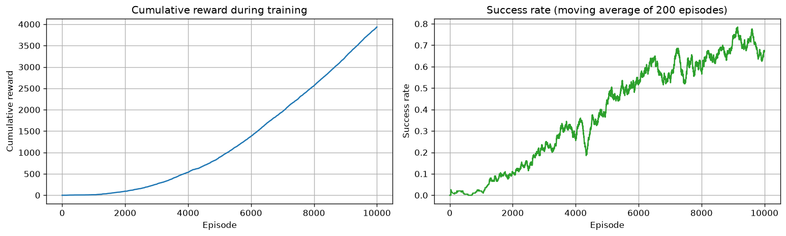
Program 11: Cumulative reward and success rate (FrozenLake)
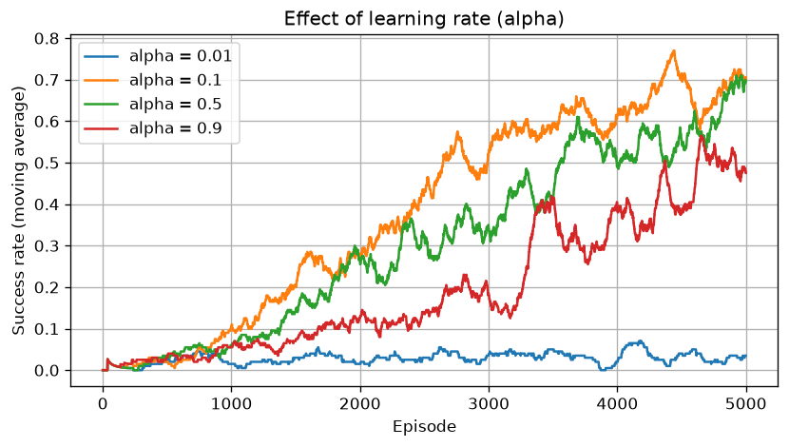
Program 12: Effect of the learning rate
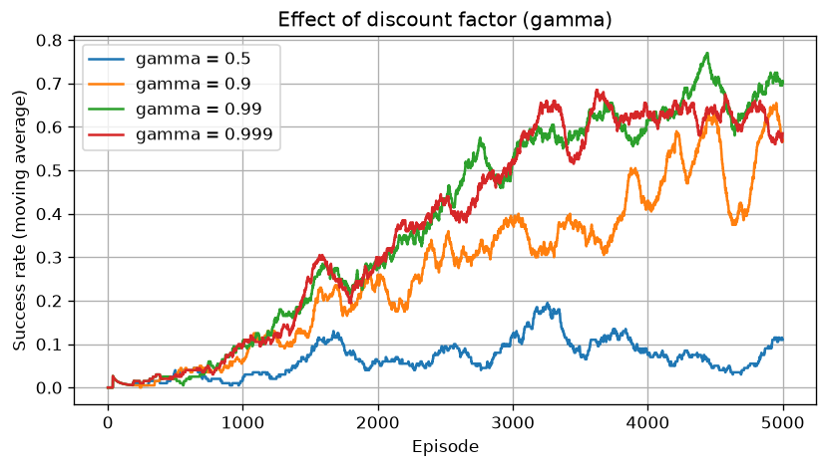
Program 13: Effect of the discount factor
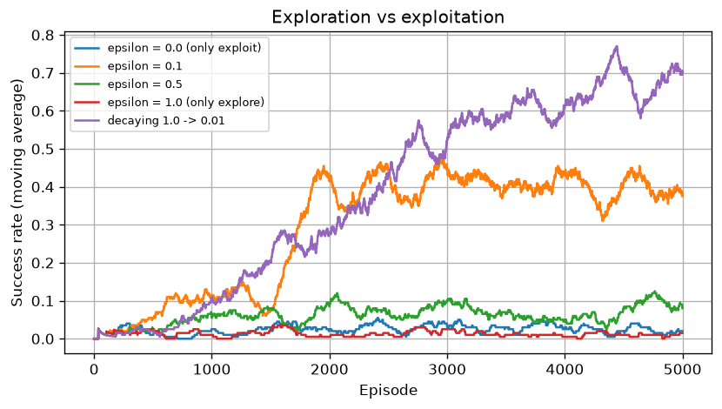
Program 14: Exploration vs exploitation
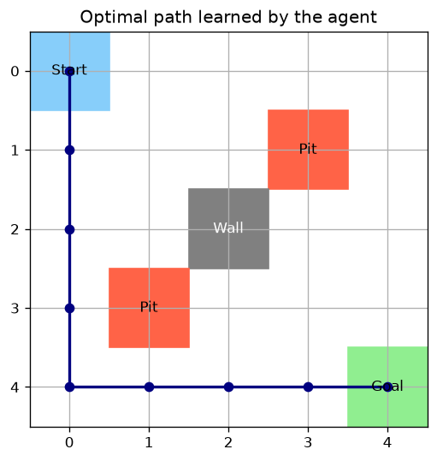
Program 18: Optimal path in Grid World
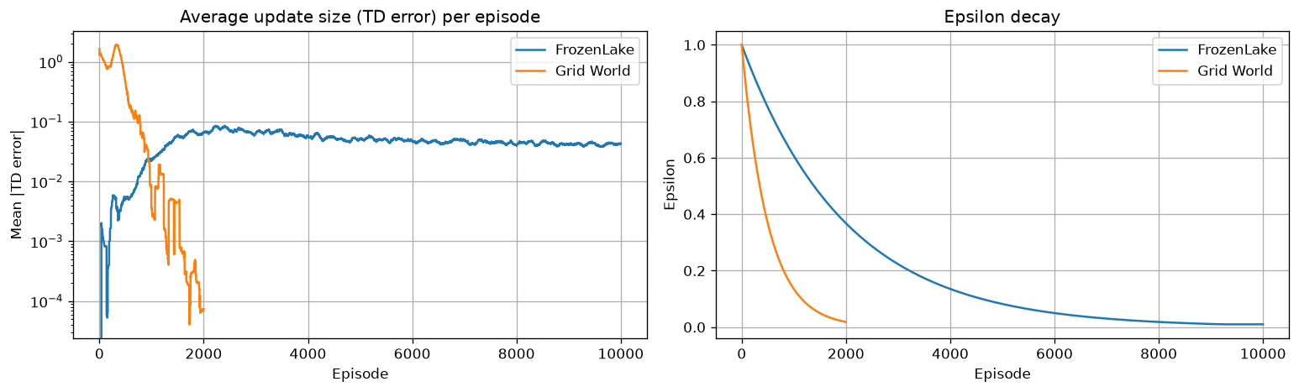
Program 20: Convergence of Q-Learning
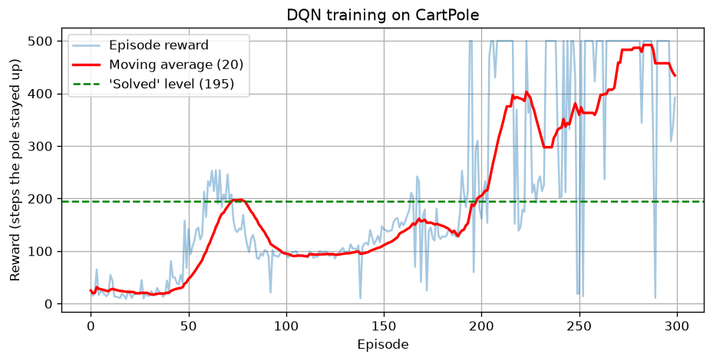
Program 24: DQN rewards during training
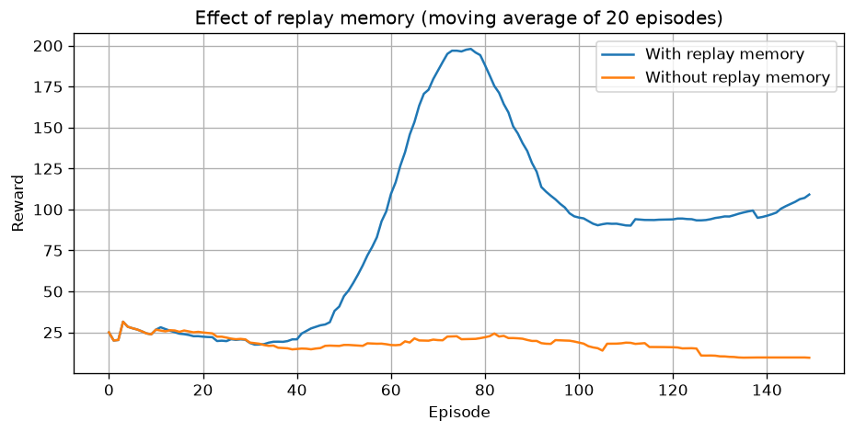
Program 27: Effect of replay memory
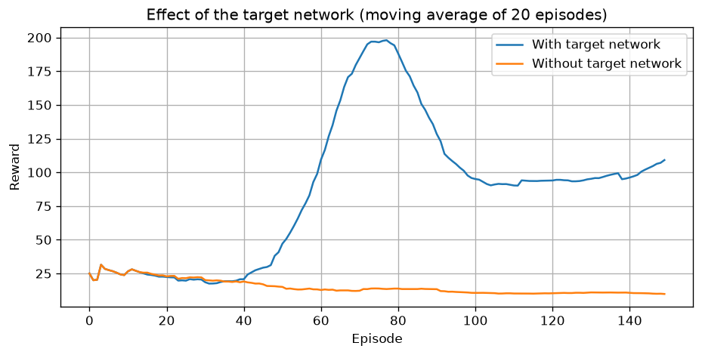
Program 28: Effect of the target network
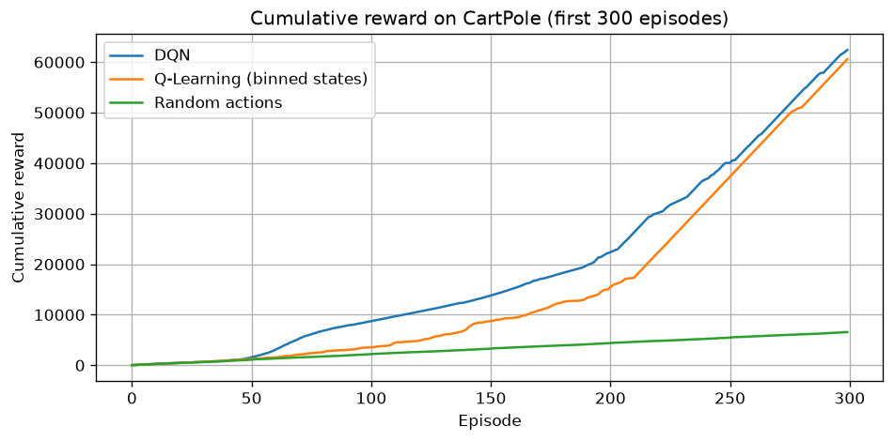
Program 31: Cumulative reward comparison
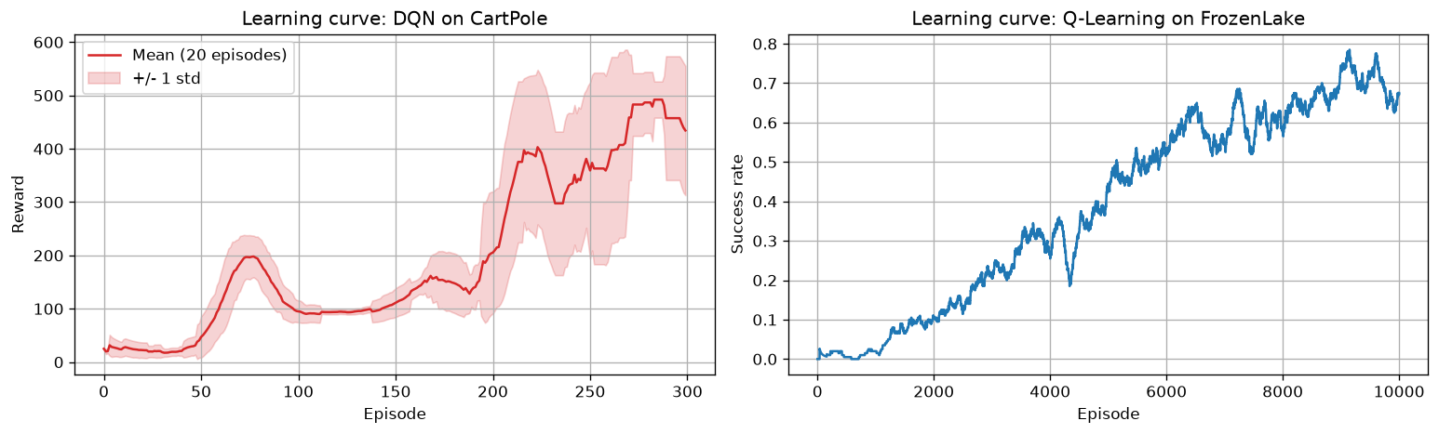
Program 32: Learning curves
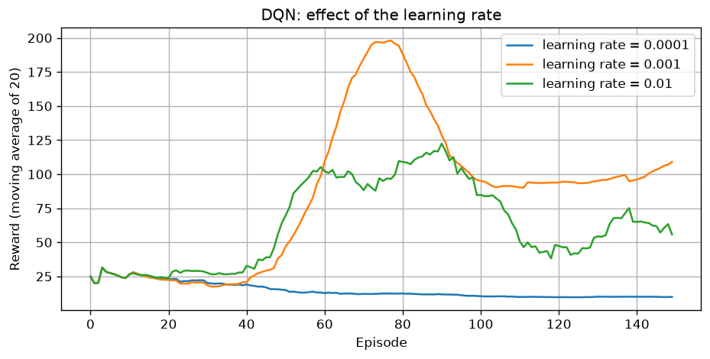
Program 34: DQN learning rate study
ADD YOUR SCREENSHOTS HERE: the Q-table (Program 9), the terminal or notebook output of the main programs, and a screenshot of the code running.

5. Performance Analysis
All numbers below come from my run of the programs.

5.1 Q-Learning
Environment | Episodes | Success rate (greedy) | Avg steps | Training time (s) | Converged at episode
FrozenLake | 10000 | 73.0% | 44.72 | 22.4 | 6255
Grid World | 2000 | 100.0% | 8.0 | 0.76 | 1201

A random agent reached the FrozenLake goal in 2.0% of the episodes.

5.2 Hyperparameter studies (FrozenLake)
Learning rate (alpha):
Learning rate | Training success rate | Greedy success rate
0.01 | 0.028 | 0.048
0.1 | 0.676 | 0.72
0.5 | 0.636 | 0.732
0.9 | 0.494 | 0.0

Discount factor (gamma):
Gamma | Training success rate | Greedy success rate
0.5 | 0.072 | 0.104
0.9 | 0.502 | 0.524
0.99 | 0.676 | 0.72
0.999 | 0.61 | 0.72

Epsilon:
Setting | Training success rate | Greedy success rate
epsilon = 0.0 (only exploit) | 0.024 | 0.028
epsilon = 0.1 | 0.396 | 0.72
epsilon = 0.5 | 0.092 | 0.732
epsilon = 1.0 (only explore) | 0.01 | 0.72
decaying 1.0 -> 0.01 | 0.676 | 0.72

5.3 CartPole: Random vs Q-Learning vs DQN
Method | Episodes | Average reward | Training time (s)
Random actions | - | 21.88 | -
Q-Learning (binned states) | 3000 | 261.35 | 111.83
DQN | 300 | 198.55 | 279.7

5.4 DQN studies
Experiment | Mean reward (last 20 episodes)
With replay memory | 109.1
Without replay memory | 9.5
With target network | 109.1
Without target network | 9.8

DQN learning rate | Mean reward (last 20) | Best episode
0.0001 | 9.9 | 65.0
0.001 | 109.1 | 254.0
0.01 | 55.8 | 281.0

6. Observation
(1) How much better was the trained Q-Learning agent than the random agent? (2) What happened with a very small and a very large learning rate? (3) Why did a low gamma or epsilon = 0 hurt learning? (4) Did DQN reach the 'solved' level of 195? How did training look: smooth or noisy? (5) What changed without replay memory and without the target network?
__________________________________________________________________________________________
__________________________________________________________________________________________
__________________________________________________________________________________________
__________________________________________________________________________________________

7. Conclusion
WRITE 3-4 LINES YOURSELF: what you learned about Q-Learning and DQN, which algorithm suits which kind of problem, and which hyperparameters mattered most. Delete this note when you are done.
__________________________________________________________________________________________
__________________________________________________________________________________________
__________________________________________________________________________________________

