**Assignment 4**

* **Title :** Interface Prototype.
* Problem statement : Design an interface prototype for the selected product/system.(Quotery)
* **Objectives :**
  + To understand the concept of interface prototyping HCI.
  + To design an interface prototype for selected product.
* **Outcomes:**
  + We will be able to understand interface prototyping in HCI.
  + We will be able to design an interface prototype for the selected system.
* **Theory:**

**What is Prototyping?**

In the initial design phase, the proposed design undergoes frequent changes, it is not advisable to even feasible to carry out evaluation with real users. An alternative way to collect feedback on proposed design is to develop and evaluate prototypes. The main purpose of prototyping is to involve the users in testing design ideas and get their feedback in the early stage of development, thus to reduce the time and cost. It provides an efficient and effective way to refine and optimize interfaces through discussion, exploration, testing and iterative revision.

**Why Use it?**

* + Saves money - “Finding and fixing a software problem after delivery is 100 times more expensive than finding and fixing it during the requirements and early design phases.”
  + Brings the design to life
  + Clarifies requirements
  + Supports user involvement and feedback

1. As observers of demonstrations, and/or
2. Through hands-on testing, and/or
3. In extended field trials (beta testing)and/or\
4. As co-designers
5. Identifies problems early - can be used to explore usability issues
6. Improves communication
7. supports exploration of imagined use – the prototype does not have to be able to do everything that the finished product does.

**Different types of Prototyping:**

**Prototyping can be divided into three groups:**

1. Low-fidelity prototyping,
2. Medium-fidelity prototyping and
3. High-fidelity prototyping

**Low-fidelity prototyping:**

Low-fidelity prototypes are quickly constructed to depict concepts, design alternatives, and screen layouts, rather than to model the user interaction with a system. Low-fidelity prototypes provide limited or no functionality. They are intended to demonstrate the general look and the feel of the interface, but not the detail how the application operates.

* + Sketches - Sketching techniques, a kind of visual brainstorming, can be useful for exploring all kinds of design ideas. After producing initial sketches the best ideas can be further developed by constructing cardboard representations of the design
  + Storyboard - Storyboard is a graphical depiction of the outward appearance of the intended system without accompanying system functionality. Storyboard provides snapshots of the interface at particular points in the interaction so that the users can determine quickly if the design is heading in the right direction.
  + PICTIVEP - ICTIVE stands for Plastic Interface for Collaborative Technology Initiatives through Video Exploration. It was developed at Bell Communications Research (Bellcore) in 1990 within the context of participatory design. PICTIVE insures that users have early exposure to the target implementation technology. The PICTIVE technique provides a fine-grained, dynamic paper and pencil concretization mock- up of what the system will eventually look like and how it will behave. The components are literally made of colored plastic. Medium-fidelity prototyping: Medium-fidelity prototypes simulate or animate some but not all features of the intended system. There are three approaches to limit prototype functionality.
  + Horizontal prototyping - Horizontal prototyping reduces the level of functionality so that the result is a surface layer that includes the entire user interface to a full-featured system without underlying functionality.
  + Vertical prototyping - Vertical prototyping cuts down on the number of features, so that the result is a narrow system that includes in-depth functionality, buy only for a few selected features.
  + Scenario - Scenario reduces both the number of features and the level of functionality. a user can use a specific set of computer facilities to achieve a specific outcome under specified circumstances. Scenarios can be easy and cheap to build.

Hi fidelity prototyping - High-fidelity prototypes are fully interactive, simulating much of the functionality in the final product. Users can operate on the prototype, or even perform some real tasks with it. High- fidelity prototypes are not as quick and easy to create as low-fidelity prototypes, but they faithfully represent the interface to be implemented in the product.

* User interface prototyping
* It is an iterative development technique in which users are actively involved in making up of UI of system.
* Prototypes have several purposes :
* As an analytical artefact that enables you to explore the problem space with stakeholder.
* A potential foundation from where to continue developing the system.

Performance Needs

Build Prototype

Evaluate Prototype

continue?

finished

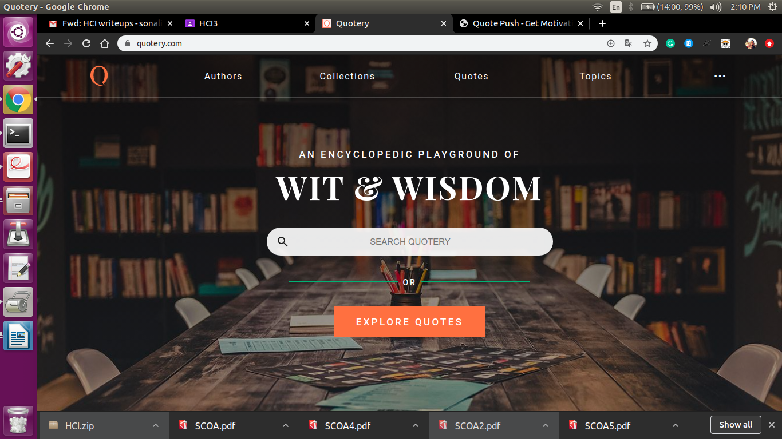

This is the basic homepage of a Quotery website.

There are buttons to perform actions such as like Authors, collection, quotes,topics.

You can enter your favourite topic for the quotes or blog.

* **Conclusion :** User Interface has been designed for the selected product Quotery.