/\* Online Assessment on Java, Selenium, Cucumber \*/

Task 1

● Please try to configure Chrome Browser or firefox browser and navigate to

https://datatables.net/

● Select 50 entries per page using the drop down. Now you will get 2 pages.

● Get the list of employee name in the page 1 and page 2, whose age is greater than or equal

to 50 and salary is greater than or equal to $200,000

● Print the name in the console.

Solution for Task 1:

1. I have downloaded the jar file for Selenium: selenium-server-standalone-3.14.0
2. I have downloaded the drive for Chrome browser: chromedriver.exe

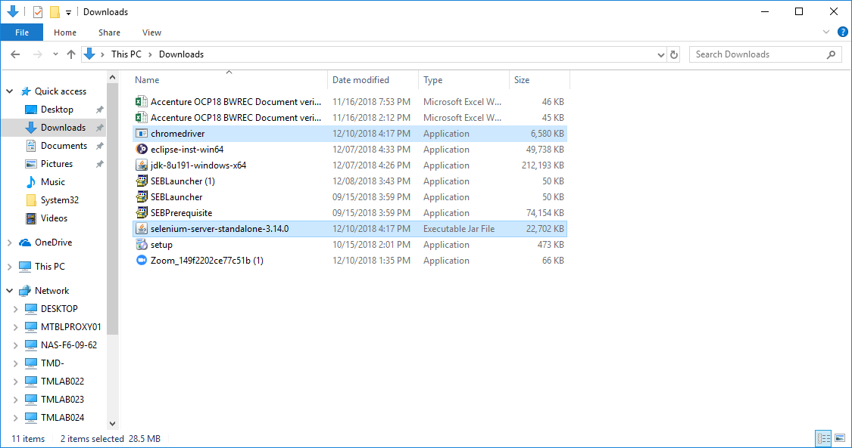

I have configured the external jar file on Eclipse and added the Chrome drive on the project under folder ‘drivers’

1. Right click on the project > Build Path > Configure Build Path
2. Go to tab Libraries
3. Click on button ‘Add External JARs..’
4. Select the path location where Selenium jar file is saved.
5. Click Apply and Close

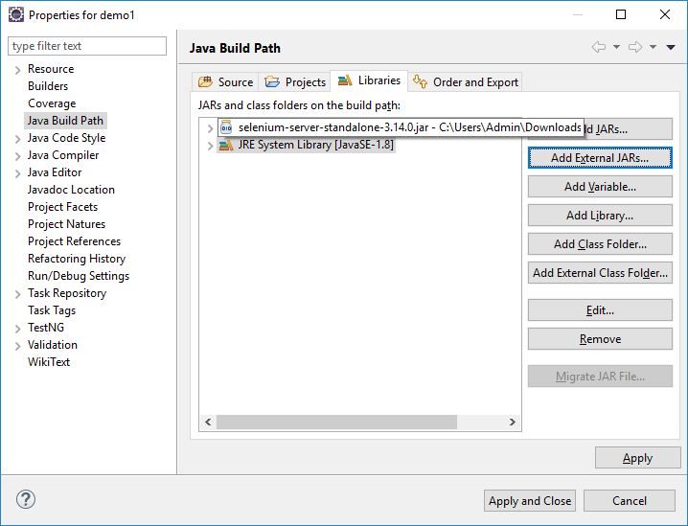

Added chromedriver.exe under folder drivers. While executing the program, below is the error message:

Exception in thread "main" java.lang.IllegalStateException: The path to the driver executable must be set by the webdriver.chrome.driver system property; for more information, see https://github.com/SeleniumHQ/selenium/wiki/ChromeDriver. The latest version can be downloaded from http://chromedriver.storage.googleapis.com/index.html

at com.google.common.base.Preconditions.checkState(Preconditions.java:847)

at org.openqa.selenium.remote.service.DriverService.findExecutable(DriverService.java:125)

at org.openqa.selenium.chrome.ChromeDriverService.access$000(ChromeDriverService.java:35)

at org.openqa.selenium.chrome.ChromeDriverService$Builder.findDefaultExecutable(ChromeDriverService.java:156)

at org.openqa.selenium.remote.service.DriverService$Builder.build(DriverService.java:346)

at org.openqa.selenium.chrome.ChromeDriverService.createDefaultService(ChromeDriverService.java:91)

at org.openqa.selenium.chrome.ChromeDriver.<init>(ChromeDriver.java:123)

at demo1.Program1.main(Program1.java:11)

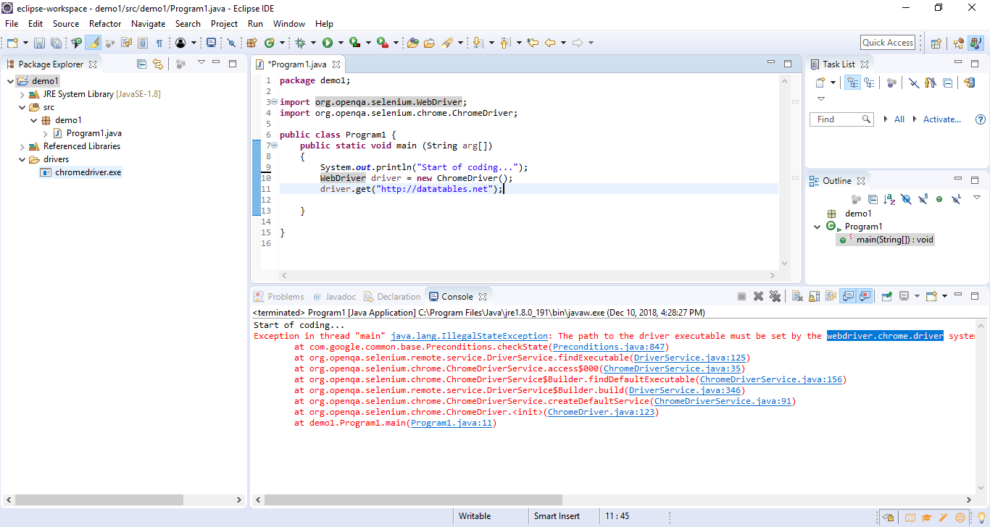

In order to resolve the error, I have added System.setProperty to recognize the chrome driver. The browser is initiated without any error message:

