Session1 > Assignment1

1. Write a program to print the sum of two numbers without using + operator. Other operators can be used.

Below is the JAVA program: (same java file also attached)

//To print the sum of two numbers without using + operator.

import java.util.Scanner;

class Session1Prg1

{

public static void main(String a[])

{

Scanner sc = new Scanner(System.in);

System.out.println("Enter first number: ");

int x = sc.nextInt();

System.out.println("Enter second number: ");

int y = sc.nextInt();

while(y != 0)

{

int carry = x & y;

x = x ^ y;

y = carry << 1;

}

System.out.println("The sum of these numbers = " +x);

}

}

OUTPUT of the program:

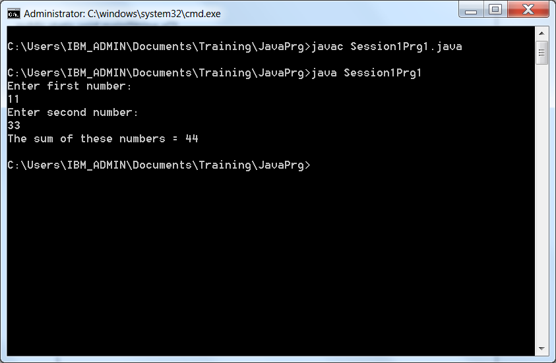

2. Write a program to print the result of the following expressions provided the integer variable a is 20 and b is 10.

int b = a-- - --a;

int c = a--;

int d = a>>2;

int e = a&b;

Below is the JAVA program: (same java file also attached)

//To print the result of the expression

class Session1Prg2

{

public static void main(String s[])

{

int a = 20;

int b = 10;

int c = a--;

int d = a >> 2;

int e = a & b;

b = a-- - --a;

System.out.println("The value of expression 'b' is: " +b);

System.out.println("The value of expression 'c' is: " +c);

System.out.println("The value of expression 'd' is: " +d);

System.out.println("The value of expression 'e' is: " +e);

}

}

/\*

int b = a-- - --a;

int c = a--;

int d = a>>2;

int e = a&b;

\*/

Output Result:

