Requirements/Design Document for

**Analysis of Providers through Yearly Medicare Beneficiary Coverage (2012 – 2015)**



**Team Name:** Data Squad

**Team Number:** 8

**Team Members:**

Rajendra kumar Rajkumar (1405755), Arjun Ashwin Bhalani (1498951), Aniruddha Joshi (1445393)

# Version History:

|  |  |  |  |
| --- | --- | --- | --- |
| Date | Who | What | Version |
| 04/08 | All members | Created Initial draft of the requirements/design document | 0.1 |
| 04/24 | All members | Modified the following sections:   1. Dataflow Process (Elaboration of Individual steps in the flow) 2. Requirement to be addressed by data warehouse (added geography wise statistics and variation in financial filed values over years) 3. Staging tables: Data types of fields were changed which supported data transfer from CSV to database 4. Mapping between Staging table and EDW Integration schema: Modified fields based on their presence in final relational model 5. EDW Integration Schema: Added the final relational model subject to 3NF 6. Data Mart – Added the final dimensional model | 0.2 |

# Objective:

* To brief about the requirements to be fulfilled by thedata warehouse housing Medicare provider beneficiary and monetary data collected from Centers for Medicare & Medicaid Services (CMS) website using Kimball architecture thereby utilizing update-driven approach.

This is intended to have Professor(Client), Team Mates (Data Engineers) as target audience

* To explain the design to be followed for below parts within Datawarehouse:
  + Data flow from Data sources (SOR) till the destination data mart
  + Relational model subject to 3-NF normalization for EDW Integration schema
  + Dimension model for Destination Data mart

This is intended to have Professor(Architect), Team Mates (Data Engineers) as target audience

# Data Description:

1. Dataset containing the provider information, who are legally eligible to order and refer in the Medicare program and who possess enrolment record in Provider Enrolment and Chain Ownership System (PECOS). This data set will act as lookup to table to filter only eligible providers, who can order and refer.

<https://data.cms.gov/Medicare-Enrollment/Order-and-Referring/qcn7-gc3g>

1. Dataset containing the provider information who are actively approved to bill Medicare and who possess enrolment record in Provider Enrolment and Chain Ownership System (PECOS). This data set will act as lookup to table to filter only approved providers.

<https://data.cms.gov/public-provider-enrollment>

1. One dataset category (containing individual datasets from year 2012 to 2017) totalling to 6 datasets containing information about the provider basic details, beneficiary count, services offered to beneficiaries, special service indicators, specific beneficiary information based on factors like age, affected disease and race and monetary information comprising of Amount charged by Provider, Amount allowed by Medicare and Final Amount paid by Medicare.

<https://data.cms.gov/utilization-and-payment/related-data>

# Dataflow Process:

Systems of Record (SOR)

Data Mart

Business Intelligence(Visualization)

EDW Integration Schema

EDW Staging

Order and Referring Dataset (1)

Transformation and Loading

Transformation and Loading,

Extraction and Loading

Public Provider enrolment Dataset (1)

Data stored as archives

Utilization and Payment Datasets (4) – 2012 to 2015

Archiving

The process hierarchy will be as follows:

1. SOR to Staging Area: Data from two normal datasets (Order and Referring Dataset, Public Provider enrolment Dataset) and four yearly datasets (Utilization and Payment Dataset) to be loaded to EDW staging area (3 tables respectively).
2. Staging Area to EDW Integration Schema: Data from Staging area (3 tables) to be subject to the below operations:
   1. Data Cleaning: Removal of junk characters
   2. Data Transformation:
      1. Setting of expected datatypes to column variables
      2. Performing ‘Enrolment’ and ‘Eligibility’ look up on the ‘Provider’ from yearly data
      3. Transforming ‘Percentage’ columns associated to beneficiary-disease count to ‘Whole number’ columns
      4. Dropping all calculatable fields and unnecessary columns
      5. All the unmatching records from the above processes will be stored in error table
      6. Forming separate tables for ‘Address’, ‘Name’, ‘City’, ‘ProviderType’ by splitting data from Main table, so that Third normal is ensured
3. Archiving data in Staging table: Once the data from staging table is moved to EDW Integration schema, the data in three tables to be archived in respective tables along with load date.
4. EDW Integration Schema to Data Mart:
   1. Copy required tables from relational model database to a new database, where dimensional model is to be maintained
   2. Merge ‘Address’ ad ‘City’ tables from relational model so that they can appear as a single ‘Address’ dimension.
5. Data Mart to Business Intelligence (Tableau):
   1. Database (Dimensional model) to be used as data source for Tableau
   2. Different forms of visualization involving facts and dimensions to be exhibited

# Requirement to be addressed by the data warehouse:

The built data warehouse will be able to answer the below sample questions, when queried through SQL Server:

* Top eligible and approved Providers per year
  1. For a particular age group
  2. For a particular disease type
  3. Based on number of services offered
  4. Based on particular location (City, State and Zip code)
* State wise break-up of number of medical/drug services offered
* Variation of Medicare Allowed Amount/Submitted Charge Amount/Payment amount across States for different years

# Source Definition:

## Dataset 1: Order and Referring

|  |  |  |  |  |
| --- | --- | --- | --- | --- |
| **ID** | **COLUMN** | **DATA TYPE** | **DEFINITION** | **DATA SIZE** |
| 1 | NPI | Number | The national provider identification number | 4 Bytes |
| 2 | LAST NAME | Text | Last name of Provider | 4 bytes + 50 bytes (characters) |
| 3 | FIRST NAME | Text | First name of Provider | 4 bytes + 50 bytes (characters) |
| 4 | PART B | Text | PART B (MEDICAL INSURANCE) claim status ('Y' = YES, 'N' = NO) | 4 bytes + 50 bytes (characters) |
| 5 | DME | Text | Durable medical equipment(DME) claim status('Y' = YES, 'N' = NO) | 4 bytes + 50 bytes (characters) |
| 6 | HHA | Text | Home health agency(HHA) claim status('Y' = YES, 'N' = NO) | 4 bytes + 50 bytes (characters) |
| 7 | PMD | Text | Power mobility device(PMD) claim status('Y' = YES, 'N' = NO) | 4 bytes + 50 bytes (characters) |

## Dataset 2: Base Provider

|  |  |  |  |  |
| --- | --- | --- | --- | --- |
| **ID** | **COLUMN** | **DATA TYPE** | **DEFINITION** | **DATA SIZE** |
| 1 | NPI | Text | The national provider identification number | 4 bytes + 50 bytes (characters) |
| 2 | PECOS_ASCT_CNTL_ID | Text | Unique number assigned to the provider by PECOS | 4 bytes + 50 bytes (characters) |
| 3 | ENRLMNT_ID | Text | Enrollment ID assigned to the provider by PECOS for provider application where the first charcter will be 'I' for individual or 'O' for an organization | 4 bytes + 10 bytes (characters) |
| 4 | PROVIDER_TYPE_CD | Text | Derived field combining PECOS_ASCT_CNTL_ID and ENRLMNT_ID | 4 bytes + 50 bytes (characters) |
| 5 | PROVIDER_TYPE_DESC | Text | Description of Provider derived from Provider ID and Enrollmen type | 4 bytes + 100 bytes (characters) |
| 6 | STATE_CD | Text | State Code | 4 bytes + 10 bytes (characters) |
| 7 | FIRST_NAME | Text | First name of Provider(Filled only if ENRLMNT_ID = I) | 4 bytes + 50 bytes (characters) |
| 8 | MDL_NAME | Text | Middle name of Provider(Filled only if ENRLMNT_ID = I) | 4 bytes + 50 bytes (characters) |
| 9 | LAST_NAME | Text | Last name of Provider(Filled only if ENRLMNT_ID = I) | 4 bytes + 50 bytes (characters) |
| 10 | ORG_NAME | Text | Name of Organization (Filled only if ENRLMNT_ID = O) | 4 bytes + 50 bytes (characters) |
| 11 | GNDR_SW | Text | Gender of the PROVIDER (Missing = '9' , FEMALE = 'F' , MALE = 'M', NOT FILLED FOR ORGANIZATION) | 4 bytes + 10 bytes (characters) |

## Dataset 3: Medicare Physician and Other Supplier Data CY 2012TO 2015

|  |  |  |  |  |
| --- | --- | --- | --- | --- |
| **ID** | **COLUMN** | **DATA TYPE** | **DEFINITION** | **DATA SIZE** |
| 1 | National Provider Identifier | Text | The national provider identification number | 4 bytes + 50 bytes (characters) |
| 2 | Last Name/Organization Name of the Provider | Text | Last name of Provider(Filled depending upon ENRLMNT_ID = 'I' or 'O') | 4 bytes + 50 bytes (characters) |
| 3 | First Name of the Provider | Text | First name of Provider(Filled only if ENRLMNT_ID = I) | 4 bytes + 50 bytes (characters) |
| 4 | Middle Initial of the Provider | Text | Middle name of Provider(Filled only if ENRLMNT_ID = I) | 4 bytes + 50 bytes (characters) |
| 5 | Credentials of the Provider | Text | I' for individual or 'O' for an organization based on registration status in NPPES | 4 bytes + 50 bytes (characters) |
| 6 | Gender of the Provider | Text | Gender of the PROVIDER (FEMALE = 'F' , MALE = 'M', NOT FILLED FOR ORGANIZATION) | 4 bytes + 50 bytes (characters) |
| 7 | Entity Type of the Provider | Text | Based on the registration in NPPES, entry will be 'I' for individual or 'O' for an organization | 4 bytes + 50 bytes (characters) |
| 8 | Street Address 1 of the Provider | Text | First line of street address for provider as registered in NPPES | 4 bytes + 100 bytes (characters) |
| 9 | Street Address 2 of the Provider | Text | Second line of street address for provider as registered in NPPES | 4 bytes + 100 bytes (characters) |
| 10 | City of the Provider | Text | City for provider as registered in NPPES | 4 bytes + 20 bytes (characters) |
| 11 | Zip Code of the Provider | Text | 4 bytes + 100 bytes (characters) | 4 bytes + 20 bytes (characters) |
| 12 | Provider RUCA | Text | Rural-Urban commuting code for provider. RUCA defines rural or urban status and the relationships between them using census data and work commute information obtained for Depatment of Agriculture (USDA) | 4 bytes + 10 bytes (characters) |
| 13 | State Code of the Provider | Text | State code for provider ('XX' = 'Unknown' 'AA' = 'Armed Forces Central/South America' 'AE' = 'Armed Forces Europe' 'AP' = 'Armed Forces Pacific' 'AS' = 'American Samoa' 'GU' = 'Guam' 'MP' = 'North Mariana Islands' 'PR' = 'Puerto Rico' 'VI' = 'Virgin Islands' 'ZZ' = 'Foreign Country') | 4 bytes + 10 bytes (characters) |
| 14 | Country Code of the Provider | Text | 2 character code of country | 4 bytes + 10 bytes (characters) |
| 15 | Provider Type of the Provider | Text | Provider type code based on speciality | 4 bytes + 50 bytes (characters) |
| 16 | Medicare Participation Indicator | Text | Status for wether provider accpets allowed medicare amount('Y' if there has been at least on instance of the same happening previously) | 4 bytes + 10 bytes (characters) |
| 17 | Number of HCPCS | Number | Identifies number of Healthcare Common Procedure Coding Services(HCPCS) provided by the provider | 4 Bytes |
| 18 | Number of Services | Number | Total number of services provided by the provider | 4 Bytes |
| 19 | Number of Medicare Beneficiaries | Number | Total number of Medicare benificiaries receiving the services | 4 Bytes |
| 20 | Total Submitted Charge Amount | Number | Total charges submitted by provider for all services | 4 Bytes |
| 21 | Total Medicare Allowed Amount | Number | Total allowed amount by medicare to the provider for their services | 4 Bytes |
| 22 | Total Medicare Payment Amount | Number | Total amount paid by medicare to the provider for their services | 4 Bytes |
| 23 | Total Medicare Standardized Payment Amount | Number | Total amount paid by medicare to the provider for their services after standardization which removes geographic differences in payments for services | 4 Bytes |
| 24 | Drug Suppress Indicator | Text | Status if payments are associated with HCPS codes for Average Drug Price have been suppressed | 4 Bytes + 10 bytes(characters) |
| 25 | Number of HCPCS Associated With Drug Services | Number | Identifies the Number of HCPCS Associated With Drug Services | 4 Bytes |
| 26 | Number of Drug Services | Number | Identifies the total number of Drug services | 4 Bytes |
| 27 | Number of Medicare Beneficiaries With Drug Services | Number | Identifies the number of benificiaries who received Drug services | 4 Bytes |
| 28 | Total Drug Submitted Charge Amount | Number | Total charges submitted by provider for Drug services | 4 Bytes |
| 29 | Total Drug Medicare Allowed Amount | Number | Total allowed amount by medicare to the provider for Drug services | 4 Bytes |
| 30 | Total Drug Medicare Payment Amount | Number | Total amount paid by medicare to the provider for Drug services | 4 Bytes |
| 31 | Total Drug Medicare Standardized Payment Amount | Number | Total amount paid by medicare to the provider for Drug services after standardization which removes geographic differences in payments for services | 4 Bytes |
| 32 | Medical Suppress Indicator | Text | Status if payments are associated with HCPS codes for medical services have been suppressed | 4 Bytes + 10 bytes(characters) |
| 33 | Number of HCPCS Associated With Medical Services | Number | Identifies the Number of HCPCS Associated With Medical Services | 4 Bytes |
| 34 | Number of Medical Services | Number | Identifies the total number of Medical services | 4 Bytes |
| 35 | Number of Medicare Beneficiaries With Medical Services | Number | Identifies the number of benificiaries who received Medical services | 4 Bytes |
| 36 | Total Medical Submitted Charge Amount | Number | Total charges submitted by provider for Medical services | 4 Bytes |
| 37 | Total Medical Medicare Allowed Amount | Number | Total allowed amount by medicare to the provider for Medical services | 4 Bytes |
| 38 | Total Medical Medicare Payment Amount | Number | Total amount paid by medicare to the provider for Medical services | 4 Bytes |
| 39 | Total Medical Medicare Standardized Payment Amount | Number | Total amount paid by medicare to the provider for Medical services after standardization which removes geographic differences in payments for services | 4 Bytes |
| 40 | Average Age of Beneficiaries | Number | Average age of benificiary served by the provider | 4 Bytes |
| 41 | Number of Beneficiaries Age Less 65 | Number | Number of benificiaries aged less than 65 | 4 Bytes |
| 42 | Number of Beneficiaries Age 65 to 74 | Number | Number of benificiaries aged between 65 to 74 | 4 Bytes |
| 43 | Number of Beneficiaries Age 75 to 84 | Number | Number of benificiaries aged between 75 to 84 | 4 Bytes |
| 44 | Number of Beneficiaries Age Greater 84 | Number | Number of benificiaries aged greater than 84 | 4 Bytes |
| 45 | Number of Female Beneficiaries | Number | Number of Female benificiaries | 4 Bytes |
| 46 | Number of Male Beneficiaries | Number | Number of Male beneficiaries | 4 Bytes |
| 47 | Number of Non-Hispanic White Beneficiaries | Number | Number of Non-Hispanic White beneficiaries | 4 Bytes |
| 48 | Number of Black or African American Beneficiaries | Number | Number of African American beneficiaries | 4 Bytes |
| 49 | Number of Asian Pacific Islander Beneficiaries | Number | Number of Asian Pacific Islander Beneficiaries | 4 Bytes |
| 50 | Number of Hispanic Beneficiaries | Number | Number of Hispanic Beneficiaries | 4 Bytes |
| 51 | Number of American Indian/Alaska Native Beneficiaries | Number | Number of American Indian/Alaska Native Beneficiaries | 4 Bytes |
| 52 | Number of Beneficiaries With Race Not Elsewhere Classified | Number | Number of Beneficiaries With Race Not Elsewhere Classified | 4 Bytes |
| 53 | Number of Beneficiaries With Medicare Only Entitlement | Number | Number of Beneficiaries With Medicare Only Entitlement | 4 Bytes |
| 54 | Number of Beneficiaries With Medicare & Medicaid Entitlement | Number | Number of Beneficiaries With Medicare & Medicaid Entitlement | 4 Bytes |
| 55 | Percent (%) of Beneficiaries Identified With Atrial Fibrillation | Number | Percent (%) of Beneficiaries Identified With Atrial Fibrillation | 4 Bytes |
| 56 | Percent (%) of Beneficiaries Identified With Alzheimer’s Disease or Dementia | Number | Percent (%) of Beneficiaries Identified With Alzheimer’s Disease or Dementia | 4 Bytes |
| 57 | Percent (%) of Beneficiaries Identified With Asthma | Number | Percent (%) of Beneficiaries Identified With Asthma | 4 Bytes |
| 58 | Percent (%) of Beneficiaries Identified With Cancer | Number | Percent (%) of Beneficiaries Identified With Cancer | 4 Bytes |
| 59 | Percent (%) of Beneficiaries Identified With Heart Failure | Number | Percent (%) of Beneficiaries Identified With Heart Failure | 4 Bytes |
| 60 | Percent (%) of Beneficiaries Identified With Chronic Kidney Disease | Number | Percent (%) of Beneficiaries Identified With Chronic Kidney Disease | 4 Bytes |
| 61 | Percent (%) of Beneficiaries Identified With Chronic Obstructive Pulmonary Disease | Number | Percent (%) of Beneficiaries Identified With Chronic Obstructive Pulmonary Disease | 4 Bytes |
| 62 | Percent (%) of Beneficiaries Identified With Depression | Number | Percent (%) of Beneficiaries Identified With Depression | 4 Bytes |
| 63 | Percent (%) of Beneficiaries Identified With Diabetes | Number | Percent (%) of Beneficiaries Identified With Diabetes | 4 Bytes |
| 64 | Percent (%) of Beneficiaries Identified With Hyperlipidemia | Number | Percent (%) of Beneficiaries Identified With Hyperlipidemia | 4 Bytes |
| 65 | Percent (%) of Beneficiaries Identified With Hypertension | Number | Percent (%) of Beneficiaries Identified With Hypertension | 4 Bytes |
| 66 | Percent (%) of Beneficiaries Identified With Ischemic Heart Disease | Number | Percent (%) of Beneficiaries Identified With Ischemic Heart Disease | 4 Bytes |
| 67 | Percent (%) of Beneficiaries Identified With Osteoporosis | Number | Percent (%) of Beneficiaries Identified With Osteoporosis | 4 Bytes |
| 68 | Percent (%) of Beneficiaries Identified With Rheumatoid Arthritis / Osteoarthritis | Number | Percent (%) of Beneficiaries Identified With Rheumatoid Arthritis / Osteoarthritis | 4 Bytes |
| 69 | Percent (%) of Beneficiaries Identified With Schizophrenia / Other Psychotic Disorders | Number | Percent (%) of Beneficiaries Identified With Schizophrenia / Other Psychotic Disorders | 4 Bytes |
| 70 | Percent (%) of Beneficiaries Identified With Stroke | Number | Percent (%) of Beneficiaries Identified With Stroke | 4 Bytes |
| 71 | Average HCC Risk Score of Beneficiaries | Number | Average HCC Risk Score of Beneficiaries | 4 Bytes |

# Staging Table Definition:

## Staging Table (STG_OrderAndReferring) for ‘Order and Referring’ dataset

|  |  |  |
| --- | --- | --- |
| **ID** | **COLUMN** | **DATA TYPE** |
| 1 | NPI | varchar(50) |
| 2 | LAST NAME | varchar(50) |
| 3 | FIRST NAME | varchar(50) |
| 4 | PART B | varchar(50) |
| 5 | DME | varchar(50) |
| 6 | HHA | varchar(50) |
| 7 | PMD | varchar(50) |

## Staging Table (STG_BaseProviderEnrolment) for ‘Base Provider’ dataset

|  |  |  |
| --- | --- | --- |
| **ID** | **COLUMN** | **DATA TYPE** |
| 1 | NPI | varchar(50) |
| 2 | PECOS_ASCT_CNTL_ID | varchar(50) |
| 3 | ENRLMNT_ID | varchar(50) |
| 4 | PROVIDER_TYPE_CD | varchar(50) |
| 5 | PROVIDER_TYPE_DESC | varchar(255) |
| 6 | STATE_CD | varchar(50) |
| 7 | FIRST_NAME | varchar(50) |
| 8 | MDL_NAME | varchar(50) |
| 9 | LAST_NAME | varchar(50) |
| 10 | ORG_NAME | varchar(255) |
| 11 | GNDR_SW | varchar(50) |

## Staging table ‘STG_MedicarePhyscianAndSupplier’ for ‘Medicare Physician and Other Supplier Data CY 2012 TO 2015’ dataset

|  |  |  |
| --- | --- | --- |
| **ID** | **COLUMN** | **DATA TYPE** |
| 1 | Year | varchar(max) |
| 2 | NPI | varchar(max) |
| 3 | Last Name/Organization Name of the Provider | varchar(max) |
| 4 | First Name of the Provider | varchar(max) |
| 5 | Middle Initial of the Provider | varchar(max) |
| 6 | Credentials of the Provider | varchar(max) |
| 7 | Gender of the Provider | varchar(max) |
| 8 | Entity Type of the Provider | varchar(max) |
| 9 | Street Address 1 of the Provider | varchar(max) |
| 10 | Street Address 2 of the Provider | varchar(max) |
| 11 | City of the Provider | varchar(max) |
| 12 | Zip Code of the Provider | varchar(max) |
| 13 | State Code of the Provider | varchar(max) |
| 14 | Country Code of the Provider | varchar(max) |
| 15 | Provider Type of the Provider | varchar(max) |
| 16 | Medicare Participation Indicator | varchar(max) |
| 17 | Number of HCPCS | varchar(max) |
| 18 | Number of Services | varchar(max) |
| 19 | Number of Medicare Beneficiaries | varchar(max) |
| 20 | Total Submitted Charge Amount | varchar(max) |
| 21 | Total Medicare Allowed Amount | varchar(max) |
| 22 | Total Medicare Payment Amount | varchar(max) |
| 23 | Drug Suppress Indicator | varchar(max) |
| 24 | Number of HCPCS Associated With Drug Services | varchar(max) |
| 25 | Number of Drug Services | varchar(max) |
| 26 | Number of Medicare Beneficiaries With Drug Services | varchar(max) |
| 27 | Total Drug Submitted Charge Amount | varchar(max) |
| 29 | Total Drug Medicare Allowed Amount | varchar(max) |
| 30 | Total Drug Medicare Payment Amount | varchar(max) |
| 31 | Medical Suppress Indicator | varchar(max) |
| 32 | Number of HCPCS Associated With Medical Services | varchar(max) |
| 33 | Number of Medical Services | varchar(max) |
| 34 | Number of Medicare Beneficiaries With Medical Services | varchar(max) |
| 35 | Total Medical Submitted Charge Amount | varchar(max) |
| 36 | Total Medical Medicare Allowed Amount | varchar(max) |
| 37 | Total Medical Medicare Payment Amount | varchar(max) |
| 38 | Average Age of Beneficiaries | varchar(max) |
| 39 | Number of Beneficiaries Age 65 to 74 | varchar(max) |
| 40 | Number of Beneficiaries Age 75 to 84 | varchar(max) |
| 41 | Number of Beneficiaries Age Greater 84 | varchar(max) |
| 43 | Number of Female Beneficiaries | varchar(max) |
| 44 | Number of Black or African American Beneficiaries | varchar(max) |
| 45 | Number of Asian Pacific Islander Beneficiaries | varchar(max) |
| 46 | Number of Hispanic Beneficiaries | varchar(max) |
| 47 | Number of American Indian/Alaska Native Beneficiaries | varchar(max) |
| 48 | Number of Beneficiaries With Race Not Elsewhere Classified | varchar(max) |
| 49 | Number of Beneficiaries With Medicare Only Entitlement | varchar(max) |
| 50 | Number of Beneficiaries With Medicare & Medicaid Entitlement | varchar(max) |
| 51 | Percent (%) of Beneficiaries Identified With Atrial Fibrillation | varchar(max) |
| 52 | Percent (%) of Beneficiaries Identified With Asthma | varchar(max) |
| 53 | Percent (%) of Beneficiaries Identified With Cancer | varchar(max) |
| 54 | Percent (%) of Beneficiaries Identified With Heart Failure | varchar(max) |
| 55 | Percent (%) of Beneficiaries Identified With Chronic Kidney Disease | varchar(max) |
| 56 | Percent (%) of Beneficiaries Identified With Chronic Obstructive Pulmonary Disease | varchar(max) |
| 57 | Percent (%) of Beneficiaries Identified With Depression | varchar(max) |
| 58 | Percent (%) of Beneficiaries Identified With Diabetes | varchar(max) |
| 59 | Percent (%) of Beneficiaries Identified With Hyperlipidemia | varchar(max) |
| 60 | Percent (%) of Beneficiaries Identified With Hypertension | varchar(max) |
| 61 | Percent (%) of Beneficiaries Identified With Ischemic Heart Disease | varchar(max) |
| 62 | Percent (%) of Beneficiaries Identified With Osteoporosis | varchar(max) |
| 63 | Percent (%) of Beneficiaries Identified With Rheumatoid Arthritis / Osteoarthritis | varchar(max) |
| 64 | Percent (%) of Beneficiaries Identified With Schizophrenia / Other Psychotic Disorders | varchar(max) |
| 65 | Percent (%) of Beneficiaries Identified With Stroke | varchar(max) |
| 66 | Number of Beneficiaries Age less than 65 | varchar(max) |
| 67 | Number of Male Beneficiaries | varchar(max) |
| 68 | Number of Non-Hispanic White Beneficiaries | varchar(max) |
| 69 | Percent (%) of Beneficiaries Identified With Alzheimer’s Disease or Dementia | varchar(max) |
| 70 | Year | nvarchar(4) |

# Mapping between Staging table and tables in EDW Integration schema:

|  |  |  |  |  |
| --- | --- | --- | --- | --- |
| **Source Table** | **Source Field** | **Destination Table** | **Destination Field** | **Logic** |
| STG_OrderAndReferring | NPI | ProviderDetail | NPI | Used as lookup column for merge current table with 'STG_MedicarePhyscianAndSupplier' |
| STG_OrderAndReferring | LAST NAME |  |  | Ignored as already present in 'STG_MedicarePhyscianAndSupplier' |
| STG_OrderAndReferring | FIRST NAME |  |  | Ignored as already present in 'STG_MedicarePhyscianAndSupplier' |
| STG_OrderAndReferring | PART B |  |  | Ignored as it is insignificant |
| STG_OrderAndReferring | DME | ProviderDetail | DMEPOSClaim_Count | Copied as is |
| STG_OrderAndReferring | HHA | ProviderDetail | HHAClaim_Count | Copied as is |
| STG_OrderAndReferring | PMD |  |  | Ignored as it is insignificant |
| STG_BaseProviderEnrolment | NPI |  |  | Ignored as already present in 'STG_OrderAndReferring' |
| STG_BaseProviderEnrolment | PECOS_ASCT_CNTL_ID |  |  | Ignored as it is insignificant |
| STG_BaseProviderEnrolment | ENRLMNT_ID | ProviderDetail | EnrolmentID | Copied as is |
| STG_BaseProviderEnrolment | PROVIDER_TYPE_CD | ProviderType | ProviderTypeCode | Used as lookup column for merge with 'STG_MedicarePhyscianAndSupplier' |
| STG_BaseProviderEnrolment | PROVIDER_TYPE_DESC | ProviderType | ProviderTypeDescription | Copied as is |
| STG_BaseProviderEnrolment | STATE_CD |  |  | Ignored as already present in 'STG_MedicarePhyscianAndSupplier' |
| STG_BaseProviderEnrolment | FIRST_NAME |  |  | Ignored as already present in 'STG_MedicarePhyscianAndSupplier' |
| STG_BaseProviderEnrolment | MDL_NAME |  |  | Ignored as already present in 'STG_MedicarePhyscianAndSupplier' |
| STG_BaseProviderEnrolment | LAST_NAME |  |  | Ignored as already present in 'STG_MedicarePhyscianAndSupplier' |
| STG_BaseProviderEnrolment | ORG_NAME |  |  | Ignored as it possessed lot of junk values |
| STG_BaseProviderEnrolment | GNDR_SW |  |  | Ignored as already present in 'STG_MedicarePhyscianAndSupplier' |
| STG_MedicarePhyscianAndSupplier | National Provider Identifier | ProviderDetail | NPI | Copied as is |
| STG_MedicarePhyscianAndSupplier | Last Name/Organization Name of the Provider | ProviderName | LastName | Copied as is |
| STG_MedicarePhyscianAndSupplier | First Name of the Provider | ProviderName | FirstName | Copied as is |
| STG_MedicarePhyscianAndSupplier | Middle Initial of the Provider | ProviderName | MiddleName | Copied as is |
| STG_MedicarePhyscianAndSupplier | Credentials of the Provider |  |  | Ignored as it possessed lot of junk values |
| STG_MedicarePhyscianAndSupplier | Gender of the Provider |  |  | Ignored as it possessed lot of junk values |
| STG_MedicarePhyscianAndSupplier | Entity Type of the Provider |  |  | Ignored as it possessed lot of junk values |
| STG_MedicarePhyscianAndSupplier | Street Address 1 of the Provider | ProviderFullAddress | AddressLine1 | Copied as is |
| STG_MedicarePhyscianAndSupplier | Street Address 2 of the Provider | ProviderFullAddress | AddressLine2 | Copied as is |
| STG_MedicarePhyscianAndSupplier | City of the Provider | City | CityName | Copied as is |
| STG_MedicarePhyscianAndSupplier | Zip Code of the Provider | ProviderFullAddress | ZIPCode | Copied as is |
| STG_MedicarePhyscianAndSupplier | Provider RUCA |  |  | Ignored as it possessed lot of junk values |
| STG_MedicarePhyscianAndSupplier | State Code of the Provider | City | StateCode | Copied as is |
| STG_MedicarePhyscianAndSupplier | Country Code of the Provider | City | CountryCode | Copied as is |
| STG_MedicarePhyscianAndSupplier | Provider Type of the Provider | ProviderType | ProviderTypeCode | Copied as is |
| STG_MedicarePhyscianAndSupplier | Medicare Participation Indicator |  |  | Ignored as it possessed lot of junk values |
| STG_MedicarePhyscianAndSupplier | Number of HCPCS |  |  | Ignored as it is insignificant |
| STG_MedicarePhyscianAndSupplier | Number of Services |  |  | Ignored as it is calculatable field |
| STG_MedicarePhyscianAndSupplier | Number of Medicare Beneficiaries | ProviderDetail | NumberOfMedicareBeneficiaries | Copied as is |
| STG_MedicarePhyscianAndSupplier | Total Submitted Charge Amount |  |  | Ignored as it is calculatable field |
| STG_MedicarePhyscianAndSupplier | Total Medicare Allowed Amount |  |  | Ignored as it is calculatable field |
| STG_MedicarePhyscianAndSupplier | Total Medicare Payment Amount |  |  | Ignored as it is calculatable field |
| STG_MedicarePhyscianAndSupplier | Total Medicare Standardized Payment Amount |  |  | Ignored as it is calculatable field |
| STG_MedicarePhyscianAndSupplier | Drug Suppress Indicator |  |  | Ignored as it is insignificant |
| STG_MedicarePhyscianAndSupplier | Number of HCPCS Associated With Drug Services |  |  | Ignored as it is insignificant |
| STG_MedicarePhyscianAndSupplier | Number of Drug Services | ProviderDetail | NumberOfDrugServices | Copied as is |
| STG_MedicarePhyscianAndSupplier | Number of Medicare Beneficiaries With Drug Services | ProviderDetail | NumberOFBeneficiariesWithDrugServices | Copied as is |
| STG_MedicarePhyscianAndSupplier | Total Drug Submitted Charge Amount | ProviderDetail | TotalDrugSubmittedChargeAmount | Copied as is |
| STG_MedicarePhyscianAndSupplier | Total Drug Medicare Allowed Amount | ProviderDetail | Total Drug Medicare Allowed Amount | Copied as is |
| STG_MedicarePhyscianAndSupplier | Total Drug Medicare Payment Amount | ProviderDetail | Total Drug Medicare Allowed Amount | Copied as is |
| STG_MedicarePhyscianAndSupplier | Total Drug Medicare Standardized Payment Amount | ProviderDetail | Total Drug Medicare Allowed Amount | Copied as is |
| STG_MedicarePhyscianAndSupplier | Medical Suppress Indicator |  |  | Ignored as insignificant value |
| STG_MedicarePhyscianAndSupplier | Number of HCPCS Associated With Medical Services |  |  | Ignored as insignificant value |
| STG_MedicarePhyscianAndSupplier | Number of Medical Services | ProviderDetail | NumberOfMedicalServices | Copied as is |
| STG_MedicarePhyscianAndSupplier | Number of Medicare Beneficiaries With Medical Services | ProviderDetail | NumberOFBeneficiariesWithMedicalServices | Copied as is |
| STG_MedicarePhyscianAndSupplier | Total Medical Submitted Charge Amount | ProviderDetail | TotalMedicalSubmittedChargeAmount | Copied as is |
| STG_MedicarePhyscianAndSupplier | Total Medical Medicare Allowed Amount | ProviderDetail | TotalMedicalMedicareAllowedAmount | Copied as is |
| STG_MedicarePhyscianAndSupplier | Total Medical Medicare Payment Amount | ProviderDetail | TotalMedicalMedicarePaymentAmount | Copied as is |
| STG_MedicarePhyscianAndSupplier | Total Medical Medicare Standardized Payment Amount |  |  | Ignored as it possessed lot of junk values |
| STG_MedicarePhyscianAndSupplier | Average Age of Beneficiaries |  |  | Ignored as it is calculatable field |
| STG_MedicarePhyscianAndSupplier | Number of Beneficiaries Age Less 65 | ProviderDetail | NumberOfBeneficiaries_AgeLess_65 | Copied as is |
| STG_MedicarePhyscianAndSupplier | Number of Beneficiaries Age 65 to 74 | ProviderDetail | NumberOfBeneficiaries_Age_65_To_74 | Copied as is |
| STG_MedicarePhyscianAndSupplier | Number of Beneficiaries Age 75 to 84 | ProviderDetail | NumberOfBeneficiaries_Age_75_To_84 | Copied as is |
| STG_MedicarePhyscianAndSupplier | Number of Beneficiaries Age Greater 84 | ProviderDetail | NumberOfBeneficiaries_Age_Greater_84 | Copied as is |
| STG_MedicarePhyscianAndSupplier | Number of Female Beneficiaries | ProviderDetail | NumberOfFemaleBeneficiaries | Copied as is |
| STG_MedicarePhyscianAndSupplier | Number of Male Beneficiaries | ProviderDetail | NumberOfMaleBeneficiaries | Copied as is |
| STG_MedicarePhyscianAndSupplier | Number of Non-Hispanic White Beneficiaries |  |  | Ignored as it possessed lot of junk values |
| STG_MedicarePhyscianAndSupplier | Number of Black or African American Beneficiaries | ProviderDetail | NumberOfBlackOrAfricanAmerican_Beneficiaries | Copied as is |
| STG_MedicarePhyscianAndSupplier | Number of Asian Pacific Islander Beneficiaries | ProviderDetail | NumberOfAsianPacificIslander_Beneficiaries | Copied as is |
| STG_MedicarePhyscianAndSupplier | Number of Hispanic Beneficiaries |  |  | Ignored as it possessed lot of junk values |
| STG_MedicarePhyscianAndSupplier | Number of American Indian/Alaska Native Beneficiaries | ProviderDetail | NumberOfAmericanIndian_AlaskaNative_Beneficiaries | Copied as is |
| STG_MedicarePhyscianAndSupplier | Number of Beneficiaries With Race Not Elsewhere Classified | ProviderDetail | NumberOfBeneficiaries_WithRaceNotElsewhereClassified | Copied as is |
| STG_MedicarePhyscianAndSupplier | Number of Beneficiaries With Medicare Only Entitlement |  |  | Ignored as insignificant value |
| STG_MedicarePhyscianAndSupplier | Number of Beneficiaries With Medicare & Medicaid Entitlement |  |  | Ignored as insignificant value |
| STG_MedicarePhyscianAndSupplier | Percent (%) of Beneficiaries Identified With Atrial Fibrillation | ProviderDetail | Number_Of_BeneficiariesIdentifiedWithAtrialFibrillation | Transformed to whole number |
| STG_MedicarePhyscianAndSupplier | Percent (%) of Beneficiaries Identified With Alzheimer’s Disease or Dementia |  |  | Ignored as it possessed lot of junk values |
| STG_MedicarePhyscianAndSupplier | Percent (%) of Beneficiaries Identified With Asthma |  |  | Ignored as it possessed lot of junk values |
| STG_MedicarePhyscianAndSupplier | Percent (%) of Beneficiaries Identified With Cancer | ProviderDetail | Number_Of_BeneficiariesIdentifiedWithCancer | Transformed to whole number |
| STG_MedicarePhyscianAndSupplier | Percent (%) of Beneficiaries Identified With Heart Failure | ProviderDetail | Number_Of_BeneficiariesIdentifiedWithHeartFailure | Transformed to whole number |
| STG_MedicarePhyscianAndSupplier | Percent (%) of Beneficiaries Identified With Chronic Kidney Disease | ProviderDetail | Number_Of_BeneficiariesIdentifiedWithChronicKidneyDisease | Transformed to whole number |
| STG_MedicarePhyscianAndSupplier | Percent (%) of Beneficiaries Identified With Chronic Obstructive Pulmonary Disease |  |  | Ignored as it possessed lot of junk values |
| STG_MedicarePhyscianAndSupplier | Percent (%) of Beneficiaries Identified With Depression |  | Number_Of_BeneficiariesIdentifiedWithDepression | Ignored as it possessed lot of junk values |
| STG_MedicarePhyscianAndSupplier | Percent (%) of Beneficiaries Identified With Diabetes | ProviderDetail | Number_Of_BeneficiariesIdentifiedWithDiabetes | Transformed to whole number |
| STG_MedicarePhyscianAndSupplier | Percent (%) of Beneficiaries Identified With Hyperlipidemia |  |  | Ignored as it possessed lot of junk values |
| STG_MedicarePhyscianAndSupplier | Percent (%) of Beneficiaries Identified With Hypertension |  |  | Ignored as it possessed lot of junk values |
| STG_MedicarePhyscianAndSupplier | Percent (%) of Beneficiaries Identified With Ischemic Heart Disease |  |  | Ignored as it possessed lot of junk values |
| STG_MedicarePhyscianAndSupplier | Percent (%) of Beneficiaries Identified With Osteoporosis |  |  | Ignored as it possessed lot of junk values |
| STG_MedicarePhyscianAndSupplier | Percent (%) of Beneficiaries Identified With Rheumatoid Arthritis / Osteoarthritis | ProviderDetail | Number_Of_BeneficiariesIdentifiedWithRheumatoidArthritis_Osteoarthritis | Transformed to whole number |
| STG_MedicarePhyscianAndSupplier | Percent (%) of Beneficiaries Identified With Schizophrenia / Other Psychotic Disorders |  |  | Ignored as it possessed lot of junk values |
| STG_MedicarePhyscianAndSupplier | Percent (%) of Beneficiaries Identified With Stroke | ProviderDetail | Number_Of_BeneficiariesIdentifiedWithStroke | Ignored as it possessed lot of junk values |
| STG_MedicarePhyscianAndSupplier | Average HCC Risk Score of Beneficiaries |  |  | Ignored as it is insignificant |

# EDW Integration Schema (Relational Model):

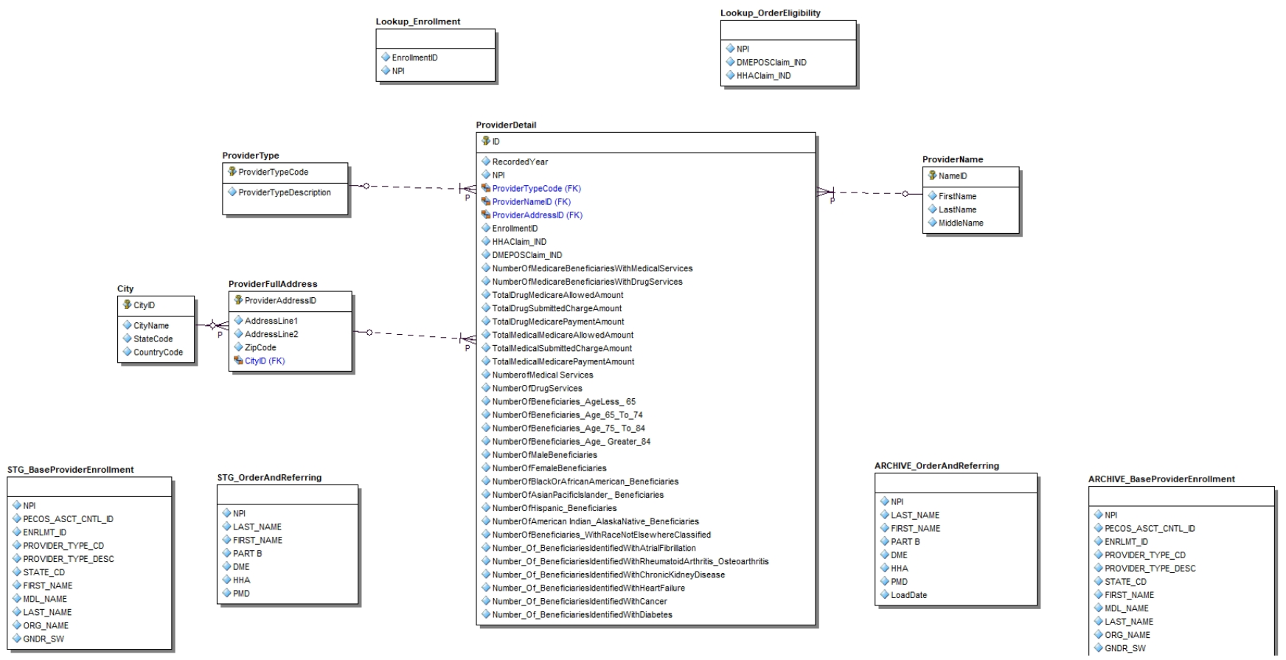 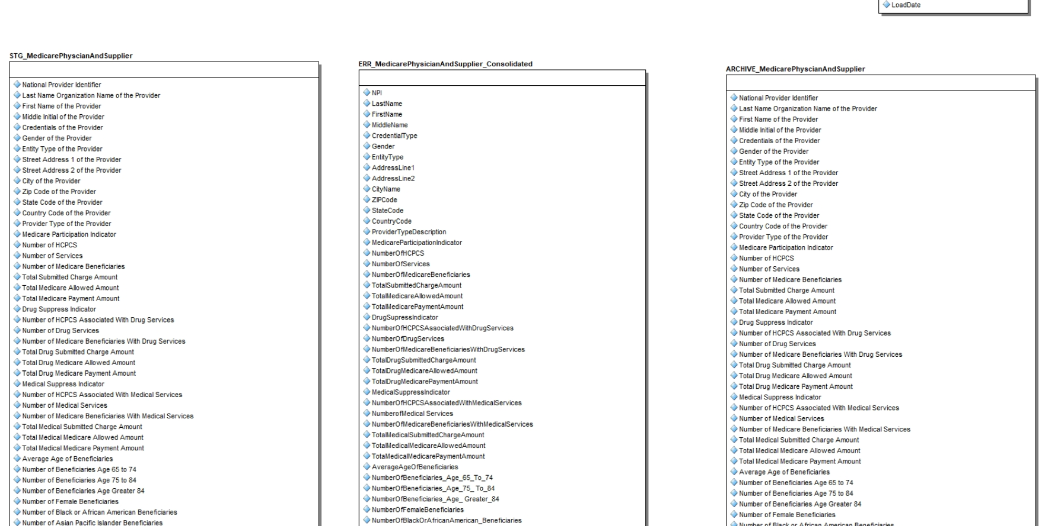 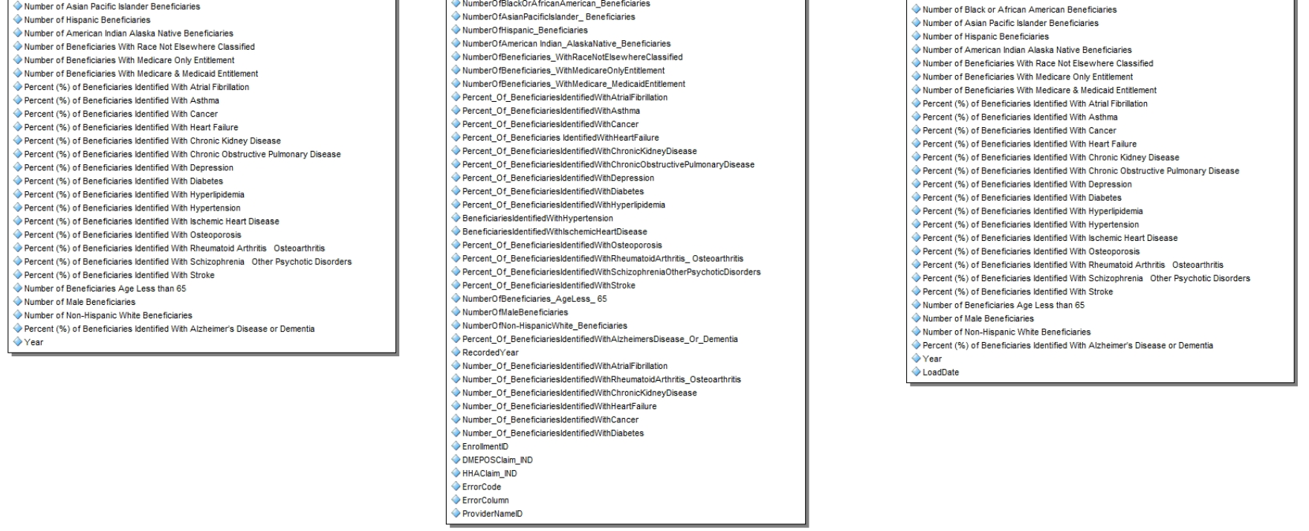

# Data Mart (Dimensional Model):

The dimensional model classifies under Snowflake schema, where it involves 9 dimension tables and one Fact table. Staging table(s), Archive table(s), Error tables(s) will be added in future.

Acronyms used in the dimensional model:

* NPI – National Provider Identifier
* HCPCS - Healthcare Common Procedure Coding System
* RUCA – Rural Urban Commuting Area Code
* DMEPOS - Durable medical equipment, prosthetics, orthotics and supplies
* HHA – Home Health Agency

