INDEX

1. Changing one Ip to another Ip.
2. Creating all users and passwords.
3. Converting them to Sudo.
4. Script for creating multiple users at a time.
5. Deleting users
6. How to recover root login password in centos.
7. Troubleshoot

**Changing one Ip to another Ip**

1. Open terminal and go to cd /etc/sysconfig/network-scripts
2. Then type ls to view all the files.

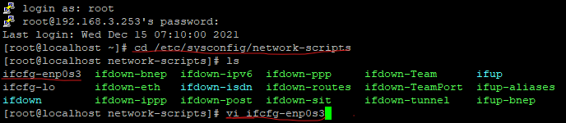

1. Open the corresponding file name (for ex: - ifcfg-p8p1) to edit it.

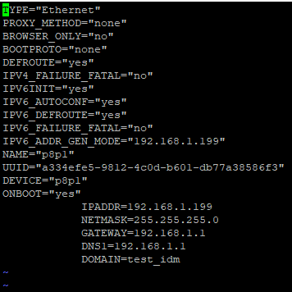

1. In that change BOOTPROTO field to “none” and save it.
2. Then restart by using the command “systemctl restart network”.

**Creating all users and passwords**

1. Open terminal and login as a root.
2. Then type below command to create users.
3. Useradd –u uid –g gid –d /homedirectory -s /bin/bash -c “comment” username
4. Then user will be created successfully.
5. To generate a password for particular user type below command.
6. Passwd username
7. Then enter password 2 times and enter.
8. Users and passwords are created successfully.

**Converting all users to sudo**

1. Open terminal and login as a root.
2. Type the command visudo
3. Go down and search for the line “root ALL=(ALL: ALL) ALL”.
4. Press enter and add all the users you want in the sudos file as below command.
5. “<Username> ALL=(ALL:ALL) ALL” for ex: - sk21163 ALL=(ALL: ALL) ALL.

**Script for creating multiple users at a time.**

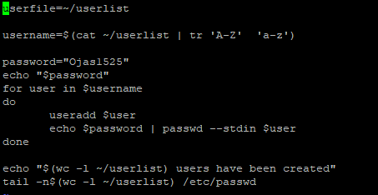

**Deleting users**

Type below command to delete a user

Userdel –rf username

**How to recover root login password in centos**

##### 1. Power up / reboot

The first step is to power up or reboot the system and edit the grub2 parameters. Timing here is critical. You must press ‘e’ before the menu times out and boots normally.  
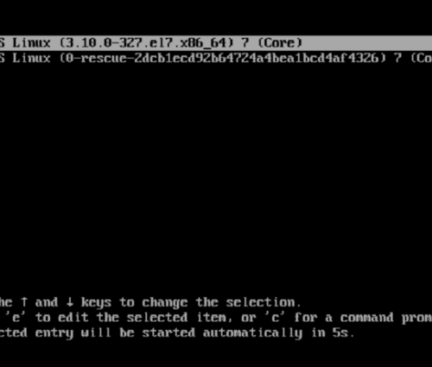

##### 2. Linux16

Look for a line that mentions **linux16** (or **linuxefi** if you are using UEFI bios). You may need to use the arrow keys to scroll down. At the end of the linux16 or linuxefi line, find and replace the **rhgb** **quiet** parameters with **rd.break** **enforcing=0**

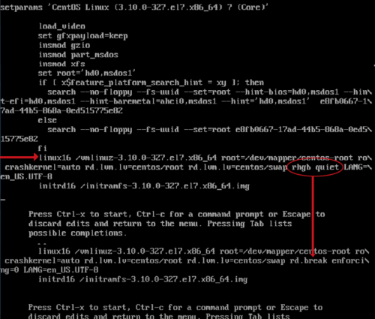

##### 3. Start boot process

Once you have edited the parameters accordingly, hit CTRL-X to start the boot process with the new parameters. The system should boot into the root system.

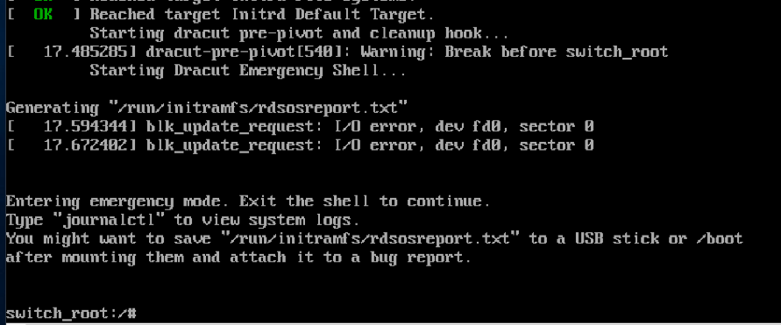

##### 4. Remount as read/write

Enter the following command to remount the sysroot filesystem as read/write: **mount -o remount,rw /sysroot**



##### 5. chroot into sysroot

Now we chroot into the sysroot, using the following command: **chroot /sysroot**



##### 6. Change the password

We can use the **passwd** command to change the root password.  
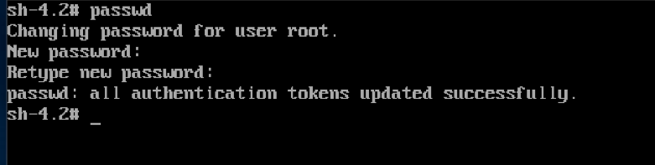

##### 7. Return to switch_root

Issue the following command to bring us back to the switch_root:/# prompt: **exit**



##### 8. Remount to read-only

Enter the following command to remount the sysroot filesystem as read-only once again: **mount -o remount,ro /sysroot**



##### 9. Exit the session

Now we can exit the session and allow the system to reboot using the following command: **exit**



##### 10. Boot and login

Allow the system to boot normally and login as root using the new password that you set in step 6.

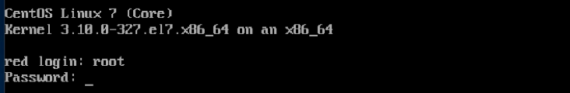

**How to take backup of etc file**

Before deleting etc first we need to take backup of that etc folder by using below command

#tar –cvf backupname backupfolder

Ex: #tar –cvf etc-backup-date etc

After deleting etc file, to extract the folder we need to use below command.

#tar –xvf backupname

Ex: - #tar –xvf etc-backup-date

**How to create another Ip :**

Step-1: check the interfaces by below command

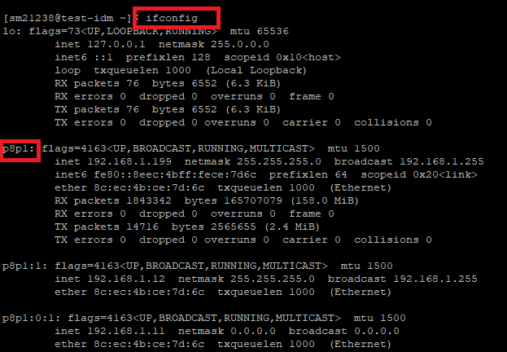

Step-2: enter the following to create new Ip by using the interface



Step-3: now check whether the interface is created or not

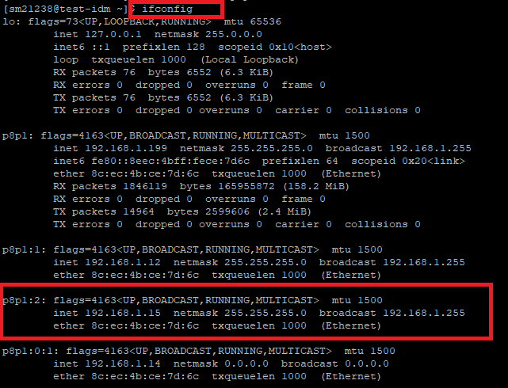

Step-4: now login through putty with the created Ip and with the same credentials of your interface

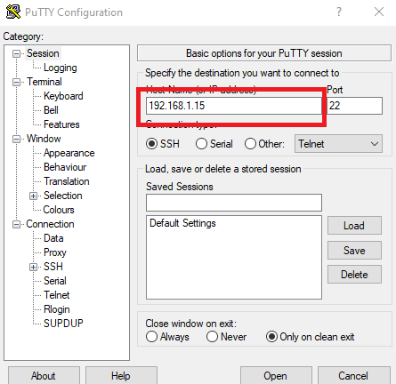

**How to delete the created Ip:**

Step-1: type the following command



Step-2: check whether the Ip which you have created is deleted or not.

