**CSYE 7200: Big Data System Engineering Using Scala**

**Section 1**

**Assignment 6**

Rajendra Kumar Rajkumar

001405755

# **Implementation for method ‘getURLs()’ in WebCrawler.scala (line: 28):**

## **Code Snippet:**

*// Hint: write as a for-comprehension, using the method createURL(Option[URL], String) to get the appropriate URL for relative links  
// 16 points.*def getURLs(ns: Node): Seq[Try[URL]] = {  
 for (des <- ns.descendant; hrAtt <- des.attribute("href"))  
 yield *createURL*(*Try*(new URL(u.getProtocol.concat(":"))).toOption, hrAtt.toString)  
}

## **Screenshot of Code Snippet from IntelliJ:**

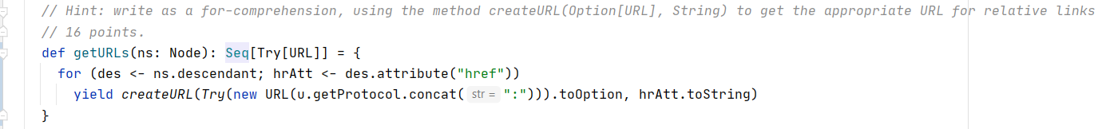

# **Implementation for method ‘wget()’ in WebCrawler.scala (line: 39):**

## **Code Snippet:**

*// Hint: write as a for-comprehension, using getURLContent (above) and getLinks above. You might also need MonadOps.asFuture  
// 9 points.*for (urlCont <- *getURLContent*(u)) yield getLinks(urlCont) match {  
 case *Success*(usl) => usl  
}

## **Screenshot of Code Snippet from IntelliJ:**

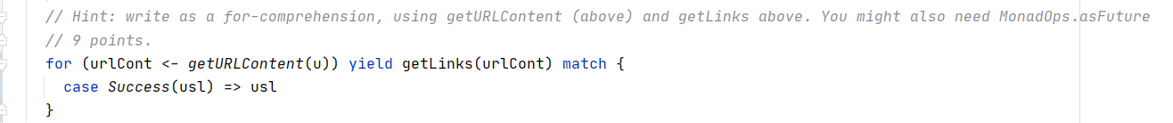

# **Implementation for method ‘wget()’ in WebCrawler.scala (line: 44):**

## **Code Snippet:**

def wget(us: Seq[URL]): Future[Seq[Either[Throwable, Seq[URL]]]] = {  
 val us2 = us.distinct take 10  
 *// Hint: Use wget(URL) (above). MonadOps.sequence and Future.sequence are also available to you to use.  
 // 15 points. Implement the rest of this, based on us2 instead of us.* val us2fs = for (us2It <- us2) yield *wget*(us2It)  
 val xUs2fs = for (us2f <- us2fs) yield MonadOps.*sequence*(us2f)  
 Future.*sequence*(xUs2fs)  
}

## **Screenshot of Code Snippet from IntelliJ:**

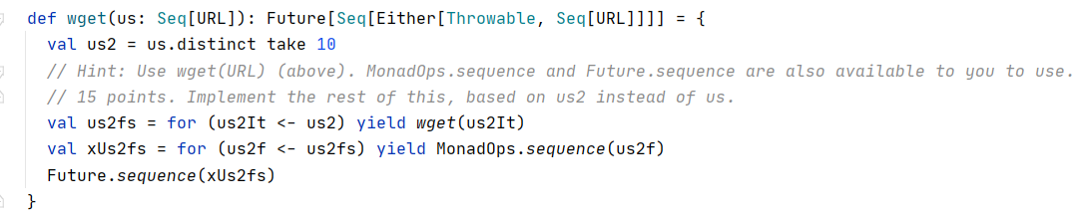

# **Implementation for method ‘mapFuture()’ in MonadOps.scala (line: 56):**

## **Code Snippet:**

*// Hint: write as a for-comprehension, using the method sequence (above).  
// 6 points.*def mapFuture[X](xfs: Seq[Future[X]])(implicit executor: ExecutionContext): Seq[Future[Either[Throwable, X]]] = for (xf <- xfs) yield *sequence*(xf)

## **Screenshot of Code Snippet from IntelliJ:**



# **Implementation for method ‘sequence()’ in MonadOps.scala (line: 91):**

## **Code Snippet:**

*// Hint: this one is a little more tricky. Remember what I mentioned about Either not being a pure monad -- it needs projecting  
// 7 points.*def sequence[X](xe: Either[Throwable, X]): Option[X] = xe.right.toOption

## **Screenshot of Code Snippet from IntelliJ:**



# **Execution of unit test class ‘WebCrawlerSpec.scala’ denoting that all 7 tests have passed:**

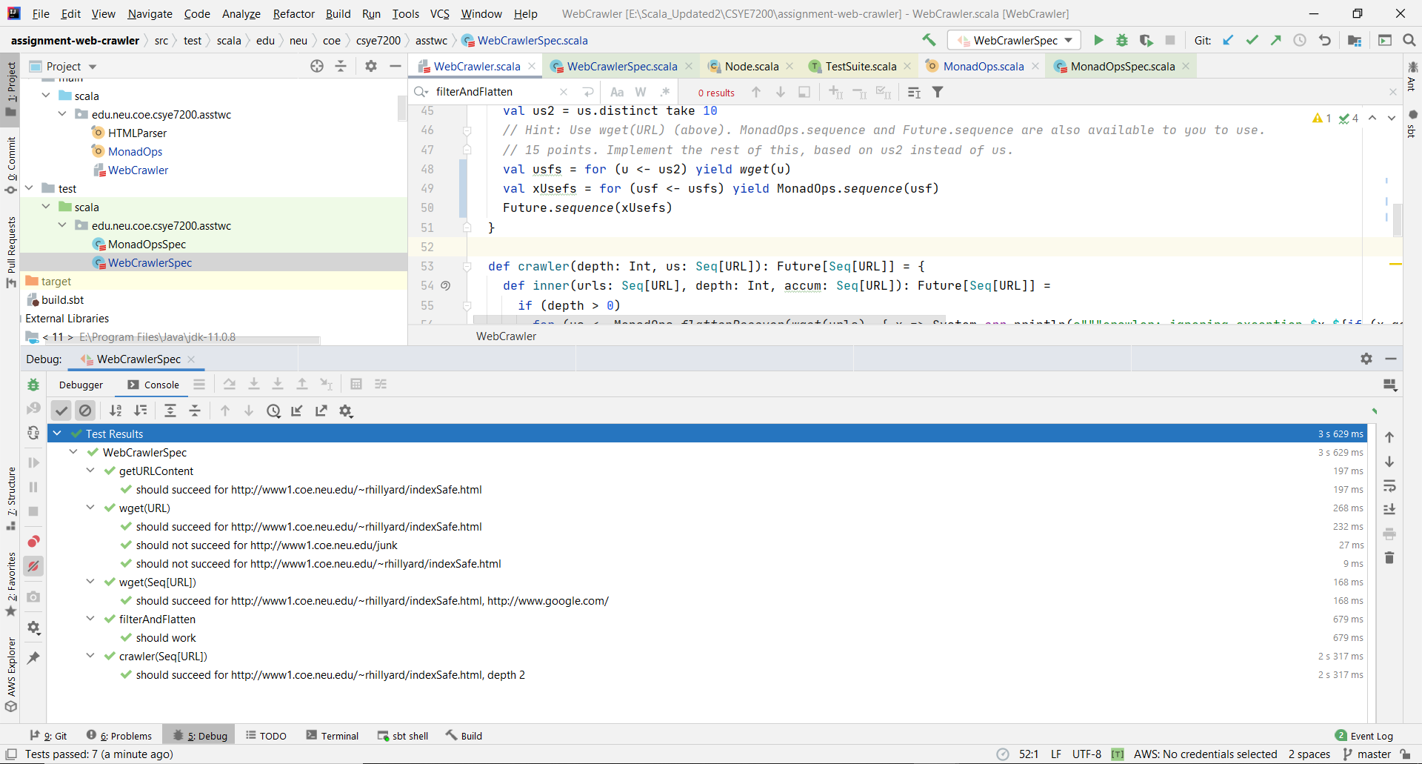

# **Execution of unit test class ‘MonadOpsSpec.scala’ denoting that all 21 tests have passed:**

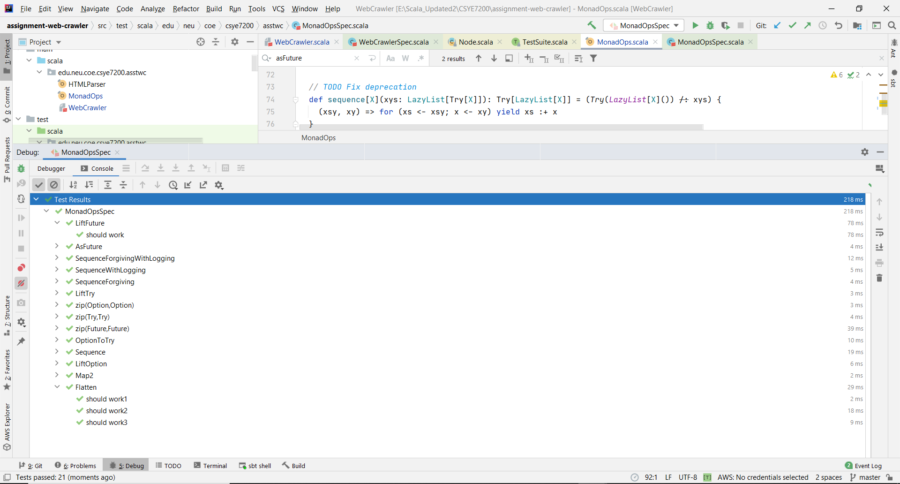

# **Execution of unit test package ‘asstwc’ denoting that all 28 tests from MonadOpsSpec.Scala and WebCrawlerSpec have passed:**

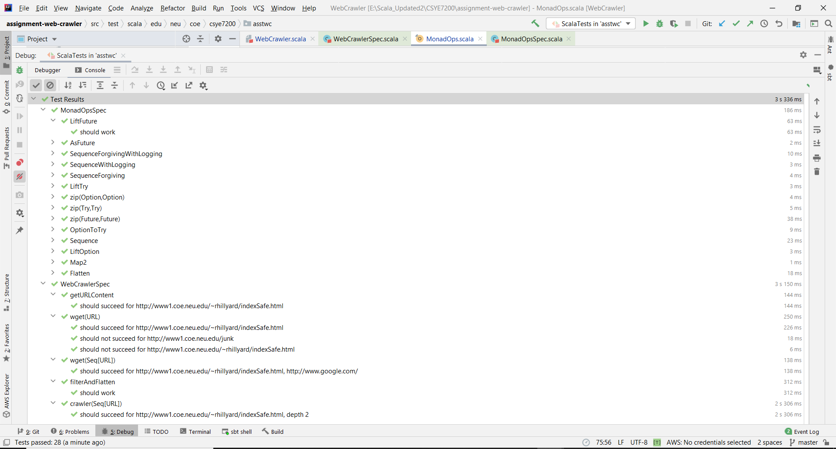

# **References:**

1. <https://stackoverflow.com/questions/20874186/scala-listfuture-to-futurelist-disregarding-failed-futures>
2. <https://stackoverflow.com/questions/52005127/scala-map-futureioresult-to-futureunit>
3. <https://www.searchenginejournal.com/10-ways-to-increase-your-site-crawl-rate/7159/>

# **Suggestion to improve Web Crawler:**

1. Including ‘content duplicacy’ check so that same content from different URLs are not crawled. Scanned through unit test cases of WebCrawler.scala, but didn’t manage to find duplicacy checks. Please ignore, if duplicacy check is present.