Download Zipkin server jar

**Run Zipkin:**

java -jar zipkin-server-2.23.18-exec.jar

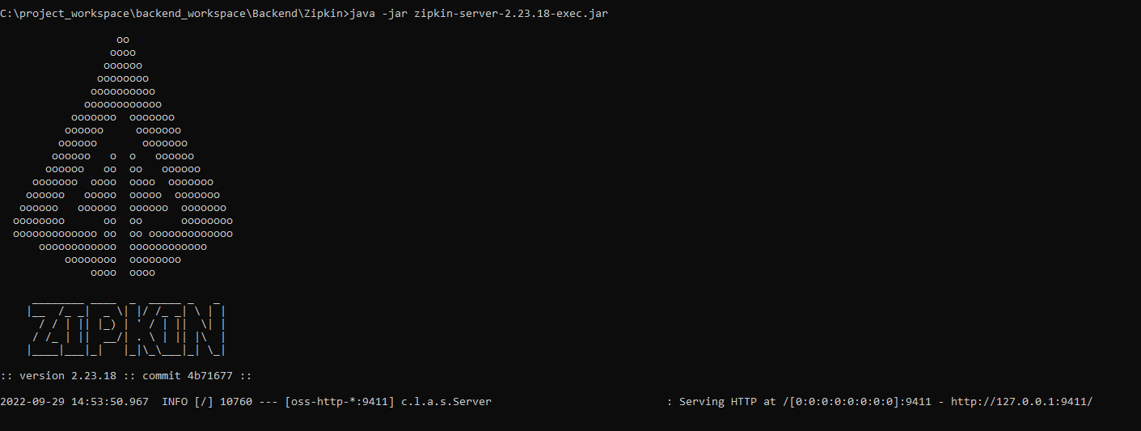

Default port is 9411

<http://127.0.0.1:9411/>

