Trade Exception Resolution
Agentic AI Solution Design — Summary Edition
LLM • LangGraph • Tools • RAG • AWS

Attribute | Value
Application | Trade Exception Resolution (ITER)
Document type | Solution Design — condensed summary of the full HLD / DLD
Source document | _Trade_Exception_Resolution_Design.docx (v1.0)
Business domain | Capital Markets — Post-Trade Operations
Version / Date | 1.0 — October 2026
Classification | Internal

Executive Summary
Post-trade operations teams handle thousands of trade exceptions daily — settlement fails, confirmation mismatches, SSI discrepancies, reconciliation breaks and allocation errors. Resolution is manual, spans 6–10 systems and is under severe time pressure since the US move to T+1 (SEC Rule 15c6-1/15c6-2), EU CSDR cash penalties, and the planned EU/UK T+1 move in October 2027.
ITER is an AI agent orchestrated with LangGraph on AWS, using Amazon Bedrock LLMs, that triages, investigates, diagnoses, resolves (within policy guardrails), communicates and learns — with humans in control of material decisions.

Why an Agentic Approach
Need | Rules / RPA | Chatbot (single LLM call) | Agentic (LangGraph)
Variable investigation path | Brittle scripts | No system access | Dynamic, bounded tool loops
Unstructured data (emails, SWIFT text) | Poor | Ungrounded | Grounded with evidence + citations
Controlled decisions | Rigid | Uncontrolled | LLM reasoning + deterministic policy gates
Human oversight & long waits | Queue only | None | Interrupts, checkpoints, event-driven resume
Auditability | Technical logs | Weak | Every node, tool call and decision recorded

Expected Outcomes (indicative)
- 40–60% lower mean time to resolve (MTTR); 30–50% of low-risk exceptions resolved straight-through.
- 20–30% fewer settlement fails / CSDR penalties; 100% evidence-backed audit trail.

1. Business Problem & Agent Objective
A trade exception is any event that stops a trade flowing straight-through from execution to settlement. Each one must be investigated and fixed before market cut-offs to avoid failed settlement, penalties, funding costs, buy-ins and regulatory scrutiny.
Exception Type | Typical Root Causes | Business Impact
Settlement fail / pending | Inventory shortfall, SSI mismatch, unmatched instruction, missed cut-off | CSDR penalties, funding cost, buy-ins
Confirmation / affirmation mismatch | Booking errors, price rounding, fee calculation | Missed T+1 same-day affirmation
SSI / static data | Stale or wrong standing settlement instructions | Fails, misdirected cash, fraud risk
Reconciliation break | Timing, missed bookings, corporate actions | Misstatement, client reporting errors
Allocation / corporate action | Late allocations; trades spanning ex/record date | Fails, market claims

Pain points: Investigation requiring navigation across multiple systems; knowledge locked in SOPs and experienced staff; volume spikes at cut-offs; inconsistent resolution quality; manual counterparty chasing; audit evidence assembled after the fact.
Target users: Operations Analysts (primary), Ops Supervisors (four-eyes approvers), Middle Office / Client Service (status queries), Risk, Compliance & Audit (oversight), and the AI Platform team (operators). Upstream systems trigger the agent with exception events.
Agent objective: give every exception an AI investigator that gathers evidence, finds the root cause, recommends or executes a policy-compliant fix, and keeps humans in control of material decisions.

KPI | Illustrative Baseline | Target
Mean time to resolve | 4–6 hours | < 1.5 hours
Auto-triage accuracy | n/a | ≥ 95%
Straight-through resolution (low risk) | ~0% | 30–50%
Analyst handling time per exception | 25–40 min | < 10 min

High-Level Architecture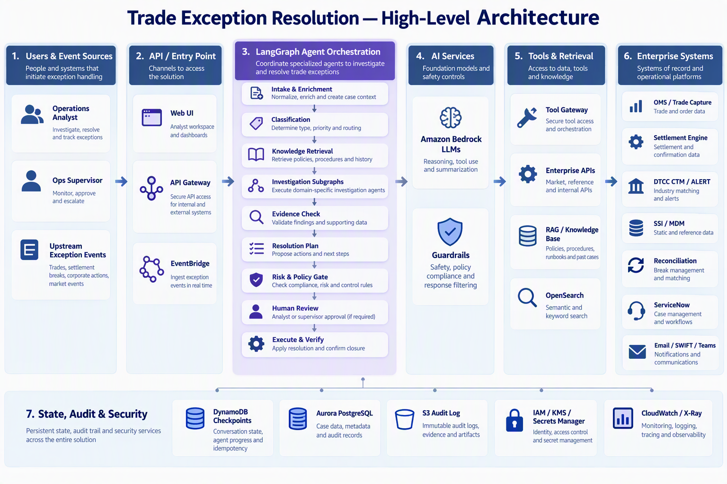
Figure 1: User → API / Entry Point → LangGraph Agent → LLM → Tools / RAG / Enterprise Systems → Final Response

2. Agent Workflow & LangGraph Design
The agent is a LangGraph StateGraph over a typed `ExceptionState`. Deterministic intake and enrichment feed LLM classification and knowledge retrieval; a conditional router dispatches to a category-specific investigation subgraph (bounded ReAct tool loop). Results pass an evidence check, resolution planning, a deterministic risk & policy gate, optional human review (interrupt), then execution, communication and verification.
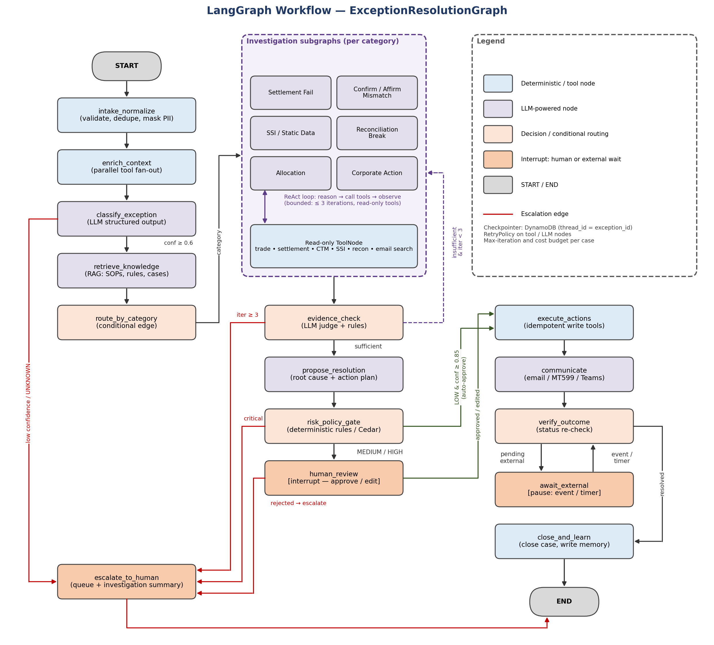
Figure 2: LangGraph workflow — nodes, conditional edges, interrupts and escalation

Workflow Stages
Stage | Nodes | Purpose
Intake & enrich | intake_normalize, enrich_context | Validate, de-dupe, mask PII; parallel data fetch
Understand | classify_exception, retrieve_knowledge | Category, priority, confidence; SOPs & similar cases
Investigate | route_by_category → investigate_<category> | Bounded ReAct loop with read-only tools
Decide | evidence_check, propose_resolution, risk_policy_gate | Root cause, action plan, policy decision
Approve | human_review (interrupt) | Approve / edit / reject; four-eyes for sensitive actions
Act & verify | execute_actions, communicate, verify_outcome, await_external | Idempotent writes, counterparty comms, status checks, pause/resume
Close | close_and_learn / escalate_to_human | Close case, write memory, or hand to a human

Key Routing Decisions
Decision Point | Rule
classify_exception | Confidence < 0.6 or UNKNOWN → escalate to human
evidence_check | Insufficient & iteration < 3 → loop; ≥ 3 → escalate; sufficient → propose
risk_policy_gate | LOW risk, confidence ≥ 0.85, pre-approved action → auto-execute; MEDIUM/HIGH → human review; CRITICAL / policy breach → escalate
verify_outcome | Resolved → close; awaiting counterparty → pause and resume on event/timer; failed → retry or escalate

Design principles: LLM proposes, policy disposes • bounded autonomy (allow-lists, iteration and cost budgets) • evidence first • durable and resumable • read and write tools separated.
class ExceptionState(TypedDict):
exception_id: str # = LangGraph thread_id
source_event: dict # PII-masked payload
trade, settlement_status, counterparty: ... # enrichment
classification: Classification | None
knowledge: list[RetrievedChunk] # RAG results + citations
evidence: Annotated[list[Evidence], operator.add]
resolution_plan: ResolutionPlan | None
risk_assessment: RiskAssessment | None
approvals: list[ApprovalDecision]
actions_executed: Annotated[list[ActionResult], operator.add]
outcome: Literal["resolved", "pending_external", "escalated", "failed"] | None
iteration: int

3. LLM & Prompt Strategy
All models are accessed through Amazon Bedrock (Converse API via `ChatBedrockConverse`) so data stays within the AWS account, is not used for training, and models are swappable by configuration. A task-based model tiering approach balances quality, latency and cost.
Task | Model | Why
Investigation, root cause, planning | Claude Sonnet (latest approved 4.x) | Multi-step reasoning, tool use
Classify, extract, judge, summarise, draft | Claude Haiku (4.x) | Fast and low cost at high volume
Embeddings / reranking | Titan Text Embeddings V2 / Bedrock Rerank | Native, cost-efficient retrieval
Resilience | Cross-region inference; fallback model | Throughput at cut-off peaks

Prompt & Context Handling
- Layered prompts: system rules → node task → structured context (`<trade>`, `<evidence>`, `<knowledge>`, `<untrusted_content>`) → 2–3 similar resolved cases as few-shot → output schema.
- Versioned prompts in Git + Bedrock Prompt Management; prompt/model version logged on every call.
- Context engineering: each node sees only the state it needs; token budgets per node; long email threads pre-summarised; large artefacts stored in S3 by reference; prompt caching for static content.
- Temperature: 0–0.1 for classification/planning, 0.1–0.2 for investigation, 0.3–0.4 for drafting.

Structured Outputs
- Pydantic models bound via tool calling (`with_structured_output`) — `Classification`, `ResolutionPlan`, `ProposedAction`.
- Categories and action codes are enumerations: the model cannot invent new actions.
- Schema validation with up to 2 automatic repair retries, then escalation.
- Every conclusion carries confidence and citations (evidence and knowledge IDs).

Evaluation
- Golden dataset of SME-labelled historical exceptions; metrics: classification and root-cause accuracy, action correctness, groundedness, hallucination rate.
- Evaluation gate in CI for every prompt/model change; online tracking of analyst acceptance and overrides.

4. Tools & System Integration
Tools are typed LangChain tools calling a Tool Gateway (private API Gateway + Lambda adapters, or MCP servers / Bedrock AgentCore Gateway). The agent never holds enterprise credentials — adapters use Secrets Manager and least-privilege IAM roles. Read and write tools are deployed and authorised separately.
Tool | Target System | Mode | Used In
get_trade_details | OMS / trade capture | Read | enrich, investigate
get_settlement_status | Settlement engine / custodian (MT548) | Read | enrich, verify
get_confirmation_status | DTCC CTM | Read | enrich, investigate
get_ssi / get_counterparty_profile | SSI store, DTCC ALERT, MDM | Read | investigate
get_positions_cash | Reconciliation platform | Read | investigate
search_knowledge_base / similar_cases | Bedrock KB / OpenSearch | Read | retrieve, investigate
search_communications | Ops mailbox (MS Graph), SWIFT archive | Read | investigate (untrusted)
reinstruct_settlement | Settlement → SWIFT MT540–543 | Write | execute (policy-gated)
amend_ssi | SSI store | Write | execute (four-eyes + callback)
create_update_ticket | ServiceNow | Write | execute, escalate, close
send_communication | Email / SWIFT MT599 / Teams | Write | communicate (templates)

Invocation Policy
- Per-node allow-lists: investigation binds read tools only; write tools exist only in `execute_actions`.
- Parallel fan-out (LangGraph `Send`) in enrichment to cut latency.
- Idempotency keys (exception + action + params hash) in DynamoDB prevent duplicate writes on retry.
- Timeouts, retries and circuit breakers per tool; dry-run for writes where supported.
- Tool outputs are data, never instructions.
Integration patterns: REST/gRPC over PrivateLink or Direct Connect for lookups; MSK / EventBridge events to trigger or resume the agent; SWIFT Alliance (MT54x / ISO 20022 sese); DTCC CTM/ALERT APIs; ServiceNow REST; Microsoft Graph for email and Teams.

5. Knowledge / RAG Architecture
Sources: operations SOPs and runbooks; market and regulatory rules (CSDR, T+1, cut-offs); counterparty SSI agreements and notes; SWIFT/ISO 20022 reason-code guides; and summarised historical resolved cases (episodic memory).
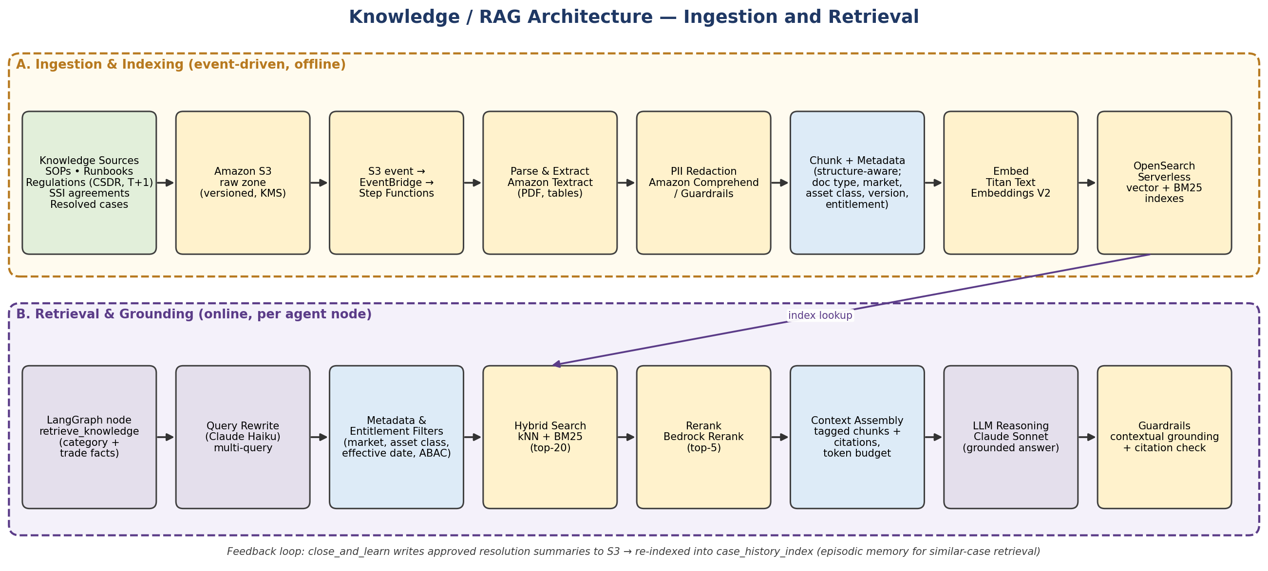
Figure 3: RAG architecture — event-driven ingestion and grounded retrieval

Ingestion & Indexing
- S3 (versioned, KMS) → EventBridge → Step Functions pipeline: Textract parsing → Comprehend PII redaction → structure-aware chunking (≈400–800 tokens, 10–15% overlap) → metadata (doc type, market, asset class, effective dates, entitlement) → Titan V2 embeddings → OpenSearch Serverless (HNSW + BM25).
- Indexes: `sop_index`, `regulatory_index`, `counterparty_index`, `case_history_index`. Bedrock Knowledge Bases can provide managed ingestion.

Retrieval & Governance
- Query built from state → rewritten into sub-queries (Haiku) → metadata + entitlement filters → hybrid search (top-20) → rerank (top-5) → context with chunk-ID citations.
- Bedrock Guardrails contextual grounding check; ungrounded answers trigger re-retrieval or escalation.
- Documents have owners, versions and effective dates; superseded versions excluded; retrieval quality tested on every re-index; only verified resolutions enter case history.

6. Memory & State Management
Memory Layer | Store | Contents | Retention
Working state | LangGraph state (in-process) | ExceptionState for the current run | Run duration
Checkpoints | DynamoDB (large blobs in S3) | State per super-step, interrupts | Case life + 90 days
Session memory | ElastiCache Redis | Analyst chat history, rolling summary | Session TTL (~12h)
Case memory | Aurora PostgreSQL | Case record, actions, approvals, outcomes | Records policy (~7 yrs)
Episodic memory | OpenSearch case_history_index | Resolution summaries, counterparty patterns | Rolling, curated
Audit record | S3 Object Lock (WORM) + CloudTrail | Prompts/response hashes, tool calls, approvals | Regulatory

Threads, Sessions & Long-Running Workflows
- `thread_id = exception_id`: one durable thread per exception; subgraphs isolated by `checkpoint_ns`.
- DynamoDB-backed checkpointer (e.g., `langgraph-checkpoint-aws`); Aurora `PostgresSaver` as alternative.
- `human_review` and `await_external` call `interrupt()` — state is persisted and the worker released.
- Resume via approval API (`Command(resume=...)`), EventBridge events (MT548/MT547, email reply) or EventBridge Scheduler timers (chase after 2h, escalate before cut-off).
- One active run per thread (DynamoDB conditional lease); events de-duplicated; state schema versioned so in-flight cases survive deployments.
- Context control: message trimming and summarisation; only projected state is passed to the LLM.

7. Security, Governance & Reliability
Area | Key Controls
Authentication | Cognito federated with corporate IdP (SAML/OIDC) + MFA; JWT at API Gateway; IAM SigV4 and mTLS/OAuth2 for services
Authorization & IAM | RBAC + ABAC (business unit, region, legal entity); Amazon Verified Permissions (Cedar) at policy gate and Tool Gateway; on-behalf-of user identity; least-privilege, separate read/write roles
PII & data protection | Tokenise client/account data at intake; KMS CMKs; TLS 1.2+; Bedrock via VPC endpoints; Macie scanning; region pinning
Guardrails | Bedrock Guardrails (prompt attack, denied topics, PII, grounding); schema validation; action allow-list; financial thresholds; run budgets; kill switch to HITL-only mode
Prompt-injection protection | External content spotlighted as `<untrusted_content>`; prompt-attack filter; fixed tool allow-lists; outputs validated against golden sources; no SSI change from email — callback + four-eyes
Audit logging | Event per node, LLM call, tool call, decision and approval → S3 Object Lock; CloudTrail; Bedrock invocation logs; OpenTelemetry traces (X-Ray / CloudWatch)
Human-in-the-loop | Triggered by risk ≥ MEDIUM, low confidence, static/cash changes; review UI with evidence, citations and action diff; maker-checker; SLA escalation before cut-off
Model governance | Model inventory, validation and monitoring per model-risk policy (SR 11-7 style)

Error Handling & Retries
Failure | Handling
Bedrock throttling / transient errors | RetryPolicy with exponential backoff + jitter; cross-region inference; fallback model
Enterprise API timeout / outage | Timeouts, circuit breakers, cached reference data, partial-evidence flag
Invalid LLM output | Repair retry (≤ 2), then escalate
Worker crash | Resume from last checkpoint; idempotency keys prevent duplicate writes
Bad events / low confidence | SQS DLQ + alerting; route to human — never guess

8. AWS Deployment & Scalability
ITER runs in dedicated workload accounts per environment (AWS Control Tower). Compute is in private subnets across multiple AZs; AWS services are reached via VPC endpoints and on-prem systems via Transit Gateway / Direct Connect.
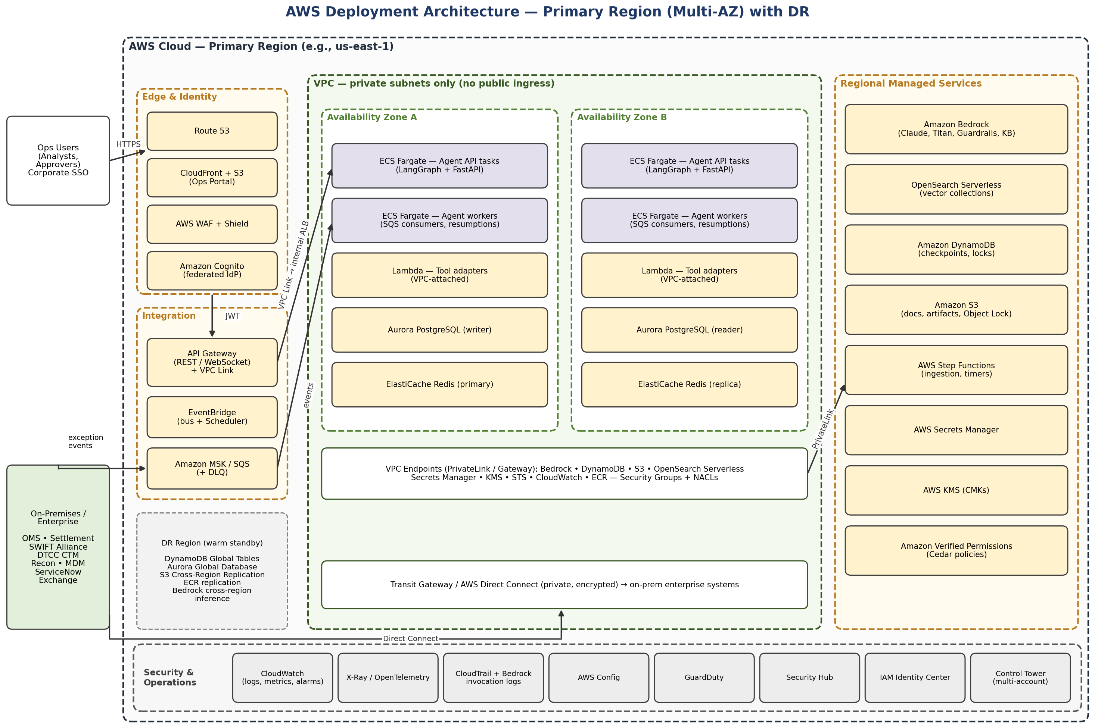
Figure 4: AWS deployment architecture — multi-AZ primary region with DR
Layer | AWS Services
Edge, identity & API | CloudFront, S3, WAF, Shield, Cognito, API Gateway (REST, WebSocket, private)
Eventing | EventBridge (+ Scheduler), Amazon MSK, SQS (+ DLQ)
Agent runtime & tools | ECS on Fargate (alt.: EKS / Bedrock AgentCore Runtime); Lambda tool adapters
AI & knowledge | Bedrock (Claude, Titan, Rerank, Guardrails, Knowledge Bases), OpenSearch Serverless, Textract, Comprehend, Step Functions
State & data | DynamoDB, Aurora PostgreSQL, ElastiCache Redis, S3
Security & operations | IAM, KMS, Secrets Manager, Verified Permissions, CloudWatch, X-Ray, CloudTrail, GuardDuty, Security Hub, Config

Scalability, Resilience & Cost
- Stateless workers scale horizontally; ECS auto-scaling on SQS depth; separate P1 queue for exceptions settling today.
- Per-system rate limits protect downstream systems; reference data cached in ElastiCache.
- Bedrock cross-region inference and provisioned throughput for cut-off peaks; serverless data tier (DynamoDB on-demand, OpenSearch Serverless, Aurora Serverless v2).
- Multi-AZ everywhere; warm-standby DR region (DynamoDB Global Tables, Aurora Global DB, S3 CRR). If LLMs are unavailable, exceptions fall back to human queues.
- CI/CD with IaC (CDK/Terraform), LLM evaluation gate and blue/green deploys; cost control via model tiering, prompt caching and per-case token budgets.
- Targets: 99.9% availability • triage < 60 s (P95) • investigation < 5 min (P95) • ≥ 20,000 exceptions/day • RPO ≤ 5 min / RTO ≤ 1 h.

Roadmap
Phase | Scope | Autonomy
0 — Foundation | Integrations (read), golden dataset, AWS landing zone | None
1 — Investigation (MVP) | Triage, investigation, recommendations for settlement fails and confirmations | Read-only; HITL for all actions
2 — Controlled autonomy | Write tools, auto-execution of low-risk actions, counterparty comms | Policy-gated
3 — Scale & prevent | All exception types, multi-region, predictive fail prevention | Expanded

