# Chapter 2 Analysis

# 2.1 Introduction

Before developing a project, the earliest stage is to appreciate what that system prerequisite to be. Analysis is the initial phase which helps to gather various information’s in order to understand its nature or to recognize the basic fundamental features. While doing analysis of the certain project it helps to know the system performance. The purpose behind analysis is to find necessities which recognize and sort out the various information need which encourages to get best objectives. Furthermore, the aspect of the current information system is also described.

**Rich Pictures:**

Rich pictures are pictorial portrayal of natural or social systems. It helps to handle the difficult situation in order to recognize the hidden problems by including each and every single relevant component and accomplices of a system.

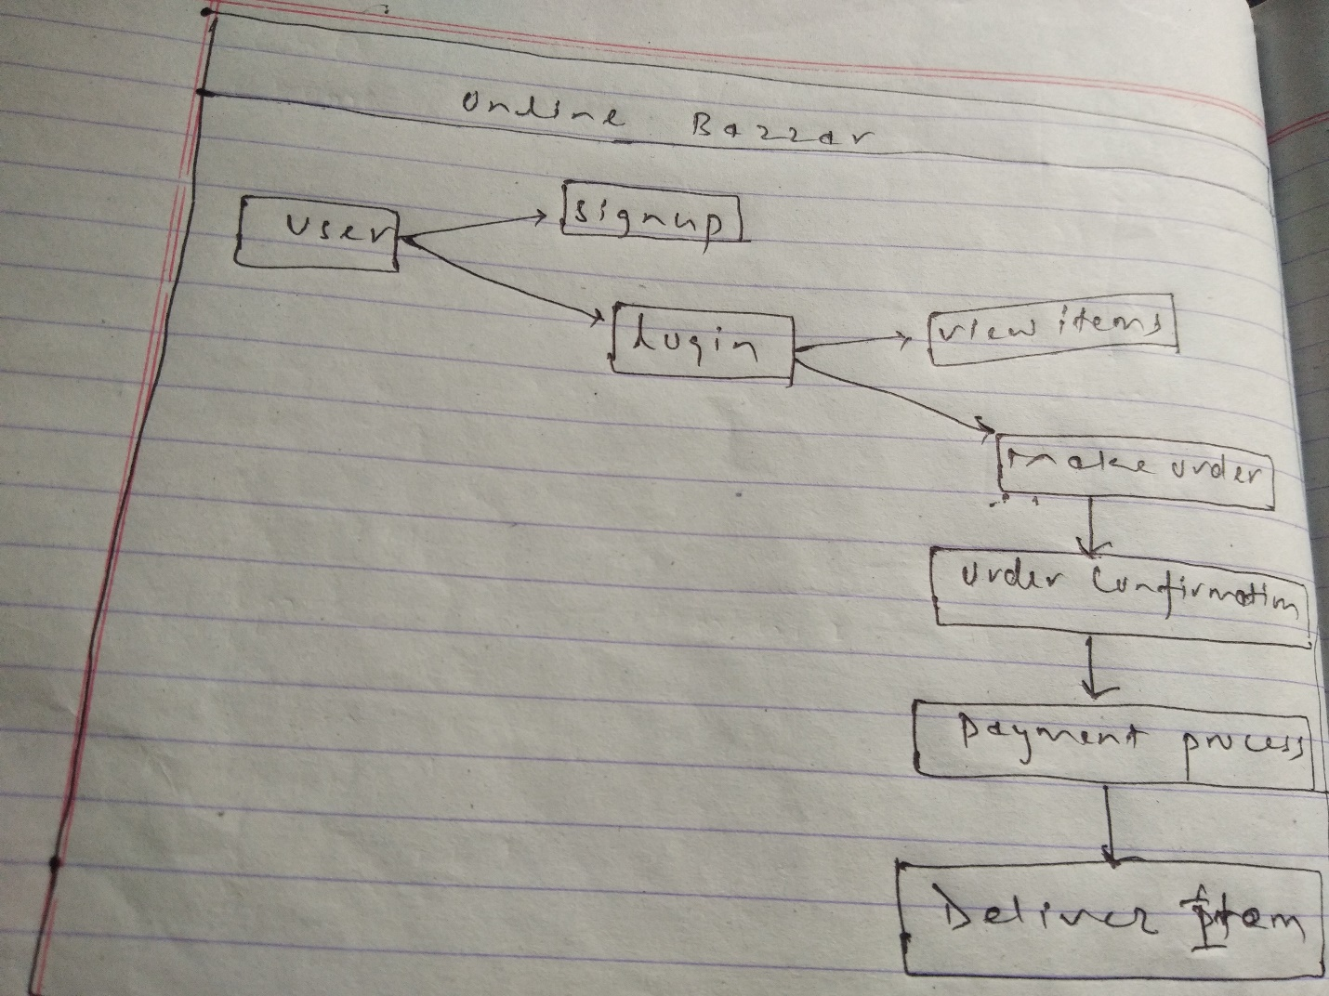

Fig: Rich picture for Online Bazzar

2.2 Information Gathering Techniques

It is a repeated process which are utilized to make and sort out data crosswise over various types of sources through different means. Here I have used some of the information gathering techniques which are as shown underneath: -

* **Brainstorming:**

This procedure is utilized for getting a summary of entire project records. All thoughts are made with the help of facilitator through an open exchange and mass gathering systems. For the most part, method of conceptualizing should be possible amid a booked gathering with mates, singular conceptualizing, or even at a casual gathering.

* **Interviews**

Interview is a formal way of information gathering in which two or more than two people are communicated face to face or any source of media. For getting different idea and opinion for this project from different people interviews plays a vital role to accumulate the information in a reasonable manner and in addition it results the sustainable information’s from the different candidates.

# 2.3 Feasibility study:

A feasibility study is an methodology of analyzing the suitable component of the project including financial, specialized, legitimate, and scheduling consideration to decide the conceivable outcomes and likelihood of finishing an project effectively. Some of the feasibility analysis are demonstrated below: -

* Technical feasibility

It evaluates the complete investigation of the project as far as software, hardware’s, fields, projects and strategies. It is a powerful tool for long term plan and trouble shooting.

* Schedule feasibility: -

It describes the time to be allocated on completing the entire project and characterize as the likelihood to finish inside its schedule time limits. at that point its timetable possibility is evaluated as high.

* Economic feasibility

Basically, it determines whether the project is cost feasible or not and checks the projects running over the budget or out of the budget. It helps to calculate by analyzing the costs and revenues for the certain project to be developed.

* Resource Feasibility:

It incorporates questions in regards to time required to finish the task, type and measure of assets required and subordinate components. So it deals with ideal use of the resource accessible.

# 2.4 Analysis Methodology:

Here in this project object Oriented methodology is used because it is system development approach empowering and encouraging re-utilization of parts. Through the adoption of this methodology, higher profitability, lower support cost and better quality can be accomplished. Additionally, it is easy for understanding and diminish the complexity of software object models.

# 2.5 System Requirements Specification(SRS): -

A system requirement specification is a report or document set which provides detail information about features and behavior of a system. Basically it is profitable for system development because it minimizes the amount of time and reduces the cost to develop a complete project. It also fills as an understanding among the designer and the customers for whom the system is being created. It provides complete description of a functionality and specifics of the website “Online Bazzar”.

1. **Functional requirements**

Basically functional requirements are the necessities which specifies what the system should do. The core functionality of the whole project is described in the presence of functional requirements and consolidates various data and functional process necessities

|  |  |  |  |  |
| --- | --- | --- | --- | --- |
| **Id** | **Title** | **Description** | **Rational** | **Dependencies** |
| FR1 | Login for Admin | Admin should use authorized username and password for login into the system. | For accessing the system and view various product. | N/A |
| FR2 | Add Categories | it can be used to categories the various online product by system admin. | It makes easier to customers to select the items by their category | N/A |
| FR3 | Add items | The various newly information about items were added to the system by admin. | To add various modern and fashionable items. | FR2 |
| FR4 | Update/Edit items | The newly product to the system were edited and updated. Admin update and edit system database. | To edit and update the modern and fashionable product. | FR2,FR3 |
| FR5 | Delete items | Admin can delete the old fashionable items and information related to the system. | To remove the unnecessary information | FR2,FR3,FR4 |
| FR6 | Order management | Various product order by customers were managed by the admin in the system. | Various customer online orders were viewed in the system. | FR2, FR3, FR4 |
| FR7 | Logout | Admin can easily log out of the system from admin panel of the system. | To get out of the system. | FR1 |

.

|  |  |  |  |  |
| --- | --- | --- | --- | --- |
| **Id** | **Title** | **Description** | **Rational** | **Dependencies** |
| FR1 | User Sign up | User should share some personal information to sign up to the account. | To signup user in the system | FR2 |
| FR2 | User login | User should use authorized username and password to login into the system. | It verifies the authorized user to access the system. | FR1 |
| FR3 | Views items | User will view various updated and fashionable items. | To view various shopping items | N/A |
| FR4 | Online ordering | User can easily order any items online through the system. | For selecting the various items required by the customers. | N/A |
| Fr6 | Payment process | Customer can pay after the required item is delivered. | To charge the cost of items | FR4 |
| FR5 | Logout | After selecting various required items users will be able to get logout of the system. | To end the process of the user. | FR2 |

1. **Non-functional Requirements:**

These are any requirements that can't be arranged into Functional, Data or Process necessities. Non-functional requirements reflect how the system need to function.

|  |  |  |  |  |
| --- | --- | --- | --- | --- |
| **Id** | **Title** | **Description** | **Rational** | **Dependencies** |
| NFR1 | Performance | Website should be able to handle various customers at a time and will have expedient response rate. | To improve the speed of information provided to numerous customers. | NFR1 |
| NFR2 | Availability | Items at the specific time should be provided to the customers as their demand. | It should be needed to provide demandable product at a pointed time. | NFR3 |
| NFR3 | Reliability | System should be authentic, accurate and steadfastness. | It helps to increase the organization performance and accuracy level. | NFR2 |
| NFR4 | Maintainability | System should be maintainable on daily basis if any fault or bugs arise. | Maintaining further is an easy technique. | N/A |
| NFR5 | Portability | The website should be mobile accessible in other words ca be fit on any device at a time. | It helps to make system easier to use to customers. | NFR2 |
| NFR6 | Security | System ought to be secured from various malwares, viruses and attackers. | To keep secure website from unauthorized access. | NFR1 |
| NFR7 | Usability | The system should be understandable to users and become user friendly. | Interest of customers will be high if it is simple to use. | N/A |

**Prioritization: -**

Simply the prioritization is the method in which a set of items are ranked with regard to their importance. It plays vital role in decision making and to gain the specific goals. It separates the various tasks according to their importance in current time and providing extra time, consideration and vitality. I have used Moscow strategy in this project. The importance regarding prioritization are as follows:

• It helps to increase productivity and reduce stress.

• It encourages people to get clear on their goals and vision.

• It provides the possible feedbacks and keeps motivated

**Moscow (Must, Should, Could, Won’t) prioritization: -**

Moscow method of prioritization is a popular strategy for requirement management which starts from the DSDM.

**Must have: -**

Must have are items in a system which plays a vital role in order to move forward and these requirements must be fulfilled. With improper implementation of these requirements project leads to unsuccessful.

**Should have: -**

These items are not more important as to move forward and to be fulfilled but in absence of these items a higher level of pain can occur in a project.

**Could have: -**

These categories items are commonly those items which are desirable in the project but not highly important. If the project is running over the specific time these requirements will be erased from the system.

**Won’t have: -**

It can be represented as those items which were recognized to be desirable or profitable, yet will not be implemented in current release. In future they might be taken as the part of the system development.

|  |  |  |
| --- | --- | --- |
| ID | Functional Requirement | Moscow |
| FR1 | Login for admin and user | Must have |
| FR2 | Customer Sign up | Must have |
| FR3 | Add, customers | Should have |
| FR4 | Add items | Must have |
| FR5 | Search items | Should have |
| FR6 | Update items | Must have |
| FR7 | Delete items | Should have |
| FR8 | Add categories | Should have |
| FR9 | Payment process | Could have |
| FR10 | Order management | Should have |
| FR11 | Customer care | Won’t have |
| FR12 | Feedback box | Won’t have |
| FR 13 | Password changing | Should have |
| FR14 | Logout | Must have |

|  |  |  |
| --- | --- | --- |
| ID | Non-functional Requirements | Moscow |
| NFR1 | Performance | Could have |
| NFR2 | Availability | Could have |
| NFR3 | Reliability | Could have |
| NFR4 | Maintainability | Should have |
| NFR5 | Portability | Should have |
| NFR6 | Security | Should have |
| NFR7 | Usability | Should have |

# 2.6 Architecture:

It is fundamentally characterized as the art and study of designing and building structures, or sweeping get-together of structures, concerning aesthetic and practical criteria. It is also known as the foundation for system development and usually called blue print of utilization although it consists each and every single element.

**System Architecture:**

System architecture is dynamic, conceptualization-situated, around the world and focused to achieve the mission and life cycle ideas for system development. It designates expected usefulness to hardware's and programming portions. It is basic since abnormal state decisions impact an undertaking for a long time.

There is the utilization of MVC design pattern in system development which basically represents the Model, View and Controller.

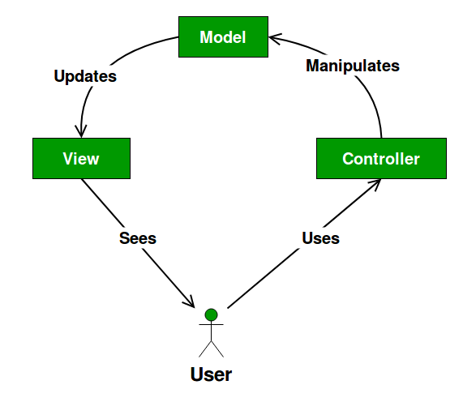

Fig: MVC design pattern

**• Model:**

It reflects the data and real world things and plays vital role in describing the essential components of the system.

**• View**

It helps to send the user action to the controller and represent the model data.

**• Controller**

The controller gives model information to the view, and deciphers client activities. It's the minds of the application, and ties together the model and the view.

# 2.7 Use Case Diagram:

Use case is a methodology which describe the users of the system and their interaction with the system. It plays an important role in designing a system from end users perceptive and describe the relationships between actor, use case and system. The purpose of the Use case diagram is demonstrated below: -

• It helps to specify the requirements for the system development.

• It provides validation to system design.

• It helps to produce test cases and for running implementation.

Some basic symbols are demonstrated below which are used as use case as system: -

**System**: -

Generally, it is denoted as rectangle shape which helps to draw the system boundaries in use cases. Beside this actor should be placed outside the boundaries of the system. The symbol for use case system is as below: -

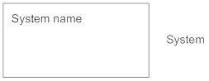

**Actors**: -

Actor is defined as anything which interact with the system. The basic symbol for actor in use case diagram is demonstrated below: -



**Use case**: -

It is denoted by the oval shaped and it shows the importance of the actor. The sign of indication for use case is demonstrated below: -

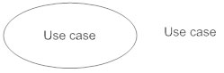

**Relationship**: -

We can mark relationship between use case and actor by arrow sign either uses or extends among the use cases. The sign of indication for is demonstrated below: -

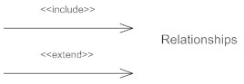

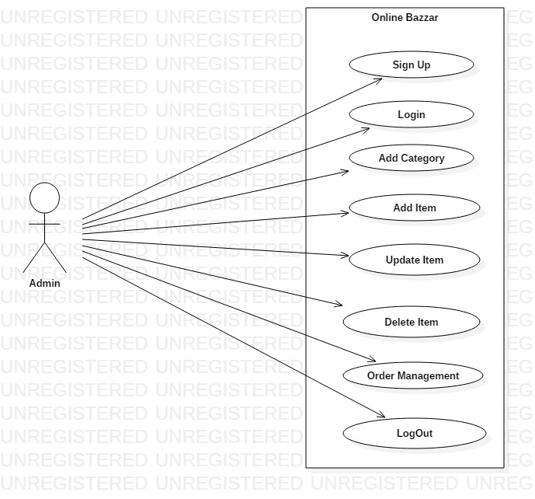

Fig: Use case diagram of Admin for online Bazzar

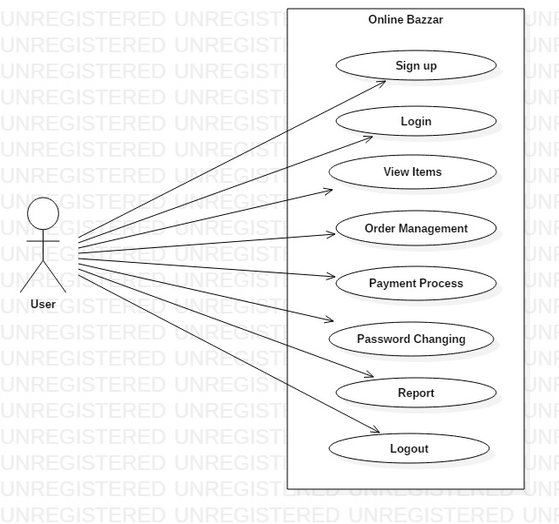

Fig: Use case diagram of User for Online Bazzar

# 2.8 Natural Language Analysis(NLA): -

Natural language analysis is the capacity of various programs for understanding human language. The scenario relating to this project “Online Bazzar “is demonstrated below: -

“Online Bazzar” is a web based application which provides their customer a relevant service. Generally, it is the process of purchasing the desirable items online through internet. Buying the product over internet has taken popularity now a days and many people find it comfort and easy means of buying the different products which diminishes the time taken mostly for the people who are busy on their daily life. It facilities its customers by making a business word smaller and relevant simply by clicking a mouse button any one can order the desirable item they view in the system.

After signup by the various customers in the proposed system they are able to choose the various items from category. The system facilitates the number of customers can have logged in at the same time and visit the item category and see various products. Customers can view the various products after login to the system they can order the desirable items through online system. The detail of the website is also illustrated if any customer wants to know about the system or organization details. The various items were updated by the admin of the proposed system. The system facilitates its customers by adding different modern and fashionable items. They can be updated and deleted by the admin on daily basis if any new products were seen the market.

The main objectives of Natural language analysis are to acquire the list of candidate classes, relationship between them and their behaviors. It helps to increase the efficiency of the proposed system and reduces the data duplication. After doing NLA process on certain scenario the list of candidates classes, their attributes and behaviors are enlisted below: -

|  |  |
| --- | --- |
| Classes | Functionality |
| Sign Up, Login, Items, Customers, Oder, Admin, items | Customer Sign Up, Customer Login, Ordering Items, Selecting Product, Admin login, Update bio, Add items, Update items, Delete items, view Items, Order view, Customer View. |

# 2.9 Initial Class Diagram:

It is a kind of static structure diagram that portrays the structure of a system by demonstrating the systems classes, their attributes, operations and the connections among objects. In class diagram some of the relationships are described below: -

* **Association: -**

Association represents the communication between two different classes is needed in class diagram so to it can be represented by the utilization of association i.e. connector.

* **Aggregation: -**

It is an arrangement of association relationship. It Is demonstrated by symbol hollow diamond.

**• Composition: -**

Basically, composition is subset of association that means they are specific cases of association.

* **Inheritance/Generalization: -**

Generalization is a mechanism for consolidating comparative classes of objects into a solitary, increasingly broad class.

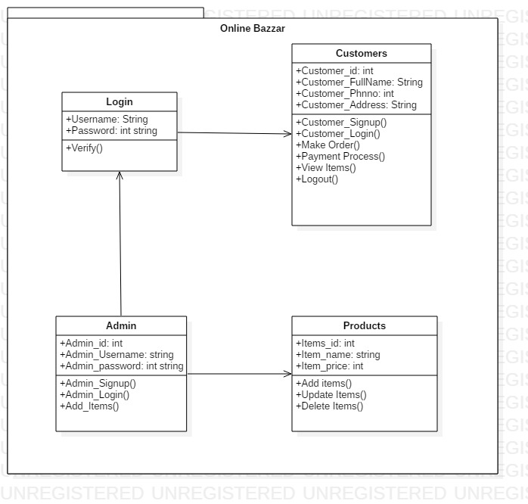

Fig: Initial Class diagram for “Online Bazzar”

# Conclusion: -

In this phase of analysis there is the utilization of the Moscow Prioritization which specifies the functional requirements of the projects. Use of use case diagram illustrates the relationship between actor and the system. beside this functional and non-functional requirement are specified. Lastly including all the above analysis is successfully completed.