# Chapter 3 Design

## 3.1. Introduction

Design of the project is one of the essential stage which leads the project to achieve its goals and explains how the requirements laid out in the functional requirements are performed by a system. Similarly, it facilitates to provide the basic ideas to test the specific requirements, setup setting and provides reviewing of codes and functions.

## 3.2. Tools

The specific tools which are used to develop a complete website “online Bazzar” are as listed below: -

• IDE (Integrated Development Environment) = Sublime Text

• Database Design= MYSQL

• Class diagram, Use case diagram, Activity diagram and sequence diagram= Star UML

• Entity relationship diagram= Visual Paradigm

## 3.3. Structural Model

Basically it involves the data flow diagram and class diagram and shows the relationship among various object and ways of communicating. It ensures that the relationship of a system to the extent the portion which help to build up their structure and association.

## 3.3.1. Class diagram

A class diagram shows the relationships between various classes and illustrates the structure of the whole system. The advantage of using class diagram is: -

• It provides a complete overview of the whole project to system developers before implementing the codes.

The basic notations used while making class diagram of the project “Online Bazzar” are demonstrated below: -

• Class: - It shows the effective approach from the objects, a group of people and their views: -

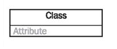

• Generalization: - It is denoted by arrow sign showing relation between various classes.

E:\you cam perfect\screenshots\generalisation.PNG

• Association: - it represents the object relation of one class to another class and denoted as: -

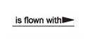

• Aggregation: - It is a specific factor of association consist of diamond shaped arrow.

E:\you cam perfect\screenshots\aggregation.PNG

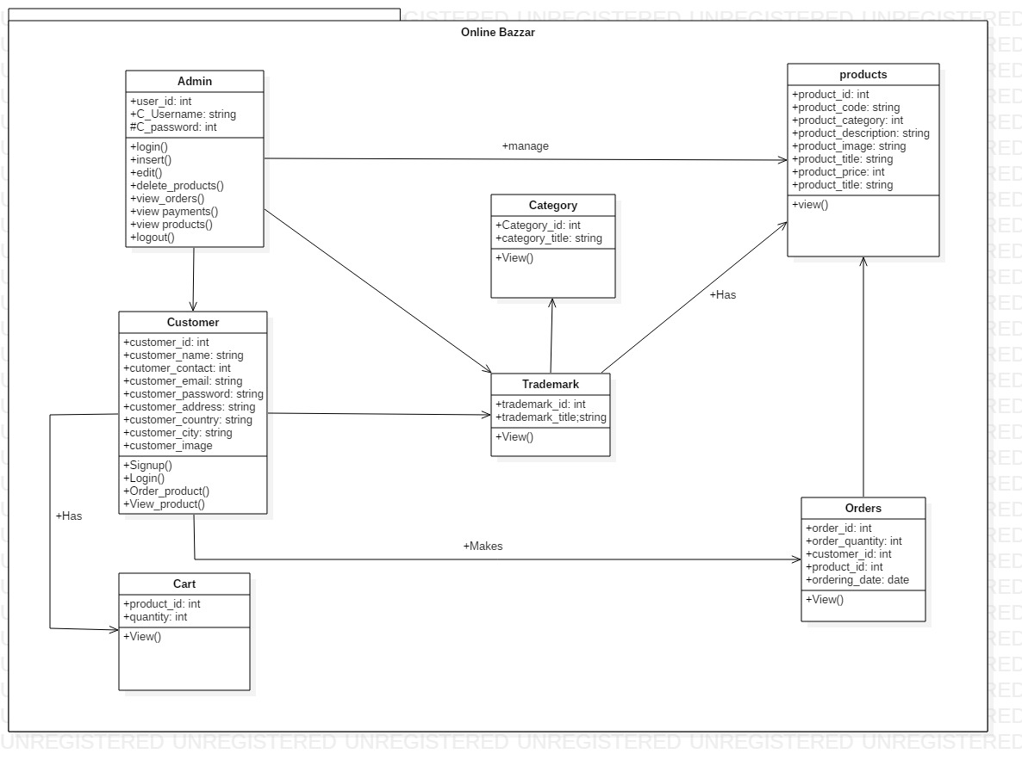

Fig: Class diagram for “online Bazzar”

**Justification:**

The above illustrated class diagram shows the interaction between various classes and represents the state of an object of the class. Here admin can manage products and product order as the need of various customer and the product category.

**3.3.3 Data Flow Diagram:**

DFD is the graphical representation of the flow of data in a certain system and describes the procedure which is engage with a framework to exchange various related data from input to system storage and helps to gain suitable report of the project.

The notation/symbols used while making data flow diagram of my projects are: -

• Entity: - It is also called source or terminator which is used to generate and expend data. It is denoted by the symbol: -

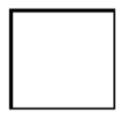

• Process: - simply it is an activity which is used in data transformation and changing data flows. It is denoted by the symbol: -

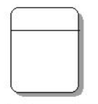

• Data store: - It is used for data influence for further access and did not perform any action. It is denoted by the symbol: -

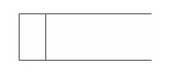

• Data flow: - It is used to represent the interaction between various entities, data stores and processes. It is denoted by the symbol: -

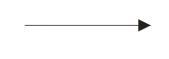

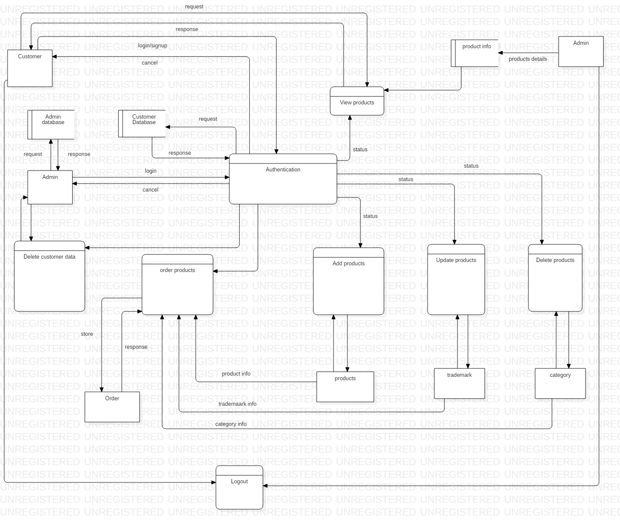

Fig: Data flow diagram for “Online Bazzar”

**Justification:**

The data flow diagram illustrated above provides detail information on describing system boundaries. The data is flowed from one entity to another i.e. after successful login of admin he can add, update and delete products and delete customer data. Here the flow of data from customer can order necessary items. In this way it is easier technique to understand the system.

## 3.4. Behavioral Model

It is the dynamic behavior of the system i.e. strong relation between various object to make a specific system. It facilitates to indicate what occurs and what should happen when a system reacts to an improvement from its condition.

In this step of behavioral model, the activity diagram and sequence diagram is used to show the strong relation between the various objects. The advantage of using behavioral model are as follows: -

• The system will be cost effective.

• It facilitates to meet all the requirements of the system.

## 3.4.1. Activity Diagram

It describes the dynamic aspects of the certain system and consider the flow of one activity to another activity which describe the system behavior. It regards as an essential tool for system developer because they are user friendly among various diagrams.

The basic notations used while making the activity diagram of the system are as below: -

• Action/Activity: It is rectangle in shape and shows non-separable object action. It is denoted by the symbol: -

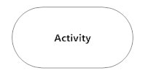

• Control flow: - It represents the transformation of the one activity to another. It is denoted by the symbol: -

E:\you cam perfect\screenshots\control flow.PNG

• Initial mode: - It represents as the starting step for any activity diagram and denoted by the symbol: -

E:\you cam perfect\screenshots\initial state.PNG

• Final mode: - It represents as the final state for any activity diagram and denoted by the symbol: -

E:\you cam perfect\screenshots\end point.PNG

• Decision Mode: - It is represented as the diamond shape and used for moving to next activity. It is denoted as: -

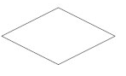

• Merge events: - it is used to combine one or more flow together and denoted as: -

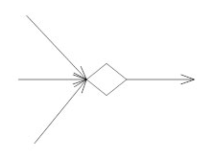

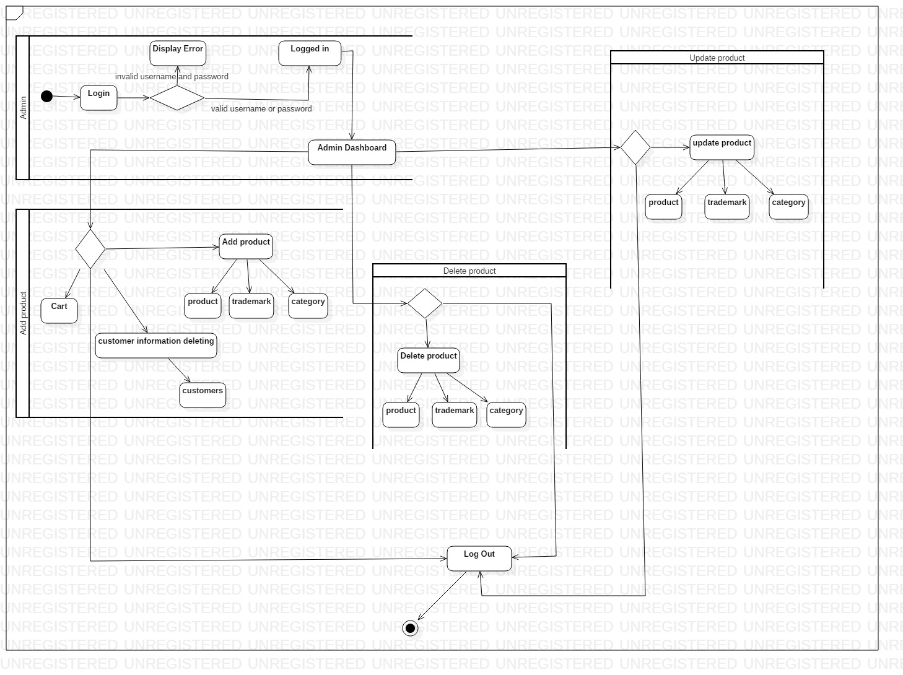

Fig: Activity diagram for Admin of system “Online Bazzar”

**Justification:**

Above activity diagram for admin shows the flow of data from admin dashboard to various activities. The diagram represents the activities of admin in system development and maintenance by adding products, deleting unnecessary customer data and makes system easy to understand.

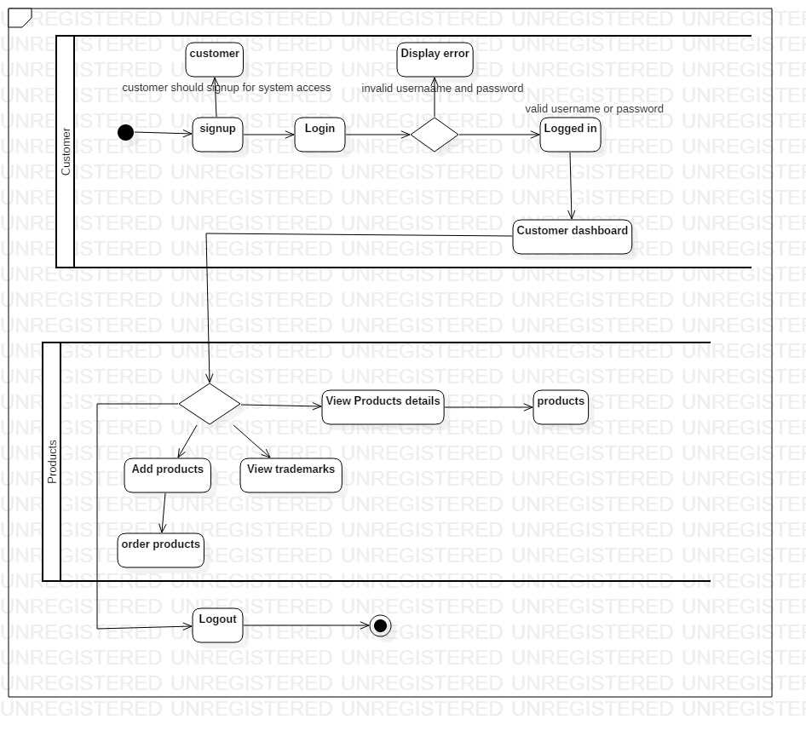

Fig: Activity diagram for customer of “Online Bazzar”

Justification:

Here after successful authentication of user the data is flowed from customer dashboard to various actions like viewing product details, ordering product and finally the customer can logout of the system.

## 3.4.2. Sequence diagram

These are communicating diagrams which Detaille explains how the task should be performed. It is also known as time Centre diagrams because it helps to demonstrate the request of collaboration outwardly by utilizing vertical pivot of diagram to show time.

The basic notation used while making the sequence diagram of “Online Bazzar” are as follows: -

• Synchronous message: - It is represented as arrow sign and needs specific response before interacting.



• Reply message: - Basically it is a reply for certain operation or action and denoted as: -

E:\you cam perfect\screenshots\reply message.PNG

• Self message: - It is a message in which object sent to itself and denoted as: -

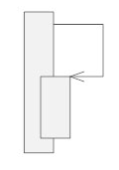

• Lifeline: - It shows the interaction of every instance and denoted as: -

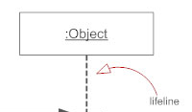

• Found message: - It is the message from unrecognized recipient.

E:\you cam perfect\screenshots\found message.PNG

• Lost message: - It is a message sent to unrecognized recipient.

E:\you cam perfect\screenshots\lost message.PNG

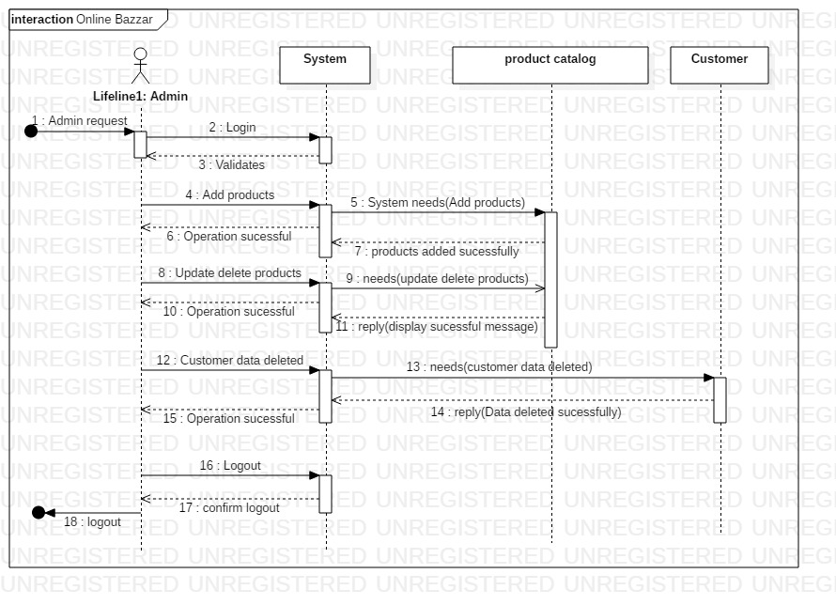

Fig: Sequence diagram for admin of system “Online Bazzar”

Justification:

The above sequence diagram for admin shows the architectural problems earlier as the admin is authenticated successfully there is the flow of data as shown by arrow sign and the message is replied by certain system.

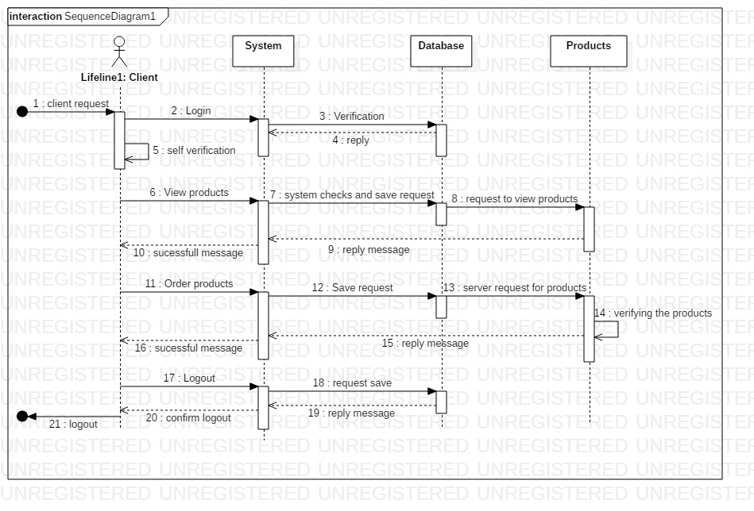

Fig: Sequence diagram for customer of “Online Bazzar”

Justification:

After successful login of client, he/she wants to access the system like ordering products, viewing products then the system checks the database whether it exist or not. The arrow sign with doted circle is the end point for the customer i.e. logout.

## Database:

## 3.3.2. Entity Relationship Diagram

It can be also indicated as the entity relationship model which is the graphical representation of the entities and relationship among various objects, events and concepts in a certain project.

The basic symbols used in developing ER diagram are as follows: -

• Entity: - It is rectangle in shape and used to store information about various objects.

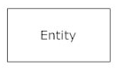

• Connecting lines: - It is used to manage the relationship among various entities by connecting different entities. The connecting lines which are used are as follows: -

1. One to one relationship: -

E:\you cam perfect\screenshots\one to one.PNG

1. Many to one: -

E:\you cam perfect\screenshots\many to one.PNG

1. Many to many: -

E:\you cam perfect\screenshots\many to many.PNG

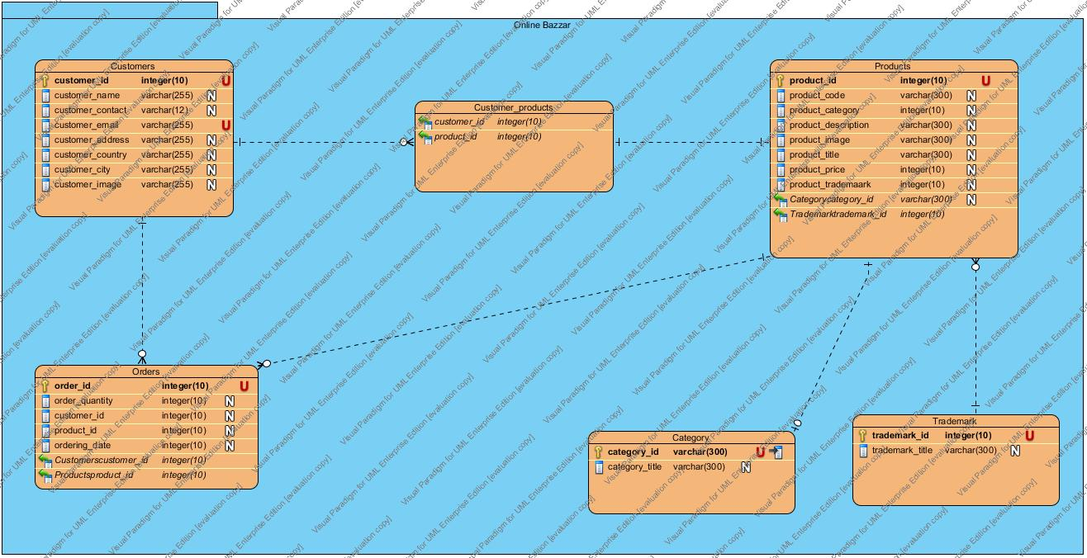

Fig: Entity relationship diagram for “Online Bazzar”

**Justification:**

In above entity relationship diagram the relation between various entities is represented. Here customer can order one or more product and one product has different category. Product is directly related with their trademark. Order is directly related with customer and product because one customer can order various products.

# Data Dictionary:

It is the process of arrangement of various data, object and items details in a data model or consist of data about database. Some of the advantages of using data dictionary are: -

• It provides effective and understandable information about database.

• It helps to track any disorder by providing specific details.

Here some of the tables are demonstrated below: -

• **Product table: -**

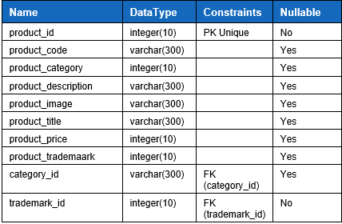

**• Customer table: -**

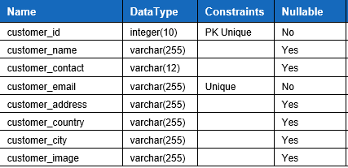

**• Customer_Product table: -**

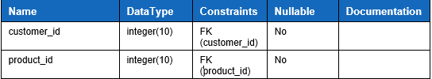

**• Trademark table: -**

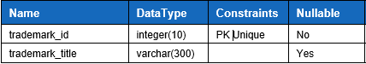

**• Category Table: -**

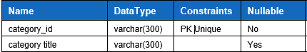

**• Order table: -**

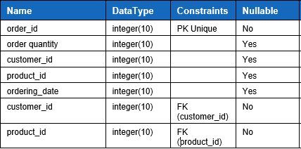

# System Architecture

## 3.5. UI Design

User interface design are the important to any system development because the whole design of the system will be meaningless if the customer did not find it easier and user-friendly. Here are some benefits of using UI design in the project: -

• It makes system easier to use and makes more attractive.

• It helps to increase company reputation and customer level of confidence.

• It will diminish the extra cost on regular maintenance of the system.

# Prototyping

prototyping is the fractional execution of an item communicated either physically or logically with every single outer interface introduced. Some of the benefits of prototyping are as follows: -

• It facilitates by reducing time, cost and ensure product quality.

• It will identify the system requirements and increases user involvement.

Here, I have used paper prototyping for the system “Online Bazzar” which are as listed below: -

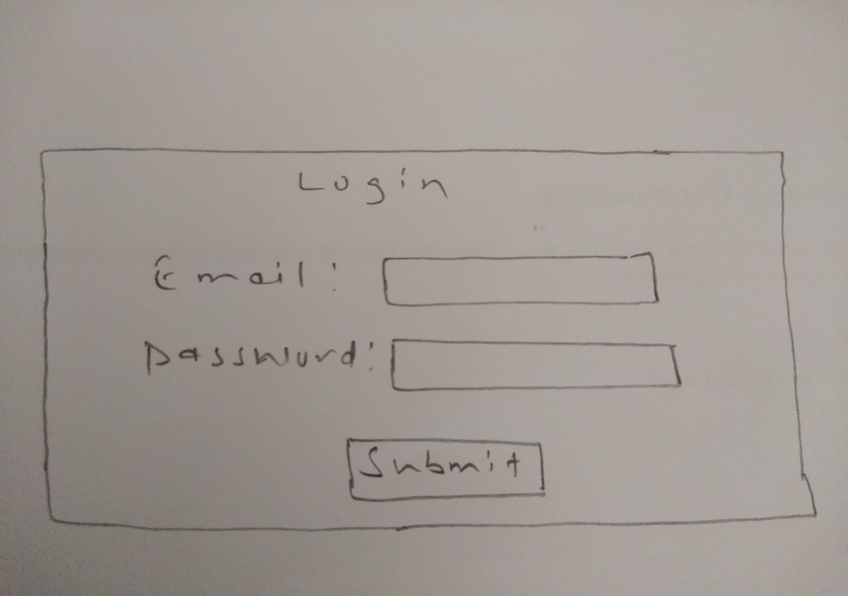

Prototype: Login form for customer

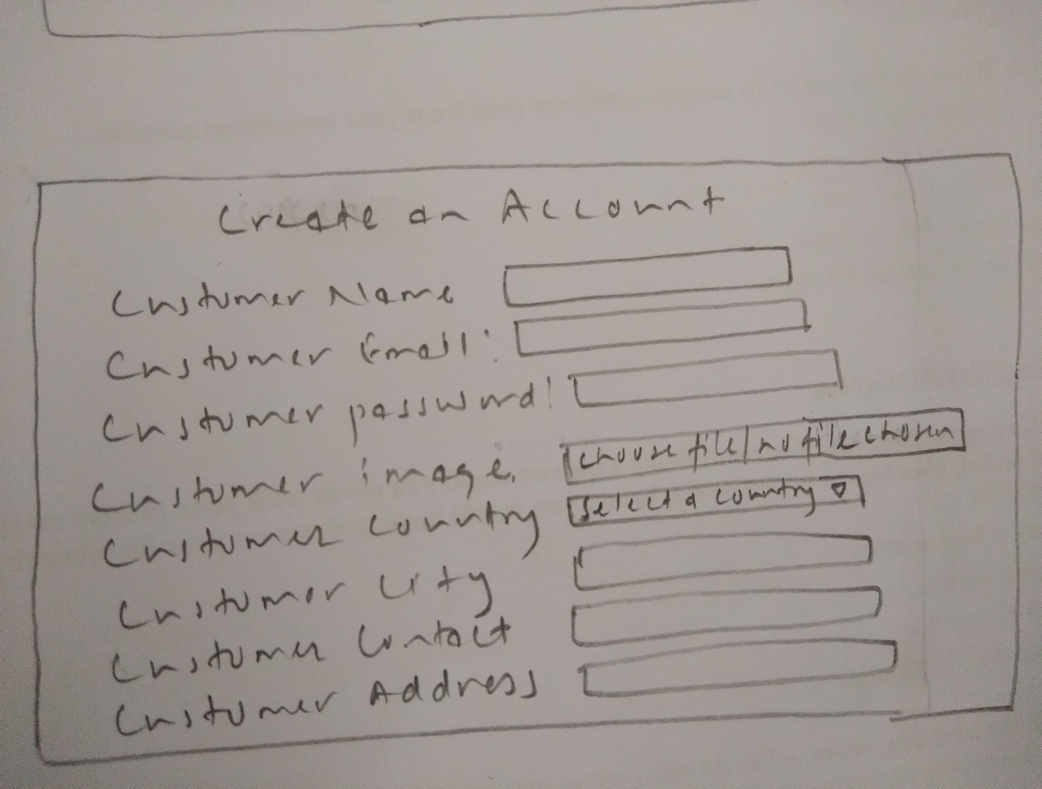

Prototype: signup form for customer

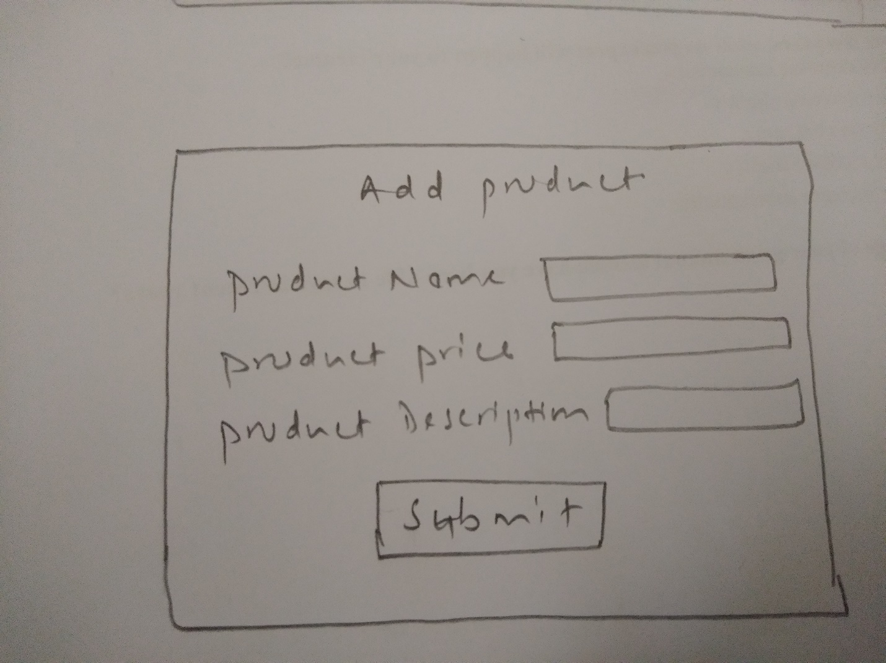

Prototype: Add product for admin

# 