Please see your account name <https://bitbucket.org/account/settings/>  under Bitbucket profile settings  <- use this for login name

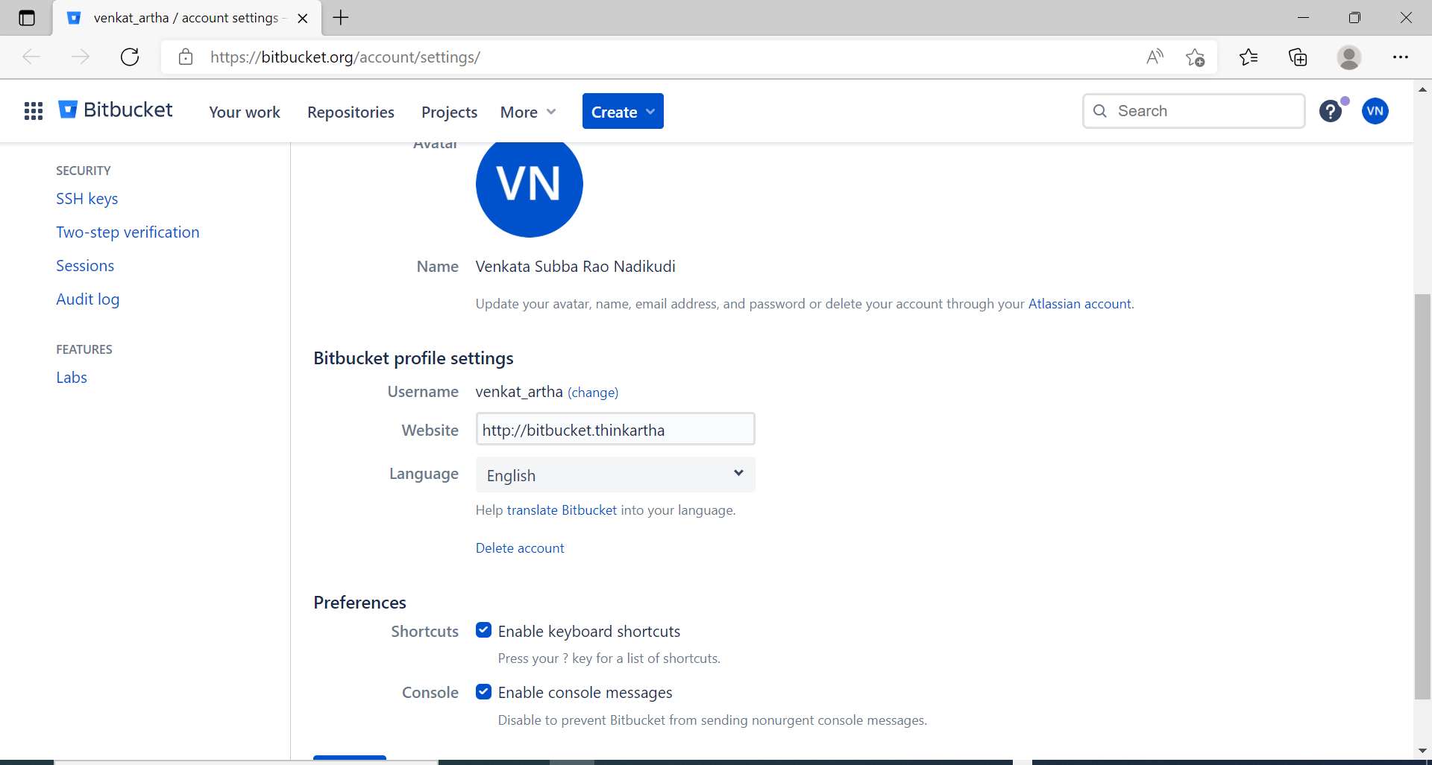

Project creation in bit bucket

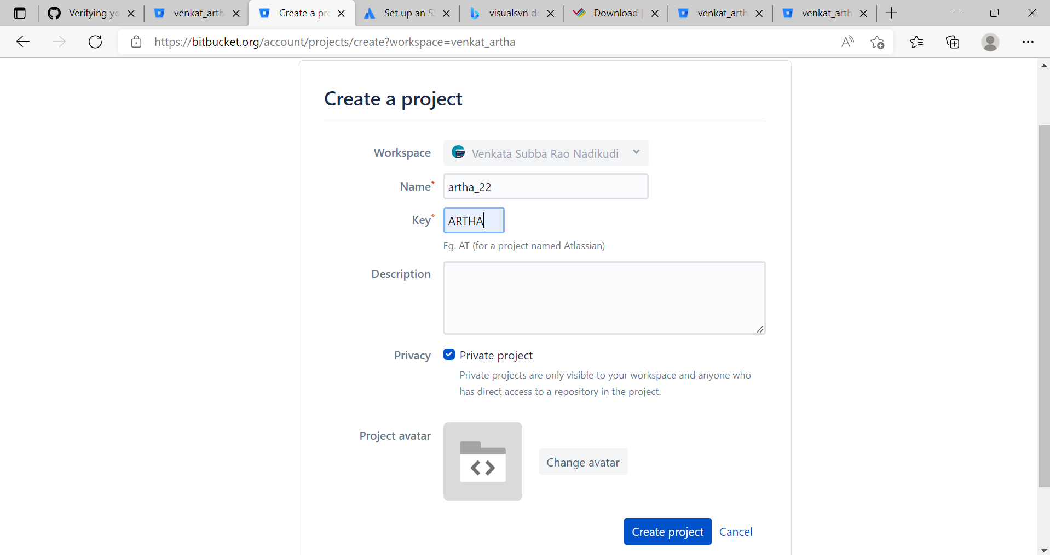

Repository creation

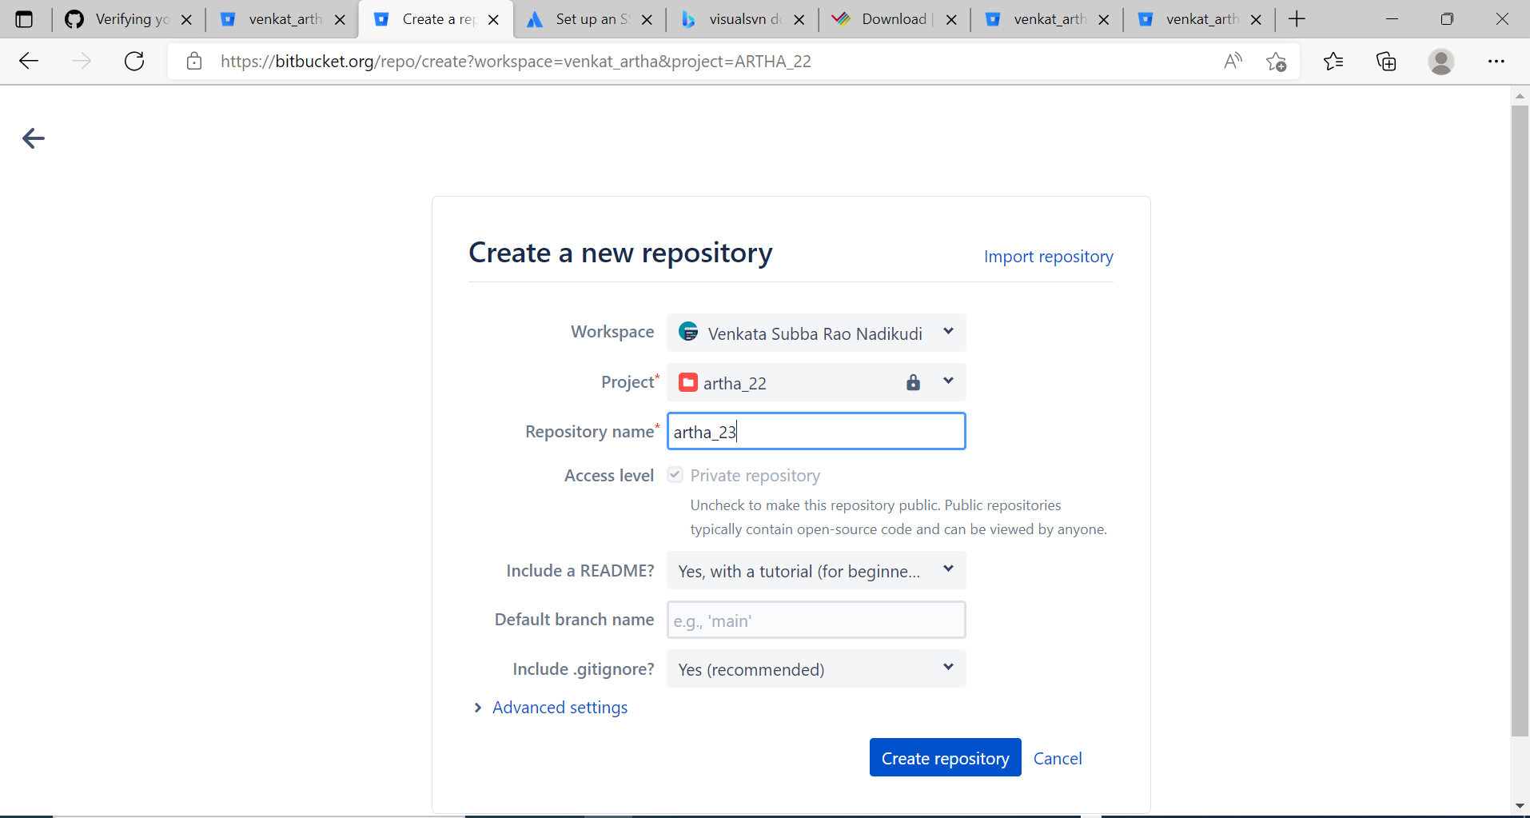

please go to <https://bitbucket.org/account/settings/app-passwords/> to create app password <- use this as password

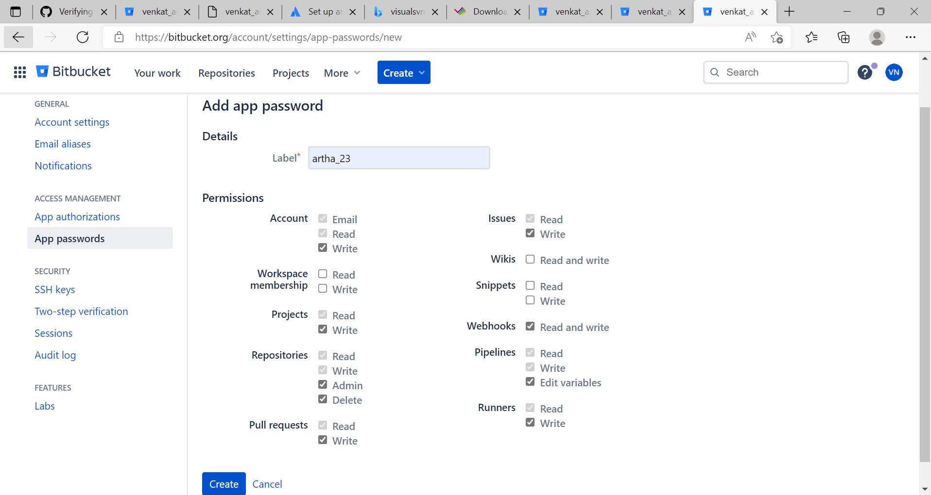

Generate app password

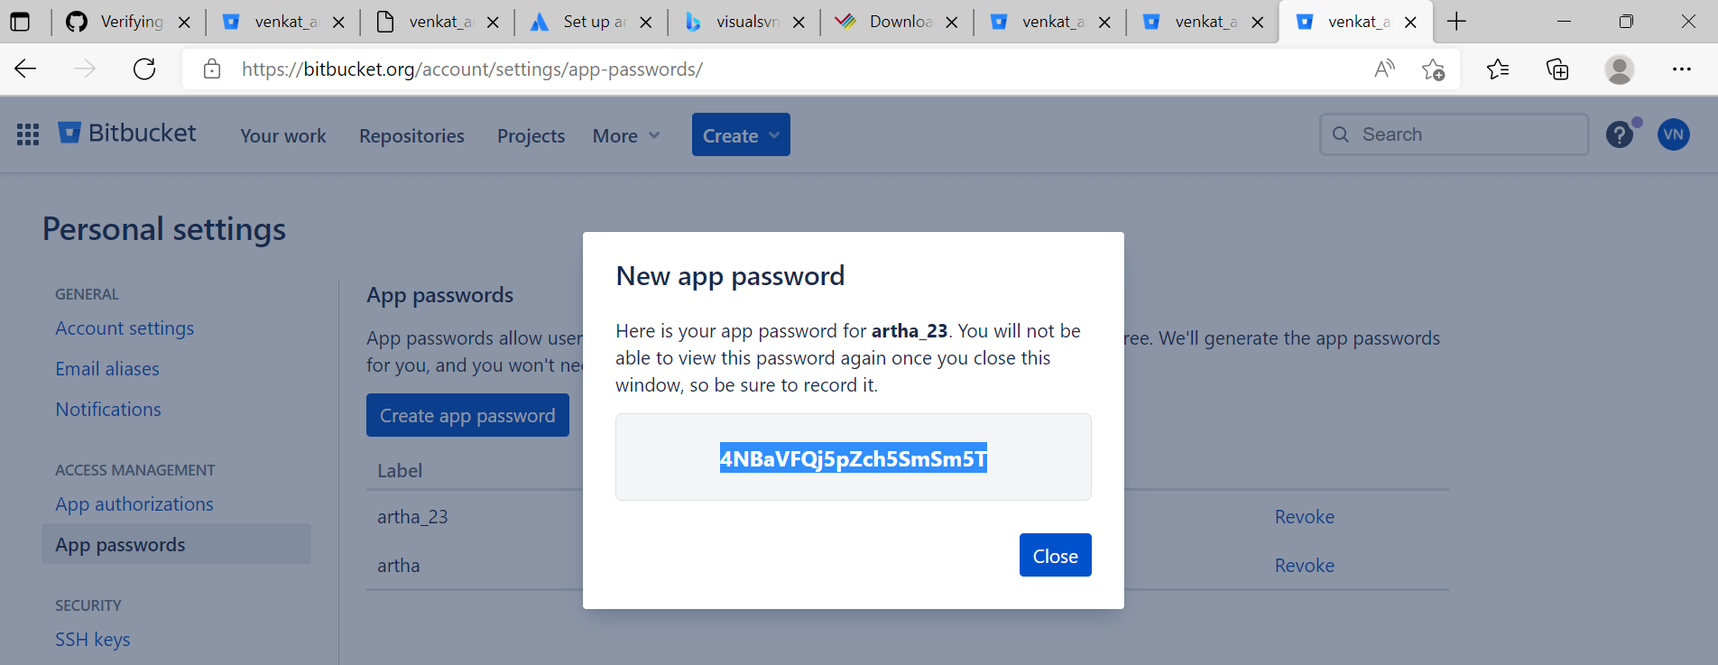

By using this url <https://bitbucket.org/dashboard/overview> we can able to see all created projects

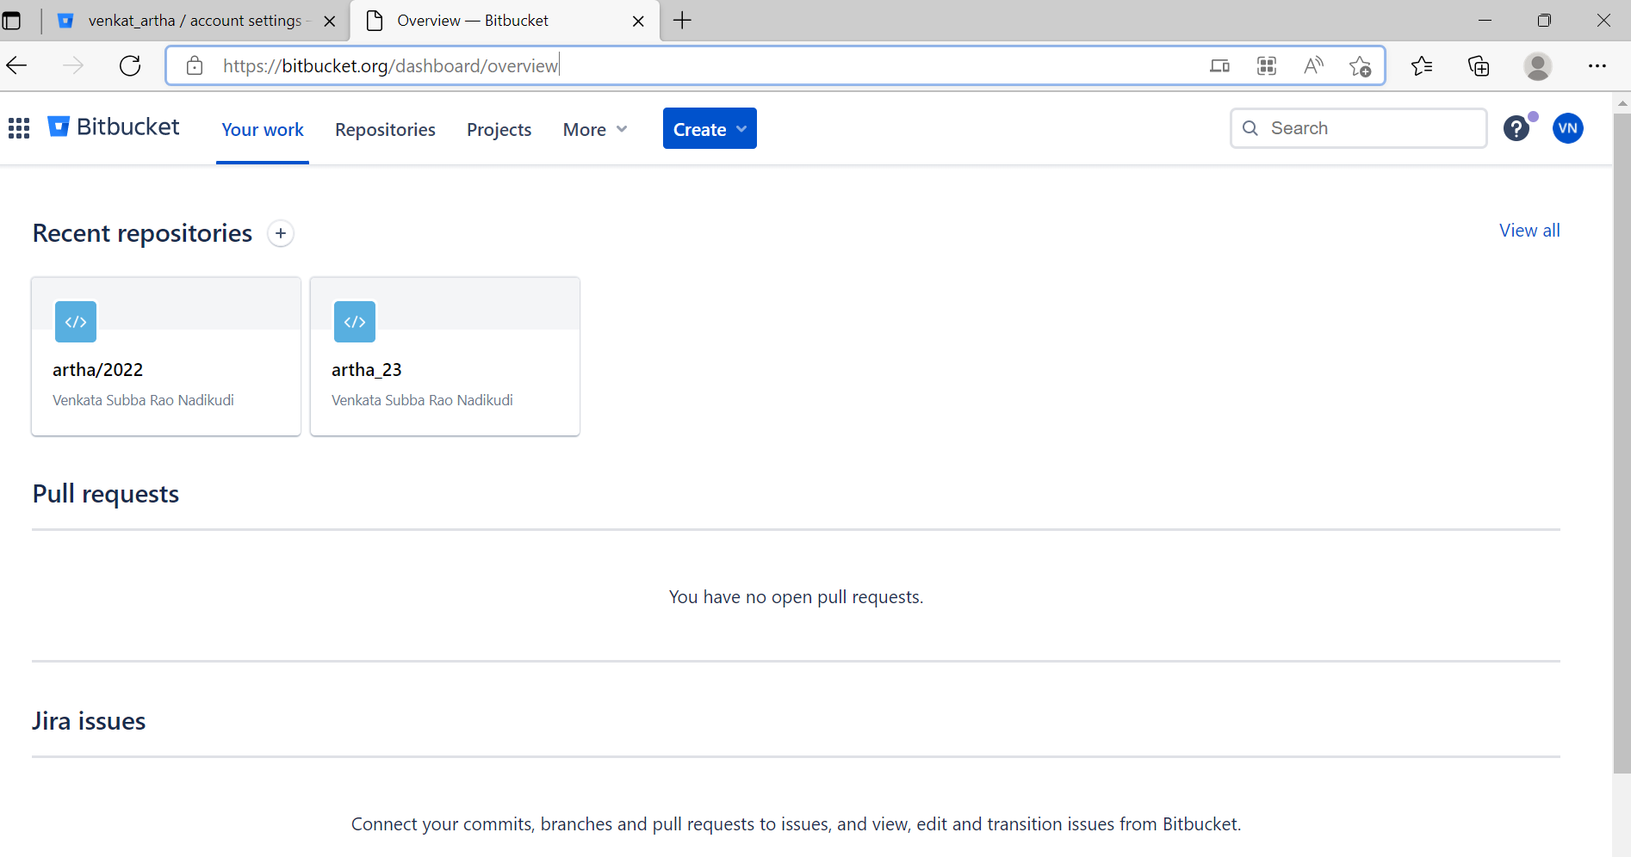

By through this URL: <https://bitbucket.org/venkat_artha/artha-2022/src/master/> we can see all project created in tac

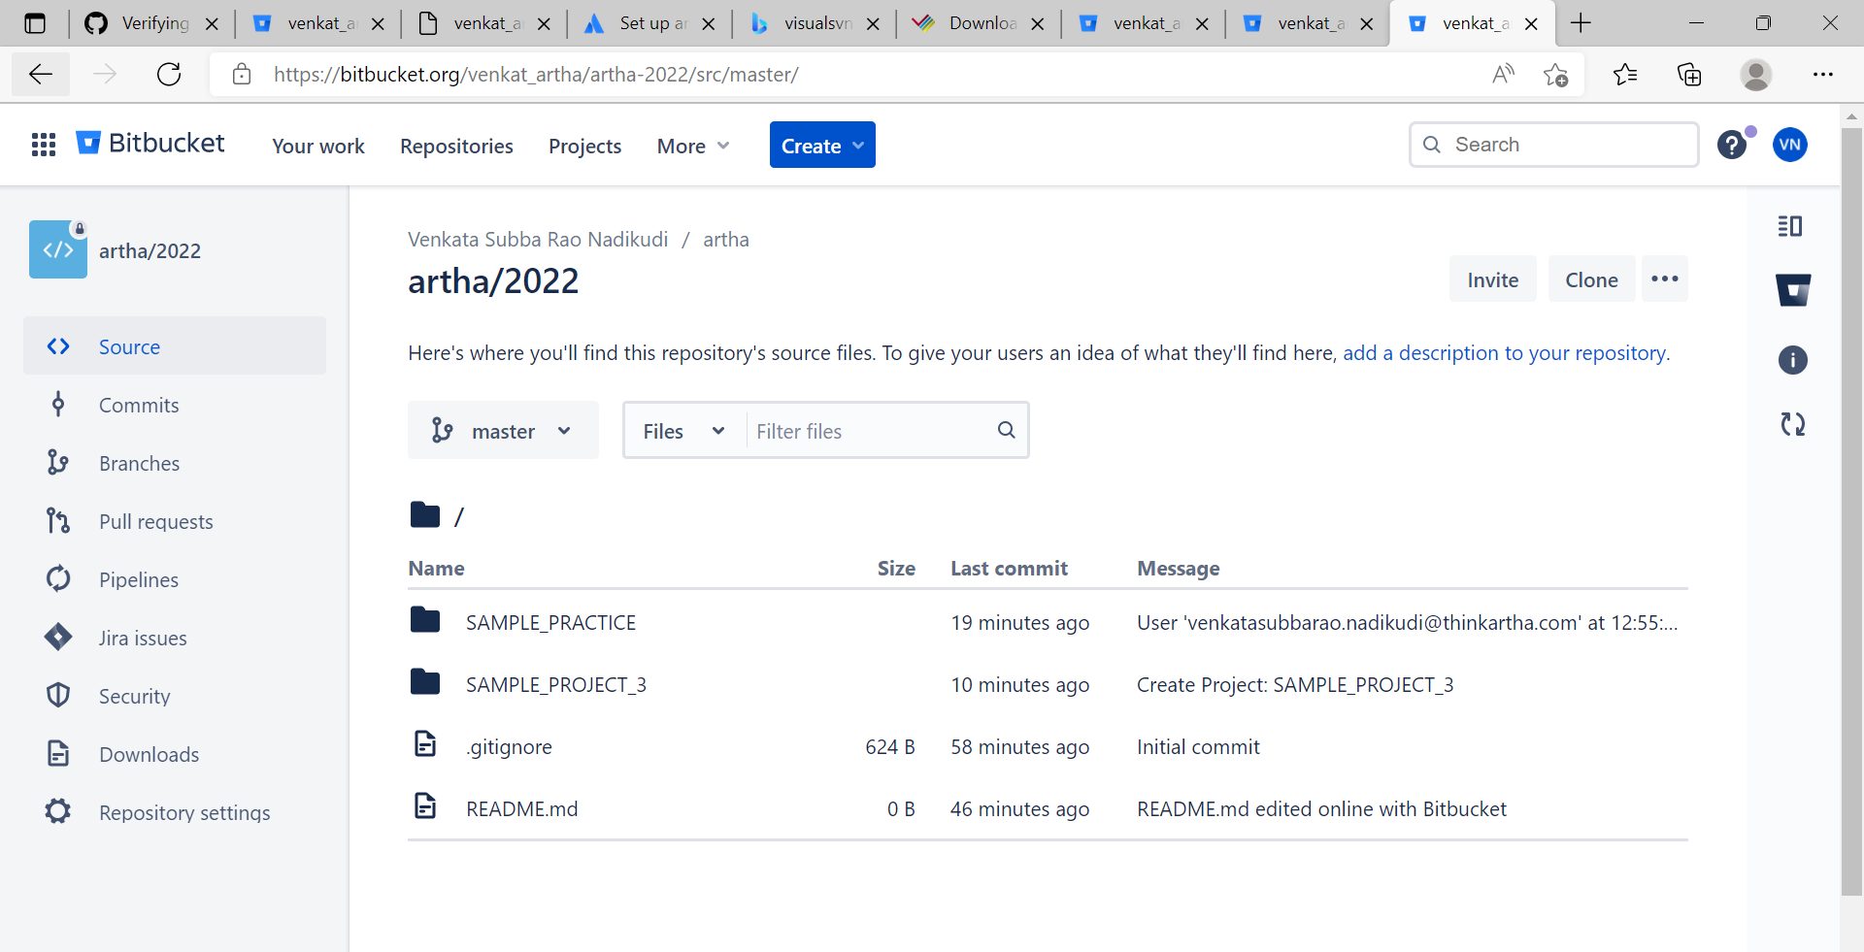

We can able to see what task are doing in talend studio. Its automatically commit in bit bucket

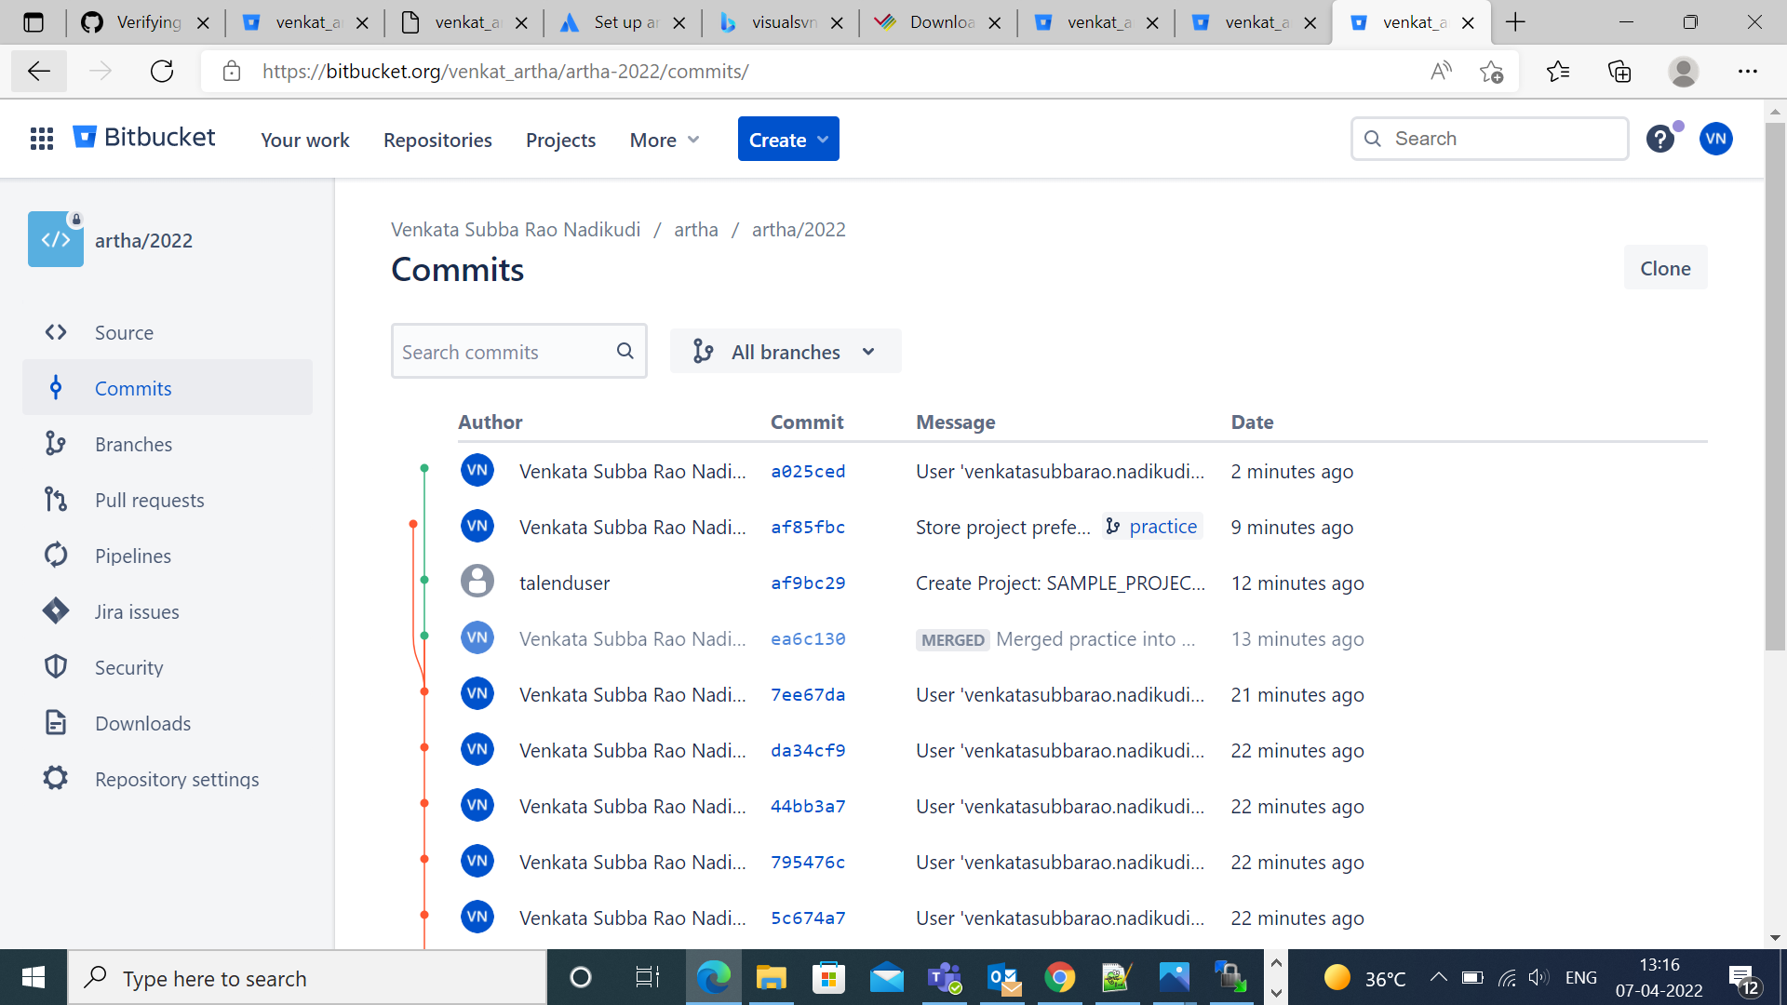

In Tac. we can give the bitbucket path and credentials under GIT tab

By using this credentials, we can connected with bitbucket through tac under GIT tab

url:<https://bitbucket.org/venkat_artha/artha-2022/src/master/>

username: venkat_artha

password: generated through pass key

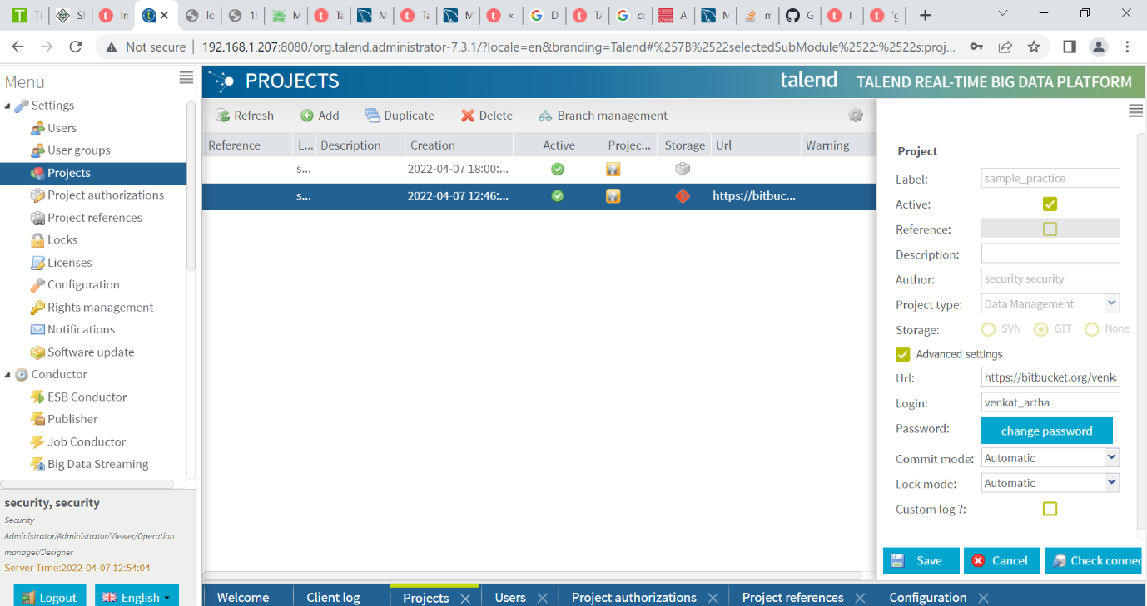

Giving to roles to the user

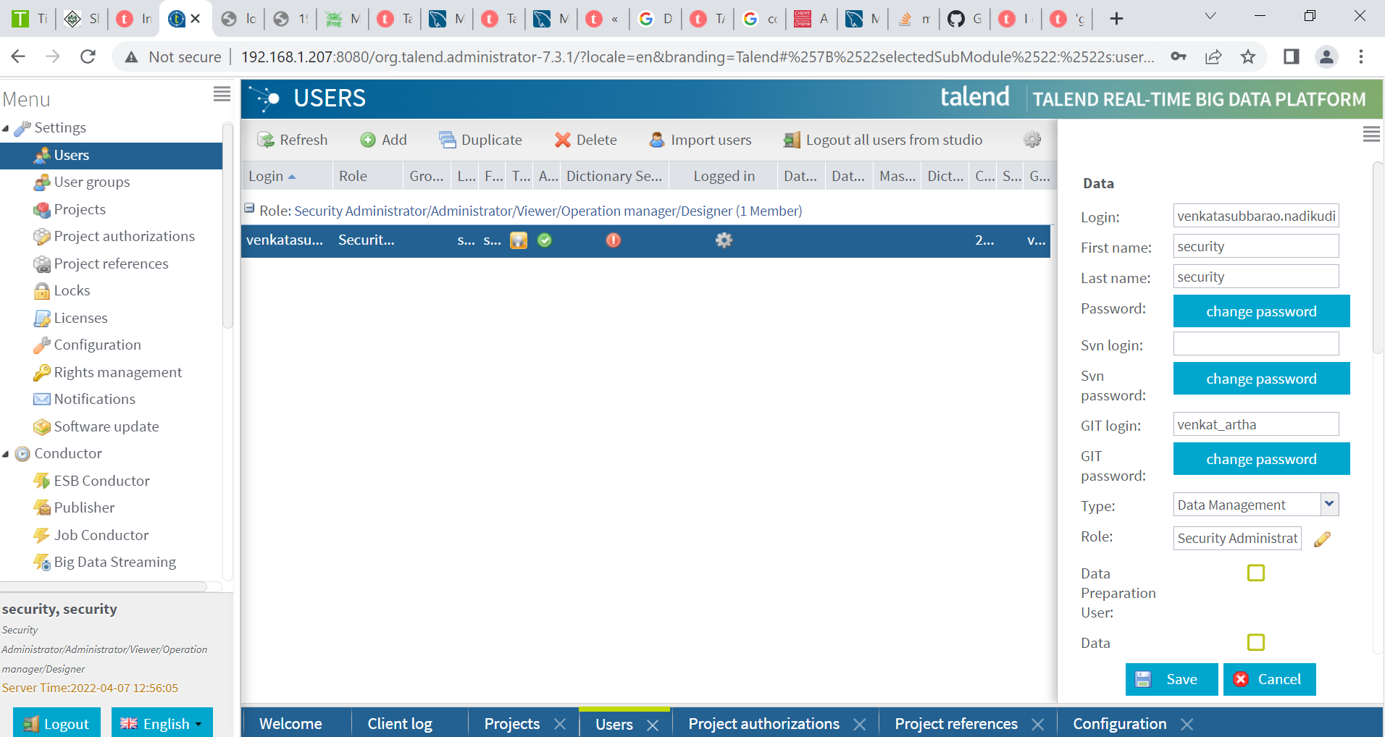

Creating user and giving permission (roles) to access projects

