Election Voting system in prediction of winning strategy with machine learning

Asani Vidhathri(700732408) | | Arun Kumar Yeddula(700739780) | | Rajesh Adepu(700741537)

Abstract:

The Election Voting Systems Assessment is an unprecedented project premised on a collaborative approach that ensures greater citizen input through partnerships within the academic community, public interest organizations, and with policy makers, in the pursuit of establishing a voting systems acquisition/development model that is collaborative and transparent and which is founded on sound data. This project analyzes the election voting in response to the growing voting system needs faced by the Country and in recognition of future regulatory changes and pending legal requirements our current systems are unable to meet. A large part of the survey and focus group research was dedicated to identifying how and what voters prioritize as core values that a voting system should satisfy. Any voting system that serves Country must satisfy all legal standards and requirements pertaining to accuracy, security, and accessibility for voters with language needs and voters with disabilities; as established by laws. However, the purpose of this work was to ascertain what voters think about when they use and the methods used to audit voting systems. The data is filtered and the data is interpreted with visualization with the help of data analytic tool.

The analysis research suggests that voters use their stated values to evaluate and make up their minds about voting systems. Voters in these studies evaluated the systems based on values associated with accuracy, security, and ease of use. The project will involve data pre-processing to ensure data quality and consistency. Various visualization techniques, such as strategy visualization and Seaborn plots, will be employed to effectively present and interpret the voting patterns.

Additionally, machine learning algorithms like logistic regression and polynomial regression will be utilized to model and predict voter behavior. The results of the project will provide actionable insights for political parties, candidates, and policymakers, aiding in the development of targeted strategies and campaigns. The findings will contribute to evidence-based decision-making, enhance the transparency and integrity of elections, and promote a deeper understanding of democratic processes.

Key words:

election prediction, machine learning, logistic regression, decision tree, voting, prediction, accuracy, preprocessing.

github link: https://github.com/Vidhathriasani/Final_machinelearning.git

Introduction:

The main aim of the project is to analyze US National Election. The main objective is to find the strategy to win the current trend election by using Analytical tool and predict which party wins the election. Python is used for analyze and visualizing the data. The total Voting between different regions in US are taken to analyze the best strategy to win the current trend election. First the data is collected and the data is pre-processed by removing the fake votes, duplicate votes and removing null values. Strategy Visualization is that visualizing the last 2 elections where winning party’s strategy is visualized and compared. From the visualization we can predict the chance of winning party. Using the machine learning algorithm to find the best trendsetting strategy from the overall positive strategy that would help parties to win the current trend election. Machine learning algorithm is used to analyze the best strategy that can help the parties to win the election. There are many strategy is used by various parties to win the election ,by using Machine learning algorithm we predict the best strategy to win the election. The algorithm that is used for analyzing the data are Logistic Regression, Polynomial Regression and Linear Regression. People survey is also taken into account for the accurate results. The year of election, party competing and the total votes occupied by the party are analyzed and the election results are also visualized using the pair plot.

Background:

Elections play a crucial role in democratic societies, shaping governments, policies, and the overall direction of a nation. Understanding voter behavior and preferences is essential for political parties, candidates, and policymakers to develop effective strategies and connect with the electorate. However, analyzing and interpreting voting patterns can be a complex task due to the vast amount of data involved.

In recent years, advancements in data analysis, visualization techniques, and machine learning algorithms have provided new opportunities to gain insights from election data. These tools allow for the exploration of relationships between various factors such as demographics, political affiliations, and voting outcomes. By leveraging these technologies, researchers and analysts can uncover hidden patterns and trends, enabling a deeper understanding of voter behavior.

The Election Voting with Visualization Pattern Interpretation project aims to harness the power of data analysis and visualization to uncover meaningful insights from election data. By applying machine learning algorithms, such as linear regression and polynomial regression, the project seeks to model and predict voter behavior based on historical data. The project also focuses on using visualization techniques, such as strategy visualization and Seaborn plots, to present the findings in an intuitive and understandable manner.

Through this project, stakeholders in the political landscape can gain valuable insights into voter preferences, voting patterns, and the effectiveness of different strategies. This knowledge can inform campaign decisions, policy-making, and the development of targeted approaches to engage with the electorate. By leveraging data-driven techniques, the project aims to enhance the understanding of democratic processes and contribute to the improvement of electoral systems.

THE PROJECT CONSISTS OF THE FOLLOWING MODULES:

Logistic Regression: Logistic regression is used as a classification technique to predict election outcomes based on historical data. The model's performance is evaluated using metrics such as accuracy, precision, and recall. Interpretation of the coefficients helps understand the influence of different variables on the prediction.

Linear Regression: Linear regression is a statistical modeling technique used to analyze the relationship between a dependent variable and one or more independent variables. In the context of the project, linear regression can be used to understand the relationship between various factors (such as demographics, socio-economic indicators, etc.) and election voting patterns.

Polynomial Regression: Polynomial regression is an extension of linear regression that allows for more complex relationships between the independent and dependent variables.
In the project, polynomial regression can be used when the relationship between the independent variables and the voting patterns is nonlinear.

Seaborn: Seaborn is a Python library for data visualization that is built on top of Matplotlib. It provides a higher-level interface for creating statistical graphics and supports more complex visualizations such as regression plots and factor plots.

Motivation:

The project is motivated by the need to gain a deeper understanding of election voting patterns and their underlying factors. Elections are crucial processes in democratic societies, and analyzing voting behavior can provide valuable insights into public opinion, political dynamics, and decision-making.

By studying election voting with visualization pattern interpretation, we aim to uncover patterns, trends, and relationships that can help in better understanding voter preferences and behaviors. The project seeks to address the increasing demand for data-driven approaches in analyzing elections and making informed decisions.

Understanding voting patterns can assist political parties, candidates, and policymakers in developing targeted strategies, crafting effective campaigns, and addressing the concerns of different voter segments. The project also aims to contribute to the improvement of election systems by identifying potential issues, such as voter bias, regional variations, or demographic disparities, and proposing solutions for more inclusive and fair elections. There are many strategies used by various parties to win the election, by using Machine learning algorithm we predict the best strategy to win the election.

By leveraging data analysis and visualization techniques, the project aims to provide actionable insights and enhance the overall transparency and integrity of the electoral process. Ultimately, the motivation behind this project is to promote evidence-based decision-making, foster democratic engagement, and contribute to the advancement of electoral practices.

Main Contributions and Objectives:
- The election vote with machine learning on will be the python-based application which contributes to find out the winning strategy.
- Identifying and pre-processing parties for customizing them and removing null values.
- Taking the past election results into account; analyzing their winning/losing ways and visualizing the comparison therefore, predicting the strategy of winners.
- Using machine learning algorithm to find the best trendsetting strategies from the overall positive strategies that would help parties to win the current trend elections.
- To create an attribute people survey percentage compared with result, and also using linear Regression Algorithm.
- Visualizing Final result using pair wise relationship plotting and calculate the accuracy score for logistic, polynomial and linear Regression.

The primary goal of the Election Voting with Visualization Pattern Interpretation project is to analyze and interpret election voting data using data analysis, visualization, and machine learning techniques. The project aims to uncover meaningful insights into voter behavior, preferences, and patterns to enhance our understanding of democratic processes.

Related Work:

US is the largest Democracy in the world, casting a vote is one of the most utilized terms in the modern age of democratic politics. In Democratic systems, adult citizen uses “voting” As a means for expressing his approval or Disapproval of governmental decisions, policies, and programmers. Casting a Voting is an Important process of the democratic system, and the decision made at the base has the power to change the power elites. [4]

US has an electorate of quite 668 million and covers 543 parliamentary constituencies. Voting is that the bridge between the governed and government. The previous couple of years have brought a renewed specialise in to the technology utilized in the voting process. The current electoral system has many security holes, and it's difficult to prove even simple security properties about them. An electoral system which will be proven correct has many concerns. There are some reasons for a government to use electronic systems are to extend elections activities and to scale back the elections expenses. Still there's some scope of labour in electronic electoral system because there's no way of identification by the electronic electoral system whether the user is authentic or not and securing electronic voting machine from miscreants.[7]

The election system isn't only seen in US, it are often seen altogether countries of the planet. The successful administration of the government is also decided by the electoral system. Even though it is a standard system in US, many changes have still been made to it itself, and it is now US's most advanced progressive system. The election system in US has many features, such as adult franchises, electoral district reservations, appointments, etc. In US, our electoral system is extremely strong administrative machinery that conducts elections on a regular basis. [8]

The US voting system has been broadly divided into two, they're Direct election supported territorial constituencies and representation by means of one transferable vote. The first system is followed for the election of members of assemblies. Second, the idea of representation continued through one transferable vote for the President and therefore the Vice-President of US, the members of council and the members of the Legislative Councils. [5]

Voting is one of the most frequently used words in democratic politics. Voting is that the life and soul of democracy because it's through elections the people elect their representatives, forms their government. Citizen uses voting as a means for communicating his endorsement or objection to governmental decisions, policies and programmers of various political parties.. An empirical study of the determinants which inspire and influence the voters to exercise his right to choose favour or against a specific candidate is influenced by various factors like gender, race and pressure groups in invoking religious and communal factors, the influence of cash or charismatic personality of a pacesetter . The main purpose of the present study is to focus interest on voting behaviour in US and to emphasize the factors that determine the voting behaviour in US [9]

Voting refers, in a limited way, to the function of electing representatives by casting votes in elections. Frequent and highly competitive elections, supported by universal adult franchise, have become the hallmark of US's most important democracy on the planet. It is an acknowledged incontrovertible fact that contrary to the history of latest representative democracies which began with the proper to vote from exclusion to inclusion. US stands out as a triumphant democracy by providing non-discriminatory Right to Vote to every citizen of US from the very inception of its constitution. [1]

The Constitution of US has provided the US Election Commission with the authority, direction and control of the entire process for the conduct of elections to the Parliament and the legislature of each State and the offices of the President and Vice-President of US. [10]

The objectives of the US Election Commission as follows: "Our country is vast, made up of various races, languages, cultures, classifications, etc. The Election Commission, consisting of the Chief Electoral Commissioner for US at all levels, is therefore required to prevent injustices that might otherwise occur to the mixed population. This central body works with, free from local influences and shall have the control over the entire Election machinery in the country”. [8]

Elections in US are almost entirely carried out using electronic voting machines set up during the last two decades by a pair of government-owned corporations. These devices, known as EVMs in US, have been praised for their basic nature, ease of use and reliability, but have also recently been criticized for the widespread reporting of election irregularities. Despite this criticism, many details of the machine design have never been publicly disclosed and have not been subject to a rigorous, independent safety assessment. [2]

A good leaders or Government is that the basic got to develop country. In US, who is largest democratic country within the world people aren't fully involved within the selection process of Leaders. On average, 60-65 percent of the vote is taken. To this end, we have built an information warehouse containing all the knowledge associated with the election to increase awareness of the vote. Using this, we will find interesting patterns that are extracted and represented using Visual Data Processing to reorder the awareness program. The approach is split into 5 phases: I) Data Pre-processing: II) Data Warehouse Creation: III) Task-Relevant Data Extraction; IV) data processing and V) Visualization. In Data Warehouse Creation phase, warehouse with vote as measure actually and voter Gender, voter age, voter education, candidate, Religion, time, session, word as dimension. Word dimension has a four-level concept hierarchy of country, state, city, area/word id. The results of the data mining phase are represented in the last phase using Visual Data mining techniques. [4]

Democratic process in US by holding free and fair elections in US. It was established in 1950 and it derives its source of authority from Article 324 of the Constitution of US and therefore the Representation of individuals Act, 1956. Elections for Legislative Assemblies, State Legislative Councils and the offices of the country's President and Vice-President have been administered since its inception.
Election studies are a distinct sub-genre of democratic studies which, so to speak, focus more on the 'mechanics' than on the 'substance' of representative democracy. This sub-genre, which is relatively more visible than other studies of representative democracy, has specific implications, both academic and political, which have been the focus of this critical review of the literature on US elections since the 1980s. [19]

Results of state elections in US yield varied and unique insights. While national news outlets do a fairly good job of analyzing and communicating federal elections, state elections, on the other hand, have remained largely devoid of rigorous analysis and informed communication. Using the data from the Assembly elections held in the state of Tamil Nadu in May 2016, we present a process and set of interaction design and visualization methods to present complex insights, but also empower readers, depending on their level of interest and civic engagement, to go beyond what is presented and to discover new insights for themselves. [12]

The study of determinants of electoral behaviour constitutes a really significant area of empirical investigation. Man may be a rational creature within the philosophical sense of term; he's not so rational within the realms of his economic or political behaviour. Influence of cash or charismatic personality of a pacesetter and host of other irrational forces have their definite influence on the minds of the voters. The main purpose of the present study is to focus attention on voting behaviour in US and to highlight the factors that determine the voting behaviour in US. [20]

Measuring Voting Behaviour in US captures the dynamics of multiple methodologies used for measuring voting behaviour in US within the past and present. The authors expand on the various approaches used to assess the views, behaviours and beliefs of the electorate. They address the benefits and disadvantages of each form of gathering the multiplicity of electoral experience of multiple voters through various settings in US. This they accomplish utilizing their long experience of conducting national- and state-level election surveys in US and by simultaneous studies using different methodologies. [15]

Political leaders of such a huge democratic nation, making micro target messages was a big challenge. It was through the state party leaders they were able to communicate the local issues of each state and each specific region through the local leaders there. But the advent of Big data has opened the wider options for national party leaders to make customised messages for any region they are visiting during election campaign. Big Data analytics techniques provides many other benefits also. [1]

Spam detection has been discussed as a text classification or categorization problem in the last decade. In this paper, we suggest a substitute dynamic weighted voting system assisted by a mixture of clustering and weighted voting, and apply it to the spam filtering mission. In order to classify a replacement sample, it first compares with all cluster centroids and its similarity to every cluster is identified; Classifiers within the vicinity of the input sample obtain greater weight for the ultimate decision of the ensemble. The evaluation shows that the algorithm outperforms pure SVM. [13]

Proposed Framework:

The primary objective of the study is to analyze the regions that are having the highest winning and losing categories in election and also analyzing process is done between the various strategies, electors, and total vote poll for the year 2009 and 2014. The analyzes of losing and winning parties in election is taken into consideration mainly. The strategies which are used for elections helps in finding out the current trend setting to win the election. A large part of the survey and focus group research was dedicated to identifying how and what voters prioritize as core values that a voting system should satisfy.

Feasibility Study
The dataset is coined with US NATIONAL ELECTION enumerated with winning or losing of various parties along with their strategies for the year 2009 and 2014.The dataset consist of state name, year, place number, place name, place type, candidate name, candidate sex, party name, party, total vote poll, electors, result, strategy1, strategy2, strategy3, strategy4, strategy5, people survey. The pre processing of data is done and all negative values are taken away and after which the process is done for analyzing the strategies used by the winning parties in the year 2009 and 2014 are taken to help them in finding the best trend setting.

SYSTEM SPECIFICATION:

HARDWARE REQUIRMENTS:

Device name- WINDOWS-74PPV22
Processor - Intel(R)Core (TM) i3-7020U CPU@ 2.30GHz 2.30 GHz
Installed RAM- 4.00 GB (3.43 GB usable)
Device ID-AEF4C744-BF5D-433D-B41A-93AF49E3C1D7
Product ID- 00326-10000-00000-AA591
System type- 64-bit Operating system, x64-based processor
Pen and touch-No pen or touch input is available for this display

SOFTWARE REQUIRMENTS:

Operating systems: Windows* 7 or later, macOS, and Linux
Python* version: 3.8.5
Operating System: Windows 10 Home/1909
Front-end Tool: Python Colab

Data visualization on Collab:

For the Python ecosystem, one starts inevitable with the foundation block of Matplotlib, for then possibly expanding to one of the higher level alternative (e.g. Seaborn, Bokeh). An additional increasingly-guaranteed choice especially for data sciency figures is the use of Jupyter notebook. Mainly combined with the support of colab, the Matplotlib+Seaborn combination works great for my visualization needs, even better with the additional embedded plotting capabilities of Pandas. When in need of animation functionalities, the simple animation framework present in Matplotlib from version 1.1 provides a great compromise between usability and results. Matplotlib is a data visualization library that can create static, animated, and interactive plots in colab Notebook. Seaborn is another commonly used library for data visualization and it is based on Matplotlib.

Data Description:

To analyze the best strategy for winning the current best trend setting National Election of US by using the past 2 elections winning party’s strategy. The dataset is imported in Python, some packages are imported to plot graph. Then the dataset is pre processed by removing null values and to know the information about the dataset. Strategy Visualization is that to find the winning parties and their strategy. After finding the winning party’s strategy, by using Machine learning Algorithm we can analyze the best strategy to win the current trend election. Here Logistic Regression, Polynomial Regression and Linear Regression is used to get accurate results. Logistic Regression compares the loss strategy and winning strategy and gives us the best strategy to win the election. Polynomial Regression is used to find the most used by the parties. Then People survey is added to the dataset, it tells the percentage of the win and loss of the parties. We used scatter plot to visualize the dataset. Linear Regression shows that total number of votes in the election by comparing two attribute which is electors and total vote poll. In this the year of election, party competing and the total votes occupied by the party are analyzed and the election results are also visualized using the pair plot.

TESTING FUNDAMENTAL:

LOGISTIC REGERESSION
Logistic Regression is the appropriate regression analysis to conduct when the dependent variable is dichotomous (binary). Logistic regression is used to describe data and to explain the relationship between one dependent binary variable and one or more nominal, ordinal, interval or ratio-level independent variables.
POLYNOMIAL REGRESSION
Polynomial Regression is a form of linear regression in which the relationship between the independent variable x and dependent variable y is modeled as an nth degree polynomial. Polynomial regression fits a nonlinear relationship between the value of x and the corresponding conditional mean of y, denoted E(y |x).
LINEAR REGRESSION
Linear regression attempts to model the relationship between two variables by fitting a linear equation to observed data. One variable is considered to be an explanatory variable, and the other is considered to be a dependent variable.
IMPLEMENTATION:
- Logistic Regression is used to analyze the best strategy from the winning party’s strategy to win the current trend election.
- Polynomial Regression is used to find the most used strategy by the party.
- Linear Regression shows that total number of votes in the election by comparing two attribute which is electors and total vote poll.

DATA PRE-PROCESSING:
Data Preprocessing is the process of simply transforming raw data into understandable format. Real world data is sometimes incomplete, inconsistent, redundant and noisy. Data Preprocessing involves various steps that help to convert raw data into processed and sensible format. the various steps involved in data preprocessing. (I)Data cleaning,(II)Data Integration,(III)Data Transformation,(IV)Data Reduction,(V)Data Discretization. Data.Isnull() First, we have to check the null values in the dataset to clean the dataset. Python uses the keyword None to define null objects and variables. As the null in Python, none is not defined to be 0 or any other value. In Python, none is an object and a first-class citizen. the null values in the dataset is displayed using the below code. Print (data.isnull.sum ()).
TO KNOW NULL VALUES:

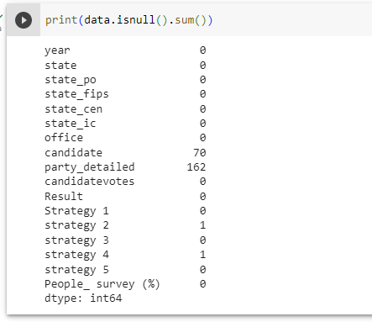

REMOVE NULL VALUE:
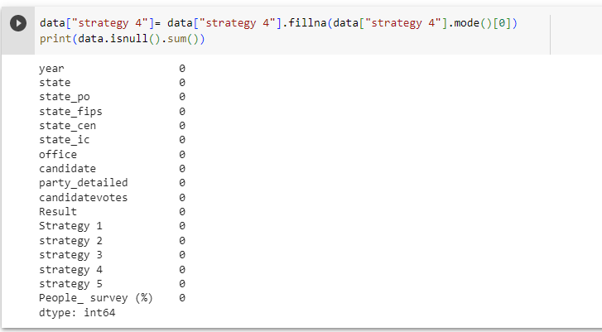

Result:
STRATEGY VISUALIZATION:
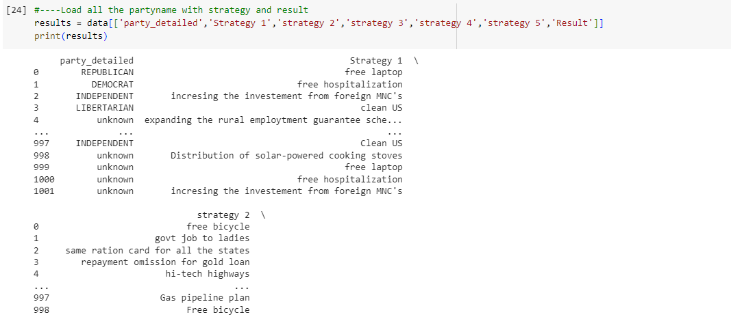

SEABORN PLOT
Seaborn is a library for making statistical graphics in Python. It builds on top of matplotlib and integrates closely with pandas data structures.
Seaborn helps you explore and understand your data. Its plotting functions operate on dataframes and arrays containing whole datasets and internally perform the necessary semantic mapping and statistical aggregation to produce informative plots. Its dataset-oriented, declarative API lets you focus on what the different elements of your plots mean, rather than on the details of how to draw them.

COUNT OF PARTY
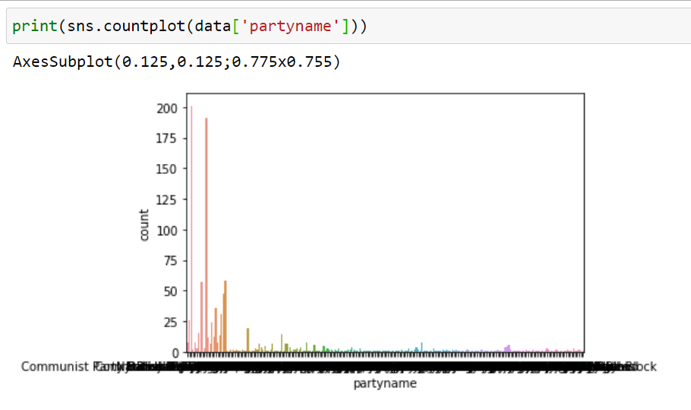
ANALYSING THE STRATEGY USING LOGISTIC REGRESSION
Logistic Regression is a Machine Learning classification algorithm that is used to predict the probability of a categorical dependent variable. In logistic regression, the dependent variable is a binary variable that contains data coded as 1 (yes, success, etc.) or 0 (no, failure, etc.). In other words, the logistic regression model predicts P(Y=1) as a function of X.

PREDICTED VALUE 1
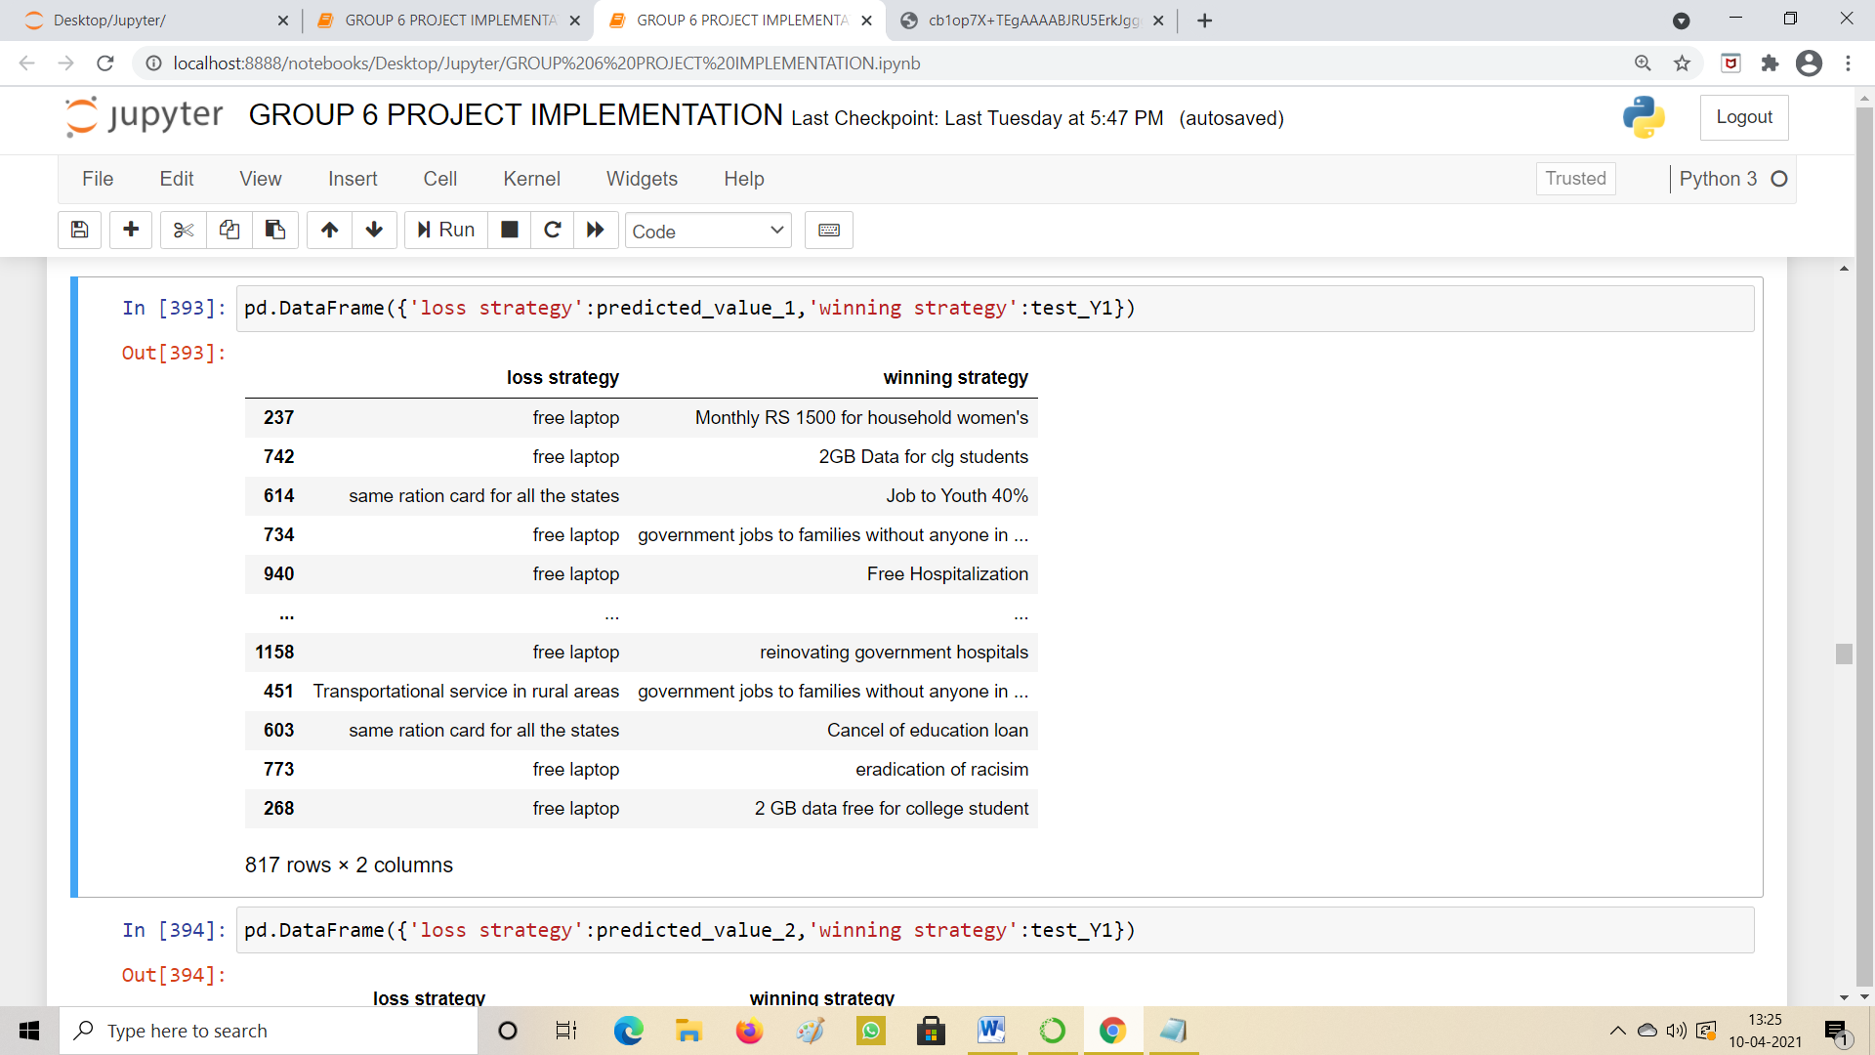
PREDICTED VALUE 2
The same procedure is done for the Predicted value 2

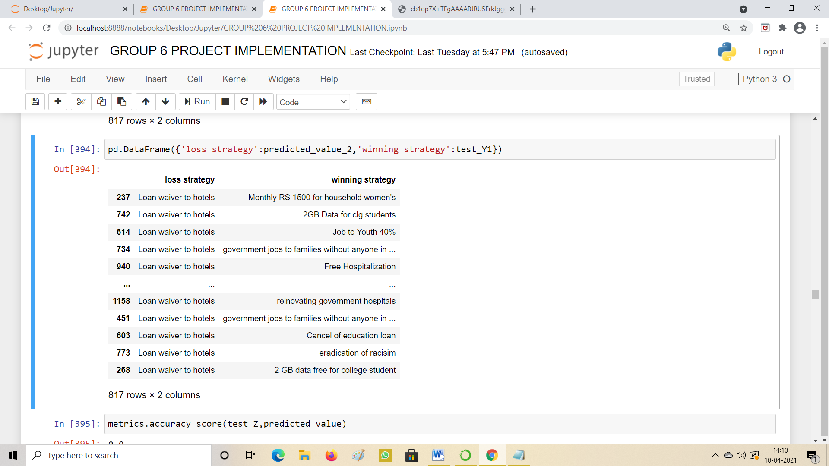

TO ANALYSE BEST TREND SETTING STRATEGY
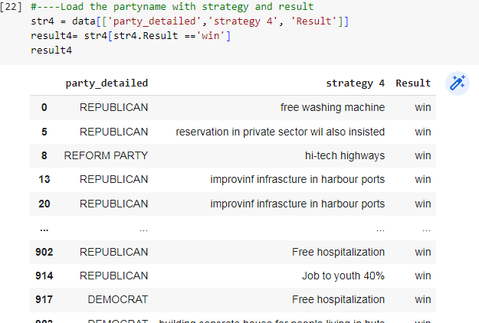

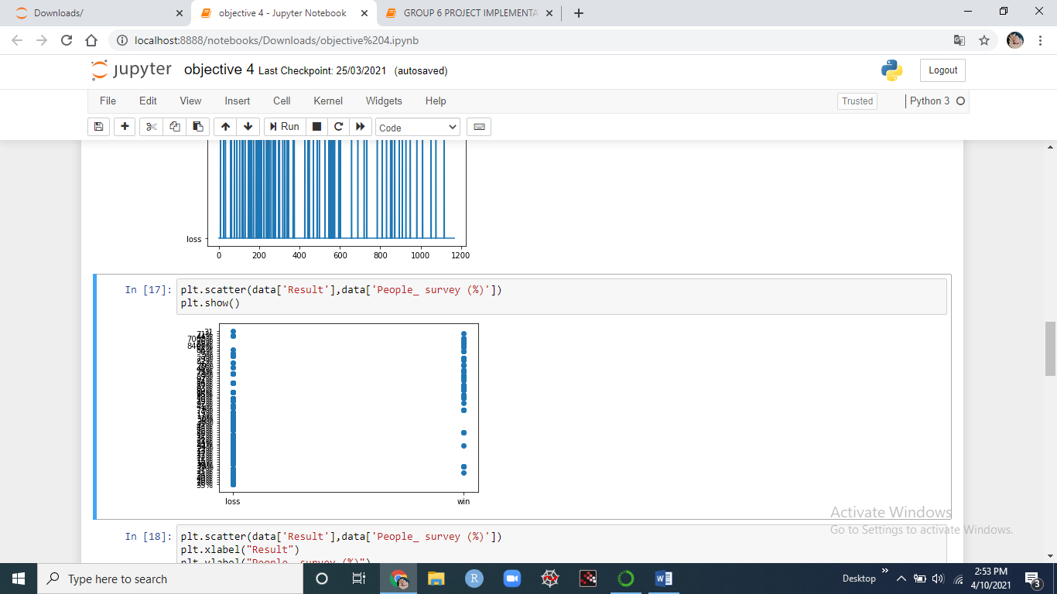
FIG 8.12 PEOPLE SURVEY vs. RESULT
The above fig 8.12 analysis the winning and losing percentage of election with Result that shows in Scatter plot.
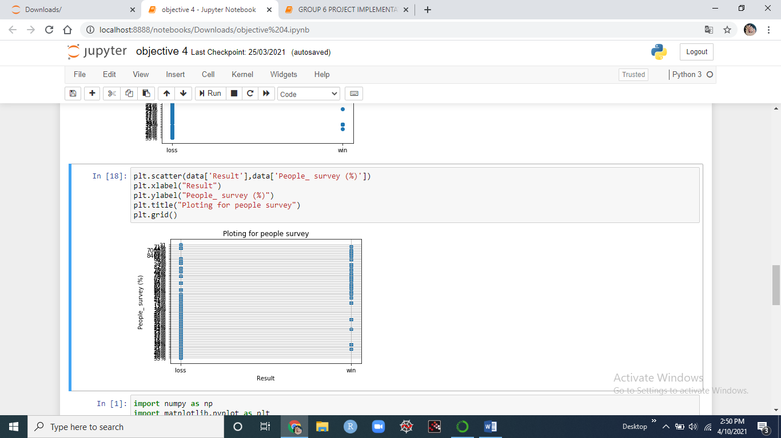
In this scatter plot we are using grid to show some lines in between People survey and Result.

SNS BAR PLOT:
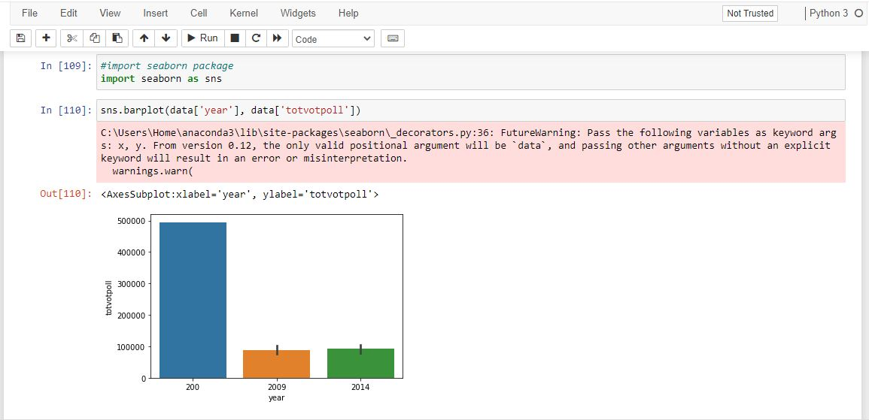

Conclusion:

This project recognized to analyze the election dataset of year from 2000. And get results of parties and strategy used to win the election. Here we used Logistic Regression and Polynomial Regression to analyze the strategy which party has used to win and separate the loss candidates and calculate the number of votes secured by the candidates. Using Linear Regression compare total electors and total vote poll to get accuracy value. And finally we analyze which party has win, and in which state and their total winning votes. Find the accuracy values using the above mentioned algorithms.
In this current developing society the needs of people in US is increasing and the people below poverty level are also increasing. Most of the family’s are dependent on government schemes so to analyze and find the useful strategies which can help the people and also the parties to win the election we used the past election data. In this project we used python as backend and colab notebook as frontend for better analysis and visualizing the result. With the election data of the year from 2000. we analyzed in which state which party used what kind of strategies to win the election. In the analysis we found that winning strategies may help in the current election situation. Before suggesting the usage of winning strategies we must need the peoples opinion about those strategies to check whether the strategies are useful in real life or not. So we added the people survey percentage to make sure analysis is correct.In this project we visualized the year,state name,party participated in the election, number of electors, and the votes secured by each parties using the strategies are visualized to give a better view about the analysis. So by this project we suggest that using the winning strategies of the past election may be very helpful for the current election system and the people.

References:
[1. Slamet Risnanto; Yahaya Abd Rahim; Kodrat Mahatma; Asep Effendi; Hendra Garnida; “U-Vote: Ubiquitous Voting Model For General Election in Global Pandemic”, IEEE-2020, 14th International Conference on Telecommunication Systems, Services, and Applications.
[2]. I. Somin, "Foot voting versus ballot box voting: why voting with your feet is crucial to political freedom", Eur. Polit. Sci., no. 0123456789, IEEE-2018.
[3]. S. Risnanto, Y. Rohim and N. Herman, "Polling Stations Secure Scheme For e-Voting System in Indonesian General Election", IEEE -2019.
[4]. S. Risnanto, Y. B. A. Rahim and N. S. Herman, "E-Voting Readiness Mapping for General Election Implementation", J. Theor. Appl. Inf. Technol., vol. 98, no. 20, pp. 3280-3290, IEEE -2020.
[5]. S. Risnanto, Y. B. A. Rahim and N. S. Herman, "Preparatory Component for Adoption E-Voting", TSSA 2019 - 13th International Conference on Telecommunication Systems Services and Applications Proceedings,IEEE 2019.
[6]. J. i Esteve, B. Goldsmith and J. Turner, "International Experience with E-Voting Norwegian E-Vote Project", IEEE,pp. 1-196, June 2012.

[7]. AboSamra, K. M. et al. (2017) ‘A practical, secure, and auditable e-voting system’, Journal of Information Security and Applications. Elsevier Ltd, 36, pp. 69–89. doi: 10.1016/j.jisa.2017.08.002.
[8]. AdelekeR., A. et al. (2013) ‘Modeling and Evaluation of E-Voting System for a Sustainable Credible Election’, International Journal of Applied Information Systems, 5(3), pp. 8–14. doi: 10.5120/ijais12-450862.

[9]. Adeshina, S. A. and Ojo, A. (2017) ‘Factors for e-voting adoption - analysis of general elections in Nigeria’, Government Information Quarterly. Elsevier, (November 2015), pp. 0–1. doi: 10.1016/j.giq.2017.09.006.

[10]. Aljarrah, E., Elrehail, H. and Aababneh, B. (2016) ‘E-voting in Jordan: Assessing readiness and developing a system’, Computers in Human Behavior. Elsevier Ltd, 63, pp. 860–867. doi: 10.1016/j.chb.2016.05.076.

[11]. Alomari, M. K. (2016) ‘“E-voting adoption in a developing country”, Transforming Government: People, Process and Policy’, Emerald insight, 10(4). doi: http://dx.doi.org/10.1108/TG-11-2015-0046.

[12]. Avgerou, C. (2013) ‘Explaining Trust in IT-Mediated Elections: A Case Study of E-Voting in Brazil.’, Journal of the Association for Information …, 14(8), pp. 420–451.

[13]. Budurushi, J., Jöris, R. and Volkamer, M. (2014) ‘Implementing and evaluating a softwareindependent voting system for polling station elections’, Journal of Information Security and Applications, 19(2), pp. 105–114. doi: 10.1016/j.jisa.2014.03.001.

[14]. Esteve, J. i, Goldsmith, B. and Turner, J. (2012) ‘International Experience with E-Voting Norwegian E-Vote Project’, (June), pp. 1–196. Everett, S. P. et al. (2008) ‘Electronic voting machines versus traditional methods’, p. 883. doi: 10.1145/1357054.1357195.

[15]. Goretta, H. et al. (2019) ‘Technology criteria analysis and e-voting adoption factors in the 2019 Indonesian presidential election’, 2018 International Conference on Advanced Computer Science and Information Systems, ICACSIS 2018. IEEE, pp. 143–149. doi: 10.1109/ICACSIS.2018.8618215.

[16]. Hapsara, M. (2013) ‘E-Voting Indonesia : A Safety-Critical-Systems model towards standard and framework for Indonesia ’ s Presidential Election’, (December), pp. 12–13.

[17].Hapsara, M. (2014) ‘E-Voting Indonesia : A Safety-Critical-Systems Model Towards Standard and Framework for Indonesia ’ s Presidential Election’, Australian Journal of Basic and Applied Sciences, 8(4), pp. 301–308.

[18]. Hapsara, M. (2016) ‘Reinstating E-Voting as A Socio-Technical System’, 2016 IEEE Region 10 Symposium (TENSYMP), pp. 282–287.
Kumar, S. et al. (2011) ‘Analysis of Electronic Voting’, International Journal on Computer Science and Engineering - IJCSE, 3(5), pp. 1825–1830. doi: 10.1177/002076409604200204

[19]. Liu, Y. and Zhao, Q. (2018) ‘E-voting scheme using secret sharing and K-anonymity’, World Wide Web. World Wide Web, (August 2017), pp. 1–11. doi: 10.1007/s11280-018-0575-0

