Data Cleaning:
- Check for the number of missing values marked with '?' in each column of the “Medical Examinations” Table and "Hospitalization Details" Table.
Medical Examinations Table:  - Customer ID: 0  - BMI: 0  - HBA1C: 0  - Heart Issues: 0  - Any Transplants: 0  - Cancer history: 0  - NumberOfMajorSurgeries: 0  - smoker: 2 | Hospitalization Details Table:  - Customer ID: 6  - year: 2  - month: 3  - date: 0  - children: 0  - charges: 0  - Hospital tier: 1  - City tier: 1  - State ID: 2
- Fill in the missing values of ‘month’ with Sep and ‘year’ with its average rounded to the nearest integer.

Filled empty month column with “Sep” and round the years between missing year columns
- Determine the most frequently occurring values in the ‘smoker’, 'Hospital tier' and 'City tier' columns, and fill in the missing values accordingly.

Using COUNTIF function, found the no. of occurrence value in the column

Data Transformation:
- Split the ‘names’ column in the “Customer Names” Table into 3 meaningful columns: ‘Title’, ‘First Name’, and ‘Last Name’.

First name - =RIGHT(B2,LEN(B2)-FIND(",",B2)-4)

Last Name - =LEFT(B2,FIND(",",B2)-1)

Title - =TRIM(MID(B2,FIND(",",B2)+2,FIND(" ",B2,FIND(",",B2)+2)-FIND(",",B2)-2))
- Convert the "NumberOfMajorSurgeries" column in the “Medical Examinations” Table to numerical data by replacing non-numeric characters with meaningful numerical values.

Using FIND AND REPLACE function, given “0” value for “No major surgery”
- Check for inconsistencies in the 'Heart Issues' and 'smoker' columns and propose corrective actions if necessary.

Using PROPER function for text format
- Merge ‘year’, ‘month’ and ‘date’ columns in the “Hospitalization Details” Table into one column named ‘Date of Birth’ and format it in ‘DD-MMM-YYYY’ custom format.

=TEXT(D2,"00")&"-"&TEXT(C2,"00")&"-"&TEXT(B2,"00")
- Calculate the ‘Age’ of each customer based on their ‘Date of Birth’ and the date of collection of the dataset, which is 8thJune 2023. (Hint: Use the DATEDIF function)

=DATEDIF(J8, DATE(2023, 6, 8),"Y")

Data Exploration:

➔ Customer Names Table:
- Are there any duplicate Customer IDs in the dataset? If yes, how many?

No
- How many customers are included in the dataset?

=COUNTA(A2:A2336) -> 2335

➔ Medical Examination Table:
- How many customers have a history of cancer?

=COUNTIF(G2:G2336,"Yes") -> 391
- How many obese customers have heart issues?

=COUNTIFS(K2:K2336,"Obesity",E2:E2336,"Yes") –> 498
- What is the total number of major surgeries performed on customers?

=SUM(H1:H2336) -> 1579
- Calculate the percentage of customers who have undergone any transplants.

=COUNTIF(F2:F2336,"yes")/COUNTA(F2:F2336)*100 - > 6.167023555
- Find the average HBA1C value of customers who are smokers.

=AVERAGEIF(J2:J2336,"Yes",C2:C2336) - > 6.61834

➔ Hospitalization details Table:
- Calculate all the Summary statistics for the ‘charges’ column.
Charges
Sum | 31768896
Count | 2343
Minimum | 563.84
Maximum | 63770.43
Median | 9634.54
Standard Deviation | 11922.66
Mean | 13559.07
Mode | 650

- Find the average hospitalization charges for customers who are more than 50 years old.

=AVERAGEIFS(F2:F2344, K2:K2344, ">50") -> $17856.791
- Compare the total charges across different hospital tiers.
Hospital tier | Sum of charges
tier - 1 | 9310917.49
tier - 2 | 15899488.89
tier - 3 | 6558489.64
Grand Total | 31768896.02
- Calculate the average charges for people who have more than 2 children.
Children | Average of charges
3 | 14500.42611
4 | 13850.6568
5 | 8786.035556
Grand Total | 14217.5205
- Find the integer average number of children of customers who are less than 40 years old.

=INT(AVERAGEIFS(E2:E2344,K2:K2344,"<40")) - > 1

Data Analysis:
Analysis using Pie/Donut Chart:
- What is the distribution of cancer history among smokers and non-smokers?
 | Without Cancer | With Cancer
Non- Smoker | 1540 | 307
Smoker | 404 | 84

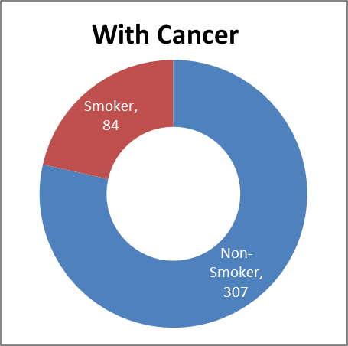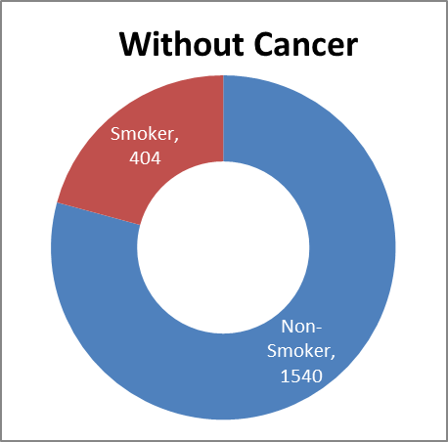
- How does the total number of major surgeries and average HbA1C differ between patients with and without a history of transplants?
Transplant | Sum of NumberOfMajorSurgeries | Average of HBA1C
With Transplant | 1417 | 6.67
Without Transplant | 162 | 5.19
Grand Total | 1579 | 6.578997859

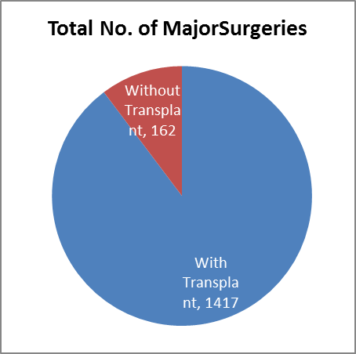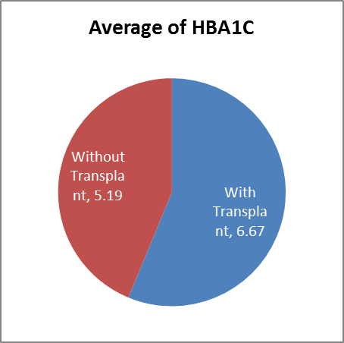
Analysis using Column/Bar Chart:
- How do healthcare charges vary based on different weight statuses and diabetes statuses?
Average of Charges | Weight status
Diabetes status | Normal weight | Obesity | Overweight | Underweight | Grand Total
Diabetes | 12510 | 19083 | 13910 | 7425 | 15974
Normal | 7897 | 15127 | 10390 | 6911 | 12091
Prediabetes | 10390 | 15465 | 10042 | 5626 | 12691
Grand Total | 9843 | 16591 | 11430 | 6899 | 13530

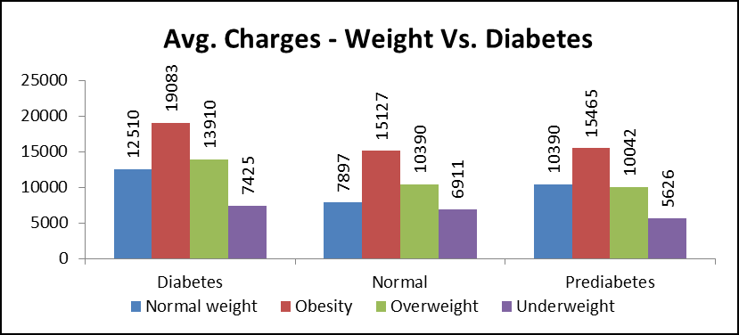
- Can you compare the average charges for each hospital tier within different states?
Average of Charges | Hospital Tier
State Id | Tier - 1 | Tier - 2 | Tier - 3 | Grand Total
R1011 | 33081 | 18997 | 9250 | 19466
R1012 | 26111 | 10334 | 10180 | 12016
R1013 | 31328 | 8439 | 6891 | 10515
R1014 | 13892 | 2395 | 16950 | 13478
R1015 | 21524 | 15676 | 7571 | 13949
R1016 | 39869 | 16076 | 8133 | 13589
R1017 | 34071 | 11366 | 8667 | 14806
R1018 | 33476 | 10140 | 12571 | 13273
R1019 | 27622 | 8117 | 12707 | 13633
R1020 |  | 6761 | 11716 | 9238
R1021 |  | 7668 | 11519 | 8933
R1022 |  | 10102 | 11638 | 10651
R1023 | 18262 | 13457 | 12786 | 13786
R1024 | 32732 | 10174 | 13361 | 12865
R1025 |  | 6886 | 10510 | 8789
R1026 | 18710 | 11920 | 12297 | 12490
Unknown | 20997 |  |  | 20997
Grand Total | 30129 | 11865 | 9462 | 13530

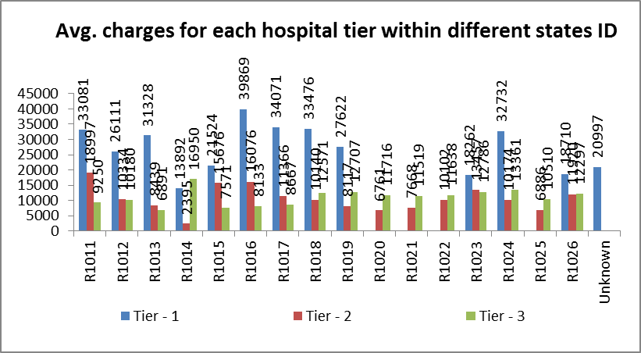

Analysis using Line/Scatter Plot:
- Is there any correlation between age and both BMI and HbA1C in the dataset?
Age | Average of BMI | Average of HBA1C
18 | 31 | 5
19 | 30 | 5
20 | 28 | 9
21 | 29 | 5
22 | 33 | 5
23 | 31 | 5
24 | 29 | 5
25 | 30 | 5
26 | 30 | 5
27 | 31 | 5
28 | 31 | 5
29 | 31 | 5
30 | 35 | 5
31 | 31 | 5
32 | 33 | 5
33 | 31 | 5
34 | 31 | 5
35 | 30 | 5
36 | 29 | 9
37 | 30 | 5
38 | 28 | 5
39 | 30 | 5
40 | 31 | 5
41 | 30 | 9
42 | 30 | 5
43 | 32 | 5
44 | 30 | 9
45 | 31 | 6
46 | 31 | 5
47 | 32 | 9
48 | 32 | 10
49 | 30 | 10
50 | 31 | 5
51 | 31 | 9
52 | 31 | 9
53 | 30 | 5
54 | 31 | 9
55 | 33 | 10
56 | 33 | 5
57 | 30 | 9
58 | 32 | 5
59 | 32 | 9
60 | 31 | 9
61 | 33 | 9
62 | 32 | 10
63 | 32 | 6
64 | 33 | 9
65 | 27 | 10
Grand Total | 31 | 7

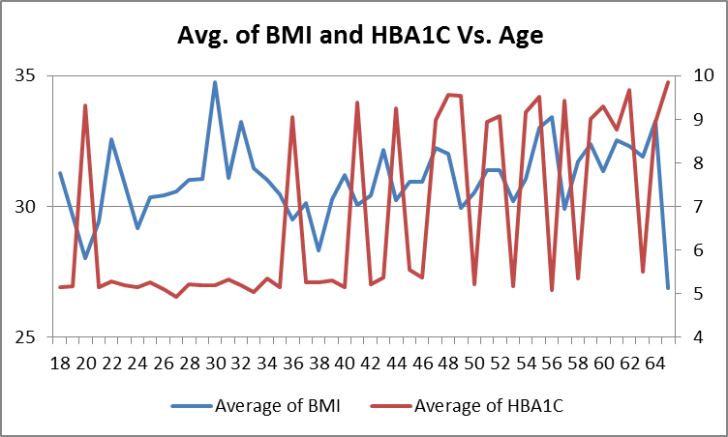

- Explore the relationship between age and healthcare charges.

Add Trendline for age
Age | Average of Charges
18 | 6611
19 | 9677
20 | 7411
21 | 5215
22 | 9806
23 | 11093
24 | 9766
25 | 9185
26 | 5921
27 | 11846
28 | 9220
29 | 9915
30 | 13788
31 | 10346
32 | 14698
33 | 11891
34 | 11887
35 | 10817
36 | 12291
37 | 16504
38 | 10223
39 | 14131
40 | 13058
41 | 12031
42 | 13180
43 | 17795
44 | 15162
45 | 15183
46 | 17592
47 | 19058
48 | 15254
49 | 14768
50 | 16208
51 | 17322
52 | 16572
53 | 16030
54 | 17862
55 | 18448
56 | 17001
57 | 15704
58 | 14948
59 | 18164
60 | 20577
61 | 22024
62 | 19325
63 | 19905
64 | 22631
65 | 29331
Grand Total | 13530

