**APSDP**

**All Products Supplier & Home Décor Providers**

Here all the categories and sub categories of this farm website will mention.

**Category of APSDP:**

EDUCATION:

**School Suppliers:**

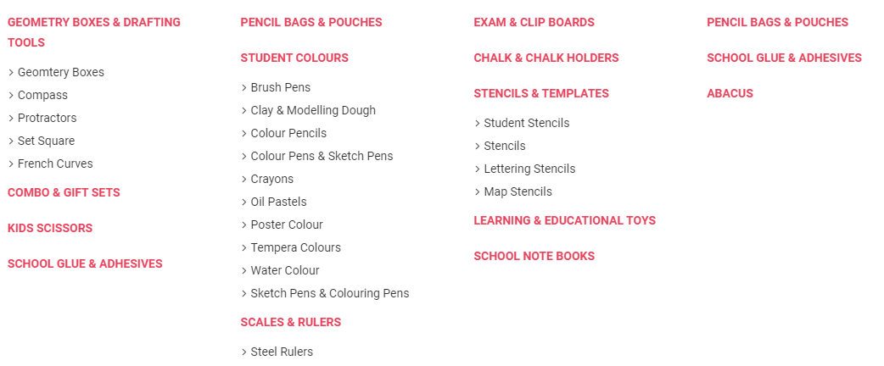

**OFFICE:**

1. **Office Basics:**

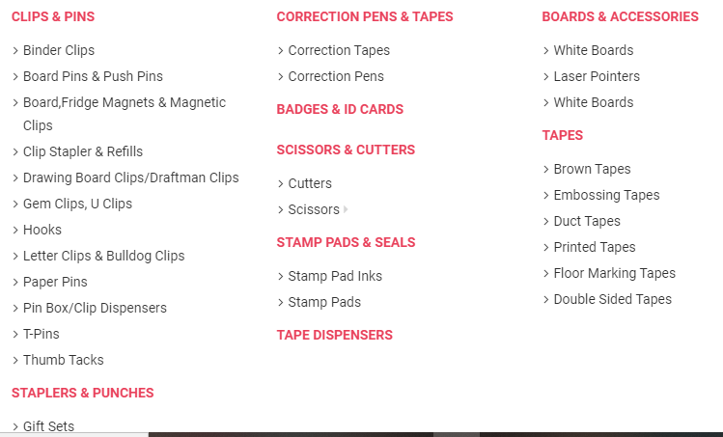

1. **Pens & Writing:**

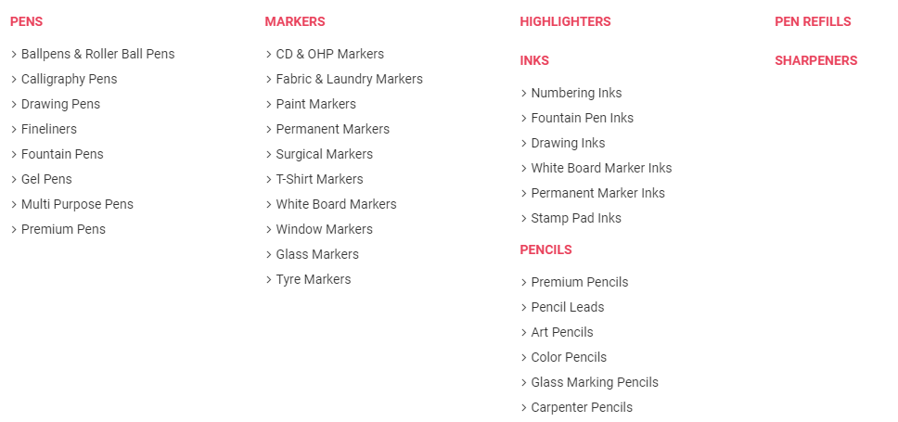

1. **Paper**

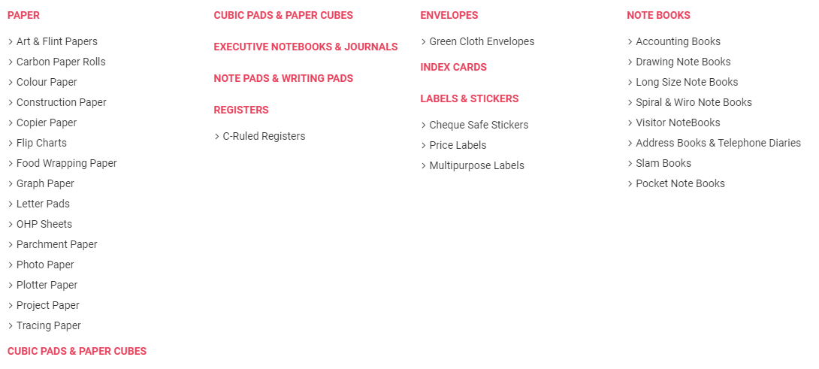

1. **Desk Accessories:**

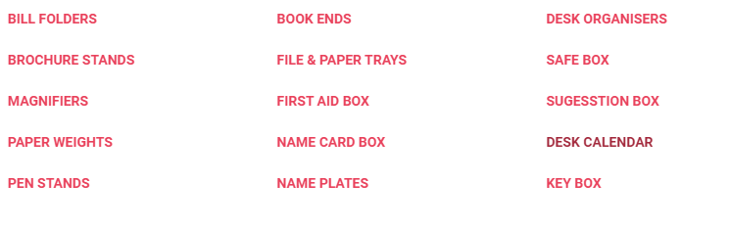

**Home & Constuction:**

1. **Steel**

|  |  |
| --- | --- |
| **TMT** | **Structural Steel** |
|  | **MS Pipes** |
|  | **MS Flats** |
|  | **MS channel** |
|  | **MS beams** |
|  | **MS Angle** |
|  | **HR coil** |

1. **Kitchens & Wardrobes:**

**Wardrobes**

**Modular Kitchen**

1. **Tiles:**
2. **Wall Tiles**
3. **Floor Tiles**
4. **Outdoor Tiles**
5. **Step Tiles**
6. **More:**

|  |  |  |  |  |
| --- | --- | --- | --- | --- |
| **Cement** | **Construction**  **Material** | **Flooring** | **Kitchen Equipment** | **Sanitary ware** |
|  | **Coarse Aggregates** | **Wooden Flooring** | **Hobs** | **Faucets** |
|  | **Fine Aggregates** | **Flooring Accessories** | **Chimneys** | **Wash Basins** |
|  | **Construction Pipes** |  |  | **Water Closets** |
|  | **Shuttering Ply** |  |  | **Urinals** |
|  | **Bitumen** |  |  | **Shower & Bath** |
|  |  |  |  | **Water Heater** |
|  |  |  |  | **Accessories** |

**Advertising, Banner & Printing :**

1. **Advertising:**

**Template Design**

**Newspaper Add**

1. **Banner & Printing:**

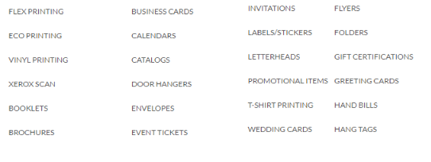

**Electronic Accessories:**

|  |  |
| --- | --- |
| **Electronic** | **Computer & Computer Accessories** |
| **Inverter** | **Desktop** |
| **Ac** | **Laptop** |
| **Bulb** | **Cooling Pads** |
| **Fans** | **Key boards** |
| **Wall Fans** | **Headsets** |
| **Tube Light** | **Mouse/Mouse Pads** |
| **Switches** | **Webcams** |
| **Board** | **UPS** |
| **sockets** | **Hard disk(Internal/External)** |
| **All other Accessories** | **Billing Machine** |
|  | **POS machine** |
|  | **CCTV** |
|  | **Other Accessories** |

**More:**

|  |  |  |  |
| --- | --- | --- | --- |
| **Travel Accessories** | **Pantry Suppliers** | **Fitness Accessories** | **House Keeping Suppliers** |
| **Adapter & Charger** | **Food Disposals** | **Yoga Mats** |  |
| **Car Charger** | **Lunch box** | **Other Fitness material** |  |
| **Bags** |  |  |  |
| **Card Holder** |  |  |  |
| **Locks** |  |  |  |
| **Torch** |  |  |  |