Confusion Matrix:

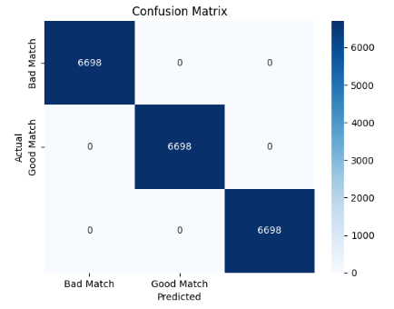

Classification report:

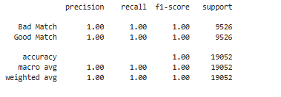

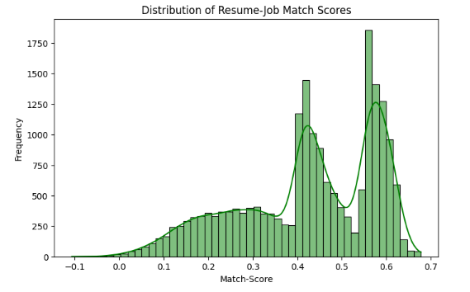

Sample Examples ->

Example 1:

Resume: Software engineer with 4 years of experience in Java, Spring Boot, and microservices.

Job: Seeking a backend developer role requiring expertise in Java, Spring Boot, and cloud computing.

Match Score: 0.6803

Classification: Moderate Match!

Example 2:

Resume: Entry-level data analyst with knowledge of SQL, Excel, and basic Python.

Job: Looking for a data analyst position where I can apply my skills in SQL, Python, and Tableau.

Match Score: 0.7143

Classification: Strong Match!

Example 3:

Resume: Mechanical engineer with experience in automotive design and CAD modeling.

Job: Seeking a software development role leveraging my experience in Java, Spring Boot, and cloud computing.

Match Score: 0.1822

Classification: Poor Match!

Example 4:

Resume: Experienced chef skilled in Italian cuisine and pastry making.

Job: Looking for opportunities to transition into blockchain development with expertise in Solidity and smart contracts.

Match Score: 0.2878

Classification: Poor Match!

Example 5:

Resume: AI engineer with Python, TensorFlow, and some knowledge of cloud computing.

Job: Seeking a cloud engineering role where I can apply my knowledge of AWS, Docker, and basic ML concepts.

Match Score: 0.5698

Classification: Moderate Match!

Example 6:

Resume: Hardworking professional, good communication skills, and team player.

Job: Looking for an ML engineering position focused on TensorFlow, NLP, and cloud deployment.

Match Score: 0.1568

Classification: Poor Match!

Example 7:

Resume: Expert in Python, machine learning, deep learning, and AI research.

Job: Looking for a senior data scientist role that involves AI, ML, Python, and research-driven projects.

Match Score: 0.6294

Classification: Moderate Match!