***BERT->***

Final BERT Test Accuracy: 89.69%

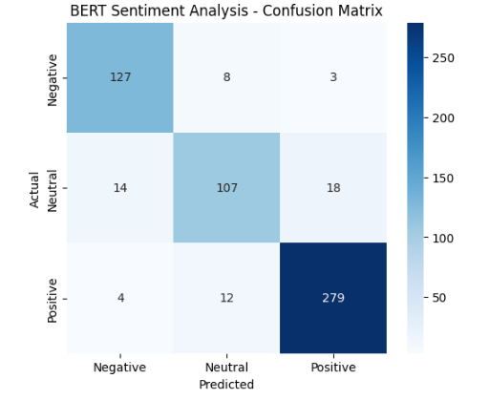

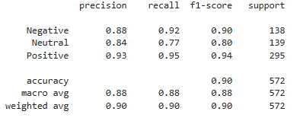

***Naïve Bayes ->***

Naive Bayes Accuracy: 75.29137529137529

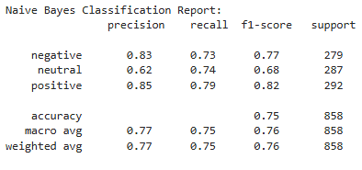

***SAMPLE INPUT AND OUTPUT->***

Predicted Sentiment for I love this product! It's amazing. -> Positive

Predicted Sentiment for Disgusting Product ! Would never recommend it. -> Negative

Predicted Sentiment for It's decent ! Not Bad Not Good -> Neutral

***Class Distribution before Upsampling***

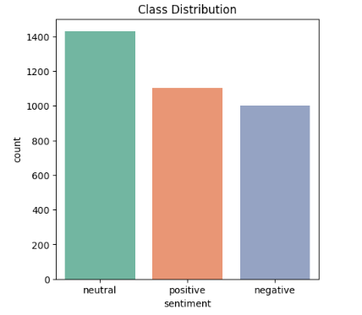

***Class Distribution after Upsampling***

