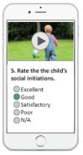



Basic details entered by user and submit the questionnaire response.

Customer login Mobile/Online app



Tested positive against ASD

No signs of ASD

ML Model predicts the risk in advance before issuing the policy.