**Symbiosis International (Deemed University)**

Half Yearly Progress Report

Semester-II , Year- 2023

|  |  |
| --- | --- |
| **Name of the Research Student:** Rajesh Siraskar | **PRN:** 2107 900 1012 |
| **Name of the Faculty:** | Engineering |
| **Topic of Ph.D. Work-** | Remaining Useful Life Estimation using Deep Reinforcement Learning during Machining |
| **Name of the institution where research is being conducted** | Symbiosis Institute of Technology (SIT) |
| **Year of Provisional Admission of the Ph.D. Programme** | 2021 |
| **Date of Registration (Confirmation)\*** | 16-Feb-2023 |
| **Research Supervisor(s) Name(s)-** | Dr. Satish Kumar, Dr. Shruti Patil |

1. **Progress Against Planned Work**

|  |  |  |  |  |
| --- | --- | --- | --- | --- |
| **Semester/**  **Half Year after Registration** | **Duration** | | **Planned Work** | **Actual Work** |
| **From** | **To** |
| 1st semester after registration | Mar-2023 | Aug-2023 | 1. Literature research  2. Research on suitable public data sets  3. Research on suitable RL algorithms to use for PdM  4. Build PdM environment | 1. Concluded SLR  2. Identified milling datasets  3. Compared 4 suitable algorithms for PdM  4. Built RL environment suitable for milling operation |

1. **Brief Description of Work done:** Code written that demonstrates use of public dataset, design of RL environment and execution and evaluation of the four RL algorithms. Empirical study of comparison can be presented.
2. **Details of Publication (will not be included for the award of degree if not submitted by student)**

|  |  |  |  |  |  |
| --- | --- | --- | --- | --- | --- |
| **Sr. No.** | **Title of Paper** | **Journal/Conference** | **Vol & No./ Venue & Dates** | **Page Number** | **Copy Attached** |
|  | Reinforcement Learning for Predictive Maintenance:  A Systematic Technical Review | Artificial Intelligence Review, Springer Nature | 9 March 2023 |  |  |
|  |  |  |  |  |  |

1. **Difficulties Encountered:** Understanding the nuances of RL elements. Substantial rework had to be done.

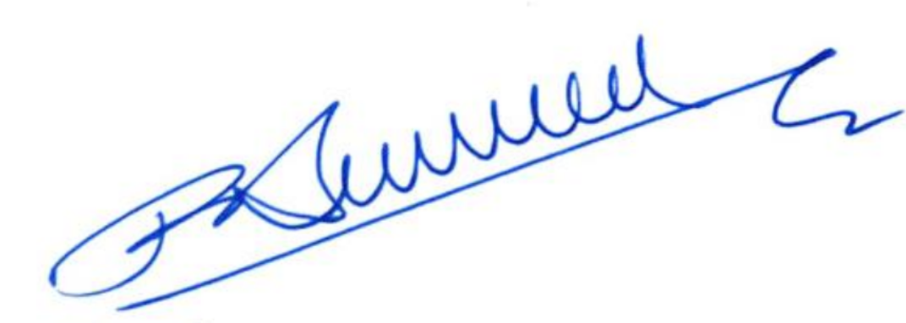

**Rajesh Siraskar**

* Signature of the Research Student Date: 24-Jul-2023

--------------------------------------------------------------------------------------------------------------------------------------

* Recommendation of Research Advisory Committee
* **Countersign by members of RAC**

1. **Name and Designation:** Dr. Ketan Kotecha, Director, SIT, Pune.
2. **Name and Designation:** Dr. Satish Kumar, Associate Processor, Mechanical Department, SIT, Pune.
3. **Name and Designation:** Dr. Rahee Walambe, Associate Professor, SIT, Pune.

* **Recommendation of Research Supervisor (s)**

Certified that the performance of research student is: **Satisfactory/ Not Satisfactory**

* Research Supervisor Signature
* Comments
* Include 1 slide on the basics of the research topic background i.e. milling machine, tool life, tool wear
* Include basic formulations of the RL / MDP elements: State, Action and Reward definitions
* Student should observe at least one cycle of actual milling operation (end-milling)
* Suggestions for future incorporation include trying of Inverse RL (IRL) for reward formulation from real data and expert “demonstration” (if available).

-------------------------------------------------------------------------------------------------------------------------------

**Dean of Faculty Date:**

**Head of Research Programmes/SCRI**