Req: Post : [**http://localhost:10090/create/orderitem**](http://localhost:10090/create/orderitem)

{

    "productName" : "mobile",

    "productCode"   : "40",

    "quantity" :"1"

}

**Res: 1 (one record /one item )**

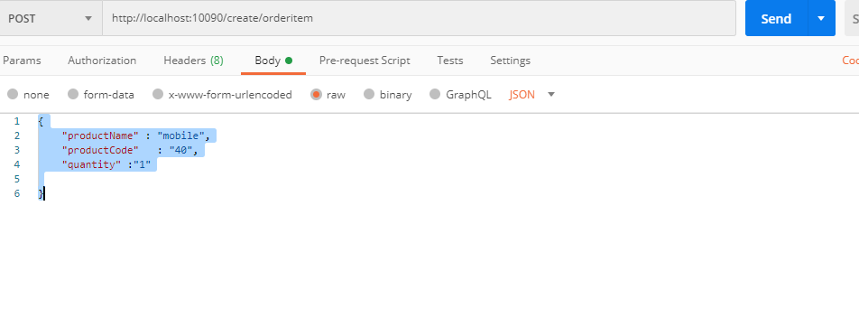

Req : Post : **http://localhost:10091/create/order**

{

    "customerName" : "manjula",

    "shippingAddress"   : "hyd",

    "orderDate" :"26-06-2020",

    "total" : 45

}

**Res: 1 (one record /one order )**

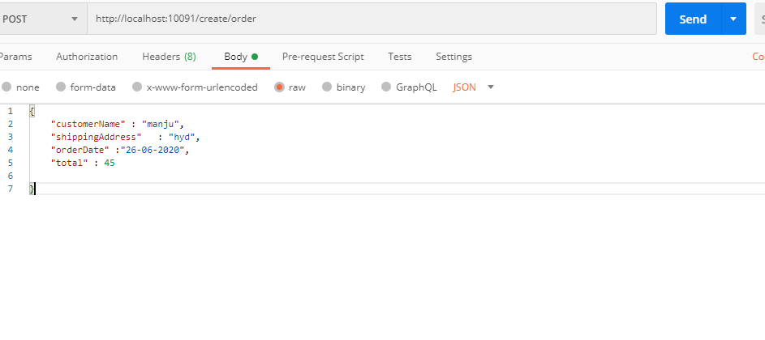

Get all Orders

Req: [**http://localhost:10091/order/getAllOrders**](http://localhost:10091/order/getAllOrders)

**Response:**

[

    {

        "orderId": 1,

        "customerName": "pmr3",

        "shippingAddress": "hyd",

        "orderDate": "25-06-2020",

        "total": 45,

        "orderItem": "[{\"orderId\":1,\"productName\":\"pmr\",\"productCode\":\"40\",\"quantity\":\"50\"}]"

    }

]

