OES
(Online Examination System)
A PROJECT REPORT
SUBMITTED BY
Roll Number | Registration Number | Student Code | Student Name
24103460167 | 24103002949 of 2024-2025 | BWU/BCA/24/175 | RAJESH DAS
24103460163 | 24103002945 of 2024-2025 | BWU/BCA/24/171 | SUDIPTA KUMAR ROY
24103460148 | 24103002930 of 2024-2025 | BWU/BCA/24/156 | REHAN SARKAR
24103460154 | 24103002936 of 2024-2025 | BWU/BCA/24/162 | SK NAZIBUL ISLAM
Of in partial fulfillment for the award of the degree
BACHELOR OF COMPUTER APPLICATION (BCA (Hons.) 5th Semester)
IN
DEPARTMENT OF COMPUTATIONAL SCIENCE

BRAINWARE UNIVERSITY
398, Ramkrishnapur Road, Barasat, North 24 Parganas, Kolkata - 700 125
CERTIFICATE
This is to certify that the project report entitled "Online Examination System" is a bonafide record of project work carried out by RAJESH DAS (Roll Number: 24103460167, Registration Number: 24103002949 of 2024-2025, Student Code: BWU/BCA/24/175), SUDIPTA KUMAR ROY (Roll Number: 24103460163, Registration Number: 24103002945 of 2024-2025, Student Code: BWU/BCA/24/171), REHAN SARKAR (Roll Number: 24103460148, Registration Number: 24103002930 of 2024-2025, Student Code: BWU/BCA/24/156), and SK NAZIBUL ISLAM (Roll Number: 24103460154, Registration Number: 24103002936 of 2024-2025, Student Code: BWU/BCA/24/162) of BCA (Hons.) 5th Semester (Session: 2024-2025) in the DEPARTMENT OF COMPUTATIONAL SCIENCE, Brainware University, in partial fulfillment of the requirements for the award of the degree of BACHELOR OF COMPUTER APPLICATION (BCA (Hons.) 5th Semester).
They have worked under our supervision and guidance during the academic session 2024-2025. To the best of our knowledge, this project work is original and has not been submitted elsewhere for the award of any other degree or diploma.
_______________________________
Project Supervisor: Mr. Sourav Sandhukhan
Assistant Professor, DEPARTMENT OF COMPUTATIONAL SCIENCE, Brainware University
_______________________________
Head of the Department: Dr. Jayanta Aich
Head of the Department, DEPARTMENT OF COMPUTATIONAL SCIENCE, Brainware University
_______________________________
External Examiner
DECLARATION
We hereby declare that the project report entitled "Online Examination System" submitted to the DEPARTMENT OF COMPUTATIONAL SCIENCE, Brainware University, in partial fulfillment of the requirements for the award of the degree of BCA (Hons.) 5th Semester (Session: 2024-2025), is an authentic record of our own group project work carried out under the supervision and guidance of Mr. Sourav Sandhukhan, Assistant Professor.
We further declare that the work reported in this project has not been submitted, either in part or in full, for the award of any other degree or diploma in this university or any other institute.
SIGNATURE OF CANDIDATES:--
1. RAJESH DAS
Roll Number: 24103460167 | Registration Number: 24103002949 of 2024-2025 | Student Code: (BWU/BCA/24/175)
Signature: _______________________________
2. SUDIPTA KUMAR ROY
Roll Number: 24103460163 | Registration Number: 24103002945 of 2024-2025 | Student Code: (BWU/BCA/24/171)
Signature: _______________________________
3. REHAN SARKAR
Roll Number: 24103460148 | Registration Number: 24103002930 of 2024-2025 | Student Code: (BWU/BCA/24/156)
Signature: _______________________________
4. SK NAZIBUL ISLAM
Roll Number: 24103460154 | Registration Number: 24103002936 of 2024-2025 | Student Code: (BWU/BCA/24/162)
Signature: _______________________________
Date: ___________________
Place: Barasat, Kolkata
ACKNOWLEDGEMENT
We would like to express our heartfelt gratitude to the Management and Faculty of Brainware University for providing us with the opportunity, guidance, and resources required to successfully complete this project. Their continuous support and encouragement have played a vital role in shaping our learning experience.
We extend our sincere thanks to our esteemed project supervisor, Mr. Sourav Sandhukhan, Assistant Professor, whose constant guidance, valuable suggestions, and insightful feedback have been instrumental throughout the development of this project. His expertise, patience, and motivation helped us overcome challenges and understand the core concepts effectively.
We are also deeply thankful to Dr. Jayanta Aich, Head of the DEPARTMENT OF COMPUTATIONAL SCIENCE, for providing a supportive academic environment and the necessary facilities that enabled us to complete this work successfully.
Our sincere appreciation goes to all the faculty members of the DEPARTMENT OF COMPUTATIONAL SCIENCE for sharing their knowledge, advice, and encouragement during the course of our project. Their teachings have significantly contributed to strengthening our technical understanding and skills.
Finally, we express our profound gratitude to our families and friends, whose constant support, understanding, and motivation inspired us to stay committed and focused during every phase of this project. Without their encouragement, this achievement would not have been possible.

SIGNATURE:--
RAJESH DAS
Roll Number: 24103460167 | Registration Number: 24103002949 of 2024-2025 | (BWU/BCA/24/175)
SUDIPTA KUMAR ROY
Roll Number: 24103460163 | Registration Number: 24103002945 of 2024-2025 | (BWU/BCA/24/171)
REHAN SARKAR
Roll Number: 24103460148 | Registration Number: 24103002930 of 2024-2025 | (BWU/BCA/24/156)
SK NAZIBUL ISLAM
Roll Number: 24103460154 | Registration Number: 24103002936 of 2024-2025 | (BWU/BCA/24/162)
ABSTRACT
The Online Examination System is a web-based application built using React JS, Vite, and Firebase that allows teachers to create and manage online exams and assignments, and allows students to attempt exams, upload assignment files, and view their results online. The main objective of this project is to implement core React JS concepts while providing a simple and organized digital examination platform for BCA (Hons.) 5th Semester academic use.
The system is developed using a component-based architecture, where the user interface is divided into reusable components such as Navbar, Sidebar, StudentLayout, and TeacherLayout. Separate login and dashboard modules are provided for students (StudentLogin, StudentDashboard) and teachers (TeacherLogin, TeacherDashboard), where each component manages its own state and receives data through props.
React Router DOM is used for client-side navigation between student pages (AvailableExams, ExamPage, ResultPage, MyResults, Assignments, MyAssignments, StudentProfile) and teacher pages (CreateExam, ManageExams, ViewResults, CreateAssignment, ManageAssignments, ViewSubmissions, TeacherProfile) without full page reloads. React Hooks (useState, useEffect, and useRef) handle timer countdowns, question navigation, form inputs, and 3-strike tab-switch anti-cheat detection on the exam page.
The application uses Firebase Authentication (authFunctions.js) and Cloud Firestore (dbFunctions.js) to store data in real Firestore collections: users, exams, questionsList, results, assignments, and submissions. Assignment files are uploaded to Cloudinary (storageFunctions.js), while teachers can also generate MCQ questions using the Groq API helper (AIHelper.js with qwen/qwen3.8-27b model) or import questions from Excel spreadsheets using SheetJS (excelHelper.js).
Overall, the Online Examination System combines React JS component architecture, client-side routing, state management, and real-time Firebase and Cloudinary integration to provide a complete online test and assignment portal.
INDEX
❖ CERTIFICATE
❖ DECLARATION
❖ ACKNOWLEDGMENT
❖ ABSTRACT
❖ LIST OF FIGURE
❖ LIST OF TABLE
❖ LIST OF SCREENSHOTS

1. INTRODUCTION
2. LITERATURE SURVEY
3. SYSTEM ANALYSIS AND DESIGN
3.1 System Analysis
3.2 System Design
4. IMPLEMENTATION
5. OUTPUT SCREENSHOT
6. SOURCE CODE
7. TESTING AND DEBUGGING
8. CONCLUSION AND FUTURE ENHANCEMENT
9. REFERENCES
1. INTRODUCTION
In today's academic environment, technology plays an important role in making examinations and coursework faster and easier to manage. The traditional method of conducting exams and collecting assignments involves printing question papers, checking answer sheets by hand, and maintaining physical records. Teachers spend a lot of time preparing papers and calculating marks, while students have to wait many days to see their results. These problems show the need for a fast, simple, and reliable online system.
The Online Examination System is a web-based application developed using React JS, Vite, and Firebase to solve the problems of manual examinations. It provides a single-page web platform where teachers can create exams and assignments, and students can take multiple-choice exams, submit assignment files, and check their results online without full-page reloads.
The system is divided into clear, reusable modules for two user roles: Teacher and Student. The Authentication Module (Landing.jsx, StudentLogin.jsx, TeacherLogin.jsx, and authFunctions.js) handles role selection, account registration, and login using Firebase Authentication. The Teacher Portal Module allows teachers to create MCQ exams manually, generate questions using the Groq AI helper (AIHelper.js powered by qwen/qwen3.8-27b), or upload bulk questions from Excel sheets (excelHelper.js), and also create assignments and grade student submissions. The Student Portal Module allows students to view active exams filtered for their course and section (AvailableExams.jsx), attempt timed exams with a 3-strike tab-switching check (ExamPage.jsx), view instant scorecards (ResultPage.jsx, MyResults.jsx), and upload assignment files to Cloudinary (Assignments.jsx, MyAssignments.jsx, storageFunctions.js).
The development of this system uses modern frontend and cloud technologies including React JS and JSX for building the user interface, React Router DOM for client-side navigation, and React Hooks such as useState, useEffect, and useRef for managing state and timers. Backend data is stored in Cloud Firestore through dbFunctions.js, file uploads are handled via Cloudinary in storageFunctions.js, and styling is implemented using App.css, index.css, Lucide React icons, and React Hot Toast notifications.
One of the main advantages of the Online Examination System is that exam status, question lists, student results, and assignment submissions update in real time without reloading the browser page. Because the interface is built from small and reusable components such as Navbar, Sidebar, StudentLayout, and TeacherLayout, the code is clean, modular, and easy to maintain.
Furthermore, the system improves fairness during online tests by providing a live countdown timer, question palette navigation, and a 3-strike anti-cheat warning system in ExamPage.jsx that detects tab switching or window blur events and automatically submits the exam on the third warning.
In conclusion, the Online Examination System is a practical, component-based React JS application that simplifies online exam conduction and assignment management for teachers and students while demonstrating core concepts of JSX, props, state management, client-side routing, and Firebase cloud integration.
2. LITERATURE SURVEY
The Online Examination System builds upon existing work in web-based academic assessment and learning management portals. Earlier examination systems were either conducted on physical paper or built using traditional multi-page web forms where every user action, such as moving to the next question or submitting an answer, required a full page reload from the server.
Studies on modern frontend web development show that Single Page Application (SPA) libraries such as React JS along with fast build tools like Vite greatly improve the user experience by updating only the parts of the page that change using a virtual DOM. This removes page reload delays during timed exams, which is very important when a student is answering multiple-choice questions against a running countdown timer.
Research into component-based software design shows that dividing an application into independent components with clearly defined props (inputs) and state (internal component data) improves code reuse, testing, and maintenance compared to large single-file templates. In our system, shared layout components (Navbar.jsx, Sidebar.jsx, StudentLayout.jsx, and TeacherLayout.jsx) separate navigation and role protection from individual page logic.
Previous work in digital assessment platforms also highlights two common challenges: the high effort required for teachers to type question banks manually, and the need to prevent students from switching browser tabs during an online test. Integrating AI question generation (AIHelper.js using the Groq API with the qwen/qwen3.8-27b model) and spreadsheet bulk import (excelHelper.js using SheetJS) helps teachers prepare question papers quickly, while browser visibilitychange and blur event listeners help detect tab switching in real time.
Based on these findings, the Online Examination System is designed as a React JS single-page application backed by Firebase Authentication, Cloud Firestore, and Cloudinary to provide a fast, organized, and reliable platform for conducting online exams and managing student assignments.
3. SYSTEM ANALYSIS AND DESIGN
The System Analysis and Design phase is an important step in developing the Online Examination System. It helps identify the limitations of manual examination methods and design a clean, component-based structure that meets the needs of teachers and students.
3.1 System Analysis
System analysis focuses on studying the problems in existing examination and assignment processes and defining the requirements for the new web-based system.
Existing System: In traditional college setups, class tests and assignments are conducted manually on paper or through basic forms that reload the entire page on every click. Teachers have to type or print question papers manually, collect physical assignment files, and check every student's answers by hand, which takes a lot of time and effort.
Problems in the Existing System:
- Time-consuming manual creation of question papers and manual checking of MCQ answer sheets
- Full page reloads in older web systems, causing delays during timed examinations
- No automatic filtering of exams by course, section, or already-attempted status
- Difficulty in tracking assignment file submissions, teacher feedback, and resubmission requests
- Lack of tab-switching detection when students take tests on their own devices
Proposed System: The proposed Online Examination System is a React JS single-page application integrated with Firebase and Cloudinary that provides separate portals for Teachers and Students. Teachers can create exams using manual input, Groq AI generation (qwen/qwen3.8-27b), or Excel file upload, and manage assignments and grades. Students can take timed exams with 3-strike anti-cheat protection, view instant results, and submit assignment files online.
Advantages of the Proposed System:
- Fast, dynamic user interface built with React JS and Vite that updates without full page reloads
- Three flexible ways for teachers to add exam questions: Manual Entry, Groq AI Generation (AIHelper.js - qwen/qwen3.8-27b), and Excel Bulk Import (excelHelper.js)
- 3-strike tab-switching and window-blur detection in ExamPage.jsx with automatic exam submission
- Instant result calculation showing total score, percentage, pass/fail status, and question-wise review
- Cloud-based storage using Cloud Firestore (dbFunctions.js) and Cloudinary (storageFunctions.js) for reliable exam and assignment management
3.2 System Design
System design describes how the application is structured into modules, how components interact, and how data is stored in Cloud Firestore collections.
Modules of the System:
- Authentication & Role Selection Module
- Teacher Exam Management Module
- Teacher Assignment & Grading Module
- Student Examination & Result Module
- Student Assignment Submission Module
- Authentication & Role Selection Module – Handles role selection on Landing.jsx and user login/registration on StudentLogin.jsx and TeacherLogin.jsx using Firebase Authentication (authFunctions.js) and stores user profiles in the users collection.
- Teacher Exam Management Module – Allows teachers to view dashboard statistics (TeacherDashboard.jsx), create exams (CreateExam.jsx) via manual entry, AI generation (AIHelper.js), or Excel upload (excelHelper.js), activate/deactivate or delete exams (ManageExams.jsx), and check student scores (ViewResults.jsx).
- Teacher Assignment & Grading Module – Enables teachers to create course and section assignments (CreateAssignment.jsx), manage active assignments (ManageAssignments.jsx), and evaluate student files, assign marks, give feedback, or ask for resubmission (ViewSubmissions.jsx).
- Student Examination & Result Module – Displays eligible active exams filtered by course, section, and past attempts (AvailableExams.jsx), runs the timed test with 3-strike anti-cheat monitoring (ExamPage.jsx), and displays detailed results (ResultPage.jsx, MyResults.jsx).
- Student Assignment Submission Module – Allows students to view active assignments for their course and section (Assignments.jsx), upload PDF or image files to Cloudinary (storageFunctions.js), and track grading status and teacher feedback (MyAssignments.jsx).
System Architecture: The system follows a modern client-cloud architecture in which the React JS frontend runs in the browser as a Single Page Application (SPA). The frontend communicates asynchronously with Firebase Authentication (authFunctions.js) for user sessions, Cloud Firestore (dbFunctions.js) for storing and querying documents across six real collections (users, exams, questionsList, results, assignments, and submissions), Cloudinary (storageFunctions.js) for assignment file uploads, and the Groq API (AIHelper.js utilizing qwen/qwen3.8-27b) for automated MCQ generation.
Database Collections in Cloud Firestore (dbFunctions.js & authFunctions.js):
- users: Stores registered student and teacher profiles (uid, email, fullName, role, rollNumber, course, semester, section, employeeId, department, subject, createdAt).
- exams: Stores exam metadata created by teachers (title, subject, duration, passingMarks, startTime, endTime, instructions, targetCourse, targetSection, teacherId, teacherName, totalMarks, questionSource, status, createdAt).
- exams/{examId}/questionsList: Subcollection storing each MCQ question for an exam (questionText, optionA, optionB, optionC, optionD, correctAnswer, marks, source).
- results: Stores student exam attempts and scores (examId, examTitle, subject, studentId, studentName, rollNumber, totalQuestions, attemptedQuestions, correctAnswers, wrongAnswers, totalMarks, obtainedMarks, percentage, status, timeTaken, warningsCount, studentAnswers, submittedAt).
- assignments: Stores teacher-created assignments (title, subject, description, dueDate, totalMarks, targetCourse, targetSection, allowedFileTypes, teacherId, teacherName, status, createdAt).
- submissions: Stores student assignment submissions and grades (assignmentId, assignmentTitle, subject, studentId, studentName, rollNumber, course, section, fileUrl, fileName, fileType, status, marksObtained, totalMarks, feedback, submittedAt).
Technologies Used:
- Frontend: React JS, Vite, JSX, React Router DOM
- State Management: React Hooks – useState, useEffect, useRef, and Browser sessionStorage / localStorage
- Styling & UI Components: Custom CSS (App.css, index.css), Inline Styling, Lucide React Icons, React Hot Toast
- Authentication & Database: Firebase Authentication & Cloud Firestore
- File Storage: Cloudinary Upload API (storageFunctions.js) & React-PDF
- Helper Integrations: Groq Cloud API - qwen/qwen3.8-27b (AIHelper.js) & SheetJS xlsx (excelHelper.js)
- Deployment Configuration: Vercel (vercel.json)
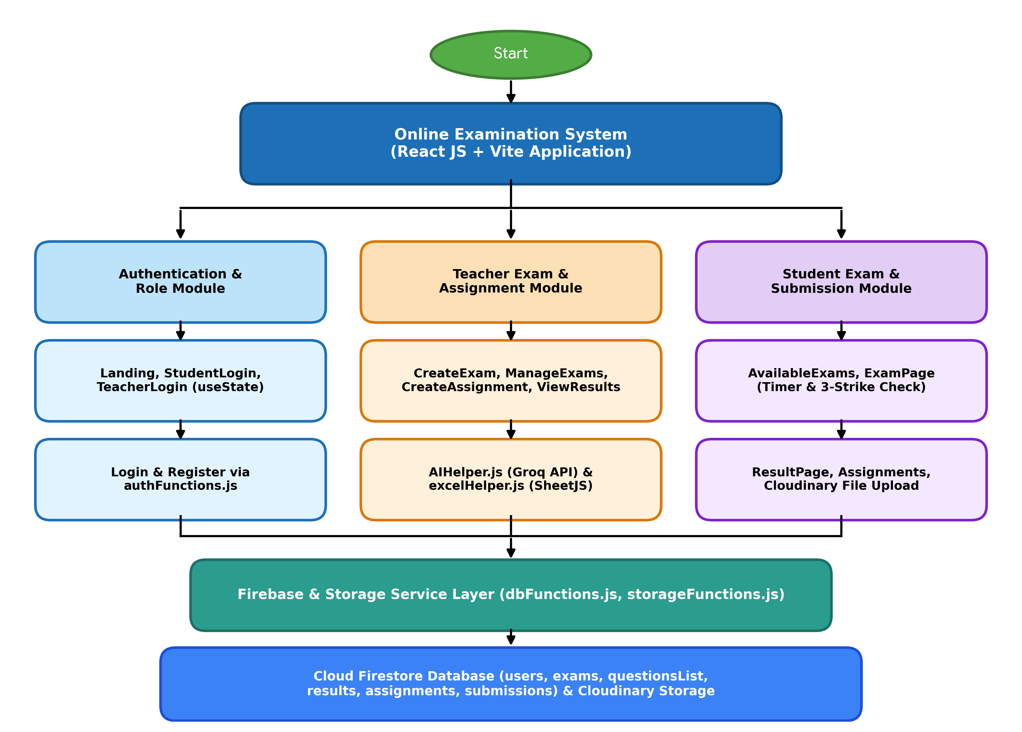
Fig. no. 3.1 – Module and data flow diagram
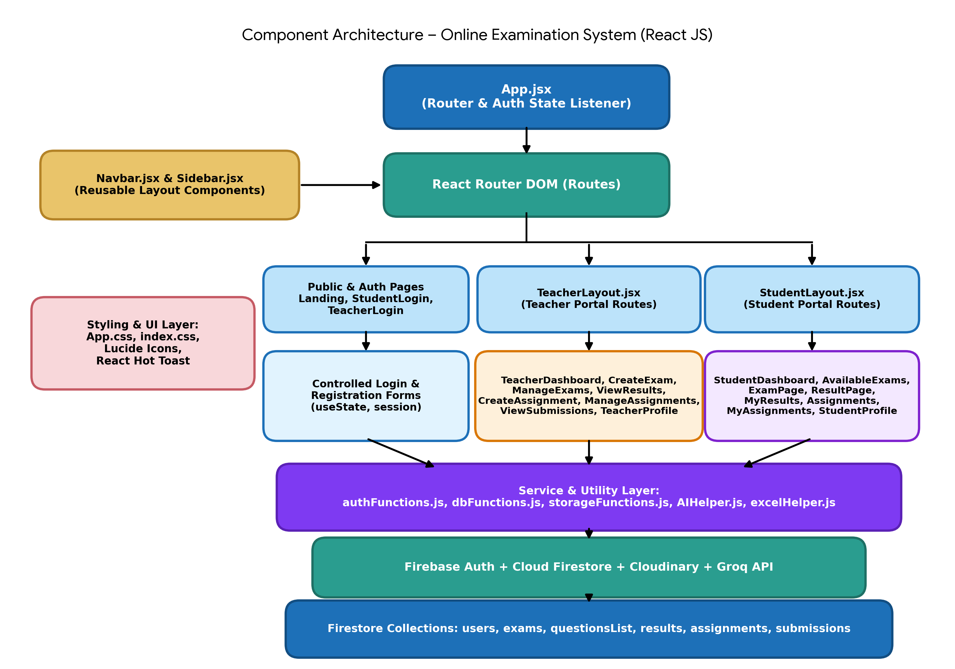
Fig. no. 3.2 – Component architecture diagram
Overall, the system design ensures that the Online Examination System is modular, responsive, and capable of handling real-time exam and assignment data cleanly while demonstrating the core building blocks of React JS and Firebase.
4. IMPLEMENTATION
The implementation phase involves developing and integrating the components and cloud services of the Online Examination System based on the system design. The project is set up using Vite (vite.config.js) and the user interface is built using functional React components written in JSX.
The interface is organized into reusable layout and page components such as Navbar, Sidebar, TeacherLayout, and StudentLayout. Role information is passed from the layout components to Navbar and Sidebar using props (for example, role="teacher" or role="student"), which dynamically renders the appropriate navigation links and header badge.
Component state such as login form inputs, active question index, selected MCQ options, marked-for-review questions, and warning counters is managed using React's useState hook. Side effects such as syncing Firebase Authentication sessions in App.jsx, loading exams and questions from Cloud Firestore, and registering browser tab-switch listeners are handled using the useEffect hook, while useRef manages the 1-second countdown interval and action locks in ExamPage.jsx. React Router DOM configures public routes (/, /student-login, /teacher-login) and nested protected routes under /teacher/* and /student/* so navigation happens without full page reloads.
Real-time database and storage operations are implemented in dedicated service files inside src/firebase/. authFunctions.js handles user registration, login, and role verification against the users collection. dbFunctions.js performs CRUD operations on the exams, questionsList, results, assignments, and submissions collections, including filtering out exams a student has already attempted. storageFunctions.js uploads student assignment files directly to Cloudinary and returns a secure file URL.
To make exam creation faster for teachers, CreateExam.jsx integrates two helper utilities from src/utils/: AIHelper.js, which sends a prompt to the Groq API (specifying model: qwen/qwen3.8-27b) to generate structured JSON multiple-choice questions by topic, difficulty, and count; and excelHelper.js, which uses SheetJS (xlsx) to parse uploaded Excel spreadsheets and download a sample question template.
Form validation and exam security rules are implemented across the portal. Required fields are validated before saving exams or assignments, and ExamPage.jsx disables copy, cut, paste, and right-click context menus while monitoring visibilitychange and window blur events to enforce the 3-strike warning and auto-submission system.
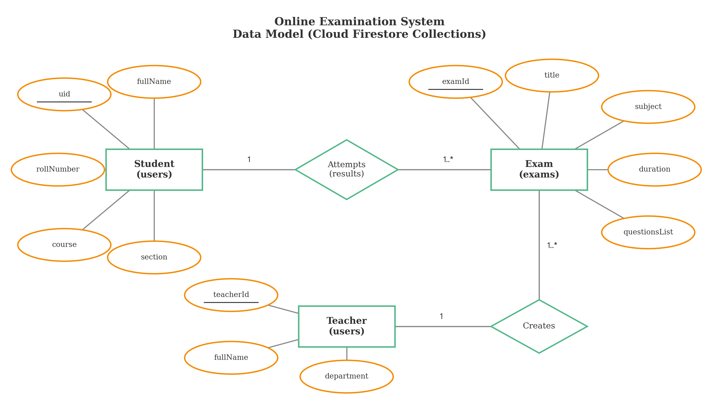
Fig. 4.1 – Data model for students, teachers and exams (Cloud Firestore collections)
Thus, the implementation phase turns the system design into a working Online Examination System that demonstrates component-based architecture, JSX, props and state management, client-side routing, helper utilities, and real-time Firebase and Cloudinary integration.
5. OUTPUT SCREENSHOT
The screenshots below are placeholders showing where each page of the running application should be inserted; replace each placeholder image with the corresponding screenshot captured from the deployed React application.
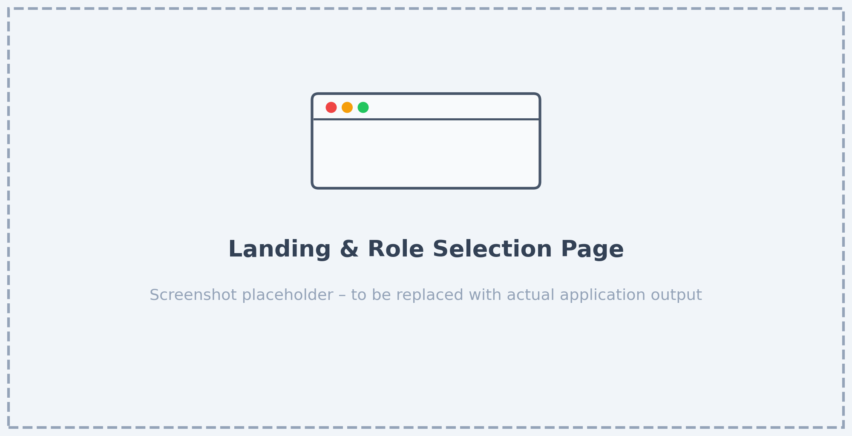
5.1 :- Landing & Role Selection Page
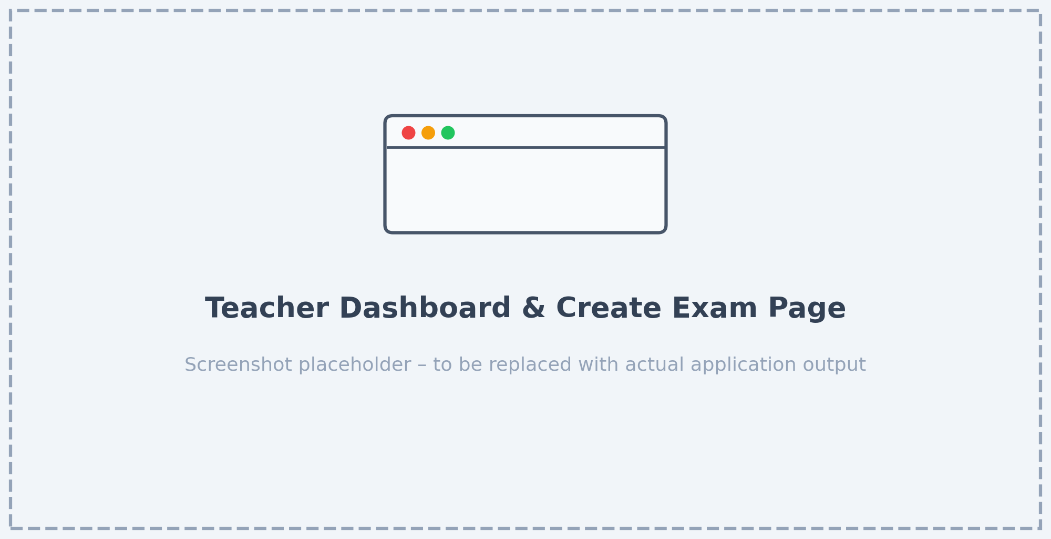
5.2 :- Teacher Dashboard & Create Exam Page
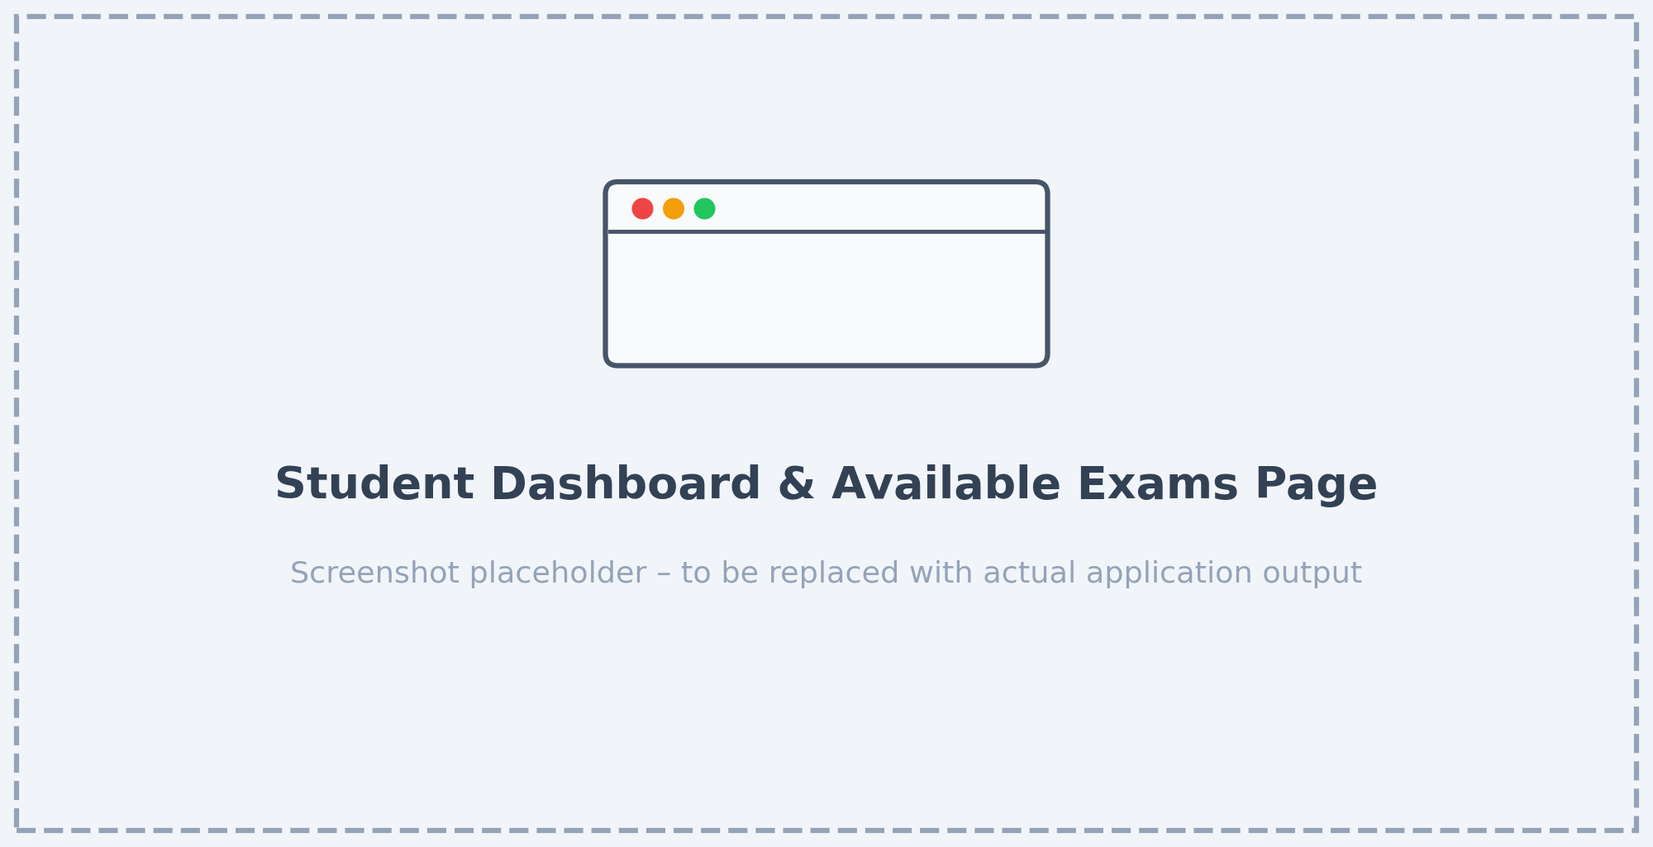
5.3 :- Student Dashboard & Available Exams Page
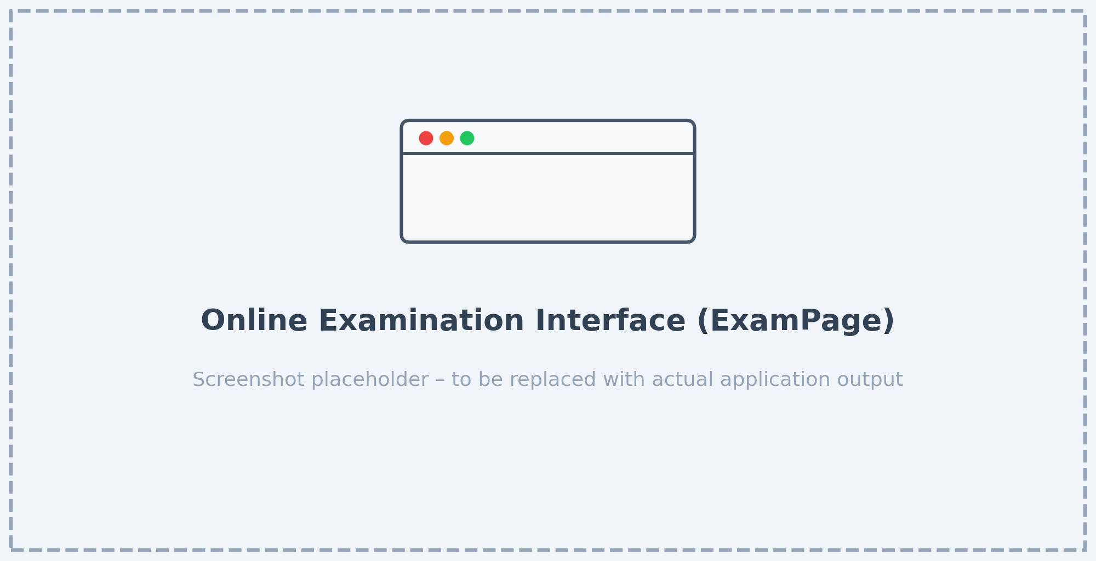
5.4 :- Online Examination Interface (ExamPage)
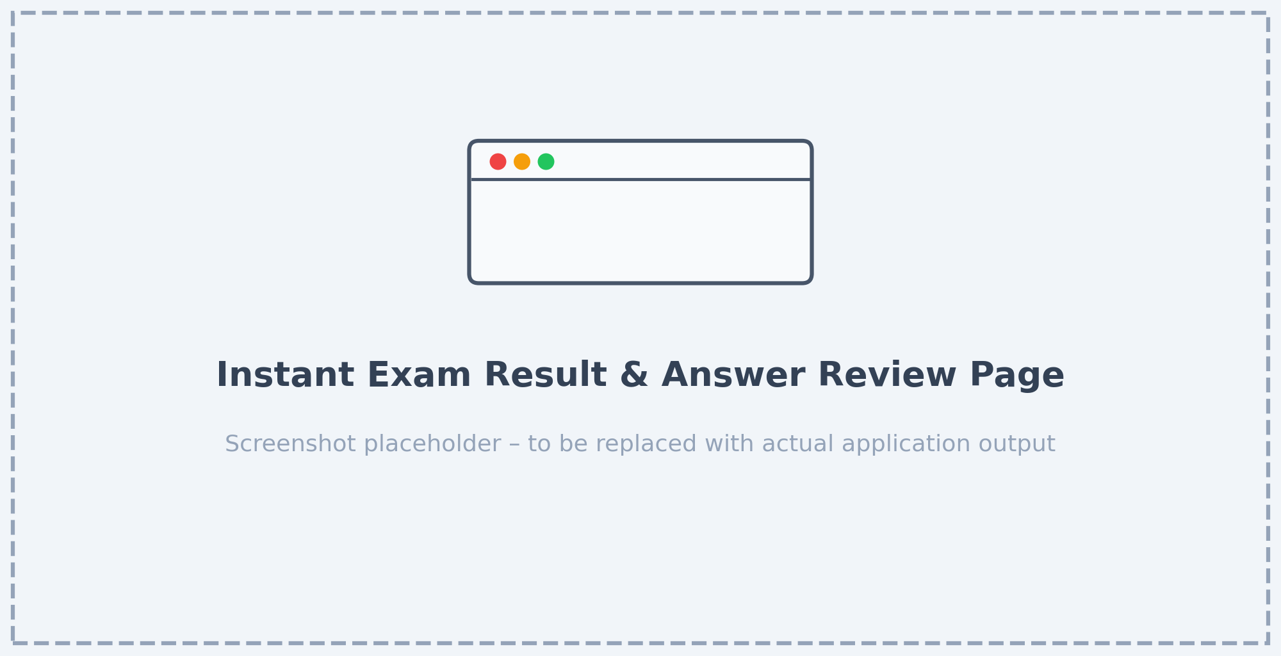
5.5 :- Instant Exam Result & Answer Review Page
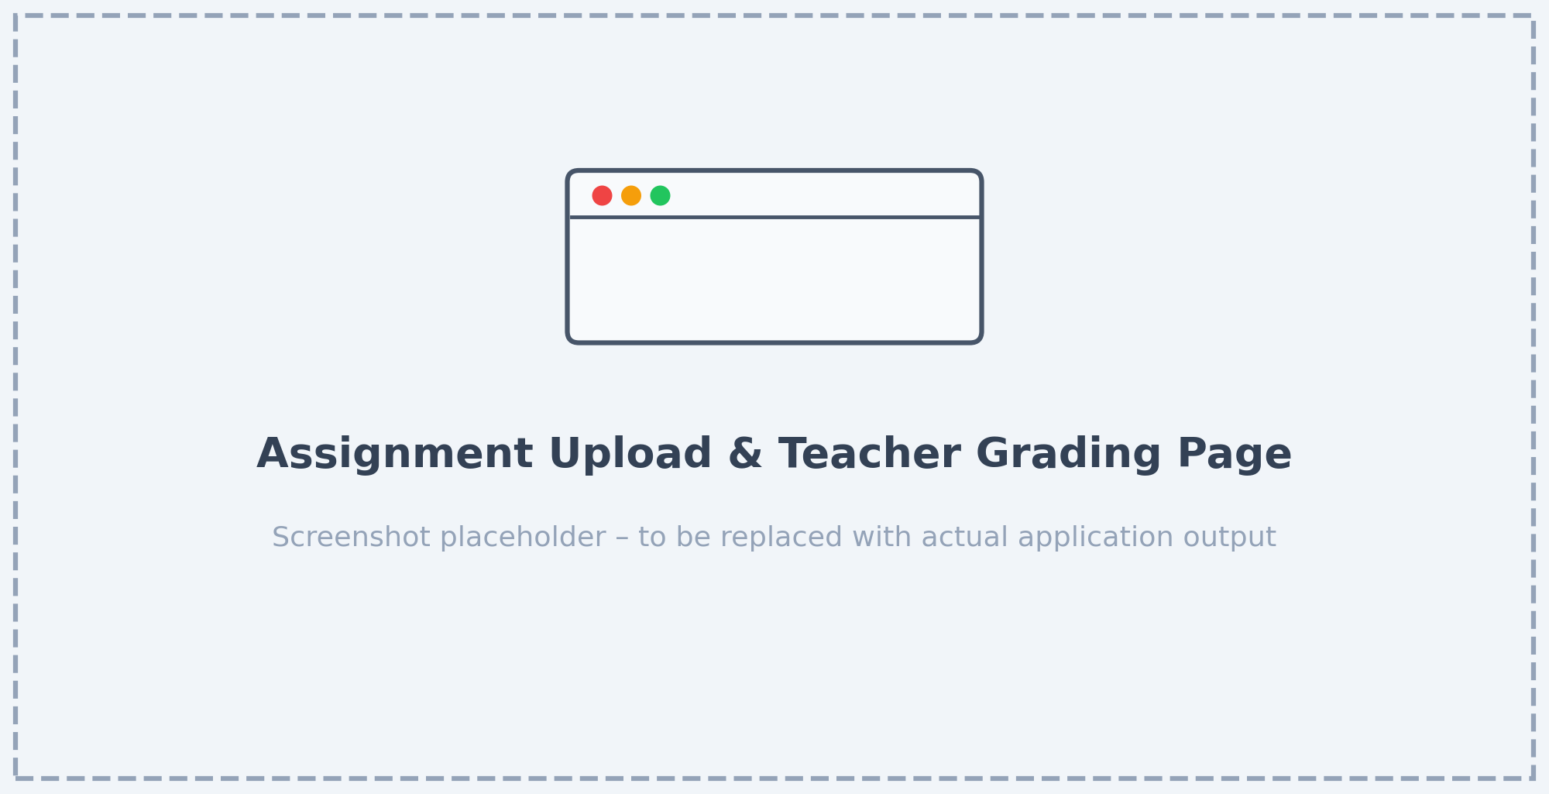
5.6 :- Assignment Upload & Teacher Grading Page
6. SOURCE CODE
6.1 :- CreateExam.jsx (Teacher exam creation with Manual, AI, and Excel tabs)
// src/pages/teacher/CreateExam.jsx
import { useState } from 'react';
import { useNavigate } from 'react-router-dom';
import { createExam, addQuestionToExam } from '../../firebase/dbFunctions';
import { generateQuestions } from '../../utils/AIHelper';
import { parseExcelQuestions, downloadExcelTemplate } from '../../utils/excelHelper';
import toast from 'react-hot-toast';

const CreateExam = () => {
const navigate = useNavigate();
const user = JSON.parse(sessionStorage.getItem('user'));
const [step, setStep] = useState(1);
const [examId, setExamId] = useState(null);
const [examDetails, setExamDetails] = useState({
title: '', subject: '', duration: '', passingMarks: '',
startTime: '', endTime: '', instructions: '', targetCourse: '', targetSection: ''
});
const [questions, setQuestions] = useState([]);
const [activeTab, setActiveTab] = useState('manual');
const [loading, setLoading] = useState(false);
const [publishLoading, setPublishLoading] = useState(false);

const saveExamDetails = async (e) => {
e.preventDefault();
setLoading(true);
const examData = {
...examDetails,
teacherId: user.uid,
teacherName: user.name,
duration: parseInt(examDetails.duration),
passingMarks: parseInt(examDetails.passingMarks),
status: 'upcoming',
totalMarks: 0,
questionSource: 'mixed'
};
const { id, error } = await createExam(examData);
if (error) {
toast.error(error);
} else {
setExamId(id);
setStep(2);
toast.success('Exam details saved! Now add questions.');
}
setLoading(false);
};

const handleAiGenerate = async (e) => {
e.preventDefault();
setLoading(true);
toast('AI is generating questions...');
try {
const generated = await generateQuestions(
aiState.topic, parseInt(aiState.numQs), aiState.difficulty, examDetails.subject
);
const customMarks = parseInt(aiState.marks) || 1;
setAiState({
...aiState,
generatedQs: generated.map(q => ({ ...q, selected: true, marks: customMarks }))
});
toast.success('Questions generated!');
} catch (err) {
toast.error(`AI Error: ${err.message}`);
}
setLoading(false);
};

const handlePublishExam = async () => {
if (questions.length === 0) {
toast.error("Add at least one question before publishing.");
return;
}
setPublishLoading(true);
for (const q of questions) {
await addQuestionToExam(examId, q);
}
toast.success('Exam Published Successfully!');
navigate('/teacher/manage-exams');
setPublishLoading(false);
};
};

export default CreateExam;
6.2 :- ExamPage.jsx (Timed student exam runner with 3-strike anti-cheat and auto-submit)
// src/pages/student/ExamPage.jsx
import { useState, useEffect, useRef } from 'react';
import { useParams, useNavigate } from 'react-router-dom';
import { getExamById, getQuestionsForExam, submitResult } from '../../firebase/dbFunctions';
import toast from 'react-hot-toast';

const ExamPage = () => {
const { examId } = useParams();
const navigate = useNavigate();
const user = JSON.parse(sessionStorage.getItem('user'));
const [exam, setExam] = useState(null);
const [questions, setQuestions] = useState([]);
const [currentQIndex, setCurrentQIndex] = useState(0);
const [answers, setAnswers] = useState({});
const [timeLeft, setTimeLeft] = useState(null);
const [warnings, setWarnings] = useState(0);
const [submitting, setSubmitting] = useState(false);
const timerRef = useRef(null);
const isActionRef = useRef(false);

// Anti-cheating (Tab switch & Blur detection)
useEffect(() => {
const handleVisibilityChange = () => {
if (document.hidden && !isActionRef.current) setWarnings(w => w + 1);
};
const handleBlur = () => {
if (!isActionRef.current) setWarnings(w => w + 1);
};
document.addEventListener("visibilitychange", handleVisibilityChange);
window.addEventListener("blur", handleBlur);
return () => {
document.removeEventListener("visibilitychange", handleVisibilityChange);
window.removeEventListener("blur", handleBlur);
};
}, []);

// Handle 3-strike warnings trigger
useEffect(() => {
if (warnings === 1) {
alert("FIRST WARNING: Do not switch tabs or leave this window! Your exam will be auto-submitted if you continue cheating.");
} else if (warnings === 2) {
alert("FINAL WARNING: If you switch tabs or leave this window one more time, your exam will be automatically submitted!");
} else if (warnings >= 3) {
alert("Maximum warnings exceeded! Your exam will now be automatically submitted.");
handleSubmit(true, 'cheating');
}
}, [warnings]);
};

export default ExamPage;
6.3 :- AIHelper.js (Automated MCQ generation using Groq API with qwen/qwen3.8-27b)
// src/utils/AIHelper.js
const GROQ_API_KEY = import.meta.env.VITE_GROQ_API_KEY;

export async function generateQuestions(topic, numberOfQuestions, difficulty, subject) {
try {
const response = await fetch('https://api.groq.com/openai/v1/chat/completions', {
method: 'POST',
headers: {
'Content-Type': 'application/json',
'Authorization': `Bearer ${GROQ_API_KEY}`
},
body: JSON.stringify({
model: 'qwen/qwen3.8-27b',
messages: [{
role: 'user',
content: `Generate exactly ${numberOfQuestions} multiple choice questions for ${subject} on the topic: ${topic}. Difficulty level: ${difficulty}.
Return ONLY a JSON array like this, with no extra text or markdown code blocks around it:
[
{
"questionText": "question here",
"optionA": "option a",
"optionB": "option b",
"optionC": "option c",
"optionD": "option d",
"correctAnswer": "A",
"marks": 1
}
]`
}],
max_tokens: 4000
})
});

if (!response.ok) {
throw new Error(`Groq API Error: ${response.status}`);
}

const data = await response.json();
const text = data.choices[0].message.content;
const jsonMatch = text.match(/\[[\s\S]*\]/);
if (jsonMatch) {
const parsed = JSON.parse(jsonMatch[0]);
return parsed.map(q => ({ ...q, source: 'ai' }));
} else {
throw new Error("Failed to parse AI response into JSON");
}
} catch (error) {
console.error("Groq API Error:", error);
throw error;
}
}
6.4 :- excelHelper.js (Bulk question import and Excel template download using SheetJS)
// src/utils/excelHelper.js
import * as XLSX from 'xlsx';

export function parseExcelQuestions(file) {
return new Promise((resolve, reject) => {
const reader = new FileReader();
reader.onload = (e) => {
try {
const data = e.target.result;
const workbook = XLSX.read(data, { type: 'binary' });
const sheet = workbook.Sheets[workbook.SheetNames[0]];
const rows = XLSX.utils.sheet_to_json(sheet);
const questions = rows.map(row => ({
questionText: row['Question'],
optionA: row['Option A'] || '',
optionB: row['Option B'] || '',
optionC: row['Option C'] || '',
optionD: row['Option D'] || '',
correctAnswer: row['Answer'],
marks: parseInt(row['Marks']) || 1,
source: 'excel'
}));
resolve(questions);
} catch (error) {
reject(error);
}
};
reader.onerror = reject;
reader.readAsBinaryString(file);
});
}

export function downloadExcelTemplate() {
const template = [{
'Question': 'Sample question here?',
'Option A': 'First option',
'Option B': 'Second option',
'Option C': 'Third option',
'Option D': 'Fourth option',
'Answer': 'A',
'Marks': 1
}];
const ws = XLSX.utils.json_to_sheet(template);
const wb = XLSX.utils.book_new();
XLSX.utils.book_append_sheet(wb, ws, 'Questions');
XLSX.writeFile(wb, 'question_template.xlsx');
}
7. TESTING AND DEBUGGING
Introduction
Testing and debugging are very important steps in the development of the Online Examination System. These processes make sure that each React component renders properly, that data moves accurately through props and state, and that the application communicates without error with Firebase Authentication, Cloud Firestore, Cloudinary, and the Groq API. Testing checks whether all features work as expected, while debugging is the process of finding and fixing bugs in the code.
During development, different types of testing were performed to verify that the Authentication, Teacher Exam & Assignment Management, and Student Examination & Submission modules work properly both individually and together.
Types of Testing
1. Unit Testing
Unit testing is the process of testing individual components and helper functions of the application separately. For example, CreateExam.jsx is tested to verify that its form state updates properly as the teacher enters exam details, excelHelper.js is tested to confirm it parses `.xlsx` columns accurately, and ExamPage.jsx is tested to verify the countdown timer and question palette buttons update correctly.
2. Integration Testing
Integration testing is performed after unit testing. In this stage, different components and service modules are combined and tested together – for example, verifying that publishing an exam in CreateExam.jsx saves the exam and its questionsList subcollection in Cloud Firestore via dbFunctions.js, and that activating the exam in ManageExams.jsx makes it immediately visible to eligible students in AvailableExams.jsx.
3. System Testing
System testing involves testing the complete application as a whole. All features of the Online Examination System, including student and teacher login, AI question generation (AIHelper.js), Excel question upload (excelHelper.js), timed exam attempts with 3-strike anti-cheat detection, instant result calculation, and Cloudinary assignment file upload, are tested together to make sure the whole system runs smoothly.
4. User Acceptance Testing (UAT)
User Acceptance Testing is the final stage of testing. In this stage, actual users test the system to check whether it meets their academic needs. Students and teachers interact with the portal to confirm that the interface is simple to use, responsive, and performs all examination and assignment tasks reliably.
Overall Conclusion
Through proper testing and debugging, the Online Examination System becomes more reliable and accurate. These steps helped catch edge cases early—such as pausing blur detection when the submit confirmation dialog opens—and ensured that teachers and students can use the application without technical issues.
TEST CASES:--
Test Id | Description | Input | Expected Result | Actual Output | Status
TC-1 | Student & Teacher role-based login | Valid email & password on StudentLogin / TeacherLogin | User role verified from Firestore users collection and redirected to dashboard | As expected | Pass
TC-2 | Create exam using AIHelper.js & excelHelper.js | Topic, difficulty, question count or valid .xlsx file in CreateExam.jsx | Questions added to pool and saved to exams/{examId}/questionsList in Firestore | As expected | Pass
TC-3 | Filter available exams for student | Student logs in and opens AvailableExams.jsx | Only active exams matching student's course & section that are not yet attempted are shown | As expected | Pass
TC-4 | 3-strike tab switch anti-cheat in ExamPage.jsx | Student switches browser tab or window 3 times during active exam | Warning alerts shown on strikes 1 & 2; exam auto-submits on strike 3 | As expected | Pass
TC-5 | Submit exam & view instant scorecard | Select MCQ answers and click Submit Exam in ExamPage.jsx | Score, percentage, and pass/fail status saved to results collection and shown on ResultPage.jsx | As expected | Pass
TC-6 | Upload assignment file & teacher grading | Student uploads PDF/image in Assignments.jsx; teacher grades in ViewSubmissions.jsx | File uploaded to Cloudinary, URL stored in submissions collection, and grade/feedback updated | As expected | Pass
8. CONCLUSION AND FUTURE ENHANCEMENT
The Online Examination System is designed to simplify and improve the process of conducting academic tests and managing course assignments by giving teachers and students a fast, interactive single-page web application. Traditional paper exams and old multi-page websites require manual checking and slow page reloads. This project provides a clean, component-based solution built with React JS, Vite, and Firebase that updates smoothly as users interact with it.
The system allows teachers to create exams using manual entry, automated Groq AI question generation (AIHelper.js utilizing qwen/qwen3.8-27b), or Excel spreadsheet import (excelHelper.js), and to publish assignments and grade student submissions. At the same time, students can view eligible exams for their course and section, take timed tests protected by a 3-strike tab-switch anti-cheat system, view instant results, and upload assignment files through Cloudinary. By using React JS, JSX, React Router DOM, React Hooks, Firebase Authentication, Cloud Firestore, and Cloudinary, the project reinforces core frontend and cloud development concepts.
Overall, the Online Examination System improves the examination and assignment workflow by saving teacher effort, preventing tab-switching during tests, calculating results immediately, and providing a clean interface for both teachers and students.
Future Enhancement
Although the current system provides all core features for conducting MCQ exams and managing assignments, several improvements can be added in the future to make the platform even more useful:
- Descriptive & Coding Question Support
Extending CreateExam.jsx and ExamPage.jsx to support short-answer and programming questions alongside multiple-choice questions.
- Question Randomization & Shuffling
Shuffling question order and option order for each student in ExamPage.jsx to further improve exam security.
- Downloadable PDF Scorecards & Result Sheets
Allowing students to download their individual result cards as PDF files and teachers to export class result tables as Excel sheets.
- Graphical Performance Analytics
Adding visual charts on StudentDashboard.jsx and TeacherDashboard.jsx to track subject-wise accuracy and semester progress.
- Offline Draft Saving for Assignments
Allowing students to save draft assignment responses before final submission before the due date.
With these future improvements, the Online Examination System can grow into an even more complete digital assessment platform for colleges and universities.
REFERENCES :--
React JS – Official Documentation
https://react.dev
(For component-based architecture, JSX, hooks, props and state)
Vite – Official Documentation
https://vite.dev
(For frontend build tooling and development server configuration)
React Router
https://reactrouter.com
(For client-side routing and protected navigation between pages)
Firebase Documentation (Authentication & Cloud Firestore)
https://firebase.google.com/docs
(For user authentication and real-time NoSQL cloud database queries)
Cloudinary Documentation
https://cloudinary.com/documentation
(For assignment PDF and image file uploads via REST API)
SheetJS (xlsx) Documentation
https://docs.sheetjs.com
(For parsing Excel question sheets and generating downloadable templates)
MDN Web Docs
https://developer.mozilla.org
(For JavaScript, Visibility API, DOM events, HTML and CSS reference)
Class notes and study materials provided by Brainware University

