1. Create Kubernetes cluster with high availability of master nodes on GCP using free tier:

GCP CLI command to create cluster:
gcloud container clusters create "postgres-gke-regional" \
--region "us-central1" \
--machine-type "e2-standard-2" --disk-type "pd-standard" --disk-size "100" \
--num-nodes "1" --node-locations "us-central1-b","us-central1-c"

Get GKE cluster credentials:

gcloud container clusters get-credentials postgres-gke-regional --region us-central1

Cluster screenshot:
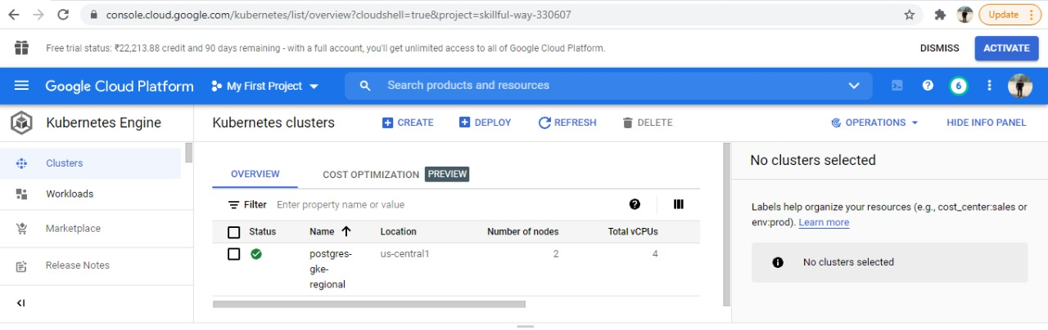

2. Deploy postgres on Kubernetes cluster
For postgress operator used reference: https://postgres-kubernetes.docs.pivotal.io/1-0/deploy-operator.html

Manually installed postgress as below:
Installed postgress via Kubernetes deployment scripts:

Created Deployment script:
Persistant Volume and Storage class:
cat > postgres-pv.yaml << EOF
kind: StorageClass
apiVersion: storage.k8s.io/v1
metadata:
name: regionalpd-storageclass
provisioner: kubernetes.io/gce-pd
parameters:
type: pd-standard
replication-type: regional-pd
allowedTopologies:
- matchLabelExpressions:
- key: failure-domain.beta.kubernetes.io/zone
values:
- us-central1-b
- us-central1-c
---
kind: PersistentVolumeClaim
apiVersion: v1
metadata:
name: postgresql-pv
spec:
storageClassName: regionalpd-storageclass
accessModes:
- ReadWriteOnce
resources:
requests:
storage: 300Gi
EOF

kubectl apply -f postgres-pv.yaml

Create and apply a PostgreSQL deployment:
cat > postgres-deployment.yaml << EOF
apiVersion: apps/v1
kind: Deployment
metadata:
name: postgres
spec:
strategy:
rollingUpdate:
maxSurge: 1
maxUnavailable: 1
type: RollingUpdate
replicas: 1
selector:
matchLabels:
app: postgres
template:
metadata:
labels:
app: postgres
spec:
containers:
- name: postgres
image: postgres:10
resources:
limits:
cpu: "1"
memory: "4Gi"
requests:
cpu: "1"
memory: "4Gi"
ports:
- containerPort: 5432
env:
- name: POSTGRES_PASSWORD
value: password
- name: PGDATA
value: /var/lib/postgresql/data/pgdata
volumeMounts:
- mountPath: /var/lib/postgresql/data
name: postgredb
volumes:
- name: postgredb
persistentVolumeClaim:
claimName: postgresql-pv
EOF

kubectl apply -f postgres-deployment.yaml
Create and apply the PostgreSQL service:
cat > postgres-service.yaml << EOF
apiVersion: v1
kind: Service
metadata:
name: postgres
spec:
ports:
- port: 5432
selector:
app: postgres
clusterIP: None
EOF

kubectl apply -f postgres-service.yaml

3. Create Postgres instance deployment manifests using helm chart:
a. Created the helm char with “helm create postgreschart”
b. Updated the Deployment.yaml, Service.yaml and Values.yaml as per postgres deployment
c. All the scripts available on https://github.com/Rajesh1584/use-case-postgres.git
d. After installation the workloads screenshot:
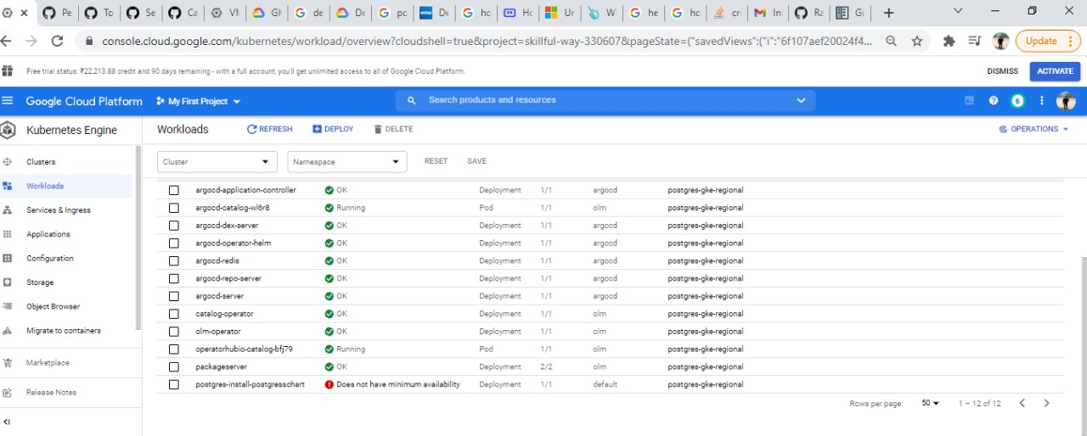

4. Installation of ArgoCD on GCP and Deployment using helm chart
References of ArgoCD installation GCP:
https://argocd-operator-helm.readthedocs.io/en/latest/k8s/gcp.html
After installation on GKE deployed the postgres on Kubernetes cluster via ArgoCD with below steps:
1. Open UI url https://104.155.141.202/
2. Provide application name: postgress-install
3. Sync Policy: Automatic (check SELF HEAL/PRUNE RESOURCES if required)
4. SOURCE: Provide URL: https://github.com/Rajesh1584/use-case-postgres.git
5. Revision: main (branch name)
6. Path: click on the text box you will get option postgreschart -> select postgreschart
7. Cluster: https://kubernetes.default.svc
8. Namespaces: default
9. Click on “Create”
10. The application will be deployed on the GKE cluster.

