**ENVIRONMENTAL IMPACTS OF GREEN REVOLUTION IN HARYANA**

By

Vinod Kumar

Assistant Professor of Geography

Ch. Bansilal Govt. College for Women, Tosham (Bhiwani)

**Dedicated**

**To My**

**Late Father**

**Sh. Krishan Prasad**



**CONTENTS**

|  |  |  |
| --- | --- | --- |
| **S No.** | **Chapters** | **Page No.** |
| **1.** | **Introduction** | **4-13** |
| **2.** | **Land, People and Economy of Haryana** | **14-25** |
| **3.** | **Ecology of Haryana: A Historical View** | **26-36** |
| **4.** | **Spread and Intensity of the Green Revolution: The Present Scenario** | **37-41** |
| **5.** | **Implication of Green Revolution on the ecology of Haryana** | **42-74** |
| **6.** | **Conclusions** | **75-76** |
| **Reference 77-80** | | |

**CHAPTER- 1**

**INTRODUCTION**

Haryana faces ecological problems due to its geographic location, scarcity of fresh water sources, and desert conditions. Deforestation and unlined canal irrigation have led to increased aridity, soil erosion, and waterlogging. The Green Revolution has exacerbated these issues, with deforestation and soil erosion on Shiwalik hills, waterlogging in canal-irrigated areas, and air pollution in industrial centers (Singh, 1998: 179-182). Throughout the course of human history, there have been several noteworthy agricultural revolutions. The Neolithic agricultural revolution, which occurred around 7500 B.C., marks a significant milestone in the history of agriculture as it witnessed the domestication of wheat and barley in the Middle East. The subsequent advancements, such as the introduction of the plough and the adoption of irrigated farming circa 2900 B.C., as well as the utilization of iron around 1400 B.C., can be characterized as revolutionary in their impact (Randhawa, 1980). Further improvement in agricultural practices and technology were gradual and scattered in occurrence.

In the mid-20th century, a major agricultural revolution emerged, focusing on high-yielding wheat and paddy varieties. This revolution spreads in developing countries, with India being a beneficiary. The Green Revolution, which began in the mid-19th century, involved rapid development, technological advancements, and increased use of fertilizers, pesticides, and irrigation infrastructure. However, this led to problems such as deforestation, soil fertility loss, water depletion, and water logging. Ecological studies examine human activities' impact on the environment for economic advancement, with ongoing debates on prioritizing ecology and development, examining whether constraints limit development or cause significant environmental damage (World Bank, 1992: 1). Population increase and poor agricultural development cause resource encroachment and environmental breaches in emerging nations (Brar, 1999: 2-3). Developing countries face challenges like dwindling forest cover, soil degradation, and water scarcity.

**The Green Revolution**

The Green Revolution in the mid-20th century significantly transformed agriculture, coined by William Gaud in 1968, focusing on the spread of new technologies in agriculture, unlike the Soviet Red or White revolutions (Gaud, 1968). Norman Borlaug, an American scientist, led the Green Revolution in Mexico in the 1940s. He developed disease-resistant high-yield wheat varieties and mechanized agricultural technologies, enabling Mexico to produce more wheat than its citizens needed. By the 1960s, Mexico became an exporter of wheat, importing nearly half of its supply. Chemical fertilizers, synthetic herbicides, and pesticides improved worldwide agricultural production during this time. These improvements enhanced output, nutrients, weed management, pest control, and disease prevention, boosting production.

The Green Revolution, first introduced by William S. Gaud in 1968, is a dramatic event promoting rapid agricultural productivity, highlighting progress and apprehensions in the field (Chandler, 1976; Wolf, 1986). It involved a large scale application of modern science and technology to agriculture (Dhanagare, 1989: 39). It is basically a biological-chemical phenomenon based on high-yielding variety of seeds and chemical fertilizers (Sharma and Dak, 1989: 2). The Green Revolution, 1940s-1960s, focused on research, development, and technology transfer to improve agricultural production globally (Hazell, 2007). Norman Borlaug led the Green Revolution, saving billions of people from starvation through cereal grain development, irrigation infrastructure expansion, and modernization of farming techniques.

Revolutionary green field creation reflects sudden, enormous change and greener fields, promoting environmental sustainability (Singh, 1974: 16). In 1961, India faced a mass famine, prompting Borlaug to collaborate with agriculture adviser C. Subramanian. The Ford Foundation and government imported wheat seed from CIMMYT, leading to the Green Revolution program in Punjab. This included plant breeding, irrigation development, and agrochemical financing. Agronomist S.K. De Datta showed that IR8, an IRRI semi-dwarf rice variety, produces 5 tons per hectare without fertilizer and almost 10 tons in ideal circumstances (Datta and Tauro, 1968). Asia loved IR8, which became IR36. From 1950 to 2004, emerging nations boosted wheat and maize yields, with the US having the highest rise since the 1940s (Fisher and Edmeades, 2009).

The rice yields in India witnessed a significant growth, rising from two tons per hectare during the 1960s to six tons in the mid-1990s. This increase in productivity was accompanied by a notable decline in rice prices, which plummeted from $550 to below $200 per ton by the year 2001 (Barta, 2007). India became a successful rice producer and exporter, shipping 4.5 million tons in 2006.In 1966, India launched the high-yielding varieties program, covering 1.89 million hectares of land in selected areas with assured irrigation for paddy, wheat, maize, and millets (Government of India, 1969). The introduction and diffusion of HYV in wheat, paddy, maize, and bajra has significantly boosted agricultural development in the last four decades. Farmers in successful areas have intensified their agriculture, transforming cropping patterns and sowing dates. Large farmers have more benefits, while small and marginal farmers benefit more. Landless workers now have more employment opportunities in agriculture and agro-based industries. However, the Green Revolution has exacerbated social tension and led to ecological problems.

Research on the ecological consequences of the Green Revolution primarily centers around the encroachment of marginal land, waterlogging, water pollution, soil fertility depletion, genetic diversity degradation, and heightened susceptibility of crops to pests (Fernando and Thomas, 1978; Kang, 1982; Brar and Singh, 1986; Bidwai, 1988; Mitra, 1988; Shiva, 1989 and 1991; Singh; G., 1991). These studies describe large areas impressionistically. These studies generally lack data analysis. The topic has seldom been studied spatially. This research fills that gap. We use the spatial perspective to identify regional variations in ecological implications of the Green Revolution in Haryana (Map 1.1), discover area-specific factors in each case, and assess the effect of the ecological change on the state's geographic personality.

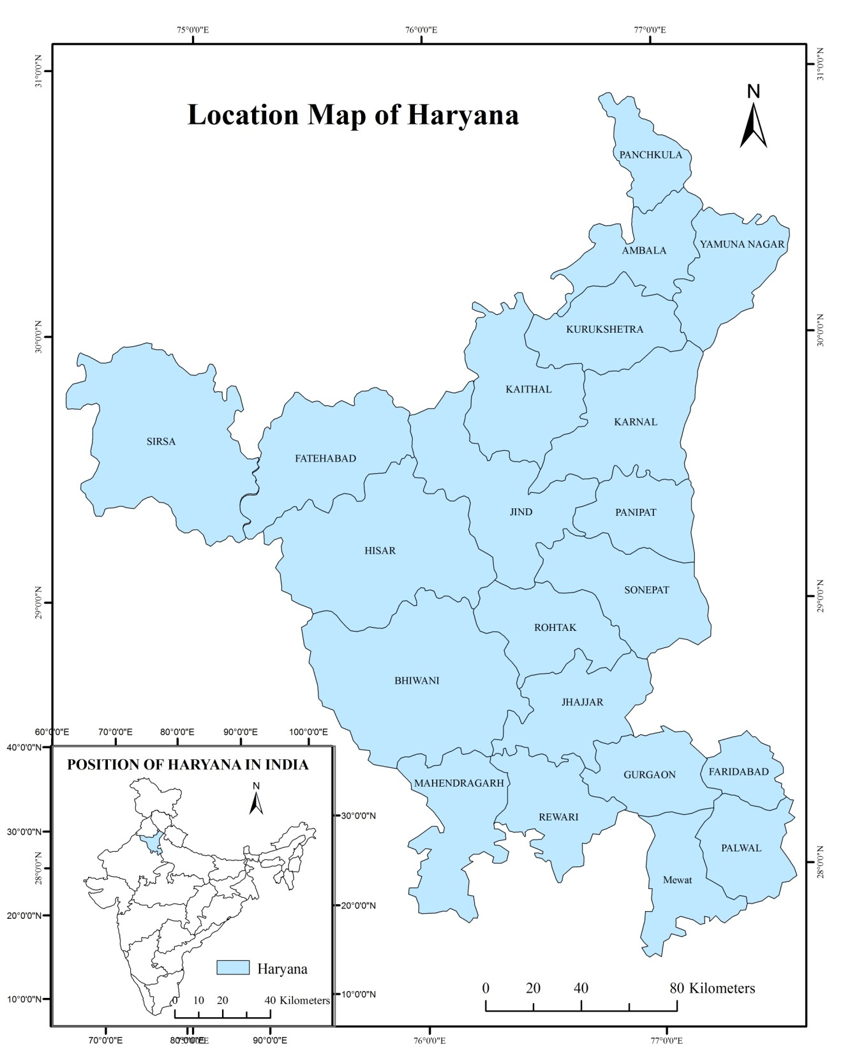

**Map 1.1**

**Green Revolution in Haryana**

India went from a food deficit to a surplus after the mid-1960s Green Revolution. One of the few states to adopt the Green Revolution package, Haryana's society, economy, and ecosystem suffered.

**Table 1.1**

**Haryana: A picture of some Indicators of Agricultural Development over time**

|  |  |  |  |  |  |  |
| --- | --- | --- | --- | --- | --- | --- |
| **Indicators** | **1966** | **1976** | **1986** | **1996** | **2006** | **2018** |
| **Fertilizers Consumption**  (Kg/ha of TCA) | 2.88 | 17.79 | 66.42 | 121.19 | 173.45 | 208.51 |
| **Irrigation Intensity**  (GIA/NIA*100) | 134 | 156 | 164 | 169 | 186 | 185 |
| **Cropping Intensity**  (TCA/NSA*100) | 135 | 150 | 155 | 167 | 183 | 185 |
| **Green Revolution**  **Intensity** | .20 | .28 | .40 | .46 | .51 | .58 |
| **Tractors**  (per 100 ha of TCA) | 2 | 5 | 15 | 28 | 38 | 42 |
| **Tubewell**  (per 1000 ha of NIA) | 20 | 117 | 181 | 199 | 211 | 245 |
| **Energy**  (Diesel pumping sets and electric tube-well per 1000 ha of NSA) | 7 | 57 | 113 | 153 | 173 | 214 |
| **Mandi**  (Per lakh ha of NSA) | 2 | 3 | 3 | 3 | 3 | 3 |

Source: Calculated from the data of Statistical abstract 2018-19, Director of Agriculture, Haryana etc.

(TCA means Total Cropped Area; GIA means Gross Irrigated Area; NIA means Net Irrigated Area; NSA Net Sown Area; ha means Hecatre)

The state's growth relied on technical innovation and irrigation expansion. Before 1966, Haryana was a less developed agricultural region of Punjab. Its net irrigated area was 35.54 %compared to Punjab's 58.48 percent. Punjab has a 2:1 agricultural compound annual growth rate. Irrigation is essential to increasing agricultural productivity per hectare, cropping patterns, and land usage (Singh, 1976). The Green evolution suggests that irrigation is the foundation for improved inputs and growing approaches (Singh, 1998). Haryana is now one of the most agriculturally developed states. Fertilizers, irrigation intensity, tractorization, and tube-well setups increased agricultural growth. These enhanced cropping intensity and Green Revolution (table 1.1). Singh (2010) said Haryana state helped launch India's Green Revolution. State agriculture development strategies prioritized high productivity and expansion. Ecological equilibrium was neglected. Due to increased herbicides and fertilizers, wheat and paddy production has increased, raising public health concerns. Insecticide usage is polluting the environment. Haryana produces wheat historically. Only high-yielding crop cultivars are related to the Green Revolution here. The influence of high-yielding rice cultivars is frequently neglected. It's Haryana's leading commercial crop.

Paddy and wheat drive Haryana's Green Revolution. Sorghum, pearl-millet, and gram seed strains improved, however these crops cover a tiny area and are not commercial crops. Thus, wheat and paddy statistics measured Haryana's Green Revolution spread and intensity. Governments and academics are increasingly addressing the Green Revolution's ecological consequences. Technological developments like the Green Revolution have production-related ecological consequences. The Green Revolution caused forest depletion, pasture land reduction, salinization, waterlogging, soil erosion, underground water table lowering, soil, water, and air pollution, soil fertility decline, and several diseases and health hazards. Researchers are studying Haryana's Green Revolution achievement. Different fields investigate the Green Revolution and its effects. This dissertation discusses green revolution-related concerns. Next chapters cover these ecological issues.

**REVIEW OF LITERATURE**

The mid-1960s Green Revolution spawned several research on its many features. Green Revolution literature assessment on water, soil, vegetation, crop cover, and air.

**Green Revolution and Water related studies**

Humanity's future depends on water. Its supply is steady, but human activities are increasing its demand. Water and economic issues are intertwined since water resources affect our economy. Humans require it biologically. This essential resource is scarce and degrading due to overuse and misuse. Sipes (2010) Overexploitation and pollution have depleted water tables, causing alarm among geographers, hydrologists, and others for decades. It causes water shortages in certain locations. Due to widespread groundwater development and depletion, groundwater volumes are dropping worldwide. Bhalla (2007) calculated that the groundwater depth in Haryana is high in the south and low in the mountainous north and northeast. It is 5–21m below ground level (bgl) pre-monsoon. Southwestern Mahendragarh district has the deepest water (21m bgl). Rohtak, Jind, Bhiwani, Sirsa, and Hisar are central districts with shallow water levels. Dhaliwal (2007) warns that excessive ground water consumption for agriculture and other uses is destroying Punjab. 103 of the 137 development blocks overuse subsoil water.

Brown (2005) deemed subsurface water depletion a larger danger to our future. He claims that irrigation wells are drying up each year in Haryana and Punjab, the biggest grain-surplus regions. Singh (2004) advised against groundwater withdrawal exceeding recharge. He stated that water table decline affects society, the economy, and the environment. Inderjeet (2001) quantified spatio-temporal groundwater loss in Eastern Haryana owing to excessive pumping. Due to rising tube-well costs and planting patterns, farmers are concerned about the 0.21 metres/year depletion rate. Subramanian (2000) predicted that India's yearly water demand is 634 km^3 and would more than treble in 50 years. Many locations' water tables are plummeting due to lack of recharge and excessive irrigation. The water table has dropped over 10 meters in certain Delhi neighborhoods and over 20 meters in Chennai and Chandigarh. Al-Saleh (1992) observed a similar pattern in Saudi Arabia, where enormous amounts of water were extracted for agricultural growth.

Groundwater is being used quicker in densely populated emerging countries, notably Asia, to fulfill rising water demand. Excessive groundwater extraction in India is also a worry. Ram Bilas (1988) said that Western Varanasi District's declining water table is due to groundwater depletion exceeding recharge. Tanwar (1984) found a rising water table in the semi-arid west and southwest of the state. The Bhakra canal irrigation system has made additional regions prone to waterlogging. Since 1974, Bhiwani, Hisar, and Sirsa districts have seen their water tables rise 0.31, 0.52, and 1.00 meters, respectively. Our water resources by Rama (1978) discusses water surplus and deficit issues. Rama remarked, “as the water table continues to fall deeper and deeper, we have to make bigger and bigger efforts to bring the water out”. According to Nace (1970) in the U.S. ogalla formation, pumping has reduced water storage by nearly 110 cubic km, and annual withdrawals in recent years have been about 6.2 cubic km, so the reserves are depleted and could be exhausted in the near future because the withdrawal rate is six to fifteen times the estimated natural recharge rate. Studies show that excessive ground water removal is the main cause of dropping water tables worldwide.

Darling (1947) showed that canal irrigation induced waterlogging and salinity and expanded farmed land into forest areas. The upper Bari doab canal command region initially suffered these changes. From 1865 to 1914, the Amritsar water table climbed 5 meters. The water table was 2.4 to 3 meters deep in 1925. The following research on the Green Revolution and water relations showed two key issues. The first issue is groundwater depletion in tubewell-irrigated regions. Second, waterlogging. Canal-irrigated regions have this issue. The groundwater level is high, causing waterlogging. Canal expansion deforested the state.

**Green Revolution and the Soil related studies**

Singh (2011) hypothesized that unplanned canal irrigation and poor drainage caused water logging and soil salinity in the south-western areas of the state. Over-irrigating agricultural land causes salinity and waterlogging. After the new agricultural policy, second or third harvests were planned each year, worsening the state's predicament. Vashistha (2007) concluded that the Green Revolution failed ecologically. It has decreased genetic diversity, insect susceptibility, soil erosion, water depletion, soil fertility, micronutrient shortages, and soil pollution. Singh (2000) found that India's Green Revolution achieved food self-sufficiency. In Haryana, this has degraded soil, vegetation, and water supplies. Chemical inputs are increasing as soil organic matter declines. New crop types respond to inputs but need more fertilizer and irrigation, contaminating water with nitrate and phosphate and changing the groundwater table. Crop production has been hampered by soil deterioration, water waste, and nutrient-use inefficiency. Waterlogging, salinity, and alkalinity affect 60% of the land. Singh (2000) noted that agricultural output increased in Haryana but degraded land. Haryana uses the most agrochemicals in India. Fertilizer use has grown from 3 to 130 kg ha^(-1) in 30 years. Rice and wheat consume 160 and 170 kg ha^(-1) of fertilizer. This area has an N, P, and K imbalance. Groundwater nitrates are rising to dangerous levels.

Kumar and Pasricha (1999) noted that the Green Revolution increased deforestation, waterlogging, salinity, alkalinity, soil erosion, and brackish water-related groundwater table fall and rise. Since the 1980s, these environmental issues have grown. Singh (1998) found that sodic soils are more common in Karnal and Kurukshetra districts and saline soils in Rohtak, Sonepat, and Gurgaon districts. Rohtak, Hisar, and Jind have more saline soils and high water tables. Kathpal and Kumari (1998) observed that excessive fertilizer, chemical, and pesticide usage increased crop output and productivity. Over 1,000 agrochemicals are used worldwide, compromising soil fertility and other issues. Rao (1998) found two main causes of rural environment deterioration. First, from deforestation, which lowers the water table and destroys top soil. These affect soil productivity. Randhawa (1998) found that Punjab was formerly affluent but is now in crisis. Discussing the ecological crisis's origins is unusual. Green Revolution included HYV, pesticides, fertilizers, and irrigation. Farmers use more fertilizers and insecticides to increase productivity. Pesticides have polluted soil and the food chain. Fitzgerald, Moore, and Parai (1996) believed the Green Revolution, like commercialized agriculture, reduces soil fertility. HYVs develop quicker, allowing a second or third harvest each year. However, absence of fallows, winter crops like sorghum, and persistent floods or water cover deplete soil micronutrients.

Shiva (1993) claimed that the Green Revolution gave the impression that soil fertility is manufactured in chemical factories and agricultural outputs are assessed primarily by marketable commodities. Nitrogen-fixing pulses were displaced. Marginal crops rejected millets with high organic matter yields. Thus, surplus trace elements caused soil toxicity during the Green Revolution. Poor water management causes salinization and waterlogging in irrigated land, according to Nadkarni, M.V. (1987). Waterlogging occurs when water is overused for short-term advantage and not drained. The subsequent Green Revolution and soil research revealed that unplanned canal irrigation and poor drainage produced considerable water logging and soil salinity. Overirrigating agricultural land causes salinity and waterlogging. Chemical inputs are increasing as soil organic matter declines. Fertilizer usage rose, causing N, P, K imbalance and soil fertility deterioration. Flooding and no fallows or winter crops decrease soil micronutrients.

**Green Revolution and Vegetation and Crop Cover related studies**

Pingali (2012) found that Green Revolution-driven intensification saved new land from conversion to agriculture, a known source of greenhouse gas emissions and climate change, and allowed marginal lands to provide alternative ecosystem services, such as forest regeneration. HYVs more sensitive to external inputs were key to productivity gains, but studies and strategies to encourage input judiciousness were often inadequate. Water consumption, soil deterioration, and chemical discharge have caused widespread environmental damage. Singh (2011) said that modern farming practices have boosted the agriculture sector's economic growth and job creation. However, new farming strategies have limited states to wheat and paddy. Diseased soil, pest-infested crops, overexploited groundwater, and water-logged deserts have ensued. Yadav (2004) said that inefficient use of surface and ground water is stressing our water resources. In irrigation, a lot of water leaks from the distribution system channels and produces waterlogging and salinization, reducing crop yields. Singh (2000) explored how the Green Revolution changed India's wet and winter cropping patterns. Rice and wheat now outnumber lentils, bajra, and jowar, but cotton is the main income crop. In 1996, rice was the predominant wet season crop, followed by bajra. Winter wheat output rose 1966–1996.

Sharma and Mukhopadhyay (1999) noted that irrigation, better seed types, herbicides, insecticides, and new farming practices have modified cropping patterns. However, rice and wheat, the two main crops, have been suffering significant restrictions and hurdles for sustained production. Brar (1999) examined Punjab's Green Revolution's environmental effects. He observed that removing marshes in floodplains, canal irrigation in sand dunes, and draining waterlogged pockets expanded agricultural land. Multiple cropping significantly increased cropped area. Different crops changed in prominence. Paddy and wheat in rotation, two profitable crops, outperformed others. Husain (1996) has been given the spread; intensification in agriculture and advanced agricultural technology have revolutionized the world's cropping patterns, producing food for the expanding population and raw material for agro-based enterprises. The environment suffered. According to Conway and Barbier (1988), the Green Revolution's equality, stability, and sustainability issues need fresh agricultural research and development. Yapa (1979) suggests using eco-political economics to assess the effects of this technology.

Following research on the Green Revolution and vegetation and crop cover revealed that intensification preserved new area from cultivation. Irrigated land salinization reduces agricultural production. Rice and wheat now outnumber lentils, bajra, and jowar, but cotton is the main income crop. In 1996, rice was the predominant wet season crop, followed by bajra. Winter wheat output rose 1966–1996. Multiple cropping significantly increased cropped area. Different crops changed in prominence. Paddy and wheat in rotation, two profitable crops, outperformed others.

**Green Revolution and Air related studies**

Brar (1999) concluded that the Green Revolution has both beneficial and negative effects on air quality. Using fossil fuels, chemical fertilizers, pesticides, and mechanization in agriculture is bad. Due to a prolonged Green cover in time and space, settlements are less "dusty." Rice merchants, which have proliferated in rural areas, pollute the air around them. Singh (1998) found that Rapid development in Haryana has led to environmental issues such as air pollution and pollution from Haryana quarrying. The Green Revolution has caused forest depletion, pasture land reduction, salinization, waterlogging, soil erosion, underground water table lowering, soil, water, and air pollution, soil fertility decline, and various diseases and health hazards. Governments and academics are increasingly addressing these ecological consequences, with Haryana's Green Revolution achievement being studied by researchers in various fields. This dissertation discusses ecological issues related to the Green Revolution and its effects.

**Objectives**

The objectives of this study are:

1. To analyse the regional variations in the intensity of the Green Revolution in Haryana.
2. To analyse the expansion of agricultural practices in Haryana and the resulting environmental challenges.
3. The objective of this study is to assess the level of spatial correlation between the intensity of the Green Revolution and the extent of degradation observed in various ecological components, including vegetation, water table, soils, and air quality.
4. To establish a comprehensive connection between the Green Revolution and its impact on the environment, specifically focusing on empirical evidence from the state of Haryana.

**Hypotheses**

Contrary to popular belief, the Green Revolution has both negative and positive impacts on Haryana's ecology. The intensity of the revolution affects water table, soil, air, and vegetation, affecting their overall health. Haryana, a state known for its Green Revolution achievements, has faced ecological costs and concerns. Analytical studies can provide a convincing answer to whether this assessment is justified or exaggerated, especially when examining spatial perspectives.

**Period of the study**

The study examines the 1966-2018 period of Haryana's Green Revolution, which began in 1966 and climaxed in 1975. It lasted ten years, followed by stabilization, and its ecological impacts began crystallizing in the early 1980s. The study covers all decades and the present status of the Green Revolution in Haryana's life history, focusing on its agricultural growth. A study, which concerns itself with issues relating to ecology, has to maintain a holistic view. Chapman (1993) emphasizes the importance of considering the complex specificities of place in environmental problems and avoids simplistic explanations. The study aims for a consistent spatial perspective in a geographic spirit, presenting a balanced view based on empirical analysis.

**Database and Methodology**

This dissertation examines the ecological impact of the Green Revolution using secondary data from various sources, including the statistical abstract of Haryana, Department of Water Resources, Department of Agriculture Haryana, Haryana Agricultural University, and CMIE. The methodology aims to identify ecological elements, examine regional variations in the spread and intensity, and detect spatial changes in various elements. The intensity index is calculated by calculating the area under wheat paddy rotation as a proportion of the total cropped area. i.e.

Index of intensity =

Crop intensity is calculated after the Green Revolution by dividing total cropped area by net area sown and multiplying by 100.

GIS arc is also used as a tool to draw the maps of the impact of the Green Revolution on the components of the ecology in Haryana.

**Components of Ecology**

The constituents of Ecology encompass the elements that are directly pertinent to the field of study. Water, vegetation, soil, and air have been widely embraced and incorporated into various contexts. In the context of the dissertation, the arrangement of the listing has been altered to prioritize the following elements: water table, soils, vegetation and crop cover, and air. The Green Revolution has influenced the relative significance of different items.

**CHAPTER SCHEME AND THE ORGANISATION OF THE STUDY**

In terms of chapter scheme and the organization of the text, the study is organized in the six chapters.

**Chapter I Introduction**

**Chapter II Land, People and Economy of the study area**

**Chapter III Spread and Intensity of the Green Revolution**

**Chapter IV Green Revolution and Ecology of Haryana: A Historical View**

**Chapter V Green Revolution and Ecology of Haryana: Post-formation Scenario**

**Chapter VI Conclusions**

**CHAPTER 2**

**HARYANA: LAND, PEOPLE AND ECONOMY**

Haryana, a landlocked state in India, was established on November 1, 1966, as a separate entity from Punjab. It is located in the north-central region, bordered by Punjab and Chandigarh, Himachal Pradesh and Uttarakhand, Uttar Pradesh and Delhi, and Rajasthan. Chandigarh serves as the administrative center for both Haryana and Punjab. The state is linguistically distinct from Punjab and is part of the Kuru region (Singh, 1998: 24). Haryana, derived from Sanskrit words Hari (Vishnu) and Aranya (dwelling), signifies "the Abode of God" and is derived from the words Hari meaning "green" and Aranya meaning "forest" (Britannica online encyclopedia).

Haryana, a geographical division between the Ganga and Indus river systems, is a transitional region between the Rajasthan desert and the Ganga plain. It has faced frequent droughts, famines, and discrimination in social, cultural, and economic progress. The region was created as a separate entity from Punjab in 1966, reducing its territorial extent to one-third of its original size. Despite concerns about its long-term sustainability, Haryana has achieved an advantageous position due to popular will and state machinery's efforts. Haryana has a rich historical legacy dating back to the dawn of civilization. It is situated at a disadvantageous position compared to the central Punjab region, with the Ghaggar River primarily traversing northern regions and the Yamuna as its eastern boundary. The region's agro-climatic conditions are unfavorable, with low precipitation levels, unpredictable soil, and scarcity of sub-soil water. The region's higher elevations pose challenges for implementing flow irrigation systems, requiring more expensive lift schemes. The ecological implications of the Green Revolution include assessing water resources, vegetation, crop cover, and soil resources. Haryana's deficiencies in water resources, forest cover, and arable land can be attributed to historical discriminatory practices targeting the region. Understanding the geographical features, inhabitants, and economic aspects of the subject is essential for this investigation.

**1. The Land**

1.i **Relief and Drainage**

Haryana has two primary physiographic regions: a vast alluvial plain and a narrow strip of the dissected Shiwalik Range in the north-eastern part. The alluvial plain has a single perennial river, the Yamuna, and is surrounded by seasonal streams from the Siwalik Range. The Ghaggar River, near the northern border, historically extended its course to merge with the Indus River in Pakistan (Map 2.1).

Haryana is a flat terrain with 94% of its land below 300 meters, extending from the northeast to the southwest. The state resembles a saucer, with its concave shape centered around the Rohtak region. It can be categorized into five landform regions for a comprehensive understanding of its topography:

1. The Shiwalik hills in the northeastern region are a narrow belt with an average elevation of 300-1000 meters.
2. Adjacent to the hills is the piedmont plain, Ghar, characterized by incisions from seasonal streams.
3. The Ghaggar Yamuna alluvial plain is the primary geographical feature of the state, with upland plains and peripheral floodplains along rivers.

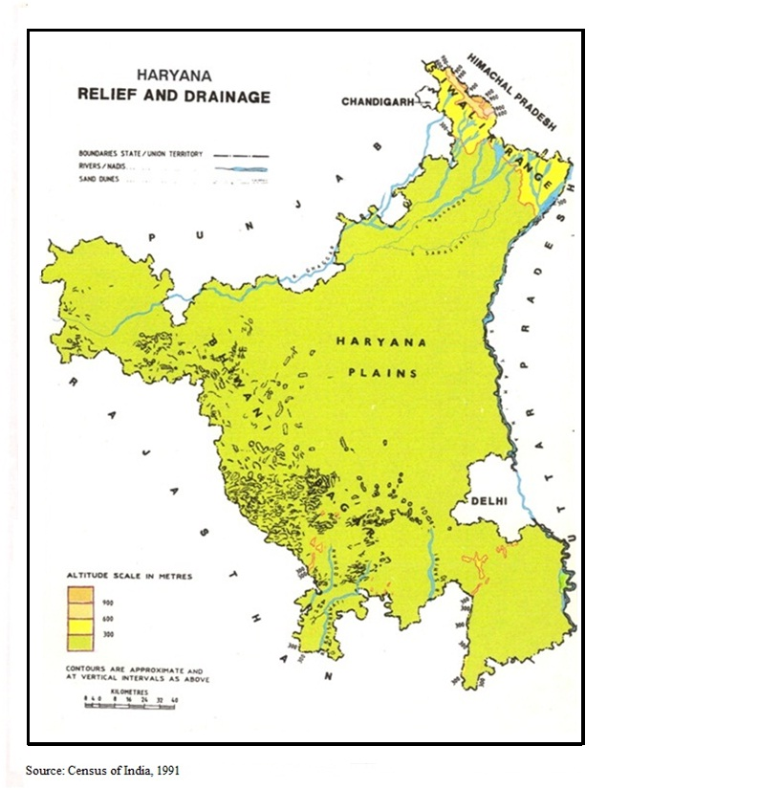

**Map 2.1**

The southwestern region has a heavily populated plain called Bagar, while the southern region of Haryana has a sandy, undulating plain. Aravalli outliers in Bhiwani, Mahendragarh, and Gurgaon exhibit significant dissection.

Haryana has a small size, but it has a diverse climate, with the Yamuna being the only permanent river. The Ghaggar, a seasonal stream, has tributaries such as Markanda, Chautang, and Saraswati. The Shiwalik's outer slopes are irrigated by Choes, while seasonal rivers like Sahibi, Krishnawati, Indoris, and Landoha convey water to the southern areas. Only a portion of Haryana's subsurface water is useful, as the sub-soil water in central and western regions is brackish to saline, making irrigation in tube wells difficult. The piedmont plain's deep and limited subsurface water makes routine irrigation difficult. Water logging is a major issue in canal-irrigated areas like Rohtak, Sonepat, Jind, and Hisar districts. Despite its small size, Haryana has a range of climatic climates in its northeast and southwest borders, ranging from sub-humid to dry.

**1.ii.** **Soils**

Haryana's soils are characterized by their depth and high fertility levels, with some exceptions like eroded terrains in the northeastern region and sandy regions in the southwestern Thar Desert. The majority of the state's land is suitable for cultivation, but a significant portion requires irrigation methods. The state is predominantly covered by alluvial deposits, with new alluvium (Khadar) consisting of silty-loam along the Yamuna and Ghaggar rivers and old alluvial (Bangar) consisting of coarse, light, or fine loam on the main upland plain. Both types are suitable for wheat, rice, gram, and barley cultivation.

Sandy soils, also known as Bagar, are prevalent in western regions and have a high concentration of sodium chloride and salinity in their underlying groundwater. In the absence of irrigation, food grains like gram and bajra can be cultivated. The Aravalli outliers in the southern and southwestern regions have rocky surfaces with low fertility for field crops. The soils in the Shiwalik hills and piedmont plains have a predominantly sandy composition, with pebbles, small stones, and larger boulders in close proximity. The diverse soil composition reflects varying cropping patterns and agricultural productivity in Haryana. The state is highly deficient in mineral resources, with small mineral bearing tracts confined to the districts of Mahendragarh, Gurgaon, and Ambala. All minerals contribute hardly 0.10 per cent to the state's net domestic product.

**1.iii.** **Climate**

Haryana experiences hot summers and cold winters, with maximum temperatures in May and June exceeding 110°F, and January's low temperatures dropping below freezing. Haryana has arid to semiarid climates, with humid conditions in the northeastern region. The state is divided into western and eastern parts, with isohyets measuring 50cm indicating agricultural productivity. Drinkable groundwater is abundant, requiring irrigation systems for consistent crop yields. Inadequacy of rainfall and insufficient rainfall necessitate additional water from neighboring states. However, there has been a lack of inclination to allocate supplementary water resources beyond the initial designated share of Haryana since its inception.

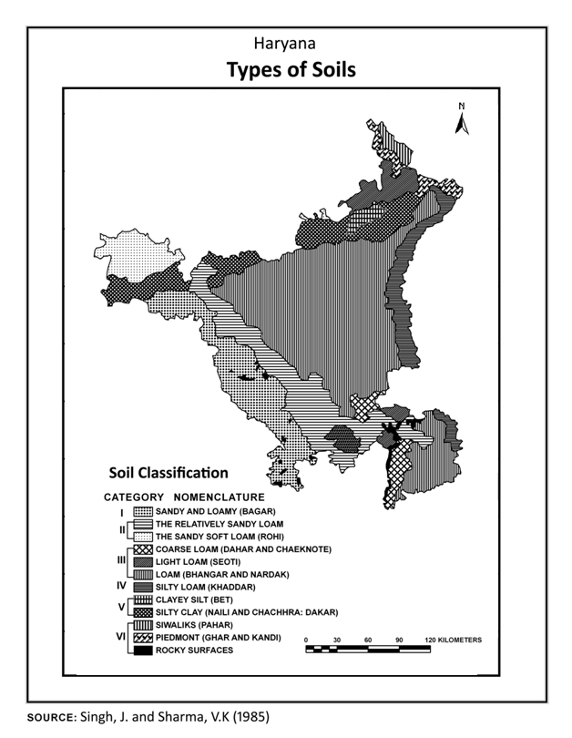

**Map 2.2**

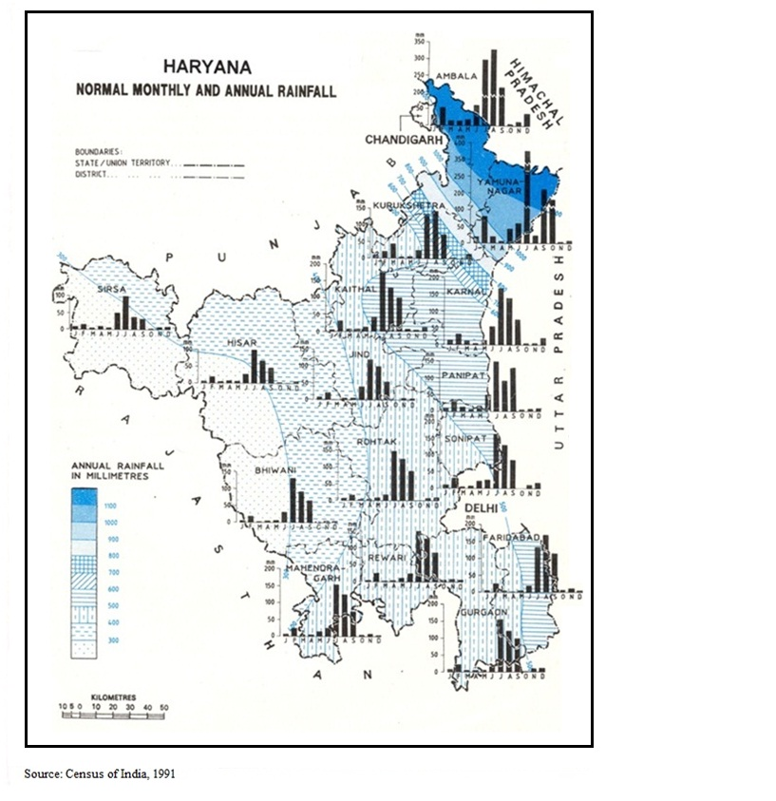

**Map 2.3**

**iv.** **Plant and animal life**

Haryana, a region rich in vegetation, has forest coverage of only 3.97% of its total land area. The Siwalik Hills and Aravalli outliers have predominantly shrub-dominated vegetation, with chil species dominating higher elevations and hardwood species dominating northern slopes. Elevated moisture levels lead to dense bamboo forests and grazing and biotic interference contribute to the development of scrub forests. Haryana faces limited wood resources, relying on neighboring hill states, particularly Himachal Pradesh.

**Table 2.1**

**Haryana: Area, Population and Density of districts, 2011**

|  |  |  |  |
| --- | --- | --- | --- |
| Districts | Area () | Persons | Density (Per () |
| Ambala | 1574 | 1136784 | 722 |
| Panchkula | 898 | 558890 | 622 |
| Yamunanagar | 1768 | 1214162 | 687 |
| Kurukshetra | 1530 | 964231 | 630 |
| Kaithal | 2317 | 1072861 | 463 |
| Karnal | 2520 | 1506323 | 598 |
| Panipat | 1268 | 1202811 | 949 |
| Sonepat | 2122 | 1480080 | 697 |
| Rohtak | 1745 | 1058683 | 607 |
| Jhajjar | 1834 | 956907 | 522 |
| Faridabad | 1792 | 1798954 | 2298 |
| Palwal | 1359 | 1040493 | 761 |
| Gurgaon | 1253 | 1514085 | 1241 |
| Mewat | 1874 | 1089406 | 729 |
| Rewari | 1582 | 896129 | 562 |
| Mahendragarh | 1859 | 921680 | 485 |
| Bhiwani | 4778 | 1629109 | 341 |
| Jind | 2702 | 1332042 | 493 |
| Hisar | 3983 | 1742815 | 438 |
| Fatehabad | 2538 | 941522 | 371 |
| Sirsa | 4277 | 1295114 | 303 |
| Haryana | 44212 | 25353081 | 573 |

Source: CMIE database, States of India, Households, Population and Demography

Eucalyptus trees are cultivated near roadways and unproductive land, while Shisam trees grow alongside roads and canals. Small, spiny kikar trees and scrub vegetation are found in the southern and south-western regions. Haryana has a diverse array of mammalian species, with larger species concentrated in hilly regions. The plains ecosystem hosts various small mammalian species, including pigeons, doves, and snakes. Water availability is constrained due to the absence of perennial streams and inadequate precipitation, and deforestation has led to inadequate mineral content. The viability of this resource depends on accessible water resources, despite the flat topography and fertile soils.

**2. People**

Haryana, a historically significant region in India, has a modest population density due to its border location, political instability, and limited water resources. Despite its modest population, Haryana has been a hub for social, cultural, and religious endeavors since predating the Vedic Civilization. The state has experienced invasions by Muslim rulers, engagements by Marathas and Sikhs, and has been influenced by Hindu saints, Buddhist monks, and Sikh gurus. Haryana's inhabitants exhibit modesty, straightforwardness, enterprising nature, and industriousness, preserving ancient Vedic traditions. Festivals are celebrated with enthusiasm and adherence to traditional customs. Females are dedicated to agricultural pursuits, while the populace follows straightforward dietary habits. In 2011, Haryana had a population of 2,53,53,081 individuals, compared to other Indian states like Punjab (550), Uttar Pradesh (820), and Kerala (860).

Haryana, an Indian state, has a significant demographic diversity, with districts primarily inhabited by Muslims and Sikhs. The Sikh community is concentrated in the northeastern and northwestern regions, while Muslims are concentrated in the southeastern districts bordering Delhi. The Jats, a caste primarily engaged in agricultural activities, play a crucial role in sustaining Haryana's agricultural economy and hold a prominent position within the armed forces of India. In 1947, the state experienced a significant demographic shift due to emigration of its Muslim population to Pakistan and a influx of non-Muslim displaced individuals from other regions. The Muslim population declined significantly, while the overall population experienced rapid growth. Haryana has a high fertility rate of 6.30 children per woman, but there was a notable transformation in the demographic composition during 2011-12, with a fertility rate of 2.3 children per woman. The state has the highest population density among all states, with a population density of 573 individuals per square kilometer, compared to India's average of 382. The state's resilience can be attributed to its abundant underground freshwater resources and favorable agricultural productivity. In 2011, Haryana had a population of 6,841 villages and 154 towns, with fifteen districts exceeding the one million mark. The state's urbanization rate increased significantly between 1991 and 2011, with advancements in 1991 and 2011 resulting in a 34% increase in urban population. The Bangaru dialect is widely used for communication, with Hindi and English being the prevailing languages.

**2.ii. Settlement patterns**

Roughly three-fourths of Haryana’s population remained rural in the early 21st century; however, cities have continued to grow rapidly as commercial, industrial, and agricultural marketing centres. The state’s largest cities include [Faridabad](http://www.britannica.com/EBchecked/topic/201856/Faridabad), [Rohtak](http://www.britannica.com/EBchecked/topic/506933/Rohtak), [Panipat](http://www.britannica.com/EBchecked/topic/441335/Panipat), [Hisar](http://www.britannica.com/EBchecked/topic/266912/Hisar), [Sonepat](http://www.britannica.com/EBchecked/topic/554306/Sonipat), and [Karnal](http://www.britannica.com/EBchecked/topic/312548/Karnal). With the exceptions of [Rohtak](http://www.britannica.com/EBchecked/topic/506933/Rohtak), which is in the central Haryana and [Hisar](http://www.britannica.com/EBchecked/topic/266912/Hisar), which is in the northwest, most of the major urban centre’s lie in the eastern part of the state. Despite the constraints posed by nature the Haryana people have tried to utilize the available resources in a meaningful manner. Their distribution corresponds to the productive capacity of different areas. The pressure of fast increasing population on the agricultural land is, however, intensifying, and there is a need for rapid diversification of economy.

**3. The Economy**

With a high per capita income, Haryana ranks high on economic development among various states of India. Its per capita income stood at Rs. 109227 in 2011-12 as compared Rs. 78171 to the Punjab and Rs. 60972 of the country at current prices. The state economy recorded an annual growth rate of 15.4 per cent during 2011-12 against 12.2 for Punjab and 14.3 per cent for the country as a whole (Govt. of India). This an index to the creditable advancement made by the state in the sphere of economy.

## 3.i. Agriculture

## Agriculture is the mainstay of economy. It absorbed above 50 per cent of the working force in 2011, as cultivators and agricultural laborers. No less than about 83 per cent of its total area is under plough in 2011-12. The all India figure is 54.66 per cent. About 78 per cent of the net area sown is irrigated in comparison to about 44 per cent in India. Agriculture contributed about 44.48 per cent of the state’s domestic product in 1985-86, 31 per cent in 2001 and 21 per cent in 2011-12. The share of agriculture in gross state domestic product is decreasing continuously in Haryana (Table 2.4). This is due to the industrial development in Haryana. The comparatively high per capita income in the state is significantly related to its progressive agriculture. Haryana’s agricultural productivity is largely attributable to the so-called Green Revolution, an international movement launched in the 1960s to diminish world hunger. As a result of this movement, large-scale investments have been made in irrigation, fertilizers, and high-quality seeds. In the early 21st century, nearly two-fifths of the state’s workforce was employed in agriculture.

## Table 2.4

## Haryana: Gross state domestic product in Agriculture at current prices: base year 2004-05

## (Rs. In Million): 1980-81 to 2017-18

|  |  |  |  |
| --- | --- | --- | --- |
| Years | GDP | Agriculture | Percentage ofAgriculture inGSDP |
| 1980-81 | 39281.8 | 18417 | 46.00 |
| 1985-86 | 76001.4 | 30023 | 39.50 |
| 1990-91 | 158180 | 60759 | 38.41 |
| 1995-96 | 320372 | 109647 | 34.22 |
| 2000-01 | 595724 | 172639 | 28.97 |
| 2005-06 | 1088845 | 217537 | 19.97 |
| 2010-11 | 2606212 | 516549 | 19.82 |
| 2017-18 | 3928940 | 747993 | 19.03 |

## Source: CMIE, States of India, Gross state domestic product, Economic outlook, Agriculture Outlook (1980-81 to 2017-18)

An agriculturally prosperous state, Haryana contributes a large amount of [wheat](http://www.britannica.com/EBchecked/topic/641558/wheat) and [rice](http://www.britannica.com/EBchecked/topic/502259/rice) to the Central Pool (a national repository system of surplus food grain). In addition, the state produces significant quantities of [cotton](http://www.britannica.com/EBchecked/topic/139828/cotton), rape and mustard seed, pearl [millet](http://www.britannica.com/EBchecked/topic/382865/millet), chickpeas, [sugarcane](http://www.britannica.com/EBchecked/topic/571999/sugarcane), sorghum, [corn](http://www.britannica.com/EBchecked/topic/137741/corn) (maize), and potatoes. Dairy cattle, buffaloes, and bullocks, which are used for ploughing the land and as draft animals, are prominent in the north-eastern region.

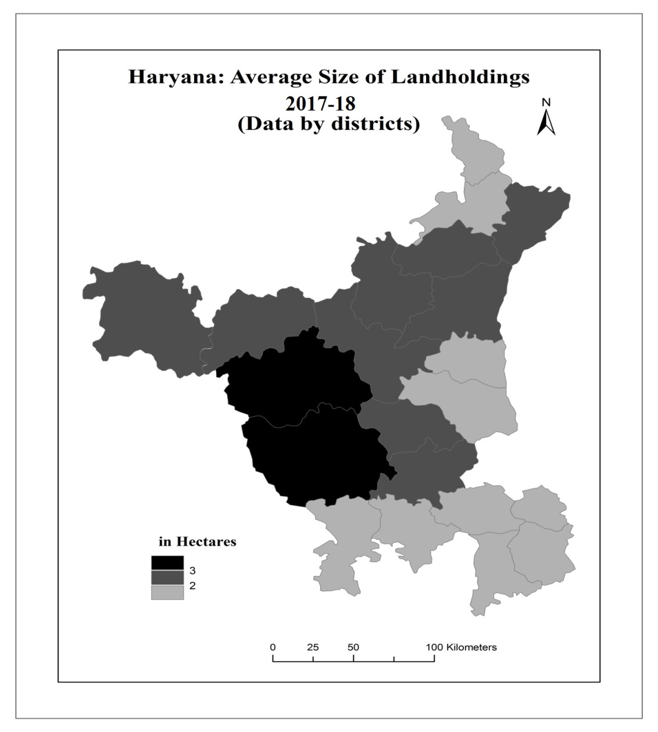

**Map 2.4**

The distribution of land is inequitable. In 1985-86, more than half of the landholdings were smaller than 2.0 hectares each and together they shared less than one-fifth of the agricultural land. Contrarily, about 5.0 per cent of the landholdings, which were larger than 10.0 hectares each, partook one-fourth of the cultivated land. But in 2011 the landholding smaller than 2.0 hectares, consisted of less than one fourth of the total cultivable land. Average size of the landholding declines from west to east at the present scenario (Map 2.4). It is generally smaller than 2.50 hectares in the eastern part and ranges from 2.50 to 4.00 hectares in the western part of the state. The average size of landholding of Haryana in 2011 was 2.25 hectares in respect to 3.77 of Punjab and 1.16 hectares of India (Table 2.5).

**Table 2.5: Haryana: Average size of landholdings, 2018**

(in hectares)

|  |  |
| --- | --- |
| Districts | **Average size of landholdings** |
| Ambala | 1.98 |
| Panchkula | 1.57 |
| Yamunanagar | 1.92 |
| Kurukshetra | 2.15 |
| Kaithal | 2.52 |
| Karnal | 2.55 |
| Panipat | 1.70 |
| Sonepat | 2.09 |
| Rohtak | 1.88 |
| Jhajjar | 1.72 |
| Faridabad | 1.57 |
| Palwal | 1.42 |
| Gurgaon | 1.48 |
| Mewat | 1.65 |
| Rewari | 1.80 |
| Mahendragarh | 1.95 |
| Bhiwani | 2.94. |
| Jind | 2.34 |
| Hisar | 2.70 |
| Fatehabad | 2.33 |
| Sirsa | 2.97 |
| Haryana | 2.22 |

Source: Statistical abstract of Haryana, 2018

Kharif and Rabi are significant crop seasons in the state, with Kharif spanning from July to November and Rabi from December to March. Kharif crops include rice, cotton, Jowar, Bajra, maize, and pulses. Rabi crops include wheat, gram, and oilseeds. Sugarcane is cultivated annually, with planting in March or April. Approximately 40% of cultivated land is allocated for food grains cultivation, with wheat being the predominant crop in most regions. Rice is second in the north-eastern region, where annual rainfall is supplemented by tube-well irrigation.

**3.ii. Manufacturing**

Haryana has made rapid strides in the development of agriculture-based manufacturing. Among the most important of such industries are cotton and sugar processing and the production of farm machinery. Haryana also manufactures chemicals as well as a great variety of consumer goods, most notably bicycles.

Despite a poor mineral resource base, the state has made significant progress in industry. The growth has been impressive since 1966. The number of registered working factories increased from 1168 to 5652 in 1990 and 10979 in 2012 and of the employees from 71061 to 821412 over the 1966-2018 periods.

Haryana is one of the growing States of the country in the Industrial outlook. The state gross domestic product consisted 22.55 per cent of the Industrial income in the 1980-81, and it has been growing since then and reached 28.50 in 1990-91 and 28.96 in 2001. At present time in 2013-14, the State gross domestic product consists of 25.72 per cent of the total and the contribution of Industries in Haryana’s GSDP is far ahead to the agriculture (table 2.6).

## Table 2.6

## Haryana: Gross state domestic product at current prices: base year 2004-05

## (Rs. In millions): 1980-81 to 2017-18

|  |  |  |  |
| --- | --- | --- | --- |
| Years | GSDP | Industry | Percentage ofIndustries in GSDP |
| 1980-81 | 39281.8 | 8858.4 | 22.55 |
| 1985-86 | 76001.4 | 21463.8 | 28.24 |
| 1990-91 | 158180 | 45089.2 | 28.50 |
| 1995-96 | 320372 | 100582.5 | 31.39 |
| 2000-01 | 595724 | 172574.6 | 28.96 |
| 2005-06 | 1088845 | 356696.0 | 32.75 |
| 2010-11 | 2606212 | 749141.9 | 28.74 |
| 2017-18 | 3928940 | 1010561.5 | 25.72 |

## Source: CMIE, States of India, Gross state domestic product, Economic outlook, Industry outlook (1980-81 to 2017-18)

Haryana is a major industrial hub in India, producing various goods such as tractors, bicycles, refrigerators, air conditioners, television sets, agricultural implements, scientific instruments, handloom linen, and sanitary wares. The state produces the largest number of tractors and one out of every five bicycles, accounting for over one-third of the country's total export of scientific instruments. It also supplies 60% of the defense forces' ammunition boxes and 75% of the Indian Army's woolen blanket requirements. However, the state's industry is not significantly linked to agriculture and its markets are generally outside the state. To promote the region's economy, it is crucial to stimulate the industry-agriculture nexus.

## 3.iii. Transportation

Haryana is a highly developed state with well-developed transportation infrastructure, with an aggregate road length of 25,635 kilometers, a significant increase from the 8,137 kilometers recorded in 1966-67. It accounts for 1.19 %of the total National Highways network and has historically maintained robust connectivity with neighboring states and the broader Indian nation. The state is traversed by significant highways and railway lines, such as the Grand Trunk Road and the Northern Railway's primary route, which intersect near Delhi. A state-owned bus service operates transportation services, and a local airport in Chandigarh facilitates the region. Haryana is known for its extensive network of metallic roads, which connect nearly every village within its boundaries. The British undertook measures to develop the transportation system, addressing the deterioration of Mughal roads during the Sikh rule. The state's inter-town and urban-rural transport connections are robust, and all regions are effectively linked to Delhi through a comprehensive road network. The significance of railways in Haryana is relatively limited due to its small size and short distances. The majority of the state is located within a five-hour travel distance from the national capital of Delhi. The Delhi-Ambala-Amritsar rail route exhibits high traffic frequency and volume, with an aggregate length of 4106.26 kilometers in 2010-11.

**Conclusion**

The study aimed to investigate the land, people, and economy of Haryana, an Indian state that gained statehood in 1966. The topography of Haryana can be categorized into various landforms, including the Shiwalik hills, piedmont plain, alluvial plain, sand dune, and Aravalli outliers. The state lacks perennial rivers and has seasonal rivers, such as Markanda, Chautang, and Saraswati. The Ghaggar and Yamuna rivers demarcate the eastern border of the state, while intermittent streams transport water through the Aravalli range into the southern regions. Water scarcity and water-logging are challenges faced in certain regions. Haryana's agricultural land is fertile, but a significant portion of it requires irrigation. The state's climate ranges from arid to semi-arid, with hot summers and cold winters. The state's forest cover varies based on topographical factors, with chil trees in the Shiwalik hills and Eucalyptus and poplar trees in strip plantations. Haryana relies on the neighboring state of Himachal Pradesh for wood procurement.

The population of Haryana is characterized by modesty, directness, entrepreneurial spirit, and diligent work ethic. The demographic makeup of the state indicates that approximately 25% of the population consists of Hindu Jats, with the Harijan community comprising approximately 20% of the total population. The predominant Muslim population is the Meo community, with a notable concentration in the Mewat region. The Sikh community resides in the districts of Ambala, Kurukshetra, and Karnal, with distinct castes. A significant majority of the population relies on agriculture as their primary means of sustenance. Haryana's economic performance in the past was weaker, but the implementation of the Green Revolution and its subsequent establishment has led to significant economic growth. Agriculture plays a pivotal role in the state's advancement, with the agricultural sector accounting for a greater proportion of the state's domestic product in 1985-86. The advancement in agriculture has significantly contributed to the state's economic prosperity, leading to notable progress in agro-based manufacturing sectors such as sugar and cotton. Currently, there is a noticeable focus on industrial development, which is not directly associated with agriculture. There is a significant imperative to invigorate agro-industries to effectively bolster the regional economy. The transportation infrastructure in Haryana is robust, with each village connected by a network of paved roads. Despite the progress made in agriculture and economic growth, it is important to note that this progress has come at the expense of the region's ecology. The progress made in the agricultural sector has had a detrimental impact on soil quality, forest ecosystems, water resources, and crop coverage.

**CHAPTER 3**

**SPREAD AND INTENSITY OF THE GREEN REVOLUTION**

The dissemination of the Green Revolution pertains to its spatial coverage. Intensity refers to the extent to which a particular region has been impacted by the Green Revolution. The data pertaining to the dissemination and magnitude were examined on a district-level basis within the state. The predominant method of cultivating paddy and wheat involves the utilization of high yielding varieties of seeds. The correlation between the cultivation of these two crops and the scope of the green Revolution has been widely acknowledged. It is worth noting that wheat is classified as a Rabi crop, cultivated during the winter season, while paddy is categorized as a Kharif crop, grown during the summer season in the state of Haryana. In 1966, following the partition of Haryana from Punjab, the adoption of high yielding varieties was in its early stages, with limited coverage across the region. By the fiscal year 2011-12, the cultivation of high yielding varieties had encompassed the entirety of the land dedicated to wheat production, as well as a significant percentage of the land allocated for paddy cultivation. The Green Revolution had a pervasive impact across all regions of the state.

An examination of the spatial distribution of wheat cultivation during the Rabi season and paddy cultivation during the Kharif season indicates that wheat exhibits a higher degree of uniformity in its distribution, as depicted in maps 1.3 and 1.4. The proportion of wheat cultivated in the Rabi season exhibits a consistently elevated level. There exists a significant disparity in the distribution of paddy percentages across different regions, with certain areas exhibiting notably elevated proportions while others demonstrate minimal presence. The aforementioned phenomenon can be attributed to the historical prevalence of sub-humid and semi-arid climatic conditions in the region of Haryana. The expansion of Paddy cultivation initially occurred predominantly via water-logged canals and irrigated tracts, subsequently extending to additional regions, primarily facilitated by tube-well irrigation. The acceleration of this process was facilitated by a government policy that provided a highly lucrative price support mechanism. Wheat accounts for approximately 90% of the total cultivated area during the Rabi season in various districts, such as Ambala, Yamunanagar, Kurukshetra, Kaithal, Karnal, Panipat, Sonepat, Faridabad, Palwal, Jind, and Fatehabad. In alternative regions, the cultivation of wheat encompasses a range of 70 to 90 percent. In the southern and southwestern regions, specifically Bhiwani, Mahendragarh, and Rewari districts, the percentage gradually decreases to less than 50%. In relation to the proportion of cultivated land, wheat comprises approximately 40 %in the majority of districts in Haryana, as indicated by Map 1.7 and Table 3.1.

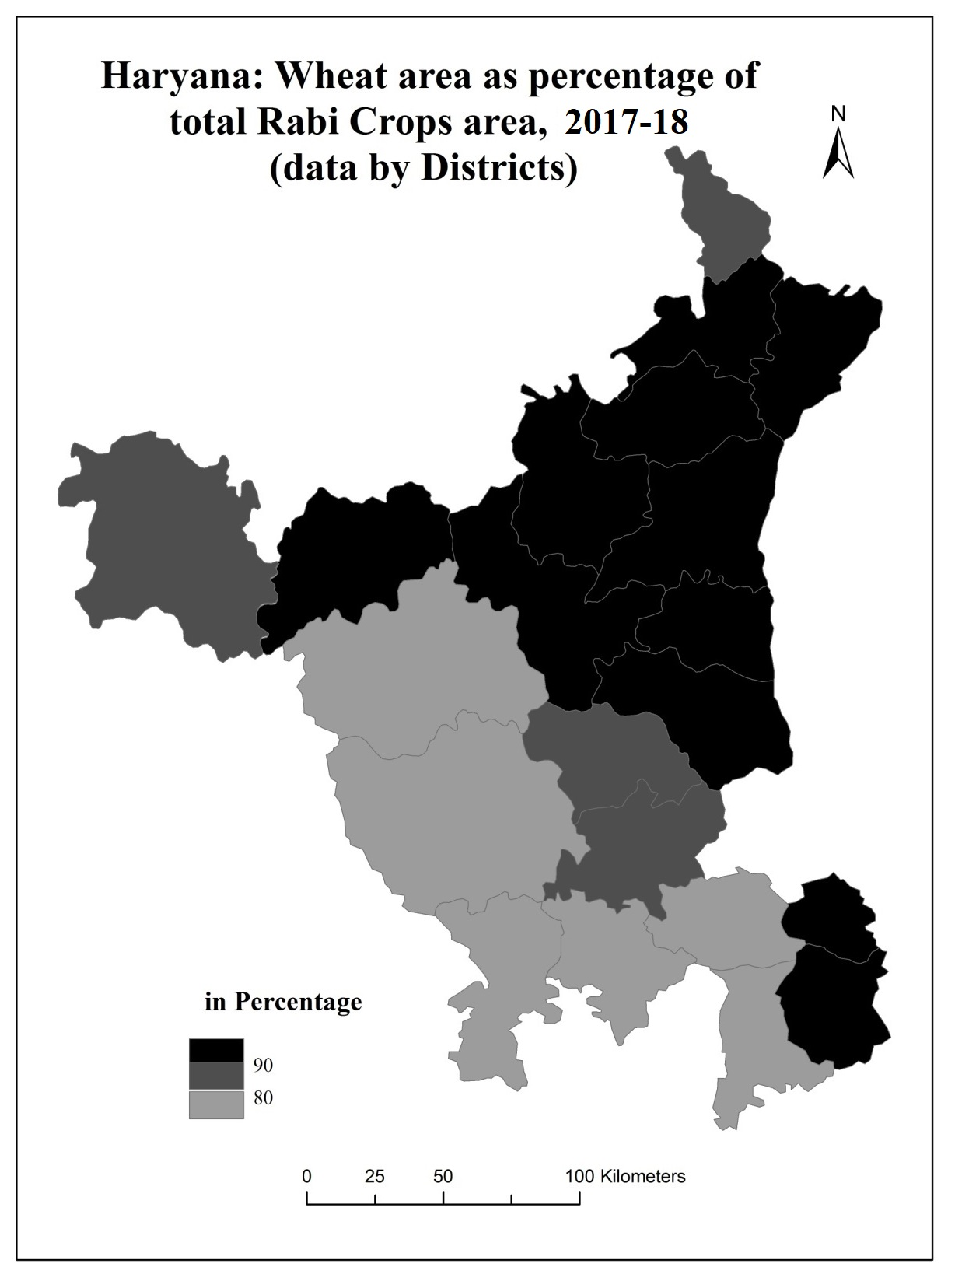

**Map 3.1**

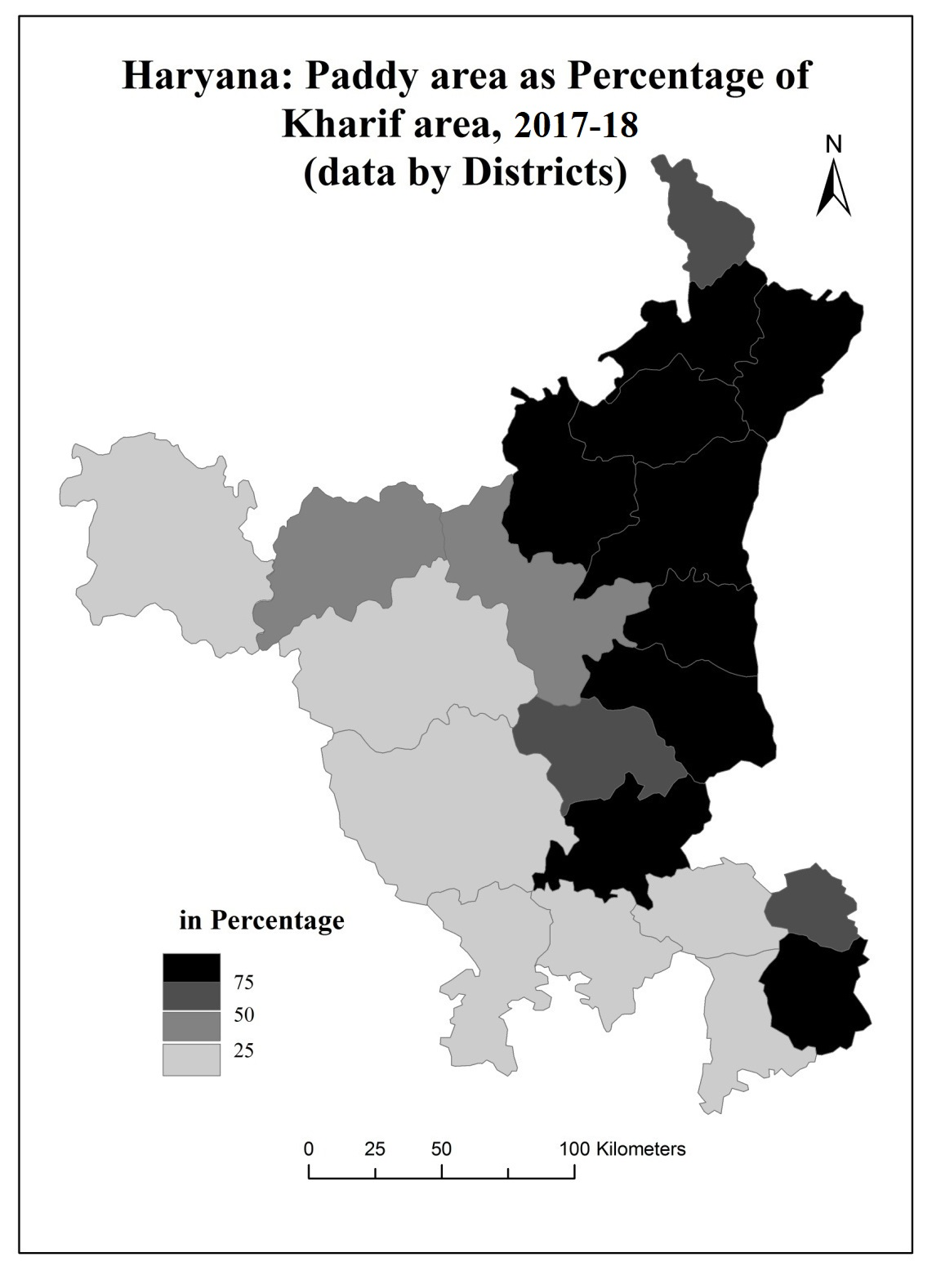

**Map 3.2**

**Table 3.1**

**Haryana: Wheat and Paddy area as percentage of Rabi and Kharif crops, 2018**

**(Data by districts)**

|  |  |  |
| --- | --- | --- |
| **District** | **Wheat area as percentage of Rabi crops area** | **Paddy area as percentage of Kharif crops area** |
| Ambala | 97 | 96 |
| Panchkula | 80 | 53 |
| Yamunanagar | 93 | 96 |
| Kurukshetra | 96 | 98 |
| Kaithal | 99 | 91 |
| Karnal | 98 | 99 |
| Panipat | 97 | 97 |
| Sonepat | 98 | 88 |
| Rohtak | 87 | 55 |
| Jhajjar | 74 | 90 |
| Faridabad | 93 | 71 |
| Palwal | 96 | 78 |
| Gurgaon | 77 | 13 |
| Mewat | 71 | 19 |
| Rewari | 42 | 5 |
| Mahendragarh | 29 | 1 |
| Bhiwani | 45 | 6 |
| Jind | 97 | 55 |
| Hisar | 78 | 17 |
| Fatehabad | 94 | 48 |
| Sirsa | 87 | 22 |

Source: calculated by the data of statistical abstract, 2018

The area under paddy as percentage to total Kharif area occupies over 70 per cent in the Ambala, Yamunanagar, Panipat, Jhajjar and K3 (Kurukshetra, Kaithal, Karnal) districts. This belt came under the water-logged region of the state. Paddy requires plenty of water to grow up. So, this area is suitable for the paddy cultivation. These are the areas where some paddy cultivation was practiced even before setting in of the Green Revolution. Elsewhere the crop occupies 50 to 70 per cent of the total Kharif area. In the south of the Haryana, this figure tapers off to below 20 per cent. This is because of the deep water table. Due to the lack of water, Paddy accounts for almost 20 per cent of the cropped area in the state (map 3.3 and table 3.1). The paddy based green revolution spread with a gradual increase in the use of high yielding varieties of these crops. The spatial diffusion was from the two cores**:** one situated in the north and other in the northwest, as mentioned above in the table. All this resulted in the emergence of almost a central belt of paddy cultivation from Ambala and Yamunanagar district in the north to K3 districts in the northeast and Sonepat, Panipat and Jhajjar districts in the east.

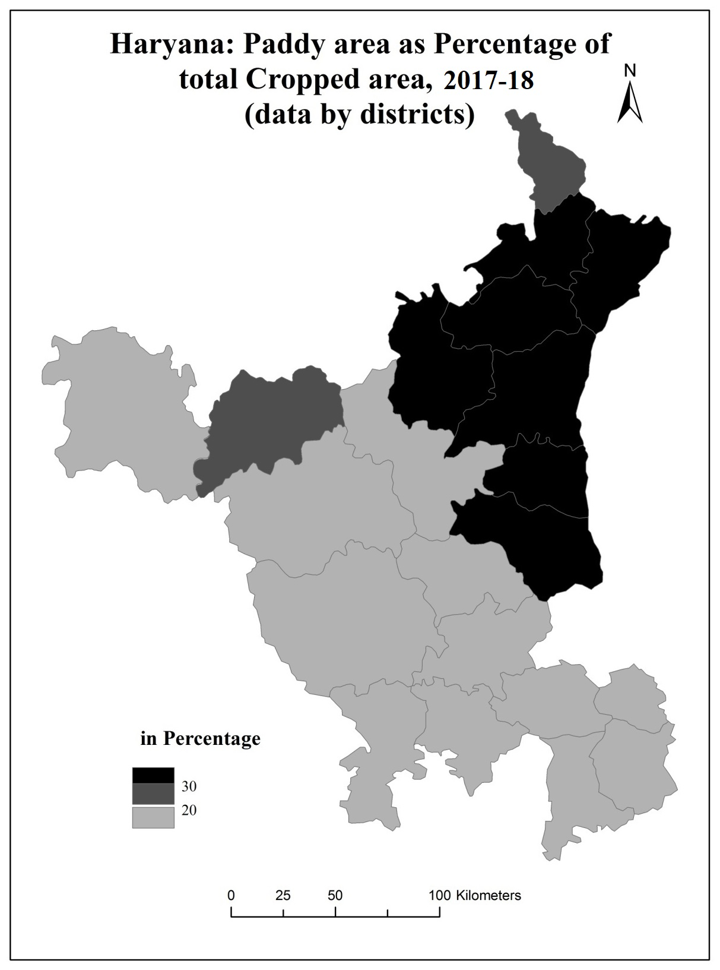

**Map 3.3**

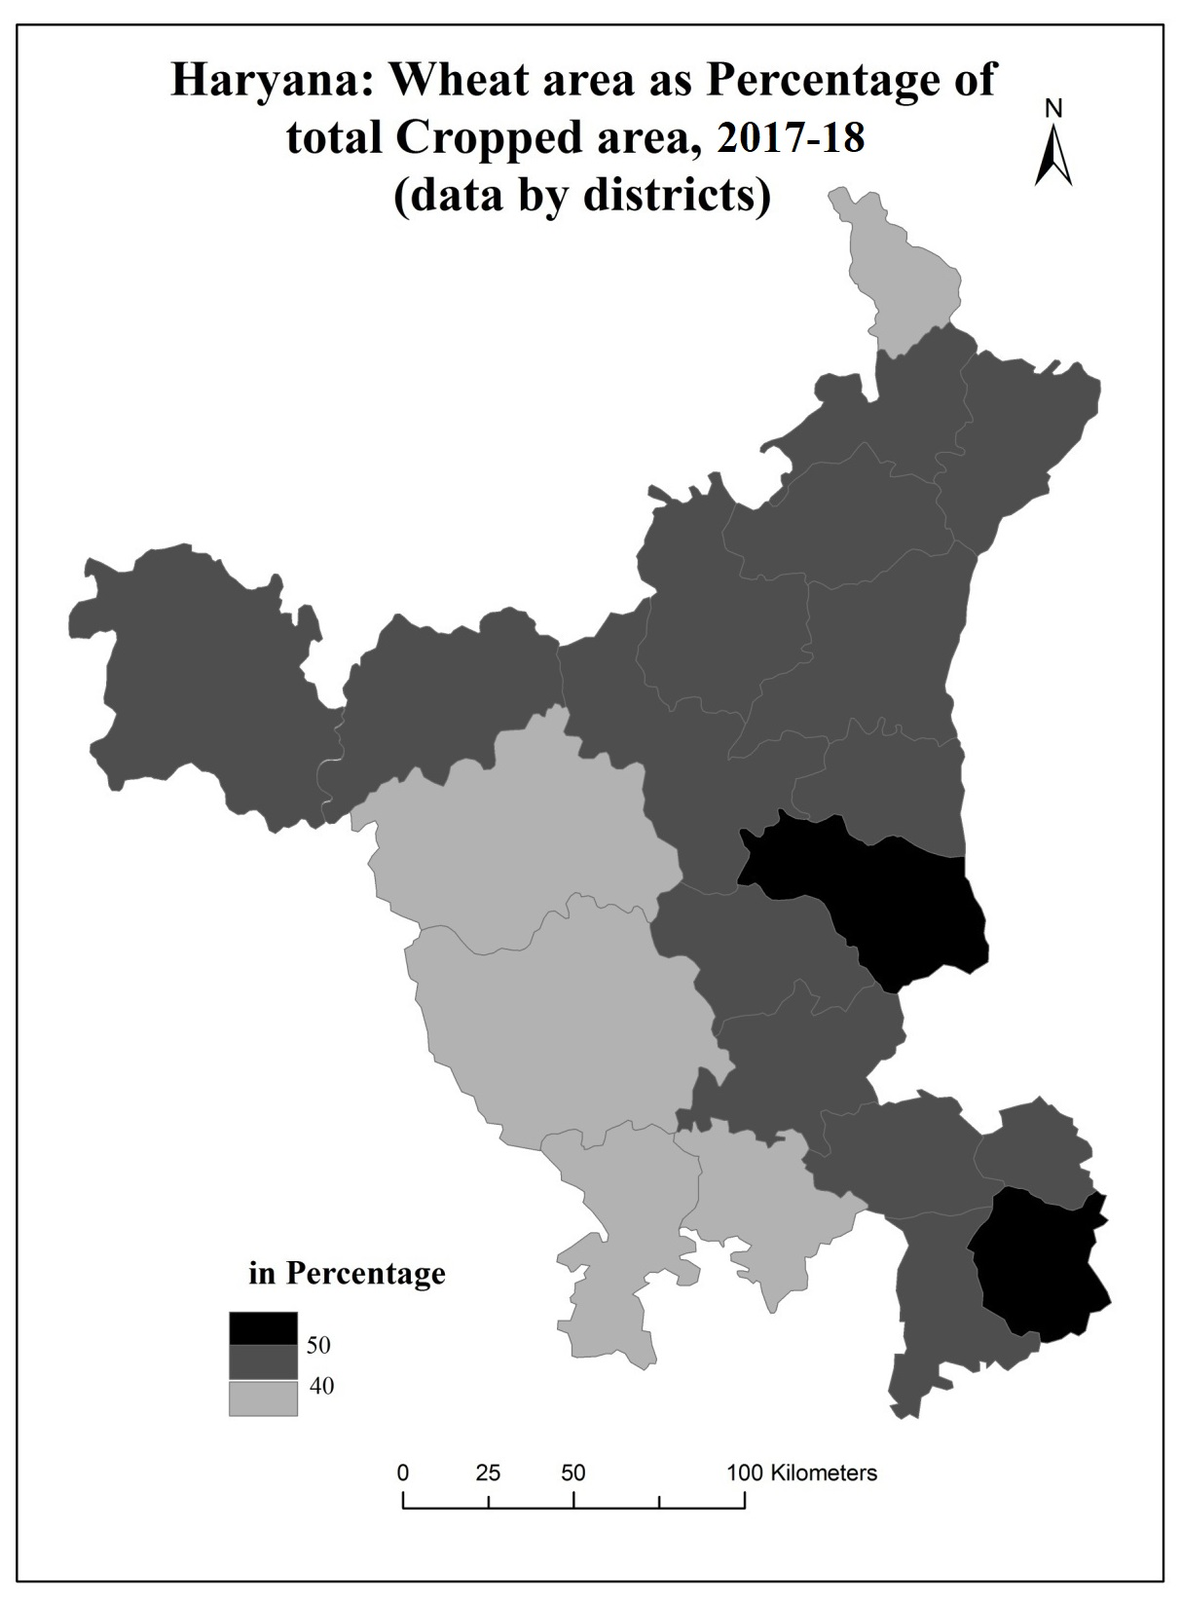

**Map 3.4**

Over 80% of cropped area in Ambala, Panipat, Sonepat, and K3 districts is under paddy and wheat, with K3 districts exceeding 85%. However, less than 50% of total cropped area in south and southwest Haryana is under wheat and paddy crops (map 3.5 and table 3.2).

**Table 3.2**

**Haryana: Wheat and Paddy area as percentage of total cropped area, 2018**

(In percentage)

|  |  |
| --- | --- |
| District | Wheat and Paddy area as percentage of total cropped area |
| Ambala | 82 |
| Panchkula | 60 |
| Yamunanagar | 75 |
| Kurukshetra | 84 |
| Kaithal | 87 |
| Karnal | 88 |
| Panipat | 85 |
| Sonepat | 81 |
| Rohtak | 62 |
| Jhajjar | 56 |
| Faridabad | 66 |
| Palwal | 67 |
| Gurgaon | 51 |
| Mewat | 45 |
| Rewari | 26 |
| Mahendragarh | 15 |
| Bhiwani | 23 |
| Jind | 69 |
| Hisar | 44 |
| Fatehabad | 66 |
| Sirsa | 50 |

Source: Computed from the data of statistical abstract, 2018

The Green Revolution impacts Haryana's regions through high-yielding wheat and paddy cultivation, affecting ecological factors. Spatial distribution is crucial for explaining its impact, with the study focusing on paddy and wheat cultivation and measuring its intensity using paddy wheat rotation area.

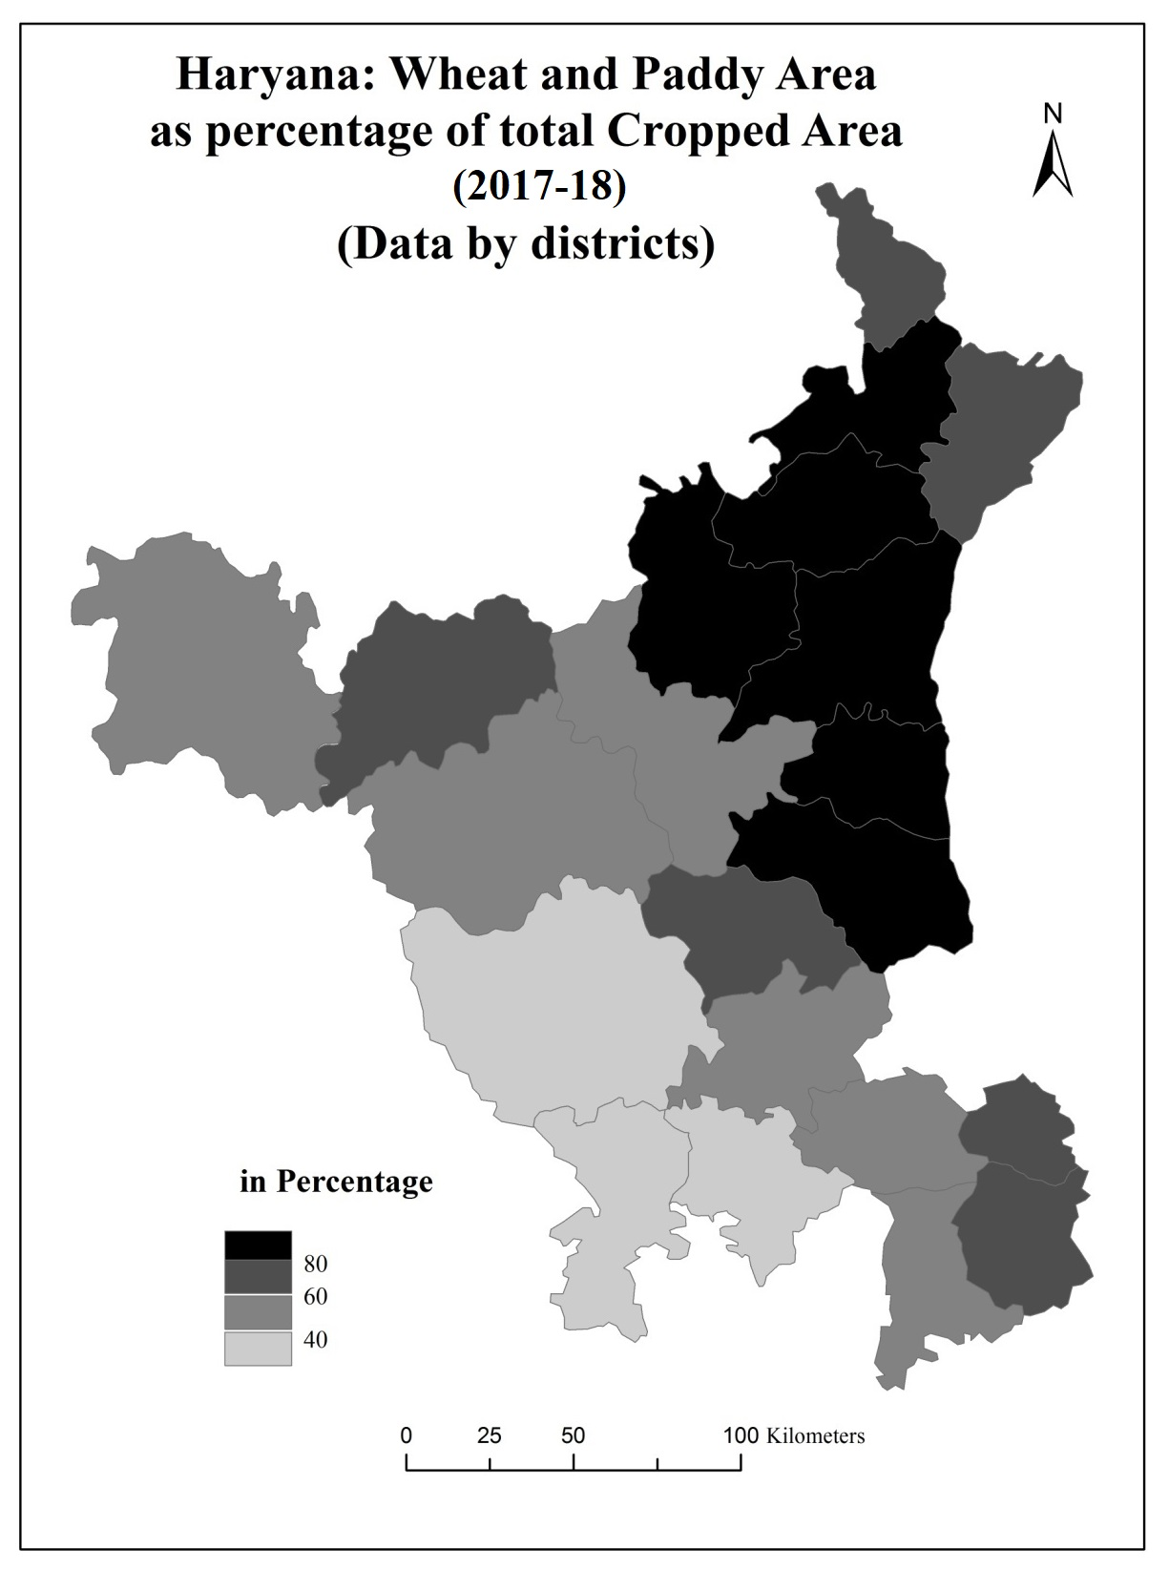

**Map 3.5**

1. The area dedicated to wheat cultivation, the area dedicated to paddy cultivation, and the data regarding the overall cropped area were recorded individually for all 21 districts in the state of Haryana.
2. The area under cultivation of wheat and paddy in a particular district was determined based on the land that is potentially suitable for wheat-paddy rotation.
3. The aforementioned figures were included to encompass both paddy and wheat cultivation areas and were determined as a ratio relative to the total cultivated area. The outcome acquired was regarded as a metric for assessing the magnitude of the Green Revolution.

The method may be illustrated by the case of Ambala and Panchkula districts:

Cropped area = 207000

Wheat area = 87000

Paddy area = 83000

Table 3.3 shows the spatial pattern of intensity of the Green Revolution in Haryana. This will form the framework of our analysis to discern the regional variations in its ecological impact.

Broadly speaking, the pattern of the intensity of the Green Revolution is high in the northern and northeastern districts like Ambala, Yamunanagar, Kurukshetra, Kaithal, Karnal, Panipat and Sonepat districts of Haryana (Map 3.6). These districts have more than .75 values in the index of intensity of the Green Revolution. The intensity falls sharply in the southern and southwestern parts in five districts (Hisar, Bhiwani, Mahendragarh, Rewari and Mewat). These districts are having less than the 0.5 index of intensity of the Green Revolution.

The calculation of the intensity of the Green Revolution shows that the northern and the north eastern parts of Haryana have high intensity of the Green Revolution rather than the other parts of the state. Karnal, Kurukshetra, Kaithal, Ambala and Panipat districts have intensity of more than .80. Index of the intensity of the Green Revolution of all the 21 districts of Haryana is divided into four categories to understand the results of the intensity of the Green Revolution easily. The Green Revolution's intensity index in Haryana is 0.58, with six districts showing significant intensity, with Karnal being the highest. Panipat, Sonepat, Kurukshetra, and Ambala are also significant concentrations. Ten districts, Yamunanagar, Jind, Palwal, Faridabad, Fatehabad, Panchkula, Rohtak, Jhajjar, Gurgaon, and Sirsa, have moderate intensity, with values ranging from 0.50 to 0.80. Five districts, Mewat, Rewari, Hisar, Bhiwani, and Mahendragarh, have low intensity, with values below 0.50.

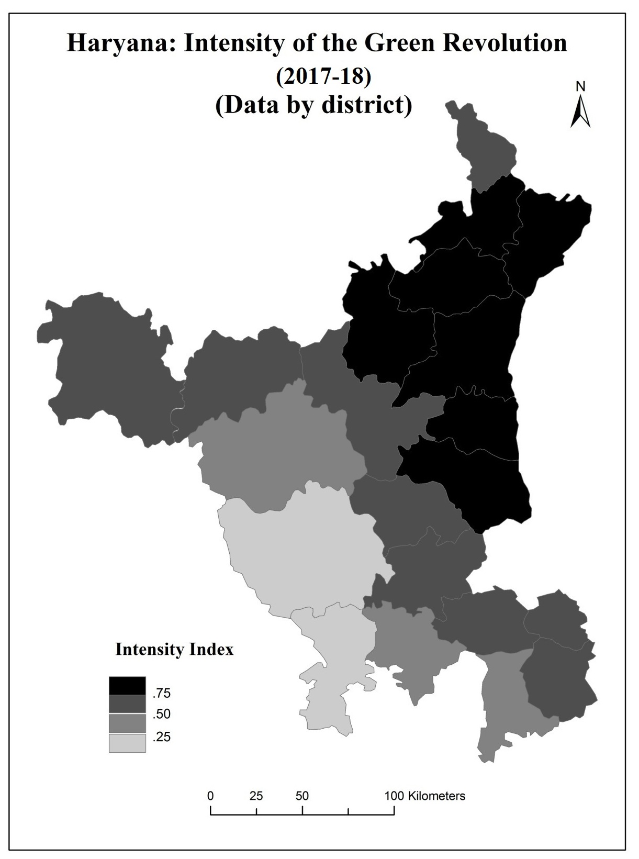

**Map 1.9**

**Table 3.3**

**Haryana: Intensity of the Green Revolution, 2017-18**

(data by districts)

|  |  |  |  |  |
| --- | --- | --- | --- | --- |
| District | Total cropped  Area  (in hectares) | Wheat area  (in hectares) | Paddy area  (in hectares) | Index of intensity |
| Ambala | 207000 | 87000 | 83000 | .82 |
| Panchkula | 42000 | 16000 | 9000 | .60 |
| Yamunanagar | 212000 | 85000 | 73000 | .75 |
| Kurukshetra | 276000 | 112000 | 121000 | .84 |
| Kaithal | 380000 | 1730000 | 159000 | .87 |
| Karnal | 383000 | 17200 | 165000 | .88 |
| Panipat | 191000 | 87000 | 76000 | .85 |
| Sonepat | 316000 | 162000 | 950000 | .81 |
| Rohtak | 229000 | 103000 | 39000 | .62 |
| Jhajjar | 232000 | 98000 | 31000 | .56 |
| Faridabad | 65000 | 31000 | 12000 | .66 |
| Palwal | 196000 | 100000 | 32000 | .67 |
| Gurgaon | 111000 | 52000 | 5000 | .51 |
| Mewat | 1720000 | 71000 | 6000 | .45 |
| Rewari | 195000 | 480000 | 300 | .26 |
| Mahendragarh | 283000 | 41000 | 1000 | .15 |
| Bhiwani | 740000 | 151000 | 18000 | .23 |
| Jind | 478000 | 217000 | 1150 | .69 |
| Hisar | 639000 | 237000 | 430000 | .44 |
| Fatehabad | 422000 | 189000 | 87000 | .66 |
| Sirsa | 720000 | 300000 | 6300 | .50 |
| Haryana | 6484000 | 2531000 | 1234000 | .58 |

Source: Computed from the data of Statistical abstract, 2017-18.

The global expansion and increased productivity in agriculture, coupled with advancements in agricultural technology, have significantly altered worldwide cropping patterns, thereby addressing the food demands of the expanding population. However, it is worth noting that these advancements have had a negative impact on the quality of the environment. The current ecological challenges are not solely attributable to contemporary development practices. These characteristics may be intrinsic to the geographical region or may have developed gradually over a period of time, necessitating interpretation. The subsequent chapter delves into a historical perspective on the ecology of Haryana.

**CHAPTER 4**

**ECOLOGY OF HARYANA: A HISTORICAL VIEW**

The ecological challenges in Haryana are not solely due to contemporary development but also due to the inherent characteristics of the physical environment, such as subsurface salinity of water. Deforestation during the colonial era led to soil erosion in the Shiwalik hill and Aravalli outlier regions. Rapid development intensified ecological dynamics, with quarrying near industrial centers contaminating water and air resources. The ecological history of Haryana can be categorized into three periods: pre-colonial, colonial, and post-colonial. These periods help understand the region's ecological dynamics and the impact of human activities on the environment (Singh, 1998:167-182).

**Pre Colonial View:-**

Haryana, established on November 1, 1966, is a state in India and the birthplace of Indian agricultural culture. Its ecological landscape has a rich history, with three distinct periods during the pre-colonial era:-

1. **Pre harappan period**
2. **Harappan period**
3. **Post harappan period**

**Pre harappan period:-** The ecological perspective of the pre-Harappan era emerged during the second millennium B.C., wherein agriculture and animal husbandry served as the primary economic pursuits. The archaeological record provides evidence indicating that the practice of agriculture predates the emergence of the Harappan culture (Haryana State Gazetteer: 21). During ancient times, the geographical area known as Haryana was characterized by a significant presence of forested areas. According to the Vaman Puran, there are seven Vanas, or forests, mentioned, which include Kamyak-vana, Madhu-vana, and Sita-vana. Additionally, this region is characterized by the presence of seven rivers, namely Saraswati, Drisadawati, Vaitarni, Apaya, Amshumati, Kaushiki, and Hirnnyawati. In ancient times, Haryana exhibited a notable level of ecological development. According to the imperial Gazetteer of India (vol. xiii), it is documented that the term "Haryana" is likely derived from "Harialban," which signifies a region characterized by verdant forests. This nomenclature evokes the historical era when this particular area was abundant and fertile.

The Neolithic period saw early humans developing fire control and technology, establishing a presence in forested environments. These innovations, such as the wheel, iron, axe, plough-share, and animal power, enabled human settlement, society formation, and food production. However, they also led to environmental changes. These innovations have significantly impacted human civilization and the environment (Randhawa, 1980: 3-4). The Vedic Aryans had extensive forested areas, valuable resources for timber, plants, and herbs. Farmers were highly valued, relying on Prijaiya, a deity associated with rainfall, and their proficient agricultural abilities (Aiyer, 1952 : 42-46). Following the Aryans, the Kurus embarked upon an ambitious endeavor to repossess the expansive Saraswati valley with the aim of enhancing their economic and political influence through agricultural means. The agricultural prosperity in Haryana was established based on spiritual beliefs and practices.

**Harappan period**

The Harappan civilization, an ancient and enduring civilization, has a rich history of sustainable ecology and agricultural progress in Haryana. The area's inhabitants have faced natural and human-induced disasters, causing ecological integrity to deteriorate. However, current understanding of Haryana's agricultural history is limited due to gaps in archaeological and literary sources. Scholars have discovered that Siswal village, in Hisar district, was one of the earliest agricultural communities, dating back to around 2500 B.C.(Suraj Bhan, 1977). During this particular time frame, in the state of Haryana, the augmented production of food grains and other agricultural commodities primarily resulted from the practice of deforestation. The phenomenon resulted in significant deforestation and catastrophic floods (Haryana State Gajatteer: 22-33)

**Post harappan period**

The current era highlights the connection between agriculture advancement and ecological impact, with artificial irrigation facilitated by wells and tanks in the region (Banerjee, 1967). Wells were excavations on earth's surface to access the water table, typically reaching two to six meters. Masonic lining wells were found in areas farther from rivers, with water depths ranging from 7 to 21 meters (Trevaskis, 1928: 9-11). During the 13th century A.D., irrigation in Punjab gained popularity due to the Persian wheel. Urban areas were predominantly Muslim, while rural areas were occupied by Hindu landowners. Progressive rulers with a strong agricultural focus led to economic growth, but also had negative consequences for forests and wildlife (Randhawa, 1982).

Sultan Firoj-shah Tughlaq, ruled India from 1351 A.D. to 1388 A.D., significantly advanced agricultural development in Haryana. He sought to reclaim desert land, implement artificial irrigation systems, and oversee canal construction, utilizing rainwater for irrigation and irrigation (Banerjee, 1967: 295-300). The extent of forest coverage during the era of the sultans was greater in comparison to the period of the Mughals (Nijjar, 1968: 124). Akbar, the Mughal emperor, appointed Todarmal as revenue minister and emphasized land reforms. He directed officials to provide monetary and seed resources to cultivators in advance. However, agricultural practices led to deforestation, causing natural disasters like floods and droughts (Randhawa, 1982, 203-208). Northwest incursions caused a negative impact on the ecosystem, leading to individuals seeking refuge in hospitable areas. This phenomenon was evident in the 18th century state of anarchy in Haryana and Punjab, where individuals lived in wooded areas and unexplored areas were made available for agriculture. This confluence led to detrimental consequences for the forest ecosystem and wildlife (Gupta, 1952: 28). Anthropologic influence and desiccation phase led to ecological changes in southern regions, with archaeological remnants found along the arid Ghaggar River's southern periphery. The region's southern areas experienced significant impacts (Brar, 1999:33)

The environmental impact of the Pre-Harappan period, Harappan period, and Post-Harappan period occurred in three distinct stages. The pre-Harappan era saw minimal ecological degradation, but agriculture advancements led to adverse effects like floods and droughts. Deforestation and desiccation, caused by climatic changes and river paths, further impacted the environment. These changes were implemented gradually over an extended duration, starting from the Vedic period and continuing through the Harappan civilization until the Mughal era. The impact of these changes was not particularly drastic, as population growth was relatively slow and had not yet manifested its influence.

**The Colonial Period:-**

During the Colonial period, Haryana, a south-eastern Punjab region, was underdeveloped and disadvantaged under British rule. It was primarily suited for providing draft animals to the Punjab region and other areas. The British prioritized agricultural productivity through strategic irrigation policies, prioritizing low-value food and fodder crops, expanding fodder cultivation, and restricting fodder crop substitution. These measures safeguarded the region's cattle wealth from potential adverse effects (Choudhary, 1986). During this period, advanced technology introduced canal systems, enabling agricultural expansion and increased timber supply for construction and industrial fuel. During the colonial period, the introduction of novel agricultural implements, technological advancements, diverse seed varieties, and the cultivation of new crops resulted in significant benefits for the agricultural sector (Imperial Gajatteer, 33). From 1858 to 1947, Haryana was a less developed state with distance from perennial rivers and Punjab's Jamuna river. The Ghaggar River, a non-perennial waterway, caused significant agricultural losses. Rainfall was scarce and irregular, leading to frequent flooding during the peak period of July to September. Well-based irrigation systems were severely constrained (Singh, 2012).

**Canal irrigation:-**

The British colonized Haryana, aiming to accelerate agricultural development through canal irrigation. However, the arid climate and limited precipitation in the region posed challenges for irrigation infrastructure development. The southeastern region's agricultural geography relied on water resources like canals, wells, ponds, and tanks, with productivity primarily reliant on rainfall (Singh, 2001). Canal irrigation has caused cultivated areas to expand, encroaching on forested lands, and water-logging and salinity issues to arise (Darling, 1947). The western Yamuna canal, constructed in 1335 A.D., diverts water from the Yamuna River. It was disrupted in 1750 due to silt accumulation. During the British colonial period, efforts were made to restore the canal. The famine of 1832-33 led to canal modeling and the construction of the Yamuna weir at Tajewala. The Sirsa branch, the largest branch, was built between 1889 and 1895. The system underwent significant remodeling and expansion between 1940 and 1943. During the colonial period, certain regions of Haryana experienced water-logging and salinity.

**Forests:-**

The gradual depletion of forest cover in Haryana has been a concern since British rule, driven by the need to support industrial civilization. The transition from communal control to state control led to unsustainable utilization of natural resources, affecting various regions (Singh, 1998). The contrast between the factors contributing to deforestation in the colonial era and the pre-colonial period is worth noting. During the pre-colonial era, the depletion of forests can be attributed to the prevalence of warfare and unrest. Conversely, in the colonial period, the expansion of agricultural, industrial, and construction activities resulted in the clearance of numerous forested areas, primarily due to the prevailing state of peace (Brar, 1999). The construction of canals and irrigation systems increased agricultural land strain and forest encroachment. This led to the removal of forested areas and increased productivity, but mostly at the expense of forested areas. Forest cover faced numerous threats, particularly in the British colonial era, where wastelands were prevalent in the southeastern region of Punjab, Haryana (Government of Punjab, 1883-84:3). The areas discussed were covered with dense vegetation, mostly small trees and undergrowth. Over time, canals and agricultural activities led to a decrease in their quantity and size. Deforestation in Shiwalik and Morni hills caused ecological degradation. Initially covered by scrub jungle, the hills were used as hunting grounds for a princess. During the colonial era, Morni hills in Haryana experienced soil erosion (Sangwan, 1991:200-203). Factors affecting agricultural productivity include sheep and goat rising in Shiwalik and Morni hills, causing forest degradation and exacerbating the issue for farmers in the foothills region.

**Wildlife:-**

During the colonial era, wildlife populations declined significantly, with lions and tigers eradicated in Shiwalik and Morni Hills in Punjab due to firearms used for hunting. Human-induced mortality was prevalent among leopards and wolves, while the cheetah population in northern India experienced a decline by around 1920 due to the decrease in prey species' populations (Prashad, 1984:32). The environmental degradation during the colonial era can be attributed to deforestation and canal construction practices. Deforestation in the Shiwalik and Morni Hills was driven by the need for wood for industrial purposes. Soil erosion from water was also observed in the Shiwalik hills and Aravalli outliers. The gradual occurrence of deforestation led to soil erosion and water-logging in various locations. Advancements in agriculture during this time were accompanied by deforestation, water-logging, and wildlife loss.

**The Post-Colonial Period (1947-66)**

The partition of Haryana occurred during India's independence in 1947, dividing the region from 1947 to 1966. Hindu and Sikh populations in Haryana and Punjab relinquished 1,592,487 hectares of land in Pakistan, while the Muslim community left behind 991,010 hectares. The Punjab province in Pakistan accounted for 60% of the total land area, 55% of the population, and 70% of the land irrigated by canals. The Indian state of Punjab, including Haryana, inherited the less productive and food-deficit region of the former Punjab (Randhawa, 1986:4). The disparity in land quality and quantity between lost and available land is significant. To address this issue, expanding arable land availability is crucial. This can be achieved by clearing forested areas or reclaiming marginal land. Sand dunes and game sanctuaries in the arid region were flattened to increase agricultural activities, but this also led to a decline in wildlife species populations. The blackbuck, along with other endangered species, which were once observed in large numbers, experienced a gradual decline and eventual disappearance (Stracey, 1963). Upon India's independence, forested regions were transformed into agricultural land, leading to ecological degradation. The Chandigarh Shiwalik Hills, located in the north-western region, form a distinct natural hilly ecosystem with fragmented topography, known as "badland" terrain. Development initiatives primarily contributed to this degradation (Singh, 1990, 1995). The semi-arid region's diverse landform features result from the convergence of transient watercourses, weathering, and soil-water erosion, resulting in a diverse landscape (Singh, 2001). Farmers felled and sold trees due to land consolidation, leading to significant depletion. Land consolidation led to positive outcomes, such as the promotion of tubewell irrigation, which facilitated the Green Revolution in limited canal water access. Trees were planted at tubewell locations, and multiple-cropping efforts were undertaken to enhance agricultural productivity. Implementing irrigation techniques was crucial in achieving these outcomes.

**Conclusion**

The ecological history of Haryana can be divided into three periods: pre-colonial, colonial, and post-colonial. During the pre-colonial era, technological advancements were limited, causing minimal ecological damage. Factors contributing to ecological degradation include desiccation, deforestation, and political instability. However, during the colonial era, political stability and peace posed a more significant threat to the ecological balance. The expansion of canal irrigation led to deforestation and species extinction. The post-colonial era saw significant strain on the ecological system, with pressing issues such as acquiring viable land for agricultural purposes and transforming the food production deficit into a surplus. Unexplored territories were discovered and canal networks constructed, leading to issues such as waterlogging and salinity. The reform of consolidating landholdings led to the felling of trees within fields. The agricultural advancements in the first two decades following independence laid the groundwork for the Green Revolution. The current ecological challenges are also attributed to recent agricultural advancements. The present discourse focuses on the effects of agricultural development on the ecological framework in Haryana's post-formation phase.

**CHAPTER 5**

**HARYANA ECOLOGY: POST FORMATION SCENARIO**

Haryana, established on November 1, 1966, was formed through bifurcation from the former Punjab state. The region, which included Hisar, Jind, Mahendragarh, Rohtak, Gurgaon, Karnal, Sangrur, and Ambala districts, gained historical coherence through administrative reorganization as Ambala division before India's independence in 1947. In 1966, it became a distinct Hindi-speaking state (Singh, 1998: 24-27). Haryana has made significant progress in agriculture due to the green revolution, introducing advanced technologies and increasing agricultural output. However, this has also led to negative consequences such as land degradation, deforestation, water resource depletion, and adverse effects on soil and air quality. Haryana's water supply is primarily based on the western Yamuna canal, and efforts have been made to improve its discharge rate. The Bhakra Canal System, constructed between 1948 and 1963, was a significant development in this area.

In 1966, Haryana allocated 37.8% of its land area for irrigation, ranking fourth in India. The canal network served 76.64% of the area, with wells serving 22.35% and alternative sources like tanks, ponds, and rivers serving the remaining 1.01 percent. The expansion of the canal network during the 1950s led to significant water-logging conditions in Haryana. To mitigate this, a network of drainage channels was implemented, and efforts were made to reclaim saline soils. The period from 1947 to 1966 is significant in Haryana's ecological history, as landholding consolidation led to the expansion of cultivated land and the establishment of an extensive irrigation network. This led to the Green Revolution, which relied on irrigation, chemical fertilizers, and high-yielding seeds. However, this led to a depletion of forested areas, decline in biodiversity, and deterioration in water resources. The agricultural advancements during the 1960s significantly influenced Haryana's ecological components:

1. **WATER 2. SOIL**

**3. VEGETATION AND CROP COVER 4. AIR**

**WATER**

Water covers 70% of Earth's surface, with only 2.5% of it being fresh water. Most fresh water is found in icecaps in Antarctica and Greenland, as well as in soil and deep aquifers. Accessible fresh water for human consumption is less than 1% of global freshwater resources. The Green Revolution relies heavily on irrigation for seeds and fertilizers, accounting for 70% of the 1% freshwater allocated for this purpose, which represents only 17% of the overall land area (Borlaug, 1970). Haryana faces a significant water deficit, with an annual average precipitation of 50 centimeters, less than half of the national average. Surface and underground water sources are insufficient, with 18% of the state's geographical expanse designated as susceptible to drought conditions. This water shortage hinders the advancement of agricultural practices in the semiarid region (Government of India, 1972). This study examines four districts in Haryana, focusing on groundwater irrigation for monsoon precipitation. Groundwater is used through wells or tube-wells, while river water is used through canals. Both methods have contrasting impacts on the water table, causing depletion and seepage. Haryana faces issues with water-logging and depletion due to contemporary agricultural technologies.

The Green Revolution relied on well-regulated water supply through tube-wells and canals, as well as financial support for farmers to improve their irrigation infrastructure. This enabled the necessity of a green revolution, addressing the need for improved water supply and enhancing irrigation infrastructure (Brar, 1999: 62-63). The Green Revolution has led to significant consequences for the water table in Haryana, with suggestions for potential replacement of paddy crops due to declining water tables at a rate of 0 to 1.0 meters per year (Singh, 1998; Bhalla, 2007). The study examines the development of an extensive irrigation system in the region, considering factors like deforestation, eucalyptus cultivation, and increased water demands. It also examines precipitation patterns and the correlation between water table depletion and the Green Revolution's magnitude.

**Water Table Changes (1966-2018)**

The water table is the boundary where water pressure equals atmospheric pressure, resulting in a gauge pressure of zero. It is the uppermost layer of subsurface materials permeated with groundwater within a specific geographic area. However, saturated conditions can exceed the water table due to surface tension that retains water in certain pores below atmospheric pressure. In hydrogeology, determining individual points on the water table is typically done by measuring the elevation at which water ascends within a well with a screen in shallow groundwater. Groundwater depth in the state varies, with elevated levels in southern regions and lower levels in northern and northeastern areas. The pre-monsoon period ranges from 5 meters to 21 meters, with Mahendragarh district in the south-western region having the most profound water levels. Shallow water level conditions are observed in Rohtak and Jind districts, as well as Bhiwani, Sirsa, and Hisar districts (Bhalla, 2007:1-2).

**Water table depth (1974-2018)**

The package program has significantly increased wheat and rice cultivation areas in regions like Haryana, Punjab, and Rajasthan. Rice cultivation is primarily in June, with average rainfall of less than 50 cm. Farmers transplant their paddy crop using irrigation methods, which require multiple rounds of field irrigation to meet water demands. Wheat crops also require regular irrigation during the winter season. However, tube-well systems have led to a decline in the groundwater table, with many farmers reducing their tube-well depths to re-drill their wells. This issue raises concerns that the continued use of tube-well irrigation for moisture-rich crops like rice may hinder the replenishment of the underground water table.

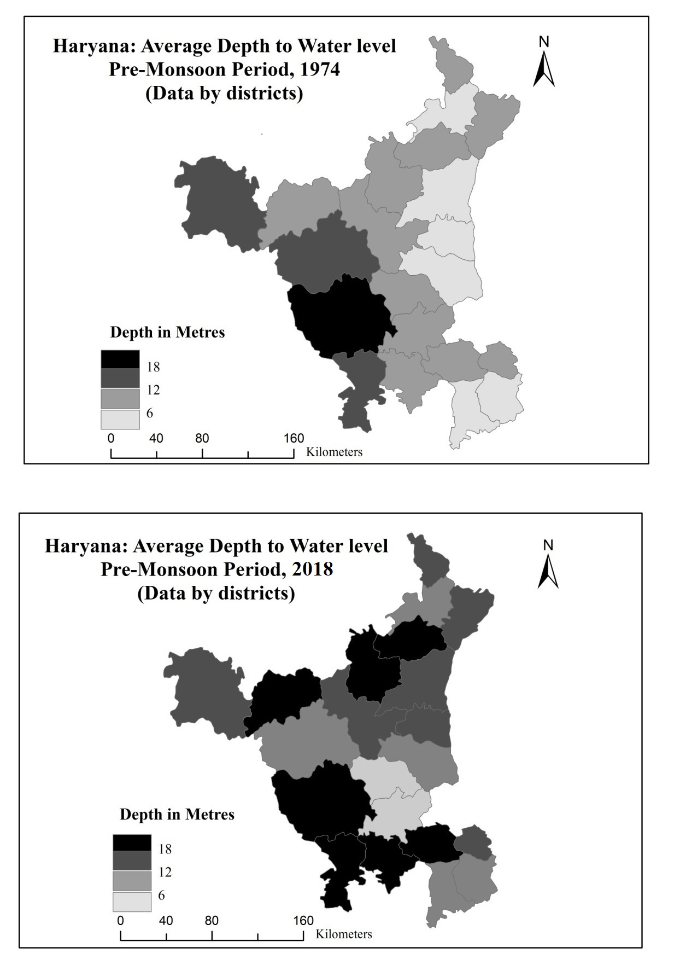

**Map 5.1**

Groundwater levels in Haryana are rapidly depleting, threatening the state's agricultural productivity. During the Green Revolution era, groundwater levels decreased by 15 to 20 meters across various districts. Mahendragarh district in southern Haryana experienced the most significant decline, with a 19.45-meter decrease. Fatehabad district followed closely behind, with a 43-meter depletion. Jhajjar and Rohtak districts experienced the least depletion, with 1.65 and 2.63 meters, respectively. Mahendragarh experienced the most significant water table depletion from 1974 to 2018, with a recorded depletion rate of 28.35 meters.

**Table 5.1: Haryana: Increase/Decrease in Net Area Irrigated by Tube-wells**

**1990-91 and 2017-18**  (in hectares)

|  |  |  |  |
| --- | --- | --- | --- |
| District | Area Served in | | Percentage increase /  Decrease |
| 1990-91 | 2017-18 |
| Ambala and  Panchkula | 24300 | 32656 | 34 |
| Yamunanagar | 23820 | 32584 | 37 |
| Kurukshetra | 32474 | 76542 | 136 |
| Kaithal | 57404 | 63138 | 10 |
| Karnal | 59476 | 43600 | -27 |
| Panipat | 36459 | 34131 | -6 |
| Sonepat | 26722 | 45035 | 69 |
| Rohtak and  Jhajjar | 21676 | 48281 | 123 |
| Faridabad and  Palwal | 26339 | 35740 | 36 |
| Gurgaon and  Mewat | 39351 | 42385 | 8 |
| Rewari | 23075 | 35544 | 54 |
| Mahendragarh | 22943 | 29618 | 29 |
| Bhiwani | 18151 | 52286 | 188 |
| Jind | 29648 | 51723 | 74 |
| Hisar and  Fatehabad | 33069 | 70885 | 114 |
| Sirsa | 22664 | 58209 | 157 |
| Haryana | 497571 | 752357 | 51 |

Source: Calculated data from the Statistical abstract of Haryana, 1991 and 2018.

Other districts followed, with depletion rates exceeding -10 meters between 1974 and 2018 (Table 4.2). Most districts have a dominant rice cultivation presence, with a substantial decline in water table rates, except for Gurgaon and Rewari. Tubewell proliferation is the primary cause of water table depletion, with an explosion in the post-1966 era (Brar, 1999: 71). Haryana's population increased significantly from 497,571 in 1990 to 752,357 in 2017-2018. The Bhiwani district saw the highest area increase, 188%, from 1990-91 to 2011-12, followed by Sirsa district, which saw a significant 157 %increase (Table 5.1). Haryana's districts, Hisar, Jhajjar, Rohtak, and Sirsa, show a lower rate of water table depletion due to lower Green Revolution intensity. Factors contributing to this depletion include urbanization, inadequate precipitation, and deforestation. The excessive extraction of groundwater through bore-wells, which are used for agricultural activities, also hinders water resource replenishment. The state has around 750,000 tube-wells, with additional wells used for other purposes (Department of agriculture, Haryana).Paddy cultivation in Haryana is not environmentally sustainable due to its lack of ecological considerations. Commercial interests drive widespread adoption, with 19.01% of cropped area in 2017-18, a significant increase from 1966-67. Paddy is a highly water-intensive crop among various crops in Haryana (Table 5.3).

**Table 5.2**

**Haryana: Area increase/decrease and Water Requirements of some Important Crops**

|  |  |  |  |  |
| --- | --- | --- | --- | --- |
| Crop | Water Requirement  (in Centimetres) | Area in 1966-67  (in Hectares) | Area in 2017-18  (in Hectares) | Increase/decrease (in percentage) |
| Rice | 180 | 192 | 1234 | 643 |
| Wheat | 45 | 743 | 2531 | 340 |
| Barley | 100 | 182 | 41 | -78 |
| Bajra | 30 | 893 | 576 | -36 |
| Jowar | 30 | 270 | 64 | -76 |

Source: Statistical Abstract of Haryana and Punjab Agricultural University, Ludhiana.

Wheat and Rice crops increased in proportion during specified years, while Barley, Bajra, and Jowar crops experienced a decline in cropped area. Wheat is a significant winter crop cultivated during Rabi season, with land under cultivation increasing from 16.15% in 1966-67 to 39.0% in 2017-18. Regular irrigation is necessary for this crop due to insufficient winter precipitation in Haryana, affecting crop yield.

Paddy-cultivated districts experience the highest seasonal variation in water table depth, with Kurukshetra, Kaithal, and Karnal showing the most pronounced variation in June 2012 (map 5.1 and table 5.3). Haryana's Department of Agriculture proposes categorization of regions for groundwater resource development, considering utilization stages and projected utilization stages (table 5.4).

**Table 5.3: Haryana: District wise Average Depth to Water**

**During Pre-monsoon period 1974 to 2018 (in Metres)**

|  |  |  |  |  |
| --- | --- | --- | --- | --- |
| District | June 74 | June, 2018 | June,74 to June, 18 | Seasonal fluctuation  June-Oct 2018 |
| Ambala | 5.79 | 10.52 | -4.73 | 0.60 |
| Bhiwani | 21.24 | 22.42 | -1.18 | 1.23 |
| Faridabad | 6.42 | 14.64 | -8.22 | -0.15 |
| Fatehabad | 10.48 | 22.21 | -11.73 | -0.55 |
| Gurgaon | 6.64 | 23.45 | -16.81 | -1.36 |
| Hisar | 15.47 | 7.81 | 7.66 | 0.35 |
| Jind | 11.97 | 12.14 | -0.17 | -0.66 |
| Jhajjar | 6.32 | 4.67 | 1.65 | 0.59 |
| Kurukshetra | 10.21 | 31.50 | -21.29 | -1.46 |
| Kaithal | 6.28 | 21.88 | -15.60 | -1.57 |
| Karnal | 5.72 | 17.19 | -11.47 | -1.10 |
| Mahendragarh | 16.11 | 44.46 | -28.35 | 1.22 |
| Mewat | 5.50 | 9.25 | -3.75 | -1.23 |
| Palwal | 5.37 | 9.06 | -3.69 | 0.08 |
| Panchkula | 7.58 | 17.02 | -9.44 | -0.69 |
| Panipat | 4.56 | 16.76 | -12.20 | 1.73 |
| Rewari | 11.75 | 21.89 | -10.14 | 0.85 |
| Rohtak | 6.64 | 4.01 | 2.63 | 0.73 |
| Sonepat | 4.68 | 7.87 | -3.19 | 1.06 |
| Sirsa | 17.88 | 17.84 | 0.04 | -0.23 |
| Yamunanagar | 6.26 | 12.75 | -6.49 | 0.62 |
| State Average | 9.19 | 16.72 | -7.53 | 0.09 |

Source: Ground water cell, Department of Agriculture, Haryana

**Table 5.4: Haryana: Distribution of Water exploitation status; 2018**

(Blocks in numbers)

|  |  |  |  |  |
| --- | --- | --- | --- | --- |
| District | Over exploited | Critical | Semi critical | Safe |
| Ambala | 3 | 2 | 1 | 0 |
| Panchkula | 1 | 2 | 0 | 0 |
| Yamunanagar | 5 | 1 | 0 | 0 |
| Kurukshetra | 5 | 0 | 0 | 0 |
| Kaithal | 5 | 0 | 0 | 0 |
| Karnal | 6 | 0 | 0 | 0 |
| Panipat | 5 | 0 | 0 | 0 |
| Sonepat | 3 | 2 | 0 | 2 |
| Rohtak | 0 | 0 | 2 | 3 |
| Jhajjar | 0 | 1 | 2 | 2 |
| Faridabad | 1 | 1 | 0 | 0 |
| Palwal | 3 | 1 | 0 | 0 |
| Gurgaon | 4 | 0 | 0 | 0 |
| Mewat | 2 | 1 | 0 | 2 |
| Rewari | 4 | 1 | 0 | 0 |
| Mahendragarh | 5 | 0 | 0 | 0 |
| Bhiwani | 4 | 2 | 0 | 3 |
| Jind | 3 | 3 | 0 | 1 |
| Hisar | 1 | 1 | 3 | 4 |
| Fatehabad | 4 | 2 | 0 | 0 |
| Sirsa | 4 | 1 | 1 | 1 |
| Haryana | 68 | 21 | 09 | 18 |

Source: Department of Agriculture, Agriculture mechanization, Ground water cell, 2018

Out of the 116 blocks in 21 districts, 68 are classified as overexploited in water resources. 21 are in critical condition, while 9 are in semi-critical condition. Only 18 blocks are classified as white or safe areas. Karnal, Kaithal, Kurukshetra, Panipat, Sonepat, and Mahendragarh have the highest levels of water exploitation, with a high concentration of blocks dedicated to paddy cultivation.

**Water-logging**

Waterlogging, a significant ecological challenge in regions where canal irrigation is used, is particularly ironic in Haryana, a state facing water scarcity. According to the definition provided by the National Commission on Agriculture in 1976, Water-logging occurs when the water table rises to the point where soil particles in a crop's root zone become saturated, causing air circulation impeded and carbon dioxide levels decreased. The threshold for water table impact on crop yield can vary, from no depth for rice cultivation to approximately 1.5 meters for other crops. Monsoon season waterlogging affects flood plains of Yamuna, Ghaggar, Markanda, Dohanand, and Sahibi rivers, primarily consisting of freshwater. Rainy season waterlogging affects low-lying areas of Kurukshetra and Karnal districts. Subterranean aquifers in these channels are saline or sodic (Singh, 1998:170-171).

**Table 5.5: Haryana: Net Area Sown under Canal irrigation, 2018**

(in thousand hectares)

|  |  |
| --- | --- |
| District | Area under canal irrigation |
| Ambala | 4 |
| Panchkula | - |
| Yamunanagar | 3 |
| Kurukshetra | 28 |
| Kaithal | 10 |
| Karnal | 36 |
| Panipat | 33 |
| Sonepat | 91 |
| Rohtak | 74 |
| Jhajjar | 40 |
| Faridabad | - |
| Palwal | 18 |
| Gurgaon | 1 |
| Mewat | 6 |
| Rewari | 4 |
| Mahendragarh | 1 |
| Bhiwani | 85 |
| Jind | 133 |
| Hisar | 206 |
| Fatehabad | 134 |
| Sirsa | 286 |

Source: Director of Land Records, Haryana (2018).

Waterlogging is affecting the Indira Gandhi Canal command area in Rajasthan, affecting districts Ganganagar, Bikaner, and Jaisalmer, causing thousands of acres of productive agricultural land and pastures to be unusable for agriculture (Husain, 1996: 404-05). The water table in semi-arid and western regions of the state is rising due to canal irrigation using the Bhakra system. This has increased vulnerability to waterlogging issues. Bhiwani district has an annual water table rise of 0.31 meters, Hisar district 0.52 meters, and Sirsa district over 1.00. meters since 1974 (Tanwar, 1984:79-80).

Waterlogging affects the majority of districts with cultivated land irrigated through canals, particularly in southern and south-western Haryana regions (Table 5.5).Between 1966 and 2018, Haryana experienced a significant decrease in water table levels and increased water-logging. The Green Revolution initially provided abundant subsurface water in some regions, but as agricultural transformation progressed, the situation reversed. Post-1966 developments led to a decline in water table levels in some regions and water-logging issues in others (see table 5.6).

**Table 5.6: Haryana: Districts wise Water-logged area**

**(in 000’ ha)**

|  |  |  |  |  |  |  |
| --- | --- | --- | --- | --- | --- | --- |
| **District** | **Geographical**  **Area** | **Hilly**  **Area**  **(sq Km)** | **Area in sq km under various depth range**  **(metres) June 2018** | | | |
| Fully water logged | Water logged | Potential water logged | Safe area |
| **0-1.5** | **1.5-3** | **3-10** | **>10** |
| Ambala | 159600 | 300 | 4600 | 14300 | 82700 | 57700 |
| Bhiwani | 487100 | 4700 | 0 | 36800 | 167400 | 278200 |
| Faridabad | 74000 | 8700 | 0 | 500 | 15900 | 48900 |
| Fatehabad | 249100 | 0 | 1600 | 7200 | 59700 | 180600 |
| Gurgaon | 124900 | 3800 | 0 | 0 | 6700 | 114400 |
| Hisar | 386100 | 0 | 1400 | 27000 | 249700 | 108000 |
| Jind | 273600 | 0 | 50 | 7400 | 115000 | 150700 |
| Jhajjar | 186800 | 0 | 6000 | 60400 | 104400 | 16000 |
| Kurukshetra | 168200 | 0 | 0 | 0 | 300 | 167900 |
| Kaithal | 228400 | 0 | 0 | 0 | 38000 | 190400 |
| Karnal | 247100 | 0 | 0 | 0 | 27500 | 219600 |
| Mahendragarh | 193900 | 4600 | 0 | 0 | 5100 | 184200 |
| Mewat | 150000 | 13900 | 0 | 19600 | 52800 | 63700 |
| Palwal | 136500 | 100 | 0 | 4700 | 89700 | 42000 |
| Panchkula | 78900 | 39400 | 0 | 0 | 10000 | 29500 |
| Panipat | 125000 | 0 | 0 | 0 | 39800 | 85200 |
| Rewari | 155900 | 2300 | 0 | 300 | 37100 | 116200 |
| Rohtak | 166800 | 0 | 5900 | 81800 | 74800 | 4300 |
| Sonepat | 226100 | 0 | 1100 | 22600 | 146800 | 55600 |
| Sirsa | 427600 | 0 | 0 | 8900 | 133700 | 285000 |
| Yamunanagar | 175600 | 15300 | 1400 | 13300 | 74800 | 70800 |
| Total | 4421200 | 93100 | 22500 | 304700 | 1531900 | 2469000 |

Source: Groundwater Cell, Department of Agriculture, Haryana.

Several districts in India, including Ambala, Jhajjar, Rohtak, Hisar, and Sonepat, are experiencing complete waterlogging due to elevated water tables. Jind, Kaithal, Karnal, Panchkula, and Panipat are also at risk of waterlogging, with water depths ranging from 3 to 10 meters. Haryana's Kurukshetra, Kaithal, Karnal, Sonepat, Panipat, Sirsa, and Yamunanagar are considered safe due to their water depths exceeding 10 meters. A cross-tabulation analysis of the relationship between water table changes and Green Revolution intensity has led to definitive findings, but the study was limited to 21 districts (Table 5.7).

**Table 5.7**

**Haryana: Intensity of the Green Revolution and Behaviour of the Water Table**

|  |  |  |  |
| --- | --- | --- | --- |
| Intensity Index | Number of Districts | Number of Districts with | |
| Fall in water table by more than 8 metres | Fall in water table by less than 8 metres |
| More than .75 | 6 | 4 | 2 |
| .5 - .75 | 9 | 4 | 5 |
| .25 - .5 | 4 | 2 | 2 |
| Less than .25 | 2 | 1 | 1 |

Source: Computed from the data of different sources

In Haryana, four districts experienced an increase in their water table, indicating a direct relationship between the intensity of the Green Revolution and the water table. The category encompassing a Green Revolution intensity exceeding 0.75 comprises six districts. Four of these regions experienced a decline in the water table exceeding 8 meters, while two districts experienced a decrease of less than 8 meters. Intensity indices ranged from.5 to.75 within the nine districts. Four districts experienced a decline in the water table exceeding 8 meters, while the remaining five districts experienced a decrease below 8 meters. The intensity levels within these districts ranged from 0.25 to 0.5. The findings suggest a direct relationship between the intensity of the Green Revolution and the water table, with localized factors affecting subsurface water (table 5.7).

The water table in Haryana has experienced significant fluctuations over the past century due to the implementation of new irrigation methods and levels. Before 1966, canals played a significant role in the elevation of the water table. The Green Revolution in 1966 emerged as a prominent factor influencing the water table, with two distinct categories: those experiencing a decline in the water table, where tubewells were the primary method of irrigation, and those witnessing an increase in the water table, where canals were the dominant form of irrigation. The decline in the water table, linked to an increase in tubewell irrigation for sustaining paddy cultivation, was more widespread compared to the rise in the water table. The southern and north-western belt, characterized by agricultural prosperity, has experienced a concerning decrease in the water table due to tubewell irrigation and a wheat-paddy rotation system. However, the correlation between water table depletion and the Green Revolution's impact is not as straightforward as initially perceived. The expansion of canal-based irrigation in the northwest and northeast regions of Haryana has led to an accelerated increase in the water table, resulting in significant waterlogging. The issue is exacerbated in circumstances where canal irrigation is not supplemented by tube-well irrigation. The mechanization of agriculture in Haryana has had both positive and negative impacts. While it has led to economic prosperity, it has also led to negative consequences, such as the depletion of the water table in most of the state and an increase in the water table in the northeast and northwest regions, leading to issues related to waterlogging.  

**SOILS**

Soil is the uppermost layer of loose, unconsolidated material covering land's surface. It is a composite blend of ground rock particles, organic material, aqueous components, and gaseous elements. Soil supports life forms like plants, animals, and humans (Robinson, 1972: 71-72). Canal irrigation in semi-arid regions with unpredictable rainfall and high evaporation rates leads to water table elevation. High salt content in groundwater causes soil profile alkalinization when the water table reaches the capillary fringe. This phenomenon has occurred in north-western and western Haryana regions (Singh, 1998: 172-73). The Green Revolution has altered soils in Haryana, affecting physical properties, chemical composition, and biological content. Sodic and saline soils are discussed as independent classifications. Soils store nutrients and water, facilitate seed germination, support plants, and provide habitat for organisms involved in mineral nutrient recycling.

**Table 5.8**

**Haryana: Salt Affected Soils**

(In hectares)

|  |  |  |  |  |
| --- | --- | --- | --- | --- |
| District | Upland | | Lowland | |
|  | Sodic | Saline | Saline | Saline intermixed  With higher  Water table |
| Ambala | 5543 | 3685 | - | - |
| Bhiwani | - | - | 3533 | 1430 |
| Faridabad | 7191 | - | - | - |
| Gurgaon | - | - | 10638 | - |
| Hisar | 488 | - | 8049 | 13215 |
| Karnal | 42605 | - | 2035 | - |
| Kurukshetra | 21372 | 7660 | - | - |
| Jind | 4220 | 1218 | 9190 | 13026 |
| Mahendragarh | - | - | 638 | - |
| Rohtak | - | - | 10762 | 14142 |
| Sirsa | - | - | - | - |
| Sonepat | 3301 | - | 23960 | 9238 |
| Haryana | 84720 | 12563 | 68805 | 51051 |

Source: R.C.Sharma and C.P.Bhargava (1987): ‘Mapping and characterization of salt affected soils in Haryana using remote sensing’, Annual report, central soil salinity research institute, Karnal.

Sodic soils are found with greater frequency in the upland plain, specifically in the districts of Karnal and Kurukshetra. Conversely, saline soils are more prevalent in the lowlands, particularly in the districts of Rohtak, Sonepat, and Gurgaon. Rohtak, Hisar, and Jind districts are characterized by the presence of saline soils that are intermixed with a high water table (Table 5.8).

Reclaiming saline soils in Haryana presents challenges compared to alkaline soil reclamation. This involves removing subterranean saline water and substituting it with freshwater. Freshwater can be easily restored using gypsum, but the salinity of the soils may persist in certain regions. Salinity and alkalinity can be addressed by using manure and selecting crops with salt-tolerant traits. Haryana's fertilizer usage has increased production and productivity, but has also negatively impacted soil fertility. In 1989-1990, nitrogen, phosphorus, and potassium fertilizers consumed increased significantly, while NPK fertilizers increased. This has led to a decline in soil fertility in Haryana, resulting from the increased consumption of fertilizers for high agricultural yields (table 5.9). From 1989-90 to 2017-18, NPK fertilizer usage increased significantly in various districts, causing soil fertility depletion in these areas.

**Table 5.9**

**Haryana: Consumption of Fertilizers per hectares of gross cropped area**

(in nutrient tonnes)

|  |  |  |  |  |  |  |
| --- | --- | --- | --- | --- | --- | --- |
| District | 1989-90 | | | 2017-18 | | |
| N | P | K | N | P | K |
| Ambala | 0.09 | 0.03 | 0.00 | 0.19 | 0.06 | 0.00 |
| Panchkula |  |  |  | 0.08 | 0.05 | 0.00 |
| Yamunanagar | 0.11 | 0.02 | 0.01 | 0.25 | 0.06 | 0.01 |
| Kurukshetra | 0.15 | 0.04 | .01 | 0.26 | 0.05 | 0.01 |
| Kaithal | 0.12 | 0.03 | 0.00 | 0.20 | 0.05 | 0.00 |
| Karnal | 0.13 | 0.03 | 0.00 | 0.23 | 0.06 | 0.00 |
| Panipat | 0.14 | 0.04 | 0.00 | 0.22 | 0.06 | 0.00 |
| Sonepat | 0.09 | 0.03 | 0.00 | 0.19 | 0.05 | 0.00 |
| Rohtak | 0.04 | 0.02 | 0.00 | 0.18 | 0.06 | 0.00 |
| Jhajjar |  |  |  | 0.07 | 0.04 | 0.00 |
| Faridabad | 0.07 | 0.02 | 0.00 | 0.12 | 0.05 | 0.00 |
| Palwal |  |  |  | 0.24 | 0.08 | 0.01 |
| Gurgaon | 0.03 | 0.01 | 0.00 | 0.10 | 0.05 | 0.00 |
| Mewat |  |  |  | 0.09 | 0.03 | 0.00 |
| Rewari | 0.04 | 0.02 | 0.01 | 0.16 | 0.08 | 0.01 |
| Mahendragarh | 0.04 | 0.02 | 0.00 | 0.08 | 0.03 | 0.00 |
| Bhiwani | 0.01 | 0.01 | 0.00 | 0.06 | 0.02 | 0.00 |
| Jind | 0.09 | 0.01 | 0.00 | 0.17 | 0.05 | 0.00 |
| Hisar | 0.08 | 0.03 | 0.00 | 0.13 | 0.04 | 0.00 |
| Fatehabad |  |  |  | 0.19 | 0.05 | 0.00 |
| Sirsa | 0.09 | 0.09 | 0.00 | 0.15 | 0.05 | 0.00 |
| Haryana | 0.07 | 0.02 | 0.00 | 0.16 | 0.05 | 0.00 |

Source: Statistical abstract and Director of agriculture, Haryana

Soil erosion is a significant issue in the Haryana region, affecting the Shiwalik hills in the northeast and the Aravalli outliers in the southern region. Deforestation has occurred due to gradual and rapid processes, with the Shiwalik hills experiencing xerophytic conditions despite annual precipitation exceeding 100 centimeters. The cultivation of High Yielding Varieties (HYV) requires regular irrigation, but farmers often engage in excessive irrigation, causing soil chemistry changes. In arid and semi-arid regions, canal and tubewell irrigation can negatively impact soil, leading to saline or alkaline properties. The capillary action phenomenon results in soil composition undergoing a transformation, leading to increased surface area in affected areas. Failure to implement scientific advancements in cropping patterns and irrigation practices could lead to a decline in agricultural productivity and loss of arable land.

**Micronutrient deficiencies**

Micronutrients, such as zinc, iron, and manganese, are crucial for proper physiological functioning and are often found in sufficient quantities in soils. Haryana is increasingly aware of the insufficiency of micronutrients due to the wheat-paddy rotation method on coarse soils. This issue can be attributed to factors like land use for agriculture, increased fertilizer use, and reduced availability of organic nitrogen fertilizers. The Green Revolution has also contributed to this issue (Millar and Foth, 1958: 325).

Iron (Fe) is the most spatially deficient micronutrient in the state, with inadequacy observed in districts like Bhiwani, Mahendragarh, Sirsa, Hisar, Kaithal, and Fatehabad (Table 5.8). The phenomenon was primarily driven by wheat and paddy cultivation expanding into previously unexplored regions.

Zinc deficiency in the state ranks second in spatial distribution, particularly in soils with high calcium carbonate levels, coarser texture, and reduced organic matter. The highest prevalence of zinc deficiency was found in Bhiwani, Sirsa, Mahendragarh, Kaithal, Hisar, and Jind. The Green Revolution led to crop failures and a significant zinc deficiency in soil, caused by high-yielding varieties. The spatial distribution of zinc deficiency does not align with the Green Revolution's intensity, but regions with significant implementation exhibit this inadequacy.

Similarly, the occurrence of manganese deficiency was also noted across large regions in Haryana (table 5.8). This observation held particularly true for tracts characterized by soils with relatively coarse textures that were subjected to a rotation of wheat and paddy cultivation. The observed insufficiency was found to have a direct correlation with the practice of Paddy cultivation (Nayyar, 1983: 18). Manganese deficiency is more prevalent in Bhiwani, Panchkula, Hisar, Gurgaon, Fatehabad, Kaithal, Sonepat, and Rewari regions. Most districts are not recognized for their intensity in relation to the Green Revolution. Insufficiency can negatively impact crop quality, necessitating soil incorporation (Table 5.10).

**Table 5.10**

**Haryana: District wise Percentage of Micronutrient Deficit Area**

|  |  |  |  |
| --- | --- | --- | --- |
| District | (Zn) Zinc | (Fe) Iron | (Mn) Manganese |
| Ambala | 1.30 | 0.70 | 4.23 |
| Panchkula | 3.63 | 2.66 | 10.75 |
| Yamunanagar | 2.57 | 2.54 | 1.16 |
| Kurukshetra | 4.43 | 4.41 | 3.00 |
| Karnal | 5.76 | 2.81 | 3.33 |
| Kaithal | 7.36 | 5.68 | 5.17 |
| Panipat | 2.10 | 1.25 | 1.03 |
| Sonepat | 2.57 | 4.74 | 4.57 |
| Rohtak | 2.57 | 2.54 | 1.74 |
| Jhajjar | 2.73 | 2.16 | 5.18 |
| Faridabad & Palwal | 4.59 | 3.27 | 4.75 |
| Gurgaon | 3.09 | 4.39 | 6.08 |
| Mewat | 4.67 | 3.86 | 4.53 |
| Rewari | 1.85 | 2.65 | 4.95 |
| Mahendragarh | 7.88 | 11.04 | 5.59 |
| Bhiwani | 12.70 | 18.77 | 17.92 |
| Jind | 6.16 | 5.14 | 4.40 |
| Hisar | 6.99 | 5.75 | 6.57 |
| Fatehabad | 5.37 | 5.64 | 2.34 |
| Sirsa | 11.66 | 10.02 | 2.71 |
| Haryana | 100.00 | 100.00 | 100.00 |

Source: Department of Agriculture, Haryana; Soil Conservation; soil testing; 2017

Haryana's soil fertility is relatively low, with agricultural practices such as intensive irrigation, fertilizers, and high-yielding variety seeds contributing to productivity. However, primary soil insufficiency is nitrogen and organic matter deficiency. The Green Revolution, along with modifications in agricultural practices and crop rotation, has significantly impacted physical, chemical, and biological aspects. Physical changes involve alterations in soil structure, influenced by factors like tractors and water-logging. Chemical alterations focus on the accessibility of nutrients for plant growth, resulting in deficiencies in nitrogen, phosphorus, and potassium. Pesticide use has also negatively impacted the presence of biological organisms in the soil, as the wheat-paddy rotation has homogenized the cropping pattern. The expansion of canal irrigation and low-quality groundwater for irrigation through tubewells has led to issues of soil salinity and sodicity, particularly in the southwestern region of Haryana. Districts like Sirsa, Hisar, Fatehabad, and Jind exhibit elevated levels of nitrogen, phosphorous, and potassium deficiencies, possibly due to higher fertilizer usage. These inadequacies are particularly evident in the northeastern and southwestern regions of Punjab, where the implementation of the Green Revolution is lower, resulting in low-quality soils.

**VEGETATION AND CROP COVER**

Haryana is an agrarian state with a land area of 44,212 square kilometers, accounting for 1.3 %of India's total geographical expanse. It has a low abundance of natural forests, with only 3.9% designated as notified forests. The state's forest cover measures 1608 square kilometers, accounting for 3.64 %of its total area. The forest and tree cover account for 6.50 % of its total geographical area (Haryana Forest Department, 2018). This chapter examines tree and crop cover assessment, focusing on spatial coverage, concentration, and characteristics. Crop cover analysis considers factors like cultivated land, cropping intensity, and crop types. The study aims to examine ecological changes by documenting vegetation alterations.

**Tree Cover**

Tree cover refers to the land surface covered by upper branches and foliage of trees, often limited in size. A forest is multifaceted ecological systems where trees are the primary life form, holding a position of ecological dominance. This makes it difficult to clearly demarcate the extent of tree cover in a forest (Encyclopedia Britannica, 1985: 879). Vegetation plays a crucial role in oxygen production, soil enrichment, and regulating the hydrological cycle within the biosphere. Any alteration to this entity leads to instability, facilitating desertification, which depletes land's capacity for sustaining biological productivity. Haryana currently has limited forest land, with only 3.08% of its total land area classified as forested in 1966-67. The Green Revolution stimulated agricultural land expansion, which was expected to decrease forested areas. However, the percentage of forested area in relation to the total area increased to 3.97% in 2012-13, with notable increases in Panchkula and Yamunanagar, and a slight increase in Gurgaon and Sonepat (Table 5.11).

**Table 5.11**

**Haryana: Forest land to total area, 1966-67 to 2017-18**

|  |  |  |  |
| --- | --- | --- | --- |
| Year | Percentage | Year | Percentage |
| 1966-67 | 3.08 | 1995-96 | 3.49 |
| 1970-71 | 3.34 | 2000-01 | 3.51 |
| 1975-76 | 3.20 | 2005-06 | 3.52 |
| 1980-81 | 3.75 | 2010-11 | 3.80 |
| 1985-86 | 3.81 | 2014-15 | 3.96 |
| 1990-91 | 3.84 | 2017-18 | 3.97 |

Source: Statistical abstract of Haryana, 1967-2013.

The paradoxical situation can be attributed to three factors: cultivation expanded to less fertile areas, such as irrigated sandy regions and reclaimed marshlands, and establishing new plantations in hilly areas. Initiatives like social forestry facilitated tree farming promotion, resulting in a triple effect;

1. The Shiwalik hills, which had previously experienced significant deforestation, have undergone some reforestation efforts resulting in the greening of the area.
2. Tree strips have started to appear along linear features such as roads, canals, and railways.
3. There are scattered fields where trees have been planted. The landscape had been transformed by the presence of additional tree cover.

Haryana has a forested land area of around 3.9% of its total geographical expanse, characterized by a thorny dry deciduous forest, pine trees, and thorny shrubs. Primary tree species include kikar, babul, khair, Neem, Shisham, Pipal, Mango, and Jamun. The Kalesar forest is abundant in Sal trees, while the Ritha tree is distributed in both Morni hills and the Kalesar forest. The Sarawati plantation near Pehowa is a larger forest. During Haryana's independence, the forested land accounted for 0.55% of the total area, but efforts were made to establish and expand afforestation initiatives. The forested area expanded significantly, reaching 1339 square kilometers in 1967-68 and 1685 square kilometers by 1985-86. However, it constitutes only 3.81 %of the overall landmass, significantly lower than the national average of 22.70% and the desired target of 33.50 %as mandated by the National Forest Policy (Singh, 1998: 175).

**Table 5.12**

**Haryana: Forests area as Percentage of Total Area**

|  |  |  |  |  |
| --- | --- | --- | --- | --- |
| District | 1950-51 | 1967-68 | 1985-86 | 2017-18 |
| Ambala | 1.36 | 22.41 | 17.30 | 2.95 |
| Panchkula | - | - | - | 21.84 |
| Yamunanagar | - | - | - | 12.40 |
| Kurukshetra | - | - | 2.94 | 2.55 |
| Kaithal | - | - | - | 4.09 |
| Karnal | 0.23 | 1.50 | 2.87 | 4.32 |
| Panipat | - | - | - | 2.38 |
| Sonepat | - | - | 3.54 | 4.83 |
| Rohtak | 0.33 | 1.39 | 2.32 | 2.61 |
| Jhajjar | - | - | - | 2.33 |
| Faridabad | - | - | 2.74 | 3.98 |
| Palwal | - | - | - | 1.64 |
| Gurgaon | - | 2.16 | 5.45 | 5.06 |
| Mewat | - | - | - | 4.49 |
| Rewari | - | - | - | 2.73 |
| Mahendragarh | - | 1.51 | 3.59 | 3.24 |
| Bhiwani | - | - | 1.86 | 5.17 |
| Jind | - | 1.11 | 2.27 | 3.86 |
| Hisar | 1.08 | 0.61 | 1.57 | 3.58 |
| Fatehabad | - | - | - | 3.12 |
| Sirsa | - | - | 1.26 | 2.73 |
| total | 0.55 | 3.04 | 3.81 | 3.97 |

Source: N. Singh (1998): “Administration & Development in Indian States: impact of area reorganisation on development process. Ed, 1. Anmol publication. New delhi. 167-182 and Statistical abstract of Haryana, 2017-18.

Forest cover percentage has slightly increased from 3.81 %in 1985-86 to 3.97 %in 2017-18, with variations in Palwal and Panchkula districts (Table 5.12 and map 5.2). Afforestation efforts prevented further deterioration.

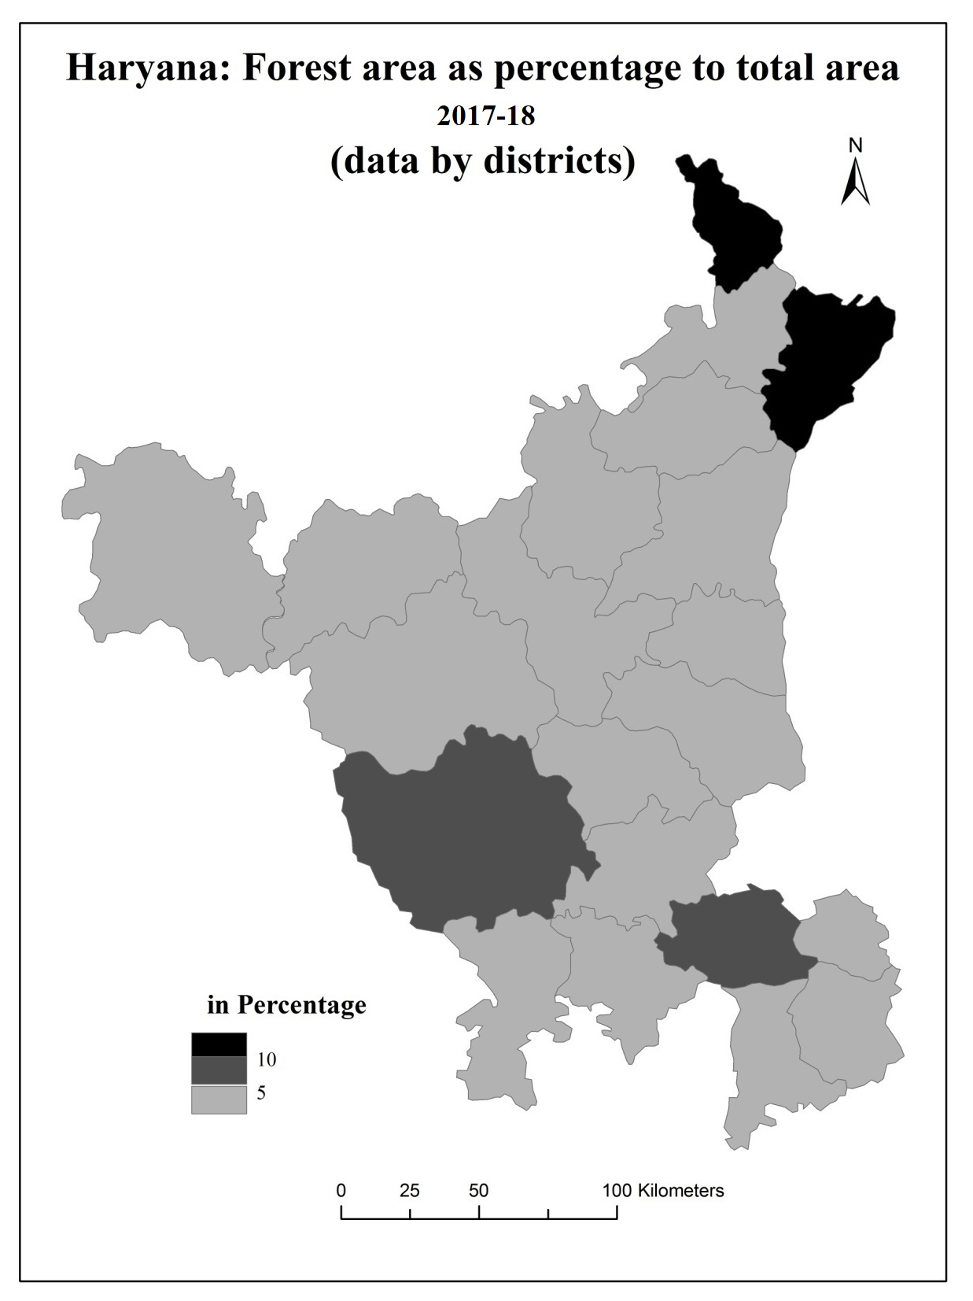

**Map 5.2**

**Crop Cover**

Contemporary agricultural technology has altered forest and tree cover in the region, with the Green Revolution affecting tree cover. The analysis now focuses on crop cover conversion. This includes:-

1. The expansion of cultivated land, which signifies the geographical distribution of the Green Revolution;
2. The augmentation of multiple cropping, which extends its temporal duration.
3. The densification of crop foliage is a consequence of the implementation of the Green Revolution input package, which includes the utilization of high-yielding variety seeds, fertilizers, and intensive irrigation practices.
4. The alteration of landscape aesthetics occurs when less remunerative crops are substituted with more remunerative crops.

**Land utilization:-**

Haryana's net area planted increased from 3.4 million hectares in 1966-1967 to 3.6 million hectares in 1985-86. However, after 1995-96, it declined from 3.58 million hectares to 3.51 million hectares in 2017-18. This increase in net area increased until the 1990s but has since declined.

**Table 5.13**

**Haryana: Net Area Sown, 1989-90 to 2017-18**

(in 000’ ha)

|  |  |  |  |
| --- | --- | --- | --- |
| **District** | **1989-90** | **2017-18** | **Change**  **(in percentage)** |
| Ambala | 139 | 107 | -23.30 |
| Panchkula | - | 25 |  |
| Yamunanagar | 126 | 125 | -1.80 |
| Kurukshetra | 154 | 151 | -2.95 |
| Kaithal | 215 | 201 | -7.52 |
| Karnal | 156 | 192 | 19.75 |
| Panipat | 155 | 96 | -39.70 |
| Sonepat | 106 | 169 | 62.72 |
| Rohtak | 378 | 140 | -72.97 |
| Jhajjar | - | 134 |  |
| Faridabad | 163 | 32 | -80.37 |
| Palwal | - | 109 |  |
| Gurgaon | 193 | 81 | -48.70 |
| Mewat | - | 117 |  |
| Rewari | 128 | 126 | -1.56 |
| Mahendragarh | 156 | 153 | -1.93 |
| Bhiwani | 396 | 370 | -6.47 |
| Jind | 225 | 238 | 5.57 |
| Hisar | 550 | 332 | -39.64 |
| Fatehabad | - | 224 |  |
| Sirsa | 353 | 392 | -9.95 |

Source: Statistical Abstract of Haryana, 1990 and 2018.

The decrease in fallow land and reclamation of cultivable but barren land led to an increase in net area sown in some districts, from 259 thousand hectares in 1966-1967 to 128 thousand hectares in 2017-18 (figure 5.1 and table 5.13).

**Figure 5.1**

Fallow land growth in various regions was influenced by factors like canal irrigation, rivers, and drainage systems. Canal irrigation in the south and southwest, rivers in the eastern and northern regions, and drainage systems enabled cultivation in wet areas during rainy seasons.

**Table 5.14**

**Haryana: fallow land, 1989-90 to 2017-18**

(in thousand hectares)

|  |  |  |  |
| --- | --- | --- | --- |
| District | 1989-90 | 2017-18 | Change points |
| Ambala | 14 | 1 | -13 |
| Panchkula | 0 | 1 | 1 |
| Yamunanagar | 2 | 0 | -2 |
| Kurukshetra | 0 | 0 | 0 |
| Kaithal | 0 | 0 | 0 |
| Karnal | 0 | 13 | 13 |
| Panipat | 0 | 8 | 8 |
| Sonepat | 4 | 0 | -4 |
| Rohtak | 6 | 5 | -1 |
| Jhajjar | 0 | 8 | 8 |
| Faridabad | 1 | 1 | 0 |
| Palwal | 0 | 5 | 5 |
| Gurgaon | 24 | 0 | -24 |
| Mewat | 0 | 0 | 0 |
| Rewari | 3 | 0 | -3 |
| Mahendragarh | 2 | 3 | 1 |
| Bhiwani | 16 | 45 | 29 |
| Jind | 15 | 5 | -10 |
| Hisar | 44 | 22 | -22 |
| Fatehabad | 0 | 0 | 0 |
| Sirsa | 44 | 11 | -33 |
| Total | 175 | 128 | -47 |

Source: Director of Land records, Haryana, 1990 and 2018.

Between 1989-2010, fallow land decreased by 47,000 hectares, with Sirsa district losing 33,000 hectares and Gurgaon losing 24,000 hectares (figure 5.1 and table 5.14).

The cultural wastelands were plowed under simultaneously, clearing vegetation, leveling sand dunes for irrigation, reducing river channel width, and encroaching on village grazing commons. This pattern followed a spatial pattern, with Yamuna flood plains extending riverbed cultivation, Bangar flood plains leveling sand dunes, and Ghaggar flood plains clearing vegetation cover.

The analysis examines the spatial correlation between cultivated land area fluctuations and Green Revolution implementation. Bhiwani and Hisar districts show a significant increase in cultivated land area, with a significant level of intensity within the context of the Green Revolution.

**Intensity of Cropping:-**

Intensification is a crucial aspect of modern agricultural practices, particularly in Haryana, where net area sown increases are less substantial than multiple sown areas (Table 5.13, 5.15 and figure 5.2).

**Table 5.15**

**Haryana: Area sown more than once, 1989-90 to 2017-18**

(in hectares)

|  |  |  |  |
| --- | --- | --- | --- |
| District | 1989-90 | 2017-18 | %increase |
| Ambala | 114000 | 100000 | 3 |
| Panchkula | - | 17000 | - |
| Yamunanagar | 72000 | 87000 | 20 |
| Kurukshetra | 91000 | 125000 | 37 |
| Kaithal | 157000 | 179000 | 24 |
| Karnal | 149000 | 191000 | 28 |
| Panipat | 87000 | 95000 | 9 |
| Sonepat | 54000 | 147000 | 172 |
| Rohtak192 | 109000 | 89000 | 72 |
| Jhajjar | - | 98000 | - |
| Faridabad | 77000 | 33000 | 56 |
| Palwal | - | 87000 | - |
| Gurgaon | 62000 | 30000 | 37 |
| Mewat | - | 55000 | - |
| Rewari | 63000 | 69000 | 10 |
| Mahendragarh | 85000 | 130000 | 53 |
| Bhiwani | 222000 | 370000 | 67 |
| Jind | 181000 | 240000 | 33 |
| Hisar | 343000 | 307000 | 47 |
| Fatehabad | - | 198000 | - |
| Sirsa | 192000 | 328000 | 71 |
| Total | 2058000 | 2975000 | 45 |

Source: calculated from the statistical abstract data, 1989-90 and 2017-18.

Multiple sowings increased cropping intensity from 158 to 184, with total area nearly tripling from 1.2 million hectares in 1966-67 to 3.0 million hectares in 2011-12 (Figure 5.3, 5.4 and table 5.14)

**Figure 5.2**

The primary contributing factor to the increased pressure on agricultural land resulting from population growth was the expansion of irrigation systems. The availability of a consistent water supply facilitated year-round cultivation. Currently, the topography is consistently adorned with a verdant attire throughout the entirety of the year.

**Table 5.14**

**Haryana: Intensity of cropping, 1989-90 to 2017-18**

|  |  |  |  |
| --- | --- | --- | --- |
| District | 1989-90 | 2012-13 | Change points |
| Ambala | 182 | 193 | 11 |
| Panchkula | - | 168 | - |
| Yamunanagar | 157 | 169 | 12 |
| Kurukshetra | 159 | 183 | 24 |
| Kaithal | 173 | 189 | 16 |
| Karnal | 195 | 199 | 4 |
| Panipat | 156 | 199 | 43 |
| Sonepat | 150 | 187 | 37 |
| Rohtak | 129 | 164 | 35 |
| Jhajjar | - | 173 | - |
| Faridabad | 172 | 203 | 31 |
| Palwal | - | 180 | - |
| Gurgaon | 132 | 137 | 5 |
| Mewat | - | 147 | - |
| Rewari | 149 | 155 | 6 |
| Mahendragarh | - | 185 | - |
| Bhiwani | 156 | 200 | 44 |
| Jind | 180 | 201 | 21 |
| Hisar | 162 | 192 | 30 |
| Fatehabad | - | 188 | - |
| Sirsa | 154 | 184 | 30 |
| Total | 158 | 184 | 16 |

Source: computed from the data of Statistical Abstract 1989-90 and 2017-18.

In 1989-90 the intensity of the Green Revolution was highest in the Karnal, Kaithal and Jind district. In the Rohtak, Rewari and Gurgaon districts measure the low intensity of the Green Revolution. On the other side in 2011-2012 the highest intensity of Green Revolution. On the other side in 2011-12 the highest intensity of the Green Revolution is 16 in the given study period. The lowest intensity region is the industrial belt and sugarcane belt of Haryana where the paddy-wheat rotation plays a smaller role.

**Figure 5.3**

**Figure 5.4**

Bycontrast,Rewari district emerged as the one with only a small increase in area sown more than once. The same was true of Panchkula district. The intensity of the Green Revolution has been low in both cases. The lack of irrigation, associated with undulating topography and deep water table, limited the scope of multiple cropping. In the high Green Revolution intensity areas, the increase in multiple cropping is significant but not as eastern part of Haryana. Under reference here are the districts of Sonepat, Panipat, Rohtak and Bhiwani from the south-western region.

**Table 5.17**

**Haryana: Paddy area as Percentage of Cropped Area, 1989-90 to 2017-18**

(in Percentage)

|  |  |  |  |
| --- | --- | --- | --- |
| District | 1989-90 | 2017-18 | Change points |
| Ambala | 25 | 40 | 15 |
| Panchkula | - | 22 | 22 |
| Yamunanagar | 22 | 35 | 13 |
| Kurukshetra | 38 | 44 | 6 |
| Kaithal | 29 | 42 | 13 |
| Karnal | 40 | 43 | 3 |
| Panipat | 31 | 40 | 9 |
| Sonepat | 14 | 30 | 16 |
| Rohtak | 2 | 17 | 15 |
| Jhajjar | - | 13 | 13 |
| Faridabad | 4 | 19 | 15 |
| Palwal | - | 16 | 16 |
| Gurgaon | .4 | 5 | 5 |
| Mewat | - | 3 | 3 |
| Rewari | 0 | 2 | 2 |
| Mahendragarh | 0 | .4 | .4 |
| Bhiwani | 0 | .02 | .02 |
| Jind | 11 | 15 | 4 |
| Hisar | 4 | 7 | 3 |
| Fatehabad | - | 21 | 21 |
| Sirsa | 4 | 9 | 5 |

Source: calculated from the data of Statistical abstract of Haryana, 1990 and 2018.

Multiple cropping, associated with an assured base of irrigation, was of a relatively high order here even in 1966-67. This limited the scope of further intensification. The decrease in land left fallow and an increase in intensity of cropping are putting a tremendous strain on the soil fertility. The soil now gets no time to recuperate its strength, farmyard manure is scarce and the practice of the green manuring is impossible due to lack of time between harvesting of one crop and sowing of the next. Soils consequently are suffering from several deficiencies as discussed earlier.

**Nature of Crops**

The Green Revolution led to a shift in crop diversification, with emphasis on wheat and paddy as main commercial crops. By 1990-91, wheat and paddy accounted for 20.33 per cent of total cropped area, while in 2017-18, it increased to 42.42 per cent. The share of other crops also declined from 1966-67 to 2017-18 due to wheat-paddy rotation.

**Table 5.18**

**Haryana: Wheat Area as percentage of cropped area, 1989-90 to 2017-18**

(in percentage)

|  |  |  |  |
| --- | --- | --- | --- |
| District | 1989-90 | 2017-18 | Change points |
| Ambala | 36 | 42 | 6 |
| Panchkula | - | 38 | 38 |
| Yamunanagar | 31 | 40 | 9 |
| Kurukshetra | 43 | 41 | -2 |
| Kaithal | 47 | 46 | -1 |
| Karnal | 43 | 45 | 2 |
| Panipat | 46 | 46 | 0 |
| Sonepat | 52 | 51 | -1 |
| Rohtak | 40 | 45 | 5 |
| Jhajjar | - | 42 | 42 |
| Faridabad | 50 | 48 | -2 |
| Palwal | - | 51 | 51 |
| Gurgaon | 35 | 47 | 12 |
| Mewat | - | 41 | 41 |
| Rewari | 22 | 25 | 3 |
| Mahendragarh | 14 | 15 | 1 |
| Bhiwani | 11 | 20 | 9 |
| Jind | 37 | 48 | 11 |
| Hisar | 28 | 37 | 9 |
| Fatehabad | - | 45 | 45 |
| Sirsa | 27 | 42 | 15 |

Source: Statistical abstract of Haryana, 1990 and 2018.

Pulses also lost importance as they were less remunerative (Table 5.19). The area under pulses decreased from 1150 thousand hectares in 1966-67 to 594 thousand hectares in 1989-90 and decreased to 123 thousand hectares on 2017-18. Area under gram, a rain-fed crop, in 1989-90 was only half of that in 1966-67. Pulses and gram are leguminous crops. It helped in controlling soil borne diseases (Punjab Agricultural University, 1978-79: 26).

The decrease in area under these two crops resulted in the soil quality being adversely affected as their soil enriching advantages were lost (Table 5.20). Bajra and Jowar were also important crops in 1966-67. But the area of both crops diminished from 893 and 270 in 1966-67 to 576 and 65 thousand hectares in 2017-18 (Table: 5.21)

**Table 5.19**

**Haryana: Pulse area as percentage of total cropped area, 1989-90 to 2017-18**

(in percentage)

|  |  |  |  |
| --- | --- | --- | --- |
| District | 1989-90 | 2017-18 | Change points |
| Ambala | 7 | 1 | -6 |
| Panchkula |  | 2 | 2 |
| Yamunanagar | 4 | 1 | -3 |
| Kurukshetra | 2 | 1 | -1 |
| Kaithal | 3 | .2 | -2.7 |
| Karnal | 1 | .2 | -.8 |
| Panipat | 2 | .5 | -1.5 |
| Sonepat | 5 | .6 | -4.4 |
| Rohtak | 9 | 3 | -6 |
| Jhajjar |  | 2 | 2 |
| Faridabad | 4 | 2 | -2 |
| Palwal |  | .5 | .5 |
| Gurgaon | 2 | .9 | -1.1 |
| Mewat |  | 2 | 2 |
| Rewari | 8 | .5 | -7.5 |
| Mahendragarh | 17 | 3 | -14 |
| Bhiwani | 32 | 7 | -25 |
| Jind | 8 | .2 | -7.8 |
| Hisar | 13 | 4 | -9 |
| Fatehabad |  | .5 | .5 |
| Sirsa | 18 | 1 | -17 |

Source: Statistical abstract of Haryana, 1990 and 2018.

**Table 5.20**

**Haryana: Gram area as percentage to total cropped area, 1989-90 to 2017-18**

|  |  |  |  |
| --- | --- | --- | --- |
| District | 1989-90 | 2017-18 | Change points |
| Ambala | 2 | .04 | -1.96 |
| Panchkula |  | .4 | .4 |
| Yamunanagar | 1 | .04 | -.96 |
| Kurukshetra | .4 | .04 | -.6 |
| Kaithal | 1 | .02 | -.98 |
| Karnal | .3 | .02 | 0 |
| Panipat | .8 | .05 | -.7 |
| Sonepat | .6 | .02 | -.5 |
| Rohtak | 7 | .03 | -6.9 |
| Jhajjar |  | .1 | .1 |
| Faridabad | .4 | .1 | -.3 |
| Palwal |  | 0 | 0 |
| Gurgaon | .7 | 0 | .7 |
| Mewat |  | .3 | .3 |
| Rewari | 7 | 0 | -7 |
| Mahendragarh | 16 | 3 | -13 |
| Bhiwani | 31 | 6 | -25 |
| Jind | 7 | .02 | -6.9 |
| Hisar | 12 | 2 | -10 |
| Fatehabad |  | .1 | .1 |
| Sirsa | 18 | 1 | -17 |

Source: Statistical Abstract of Haryana 1990 and 2018.

The crop combination map of Haryana got simplified with the ushering in the Green Revolution. Wheat emerged as the first ranking crop not only in those areas where it was traditionally dominant but also in others where Bajra, Jowar, cotton and gram held sway. Such a change was more visible in eastern and southern Haryana. A similar change was noticed in Rohtak, Bhiwani, Jind, Hisar districts. Paddy emerged as the second most important crop in area and the first in terms in economic returns in 2017-18. Thus this event was technology based in contravention of ecological norms. Paddy, being a water intensive plant is not deemed as appropriate for areas like Haryana where it average annual rainfall of around 50 cms is less than one half of the national average of 108cms, nor is the surface or underground water adequate in anyway.

**Table 5.21**

**Haryana: Jowar and Bajra area as percentage to total cropped area, 1989-90 to 2017-18**

(in percentage)

|  |  |  |  |  |  |  |
| --- | --- | --- | --- | --- | --- | --- |
|  | Jowar | | | Bajra | | |
| District | 1989-90 | 2017-18 | Change | 1989-90 | 2017-18 | Change |
| Ambala | 0 | 0 | 0 | .6 | .1 | -.5 |
| Panchkula | - | 0 | 0 | - | 2 | 2 |
| Yamunanagar | .2 | 0 | -.2 | .8 | .2 | -.6 |
| Kurukshetra | .1 | 0 | -.1 | 0 | .1 | -.1 |
| Kaithal | .5 | 0 | -.5 | 4 | 2 | -2 |
| Karnal | 0 | 0 | 0 | 0 | .2 | .2 |
| Panipat | .5 | 0 | -.5 | 1 | .2 | -1.8 |
| Sonepat | 5 | 3 | -2 | 2 | 3 | 1 |
| Rohtak | 10 | 9 | -1 | 9 | 0 | -9 |
| Jhajjar | - | 6 | 6 | - | 3 | 3 |
| Faridabad | 7 | 2 | -5 | 8 | 6 | -2 |
| Palwal | - | 4 | 4 | - | 4 | 4 |
| Gurgaon | 6 | 1 | -5 | 21 | 29 | 8 |
| Mewat | - | 8 | 8 | - | 15 | 15 |
| Rewari | 2 | .5 | -1.5 | 29 | 32 | -3 |
| Mahendragarh | 0 | 0 | 0 | 39 | 40 | -1 |
| Bhiwani | .5 | 0 | -.5 | 32 | 23 | -9 |
| Jind | 9 | 0 | -9 | 13 | 6 | -7 |
| Hisar | .1 | 0 | -.1 | 9 | 7 | -2 |
| Fatehabad | - | 0 | 0 | - | 1 | 1 |
| Sirsa | 0 | 0 | 0 | 1 | .5 | -1.5 |

Source: Statistical Abstract of Haryana 1989-90 an 2017-18.

It follows from above that wheat and paddy as the two main crops in rotation extended their domain at the expense of the less remunerative food crops. The nature of crop cover got modified and this was equally true of both kharif (summer) and Rabi (winter) seasons. A dominance of wheat during Rabi and that of paddy during Kharif is the most visible feature of the Haryana landscape now.

**High yielding varieties**

The Green Revolution was a package of high yielding variety seeds, fertilizers and irrigation. In 1970 and 1971 56 per cent of area under wheat was covered by high yielding varieties seeds. This percentage reached 98.9 per cent in 1990-91 and 95.3 per cent in 2017-18. By 1985-86, these seeds had been universally adopted and practically no traditional variety of wheat is now being grown.

Paddy made a big entry in the mid-seventies with its high-yielding variety seeds. By 1970-71 only, 11 per cent of all paddy in Haryana had been covered by the high yielding varieties, that increased by 2017-18, 60 per cent of all paddy in Haryana had been covered by the high yielding varieties (Table 5.21).

**Table 5.22**

**Haryana: Paddy and Wheat area under high yielding variety seeds, 1989-90 and 2017-18**

(in percentage)

|  |  |  |  |  |
| --- | --- | --- | --- | --- |
| **Paddy** | | | **Wheat** | |
| District | 1989-90 | 2017-18 | 1989-90 | 2017-18 |
| Ambala | 67 | 57 | 100 | 95 |
| Panchkula | 65 | 78 | 81 | 87 |
| Yamunanagar | 66 | 62 | 98 | 98 |
| Kurukshetra | 69 | 63 | 99 | 98 |
| Kaithal | 66 | 68 | 95 | 96 |
| Karnal | 65 | 66 | 99 | 98 |
| Panipat | 65 | 47 | 100 | 95 |
| Sonepat | 81 | 55 | 100 | 96 |
| Rohtak | 71 | 44 | 99.5 | 94 |
| Jhajjar | 71 | 84 | 84 | 90 |
| Faridabad | 78 | 67 | 98.3 | 90 |
| Palwal | 29 | 56 | 86 | 94 |
| Gurgaon | - | - | 98 | 94 |
| Mewat | - | - | 75 | 96 |
| Rewari | - | - | 95 | 92 |
| Mahendragarh | - | - | 97 | 78 |
| Bhiwani | 21 | 67 | 95 | 92 |
| Jind | 60 | 59 | 100 | 98 |
| Hisar | 81 | 60 | 100 | 96 |
| Fatehabad | 38 | 57 | 95 | 96 |
| Sirsa | 72 | 88 | 99 | 94 |

Source: computed from the data from the Statistical abstract of Haryana 1989-90 and 2017-18.

High yielding varieties in Haryana have negative impacts, including loss of genetic diversity, reduced adaptation to local conditions, increased vulnerability to pest attacks, and the use of pesticides. This leads to a cycle of deterioration and increased nutrient uptake, causing micronutrient deficiencies and toxic chemicals build-up in the soil (Shiva 1989: 74).

**AIR**

The Green Revolution has had a big influence on a place's ecosystem since it has accelerated growth and caused air pollution in Haryana from quarrying close to industrial hubs. Two thermal facilities in Panipat and Faridabad are to blame for almost 80% of the state's air pollution. When the makeup of the air deviates from that of the natural world and has an immediate and direct effect on humans, it is said to be polluted. Rural air pollution, particularly that caused by agricultural activities, has not gotten much attention, and urban air pollution is considerably more common than it is in rural areas. The advent of irrigated agriculture in the arid southwest has decreased the frequency and severity of dust storms, which has contributed to a decrease in dust in rural areas since the Green Revolution. However, the Green Revolution has also brought about the automation of agriculture, which has increased the usage of fossil fuels and resulted in loud sounds, nitrous oxide emissions, and higher fuel consumption. Due to the rice cultivation that is prevalent in Haryana, which covers more than half of the state, and the paddy fields frequent flooding and heavy irrigation, the countryside sometimes resembles a vast lake. Pesticides, which have increased since their creation from a nearly zero foundation, are necessary for the control of pests. Wheat and paddy threshing contribute to the farm's increased pollution, which leads to eye problems and respiratory conditions. Haryana's harvest times between April and May and October and November are especially polluting since almost half of the plant stems are burnt. Intensified repeated cropping has created a blanket of green virtually all year long, giving mosquitoes a place to reproduce and hide. The formerly thought to be extinct disease of malaria has returned, with 33401 instances reported in 2018. Surprisingly, regions with a less intense Green Revolution, such Rewari, Mahendragarh, Faridabad, Gurgaon, and Jhajjar, have lower malaria rates.

Agro- based industries units, such as rice-shellers, which have come up in the countryside in large numbers also produce air pollution in their vicinity. The rice husk is often thrown outside the factory to fly about freely or is burnt. Either way it reduces the quality of air in its surrounding area.Thus, the Green Revolution's effect on air quality may be seen as both beneficial and harmful. The detrimental effects are connected to agricultural activities that make use of equipment, chemical fertilizers, pesticides, and fossil fuels. On the plus side, metalized roads, more green cover across time and space, and weaker storms have made living in the villages less dusty. However, the reappearance of malaria, particularly in places with a paddy-wheat cycle, is a cause for grave worry. An area of inquiry that merits investigation is how agricultural activities contribute to air pollution. With more and more technology being used in agriculture today, the topic takes on a unique relevance. For this aim, Haryana makes a compelling case study. Therefore, the Green Revolution sparked a trend wherein land started to become valuable and was exploited more heavily for economic purposes. Both the area covered by trees and crops increased at the same time. The usual doesn't take place. Forest land often does not extend beyond agricultural land. In Haryana, events happened in a somewhat different way.

**Table 5.23**

**Haryana: Positive Cases of Malaria, 2018**

|  |  |
| --- | --- |
| District | Number |
| Ambala | 282 |
| Panchkula | 418 |
| Yamunanagar | 5212 |
| Kurukshetra | 525 |
| Kaithal | 252 |
| Karnal | 2559 |
| Panipat | 535 |
| Sonepat | 806 |
| Rohtak | 1315 |
| Jhajjar | 290 |
| Faridabad | 259 |
| Palwal | 489 |
| Gurgaon | 530 |
| Mewat | 1558 |
| Rewari | 91 |
| Mahendragarh | 359 |
| Bhiwani | 3661 |
| Jind | 656 |
| Hisar | 9308 |
| Fatehabad | 1044 |
| Sirsa | 2575 |

Source: Annual report on implementation of National Vector Borne Disease Control Program in Haryana, Director Health services (Malaria), 2018

The expansion of agricultural land in India has been achieved through various methods, including removing marshes from flood plains, installing canal irrigation, and draining water from wet areas. Government-owned property has also been developed, with Khair (acacia catechu) being widely grown on Shiwalik hills. The relative value of other crops has also shifted, with paddy and wheat being the primary cash crops under rotation. This has led to a longer-lasting and more comprehensive green cover, increasing the density of the landscape. Historically, India's Haryana state has been underdeveloped in terms of tree or forest cover, but the uniformity achieved by focusing on a few crops, such as rice and wheat, does not benefit the state's ecology.

**Model: Environmental Impacts of Green Revolution in Haryana**

**Water Table**

**Vegetation**

**Air**

**Soil**

Positive outcome and negative outcome

Tubewell Irrigation

Expansion of Agriculture into forests and pastures land

Frequent application of irrigation, chemical fertilizers and heavy machinery

Extension of Green cover and irrigation; Reduction in dust storms

Fall in water table, wheat and paddy rotation, loss of tanks and ponds

Change in the physical and chemical properties of soils

Depletion of indigenous tress, plantation of water intensive trees

Increased use of modern machinery, NPK, insecticides → Air Pollution

Canal Irrigation

Pudding for paddy – negative impact on soil structure

Shrinking of forest cover

Increase in the incidences of malaria and air pollution related

Rise in Water Table Waterlogging disruption of natural drainage

Saline and alkaline formation, soil depletion

Problems of soil erosion and reduction in biodiversity

Demises of natural habitat, salinisation, soil erosion, water logging, lowering of underground Water-table, spread of malaria, soil , water and air pollution, environmental degradation, poor Sustainability of Agricultural land, Ecological Imbalances

**Conclusion**

This book aimed to conduct a comprehensive study of the ecological implications of the Green Revolution in the Indian state of Haryana. The main objectives were to conduct a situational analysis of the ecology-development scenario, particularly in the field of agriculture in Haryana, identify regional variations in the intensity of the Green Revolution, and examine the degree of association between intensity and degradation of different components of the ecology, such as water, soil, air, and vegetation in spatial terms. The study was conducted between the 1966-2013 periods, which were witness to the beginning of the Green Revolution, attaining its climax, and subsequently reaching a plateau stage. Haryana was selected for the study because it offered the right kind of development-ecology conflict situation for a detailed analysis. A consistent geographic approach was used to identify regional variations in ecological implications of the Green Revolution in Haryana, discover the area-specific factors in each case, and assess the impact of ecological change on the overall geographic personality of the state.

The methodology followed was in consonance with these aims, including the processing, mapping, and analysis of all relevant secondary data. A technique for measuring intensity of the Green Revolution was devised, which was computed by dividing the area under wheat and paddy rotation by the cropped area in a spatial unit. This allowed for an objective assessment of the spatial correspondence between the two. A historical view is essential for understanding ecological change in any context, as problems could have threefold origins: inherited from nature, damage suffered in the historical process, and the emerging scenario of rapid population growth, strong urge for consumerism, and unrestrained use of resources.

In Haryana, much progress was made in agricultural productivity but at the cost of land and water degradation. Intensive agriculture during the period of the Green Revolution brought significant land and water problems relating to soil degradation over exploitation of ground water and soil pollution due to the use of high doses of fertilizers and pesticides. The adoption of high yielding variety seeds, extension of irrigation, and use of chemical in agriculture led to increased greenery and prosperity, but also led to soil degradation, pesticide use, and air quality issues. The damaged ecology increased the cost of agriculture by increasing the expenditure on irrigation, fertilizers, land reclamation, and pesticides. The erosion in profits resulted in farmers feeling victimized, and a depleted water resource made them sensitive about any sharing of it with neighboring states. The first hypotheses, which envisaged both positive and negative ecological impacts of the Green Revolution, were validated. Negative effects of the Green Revolution far outweighed the positive ones, with major impacts related to the depleting water table and adversely affected soil properties. The second hypotheses, which expected a positive relationship between intensity of the Green Revolution and degree of ecological damage, was supported but not to the extent envisaged. The study found that the southern and southwestern parts of Haryana, where the Green Revolution intensity was low, experienced greater ecological damage. Moderate intensity areas had greater strain on ecology, possibly due to higher land care and local differences in inherited ecological endowments.

However, data gaps were encountered, and it was suggested that all ecological parameters should be collected and stored at a central location. The Department of Geography at Maharishi Dayanand University could serve as a documentation center for this purpose. The study also highlighted the need for micro-level investigations, focusing on water table decline, soil fertility, waterlogging, and deforestation. Additional aspects of ecology, such as air pollution in rural areas, should also be addressed. The fallouts of ecological degradation associated with the Green Revolution on economy, society, and polity can also be examined through empirical analysis. The study reveals that the development process impinges on ecology but also creates conditions and capacities that benefit it. This conviction is crucial for achieving an economically and ecologically sustainable society in Haryana.

**Bibliography**

Al-Saleh, M.A. (1992). “Declining ground water level of Minjur acqifer, Tebrak area. Saudi Arabia. The Geographical Journal. 158: 215-222.

Aiyer, A.k. (1952). ‘’Agriclture and allied arts in Vedic India’’. Bombay. 42-46.

Banerjee, J.M. (1967). ‘’History of Firojshah Tughalaq’’. Delhi. 118-128.

Bhalla, P. (2007). “Impact of declining groundwater levels on acreage allocation in Haryana”. Economic and Political weekly. 2702-2707.

Bhan, S. (1950). ‘’The prehistoric settlements in Haryana’’. ITAS Shimla. Seminar-proceedings. Vol I: 157-158.

Bidwai, P. (1988). “Indian agriculture in trouble: consequences of Green Revolution”. The Times of India, New Delhi. Monday, February 22: 6.

Borlaug, N.E. (1970). “The Green Revolution and the Road Ahead”. Speech. Oslo.

Brar, K.K.(1999). ‘’Green Revolution: Ecological Implications’’. Dominant publication. Ed, 1. New delhi. 33-34.

Brar, S.P.S. and Singh, B. (1986). “Changes in soil fertility under intensive cultivation”. Indian journal of Ecology. 13: 152-157.

Chandler, R.F. (1976). “The physical and biological potentials and constraints in meeting world food needs”. Proceedings of the world Food Conference. Lowa. U.S.A.

Chowdhary, P. (1986). ‘’The advantages of backwardness: colonial policy and agricuture in Haryana’’. The Indian economic and social historic review. 23(3): 263-288.

Conway, G.R. and Barbier, E.B. (1988). “After the Green Revolution”, Futures. 20: 651-670.

Darling, M. (1947). ‘’The Punjab peasant in prosperity and debt’’. London: Oxford university press: 105-128.

Dhaliwal, S. (2007). The Tribune. New Delhi. Thursday. April 26, 2007.

Datta, S.K. and Tauro, A.C. (1968). “Effect of plant type and nitrogen level on growth characterstics and grain yield of indica in the tropics”. Agron. 60(6): 643-647.

Fernando, V. and Thomas, M.P. (1978). “An assessment of the ecological implications of new varieties of seeds”. International journal of Environmental Studies. 12:289-293.

Fischer, R. A. and Edmeades, E. O.(2009). ["Can Technology Deliver on the Yield Challenge to 2050"](ftp://ftp.fao.org/docrep/fao/012/ak977e/ak977e00.pdf). Expert Meeting on How to Feed the World (Food and Agriculture Organization of the United Nations).

Gaud, W.S. (1968). ["The Green Revolution: Accomplishments and Apprehensions"](http://www.agbioworld.org/biotech-info/topics/borlaug/borlaug-green.html). AgBioWorld. Retrieved 8 August 2011.

Gupta, H.R. (1952). ‘’A history of Sikhs’’. I. Simla. Minerva book shop.

Gupta, S.L. (1971). ‘’The cropping pattern of Haryana’’. Geographical review of India. 33: 23-55.

Habib, I. (1969). ‘’Medieval India, Proceedings of Indian history congress’’. Varanasi.presidential address. 139-161.

Haryana state gazetteer. ‘’History of agriculture’’. Vol, II: 22-23.

Haryana (http://www.britannica.com/ebc/article-9111200) Britannica Online Encyclopedia.

Hazell, P. (2009). “[The Asian Green Revolution](http://books.google.com/books?id=frNfVx-KZOcC&pg=PA1)”. IFPRI Discussion Paper (Intl Food Policy Res Inst). GGKEY:HS2UT4LADZD.

Imperial gajetteer of India. Vol II. 22-23.

Imperial gajetteer of India. Vol XIII. 67-68.

Inderjeet (2001). “Water resource management”.Manisha Publications. New Delhi.

Kang, D.S. (1982). “Environmental problems of the Green Revolution with a focus on Punjab, India”.in Richard Barrett ed.. International Dimensions of the Environmental Crisis. Colorado: Westview press.

Kathpal, T.S. and Kumari, B. (1998). “Pesticidal contamination Environment, its implications and Management”. Ecological Agriculture and Sustainable development. 2: 535-551.

Kumar, R., Pasricha, N.S., 1999. ‘’Land use and land cover changes in the Indus plains of Punjab in the post Green Revolution period 1965–1995’’. In: Proceedings of the International Seminar on Historical Perspectives of Land-use/Land-cover Change in South Asia for the Study of Global Change, April 11–13, 1999. NPL, New Delhi.

Millar, C.E; Turk, L.M. and Foth, H.D. (1958). “Fundamental of Soil Science. New York: John Wiley and Sons: 325.

Mitra, N. (1988). “The price of the Green Revolution: ground water reserves”. Sunday. 21-27 february: 61-63.

Nace, R.L. (1970). “Human use of ground water in R.J. Chorley (ed.) Water, Earth and Men. Land Menthen Publishing: 285-293.

Nadkarni, M.V. (1987).”Agricultural development and Ecology: an Ecnomists view”. Indian journal of Agricultural Economics. 42: 3.

Nayyar, V.K. (1983). “Manganese deficiency in Punjab Soils”. Progressive Farming.19: 18-19.

Nijjar, B.S. (1968). ‘’Punjab under the sultans (1000-1526 A.D)’’. Delhi. Sterling.

Patrick, B. (2007). ["Feeding Billions, A Grain at a Time"](http://online.wsj.com/article/SB118556810848880619.html). The Wall Street Journal: A1.

Powell, B. (1988). ‘’Indian village community’’. Reprint. London longmans.

Piggot, S. (1950). ‘’Prehistoric India’’. London: cassell.

Pingali, P. “Green Revolution: Impacts, limits, and the path ahead”. Bill & Melinda Gates Foundation, Agricultural Development. Harvard University, Cambridge: 3-4.

Prakash, B. (1970). ‘’Rigveda’’. 11. 29: 3-5.

Prasad, V.R. (1984). ‘’Mammalian fauna of Punjab’’. in Atwal bains & Dhindsa eds. Status of wildlife in Punjab, Ludhiana: the Indian ecological society: 25-39.

Rama (1978). “Our Water resources’’: National Book Trust. India.

Ramakrishnan, P.S. (2008). ‘’Ecology and Sustainable development: working with knowledge system’’. National book trust. New Delhi.

Randhawa, M.S. (1980). ‘’A history of agriculture in India’’. Vol.I. ICAR. New delhi: iii-iv.

Randhawa, M.S. (1986). ‘’A history of agriculture in India’’. IV. New delhi: Indian council of agricultural research: iv-v.

Randhawa, M.S. (1982). Op.cit. 203-208.

Randhawa, M.S. (1982). ‘’A history of agricuture in India’’. Vol, II. ICAR. New delhi. 10-11.

Randhawa, M.S. (1980). “ A history of Agriculture in India. 1. New Delhi. Indian council of Agricultural Research.

Singh, N. (1998). ‘’Administration and development in Indian state : impact of area reorganisation on development process’’. Ed, 1. Anmol publication. New delhi. 167-182.

Singh, M. (2012). ‘’Mapping the agricultural geography: a district wise pattern in the south-eastern part of Punjab province in colonial India’’. IJMIE. 2(6).

Singh, Y. (2001). ‘’Geo-ecology of the trans Satluj Punjab-Haryana shiwalik hills, NW India’’. Envis bull: Himalayan ecology and development. 9(2): 15-34.

Starcey, P.D. (1963). ‘’Wildlife in India: its conservation and control’’. New delhi: ministry of food & agriculture.

Shiva, V. (1991). “ The Green Revolution in Punjab”. The Ecologist. 21: 57-60.

Shiva, V. (1989). ‘’The Violence of the Green Revolution: Ecological Degradation and Political Conflict in Punjab’’. Dehra Dun: Research Foundation for Science and Ecology.

Singh, G. (1991). ‘’Environmental Deterioration in India- Causes and Control: With Special Reference to Punjab’’. New Delhi: Agricole Publishing Academy.

Sharma, M.L. and Dak, T.M. (1989). “Green Revolution and Social Change’’. Delhi. Ajanta books.

Singh, J. (1974). “The Green Revolution: How Green it is”. Kurukshetra. Vishal Publications.

Singh, P. (2011). “Economic benefits and Ecological cost of the Green Revolution”. Journal of Social and Economic development. 7. 1: 64-74.

Singh, R.B. (2000). “Environmental consequences of agricultural development: a case study from the Green Revolution state of Haryana, India”. ELSVIER. Agriculture, Ecosystem and Environment. 82: 97-103.

Singh, R.B., 1997. ‘’Impact of agriculture and land use/cover change on soil and water resources and ecosystem sustainability: a case study of Punjab’’. In: Epps, R. (Ed.), Sustainability of Rural System in the Context of Global Change. University of New England, Armidale.

Subramanian, V. (2000). “Water quantity-quality perspective in South Asia. Kingston International publishers. Surrey, U.K.

Trevaskis, H.K. (1928). ‘’The land of five rivers’’. Oxford university press.

Vashistha, N. (2007). “Green Revolution”. Pratiyogita Darpan. 636-637.

Wilson, F. (1904). ‘’Punjab notes and quarries’’. 547. 67-68.

World Bank (1992). ‘’World Development Report: Development and Environment’’. Oxford: Oxford University Press.

Wolf, E.C. (1986). “Beyond the Green Revolution”. New approaches for Third World Agriculture. Paper73. Washington: Worldwatch Institute.

World Bank (1992). ‘’World Development Report: Development and Environment’’. Oxford: Oxford University Press: 1.

Yadav, S. (2004). “Water: Problem and its Management. Hope India Publications. Gurgaon.

Yapa, L.S. (1979). “Ecopolitical economy of the Green Revolution”, Professional Geographer. 31: 371-376.